Lesson 20
Objective: Look at a numeral and count out a group of up to 8 objects.

Suggested Lesson Structure
 Fluency Practice (3 minutes)
 Concept Development (14 minutes)
 Application Problem (5 minutes)
 Student Debrief (3 minutes)
Total Time (25 minutes)
Fluency Practice (3 minutes)
- Balance and Count to 9 and 10 PK.CC.1 (3 minutes)
Balance and Count to 9 and 10 (3 minutes)
Note: Rote counting to 9 and 10 prepares students for the objective of touching and counting to 9 and 10 in Topic E.
T: Let’s stand on one leg and count to 9. Ready? 1, 2, 3, 4, fiiiiive, 6, 7, 8, 9. (Repeat until most chidren are able to balance the whole time. Have some laughs by slowing down or speeding up the count and at times dragging out the fiiiive more or less!)
T: Let’s stand on the other leg and count to 9. Ready? 1, 2, 3, 4, 5, 6, 7, 8, 9. (Follow the same process as above.)
T: Let’s stand on the other leg again and count to 10. Ready? 1, 2, 3, 4, 5, 6, 7, 8, 9, 10.
T: Let’s stand on our other leg and count to 10. Ready? 1, 2, 3, 4, 5, 6, 7, 8, 9, 10.
Concept Development (14 minutes)
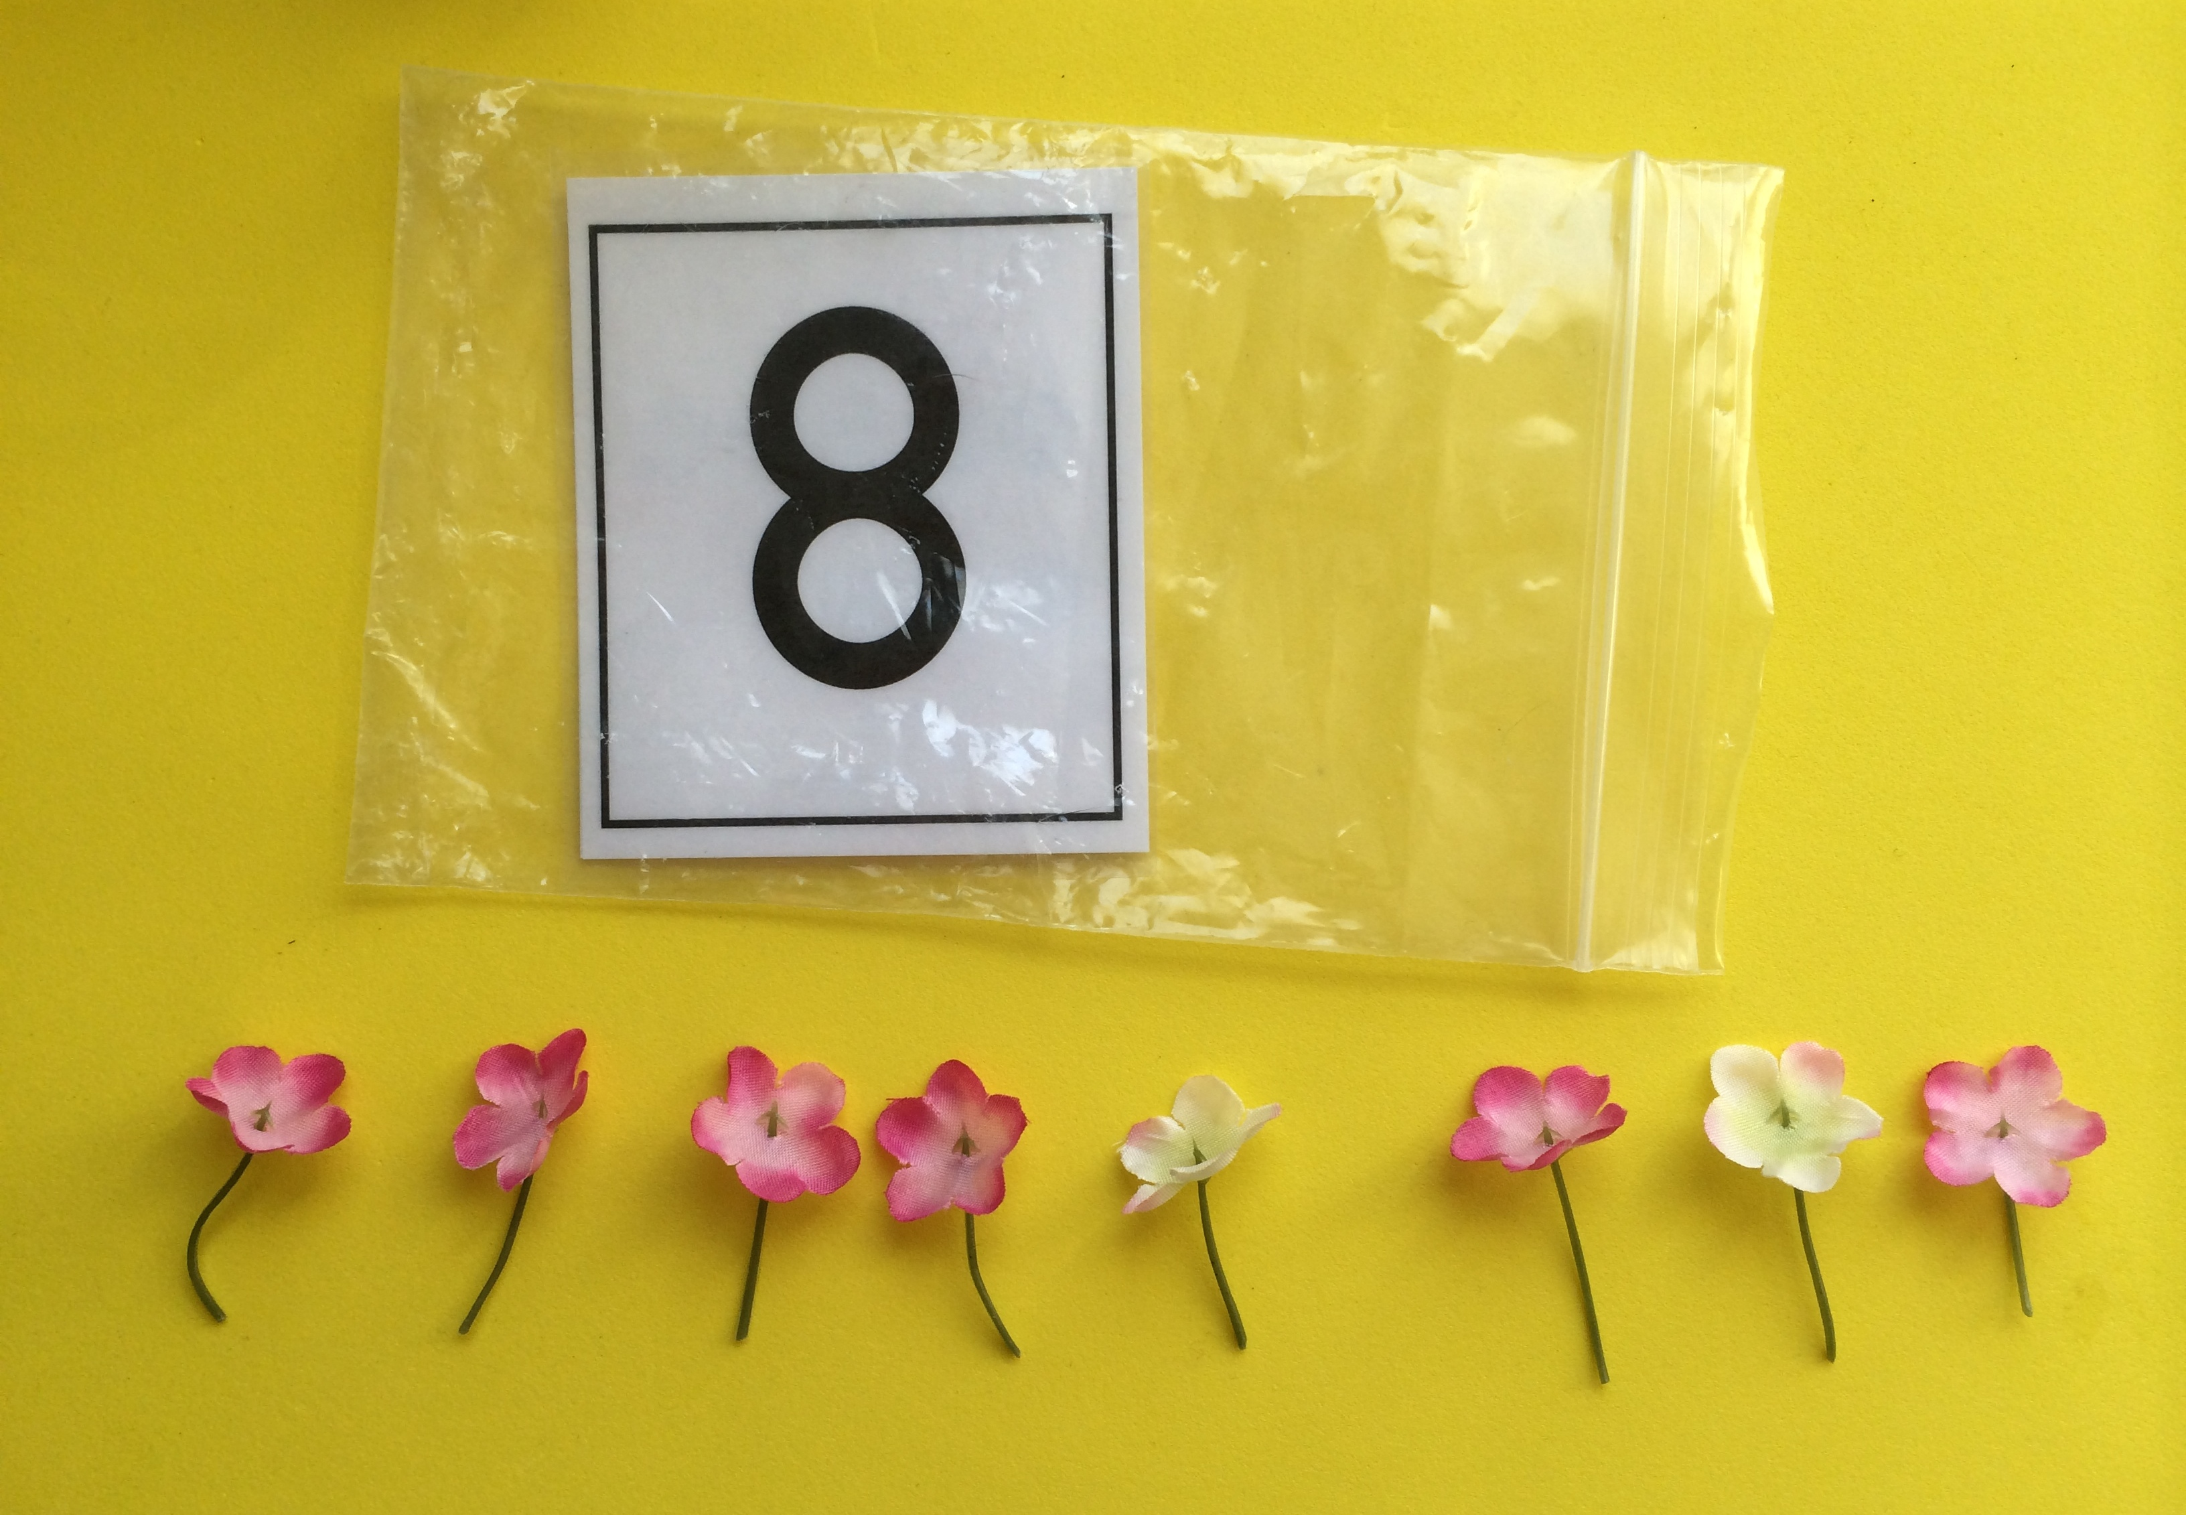
Part 1: Concept Introduction
Materials: (T/S) Cup of 10 flowers, baggie containing the numeral card 8 (Lesson 16 Template 2)

- Tell students that today the chefs at the Pollen Café must prepare bags of flowers for their customers. They will have to count out the right number of flowers for each baggie.
- Invite children to take the numeral cards out of their bags. Ask all students to name the number and trace it with a finger. Ask, “How many flowers do we need for this baggie?” Guide children to respond, “8 flowers!”
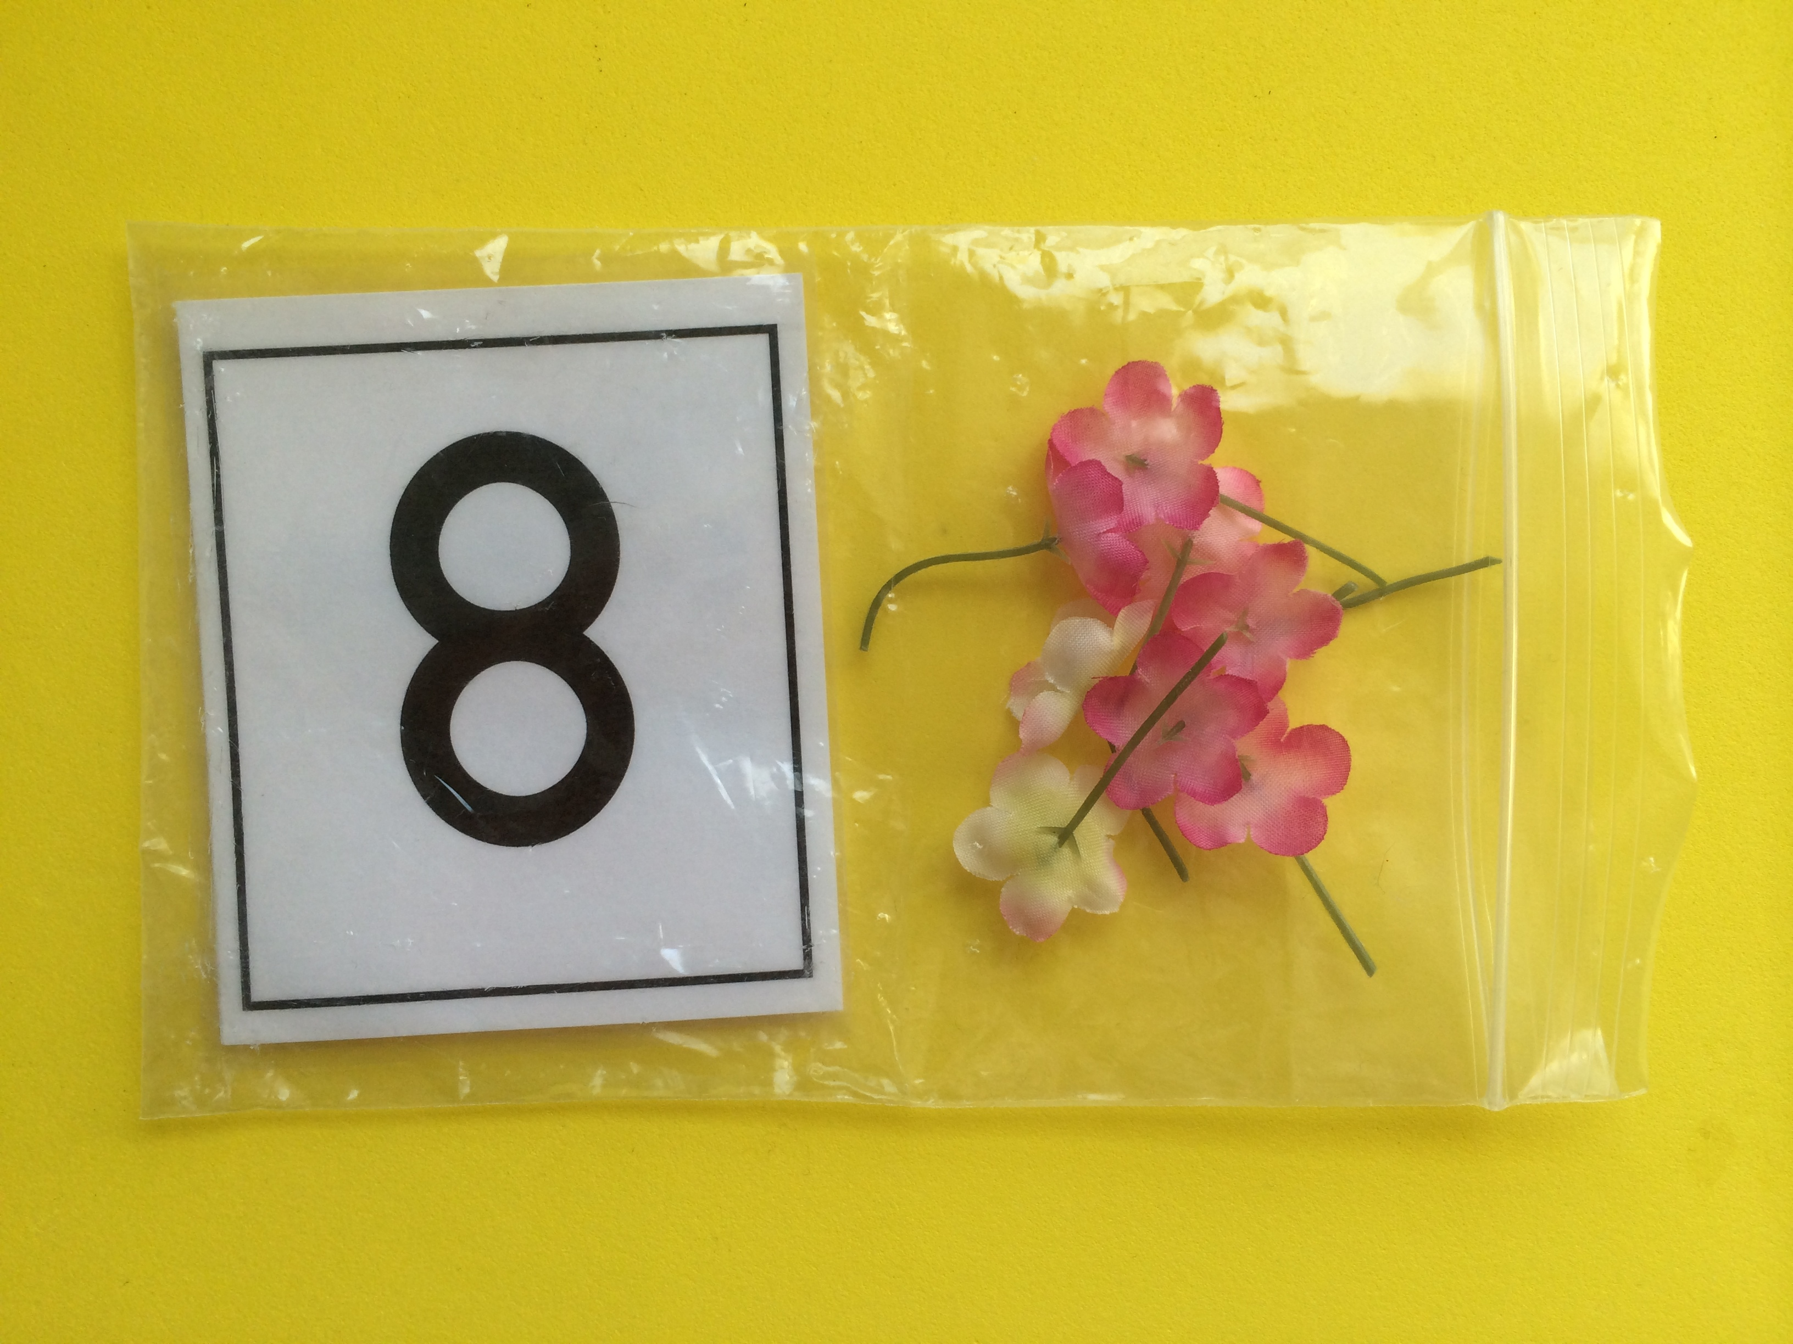
- Dump the flowers from the cup. Count out the correct number of flowers using self-talk to describe your thinking, “I’ll make a line of 8 flowers for this baggie. I’ll count and stop when I get to 8. 1 flower, 2 flowers, …8 flowers (place eighth flower in line). Stop.”
MP.7
- Ask students to count and make sure the flowers match the numeral card. Put the flowers in the bag.
- Invite children to count out their own line of 8 flowers. Encourage children to say, “Stop!” when they hear the target number. If children are not able to count and keep the target number in their mind, let them use the number path folded at 8.
Part 2: Practice
Materials: (S) Cup of 8 flowers, baggie containing one numeral card 3–8 (Lesson 7 Template 2 and Lesson 16 Template 2)

NOTES ON
MULTIPLE MEANS
OF REPRESENTATION:
Provide challenging extensions for students who are ready to work with larger numbers. Students who are ready could make sets of bees to 10.

- Distribute one order (one bag) to each chef. If students have not yet mastered counting to 8 with one-to-one correspondence, let them practice making groups with smaller numbers.
- Tell the chefs to say how many flowers are being ordered (the number in their bag) and to trace it with a finger.
- Have the chefs count out a line of flowers to match their order. Encourage students to use the dots on the back of the cards if they need to match one-to-one to make a group.
- When they have correctly completed an order, the chefs may get another order and repeat Steps 2 and 3, reusing the same flowers.
- As students work, circulate and describe what they are doing using parallel talk, (e.g., “Anu’s order had the number 6, so she is counting out 6 flowers. Mikey stopped putting flowers in the line when he got to 8.”)

Application Problem (5 minutes)
Materials: (T) Cup containing 3–8 bee stickers (S) Waiters: number path (Lesson 10 Template) folded to 8, paper and crayon or white board and dry erase crayon; Chefs: 10 flowers
Select two children to play the roles of waiter and chef. While leading these students through the role play, look for ways to bring other students into the action and assure them that they will have a chance to play in the dramatic play center. Walk students through the following steps.
- Step 1: Place the bees in their seats on the number path.
- Step 2: Waiter makes tally marks to show the number of flower orders and takes order to chef.
- Step 3: Chef fills the flower order.
- Step 4: Waiter checks to see that the chef counted the right number of flowers and takes the flowers to the seated bees.
Note: In this activity, children combine their ability to count with one-to-one correspondence, tally, and count out a group of up to 8 objects. Giving children the opportunity to use their newly learned skills in a real world context provides meaning and motivation for their learning.
Student Debrief (3 minutes)
Lesson Objective: Look at a numeral and count out a group of up to 8 objects.
The Student Debrief is intended to invite reflection and active processing of the total lesson experience. It is also an opportunity for informal assessment. Consider taking anecdotal notes or using a simple checklist to note each child’s progress towards meeting the lesson objective.
As students complete the Practice portion of the Concept Development, listen for misconceptions or misunderstandings that can be addressed in the Debrief. You may choose to use any combination of the questions below to help students express ideas, make connections, and use new vocabulary.
- Could you add as many flowers as you wanted to your order? How did you know when to stop putting more flowers in the order?

CENTER CONNECTION:
Continue to set up the dramatic play center as Pollen Café. As children play today, have the chefs create a group of flowers based on the tallies brought by the waiter instead of relying on prepared baggies.
- (Show 8 flowers, 8 tallies, the dot configuration for 8, and the numeral 8.) Which of these tells how many flowers I have? (Help students realize that all of these represent 8.)
- (Show a bag of pretzels.) If I asked you to give 8 pretzels to your friend, how would you do it?

