Lesson 19
Objective: Tally 8 objects.

Suggested Lesson Structure
 Fluency Practice (2 minutes)
 Application Problem (3 minutes)
 Concept Development (17 minutes)
 Student Debrief (3 minutes)
Total Time (25 minutes)
Fluency Practice (2 minutes)
- March and Count to 9 and 10 PK.CC.1 (2 minutes)
March and Count to 9 and 10 (2 minutes)
Note: Rote counting to 9 and 10 prepares students for the objective of touching and counting to 10 in the latter half of Module 3.
T: Let’s march 9 times and count our steps! Join in when you are ready. 1, 2, 3, 4, 5, 6, 7, 8, 9. (Repeat until all are marching. Pause between counts.)
T: Let’s march 10 times and count our steps! Join in when you are ready. 1, 2, 3, 4, 5, 6, 7, 8, 9, 10. (Repeat until all are marching. Pause between counts.)
Application Problem (3 minutes)
Materials: (S) Cup containing 3–8 bee stickers, numeral cards 3–8 (1 to match each cup, Lesson 7 Template 2, Lesson 16 Template 2)
Distribute a cup to each child, and spread the numeral cards in the center of the circle.
Say, “Today, we are going to be workers at a very special café for bees called the Pollen Café. Our customers will be bees! They will want pollen from the flowers that we serve. Let’s get the bees ready. Find the number that tells how many bees are in your cup.”
Circulate and make sure that students are lining up their bees and counting with one-to-one correspondence. Once children have found the correct numeral, have them place it in the cup with the bees.
Note: This Application Problem sets the context for the Concept Development. Create cups with 3–5 bees for students who are still mastering smaller numbers, but have 6–8 bees in most cups.
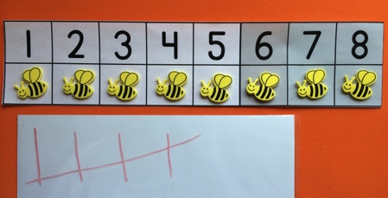
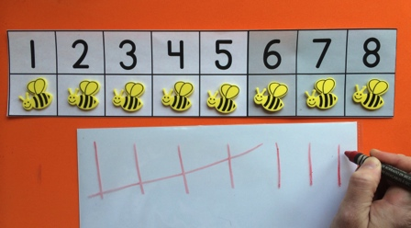
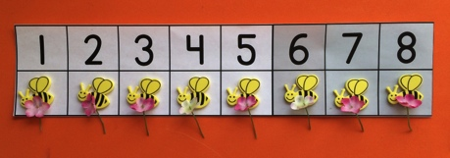
Concept Development (17 minutes)
Part 1: Concept Introduction
Materials: (T) Cup containing 8 bee stickers, number path (Lesson 10 Template) folded to 8, paper and crayon (or white board),
8 flowers (S) Paper and crayon (or white board)
- Select a child to bring the customers to the Pollen Café, the bees. Give him the cup of bees. Display the number path. Say, “Carefully put the customers in these special bee seats.” Help student place 1 bee in each spot on the number path.
- Ask, “How many bees did Noah seat in the Pollen Café?” Give students a moment to think before prompting the count. Touch and count along with the class. Use self-talk to point out the relationship between the count and the number path, “We counted 8 bees. Look! The last bee is sitting in the chair next to the number 8. That is the same as our count.”
- Say, “I’m going to be the waiter. I need to write down the order. I’ll make a tally for each flower to show how many flowers I need to get.” Direct eight students to place their order by saying, “May I have 1 flower please?” Tally the flowers as each one orders.
- Demonstrate how to tally 8. Use the white board to draw tallies under the first 5 bees, then make tallies beneath the last 3 bees (move the white board as needed). Have the children do the same on their papers or white boards.
- Say, “Now, the waiter is ready to take the order to the chef!” Take out the “order” of 8 flowers. Have children count the flowers with you, giving each bee a flower as students count. Demonstrate as in Step 4 for students who need to see another model of tallying.
Part 2: Practice
Materials: (S) cup containing 3–8 bee stickers, number path (Lesson 10 Template) folded to 8, paper and crayon (or white board)

NOTES ON
MULTIPLE MEANS
OF ENGAGEMENT:
Assigning roles to students is a way to differentiate instruction. For example, assign students who need practice with one-to-one correspondence to seat the customers. The role of waiter could be assigned to students who need more practice with tally marks.

Assign each student to be either the person to seat the bees or a waiter. Distribute the appropriate materials.
- Have one partner seat the bee customers from the cup on their number path. Have the waiters tally the flower orders, 1 per bee.
- Support waiters as they tally the order. Encourage the other partner to count the tally to make sure it matches the order.
- Have children switch roles and repeat with a new cup of bees, ensuring that everyone has a chance to practice making tally marks.
Student Debrief (3 minutes)
Lesson Objective: Tally 8 objects.
The Student Debrief is intended to invite reflection and active processing of the total lesson experience. It is also an opportunity for informal assessment. Consider taking anecdotal notes or using a simple checklist to note each child’s progress towards meeting the lesson objective.
As students complete the Practice portion of the Concept Development, listen for misconceptions or misunderstandings that can be addressed in the Debrief. You may choose to use any combination of the questions below to help students express ideas, make connections, and use new vocabulary.

CENTER CONNECTION:
Set up the Pollen Café in the dramatic play center. Make sure students take turns seating customers and being waiters so everyone has a chance to practice tallying. Prepare a few bags with flowers (3–8 to match the bees) and include the matching numeral. Waiters can deliver the flowers to the customers.
- What tools did we use today to count to 8?
- (Display an example of student work from the Practice including the number path, bees, and tally.) How could these tally marks help the waiter remember how many flowers to get in the kitchen?
- How does the number path help us see that 5 and 3 more is 8?
MP.7
- How do our tallies help us see that 5 and 3 more is 8?
- (Show the number path with the color change at 5.) How does the color change on the bees’ seats match the tally mark that goes across?

