Lesson 17
Objective: Count 8 objects in circular configurations.

Suggested Lesson Structure
 Fluency Practice (6 minutes)
 Application Problem (4 minutes)
 Concept Development (12 minutes)
 Student Debrief (3 minutes)
Total Time (25 minutes)
Fluency Practice (6 minutes)
- Clap and Count to 10 PK.CC.3a (2 minutes)
- Make a Line of 8 Beans PK.CC.3a (4 minutes)
Clap and Count to 10 (2 minutes)
Note: This fluency activity anticipates the work of the second half of Module 3 by preparing students to count to 10 by rote so they are ready to count with one-to-one correspondence. By drawing out the “fiiiiive,” the students start to see the relationship of 9 and 10 to 5.

NOTES ON
MULTIPLE MEANS
OF REPRESENTATION:
Daily counting practice strengthens memory. When students move around the classroom for different purposes, have them count their steps up to 10 and then restart another count to 10.

T: Let’s clap and count to 9. Join in when you are ready. 1, 2, 3, 4, fiiiive, 6, 7, 8, 9. (Repeat the count until all are participating.)
T: Let’s clap and count to 10. Join in when you are ready. 1, 2, 3, 4, fiiiive, 6, 7, 8, 9, 10. (Repeat the count until all are participating.)
Make a Line of 8 Beans (4 minutes)
Materials: (S) 5 red beans, 3 white beans
Note: During this fluency activity, circulate and watch students’ counting strategies.
T: Put your red beans in a line. (Pause.) Count them. Let me hear you counting!
S: 1, 2, 3, 4, 5.
T: Put your white beans in a different line. (Pause.) Count them! Let me hear you counting!
S: 1, 2, 3.
T: Move your line of white beans to the end of your line of red beans to make one long line of beans.
T: Touch and count to find out how many beans are in your line now.
S: 1, 2, 3, 4, 5, 6, 7, 8.
Show students the numerals from 1 to 8. Ask them which one shows the number 8.
Application Problem (4 minutes)
Materials: (T) 1–5 white board or poster from GPK–M1–Lesson 22, 6-7 white board or poster from
GPK-M3-Lesson 8, 8 apples (Template 1), magnetic numerals 1–8
Gather children in a circle. Say the following rhyme, gesturing to each object on the chart:
One little flower, 2 little bees,
3 little birds in a tree.
Nice warm sun shines down on me.
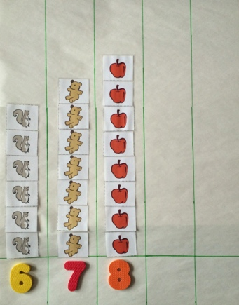
I can count! 1, 2, 3!

Four little kittens come out to play,
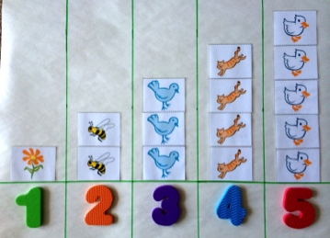
On this warm and sunny day.
Five little ducks take a dive.
Count them: 1, 2, 3, 4, 5!

Six little squirrels, quick as can be,
Climbing up the old oak tree.
In its shade sit 7 chairs,
1, 2, 3, 4, 5, 6, 7 bears!

Eight little apples up in the tree,
Some for you and some for me.

Pass out the magnetic numerals 1–8. Ask, for each number, “Who has the number to show how many flowers there are? How many bees?” continuing up to “How many apples?” Have students put the magnetic numerals on the chart to match. Say, “Clap once when I touch the number 8!” Point to each number in order from 1. The students should be completely silent to encourage internal counting, clapping only once when the number 8 is touched.
Note: In Topics E and G, numbers 9–10 will be added to this chart. Select a white board that can be used for this purpose for several days and leave space on the right side for the additions. Alternatively, use chart paper and objects and numerals with tape on the back.

Concept Development (12 minutes)
Part 1: Concept Introduction
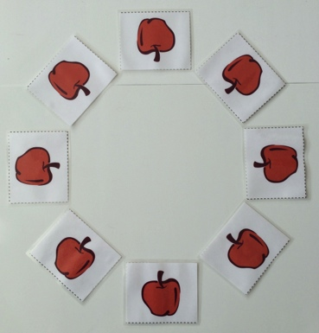
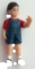
Materials: (T) Magnetic numerals 6–8, 8 apples (Template 1), 1 small doll, crown picture (Template 2)
- Take the apples off the board, and put them in a circle. Say, “These apples are on the table for a tea party. Let’s count how many apples are on the table.” Touch and count each apple. Instead of stopping at 8, continue around the circle until students notice a problem.
MP.2
- Ask students for ideas about how to count things in a circle. Support them as they remember how to mark the start. Repeat the count, perhaps using the small doll to mark the start of the count.
- Ask children, “Point to the number that shows how many apples are on the table.” Ask them, “This number? This number?”
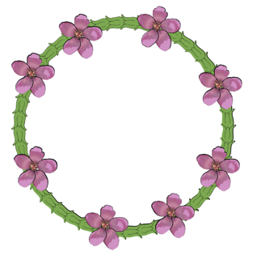
- Display the crown of apple blossoms. Say, “This is a crown for someone to wear at the tea party. How many apple blossoms are on the crown?” Call a student forward to touch and count each blossom. Show the student how to make a dot on the first blossom with a crayon to mark the start of the count.
Part 2: Practice
Materials: (S) Per pair: numeral cards 6–8 (Lesson 7 Template 2, Lesson 16 Template 2, cut apart), baggies containing circular configuration cards (Template 3, cut apart), sticker or linking cube (to mark start)
- Match students with a partner, and tell them, “Let’s play school! One of you will be the teacher, and one of you will be the student.”
- Say, “Teachers, pick a bag and choose a card. Ask your student how many things are in the circle.”
- After students have done so, say, “Teachers, find the number that matches.”
- Students switch roles, repeating Steps 2–4.
- Circulate among groups and support as necessary. In particular, watch to see if students are marking a starting point for the count and if they realize the marked object is the first object counted and does not get recounted at the end of the count.

Student Debrief (3 minutes)
Lesson Objective: Count 8 objects in circular configurations.
The Student Debrief is intended to invite reflection and active processing of the total lesson experience. It is also an opportunity for informal assessment. Consider taking anecdotal notes or using a simple checklist to note each child’s progress towards meeting the lesson objective.
As students complete the Practice portion of the Concept Development, listen for misconceptions or misunderstandings that can be addressed in the Debrief. You may choose to use any combination of the questions below to help students express ideas, make connections, and use new vocabulary.

CENTER CONNECTION:
Make crowns (either apple blossom or jeweled king and queen crowns) in the art center to practice counting up to 8 in a circular configuration. Use a sentence strip or a long piece of construction paper to make the crowns. Give children up to 8 medium pieces of tissue paper to crumple into flowers or jewels to glue on the crown. Help them find ways to mark the start of their count once the flowers or jewels are glued to the crown.
- How can you remember where you started counting on the circle?
- Is it easier to count 8 things in a line or 8 things in a circle? Why?
- (Place a set of 8 objects in a circular configuration on the floor.) My friend Jason says that there are 5 objects in this circle. How can we find out if he is right? (Work as a group to count and check.)

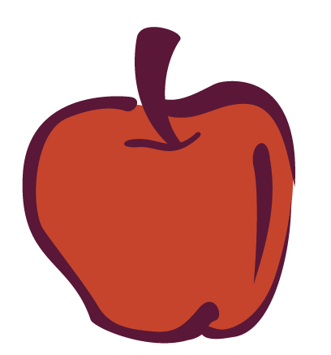
_________________
8 apples

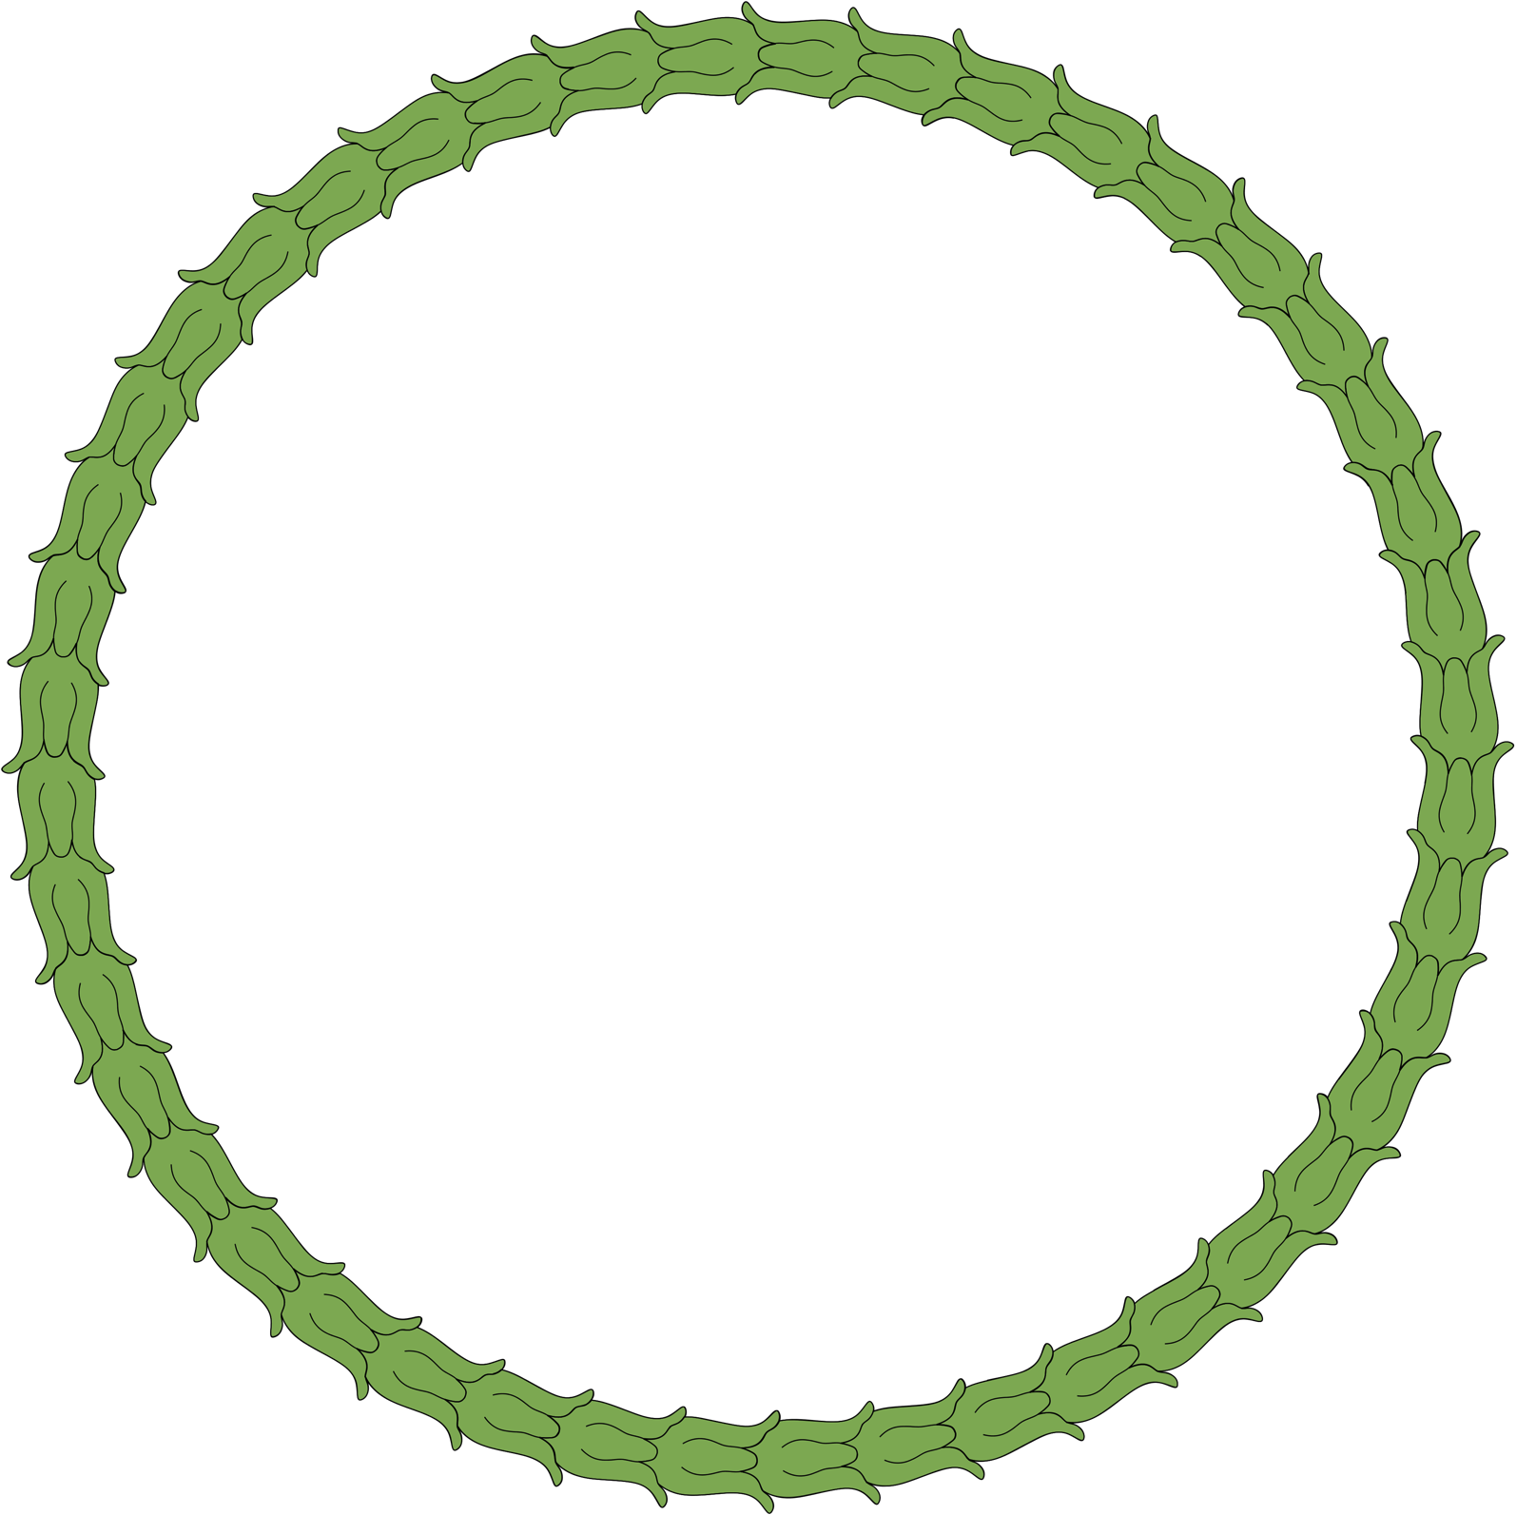
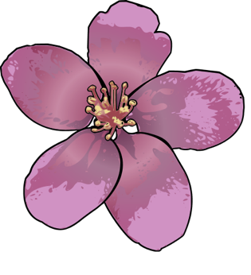
_________________
crown picture

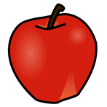 | 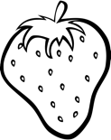
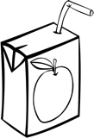 | 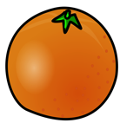
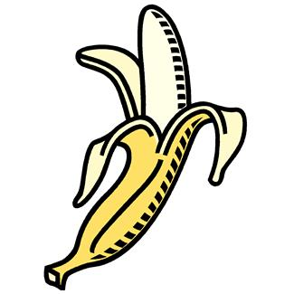 | 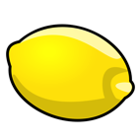
_________________________
circular configuration cards

