Lesson 15
Objective: Count 8 objects in array configurations.

Suggested Lesson Structure
 Fluency Practice (6 minutes)
 Concept Development (15 minutes)
 Student Debrief (4 minutes)
Total Time (25 minutes)
Fluency Practice (6 minutes)
- Change of Pace Counting to 8 PK.CC.1 (2 minutes)
- Compose a Tower of 8 PK.CC.3c (4 minutes)
Change of Pace Counting to 8 (2 minutes)
Materials: (T) 8 paper dessert plates, 8 forks
Note: By using a change of pace, students start to retain the number words for longer periods of time, helping them to remember what 1 more is, which lays the foundation for counting on in Grade 1.
T: (Place the plates in an array of 2 fours, as if at a rectangular table.) Who remembers how many plates we set yesterday?
S: 8.
T: Let’s count a fork for each plate so the guests can eat birthday cake!
As in Lesson 14, use a change of pace while counting out the forks for each plate. Do not let the students count ahead of the placement of each fork. Keep it playful and fun.

NOTES ON
MULTIPLE MEANS
OF REPRESENTATION:
Periodically check for understanding of the directions. Students who are acquiring language may be hesitant to ask questions. One option to check for understanding of the directions while still allowing exploration of 8 is to provide a visual model of the direction using a different number of cubes (e.g., 4 or 6 cubes).

Compose a Tower of 8 (4 minutes)
Materials: (S) 8 loose linking cubes (4 of one color, 4 in another)
Note: Moving forward from Lesson 14, today’s fluency activity sets the stage for the Concept Development’s array configuration. Observe the choices students make when you ask them to make two towers that are the same. Do they make towers that are simply the same size? The same color? Or, the same color pattern? Assure students there are many correct ways to make the towers.
T: Use all your blocks to make two towers that are the same. (Pause and observe.)
T: Put your two small towers together to make one tall tower. (Pause and observe.)
T: Break your tower again into two towers that are exactly the same. How many cubes are in one small tower? (Pause and observe counting strategies.)
T: Put your towers together again. Touch and count to find how many cubes there are in all. (Pause and observe counting strategies.)
Concept Development (15 minutes)
Part 1: Concept Introduction
Materials: (T) 2 tongue depressors (craft sticks, pencils), 7 chenille sticks
Prepare the “ant” by twisting three chenille sticks an equal distance apart around the depressor, stick, or pencil. Prepare the “spider” in the same way using four chenille sticks.
- Introduce students to Ansel Ant. Tell them, “Ansel needs to stretch his legs before he goes for a walk. Let’s count his legs.”
- Bend each leg, moving through the array configuration from left to right, top to bottom, as students count, “1, 2, 3, 4, 5, 6. 6 legs.” Set Ansel down so that he is standing, ready to go for a walk. Tell students Ansel would like an ant made out of children to go for a walk with him.
- Ask three students to pretend to be an ant by having them stand one behind the other. Have the last two children place their hands on the shoulders of the child in front of them.
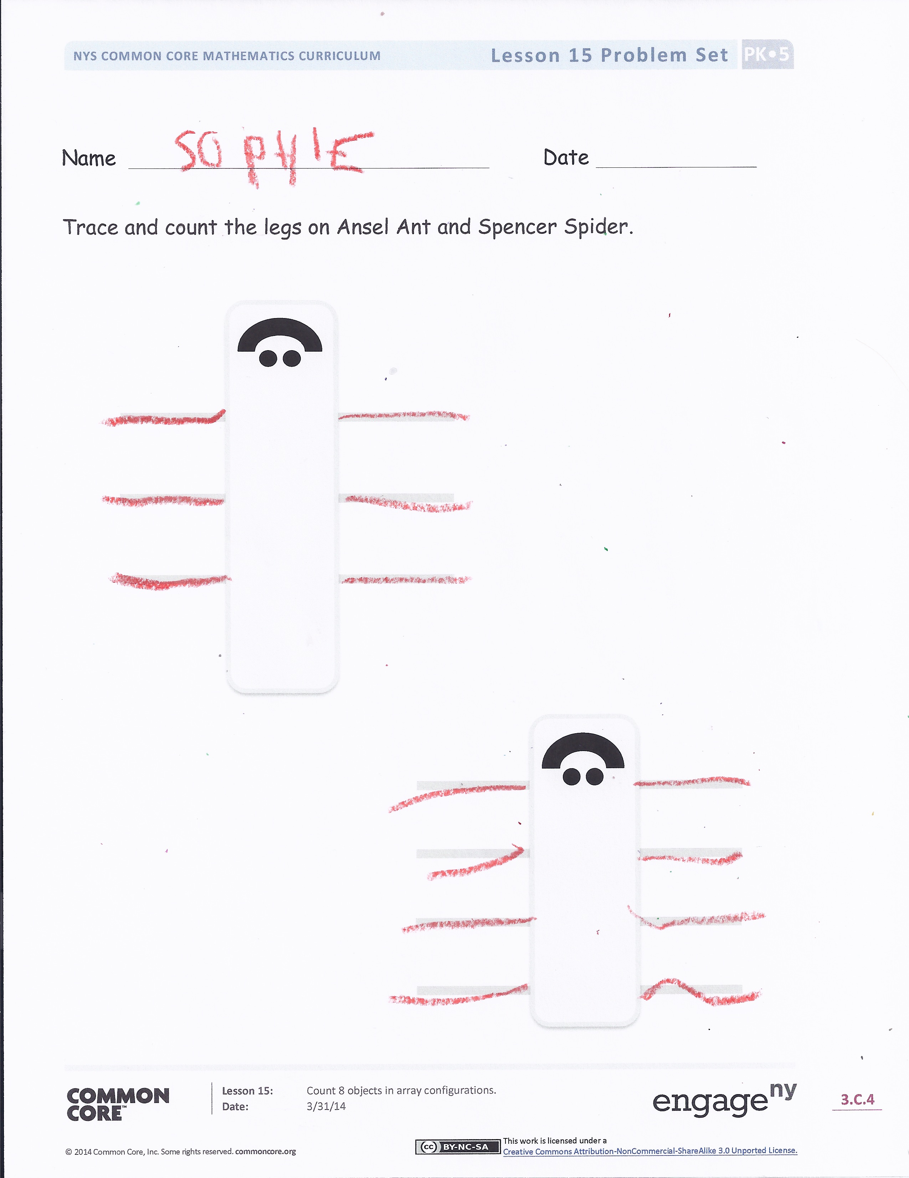
- Starting with the child in front, have each student shake one leg, then the other, as the class counts, “1, 2, 3, 4, 5, 6. 6 legs.”
- Repeat Steps 1 through 4 to introduce Spencer Spider.
- Group the remaining students so that everyone is a part of an ant or a spider. Invite them to stroll around the room with Ansel and Spencer.
Part 2: Practice
Materials: (T) Problem Set (S) Problem Set, crayon
Gather students in a circle before sending them to the prepared tables.
- Show students the Problem Set. Tell them, “Use your crayon to put legs on Ansel and Spencer.”
- Show students how to trace each leg, moving from left to right and top to bottom. Have them count aloud as they trace each leg.
MP.6
- Instruct students to ask and answer how many questions about each animal with a neighbor.
- Circulate as students work, encouraging them to follow an organized counting path, so that they do not skip any legs.
Student Debrief (4 minutes)

CENTER CONNECTION:
Use the dramatic play center as place for children to pretend to be different animals alone or in a group. Animal legs generally come in pairs and can provide interesting array configurations for students to count (e.g., duck, horse, ladybug, octopus). Students may want to make extra “legs” so that they can play Ansel or Spencer independently. Support them in counting out the right number of legs.
Lesson Objective: Count 8 objects in array configurations.
The Student Debrief is intended to invite reflection and active processing of the total lesson experience. It is also an opportunity for informal assessment. Consider taking anecdotal notes or using a simple checklist to note each child’s progress towards meeting the lesson objective.
As students complete the Practice portion of the Concept Development, listen for misconceptions or misunderstandings that can be addressed in the Debrief. You may choose to use any combination of the questions below to help students express ideas, make connections, and use new vocabulary.
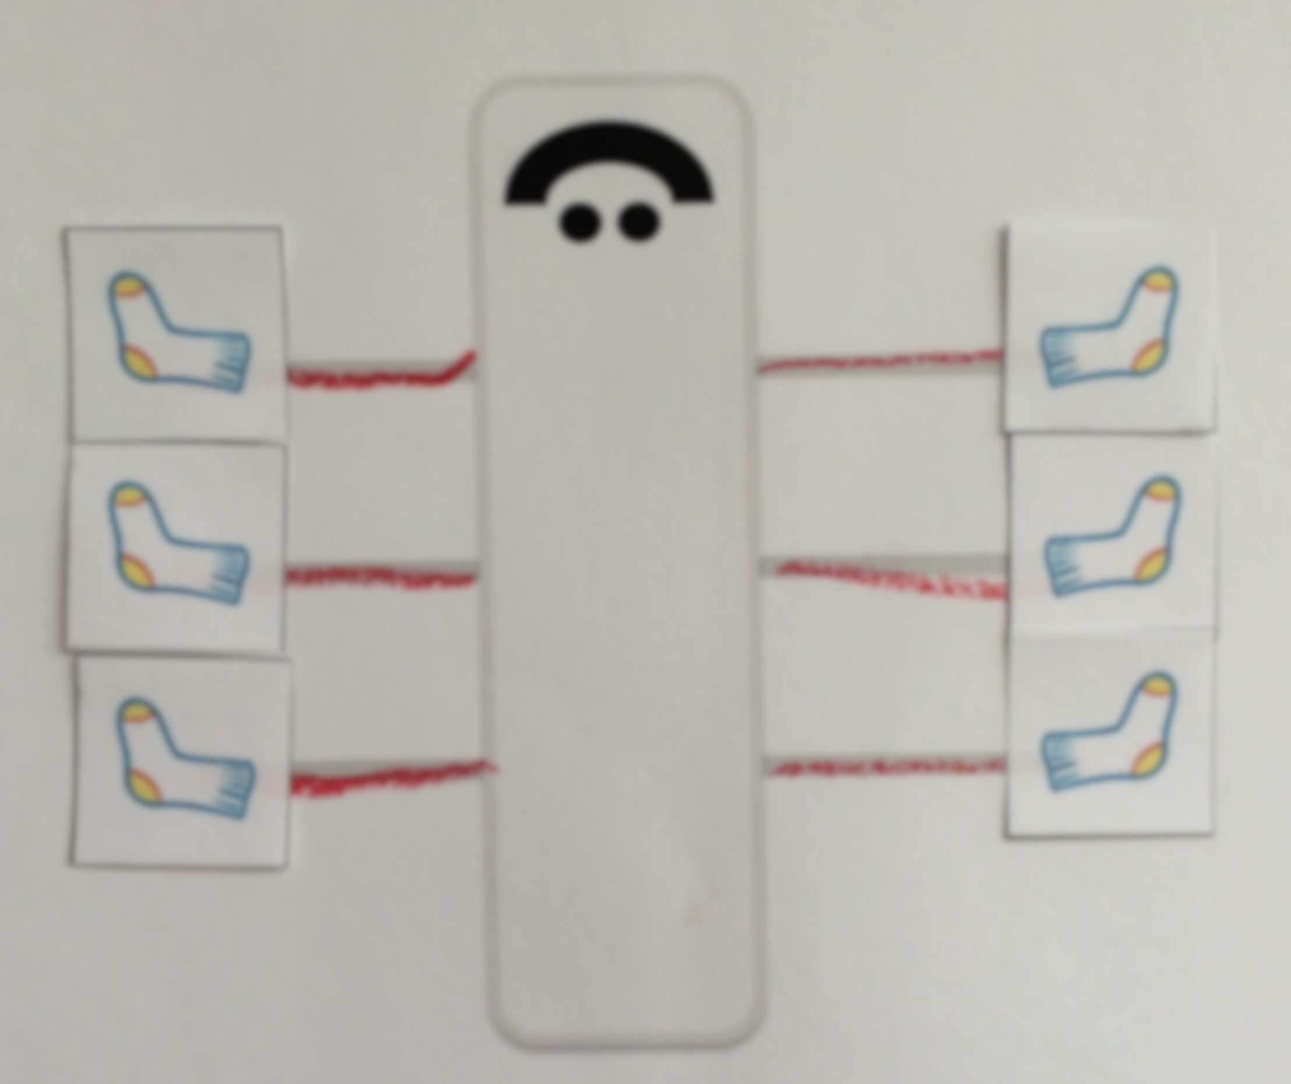
Cut out socks (Template) for Ansel and Spencer in advance.
- Let’s lay out some socks for Ansel Ant. Tell me when to stop. (Lay out three pairs in an array configuration, one sock at a time.) (Repeat for Spencer.)
- (Remove one of Spencer’s socks.) Spencer Spider can’t find all his socks! How many socks is he missing? How do you know? How many socks does he need so that every foot is warm and toasty?
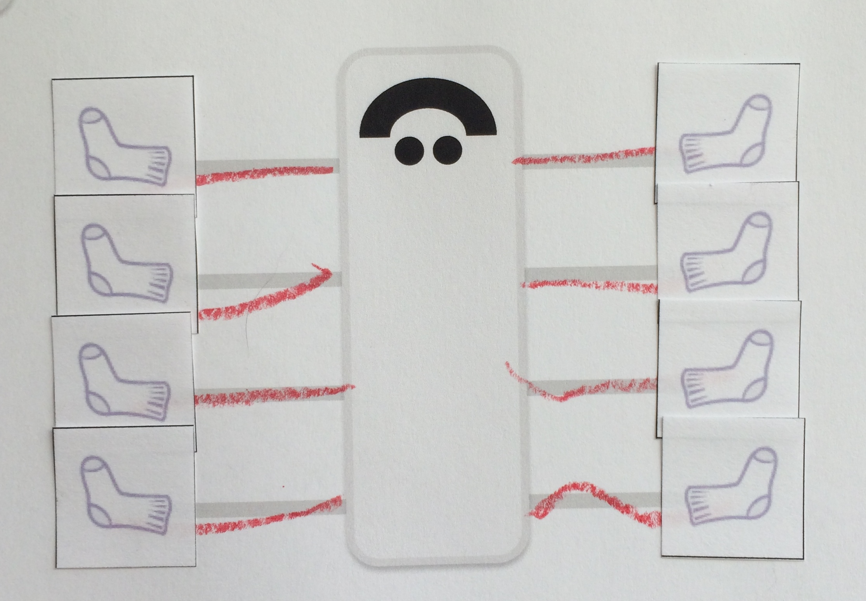
- (Show images of 6 and 8 dots in array configurations.) Which set of dots shows how many legs Ansel Ant has? Which set of dots shows how many legs Spencer Spider has?

Name Date
Trace and count the legs on Ansel Ant and Spencer Spider.

socks for Ansel and Spencer

