Lesson 14
Objective: Count to 8 from left to right on the fingers.

Suggested Lesson Structure
 Fluency Practice (6 minutes)
 Application Problem (3 minutes)
 Concept Development (13 minutes)
 Student Debrief (3 minutes)
Total Time (25 minutes)
Fluency Practice (6 minutes)
- Change of Pace Counting to 8 PK.CC.1 (2 minutes)
- Use 1 More to Make a Tower of 8 PK.CC.3c (4 minutes)
Change of Pace Counting to 8 (2 minutes)
Materials: (T) 8 small paper plates
Note: By changing the pace of the counting, students start to retain the number words for longer periods of time, helping them to remember what 1 more is, which lays the foundation for counting on in Grade 1.
T: Let’s set the table for 8 people. Only say the number when the plate touches the carpet. (Hover the first plate over the “table.” There might be some false starts that make everyone laugh.)
S: 1.
T: (Place the second and third plates quickly.)
S: 2, 3.
T: (Pause before placing the fourth and fifth plates quickly. Again, there might be laughter and false starts.)
S: 4, 5.
T: (Pause before placing the sixth, seventh, and eighth plates quickly. If students have lost track, simply start at 1 and build up again without replacing the plates.)
S: 6, 7, 8.

Use 1 More to Make a Tower of 8 (4 minutes)
Materials: (S) 8 loose linking cubes (5 of one color, 3 of another color)
Note: Moving forward from Lesson 13, this fluency activity focuses on 1 more, again with the teacher observing more than directing. For example, the fluency does not direct the students to make 2 towers of distinct colors. Rather, observe what they do independently. Also, the student language piece is omitted to allow for listening to what the students say as they build their tower.
T: Open your bags and take out 1 cube to start your tower.
T: Take out 1 more cube. Put 1 more cube on your tower.
T: Take out 1 more cube. Add 1 more cube to your tower.
Continue the process until the tower reaches a height of 8 cubes. Have students compare their towers.
Application Problem (3 minutes)
Materials: (S) Per pair: 2 nests (e.g., plastic grass or yarn, small bowl), 5 plastic eggs of one color, 3 plastic eggs of another color
Pair students and give each pair two nests and 9 eggs. Say, “5 blue eggs are in a nest. Put 5 blue eggs in one nest.” (Pause.) “There are 3 eggs in another nest. Put 3 orange eggs in the other nest.” (Pause.) “Count how many eggs are in the two nests.”
Note: The color change and use of two nests help students connect the number composition and decomposition from Modules 1 and 3 to addition and subtraction stories in Module 5. Place a cotton ball “chick” in each egg in advance as children will count them in the Concept Development.
Concept Development (13 minutes)
Part 1: Concept Introduction
- Say, “It’s almost spring, and all the baby chicks (wiggle fingers) are warm inside their eggs inside their nests (make two fists on a surface).”
- Say, “When spring comes, the chicks in this nest (shake left hand) hatch first and stand up. This little one hatched first (wiggle pinky).” Demonstrate the first 5 hatching and standing up, starting with the pinky (left to right starting from the pinky and moving to the thumb of the left hand). Have the children count the chicks as they emerge, “1, 2, 3, 4, 5.”
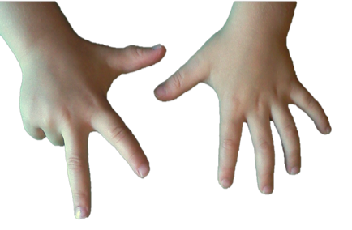
- Say, “There are more chicks hatching in this nest! (Shake your right fist.) Three of them hatch and stand, starting with the shortest one!” Have 3 more chicks come out by showing the thumb, index finger, and middle of the right hand

- Say, “Let’s count how many chicks have hatched.” To support a precise count, lift your fingers off the surface and then drop them as the students count, “1, 2, 3, 4, 5, 6, 7, 8.”
- Have the students show their nests and eggs again (two fists), and then count 8 chicks hatching, starting with the pinky.
- Ask them how many eggs are still in their nests.
Part 2: Practice

NOTES ON
MULTIPLE MEANS
FOR ACTION AND EXPRESSION:
Students may have a difficult time lifting their fingers as they count while their fists are laying flat on the table. Taping the nest template to the wall or board or placing it on an inclined plane (e.g., a binder) could help students manipulate their fingers more easily.
Materials: (S) Per pair: nests from Application Problem, cotton ball “chick” in each of 8 plastic eggs
Send students to prepared tables.
- Have pairs “hatch” the chicks in their nests by opening the plastic eggs. Invite partners to touch and count the cotton ball “chicks.”
- Have students make their fists next to the nests. Tell them, “Eight chicks (fingers) hatch and stand, one at a time. Let’s count them as they hatch!” Have them count from left to right as they show each finger.
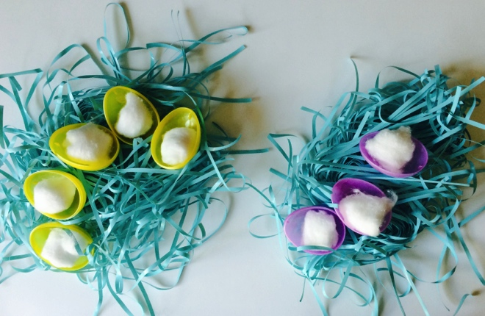
- Ask questions as you circulate. “How many chicks hatched?” “How many chicks hatched in this nest? This one?” “Who was the first chick to come out? Who was the last?”
MP.6
- Ask the children to show their partner two ways to count the chicks who hatched, by touching and counting using the chicks and by counting on their fingers.
Student Debrief (3 minutes)

CENTER CONNECTION:
In the sensory center, provide opportunities for students to practice moving 8 fingers through a variety of materials (e.g., sand, oatmeal, shaving cream, finger paint). Use the nest context as a starting point, but invite children to make up other stories about their 8 fingers and the 8 paths that they create. This activity will help build fine motor muscles needed for counting the Math Way.
Lesson Objective: Count to 8 from left to right on the fingers.
The Student Debrief is intended to invite reflection and active processing of the total lesson experience. It is also an opportunity for informal assessment. Consider taking anecdotal notes or using a simple checklist to note each child’s progress towards meeting the lesson objective.
As students complete the Practice portion of the Concept Development, listen for misconceptions or misunderstandings that can be addressed in the Debrief. You may choose to use any combination of the questions below to help students express ideas, make connections, and use new vocabulary.
- Show me your two nests. (Students show two fists.)
Show me all the eggs. (Students show all their fingers.) On your fingers, show me the chicks that hatched.
- (Display a set of cotton ball chicks while children continue to show 8 fingers.) How are the chicks that hatched like the 8 fingers you are showing?
- What is different about counting on your fingers to 5 from counting to 8? What is different about counting to 7 from counting to 8?

