Lesson 12
Objective: Introduce 8, and relate 8 to 7 and 1 more.

Suggested Lesson Structure
 Fluency Practice (6 minutes)
 Application Problem (3 minutes)
 Concept Development (13 minutes)
 Student Debrief (3 minutes)
Total Time (25 minutes)

Fluency Practice (6 minutes)
- March, Flap, and Count to 8 PK.CC.1 (2 minutes)
- Decompose 7 into 5 and 2 PK.CC.3ab (4 minutes)
March, Flap, and Count to 8 (2 minutes)
Note: Rote counting to 7 and 8 prepares students for the objective of touching and counting to 8.
T: Let’s march in place and count to 7. Ready? 1, 2, 3, 4, 5, 6, 7. Repeat until all are engaging at some level with the activity: marching, counting, or both marching and counting.
T: Let’s flap and count to 7. Ready? 1, 2, 3, 4, 5, 6, 7. (Follow the same process as above.)
T: Let’s march in place and count to 8. Ready? 1, 2, 3, 4, 5, 6, 7, 8.
T: Let’s flap and count to 8. Ready? 1, 2, 3, 4, 5, 6, 7, 8.
Decompose 7 into 5 and 2 (4 minutes)
Materials: (S) 5 loose cubes of one color, 2 loose cubes of another color.
Note: Moving forward from Lesson 11, this fluency activity focuses on decomposing 7 into a tower of 5 and 2. As students decompose and count, they become more familiar with the number 7. Again, observe the ways students relate to the smaller towers. Which students tell the number of cubes in each part when they decompose? Which students decompose and then touch and count to figure it out? Which students do not count the cubes at all after decomposing? After composing?
T: Open your bags, and make a tall tower with all the cubes of one color touching.
T: Count the number of cubes in your tall tower.
T: Break your tower into parts by color.
T: Put your tall tower back together.
Application Problem (3 minutes)
Materials: (T) 8 small potatoes
Tell students that you are going to be making a potato salad for a picnic. “Let’s count how many potatoes I’ll need to cook.” Say the “One Potato, Two Potato” rhyme while touching and counting the potatoes.
One potato, two potato,
Three potato, four,
Five potato, six potato,
Seven potato, more.
Ask, “What does more mean? How many potatoes do you think there will be at the end?” Variations on this task can include each child holding a potato and saying a part of the rhyme (e.g., “Three potato”) when it’s his or her turn.
Note: This task serves as a nice lead-in to today’s Concept Development, where children relate 7 and 1 more to 8.
Concept Development (13 minutes)
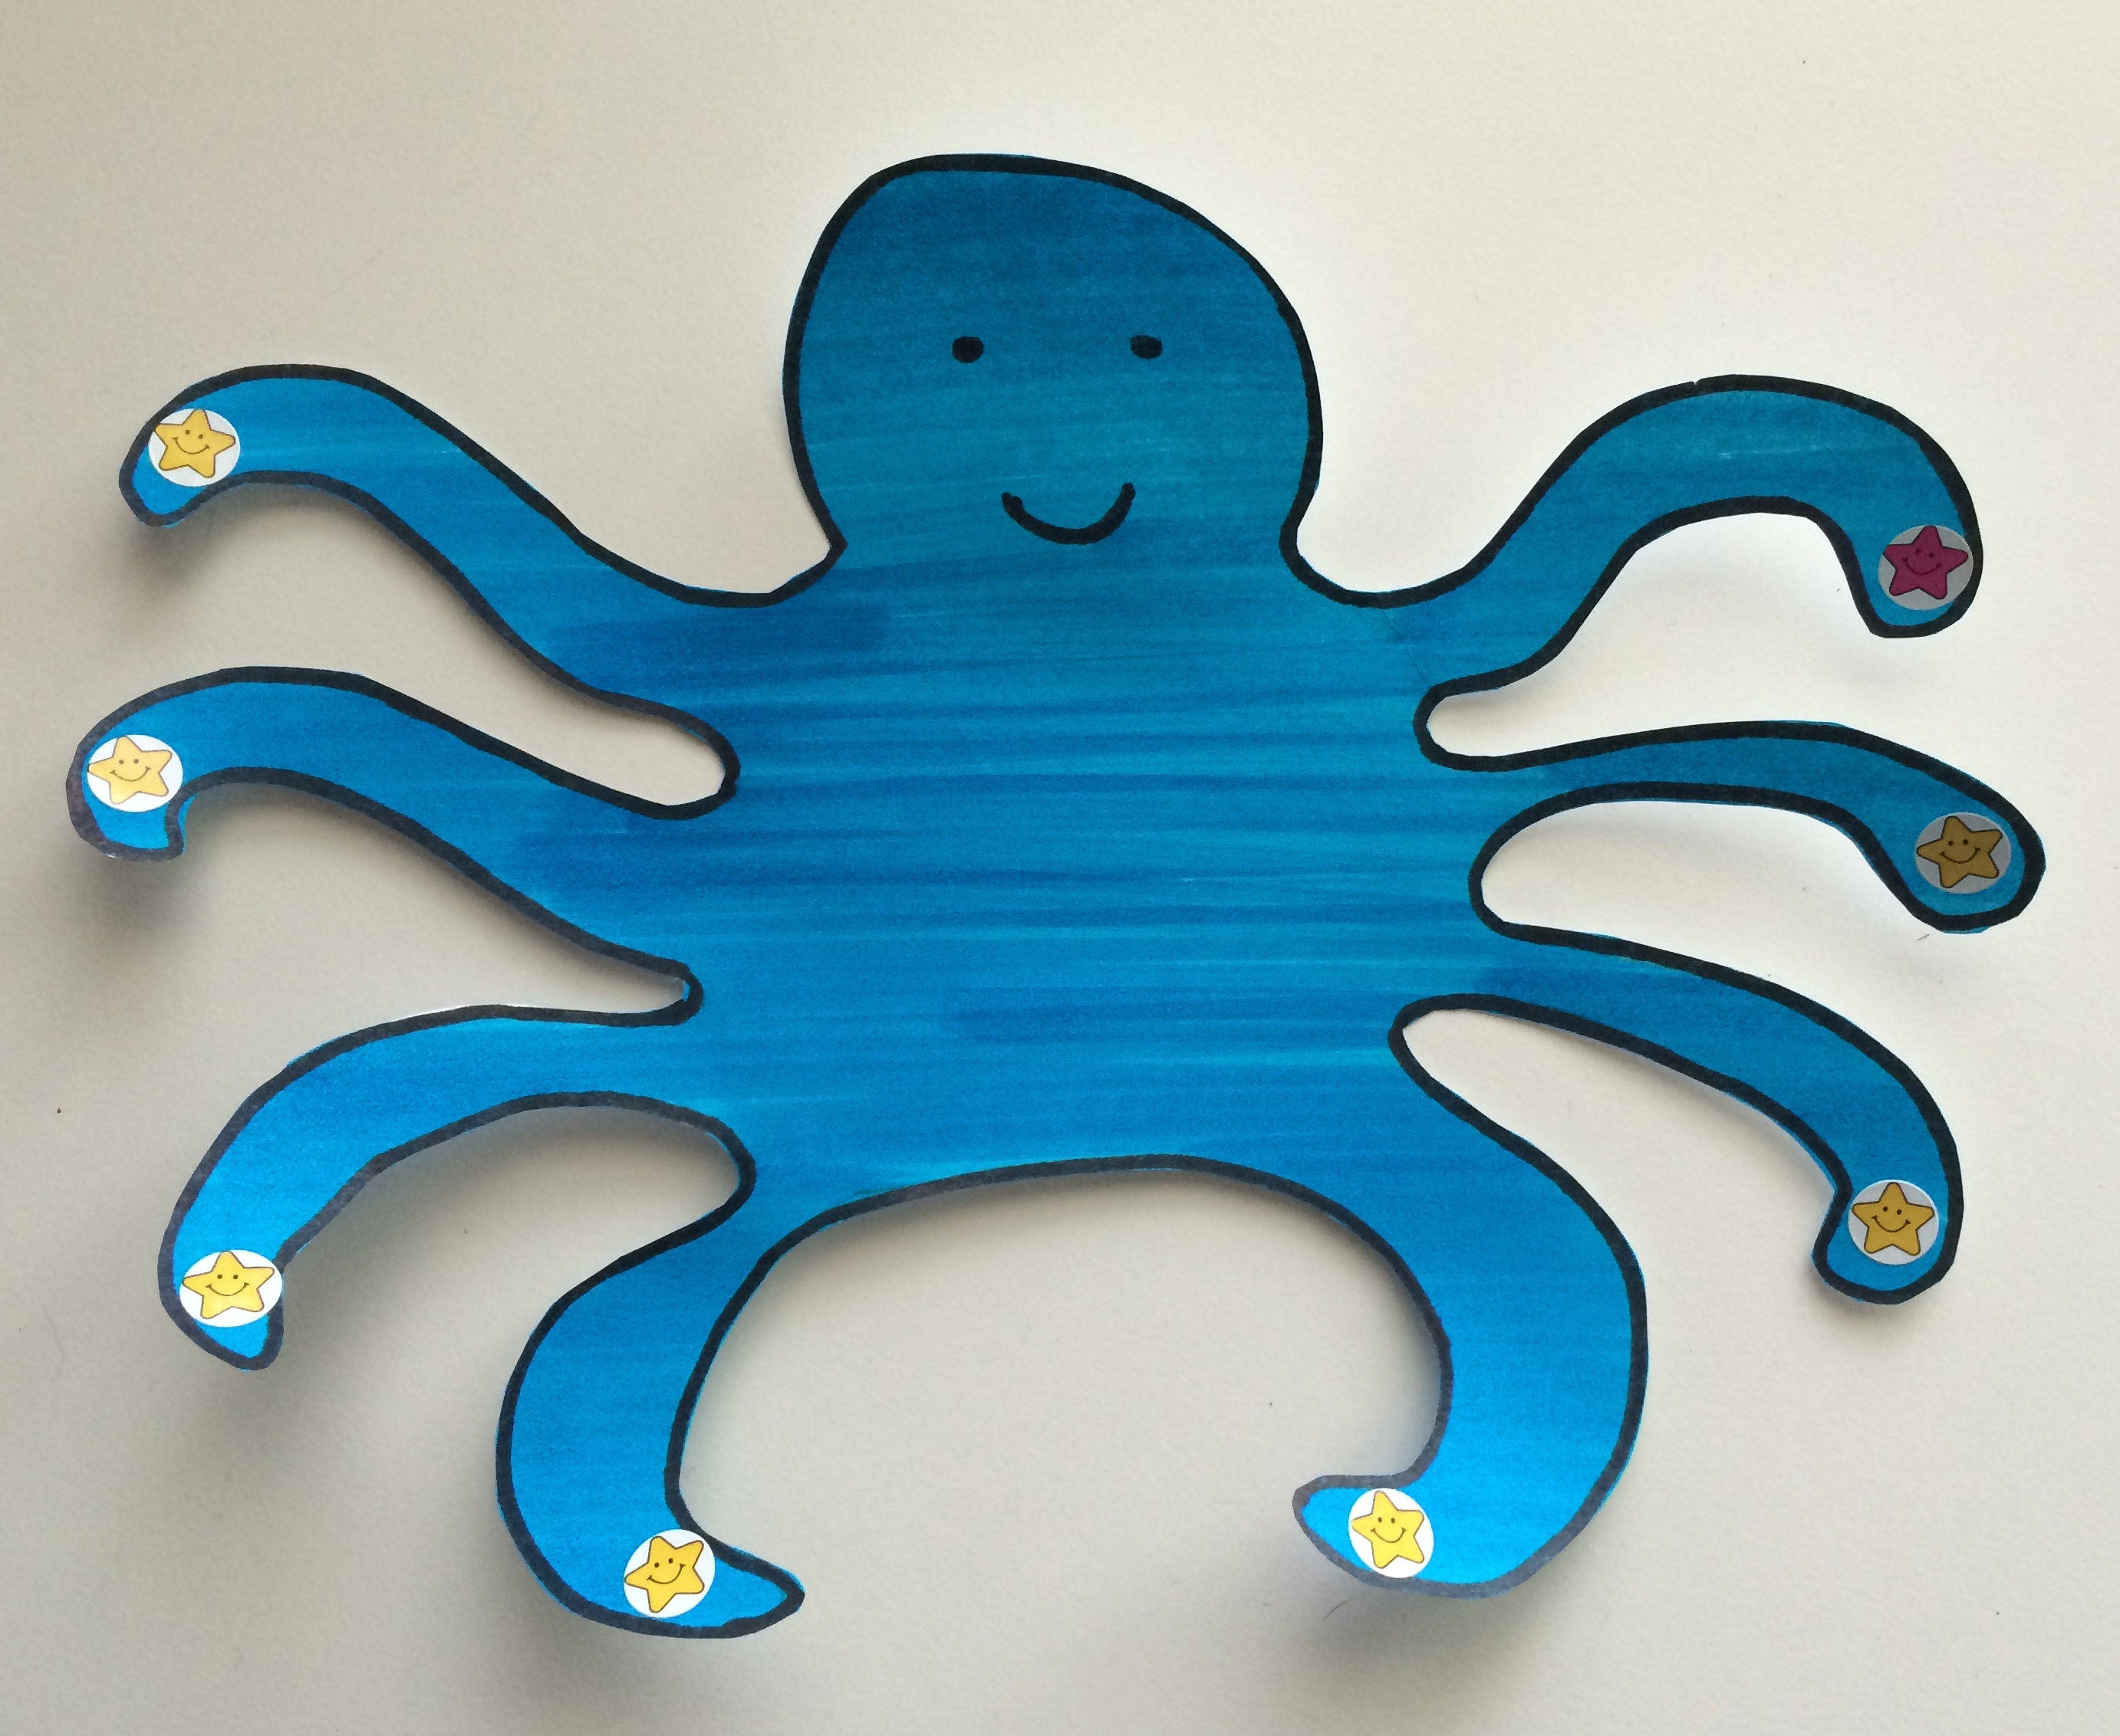
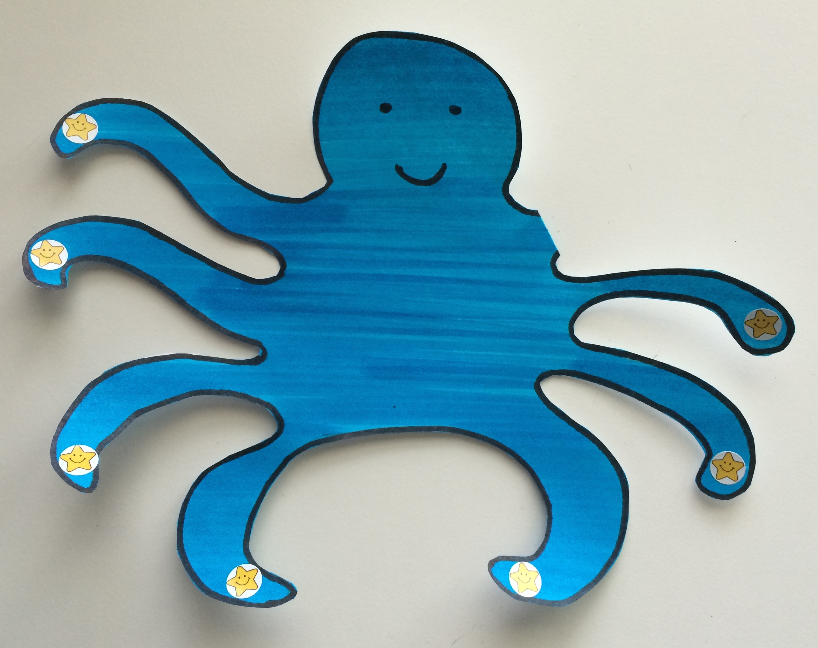
Part 1: Concept Introduction
Materials: (T) Cutout of Ollie Octopus (Template 1)
1. Show students the octopus with one arm hidden from view (bend arm back). Say, “This is Ollie Octopus! Let’s count his arms.”
2. Touch each arm as students count to 7. Say, “I’ll put a sticker on each arm as you count again.” Students count, “1, 2, 3, 4, 5, 6, 7.”
3. After placing the last sticker, unbend the hidden arm and say, “Wait! He has 1 more arm! I’ll touch while you count together:
1, 2, 3, 4, 5, 6, 7, 8.”
4. (Fold back the eighth arm.) Ask, “What is 7 and 1 more (unfold the arm)? Say, “Let’s put on 1 more sticker.” Place the sticker and have students count again, “1, 2, 3, 4, 5, 6, 7, 8.”
5. Ask, “How many stickers does Ollie have now?” Lead students to use a complete sentence, “Ollie has 8 stickers.”
6. (Fold back the eighth arm.) Say, “Yes! So, 7 and 1 more is… (unfold the eighth arm)?” “8!”

Part 2: Practice
Materials: (S) Baggie with small Ollie card (Template 2 cut out), two colors of commercial counters or beans or macaroni (e.g., 7 green and 1 red)

NOTES ON
MULTIPLE MEANS
OF REPRESENTATION:
Students who are struggling to make connections using the octopus model could pair counting the octopus’ arms with counting their own fingers.

Send partners to prepared tables.
1. Ask students to take out all the counters. Have them place each green counter on top of each of Ollie’s arms, “Count all the green counters.” Have them touch and count and tell their partner how many they counted. (7.)
2. Tell students that Ollie has a scrape on 1 arm. Have students put the red counter on Ollie’s hurt arm and count, “1, 2, 3, 4, 5, 6, 7, 8.”
3. Say, “So, there are 7 green arms without scrapes and 1 red arm with a scrape.” Tell your partner: “7 and 1 more is…?”
4. Invite partners to take turns telling a number story about Ollie’s hurt arm using the 8 green and red counters.
5. Instruct students to count as they put one counter on each arm. Lead them to say, “1, 2, 3, 4, 5, 6, 7, 8. 7 and 1 more is 8.”
Student Debrief (3 minutes)

CENTER CONNECTION:
Help children make Ollie Octopus in the art center. For each student, provide a card stock circle with 8 hole punches and a set of 8 chenille stems with a knot on one side. Have children count the chenille stems before and after they thread them through the circle. Students might also enjoy painting Ollie Octopus.

Lesson Objective: Introduce 8, and relate to 7 with 1 more.
The Student Debrief is intended to invite reflection and active processing of the total lesson experience. It is also an opportunity for informal assessment. Consider taking anecdotal notes or using a simple checklist to note each child’s progress towards meeting the lesson objective.
As students complete the Practice portion of the Concept Development, listen for misconceptions or misunderstandings that can be addressed in the Debrief. You may choose to use any combination of the questions below to help students express ideas, make connections, and use new vocabulary.
- Close your eyes and picture Ollie Octopus. Do you remember how many arms were not hurt? How many arms had a scrape? How many arms did Ollie have altogether?
- What was the same about Ollie Octopus and the counters that you counted?
- What is 7 and 1 more? Would you like to count to answer that question? Can you just remember the answer?
- Let’s see which of these answers you know now. (Show 2 fingers.) “What is 2 and 1 more?” (Pause, give time to respond, and pop up 1 more finger.) Yes! Three. (Continue to show 3 fingers.) “What is 3 and 1 more?” etc.

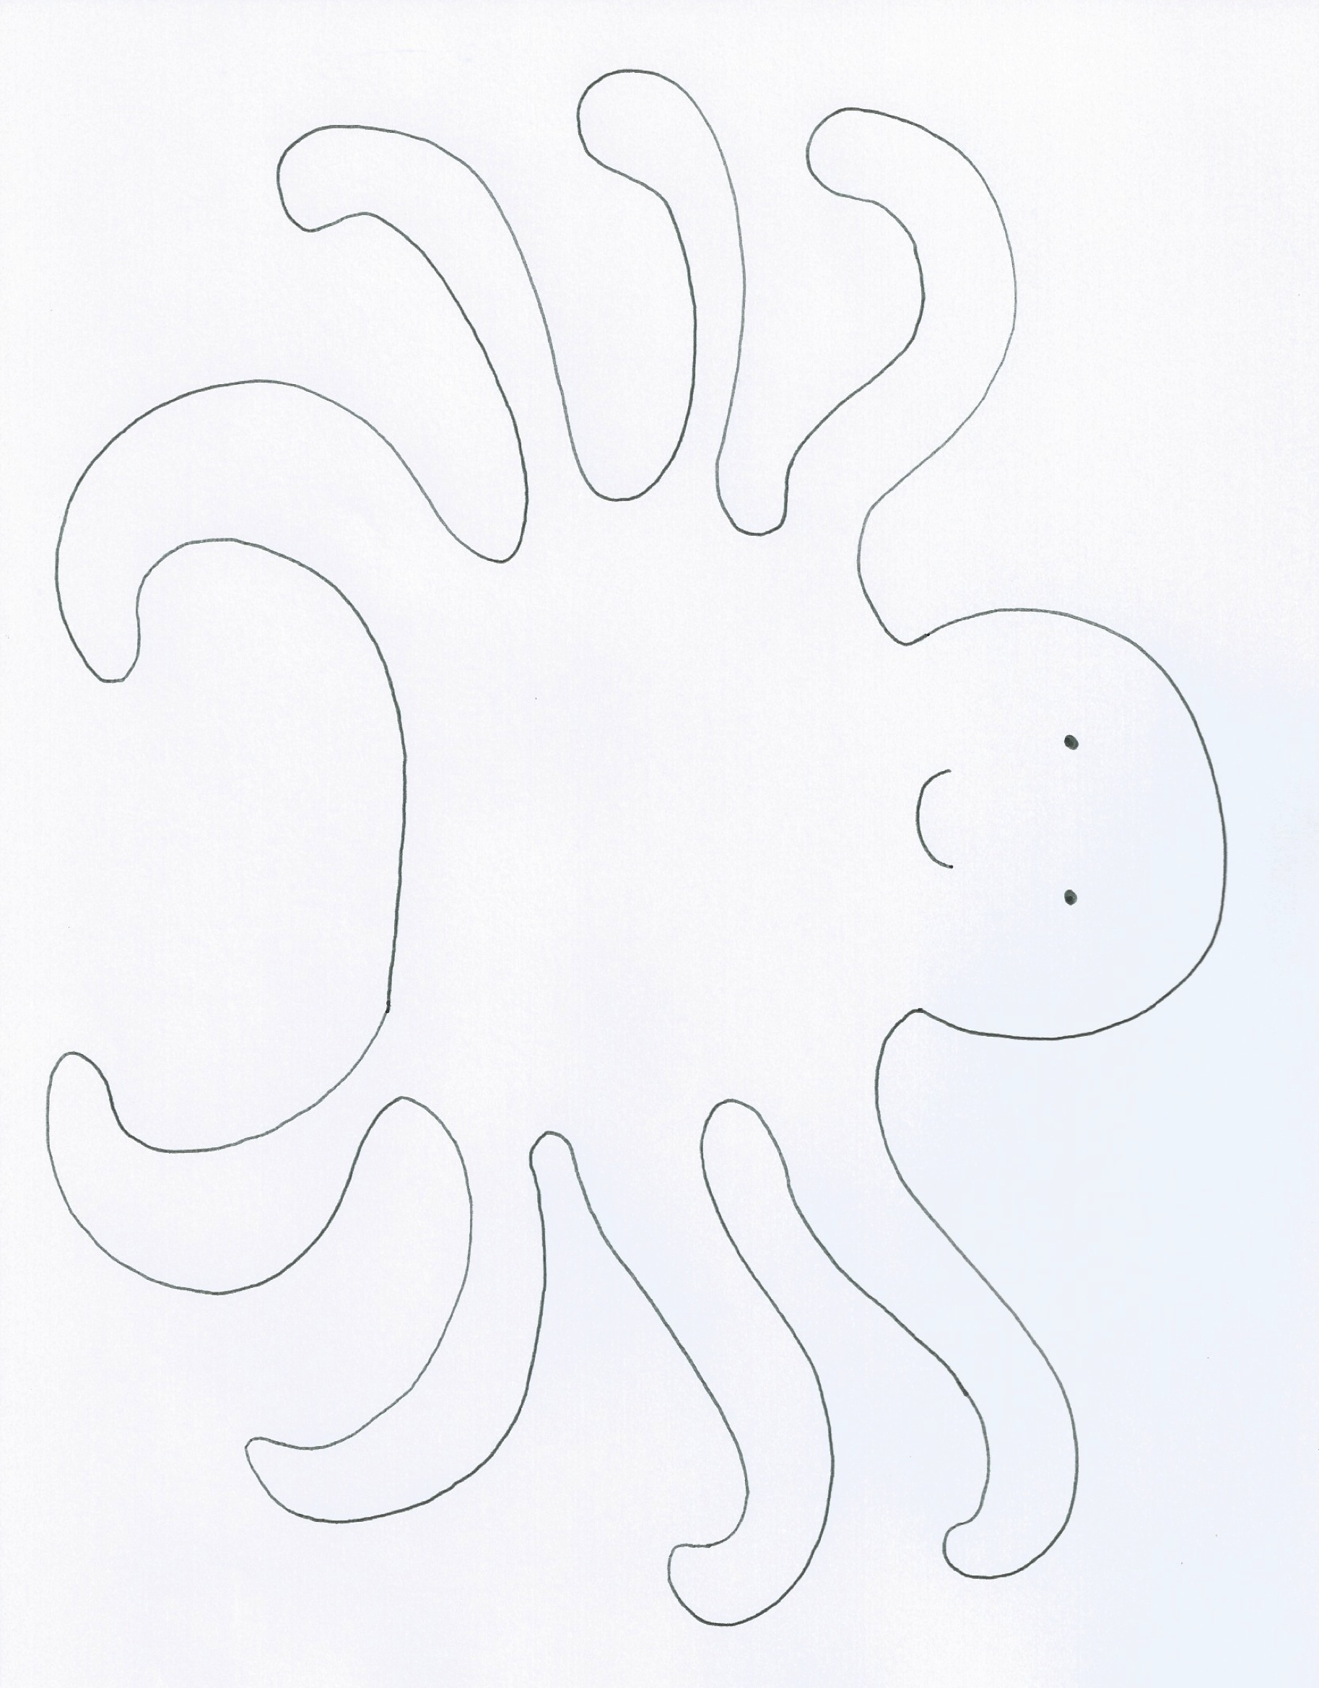
_________________
Ollie Octopus

_________________
small Ollie cards

