Topic C
How Many Questions with up to 8 Objects
PK.CC.1, PK.CC.3abc, PK.CC.4
Focus Standard: | PK.CC.1 | Count to 20.
 | PK.CC.3abc | Understand the relationship between numbers and quantities to 10; connect counting to cardinality.  - When counting objects, say the number names in the standard order, pairing each object with one and only one number name and each number name with one and only one object.  - Understand that the last number name said tells the number of objects counted. The number of objects is the same regardless of their arrangement of the order in which they were counted.  - Understand that each successive number name refers to a quantity that is one larger.
 | PK.CC.4 | Count to answer "how many?" questions about as many as 10 things arranged in a line, a rectangular array, or a circle, or as many as 5 things in a scattered configuration; given a number from 1─10, count out that many objects.
Instructional Days: | 4
Coherence -Links to: | GK─M1 | Numbers to 10
 | GK─M5 | Numbers 10–20 and Counting to 100
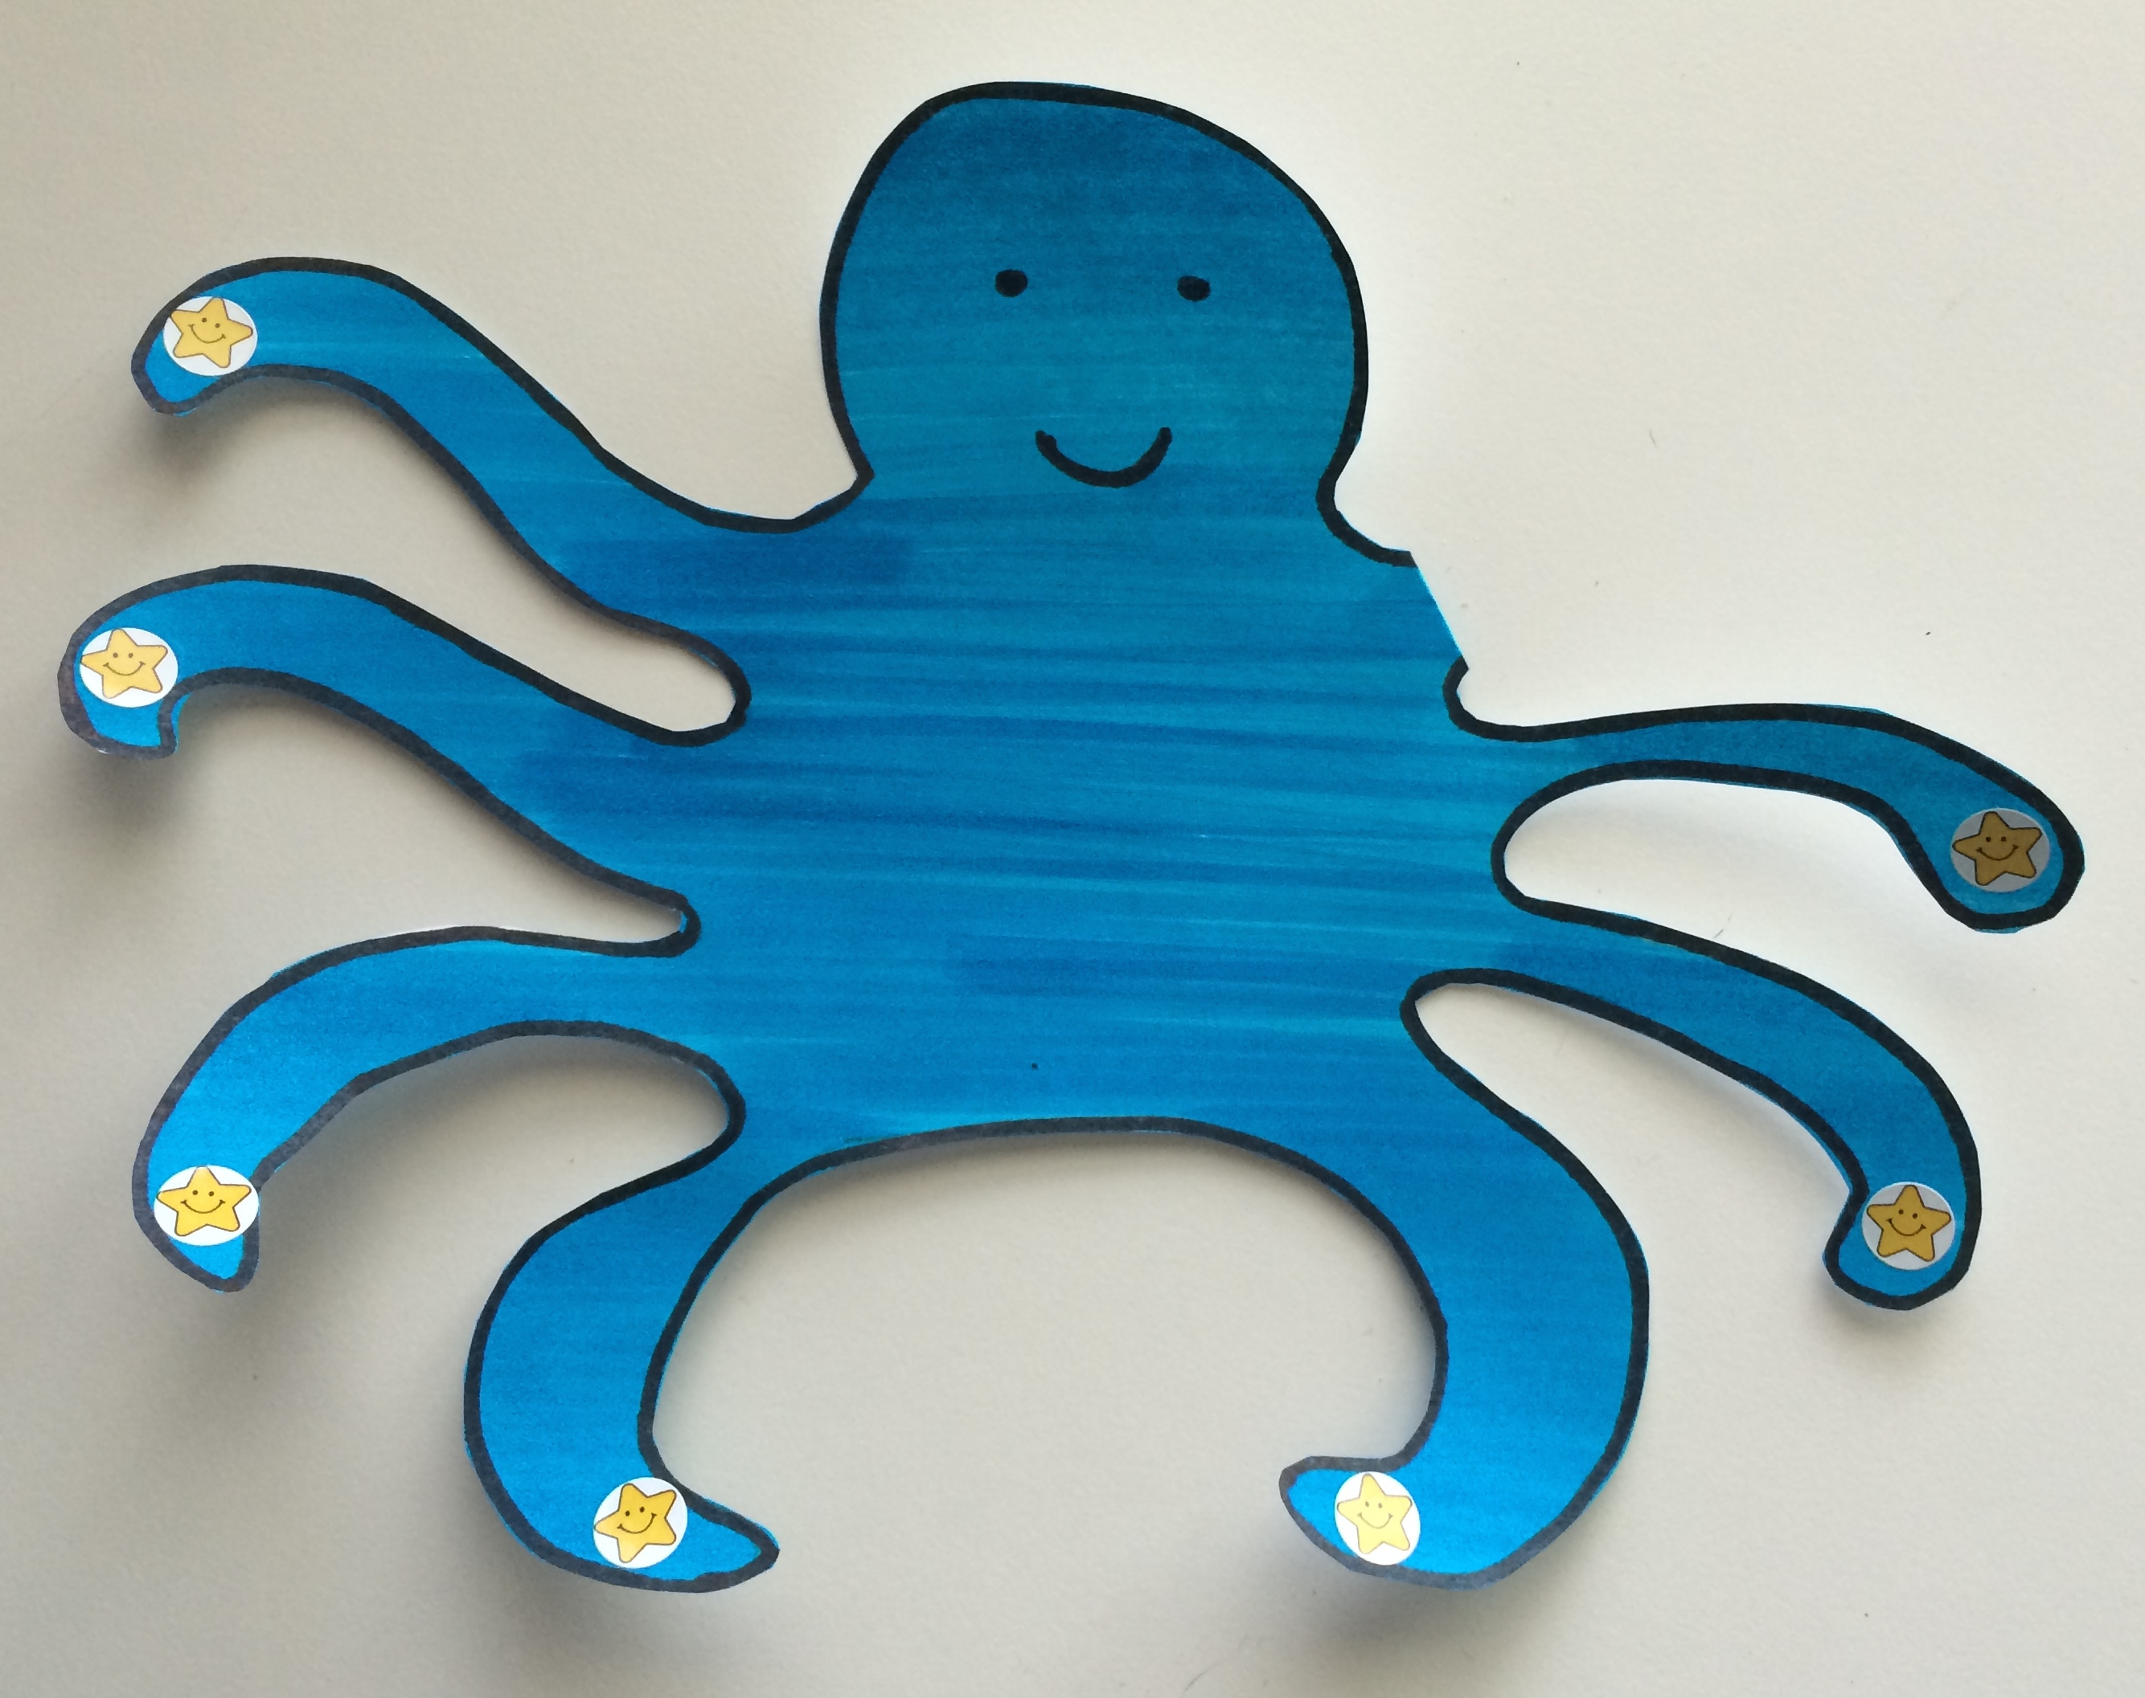
In Topic C, children incorporate the number 8 into their understanding of the number core. More time is spent with the number 8 because it is the most challenging of the numbers 6–9, being 3 away from 5 and 2 away from 10.
Lesson 12 introduces 8 as 7 and 1 more. Children touch and count 7 octopus tentacles with one-to-one correspondence (shown on right). When they discover that 1 more tentacle is hiding, they touch and count again to find that the octopus has 8 tentacles (PK.CC.3c).
Lesson 13 explores 8 in relationship to 5 and asks children to count to 8 in linear configurations (PK.CC.3abc). In the analogous lesson in Topic A, an explorer used rocks to make a path across a creek. The explorer uses different rocks to cross the creek, and finds that she needs more rocks, which are represented by a different color. Children touch and count 8 rocks as the explorer crosses. The color change in the rocks emphasizes that 8 is 5 and 3 more. Understanding and using 5-groups in early numerical learning supports addition and subtraction work in Kindergarten and Grade 1.
In Lesson 14, children count the Math Way to 8, starting with the left hand pinky and ending on the middle finger of the right hand. As they do so, they pretend each finger is a chick hatching from its egg. Following the same context from Topic A, students open plastic eggs, counting the cotton ball chicks as they hatch. Students see that touching and counting “chicks” and counting on fingers are useful counting strategies for determining how many are in a given set.
In Lesson 15, children work with arrays, first counting the legs on an ant and then representing them in a 2 by 3 array. Then, they count 8 legs on a spider and represent them in a 2 by 4 array (PK.CC.4). This early work with arrays supports the understanding that numbers can be broken into smaller numbers (decomposition) and put back together (composition) to form the original whole.
In Topic C, children develop fluency counting with one-to-one correspondence through 8. Through the Change of Pace Counting activity, children begin to retain the number words for longer periods of time. Regular interactions with composition and decomposition help solidify understanding of the numbers 6–8.

A Teaching Sequence Towards Mastery of How Many Questions with up to 8 Objects
Objective 1: Introduce 8, and relate 8 to 7 and 1 more.
(Lesson 12)
Objective 2: Use linear configurations to count 8 in relation to 5.
(Lesson 13)
Objective 3: Count to 8 from left to right on the fingers.
(Lesson 14)
Objective 4: Count 8 objects in array configurations.
(Lesson 15)

