Lesson 17: Trigonometric Identity Proofs

Student Outcomes
- Students see derivations and proofs of the addition and subtraction formulas for sine and cosine.
- Students prove some simple trigonometric identities.

Lesson Notes
We start the lesson with students looking for patterns in a table to make conjectures about the formulas for$sin(α+ β)$ and $cos(α+β)$. From these formulas, we can quickly deduce the formulas for $sin(α-β)$ and $cos(α-β)$. The teacher gives proofs of important formulas, and then students prove some simple trigonometric identities. The lesson will highlight practices MP.3 and MP.8, as students look for patterns in repeated calculations and construct arguments about the patterns they find.
Scaffolding:
- Students should have access to calculators.
- The teacher may want to model a few calculations at the beginning.
- Pairs of students who fill in the table quickly should be encouraged to help those who might be struggling.
- Once a few students have filled in the table, one or two might be encouraged to share their entries with the class because when all students have the entries, they will be in a better position to discover the rule.

Classwork
Opening Exercise (10 minutes)
Students should work in pairs to fill out the table and look for patterns. They should be looking for columns whose entries might be combined to yield the entries in the column for $\sin\left(α+β\right)$.
MP.8
Opening Exercise
We have seen that $\sin\left(α+β\right)≠\sin\left(α\right)+\sin\left(β\right)$. So, what is $\sin\left(α+β\right)$? Begin by completing the following table:
$$α$$ | $$β$$ | $$\sin\left(α\right)$$ | $$\sin\left(β\right)$$ | $$\sin\left(α+β\right)$$ | $$\sin\left(α\right)\cos\left(β\right)$$ | $$\sin\left(α\right)\sin\left(β\right)$$ | $$\cos\left(α\right)\cos\left(β\right)$$ | $$\cos\left(α\right)\sin\left(β\right)$$
$$\frac{π}{6}$$ | $$\frac{π}{6}$$ | $$\frac{1}{2}$$ | $$\frac{1}{2}$$ | $$\frac{\sqrt{3}}{2}$$ | $$\frac{\sqrt{3}}{4}$$ | $$\frac{1}{2}$$ | $$\frac{3}{4}$$ | $$\frac{\sqrt{3}}{4}$$
$$\frac{π}{6}$$ | $$\frac{π}{3}$$ | $$\frac{1}{2}$$ | $$\frac{\sqrt{3}}{2}$$ | $$1$$ | $$\frac{1}{4}$$ | $$\frac{\sqrt{3}}{4}$$ | $$\frac{\sqrt{3}}{4}$$ | $$\frac{3}{4}$$
$$\frac{π}{4}$$ | $$\frac{π}{6}$$ | $$\frac{1}{\sqrt{2}}$$ | $$\frac{1}{2}$$ | $$\frac{1+\sqrt{3}}{2\sqrt{2}}$$ | $$\frac{\sqrt{3}}{2\sqrt{2}}$$ | $$\frac{1}{2\sqrt{2}}$$ | $$\frac{\sqrt{3}}{2\sqrt{2}}$$ | $$\frac{1}{2\sqrt{2}}$$
$$\frac{π}{4}$$ | $$\frac{π}{4}$$ | $$\frac{1}{\sqrt{2}}$$ | $$\frac{1}{\sqrt{2}}$$ | $$1$$ | $$\frac{1}{2}$$ | $$\frac{1}{2}$$ | $$\frac{1}{2}$$ | $$\frac{1}{2}$$
$$\frac{π}{3}$$ | $$\frac{π}{3}$$ | $$\frac{\sqrt{3}}{2}$$ | $$\frac{\sqrt{3}}{2}$$ | $$\frac{\sqrt{3}}{2}$$ | $$\frac{\sqrt{3}}{4}$$ | $$\frac{3}{4}$$ | $$\frac{1}{4}$$ | $$\frac{\sqrt{3}}{4}$$
$$\frac{π}{3}$$ | $$\frac{π}{4}$$ | $$\frac{\sqrt{3}}{2}$$ | $$\frac{1}{\sqrt{2}}$$ | $$\frac{1+\sqrt{3}}{2\sqrt{2}}$$ | $$\frac{\sqrt{3}}{2\sqrt{2}}$$ | $$\frac{\sqrt{3}}{2\sqrt{2}}$$ | $$\frac{1}{2\sqrt{2}}$$ | $$\frac{1}{2\sqrt{2}}$$
Ask students to write an equation that describes how the entries in other columns might be combined to yield the entries in the shaded column. The identity we are looking for in the table is the following:
MP.8
Scaffolding:
- If no student offers the identity, the teacher might suggest that students look for two columns whose entries sum to yield $\sin\left(α+β\right)$.
- It might even be necessary for the teacher to point at the two columns.
$$\sin\left(α+β\right)=\cos\left(α\right)\sin\left(β\right)+\sin\left(α\right)\cos\left(β\right).$$

Emphasize in the discussion that the proposed identity has not been proven; it has only been tested for some specific values of $α$ and $β$. Its status now is as a conjecture.
The conjecture is strengthened by the following observation: Because $α$ and $β$ play the same role in $\left(α+β\right)$, they should not play different roles in any formula for the sine of that sum. In our conjecture, if $α$ and $β$ are interchanged, the formula remains essentially the same. That symmetry helps make the conjecture more plausible.
Use the following table to formulate a conjecture for $\cos\left(α+β\right)$:
$$α$$ | $$β$$ | $$\cos\left(α\right)$$ | $$\cos\left(β\right)$$ | $$\cos\left(α+β\right)$$ | $$\sin\left(α\right)\cos\left(β\right)$$ | $$\sin\left(α\right)\sin\left(β\right)$$ | $$\cos\left(α\right)\cos\left(β\right)$$ | $$\cos\left(α\right)\sin\left(β\right)$$
$$\frac{π}{6}$$ | $$\frac{π}{6}$$ | $$\frac{1}{2}$$ | $$\frac{1}{2}$$ | $$\frac{1}{2}$$ | $$\frac{\sqrt{3}}{4}$$ | $$\frac{1}{2}$$ | $$\frac{3}{4}$$ | $$\frac{\sqrt{3}}{4}$$
$$\frac{π}{6}$$ | $$\frac{π}{3}$$ | $$\frac{\sqrt{3}}{2}$$ | $$\frac{1}{2}$$ | $$0$$ | $$\frac{1}{4}$$ | $$\frac{\sqrt{3}}{4}$$ | $$\frac{\sqrt{3}}{4}$$ | $$\frac{3}{4}$$
$$\frac{π}{4}$$ | $$\frac{π}{6}$$ | $$\frac{1}{\sqrt{2}}$$ | $$\frac{\sqrt{3}}{2}$$ | $$\frac{\sqrt{3}-1}{2\sqrt{2}}$$ | $$\frac{\sqrt{3}}{2\sqrt{2}}$$ | $$\frac{1}{2\sqrt{2}}$$ | $$\frac{\sqrt{3}}{2\sqrt{2}}$$ | $$\frac{1}{2\sqrt{2}}$$
$$\frac{π}{4}$$ | $$\frac{π}{4}$$ | $$\frac{1}{\sqrt{2}}$$ | $$\frac{1}{\sqrt{2}}$$ | $$0$$ | $$\frac{1}{2}$$ | $$\frac{1}{2}$$ | $$\frac{1}{2}$$ | $$\frac{1}{2}$$
$$\frac{π}{3}$$ | $$\frac{π}{3}$$ | $$\frac{1}{2}$$ | $$\frac{1}{2}$$ | $$-\frac{1}{2}$$ | $$\frac{\sqrt{3}}{4}$$ | $$\frac{3}{4}$$ | $$\frac{1}{4}$$ | $$\frac{\sqrt{3}}{4}$$
$$\frac{π}{3}$$ | $$\frac{π}{4}$$ | $$\frac{1}{2}$$ | $$\frac{1}{\sqrt{2}}$$ | $$\frac{1-\sqrt{3}}{2\sqrt{2}}$$ | $$\frac{\sqrt{3}}{2\sqrt{2}}$$ | $$\frac{\sqrt{3}}{2\sqrt{2}}$$ | $$\frac{1}{2\sqrt{2}}$$ | $$\frac{1}{2\sqrt{2}}$$
MP.8
Again, ask students to write an equation that describes how the entries in other columns might be combined to yield the entries in the shaded column. The identity we are looking for in the table is the following:
$$\cos\left(α+β\right)=\cos\left(α\right)\cos\left(β\right)-\sin\left(α\right)\sin\left(β\right).$$
Again, in a class discussion of the exercise after the students have looked for a pattern, if no student comes up with that identity, the teacher may want to point at the two columns whose entries differ to yield $\cos\left(α+β\right)$. It should be repeated that the proposed identity has not been proven; it has only been tested for some specific values of $α$ and $β$. It is a conjecture.
This conjecture, too, is strengthened by the observation that because $α$ and $β$ play the same role in $\left(α+β\right)$, they should not play different roles in any formula for the cosine of that sum. And again, if $α$ and $β$ are interchanged in our conjectured formula, it remains essentially the same. That symmetry helps make the conjecture more plausible.
Examples 1–2 (15 minutes): Formulas for $sin(α+β)$ and $cos(α+β)$
Scaffolding:
Because the proofs of the addition and subtraction formulas for sine and cosine can be complicated, only the proof of the sine addition formula is presented in detail here. Advanced students might be asked to prove, in much the same fashion, any of the other three formulas, as well as by deriving them from the sine addition formula. Problem 1 in the Problem Set concerns one of those proofs.
Examples 1–2: Formulas for $sin(α+β)$ and $cos(α+β)$
- One conjecture is that the formula for the sine of the sum of two numbers is $\sin\left(α+β\right)=\sin\left(α\right)\cos\left(β\right)+\cos\left(α\right)\sin\left(β\right)$. The proof can be a little long, but it is fairly straightforward. We will prove only the case when the two numbers are positive, and their sum is less than $\frac{π}{2}$.
  - Let $α$ and $β$ be positive real numbers such that $0<α+β<\frac{π}{2}.$

  - Construct rectangle $MNOP$such that $PR=1$, $m∠PQR=90°$, $m∠RPQ=β$, and $m∠QPM=α$. See the figure at the right.

  - Fill in the blanks in terms of $α$ and $β$:
    - $m∠RPO=$ _____________.
$$\frac{π}{2}-α-β$$

    - $m∠PRO=$ _______________.
$$α+β$$

    - Therefore, $\sin\left(α+β\right)=PO$.

    - $RQ=\sin{(______)}$.
$$β$$

    - $PQ=\cos{(______)}$.
$$β$$
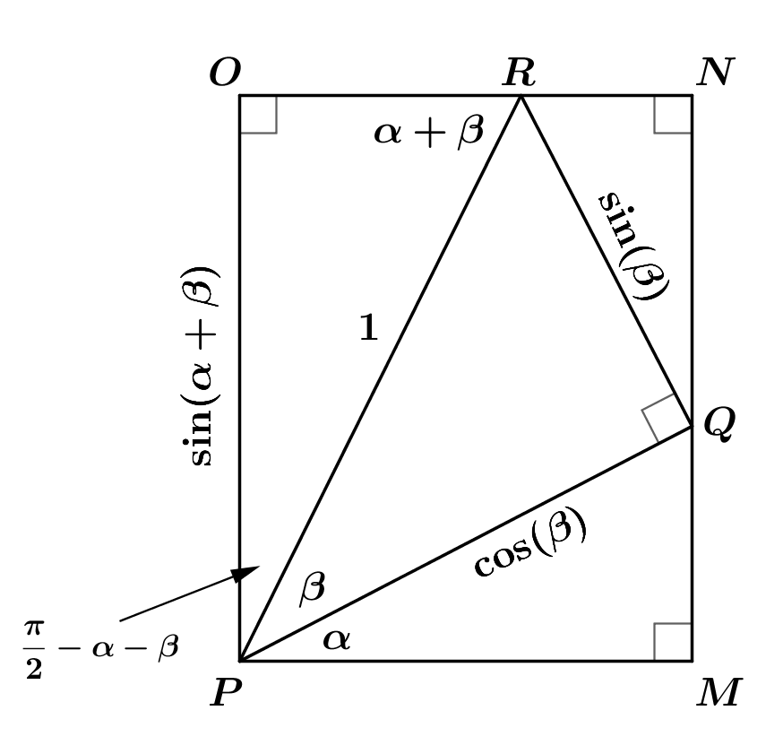
  - Let’s label the angle and length measurements as shown.

  - Use this new figure to fill in the blanks in terms of $α$ and $β:$
    - Why does $\sin\left(α\right)=\frac{MQ}{\cos\left(β\right)}$?
The length of the hypotenuse of $∆PQM$ is $\cos\left(β\right)$, and $MQ$ is the length of the side opposite $α.$

    - Therefore,$MQ=$_________.
$$\sin{(α)cos⁡(β)}$$

    - $m∠RQN=$____________.
$$α$$
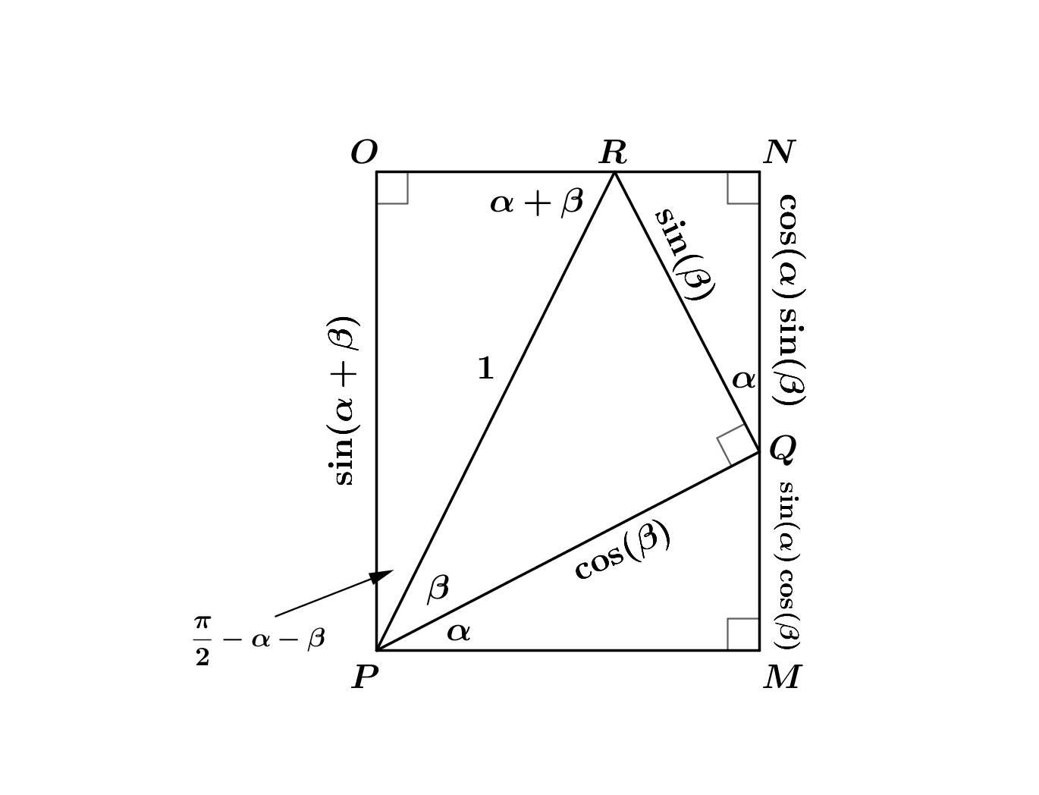
  - Now consider $∆RQN.$ Since $\cos\left(α\right)=\frac{QN}{sin\left(β\right)}$,
    - $QN=$_________.
$$\cos{(α)sin⁡(β)}$$

  - Label these lengths and angle measurements in the figure.

  - Since $MNOP$ is a rectangle, $OP=MQ+QN$.

  - Thus, $\sin\left(α+β\right)=\sin\left(α\right)\cos\left(β\right)+\cos\left(α\right)\sin\left(β\right)$.

Note that we have only proven the formula for the sine of the sum of two real numbers $α$ and $β$ in the case where $0<α+β<\frac{π}{2}$. A proof for all real numbers $α$ and $β$ breaks down into cases that are proven similarly to the case we have just seen. Although we are omitting the full proof, this formula holds for all real numbers $α$and $β$.
Thus, for any real numbers $α$ and $β,$
$sin(α+β)=sin\left(α\right)cos\left(β\right)+cos\left(α\right)sin\left(β\right)$.
Scaffolding:
A wall poster with all four sum and difference formulas will help students keep these formulas straight.

- Now let’s prove our other conjecture, which is that the formula for the cosine of the sum of two numbers is
$$\cos\left(α+β\right)=\cos\left(α\right)\cos\left(β\right)-\sin\left(α\right)\sin\left(β\right).$$
Again, we will prove only the case when the two numbers are positive, and their sum is less than $\frac{π}{2}$. This time, we will use the sine addition formula and identities from previous lessons instead of working through a geometric proof.
Fill in the blanks in terms of $α$ and $β$:
Let $α$ and $β$ be any real numbers. Then,
$$\cos\left(α+ β\right)=\sin\left(\frac{π}{2}-\left(__________\right)\right) \\ =\sin\left(\left(__________\right)-β\right) \\ =\sin\left(\left(__________\right)+\left(-β\right)\right) \\ =\sin\left(__________\right)\cos\left(-β\right)+\cos\left(__________\right)\sin\left(-β\right) \\ =\cos\left(α\right)\cos\left(-β\right)+\sin\left(α\right)\sin\left(-β\right) \\ =\cos\left(α\right)\cos\left(β\right)-\sin\left(α\right)sin\left(β\right).$$
The completed proof should look like the following:
$$\cos\left(α+ β\right)=\sin\left(\frac{π}{2}-\left(α+β\right)\right) \\ =\sin\left(\left(\frac{π}{2}-α\right)-β\right) \\ =\sin\left(\left(\frac{π}{2}-α\right)+\left(-β\right)\right) \\ =\sin\left(\frac{π}{2}-α\right)\cos\left(-β\right)+\cos\left(\frac{π}{2}-α\right)\sin\left(-β\right) \\ =\cos\left(α\right)\cos\left(-β\right)+\sin\left(α\right)\sin\left(-β\right) \\ =\cos\left(α\right)\cos\left(β\right)-\sin\left(α\right)sin\left(β\right).$$

Thus, for all real numbers $α$ and $β$,
$cos(α+β)=cos\left(α\right)cos\left(β\right)-sin\left(α\right)sin\left(β\right)$.

Exercises 1–2 (6 minutes): Formulas for $sin(α-β)$ and $cos(α-β)$
In these exercises, formulas for the sine and cosine of the difference of two angles are developed from the formulas for the sine and cosine of the sum of two angles.
Exercises 1–2: Formulas for $sin(α-β)$ and $cos(α-β)$
- Rewrite the expression $\sin\left(α-β\right)$ as follows: $\sin\left(α+\left(-β\right)\right)$. Use the rewritten form to find a formula for the sine of the difference of two angles, recalling that the sine is an odd function.
Let $α$ and $β$ be any real numbers. Then,
$$\sin\left(α+\left(-β\right)\right)=\sin\left(α\right)\cos\left(-β\right)+\cos\left(α\right)\sin\left(-β\right) \\ =\sin\left(α\right)\cos\left(β\right)-\cos\left(α\right)\sin\left(β\right).$$Therefore,$\sin\left(α-β\right)=\sin\left(α\right)\cos\left(β\right)-\cos\left(α\right)\sin\left(β\right)$ for all real numbers $α$ and $β$.

- Now use the same idea to find a formula for the cosine of the difference of two angles. Recall that the cosine is an even function.
Let $α$ and $β$ be any real numbers. Then,
$$\cos\left(α-β\right)=\cos\left(α+\left(-β\right)\right) \\ =\cos\left(α\right)\cos\left(-β\right)-\sin\left(α\right)\sin\left(-β\right) \\ =\cos\left(α\right)\cos\left(β\right)+\sin\left(α\right)\sin\left(β\right).$$
Therefore, $cos\left(α-β\right)=\cos\left(α\right)\cos\left(β\right)+\sin\left(α\right)\sin\left(β\right)$ for all real numbers $α$ and $β$.
Scaffolding:
- To help students understand the difference formulas, you might give them some examples to calculate.
- $\sin\left(\frac{π}{12}\right)=sin\left(\frac{π}{4}-\frac{π}{6}\right)=$
$$sin\left(\frac{π}{4}\right)\cos\left(\frac{π}{6}\right)-\cos\left(\frac{π}{4}\right)\sin\left(\frac{π}{6}\right)=\frac{1}{\sqrt{2}}∙\frac{\sqrt{3}}{2}-\frac{1}{\sqrt{2}}∙\frac{1}{2} \\ =\frac{\sqrt{2}\sqrt{3}}{4}-\frac{\sqrt{2}}{4} \\ =\frac{\sqrt{2}\left(\sqrt{3}-1\right)}{4}$$
- $\cos\left(\frac{π}{12}\right)=cos\left(\frac{π}{4}-\frac{π}{6}\right)=$
$$cos\left(\frac{π}{4}\right)\cos\left(\frac{π}{6}\right)+\sin\left(\frac{π}{4}\right)\sin\left(\frac{π}{6}\right)=\frac{1}{\sqrt{2}}∙\frac{\sqrt{3}}{2}+\frac{1}{\sqrt{2}}∙\frac{1}{2} \\ =\frac{\sqrt{2}\sqrt{3}}{4}+\frac{\sqrt{2}}{4} \\ =\frac{\sqrt{2}\left(\sqrt{3}+1\right)}{4}$$

Thus, for all real numbers $α$ and $β$,
$sin\left(α- β\right)=sin\left(α\right)cos\left(β\right)-cos\left(α\right)sin\left(β\right)$, and
$cos\left(α-β\right)=cos\left(α\right)cos\left(β\right)+sin\left(α\right)sin\left(β\right)$.

Exercises 3–5 (10 minutes)
These exercises make use of the formulas proved in the examples. Students should work on these exercises in pairs.
Use the sum and difference formulas to do the following:
Exercises 3–5
- Derive a formula for $\tan\left(α+β\right)$ in terms of $tan(α)$and $tan(β$) for $\frac{ 2n+1}{2π}<θ<\frac{2n+3}{2π}$, for any integer $n$.
Hint: Use the addition formulas for sine and cosine.
Let $α$and$β$ be any real numbers so that $cos\left(α\right)≠0$, $cos\left(β\right)≠0$, and $cos\left(α+β\right)≠0$. By the definition of tangent, $tan\left(α+β\right){=\frac{\sin\left(α+β\right)}{\cos\left(α+β\right)}}$.
Using sum formulas for sine and cosine, we have
$$\frac{\sin\left(α+β\right)}{\cos\left(α+β\right)}=\frac{\sin\left(α\right)\cos\left(β\right)+\cos\left(α\right)\sin\left(β\right)}{\cos\left(α\right)\cos\left(β\right)-\sin\left(α\right)\sin\left(β\right)}.$$
Dividing numerator and denominator by $\cos\left(α\right)\cos\left(β\right)$ gives
$$\frac{\sin\left(α\right)\cos\left(β\right)+\cos\left(α\right)\sin\left(β\right)}{\cos\left(α\right)\cos\left(β\right)-\sin\left(α\right)\sin\left(β\right)}=\frac{\tan\left(α\right)+\tan\left(β\right)}{1-\tan\left(α\right)\tan\left(β\right)}.$$
Therefore, $\tan\left(α+β\right)=\frac{\tan\left(α\right)+\tan\left(β\right)}{1-\tan\left(α\right)\tan\left(β\right)}$ for any real numbers $α$ and $β$ so that $cos\left(α\right)≠0$, $cos\left(β\right)≠0$, and $cos\left(α+β\right)≠0$.

- Derive a formula for $\sin\left(2u\right)$ in terms of $\sin\left(u\right)$ and $\cos\left(u\right)$for all real numbers$u$.
Let $u$ be any real number. Then, $\sin\left(2u\right)=sin\left(u+u\right)=sin\left(u\right)cos\left(u\right)+cos\left(u\right)sin\left(u\right)$, which is equivalent to $\sin\left(2u\right)=2\sin\left(u\right)\cos\left(u\right)$.
Therefore, $\sin\left(2u\right)=2\sin\left(u\right)\cos\left(u\right)$ for all real numbers$u$.

- Derive a formula for $\cos\left(2u\right)$ in terms of $\sin\left(u\right)$ and $\cos\left(u\right)$for all real numbers$u$.
Let $u$ be a real number. Then, $\cos\left(2u\right)=cos\left(u+u\right)=cos\left(u\right)\cos\left(u\right)-\sin\left(u\right)\sin\left(u\right)$, which is equivalent to $\cos\left(2u\right)=\cos^{2}\left(u\right)-\sin^{2}\left(u\right)$.
Therefore, $\cos\left(2u\right)=\cos^{2}\left(u\right)-\sin^{2}\left(u\right)$ for all real numbers$u$.

Closing (1 minute)
Ask students to respond to this question in writing, to a partner, or as a class.
- Edna claims that in the same way that $2\left(α+β\right)=2\left(α\right)+2\left(β\right),$ it follows by the distributive property that
$\sin\left(α+β\right)=\sin\left(α\right)+\sin\left(β\right)$for all real numbers $α$ and $β$. Danielle says that can’t be true. Who is correct, and why?
  - Danielle is correct. Given that $sin\left(α+ β\right)=sin\left(α\right)cos\left(β\right)+cos\left(α\right)sin\left(β\right),$it follows that $\sin\left(α+β\right)$ $=\sin\left(α\right)+\sin\left(β\right)$ only for special values of $α$ and $β.$ That is, when $\cos\left(β\right)=1$ and $\cos\left(α\right)=1$, or when $α=β=πn$for $n$ an integer. So, in general,

$$\sin\left(α+β\right)≠\sin\left(α\right)+\sin\left(β\right).$$

A simple example is when $α=β=\frac{π}{2}$. Then, $sin\left(α+β\right)=\sin\left(π\right)=0$, but $\sin\left(α\right)+\sin\left(β\right)=\sin\left(\frac{π}{2}\right)+\sin\left(\frac{π}{2}\right)=2$. Since $0≠2$, $sin\left(α+β\right)$ is generally not equal to $sin\left(α\right)+sin(β)$.

Exit Ticket (3 minutes)
Name Date
Lesson 17: Trigonometric Identity Proofs

Exit Ticket

Derive a formula for $tan\left(α-β\right)$ in terms of $tan\left(α\right)$ and $tan\left(β\right)$, where $α≠\frac{π}{2}+kπ$ and $β≠\frac{π}{2}+kπ$, for all integers $k$.

Exit Ticket Sample Solutions

Derive a formula for $tan\left(α-β\right)$ in terms of $tan\left(α\right)$ and $tan\left(β\right)$, where $α≠\frac{π}{2}+kπ$ and $β≠\frac{π}{2}+kπ$, for all integers $k$.
Let $θ$ be a real number so that $θ≠\frac{π}{2}+kπ$, for all integers $k$. Using the definition of tangent, $tan\left(α-β\right)=\frac{\sin\left(α-β\right)}{\cos\left(α-β\right)}$.
Using the difference formulas for sine and cosine,
$$\frac{\sin\left(α-β\right)}{\cos\left(α-β\right)}=\frac{\sin\left(α\right)\cos\left(β\right)-\cos\left(α\right)\sin\left(β\right)}{\cos\left(α\right)\cos\left(β\right)+\sin\left(α\right)\sin\left(β\right)}.$$
Dividing numerator and denominator by $\cos\left(α\right)\cos\left(β\right)$ gives
$$\frac{\sin\left(α\right)\cos\left(β\right)-\cos\left(α\right)\sin\left(β\right)}{\cos\left(α\right)\cos\left(β\right)+\sin\left(α\right)\sin\left(β\right)}=\frac{\tan\left(α\right)-\tan\left(β\right)}{1+\tan\left(α\right)\tan\left(β\right)}.$$
Therefore, $\tan\left(α-β\right)=\frac{\tan\left(α\right)-\tan\left(β\right)}{1+\tan\left(α\right)\tan\left(β\right)}$, where $α≠\frac{π}{2}+kπ$ and $β≠\frac{π}{2}+kπ$, for all integers $k$.

Problem Set Sample Solutions
These problems continue the derivation and demonstration of simple trigonometric identities.

- Prove the formula
$\cos\left(α+β\right)=\cos\left(α\right)\cos\left(β\right)-\sin\left(α\right)\sin\left(β\right)$ for $0<α+β<\frac{π}{2}$
using the rectangle $MNOP$ in the figure at the right and calculating $PM$,$RN$, and $RO$ in terms of $α$ and $β$.
Proof. Let $α$ and $β$ be real numbers so that $0<α+β<\frac{π}{2}$.
Then $PM=\cos\left(α\right)\cos\left(β\right)$, $RN=\sin\left(α\right)\sin\left(β\right)$, and $RO=\cos\left(α+β\right)$.
Because $RO=PM-RN$, it follows that
$\cos\left(α+β\right)=\cos\left(α\right)\cos\left(β\right)-\sin\left(α\right)\sin\left(β\right)$for $0<α +β<\frac{π}{2}$.

- Derive a formula for $\tan\left(2u\right)$ for $u≠\frac{π}{4}+\frac{kπ}{2}$ and $u≠\frac{π}{2}+kπ$, for all integers $k$.
Proof. Let $u$ be any real number so that $u≠\frac{π}{4}+\frac{kπ}{2}$, and $u≠\frac{π}{2}+kπ$, for all integers $k$. In the formula
$\tan\left(α+β\right)=\frac{\tan\left(α\right)+\tan\left(β\right)}{1-\tan\left(α\right)\tan\left(β\right)}$, replace $α$ and $β$ both by $u$. The resulting equation is $\tan\left(2u\right)=\frac{\tan\left(u\right)+\tan\left(u\right)}{1-\tan\left(u\right)\tan\left(u\right)}$ , which is equivalent to
$\tan\left(2u\right)=\frac{2\tan\left(u\right)}{1-tan^{2}\left(u\right)}$ for $u≠\frac{π}{4}+\frac{kπ}{2}$ and $u≠\frac{π}{2}+kπ$, for all integers $k$.

- Prove that $cos\left(2u\right)={2cos}^{2}\left(u\right)-1$ is true for any real number $u$.
Proof. Let $u$ be any real number. From Exercise 3 in class, we know that $\cos\left(2u\right)=\cos^{2}\left(u\right)-\sin^{2}\left(u\right)$ for any real number $u$. Using the Pythagorean identity, we know that $\sin^{2}\left(u\right)=1-\cos^{2}\left(u\right)$. By substitution,
$\cos\left(2u\right)=\cos^{2}\left(u\right)-1+\cos^{2}\left(u\right)$.
Thus, $\cos\left(2u\right)={2cos}^{2}\left(u\right)-1$ for any real number $u$.
- Prove that $\frac{1}{\cos\left(x\right)}-cos\left(x\right)=sin\left(x\right)⋅tan\left(x\right)$ is true for $x≠\frac{π}{2}+kπ$, for all integers $k$.
We begin with the left side, get a common denominator, and then use the Pythagorean identity.
Proof: Let $x$ be a real number so that $x≠\frac{π}{2}+kπ,$ for all integers $k.$ Then,
$$\frac{1}{\cos\left(x\right)}-\cos\left(x\right)=\frac{1-\cos^{2}\left(x\right)}{\cos\left(x\right)} \\ =\frac{\sin^{2}\left(x\right)}{\cos\left(x\right)} \\ =\frac{\sin\left(x\right)}{\cos\left(x\right)}∙\sin\left(x\right) \\ =\sin\left(x\right)∙\tan\left(x\right).$$Therefore, $\frac{1}{\cos\left(x\right)}-cos\left(x\right)=sin\left(x\right)⋅tan\left(x\right)$, where $x≠\frac{π}{2}+kπ$, for all integers $k$.

- Write as a single term: $cos\left(\frac{π}{4}+θ\right)+cos\left(\frac{π}{4}-θ\right)$.
We use the formulas for the cosine of sums and differences:
$$\cos\left(\frac{π}{4}+θ\right)+\cos\left(\frac{π}{4}-θ\right)=\cos\left(\frac{π}{4}\right)\cos\left(θ\right)-\sin\left(\frac{π}{4}\right)\sin\left(θ\right)+\cos\left(\frac{π}{4}\right)\cos\left(θ\right)+\sin\left(\frac{π}{4}\right)\sin\left(θ\right) \\ =\frac{1}{\sqrt{2}}cos\left(θ\right)-\frac{1}{\sqrt{2}}{\sin\left(θ\right)+}\frac{1}{\sqrt{2}}\cos\left(θ\right)+\frac{1}{\sqrt{2}}{\sin\left(θ\right)} \\ =\sqrt{2}\cos\left(θ\right).$$
Therefore, $cos\left(\frac{π}{4}+θ\right)+cos\left(\frac{π}{4}-θ\right){=\sqrt{2}\cos\left(θ\right)}$.

- Write as a single term: $\sin\left(25°\right)\cos\left(10°\right)-\cos\left(25°\right)\sin\left(10°\right)$.
Begin with the formula $\sin\left(α-β\right)=\sin\left(α\right)\cos\left(β\right)-\cos\left(α\right)\sin\left(β\right)$, and let $α=25°$ and $β=10°.$
$$\sin\left(25°\right)\cos\left(10°\right)-\cos\left(25°\right)\sin\left(10°\right)=\sin\left(25°-10°\right) \\ =\sin\left(15°\right).$$

- Write as a single term: $\cos\left(2x\right){\cos\left(x\right)+\sin\left(2x\right)\sin\left(x\right)}$.
Begin with the formula $\cos\left(α-β\right)=\cos\left(α\right)\cos\left(β\right)+\sin\left(α\right)\sin\left(β\right)$, and let $α=2x$ and $β=x$.
$$\cos\left(2x\right){\cos\left(x\right)+\sin\left(2x\right)\sin\left(x\right)}=\cos\left(2x-x\right) \\ =\cos\left(x\right)$$

- Write as a single term: $\frac{\sin\left(α+β\right)+\sin\left(α-β\right)}{\cos\left(α\right)\cos\left(β\right)}$, where$cos\left(α\right)≠0$ and $cos\left(β\right)≠0$.
Begin with the formulas for the sine of the sum and difference:
$$\frac{\sin\left(α+β\right)+\sin\left(α-β\right)}{\cos\left(α\right)\cos\left(β\right)}=\frac{sin\left(α\right)cos\left(β\right)+cos\left(α\right)sin\left(β\right)+\sin\left(α\right)\cos\left(β\right)-\cos\left(α\right)\sin\left(β\right)}{\cos\left(α\right)\cos\left(β\right)} \\ =\frac{2\sin\left(α\right)\cos\left(β\right)}{\cos\left(α\right)\cos\left(β\right)} \\ =\frac{2\sin\left(α\right)}{\cos\left(α\right)} \\ =2\tan\left(α\right).$$
- Prove that for all values of $θ$, $cos\left(\frac{3π}{2}+θ\right)=sin\left(θ\right)$.
Proof. Let $θ$ be any real number. Then, from the formula for the cosine of a sum,
$$\cos\left(\frac{3π}{2}+θ\right)=\cos\left(\frac{3π}{2}\right)\cos\left(θ\right)-\sin\left(\frac{3π}{2}\right)∙\sin\left(θ\right) \\ =0∙\cos\left(θ\right)-\left(-1\right)\sin\left(θ\right) \\ =\sin{θ.}$$
Therefore, $\cos\left(\frac{3π}{2}+θ\right)=\sin\left(θ\right)$ for all values of $θ.$

- Prove that for all values of $θ$, $\cos\left(π-θ\right)=-\cos\left(θ\right).$
Proof: Let $θ$ be any real number. Then, from the formula for the cosine of a difference:
$$\cos\left(π-θ\right)=\cos\left(π\right)\cos\left(θ\right)+\sin\left(π\right)\sin\left(θ\right) \\ =-\cos{θ.}$$
Therefore, $\cos\left(π-θ\right)=-\cos\left(θ\right)$ for all real numbers $θ$.

