Lesson 17: Trigonometric Identity Proofs

Classwork
Opening Exercise
We have seen that $\sin\left(α+β\right)≠\sin\left(α\right)+\sin\left(β\right)$. So, what is $\sin\left(α+β\right)$? Begin by completing the following table:

$$α$$ | $$β$$ | $$\sin\left(α\right)$$ | $$\sin\left(β\right)$$ | $$\sin\left(α+β\right)$$ | $$\sin\left(α\right)\cos\left(β\right)$$ | $$\sin\left(α\right)\sin\left(β\right)$$ | $$\cos\left(α\right)\cos\left(β\right)$$ | $$\cos\left(α\right)\sin\left(β\right)$$
$$\frac{π}{6}$$ | $$\frac{π}{6}$$ | $$\frac{1}{2}$$ | $$\frac{1}{2}$$ | $$\frac{\sqrt{3}}{2}$$ | $$\frac{\sqrt{3}}{4}$$ | $$\frac{1}{2}$$
$$\frac{π}{6}$$ | $$\frac{π}{3}$$ | $$\frac{1}{2}$$ | $$\frac{\sqrt{3}}{2}$$ | $$1$$ |  |  | $$\frac{\sqrt{3}}{4}$$
$$\frac{π}{4}$$ | $$\frac{π}{6}$$ | $$\frac{1}{\sqrt{2}}$$ | $$\frac{1}{2}$$ | $$\frac{1+\sqrt{3}}{2\sqrt{2}}$$ | $$\frac{\sqrt{3}}{2\sqrt{2}}$$
$$\frac{π}{4}$$ | $$\frac{π}{4}$$ | $$\frac{1}{\sqrt{2}}$$ | $$\frac{1}{\sqrt{2}}$$ | $$1$$ |  | $$\frac{1}{2}$$ | $$\frac{1}{2}$$
$$\frac{π}{3}$$ | $$\frac{π}{3}$$ | $$\frac{\sqrt{3}}{2}$$ | $$\frac{\sqrt{3}}{2}$$ | $$\frac{\sqrt{3}}{2}$$ |  |  |  | $$\frac{\sqrt{3}}{4}$$
$$\frac{π}{3}$$ | $$\frac{π}{4}$$ | $$\frac{\sqrt{3}}{2}$$ | $$\frac{1}{\sqrt{2}}$$ | $$\frac{1+\sqrt{3}}{2\sqrt{2}}$$ |  | $$\frac{\sqrt{3}}{2\sqrt{2}}$$ | $$\frac{1}{2\sqrt{2}}$$

Use the following table to formulate a conjecture for $\cos\left(α+β\right)$:

$$α$$ | $$β$$ | $$\cos\left(α\right)$$ | $$\cos\left(β\right)$$ | $$\cos\left(α+β\right)$$ | $$\sin\left(α\right)\cos\left(β\right)$$ | $$\sin\left(α\right)\sin\left(β\right)$$ | $$\cos\left(α\right)\cos\left(β\right)$$ | $$\cos\left(α\right)\sin\left(β\right)$$
$$\frac{π}{6}$$ | $$\frac{π}{6}$$ | $$\frac{1}{2}$$ | $$\frac{1}{2}$$ | $$\frac{1}{2}$$ | $$\frac{\sqrt{3}}{4}$$ | $$\frac{1}{2}$$ | $$\frac{3}{4}$$ | $$\frac{\sqrt{3}}{4}$$
$$\frac{π}{6}$$ | $$\frac{π}{3}$$ | $$\frac{\sqrt{3}}{2}$$ | $$\frac{1}{2}$$ | $$0$$ | $$\frac{1}{4}$$ | $$\frac{\sqrt{3}}{4}$$ | $$\frac{\sqrt{3}}{4}$$ | $$\frac{3}{4}$$
$$\frac{π}{4}$$ | $$\frac{π}{6}$$ | $$\frac{1}{\sqrt{2}}$$ | $$\frac{\sqrt{3}}{2}$$ | $$\frac{\sqrt{3}-1}{2\sqrt{2}}$$ | $$\frac{\sqrt{3}}{2\sqrt{2}}$$ | $$\frac{1}{2\sqrt{2}}$$ | $$\frac{\sqrt{3}}{2\sqrt{2}}$$ | $$\frac{1}{2\sqrt{2}}$$
$$\frac{π}{4}$$ | $$\frac{π}{4}$$ | $$\frac{1}{\sqrt{2}}$$ | $$\frac{1}{\sqrt{2}}$$ | $$0$$ | $$\frac{1}{2}$$ | $$\frac{1}{2}$$ | $$\frac{1}{2}$$ | $$\frac{1}{2}$$
$$\frac{π}{3}$$ | $$\frac{π}{3}$$ | $$\frac{1}{2}$$ | $$\frac{1}{2}$$ | $$-\frac{1}{2}$$ | $$\frac{\sqrt{3}}{4}$$ | $$\frac{3}{4}$$ | $$\frac{1}{4}$$ | $$\frac{\sqrt{3}}{4}$$
$$\frac{π}{3}$$ | $$\frac{π}{4}$$ | $$\frac{1}{2}$$ | $$\frac{1}{\sqrt{2}}$$ | $$\frac{1-\sqrt{3}}{2\sqrt{2}}$$ | $$\frac{\sqrt{3}}{2\sqrt{2}}$$ | $$\frac{\sqrt{3}}{2\sqrt{2}}$$ | $$\frac{1}{2\sqrt{2}}$$ | $$\frac{1}{2\sqrt{2}}$$

Examples 1–2: Formulas for $sin(α+β)$ and $cos(α+β)$
- One conjecture is that the formula for the sine of the sum of two numbers is $\sin\left(α+β\right)=\sin\left(α\right)\cos\left(β\right)+$ $\cos\left(α\right)\sin\left(β\right)$. The proof can be a little long, but it is fairly straightforward. We will prove only the case when the two numbers are positive, and their sum is less than $\frac{π}{2}$.
  - Let $α$ and $β$ be positive real numbers such that $0<α+β<\frac{π}{2}$.

  - Construct rectangle $MNOP$such that $PR = 1,$ $m∠PQR=90°,$ $m∠RPQ=β$, and $m∠QPM=α.$ See the figure at the right.

  - Fill in the blanks in terms of $α$ and $β:$

    - $m∠RPO=$ _____________.

    - $m∠PRO=$ _______________.

    - Therefore, $\sin\left(α+β\right)=PO$.

    - $RQ=\sin{(______)}$.

    - $PQ=\cos{(______)}$.

  - Let’s label the angle and length measurements as shown.

  - Use this new figure to fill in the blanks in terms of $α$ and $β:$
    - Why does $\sin\left(α\right)=\frac{MQ}{\cos\left(β\right)}$?

    - Therefore,$MQ=$_________.

    - $m∠RQN=$____________.

  - Now consider $∆RQN.$ Since $\cos\left(α\right)=\frac{QN}{sin⁡(β)},$

$QN=$_________.

  - Label these lengths and angle measurements in the figure.
  - Since $MNOP$ is a rectangle, $OP=MQ+QN.$

  - Thus,$\sin\left(α+β\right)=\sin\left(α\right)\cos\left(β\right)+\cos\left(α\right)\sin\left(β\right)$.

Note that we have only proven the formula for the sine of the sum of two real numbers $α$ and $β$ in the case where $0<α+β<\frac{π}{2}$. A proof for all real numbers $α$ and $β$ breaks down into cases that are proven similarly to the case we have just seen. Although we are omitting the full proof, this formula holds for all real numbers $α$and $β$.

Thus, for any real numbers $α$ and $β,$
$sin(α+ β)=sin\left(α\right)cos\left(β\right)+cos\left(α\right)sin\left(β\right)$.

- Now let’s prove our other conjecture, which is that the formula for the cosine of the sum of two numbers is
$$\cos\left(α+β\right)=\cos\left(α\right)\cos\left(β\right)-\sin\left(α\right)\sin\left(β\right).$$
Again, we will prove only the case when the two numbers are positive, and their sum is less than $\frac{π}{2}$. This time, we will use the sine addition formula and identities from previous lessons instead of working through a geometric proof.
Fill in the blanks in terms of $α$ and $β$:
Let $α$ and $β$ be any real numbers. Then,

$$\cos\left(α+ β\right)=\sin\left(\frac{π}{2}-\left(__________\right)\right) \\ =\sin\left(\left(__________\right)-β\right) \\ =\sin\left(\left(__________\right)+\left(-β\right)\right) \\ =\sin\left(__________\right)\cos\left(-β\right)+\cos\left(__________\right)\sin\left(-β\right) \\ =\cos\left(α\right)\cos\left(-β\right)+\sin\left(α\right)\sin\left(-β\right) \\ =\cos\left(α\right)\cos\left(β\right)-\sin\left(α\right)sin\left(β\right).$$
Thus, for all real numbers $α$ and $β,$
$$cos(α+β)=cos\left(α\right)cos\left(β\right)-sin\left(α\right)sin\left(β\right).$$

Exercises 1–2: Formulas for $sin(α-β)$ and $cos(α-β)$
- Rewrite the expression $\sin\left(α-β\right)$ as follows: $\sin\left(α+\left(-β\right)\right)$. Use the rewritten form to find a formula for the sine of the difference of two angles, recalling that the sine is an odd function.

- Now use the same idea to find a formula for the cosine of the difference of two angles. Recall that the cosine is an even function.

Thus, for all real numbers $α$ and $β,$
$$sin\left(α- β\right)=sin\left(α\right)cos\left(β\right)-cos\left(α\right)sin\left(β\right), and$$
$$cos\left(α-β\right)=cos\left(α\right)cos\left(β\right)+sin\left(α\right)sin\left(β\right).$$

Exercises 3–5
- Derive a formula for $\tan\left(α+β\right)$ in terms of $tan(α)$and $tan(β$) for $\frac{ 2n+1}{2}π<θ<\frac{2n+3}{2}π,$ for any integer $n$.
Hint: Use the addition formulas for sine and cosine.

- Derive a formula for $\sin\left(2u\right)$ in terms of $\sin\left(u\right)$ and $\cos\left(u\right)$for all real numbers$u$.

- Derive a formula for $\cos\left(2u\right)$ in terms of $\sin\left(u\right)$ and $\cos\left(u\right)$for all real numbers$u$.

Problem Set

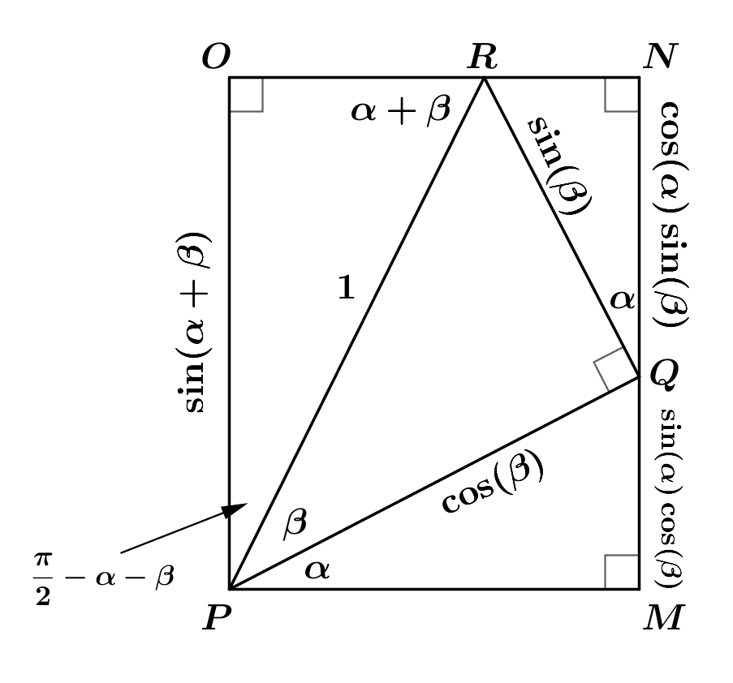
- Prove the formula
$\cos\left(α+β\right)=\cos\left(α\right)\cos\left(β\right)-\sin\left(α\right)\sin\left(β\right)$ for $0<α+β<\frac{π}{2}$
using the rectangle $MNOP$ in the figure at the right and calculating $PM, RN,$ and $RO$ in terms of $α$ and $β$.

- Derive a formula for $\tan\left(2u\right)$ for $u≠\frac{π}{4}+\frac{kπ}{2}$ and $u≠\frac{π}{2}+kπ$, for all integers $k$.

- Prove that $cos\left(2u\right)={2cos}^{2}\left(u\right)-1$ is true for any real number $u$.

- Prove that $\frac{1}{\cos\left(x\right)}-\cos\left(x\right)=\sin\left(x\right)∙\tan\left(x\right)$ is true for $x≠\frac{π}{2}+kπ$, for all integers $k$.

- Write as a single term: $\cos\left(\frac{π}{4}+θ\right)+\cos\left(\frac{π}{4}-θ\right)$.

- Write as a single term: $\sin\left(25°\right)\cos\left(10°\right)-\cos\left(25°\right)\sin\left(10°\right).$

- Write as a single term: $\cos\left(2x\right){\cos\left(x\right)+\sin\left(2x\right)\sin\left(x\right)}.$

- Write as a single term: $\frac{\sin\left(α+β\right)+\sin\left(α-β\right)}{\cos\left(α\right)\cos\left(β\right)}$, where$cos\left(α\right)≠0$ and $cos\left(β\right)≠0.$

- Prove that for all values of $θ$, $\cos\left(\frac{3π}{2}+θ\right)=\sin\left(θ\right)$.

- Prove that for all values of $θ$, $\cos\left(π-θ\right)=-\cos\left(θ\right).$

