Lesson 15: What Is a Trigonometric Identity?

Student Outcomes
- Students prove the Pythagorean identity $\sin^{2}\left(x\right)+\cos^{2}\left(x\right)=1$.
- Students extend trigonometric identities to the real line, with attention to domain and range.
- Students use the Pythagorean identity to find $sin(θ)$, $cos(θ)$, or $tan\left(θ\right)$, given $sin(θ)$,$cos(θ)$, or $tan(θ)$ and the quadrant of the terminal ray of the rotation.

Lesson Notes
The lesson begins with an example that develops and proves the Pythagorean identity for all real numbers. An equivalent form of the Pythagorean identity is developed, and students observe that there are special values for which the resulting functions are not defined; therefore, there are values for which the identity does not hold. Students then examine the domains for several identities and use the Pythagorean identity to find one function in terms of another in a given quadrant.
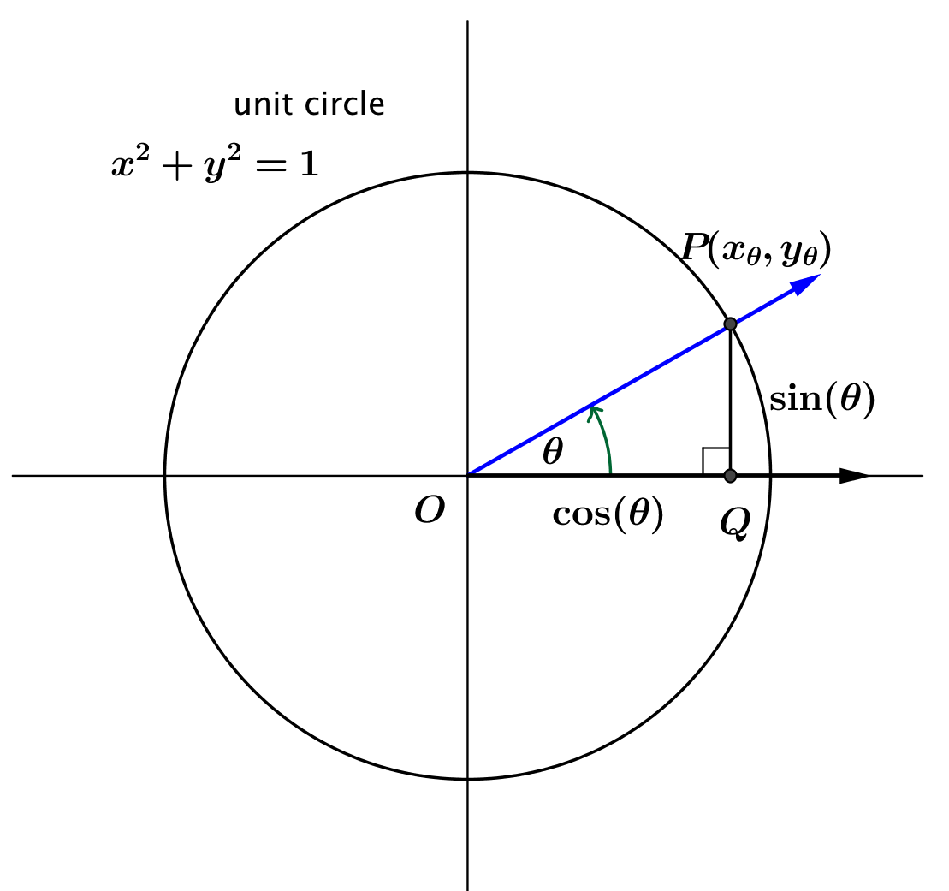
Classwork
Opening (5 minutes): The Pythagorean Identity
In Lessons 4 and 5, we extended the definitions of the sine and cosine functions so that $sin(θ)$ and $\cos\left(θ\right)$ are defined for all real numbers $θ.$
- What is the equation of the unit circle centered at the origin?
  - The unit circle has equation $x^{2}{+ y^{2}=1.}$
- Recall that this equation is a special case of the Pythagorean theorem. Given the number $θ,$ there is a unique point $P$ on the unit circle that results from rotating the positive $x$-axis through $θ$ radians around the origin. What are the coordinates of $P$?
  - The coordinates of $P$ are $(x_{θ}, y_{θ})$, where $x_{θ}=cos(θ)$, and $y_{θ}=sin(θ)$.
Scaffolding:
- English language learners may need support (choral recitation, graphic organizer, etc.) for learning the word identity.
- An alternative, more challenging Opening might be, “Prove that $\sin^{2}\left(θ\right)+\cos^{2}\left(θ\right)=1$, for all real values of $θ$.” (MP.3)
- How can you combine this information to get a formula involving $sin(θ)$ and $cos(θ)$?
  - Replace $x$ and $y$ in the equation of the unit circle by the coordinates of $P$. That gives $\sin^{2}\left(θ\right){+\cos^{2}{(θ})}=1$, where $θ$ is any real number.
- Notice that we use the notation $\sin^{2}\left(θ\right)$ in place of ${\left(\sin\left(θ\right)\right)}^{2}$. Both are correct, but the first is notationally simpler. Notice also that neither is the same function as $\sin\left(θ^{2}\right).$

- The equation $\sin^{2}{(θ)+\cos^{2}{(θ)}}=1$ is true for all real numbers $θ$ and is an identity. The functions on either side of the equal sign are equivalent for every value of $θ$. They have the same domain, the same range, and the same rule of assignment. You saw polynomial identities in Module 1. The identity we just proved is a trigonometric identity, and it is called the Pythagorean identity because it is another important consequence of the Pythagorean theorem.

Example 1 (8 minutes): Another Identity?
This example gets into the issue of what an identity is. Students should work in pairs to answer the questions.
Scaffolding:
- Circulate to identify student pairs who might be prepared to share their results and to assist any students having trouble.
- You may need to model the substitution process, showing explicitly how the equation becomes $\tan^{2}\left(θ\right)+ 1=\frac{1}{\cos^{2}\left(θ\right)}$.
- Divide both sides of the Pythagorean identity by $\cos^{2}\left(θ\right)$. What happens to the identity?
  - The equation becomes $\tan^{2}\left(θ\right)+ 1=\frac{1}{\cos^{2}\left(θ\right)}$, which we can restate as $\tan^{2}\left(θ\right)+1=\sec^{2}\left(θ\right)$. This appears to be another identity.
- What happens when $θ=-\frac{π}{2}$, $θ=\frac{π}{2}$, and $θ=\frac{3π}{2}$? Why?
  - Both $\tan\left(θ\right)$ and $\sec\left(θ\right)$ are undefined at these values of $θ$. That happens because $\cos\left(θ\right)=0$ for those values of $θ,$ and we cannot divide by zero. Therefore, we can no longer say that the equation is true for all real numbers $θ$.
- How do we need to modify our claim about what looks like a new identity?
  - We need to say that $\tan^{2}\left(θ\right)+1=\sec^{2}\left(θ\right)$is a trigonometric identity for all real numbers $θ$ such that the functions $f\left(x\right)=\tan^{2}\left(θ\right)+1$ and $g\left(x\right)=\sec^{2}\left(θ\right)$ are defined. In some cases, the functions are defined$,$ and in other cases, they are not defined.
- For which values of $θ$ are the functions $f\left(x\right)=\tan^{2}\left(θ\right)+1$ and $g\left(x\right)=\sec^{2}\left(θ\right)$ defined?
  - The function $f\left(x\right)=\tan^{2}\left(θ\right)+1$ is defined for $θ≠\frac{π}{2}+kπ$, for all integers $k$.
  - The function $f\left(x\right)=\sec^{2}\left(θ\right)$ is defined for $θ≠\frac{π}{2}+kπ$, for all integers $k.$
- What is the range of each of the functions $f\left(x\right)=\tan^{2}\left(θ\right)+1$ and $g\left(x\right)=\sec^{2}\left(θ\right)$?
  - The ranges of the functions are all real numbers $f(x)≥1$ and $g(x)≥1$.
- The two functions have the same domain and the same range, and they are equivalent.
- Therefore, $\tan^{2}\left(θ\right)+1=\sec^{2}\left(θ\right)$is a trigonometric identity for all real numbers $θ$ such that $θ≠\frac{π}{2}+kπ$, for all integers $k.$ For any trigonometric identity, we need to specify not only the two functions that are equivalent, but also the values for which the identity is true.
Be sure that the discussion clarifies that any equation is not automatically an identity. The equation needs to involve the equivalence of two functions and include the specification of their identical domains.

Exercises 1–3 (25 minutes)
Students should work on these exercises individually and then share their results either in a group or with the whole class. If some students are struggling, they should be encouraged to work together with the teacher while the others work individually.
Exercises 1–3
- Recall the Pythagorean identity $\sin^{2}\left(θ\right)+\cos^{2}\left(θ\right)=1$, where $θ$ is any real number.
  - Find $sin\left(x\right)$, given $cos\left(x\right)=\frac{3}{5}$, for $-\frac{π}{2}<x<0$.
From the Pythagorean identity, $sin^{2}\left(x\right)+{\left(\frac{3}{5}\right)}^{2}=1$. So, $\sin^{2}\left(x\right)=1-\frac{9}{25}=\frac{16}{25}$, and $sin\left(x\right)=-\frac{4}{5}$, or $sin\left(x\right)= \frac{4}{5}$. Since $-\frac{π}{2}<x<0$, we know that $sin\left(x\right)$ is negative; therefore, $sin\left(x\right)=-\frac{4}{5}.$

  - Find $tan\left(y\right)$, given $cos\left(y\right)=-\frac{5}{13},$for $\frac{π}{2}<y<π$.
From the Pythagorean identity, $sin^{2}\left(y\right)+{\left(-\frac{5}{13}\right)}^{2}=1$. So, $\sin^{2}\left(y\right)=1-\frac{25}{169}=\frac{144}{169}$, and $sin\left(y\right)=-\frac{12}{13}$, or $sin\left(y\right)=\frac{12}{13}.$ Since $\frac{π}{2}<y<π$, we know that $sin\left(y\right)$ is positive; therefore, $sin\left(y\right)=\frac{12}{13}$.
Therefore, $tan\left(y\right)=\frac{sin\left(y\right)}{cos\left(y\right)}=\frac{\frac{12}{13}}{-\frac{5}{13}}=-\frac{12}{5}.$

  - Write $tan(z$) in terms of $cos(z)$, for $π<z<\frac{3π}{2}$.
From the Pythagorean identity, $\sin^{2}\left(z\right)=1-cos^{2}\left(z\right)$. Therefore, either $\sin\left(z\right)=-\sqrt{1-cos^{2}\left(z\right)}$, or $\sin\left(z\right)=\sqrt{1-cos^{2}\left(z\right)}$. Since $sin\left(z\right)$ is negative for $π<x<\frac{3π}{2}$, $sin\left(z\right)=-\sqrt{1-cos^{2}\left(z\right)}$. Because $tan\left(z\right)=\frac{sin\left(z\right)}{cos\left(z\right)}$, we have $tan\left(z\right)=\frac{-\sqrt{1-cos^{2}\left(z\right)}}{cos\left(z\right)}$.

- Use the Pythagorean identity to do the following:
  - Rewrite the expression $\cos\left(θ\right)\sin^{2}\left(θ\right){-\cos{(θ)}}$ in terms of a single trigonometric function.
$$\cos\left(θ\right)\sin^{2}\left(θ\right){-\cos\left(θ\right)}=\cos{(θ)\left(\sin^{2}\left(θ\right)-1\right)} \\ =\cos\left(θ\right)(-\cos^{2}\left(θ\right)) \\ =-\cos^{3}\left(θ\right)$$
Therefore, $\cos\left(θ\right)\sin^{2}\left(θ\right){-\cos\left(θ\right)}=-\cos^{3}\left(θ\right)$ for all real numbers $θ$.

  - Rewrite the expression $\left(1-\cos^{2}\left(θ\right)\right)\csc\left(θ\right)$ in terms of a single trigonometric function.
$$\left(1-\cos^{2}\left(θ\right)\right)\csc\left(θ\right)=\sin^{2}\left(θ\right)\csc\left(θ\right) \\ =\sin^{2}\left(θ\right)\frac{1}{\sin\left(θ\right)} \\ =\sin\left(θ\right)$$
Therefore, $\left(1-\cos^{2}\left(θ\right)\right)\csc\left(θ\right)=\sin\left(θ\right)$ for $θ≠kπ$, for all integers $k$.

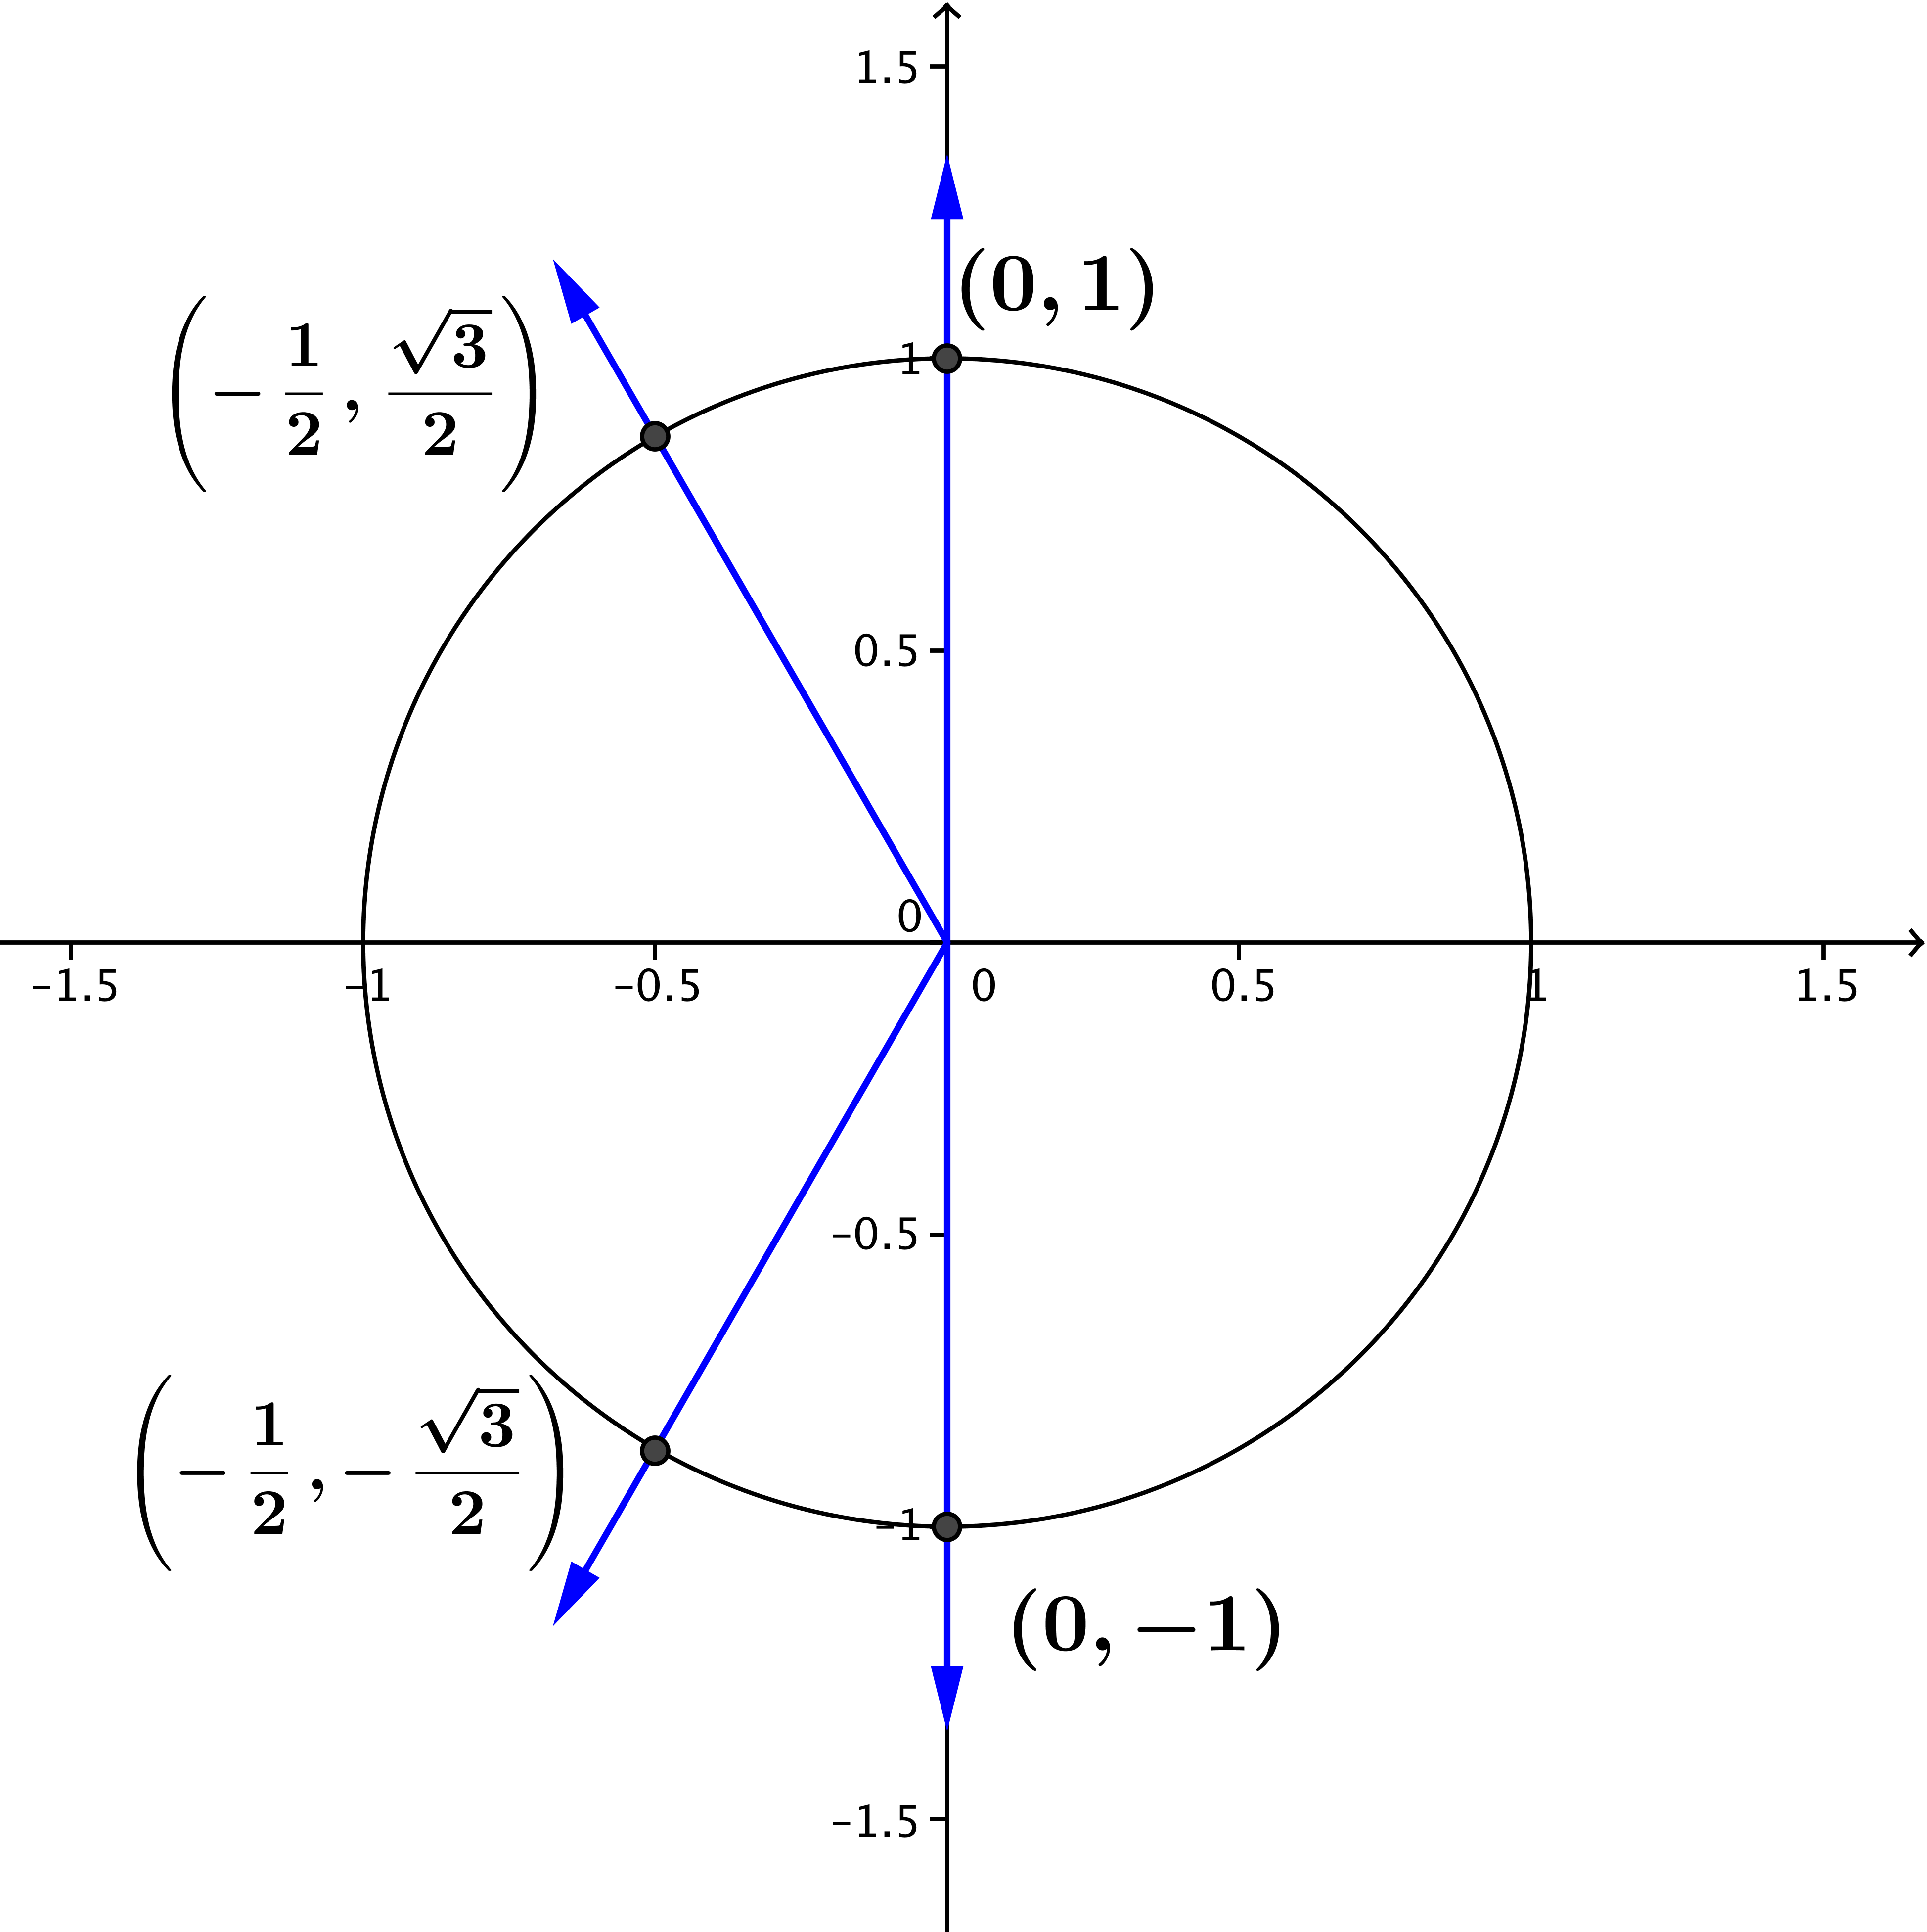
  - Find all the solutions of the equation $2\sin^{2}\left(θ\right)=2+\cos\left(θ\right)$ in the interval $[0,2π)$. Draw a unit circle that shows the solutions.
$$2\sin^{2}\left(θ\right)=2+\cos\left(θ\right) \\ 2\left(1-\cos^{2}\left( θ\right)\right)=2+\cos\left(θ\right) \\ 2-{2cos}^{2}\left(θ\right)=2+\cos{θ} \\ -{2cos}^{2}\left(θ\right)-\cos\left(θ\right)=0 \\ {2cos}^{2}\left(θ\right)+\cos\left(θ\right)=0 \\ \cos\left(θ\right)\left(2\cos\left(θ\right)+1\right)=0$$
Therefore, $\cos\left(θ\right)=0$, or $\cos\left(θ\right)=-\frac{1}{2}$.
See the unit circle at the right, which shows the four points where $\cos\left(θ\right)=0$, or $\cos\left(θ\right)=-\frac{1}{2}$.
In the interval $[0,2π)$, $\cos\left(θ\right)=0$ only if $θ=\frac{π}{2}$, or
$θ=\frac{3π}{2}$. Also, $\cos\left(θ\right)=-\frac{1}{2}$ only if $θ=\frac{2π}{3}$, or$θ=\frac{4π}{3}$. Therefore, the solutions of the equations in the interval $\left[0,2π\right)$ are$\frac{π}{2}$,$\frac{3π}{2}$,$\frac{2π}{3}$, and$\frac{4π}{3}$.

- Which of the following equations are identities? For those equations that are identities, which ones are defined for all real numbers and which are not? For the latter, for which values of $x$ are they not defined?
  - $\sin\left(x+2π\right)=\sin\left(x\right)$ where the functions on both sides are defined$.$
This is an identity defined for all real numbers.

  - $\sec\left(x\right)=1$ where the functions on both sides are defined$.$
This is not an identity. The functions are not equivalent for all real numbers. For example, although
$\sec\left(0\right)=1$, $\sec\left(\frac{π}{4}\right)=\sqrt{2}$. The functions have equal values only when $x$ is an integer multiple of$2π$, and the ranges are different. The range of $f\left(x\right)=\sec\left(x\right)$ is all real numbers $y$ such that $y≤-1$ or $y≥1$, whereas the range of $g\left(x\right)=1$ is the single number $1$.

  - $\sin\left(-x\right)=\sin\left(x\right)$ where the functions on both sides are defined$.$
This is not an identity; this statement is only true when $sin\left(x\right)=0$, which happens only at integer multiples of $π$.

  - $1+tan^{2}\left(x\right)=sec^{2}\left(x\right)$ where the functions on both sides are defined$.$
This is an identity, but the functions on either side are defined for $θ≠\frac{π}{2}+kπ$, for all integers $k$.

  - $\sin\left(\frac{π}{2}-x\right)=\cos\left(x\right)$ where the functions on both sides are defined$.$
This is an identity defined for all real numbers.

  - $\sin^{2}\left(x\right)=\tan^{2}\left(x\right)$ for all real $x.$
This is not an identity. The equation $sin^{2}\left(x\right)=tan^{2}(x)$ is only true where $\sin^{2}\left(x\right)=\frac{\sin^{2}\left(x\right)}{\cos^{2}\left(x\right)}$, so
$\cos^{2}\left(x\right)=1$, and then $cos\left(x\right)=1$, or $\cos\left(x\right)= -1$, which gives $x=πk$, for all integers $k$. For all other values of $x$, the functions on the two sides are not equal. Moreover, $\tan^{2}\left(x\right)$ is defined only for $θ≠\frac{π}{2}+kπ$, for all integers $k$, whereas $\sin^{2}\left(x\right)$ is defined for all real numbers.
Another argument for why this statement is not an identity is that $sin^{2}\left(\frac{π}{4}\right)={\left(\frac{\sqrt{2}}{2}\right)}^{2}=\frac{1}{2}$, but
$tan^{2}\left(\frac{π}{4}\right)=1^{2}=1$, and $1≠\frac{1}{2}$; therefore, the statement is not true for all values of $x$.

Closing (2 minutes)
- One trigonometric equation is $cos \left(x\right)=\frac{5}{13}$. Explain why this equation is not a trigonometric identity.
  - The functions on each side of the equal sign have the same domain. The left side, $f\left(x\right)=\cos\left(x\right),$ is defined for all real $x.$ The right side, $g\left(x\right)= \frac{5}{13}$, is also defined for all real $x.$
  - The two functions are not, however, equivalent. The left side is a trigonometric function that equals $\frac{5}{13}$ only periodically. For example, if $x=0$, then $cos\left(x\right)=1.$ The right side, in contrast, is a constant function. The functions $f\left(x\right)$ and $g\left(x\right)$ are not equal wherever they are defined.
  - Further, the range of $f\left(x\right)=\cos\left(x\right)$ is the set of all real numbers $y$ such that $-1≤y≤1,$ whereas the range of $g\left(x\right)= \frac{5}{13}$ is the single number $y=\frac{5}{13}.$
  - The graphs of the two functions show how the functions are different. The graph of $f\left(x\right)=\cos\left(x\right)$ is periodic, whereas the graph of $g\left(x\right)=\frac{5}{13}$ is a straight line. See the graphs below.
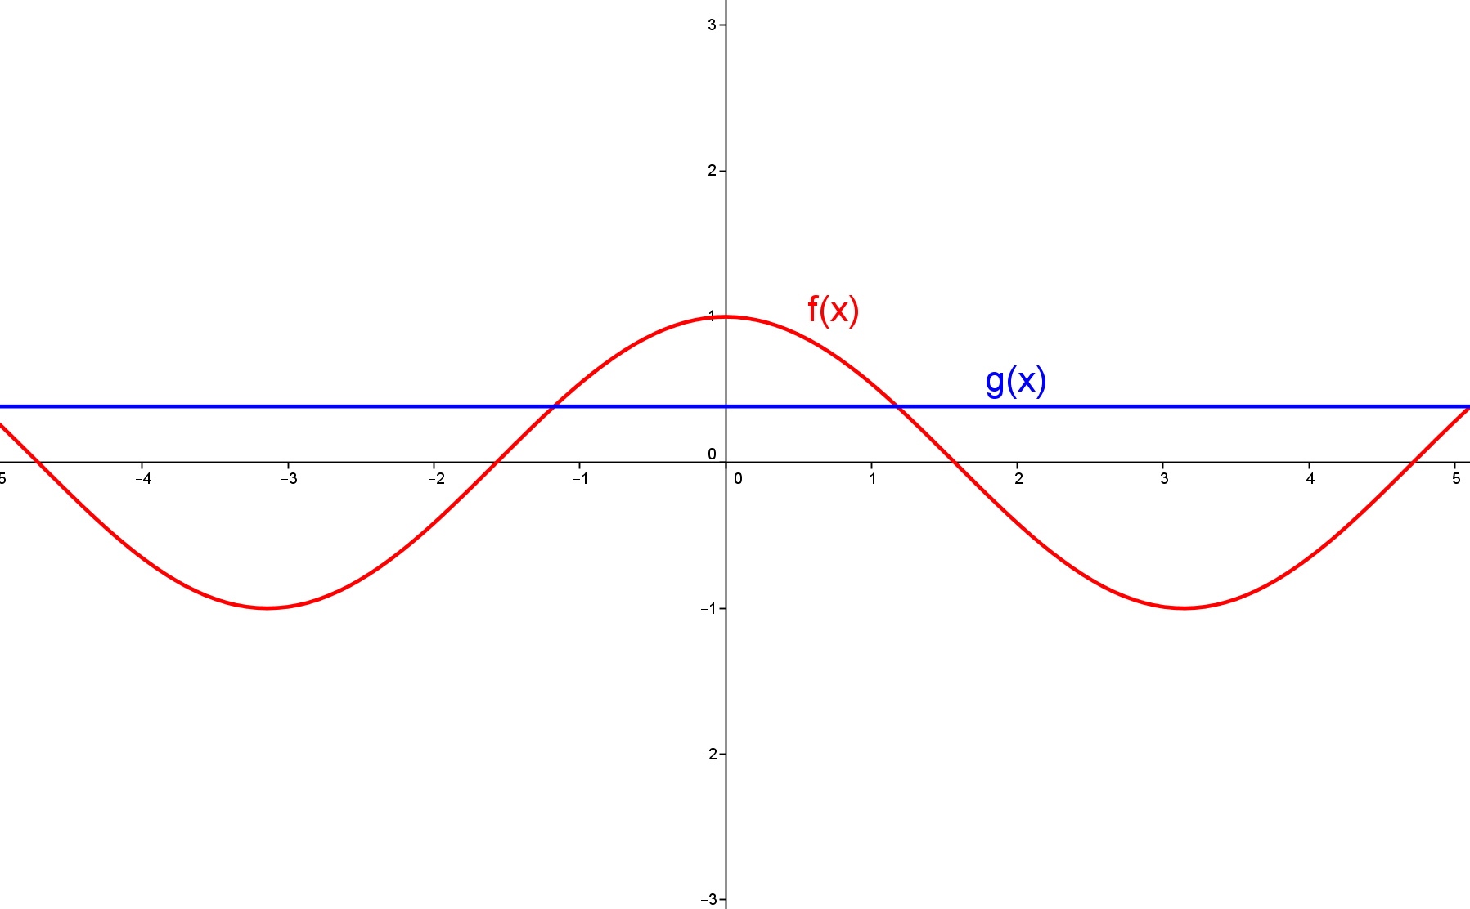

  - Because the two functions are not equivalent wherever they are defined, the equation is not an identity.
Lesson Summary
The Pythagorean identity: $\sin^{2}\left(θ\right)+\cos^{2}\left(θ\right)=1$ for all real numbers $θ$.

Exit Ticket (5 minutes)
Name Date
Lesson 15: What Is a Trigonometric Identity

Exit Ticket

April claims that $1{+ \frac{\cos^{2}\left(θ\right)}{\sin^{2}\left(θ\right)}}=\frac{1}{\sin^{2}\left(θ\right)}$ is an identity for all real numbers $θ$ that follows from the Pythagorean identity.
  - For which values of $θ$ are the two functions $f\left(θ\right)=1{+ \frac{\cos^{2}\left(θ\right)}{\sin^{2}\left(θ\right)}}$ and $g\left(θ\right)=\frac{1}{\sin^{2}\left(θ\right)}$ defined?

  - Show that $1{+ \frac{\cos^{2}\left(θ\right)}{\sin^{2}\left(θ\right)}}=\frac{1}{\sin^{2}\left(θ\right)}$ follows from the Pythagorean identity.

  - Is April correct? Explain why or why not.

  - Write the equation $1{+ \frac{\cos^{2}\left(θ\right)}{\sin^{2}\left(θ\right)}}=\frac{1}{\sin^{2}\left(θ\right)}$ in terms of other trigonometric functions.

Exit Ticket Sample Solutions

April claims that $1{+ \frac{\cos^{2}\left(θ\right)}{\sin^{2}\left(θ\right)}}=\frac{1}{\sin^{2}\left(θ\right)}$ is an identity for all real numbers $θ$ that follows from the Pythagorean identity.
  - For which values of $θ$ are the two functions $f\left(θ\right)=1{+ \frac{\cos^{2}\left(θ\right)}{\sin^{2}\left(θ\right)}}$ and $g\left(θ\right)=\frac{1}{\sin^{2}\left(θ\right)}$ defined?
Both functions contain $sin(θ)$ in the denominator, so they are undefined if $sin\left(θ\right)=0$. Thus, the two functions $f$ and $g$ are defined when $θ≠kπ$, for all integers $k$.

  - Show that the equation $1{+ \frac{\cos^{2}\left(θ\right)}{\sin^{2}\left(θ\right)}}=\frac{1}{\sin^{2}\left(θ\right)}$ follows from the Pythagorean identity.
By the Pythagorean identity, $sin^{2}\left(θ\right)+cos^{2}\left(θ\right)=1.$
If $sin\left(θ\right)≠0$, then, $$\frac{sin^{2}\left(θ\right)}{sin^{2}\left(θ\right)}+\frac{cos^{2}\left(θ\right)}{sin^{2}\left(θ\right)}=\frac{1}{sin^{2}\left(θ\right)} \\ 1+\frac{cos^{2}\left(θ\right)}{sin^{2}\left(θ\right)}=\frac{1}{sin^{2}\left(θ\right).}$$

  - Is April correct? Explain why or why not.
No. While April’s equation does follow from the Pythagorean identity, it is not valid for all real numbers $θ$. For example, if $θ=π$, then both sides of the equation are undefined. In order to divide by $sin^{2}(θ)$, we need to be sure that we are not dividing by zero.

  - Write the equation $1{+ \frac{\cos^{2}\left(θ\right)}{\sin^{2}\left(θ\right)}}=\frac{1}{\sin^{2}\left(θ\right)}$ in terms of other trigonometric functions, and state the resulting identity.
Because $cot\left(θ\right)=\frac{cos\left(θ\right)}{sin\left(θ\right)}$ and $csc\left(θ\right)=\frac{1}{sin\left(θ\right)}$, we can rewrite the equation as
$$1{+ \frac{\cos^{2}\left(θ\right)}{\sin^{2}\left(θ\right)}}=\frac{1}{\sin^{2}\left(θ\right)} \\ 1+{\left(\frac{cos\left(θ\right)}{sin\left(θ\right)}\right)}^{2}={\left(\frac{1}{sin\left(θ\right)}\right)}^{2} \\ 1+cot^{2}\left(θ\right)=csc^{2}\left(θ\right).$$
Thus, $1+cot^{2}\left(θ\right)=csc^{2}\left(θ\right)$, where $θ≠kπ$, for all integers $k$.

Problem Set Sample Solutions
Problems are intended to give students practice in distinguishing trigonometric identities from other trigonometric equations, in distinguishing identities defined for all real numbers from those that are defined on a subset of the real numbers, and in using the Pythagorean identity and given information to find values of trigonometric functions.

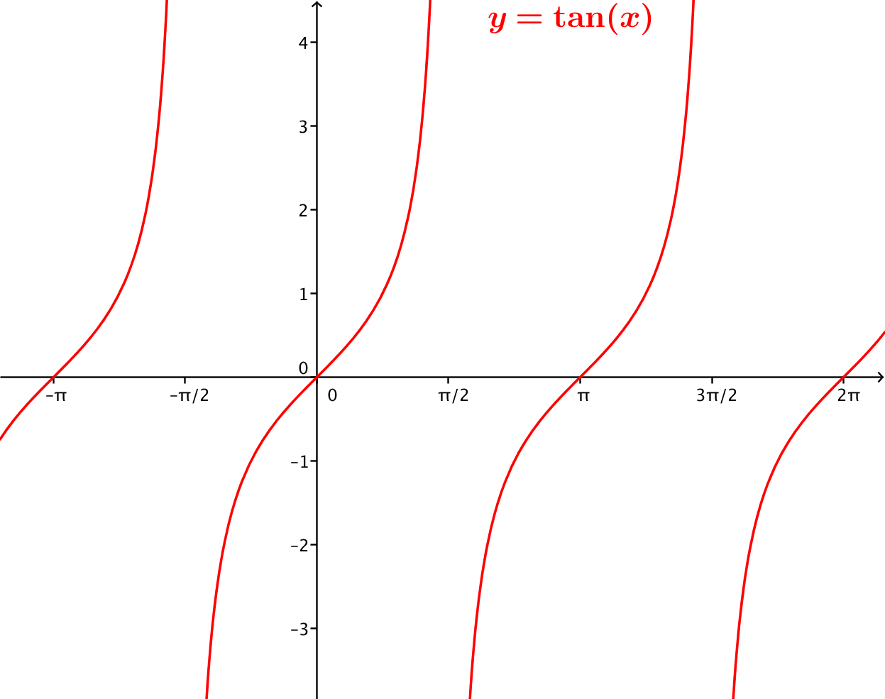
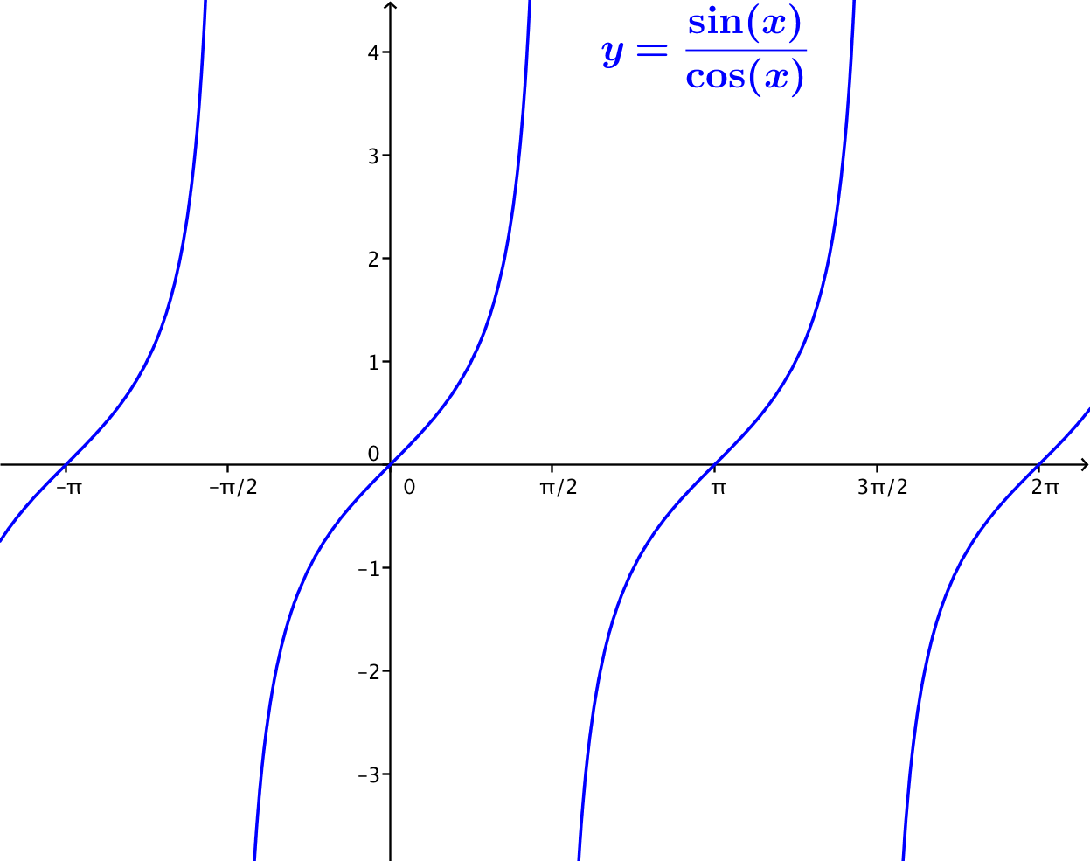
- Which of the following are trigonometric identities? Graph the functions on each side of the equation.
  - $\tan\left(x\right)=\frac{\sin\left(x\right)}{\cos\left(x\right)}$ where the functions on both sides are defined.
This is an identity that is defined for $x≠\frac{π}{2}+kπ$, for all integers $k$. See the identical graphs below.

  - $\cos^{2}\left(x\right)=1+\sin\left(x\right)$ where the functions on both sides are defined.
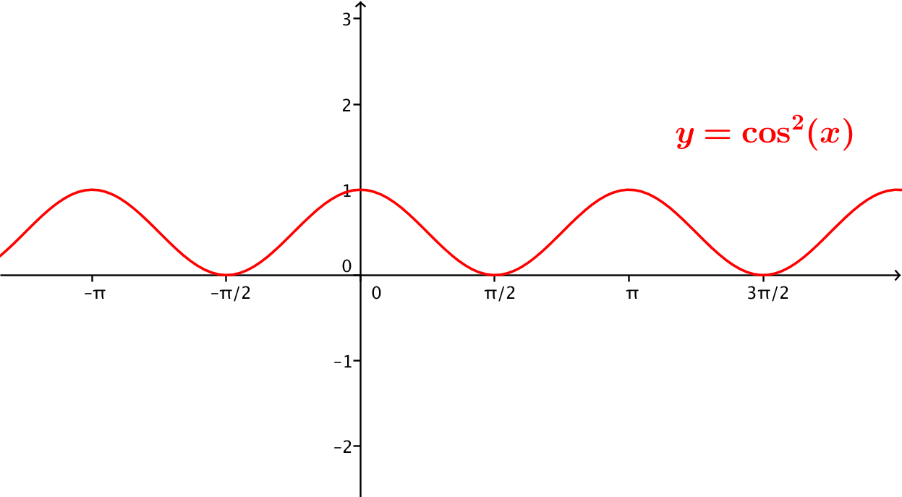
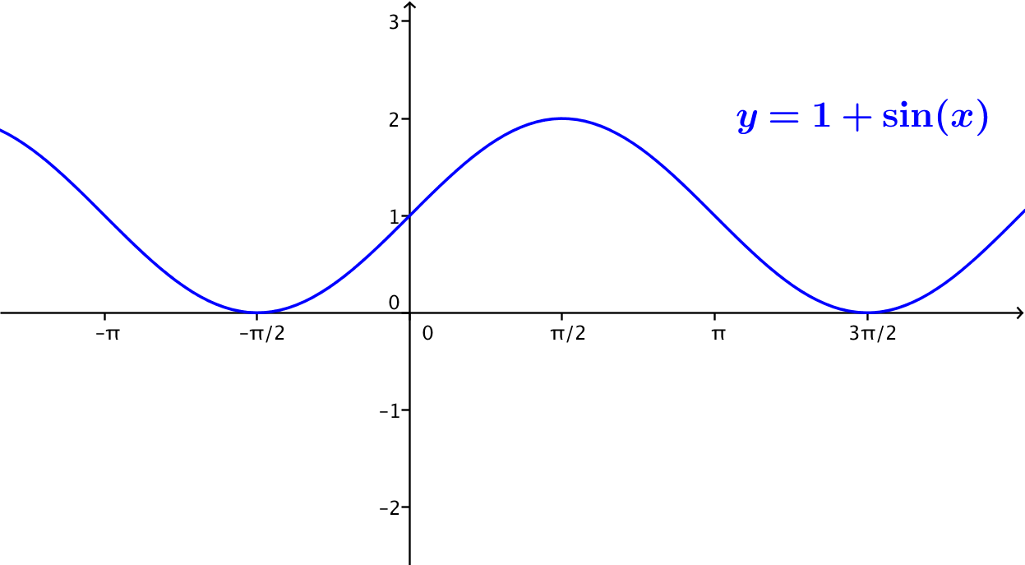
This is not an identity. For example, when $x=0$, the left side of the equation is $1$, and the right side is also $1$. But when $x=\frac{π}{2}$, the left side is $0$, and the right side is $2$. The graphs below are clearly different.

  - $\cos\left(\frac{π}{2}-x\right){=\sin\left(x\right)}$ where the functions on both sides are defined.
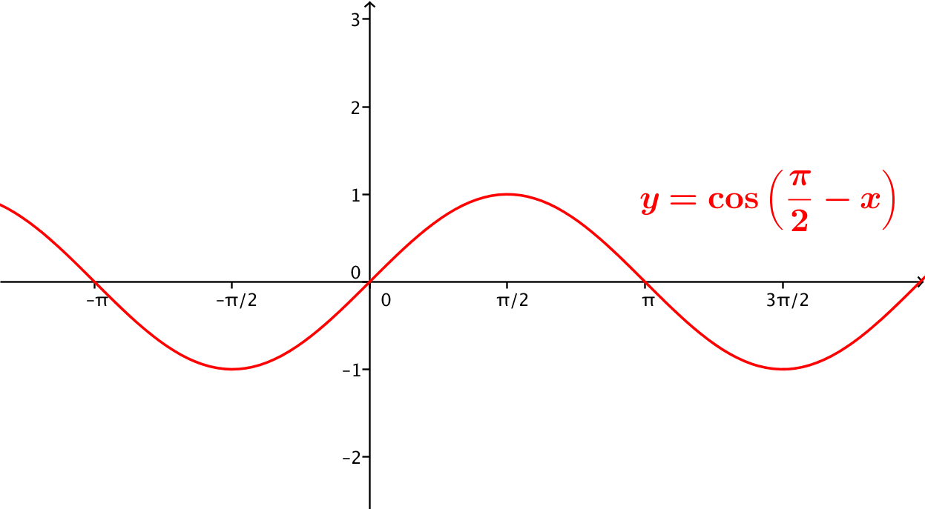
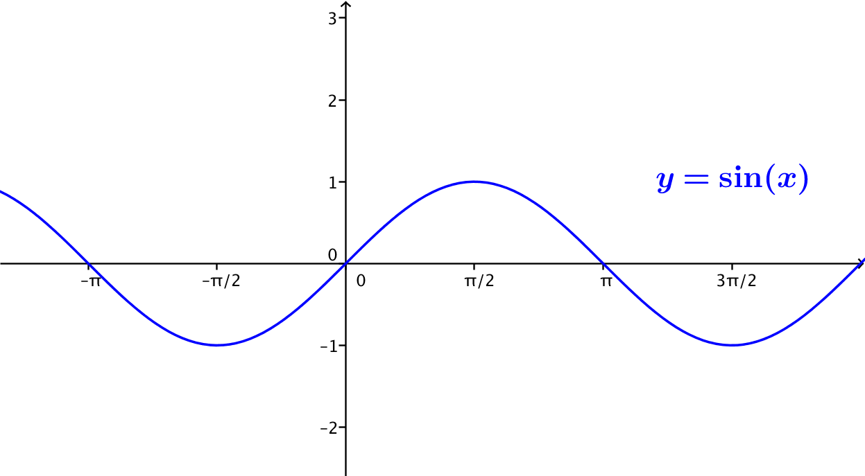
This is an identity that is defined for all real numbers $x$. See the identical graphs below.
- Determine the domain of the following trigonometric identities:
  - $\cot\left(x\right)=\frac{\cos\left(x\right)}{\sin\left(x\right)}$ where the functions on both sides are defined.
This identity is defined only for $x≠kπ$, for all integers $k$.

  - $\cos\left(-u\right)=cos \left(u\right)$ where the functions on both sides are defined.
This identity is defined for all real numbers $u$.

  - $\sec\left(y\right)=\frac{1}{\cos\left(y\right)}$ where the functions on both sides are defined.
This identity is defined for $y≠\frac{π}{2}+kπ$, for all integers $k$.

- Rewrite$sin(x)\cos^{2}(x)-sin(x)$ as an expression containing a single term.
$$sin\left(x\right)-sin\left(x\right)\cos^{2}\left(x\right)=sin\left(x\right)\left({1-cos}^{2}\left(x\right)\right) \\ =sin\left(x\right)\sin^{2}\left(x\right) \\ =\sin^{3}\left(x\right)$$

- Suppose $0<θ<\frac{π}{2}$, and $\sin{(θ)=\frac{1}{\sqrt{3}}}$. What is the value of $\cos{(θ)}$?
$$\cos{(θ)}=\frac{\sqrt{6}}{3}$$

- If $\cos{(θ)= -\frac{1}{\sqrt{5}}}$, what are possible values of $\sin{(θ)}$?
$\sin{(θ)}=\frac{2}{\sqrt{5}}$, or $\sin{(θ)}=-\frac{2}{\sqrt{5}}$

- Use the Pythagorean identity $\sin^{2}\left(θ\right)+ \cos^{2}\left(θ\right)=1$, where $θ$ is any real number, to find the following:
  - $\cos\left(θ\right)$, given $sin\left(θ\right)=\frac{5}{13},$for $\frac{π}{2}<θ<π$.
From the Pythagorean identity, $\cos^{2}\left(θ\right)=1- {\left(\frac{5}{13}\right)}^{2}.$ So, $\cos^{2}\left(θ\right)= 1-\frac{25}{169}=\frac{144}{169},$ and $cos \left(θ\right)=\frac{12}{13}$, or $cos \left(θ\right)=-\frac{12}{13}$. In the second quadrant, $cos\left(θ\right)$ is negative, so $\cos\left(θ\right)=-\frac{12}{13}.$

  - $\tan\left(x\right),$ given $cos\left(x\right)=-\frac{1}{\sqrt{2}},$for $π <x<\frac{3π}{2}$.
From the Pythagorean identity, $\sin^{2}\left(x\right)=1- {\left(\frac{1}{\sqrt{2}}\right)}^{2}$. So, $\sin^{2}\left(x\right)= \frac{1}{2}$, and $\sin\left(x\right)=\frac{1}{\sqrt{2}}$, or $\sin\left(x\right)=-\frac{1}{\sqrt{2}}$. Because $\sin\left(x\right)$ is negative in the third quadrant, $\tan\left(x\right)=\frac{-\frac{1}{\sqrt{2}}}{-\frac{1}{\sqrt{2}}}=1$.

- The three identities below are all called Pythagorean identities. The second and third follow from the first, as you saw in Example 1 and the Exit Ticket.
- For which values of $θ$ are each of these identities defined?
    - $\sin^{2}\left(θ\right)+ \cos^{2}\left(θ\right)=1$, where the functions on both sides are defined.
Defined for any real number $θ$.

    - $\tan^{2}\left(θ\right)+1=\sec^{2}\left(θ\right)$, where the functions on both sides are defined.
Defined for real numbers $θ$ such that $θ≠\frac{π}{2}+kπ$, for all integers $k$.

    - $1+{ \cot^{2}\left(θ\right)}=\csc^{2}\left(θ\right)$, where the functions on both sides are defined.
Defined for real numbers $θ$ such that $θ≠kπ$, for all integers $k$.

  - For which of the three identities is $0$ in the domain of validity?
Identities 1 and 2

  - For which of the three identities is $\frac{π}{2}$ in the domain of validity?
Identities 1 and 3

  - For which of the three identities is $-\frac{π}{4}$ in the domain of validity?
Identities 1, 2, and 3

