Lesson 15: The Distance from a Point to a Line

Student Outcomes
- Students are able to derive a distance formula and apply it.

Lesson Notes
In this lesson, students review the distance formula, the criteria for perpendicularity, and the creation of the equation of a perpendicular line. Students reinforce their understanding that when they are asked to find the distance between a line $l$ and a point $P$ not on line $l$, they are looking for the shortest distance. This distance is equal to the length of the segment that is perpendicular to $l$ with one endpoint on line $l$ and the other endpoint $P$. Students derive the general formula for the distance $d$ of a point $P(p,q)$ from a line $y=mx+b$ through a teacher-led exercise, and then practice using the formula.

Classwork
Opening Exercise (5 minutes)
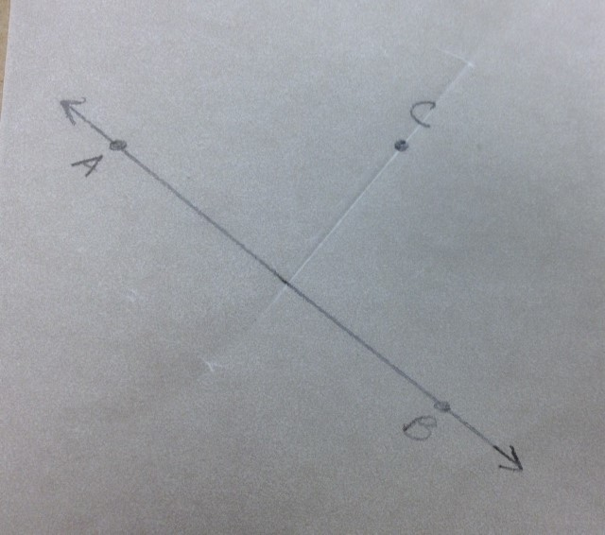
This Opening Exercise has students construct a line that is perpendicular to a given line passing through a point not on the given line. This will lead them to the understanding that the shortest distance from point to a line that does not contain that point is the perpendicular distance. Any other segment from the point to the line would create a right triangle. This new segment would be the hypotenuse of that right triangle and, therefore, would be longer than the segment that is perpendicular to the line.
Students draw a line on a piece of patty paper and a point not on that line. Ask the students to create the shortest segment from the point to the line by folding the patty paper.
Students should fold the patty paper so that the line folds back onto itself and the crease passes through the point not on the line.
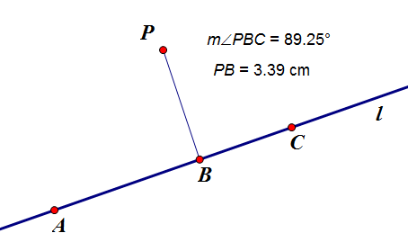
A similar exercise can be done using geometry software where the students construct a line $l$ and a point $P$ not on line $l$. Then construct a segment with one endpoint on line $l$ and the other endpoint at $P$. The students measure the angle formed by the segment and the line and the corresponding length of the segment. The students should recognize that the segment is the shortest when the angle is a right angle.

Discussion (2 minutes)
- How do you know the segment you created is the shortest segment from the point to the line?
  - This segment is perpendicular to the line, so it must be the shortest. Any other segment from the point to the line would create a right triangle. This new segment would be the hypotenuse of that right triangle and, therefore, would be longer than the segment that is perpendicular to the line.
- How can we determine the distance point$C$ is from line $AB$?
  - We could measure the length of the perpendicular segment that we created that has one endpoint on line $AB$ and the other at point $P$.

Exercise 1 (8 minutes)
Scaffolding:
- For struggling learners the question can be changed to ask, “Where on this line will the robot be closest to the beacon?” Show a picture of the line and the beacon, and ask students to estimate their answer.
- For advanced learners the coordinates of the homing beacon can be changed to $(40, 50)$.
Exercise 1
A robot is moving along the line $20x+30y=600$. A homing beacon sits at the point $(35, 40)$.
  - Where on this line will the robot hear the loudest ping?
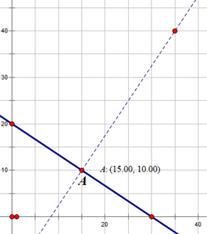
Students will need to determine the equation of the line passing through the point
$(35, 40)$that is perpendicular to the line$20x+30y=600$. The slope of this line is$-\frac{2}{3}$.
$$y-40=\frac{3}{2}\left(x-35\right) \text{or} y=\frac{3}{2}\left(x-35\right)+40$$
There are a variety of methods available to students to use to determine the point where these two lines intersect. Using substitution is one of the more efficient methods.
$$20x+30\left(\frac{3}{2}\left(x-35\right)+40\right)=600 \\ 20x+45x-1575+1200=600 \\ 65x=975 \\ x=15$$
$$y=\frac{3}{2}\left(15-35\right)+40 \\ y=10$$
The robot will be closest to the beacon when it is on the point $\left(15, 10\right)$.

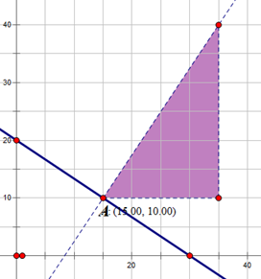
  - At this point, how far will the robot be from the beacon?
Students need to calculate the distance between the two points
$B\left(35,40\right)$ and $A\left(15, 10\right)$. Encourage students to think about the right triangle that is created if one moves from$A$ to $B$ in two moves: one horizontal and the other vertical.
$$AB=\sqrt{{\left(35-15\right)}^{2}+{\left(40-10\right)}^{2}}$$
$$AB=\sqrt{{\left(20\right)}^{2}+{\left(30\right)}^{2}}$$
$$AB=\sqrt{1300}=10\sqrt{13}$$
Example 1 (12 minutes)
Scaffolding:
- For advanced learners, assign this as a partner or small group exercise instead of a teacher led example.
In this example students develop a formula for the distance $d$ that a point $P(p,q)$ is from the line $l$ given by the equation $y=mx+b$. That is, we only know the point $P$ and the line $l$, we do not know where to drop the perpendicular from $P$ to $l$ algebraically.
We can do this with a construction, but then we would not know the coordinates of the intersection point $R$.
Since $R$ is some point on the line $l$, let’s call it $R(r,s)$; it is our goal to first find the values of $r$ and $s$ in terms of $p$, $q$, $m$, and $b$. To accomplish this we note that $\overline{PR}⊥l$ allows us to use the formula from Lesson 5 (and Lesson 8). To use this formula, we will need a segment on line $l$. In this example, we chose to use $T\left(r+1, m\left(r+1\right)+b\right)$. By strategically choosing point $R\left(r, mr+b\right)$and$T(r+1,m\left(r+1\right)+b)$ when we apply the formula from Lesson 5, the second set of differences reduces nicely. Recall that we developed this formula by translating the figure so that the image of the vertex of the right angle, in this example, it would be $R'$, was at the origin. When we do this, the coordinates of the image of the other endpoint of the segment, $T'$ in this example, will have coordinates $\left(1,m\right).$

Proof:
Let $l$ be a line given by the graph of the equation $y=mx+b$ (for some real numbers $m$ and$b$) and let $P(p,q)$ be a point not on line $l$. To find point$R(r,s)$ in terms of $p$, $q$, $m$, and $b$ such that $\overset{⃡}{RP}⊥l$ , consider points $R\left(r, mr+b\right)$ and $T\left(r+1, m\left(r+1\right)+b\right)$ on the line $l$.
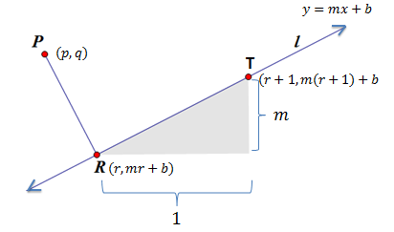
- How do we know that the points $R\left(r, mr+b\right)$ and $T\left(r+1, m\left(r+1\right)+b\right)$ lie on line $l$?
  - We know both points lie on line $l$ because their coordinates are of the form $\left(x,mx+b\right).$
Direct students to construct a diagram depicting the relationships described above or provide the diagram show to the right.
- If $PR$ represents the distance from $P$ to line $l$, what do we know about the relationship between $\overline{PR}$ and line $l$?
  - $\overline{PR}$ must be perpendicular line $l$.
- What kind of triangle is $△PTR$?
  - $△PTR$ is a right triangle with the right angle at vertex $R$. Which means $\overline{PR}⊥\overline{RT}$.
- This means $\overline{PR}⊥\overline{RT}$
$↔\left(p-r\right)\left(1\right)+\left(q-\left(mr+b\right)\right)\left(m\right)=0$
Scaffolding:
- For struggling learners, review Lesson 5, Example 2.
$$↔p-r+qm-m^{2}r-bm=0$$
$$↔-r-m^{2}r=-p-qm+bm$$
$$↔r\left(1+m^{2}\right)=p+qm-bm$$
$$↔r=\frac{p+qm-bm}{1+m^{2}}$$
- This gives us the coordinates for points $R$ and $P$ in terms of $p$, $q$, $m$, and $b.$
  - $R\left(\frac{p+qm-bm}{1+m^{2}},m\left(\frac{p+qm-bm}{1+m^{2}}\right)+b\right)$ and $P\left(p,q\right)$

- We can now find the distance $d$ between points $P$ and $R$ using the distance formula.
$$d=\sqrt{{\left(x_{2}-x_{1}\right)}^{2}+{\left(y_{2}-y_{1}\right)}^{2}} \\ d=\sqrt{{\left(\frac{p+qm-bm}{1+m^{2}}-p\right)}^{2}+{\left(m\left(\frac{p+qm-bm}{1+m^{2}}\right)+b-q\right)}^{2}}$$

Understanding this formula addresses standard A-SSE.A.1b (interpret complicated expressions by viewing one or more of their parts as a single entity).
- What are the coordinates of point $P$ in terms of $p, q, m,$and $b$?
  - $\left(p,q\right)$
- What are the coordinates of point $R$ in terms of $p, q, m,$and $b$?
  - $\left(\frac{p+qm-bm}{1+m^{2}},m\left(\frac{p+qm-bm}{1+m^{2}}\right)+b\right)$
- Which point represents $(x_{1},y_{1})$ in the distance formula?
  - Point $P$
- Which point represents $(x_{2},y_{2})$ in the distance formula?
  - Point $R$
- Does this formula allow us to calculate the distance between the point $P$ and the line $l$ knowing only coordinates of the point $P(p,q)$ and the equation of the line $y=mx+b$?
MP.7
  - Yes.
- This formula is quite cumbersome. Do you feel it is realistic to expect us to memorize this formula and use it “by hand” on a regular basis?
  - No.
- How might this formula be best used?
  - We could create a calculator or computer program that asks us to input the values of $p$, $q$, $m$, and $b$ and will return the corresponding distance.
- Are there limitations to this formula?
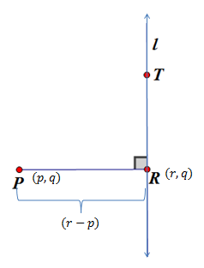
  - The formula depends on a real number value for $m$; therefore, the line $l$ cannot be vertical.
- How could we calculate the distance from $P$ to the line $l$ if $l$ were vertical?
  - We would only need to look at the differences in the $x$-coordinates between points $P$and$R.$

Exercise 2 (10 minutes)
Students apply the formula for distance found in the previous example to a variety of problems. Students can solve several of these problems using alternate methods to check that the formula does in fact work.
Exercise 2
For the following problems, use the formula to calculate the distance between the point $P$ and the line $l$.
$$d=\sqrt{{\left(\frac{p+qm-bm}{1+m^{2}}-p\right)}^{2}+{\left(m\left(\frac{p+qm-bm}{1+m^{2}}\right)+b-q\right)}^{2}}$$
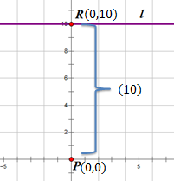
  - $P(0,0)$ and the line $y=10$
$p=0$, $q=0$,$m=0$, and$b=10$
$$d=\sqrt{{\left(\frac{0+0-10(0)}{1+0^{2}}-0\right)}^{2}+{\left(0\left(\frac{0+0-10(0)}{1+0^{2}}\right)+10-0\right)}^{2}}$$
$$d=\sqrt{0+{\left(10\right)}^{2}}$$
$$d=10$$

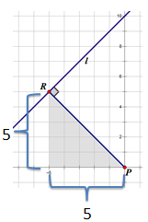
  - $P(0,0)$ and the line $y=x+10$
$p=0$,$q=0$,$m=1$, and$b=10$
$$d=\sqrt{{\left(\frac{0+0(1)-10(1)}{1+1^{2}}-0\right)}^{2}+{\left(1\left(\frac{0+0(1)-10(1)}{1+1^{2}}\right)+10-0\right)}^{2}}$$
$$d=\sqrt{{\left(\frac{10}{2}\right)}^{2}+{\left(\frac{-10}{2}+10\right)}^{2}}$$
$$d=\sqrt{{\left(\frac{10}{2}\right)}^{2}+{\left(\frac{10}{2}\right)}^{2}}$$
$$d=\sqrt{5^{2}+5^{2}}$$
$$d=\sqrt{2\left(5^{2}\right)}$$
$$d=5\sqrt{2}$$

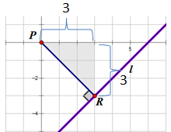
  - $P(0,0)$ and the line $y=x-6$
$p=0$,$q=0$, $m=1$, and$b=-6$
$$d=\sqrt{{\left(\frac{0+0(1)-(-6)(1)}{1+1^{2}}-0\right)}^{2}+{\left(1\left(\frac{0+0(1)-(-6)(1)}{1+1^{2}}\right)+(-6)-0\right)}^{2}} \\ d=\sqrt{{\left(\frac{6}{2}\right)}^{2}+{\left(\left(\frac{6}{2}\right)+\left(-6\right)\right)}^{2}} \\ d=\sqrt{3^{2}+3^{2}} \\ d=\sqrt{2\left(3^{2}\right)} \\ d=3\sqrt{2}$$

Note: Students can also use the isosceles right triangle ($45°$–$45°$–$90°$) that has a hypotenuse of $\overline{PR}$ to calculate the distance from $P$ to $l$ to confirm the results obtained using the formula in parts (b) and (c).

Closing (3 minutes)
Ask students to respond to these questions individually in writing, with a partner, or as a class.
- Before today’s lesson how did you determine the distance from a line to a point not on the line?
  - We had to find the point of intersection of the given line and the line perpendicular to the given line through the point not on the line. Then we used the formula $d=\sqrt{{\left(x_{2}-x_{1}\right)}^{2}+{\left(y_{2}-y_{1}\right)}^{2}}$ to find the distance between the two points.
- What advantage does our newly discovered formula $d=\sqrt{{\left(\frac{p+qm-bm}{1+m^{2}}-p\right)}^{2}+{\left(m\left(\frac{p+qm-bm}{1+m^{2}}\right)+b-p\right)}^{2}}$offer?
  - Now we do not need to find the other endpoint of the shortest segment from the given line to the point not on the line. If we know the equation of the given line and the coordinates of the point not on the line, we have enough information to calculate the distance from the point to the line. The formula is cumbersome to apply in the majority of cases; therefore, it would be most efficient to write a calculator or computer program that uses this formula to calculate distances for given values of $p$, $q$, $m$, and $b$
- In each of the exercises we were able to also calculate the distance using an isosceles right triangle. Will this method always apply, or are there certain conditions that make this possible?
  - The segment that represented the distance from the point $P$ to the line $l$ was the hypotenuse of an isosceles right triangle because the line had a slope of $1$ or $-1$.

Exit Ticket (5 minutes)

Name Date
Lesson 15: The Distance from a Point to a Line

Exit Ticket

- Find the distance between the point $P(0,0)$ and the line $y=-x+4$ using the formula from today’s lesson.

- Verify using another method.

Exit Ticket Sample Solutions

- Find the distance between the point $P(0,0)$ and the line $y=-x+4$ using the formula from today’s lesson.
$$d=\sqrt{{\left(\frac{p+qm-bm}{1+m^{2}}-p\right)}^{2}+{\left(m\left(\frac{p+qm-bm}{1+m^{2}}\right)+b-q\right)}^{2}}$$
$p=0$, $q=0$,$m-1$, and$b=4$
$$d=\sqrt{{\left(\frac{0+0(-1)-4(-1)}{1+{(-1)}^{2}}-0\right)}^{2}+{\left((-1)\left(\frac{0+0(-1)-4(-1)}{1+1^{2}}\right)+4-0\right)}^{2}}$$
$$d=\sqrt{{\left(\frac{4}{2}\right)}^{2}+{\left(\left(-1\right)\left(\frac{4}{2}\right)+4\right)}^{2}}$$
$$d=\sqrt{2^{2}+2^{2}}$$
$$d=\sqrt{2\left(2^{2}\right)}$$
$$d=2\sqrt{2}$$

- Verify using another method.
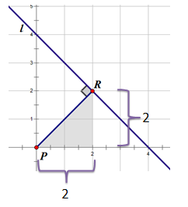

Note: Most students will also use the isosceles right triangle ($45°$–$45°$–$90°$) shown below that has a hypotenuse of $\overline{PR}$ to calculate the distance from $P$ to $l$ to confirm the results obtained using the formula.

Problem Set Sample Solutions

- Given $△ABC$ with vertices $A\left(3,-1\right)$, $B\left(2,2\right)$, and $C(5,1)$.
  - Find the slope of the angle bisector of $∠ABC$.
slope$=-1$

  - Prove that the bisector of $∠ABC$ is the perpendicular bisector of $\overline{AC}$.
Let $\overline{BD}$ be the bisector of $∠ABC$, where $D$ is the point of interection with $\overline{AC}$.
$AB=CB=\sqrt{10}$; therefore, $△ABC$ is isosceles, and $m∠A=m∠C$ (base angles of isosceles have equal measures).
$m∠ABD=m∠CBD$ by definition of angle bisector.
$△ABD≅△CBD$ by ASA.
$AD=CD$, since corresponding sides of congruent triangles have equal lengths; therefore, $\overline{BD}$bisects $\overline{AC}$.
The slope of $\overline{AD}$ is $-1$; therefore, $\overline{AD}⊥\overline{AC}$.
Therefore, $\overline{AD}$ is the perpendicular bisector of $\overline{AC}$.

  - Write the equation of the line containing $\overline{AD}$.
$$y=-x+4$$

- Use the distance formula from today’s lesson to find the distance between the point $P(-2,1)$ and the line $y=2x$.
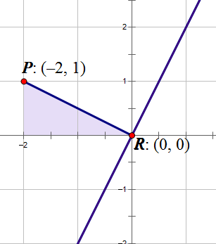
$p=-2$,$q=1$,$m=2$, and$b=0$
$$d=\sqrt{{\left(\frac{p+qm-bm}{1+m^{2}}-p\right)}^{2}+{\left(m\left(\frac{p+qm-bm}{1+m^{2}}\right)+b-q\right)}^{2}}$$
$$d=\sqrt{{\left(\frac{-2+1(2)-0(2)}{1+2^{2}}-(-2)\right)}^{2}+{\left(2\left(\frac{-2+1(2)-0(2)}{1+2^{2}}\right)+0+1\right)}^{2}}$$
$$d=\sqrt{{\left(\frac{0}{5}+2\right)}^{2}+{\left(2\left(\frac{0}{5}\right)+1\right)}^{2}}$$
$$d=\sqrt{{\left(2\right)}^{2}+{\left(1\right)}^{2}}$$
$d=\sqrt{5}$

- Confirm the results obtained in Problem 1 using another method.
$\overline{PR}$ is the hypotenuse of the right triangle with vertices $P(-2,1)$, $R(0,0)$, and $(-2,0)$. Using the Pythagorean theorem, we find that $=\sqrt{2^{2}+1^{2}}=\sqrt{5}$ .

- Find the perimeter of quadrilateral $DEBF$ shown below.
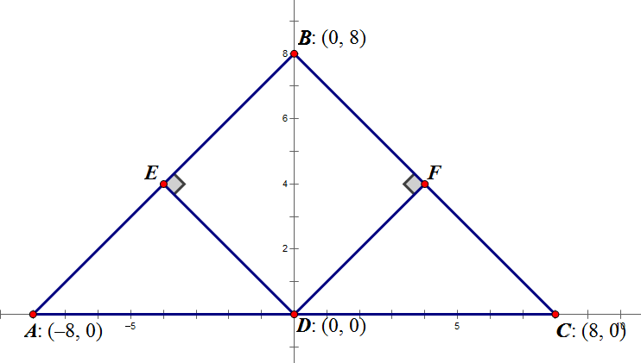
The equation of $\overset{⃡}{AB}$ is $y=x+8$ (students may also choose to use $\overset{⃡}{BC}$ which would make $m=-1$ instead of $1$).
$p=0$,$q=0$, $m=1$, and$b=8$
$$ED=\sqrt{{\left(\frac{p+qm-bm}{1+m^{2}}-p\right)}^{2}+{\left(m\left(\frac{p+qm-bm}{1+m^{2}}\right)+b-q\right)}^{2}}$$
$$ED=\sqrt{{\left(\frac{0+0(1)-8(1)}{1+1^{2}}-0\right)}^{2}+{\left(1\left(\frac{0+0(1)-8(1)}{1+1^{2}}\right)+8-0\right)}^{2}}$$
$$ED=\sqrt{{\left(\frac{-8}{2}\right)}^{2}+{\left(\left(\frac{-8}{2}\right)+8\right)}^{2}}$$
$$ED=\sqrt{{\left(\frac{-8}{2}\right)}^{2}+{\left(\left(\frac{-8}{2}\right)+8\right)}^{2}}$$
$$ED=\sqrt{4^{2}+4^{2}}$$
$$ED=4\sqrt{2}$$
$△AED$ is a right triangle with hypotenuse $\overline{AD}$ with length $8$ and leg $\overline{ED}$ with length $4\sqrt{2}$. This means that $△AED$ is an isosceles right triangle ($45°$–$45°$–$90°$), which means $AE=4\sqrt{2}$. We also know that $△AED≅△DEB≅△BFD≅ △DFC$ because they are all right triangles with hypotenuse of length $8$ and leg of length $4\sqrt{2}$. Therefore, the perimeter of $DEBF$ is $4\left(4\sqrt{2}\right)=16\sqrt{2}$.

