Lesson 13: Analytic Proofs of Theorems Previously Proved by Synthetic Means

Student Outcomes
- Using coordinates, students prove that the intersection of the medians of a triangle meet at a point that is two-thirds of the way along each median from the intersected vertex.
- Using coordinates, students prove the diagonals of a parallelogram bisect one another and meet at the intersection of the segments joining the midpoints of opposite sides.

Lesson Notes
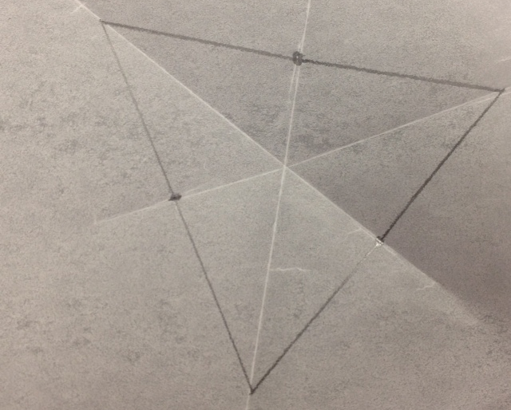
This lesson highlights MP.3 as students develop and justify conjectures. The lesson focuses on proofs and can be extended to a two day lesson if students need additional practice.
In the Opening Exercise, students do a paper folding activity to review the fact that the medians of any triangle intersect at one point. Next, students determine the coordinates of the point of concurrency of the medians of a given triangle. Students then prove that the medians of any triangle are concurrent and that the point of concurrency is located one third of the length of the median from the midpoint of the side of the triangle.

Classwork
Opening (5 minutes)
Have students draw triangles on patty paper then, focusing on one side of the triangle at a time, fold the patty paper so that the two endpoints of the segments coincide and make a small crease marking the midpoint of that segment. To save time, the triangles can be drawn on the patty paper ahead of time, but make sure to draw a variety of triangles: acute, obtuse, right, scalene, isosceles, and equilateral. Repeat the process for all three sides and then mark the midpoints with a pencil. Next, create a crease through the midpoint of one of the sides and the vertex opposite that side. Repeat this for all three sides of the triangle.
- What segments are contained on the creases that you constructed?
- What do you notice about these segments?
- Do you think this will be the case for all triangles? Are all of the triangles you constructed congruent? Did the creases intersect at one point on all of your triangles?
- Given two points $A(a_{1},a_{2})$ and $B(b_{1}, b_{2})$, what is the midpoint of $\overline{AB}$?

Opening Exercise (15 minutes)
In the previous lesson, students learned that given two points $A(a_{1}, a_{2})$ and $B\left(b_{1}, b_{2}\right),$ the midpoint of
$\overline{AB}$is$\left(\frac{1}{2}\left(a_{1}+b_{1}\right),\frac{1}{2}\left(a_{2}+b_{2}\right)\right)$. In this exercise, students extend their knowledge of the midpoint of a segment to find the point on each median of a given triangle that is one third of the distance from the side of the triangle to the opposite vertex. The students will discover that this point is the same for all three sides of the triangle hence demonstrating that not only are the medians of a triangle concurrent, they intersect at a point that divides each median into a ratio of $1:2$. This opening exercise may be split up in several ways; each group could be given one of each type of triangle and each work with a different vertex, or each group could be given one type of triangle and work with all vertices of that triangle. Regardless, bring the class together in the end to discuss findings.

Opening Exercise
Let $A(30,40), B(60,50)$, and $C(75, 120)$ be vertices of a triangle.
  - Find the coordinates of the midpoint $M$ of $\overline{AB}$ and the point $G_{1}$ that is the point one-third of the way along $\overline{MC}$, closer to $M$ than to $C$.
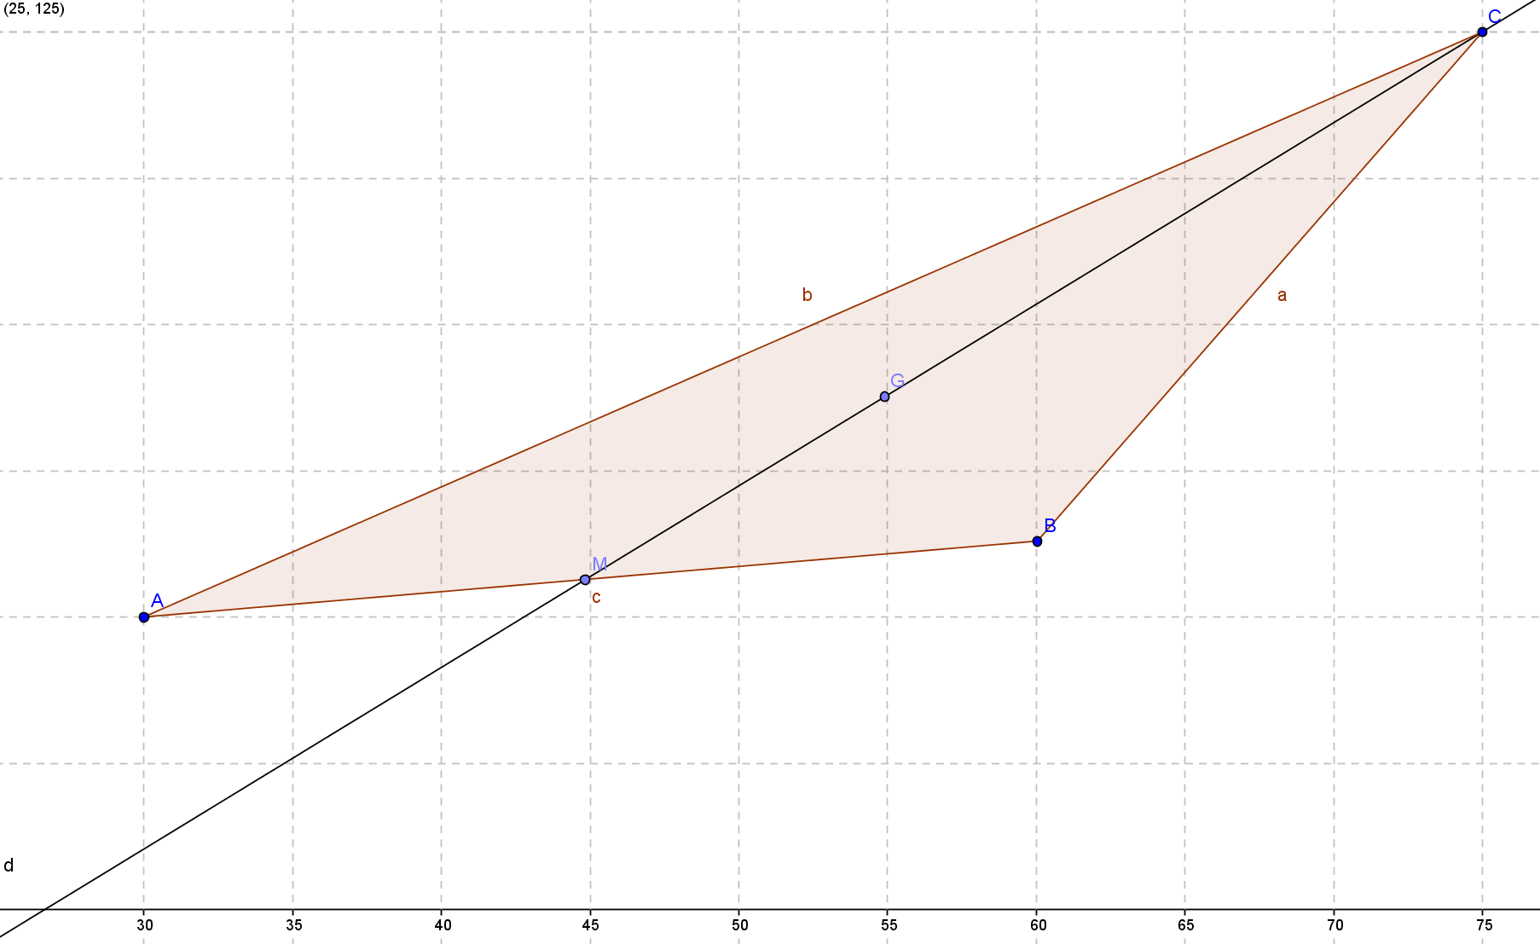
v = 60 - 30
v = 50 - 40
Midpoint is the midpoint of each component vector.

$$M=\left(30+\frac{1}{2}\left(60-30\right),40+\frac{1}{2}\left(50-40\right)\right)=\left(45,45\right) \text{or} M=\left(\frac{1}{2}\left(30+60\right),\frac{1}{2\left(40+50\right)}\right)= \left(45,45\right)$$
$$G_{1}: \left(45+\frac{1}{3}\left(75-45\right),45+\frac{1}{3}\left(120-45\right)\right)=\left(55,70\right) \text{or} \left(\frac{1}{3}\left(45+45+75\right),\frac{1}{3}\left(45+45+120\right)\right)=\left(55,70\right)$$

  - Find the coordinates of the midpoint $N$ of $\overline{BC}$ and the point $G_{2}$ that is the point one-third of the way along $\overline{NA}$, closer to $N$ than to $A$.
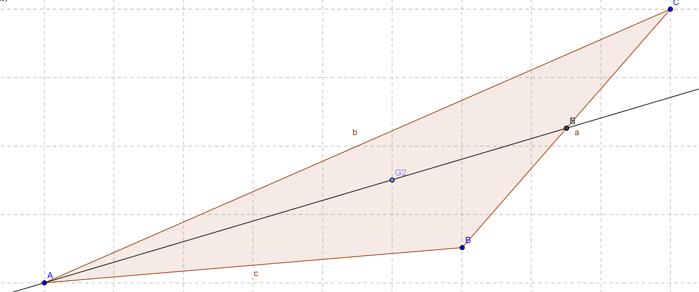

$$N=\left(60+\frac{1}{2}\left(75-60\right),50+\frac{1}{2}\left(120-50\right)\right)=\left(67.5,85\right) \text{or} N=\left(\frac{1}{2}\left(60+75\right),\frac{1}{2\left(50+120\right)}\right)= \left(67.5,85\right)$$
$$G_{2}: \left(67.5+\frac{1}{3}\left(30-67.5\right),85+\frac{1}{3}\left(40-85\right)\right)=\left(55,70\right) \text{or} \left(\frac{1}{3}\left(30+67.5+67.5\right),\frac{1}{3}\left(40+85+85\right)\right)=\left(55, 70\right)$$

  - Find the coordinates of the midpoint $R$ of $\overline{CA}$ and the point $G_{3}$ that is the point one-third of the way along $\overline{RB}$, closer to $R$ than to $B$.
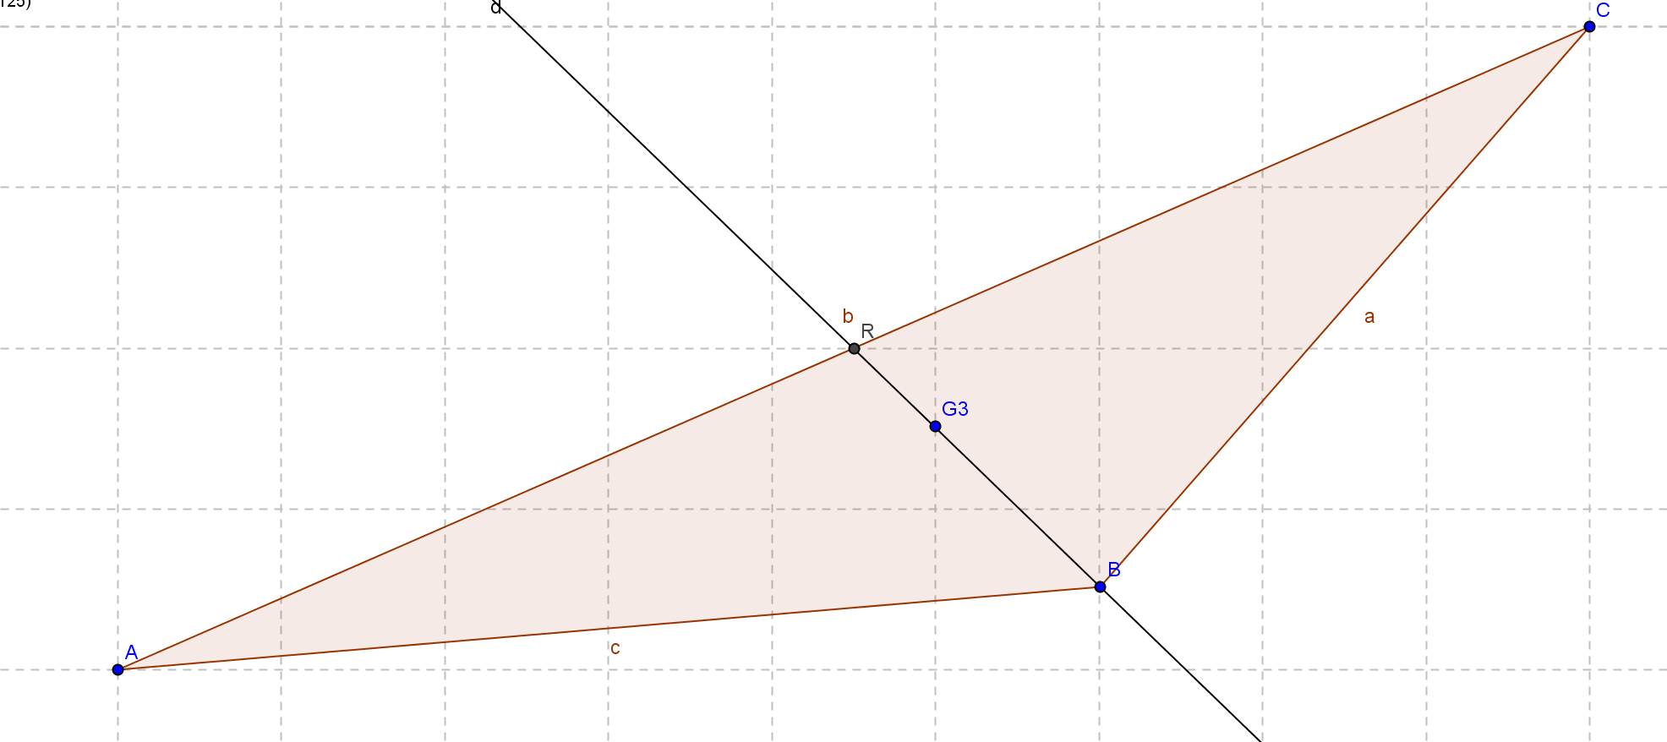

$$R=\left(30+\frac{1}{2}\left(75-30\right),40+\frac{1}{2}\left(120-40\right)\right)=\left(52.5,80\right) \text{or} R=\left(\frac{1}{2}\left(75+30\right),\frac{1}{2}(120+40)\right)=\left(52.5,80\right)$$
$$G_{3}: \left(52.5+\frac{1}{3}\left(60-52.5\right),80+\frac{1}{3}\left(50-80\right)\right)=\left(55,70\right) \text{or} \left(\frac{1}{3}\left(52.5+52.5+60\right),\frac{1}{3}(50+80+80)\right)=\left(55, 70\right)$$

Discussion (2 minutes)
- What are the coordinates of $G_{1}$,$G_{2}$, and $G_{3}$?
  - They all have the same coordinates.
- Are you surprised that all three points, $G_{1}$,$G_{2}$, and $G_{3}$, have the same coordinates?
  - Most students will have expected the three medians to intersect at one point, but they may not have known that this point is one-third of the length of each medial from each of the midpoints. Some students may have figured this out from the opening activity.
MP.3
- What is true about the point of concurrency for the three medians? How do you know?
  - They intersect one-third of the length of the median from the midpoint as proven in the above exercises.
- Do you think this is true for all triangles?
  - Most students will say yes because it was just shown on the last triangle. If students are not convinced, ask them to take out their patty paper from the Opening Exercise and measure the distances.

Exercise 1 (10 minutes)
Scaffolding:
This exercise can be broken down for students with varying levels of ability.
- Give students the steps of each example and have them explain the steps or fill in certain easier parts.
- Talk the group through the first example, and then have them try the other two on their own.
- Assign the exercise as written.
This exercise asks students to prove that the three medians of any triangle are concurrent. They will also discover that the coordinates of the point of concurrency of the medians, the centroid, can be easily calculated given the coordinates of the three vertices of the triangle.
Exercise 1
  - Given triangle $ABC$ with vertices $A\left(a_{1},a_{2}\right)$, $B\left(b_{1},b_{2}\right)$, and $C\left(c_{1},c_{2}\right)$, find the coordinates of the point of concurrency.
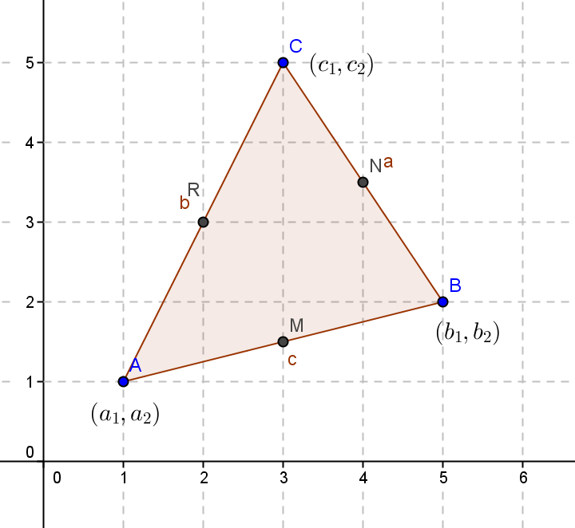

Midpoint of$\overline{AB}: M=\left(\frac{1}{2}\left(a_{1}+b_{1}\right),\frac{1}{2}\left(a_{2}+b_{2}\right)\right)$

One third of the length of$\overline{MC}$from$M:$
$$\left(\frac{1}{2}\left(a_{1}+b_{1}\right)+\frac{1}{3}\left(c_{1}-\frac{1}{2}\left(a_{1}+b_{1}\right)\right),\frac{1}{2}(a_{2}+b_{2})+\frac{1}{3}\left(c_{2}-\frac{1}{2}(a_{2}+b_{2})\right)\right)$$
$$\left(\frac{1}{2}a_{1}+\frac{1}{2}b_{1}+\frac{1}{3}c_{1}-\frac{1}{6}a_{1}-\frac{1}{6}b_{1},\frac{1}{2}a_{2}+\frac{1}{2}b_{2}+\frac{1}{3}c_{2}-\frac{1}{6}a_{2}+\frac{1}{6}b_{2}\right)$$
$$\left(\frac{1}{3}a_{1}+\frac{1}{3}b_{1}+\frac{1}{3}c_{1},\frac{1}{3}a_{2}+\frac{1}{3}b_{2}+\frac{1}{3}c_{2}\right)$$

Midpoint of$\overline{BC}: N=\left(\frac{1}{2}\left(b_{1}+c_{1}\right),\frac{1}{2}\left(b_{2}+c_{2}\right)\right)$
One third of the length of$\overline{NA}$from$N:$
$$\left(\frac{1}{2}\left(a_{1}+c_{1}\right)+\frac{1}{3}\left(b_{1}-\frac{1}{2}\left(a_{1}+c_{1}\right)\right),\frac{1}{2}\left(a_{2}+c_{2}\right)+\frac{1}{3}\left(b_{2}-\frac{1}{2}\left(a_{2}+c_{2}\right)\right)\right)$$
$$\left(\frac{1}{2} a_{1}+\frac{1}{2} c_{1}+\frac{1}{3} b_{1}-\frac{1}{6} a_{1}-\frac{1}{6} c_{1},\frac{1}{2}a_{2}+\frac{1}{2}c_{2}+\frac{1}{3}b_{2}-\frac{1}{6}a_{2}+\frac{1}{6}c_{2}\right)$$
$$\left(\frac{1}{3}a_{1}+\frac{1}{3}b_{1}+\frac{1}{3}c_{1},\frac{1}{3}a_{2}+\frac{1}{3}b_{2}+\frac{1}{3}c_{2}\right)$$

Midpoint of$\overline{AC}: R=\left(\frac{1}{2}\left(a_{1}+c_{1}\right),\frac{1}{2}\left(a_{2}+c_{2}\right)\right)$
One third of the length of $\overline{RA}$from$R:$
$$\left(\frac{1}{2}\left(a_{1}+c_{1}\right)+\frac{1}{3}\left(b_{1}-\frac{1}{2}\left(a_{1}+c_{1}\right)\right),\frac{1}{2}(a_{2}+c_{2})+\frac{1}{3}\left(b_{2}-\frac{1}{2}(a_{2}+c_{2})\right)\right)$$
$$\left(\frac{1}{2}a_{1}+\frac{1}{2} c_{1}+\frac{1}{3} b_{1}-\frac{1}{6} a_{1}-\frac{1}{6} c_{1}, \frac{1}{2} a_{2}+\frac{1}{2} c_{2}+\frac{1}{3} b_{2}-\frac{1}{6} a_{2}+\frac{1}{6} c_{2}\right)$$
$$\left(\frac{1}{3}a_{1}+\frac{1}{3} b_{1}+\frac{1}{3}c_{1}, \frac{1}{3}a_{2}+\frac{1}{3} b_{2}+\frac{1}{3} c_{2}\right)$$

After part (a), bring the group back together to discuss the formulas. Name the formula after the person who presents it most clearly— for example: We will call this “Tyler’s formula”.

  - Let $A(-23, 12)$, $B(13, 36)$, and $C(23, -1)$ be vertices of a triangle. Where will the medians of this triangle intersect? (Use “Tyler’s formula” from part (a) to complete this problem.)
$$\left(\frac{1}{3}\left(-23\right)+\frac{1}{3}\left(13\right)+\frac{1}{3}\left(23\right),\frac{1}{3}\left(12\right)+\frac{1}{3}\left(36\right)+\frac{1}{3}\left(-1\right)\right)\text{ or }\left(\frac{1}{3}\left(-23+13+23\right),\frac{1}{3}\left(12+36+-1\right)\right)=\left(\frac{13}{3},\frac{47}{3}\right)$$

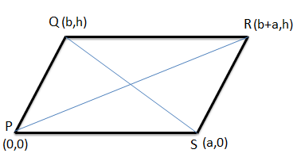
Exercise 2 (6 minutes)
Scaffolding:
You may want to provide students with the following diagram.
In this exercise, students are asked to use this coordinate approach to prove that the diagonals of a rectangle bisect each other.
Exercise 2
Prove that the diagonal of a parallelogram bisect each other.
Students will show that the diagonals are concurrent at their midpoints. Stated another way, both diagonals have the same midpoint.
Midpoint of$\overline{PQ}$: $\left(\frac{1}{2}\left(b+a\right),\frac{1}{2}h\right)$
Midpoint of $\overline{QS}$:$\left(\frac{1}{2}\left(b+a\right),\frac{1}{2}h\right)$

Closing (3 minutes)
Ask students to respond to this question individually in writing, to a partner, or as a class.
- How did we use coordinates to prove that the medians of any triangle will always meet at a point that is two-thirds of the way along each median from the intersected vertex?
  - We found the point of intersection of the three medians, and then we found the point on each median two-thirds of the way from each vertex and noticed that they were all the same. This was true for any triangle we studied.

Exit Ticket (4 minutes)

Name Date
Lesson 13: Analytic Proofs of Theorems Previously Proved by Synthetic Means

Exit Ticket

Prove that the medians of any right triangle form similar right triangles whose area is $\frac{1}{4}$ the area of the original triangle. Prove the area of $△CMR$ is $\frac{1}{4}$ the area of$△CAB$.
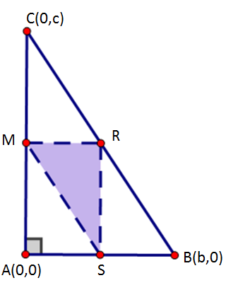

Exit Ticket Sample Solutions

Prove that the medians of any right triangle form a similar right triangles whose area is $\frac{1}{4}$ the area of the original triangle. Prove the area of $△CMR$ is $\frac{1}{4}$ the area of $△CAB$.
Place the triangle on the coordinate plans as shown to the right will allow for the most efficient algebraic solution yielding midpoints
$M=\left(0,\frac{1}{2}c\right)$, $R=\left(\frac{1}{2}b,\frac{1}{2}c\right)$, and$S=\left(\frac{1}{2}b,0\right)$.
$$\frac{RM}{AB}=\frac{\frac{1}{2}b}{b}=\frac{1}{2}$$ $$\frac{RS}{AC}=\frac{\frac{1}{2}c}{c}=\frac{1}{2}$$
$\overline{AC }$ and $\overline{RS}$ are both vertical as their slopes are undefined.
$\overline{AB }$ and $\overline{RM}$ are both horizontal as their slopes are zero.
$△ABC≅ △RMS$ by SAS similarity.
The area of $△ABC=\frac{1}{2}b∙c$.
The area of $△RMS=\frac{1}{2}\left(\frac{1}{2} b\right)∙\left(\frac{1}{2}c\right)=\frac{1}{4}\left(\frac{1}{2} b∙c\right)=\frac{1}{8}△ABC$.

Problem Set Sample Solutions

- Point $M$ is the midpoint of segment $\overline{AC}$. Find the coordinates of $M$:
  - $A(2, 3), C(6, 10)$
$$(4, 6.5)$$

  - $A(-7, 5), C(4, -9)$
$$(-1.5, -2)$$

- $M(-2, 10)$ is the midpoint of segment $\overline{AB}$. If A has coordinates $(4, -5)$, what are the coordinates of $B$?
$$(-8, 25)$$

- Line $A$ is the perpendicular bisector of segment $\overline{BC}$ with $B(-2, -1)$ and $C(4, 1)$.
  - What is the midpoint of $\overline{BC}$?
$$(1, 0)$$

  - What is the slope of $\overline{BC}$?
$$\frac{1}{3}$$

  - What is the slope of line $A$? (Remember, it is perpendicular to $\overline{BC}$.)
$$-3$$
  - Write the equation of line $A$, the perpendicular bisector of $\overline{BC}$.
$$y=-3x+3$$

- Find the coordinates of the intersection of the medians of $△ABC$ given $A\left(-5,3\right)$, $B\left(6,-4\right)$, and$C\left(10, 10\right)$.
$$\left(\frac{1}{3}\left(-5+6+10\right),\frac{1}{3}(3+\left(-4\right)+10)\right)=\left(3\frac{2}{3},3\right)$$

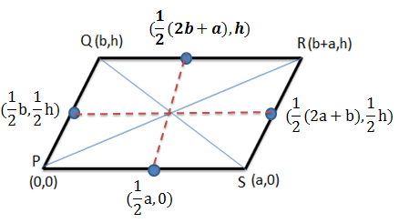
- Use coordinates to prove that the diagonals of a parallelogram meet at the intersection of the segments that connect the midpoints of its opposite sides.
This problem builds upon the findings of Exercise 2 where students proved that the diagonals of a parallelogram bisected each other by showing that the midpoints of the two diagonals occurred at the same point, $\left(\frac{1}{2}\left(b+a\right),\frac{1}{2}h\right).$
$A$: Midpoint of $\overline{PS}=\left(\frac{1}{2}a,0\right)$
$B$: Midpoint of $\overline{QR}=\left(\frac{1}{2}\left(2b+a\right),h\right)$
$C$: Midpoint of $\overline{PQ}=\left(\frac{1}{2}b,\frac{1}{2}h\right)$
$D$: Midpoint of $\overline{RS}=\left(\frac{1}{2}\left(2a+b\right),\frac{1}{2}h\right)$
Finding the midpoint of the segment connecting the midpoints of $\overline{PS}$ and $\overline{QR}$:
$$\left(\frac{1}{2}\left(\frac{1}{2}a+\frac{1}{2}\left(2b+a\right)\right),\frac{1}{2}\left(0+h\right)\right)=\left(\frac{1}{2}\left(a+b\right),\frac{1}{2}h\right)$$
Finding the midpoint of the segment connecting the midpoints of $\overline{PQ}$ and $\overline{RS}$:
$$\left(\frac{1}{2}\left(\frac{1}{2}b+\frac{1}{2}\left(2a+b\right)\right),\frac{1}{2}\left(\frac{1}{2}h+\frac{1}{2}h\right)\right)=\left(\frac{1}{2}\left(a+b\right),\frac{1}{2}h\right)$$
The segments connecting the midpoints of the opposite sides of the parallelogram intersect at their midpoints which is located at $\left(\frac{1}{2}\left(a+b\right),\frac{1}{2}h\right)$.

- Given a quadrilateral with vertices $E(0, 5)$,$F(6, 5)$,$G(4, 0)$, and $H(-2, 0)$:
  - Prove quadrilateral $EFGH$ is a parallelogram.
$\overline{EF}$ and $\overline{GH}$ are horizontal segments, so they are parallel.
$\overline{HE}$ and $\overline{GF}$ have slopes of $\frac{5}{2}$, so they are parallel.
Both pairs of opposite sides are parallel, so the quadrilateral is a parallelogram.

  - Prove $(2, 2.5)$ is a point on both diagonals of the quadrilateral.
Since $EFGH$ is a parallelogram, the diagonals intersect at their midpoints. $(2, 2.5)$ is the midpoint of $\overline{HF}$ and $\overline{GE}$, so it is a point on both diagonals.

- Prove quadrilateral $WXYZ$with vertices $W(1, 3)$,$X(4, 8)$,$Y(10, 11)$, and $Z(4, 1)$ is a trapezoid.
$\overline{WX}$ and $\overline{YZ}$ have slopes of $\frac{5}{3}$, so they are parallel.
$\overline{WZ}$ has a slope of $-\frac{2}{3}$ and $\overline{XY}$ has a slope of $\frac{1}{2}$, so they are not parallel.
When one pair of opposite sides is parallel, the quadrilateral is a trapezoid.

- Given quadrilateral $JKLM$ with vertices $J(-4, 2)$,$K(1, 5)$, $L(4, 0)$, and $M(-1, -3):$
  - Is it a trapezoid? Explain.
Yes, one pair of opposite sides is parallel. $\overline{JK}$ and $\overline{LM}$ both have slopes of $\frac{3}{5}$.
When one pair of opposite sides is parallel, the quadrilateral is a trapezoid.

  - Is it a parallelogram? Explain.
Yes, both pairs of opposite sides are parallel. $\overline{JM}$ and $\overline{KL}$ both have slopes of $-\frac{5}{3}$.
When both pairs of opposite sides are parallel, the quadrilateral is a parallelogram.

  - Is it a rectangle? Explain.
$\overline{JK}⊥\overline{KL}$,$\overline{ KL}⊥\overline{ML}$, $\overline{ML}⊥\overline{MJ}$,$\overline{MJ}⊥\overline{JK}$ because their slopes are negative reciprocals.
Yes, because a parallelogram with four right angles is a rectangle.

  - Is it a rhombus? Explain.
$$JK=KL=LM=MJ=\sqrt{34}$$
Yes, because a parallelogram with four congruent sides is a rhombus.

  - Is it a square? Explain.
Yes, because a rectangle with four congruent sides is a square.

  - Name a point on the diagonal of $JKLM$. Explain how you know.
$(0, 1)$ is the midpoint of $\overline{KM}$ and $\overline{JL}$ and is on both diagonals.

