Lesson 12: Dividing Segments Proportionately

Classwork
Exercises 1–4
- Find the midpoint of $\overline{ST}$ given $S(-2, 8)$ and $T(10, -4).$

- Find the point on the directed segment from $(-2,0)$ to $(5,8)$ that divides it in the ratio of $1:3$.

- Given $\overline{PQ}$ and point $R$ that lies on $\overline{PQ}$ such that point $R$ lies $\frac{7}{9}$ of the length of $\overline{PQ}$ from point $P$ along $\overline{PQ}$.
  - Sketch the situation described.

  - Is point $R$ closer to $P$ or closer to $Q,$ and how do you know?

  - Use the given information to determine the following ratios:
    - $PR:PQ$

    - $RQ:PQ$

    - $PR:RQ$

    - $RQ:PR$

  - If the coordinates of point $P$ are $(0,0)$ and the coordinates of point $R$ are $(14,21)$, what are the coordinates of point $Q$?

- A robot is at position $A(40, 50)$ and is heading toward the point $B(2000, 2000)$along a straight line at a constant speed. The robot will reach point $B$ in $10$hours.
  - What is the location of the robot at the end of the third hour?

  - What is the location of the robot five minutes before it reaches point $B$?

  - If the robot keeps moving along the straight path at the same constant speed as it passes through point $B$, what will be its location at the twelfth hour?

  - Compare the value of the abscissa ($x$-coordinate) to the ordinate ($y$-coordinate) before, at, and after the robot passes point $B$?

  - Could you have predicted the relationship that you noticed in part (d) based on the coordinates of points $A$ and $B$?

Problem Set

- Given $F(0, 2)$ and $G(2, 6)$. If point $S$ lies $\frac{5}{12}$ of the way along $\overline{FG}$, closer to $F$ than to $G$, find the coordinates of $S$. Then verify that this point lies on $\overline{FG}$.

- Point $C$ lies $\frac{5}{6}$ of the way along $\overline{AB}$, closer to $B$ than to$A$. If the coordinates of point $A$ are $(12, 5)$ and the coordinates of point $C$ are $\left(9.5, -2.5\right)$, what are the coordinates of point $B$?

- Find the point on the directed segment from $(-3, -2)$ to $(4, 8)$ that divides it into a ratio of $3:2$.

- A robot begins its journey at the origin, point $O$, and travels along a straight line path at a constant rate. Fifteen minutes into its journey the robot is at $A(35, 80)$.
  - If the robot does not change speed or direction, where will it be $3$ hours into its journey (Call this point $B$)?
  - The robot continues past point $B$ for a certain period of time until it has traveled an additional $\frac{3}{4}$ the distance it traveled in the first $3$ hours and stops.
    - How long did the robot’s entire journey take?
    - What is the robot’s final location?
    - What was the distance the robot traveled in the last leg of its journey?

- Given $\overline{LM}$ and point $R$ that lies on $\overline{LM}$, identify the following ratios given that point $R$ lies $\frac{a}{b}$ of the way along $\overline{LM}$, closer to $L$ than to$M$.
  - $LR:LM$
  - $RM:LM$
  - $RL:RM$

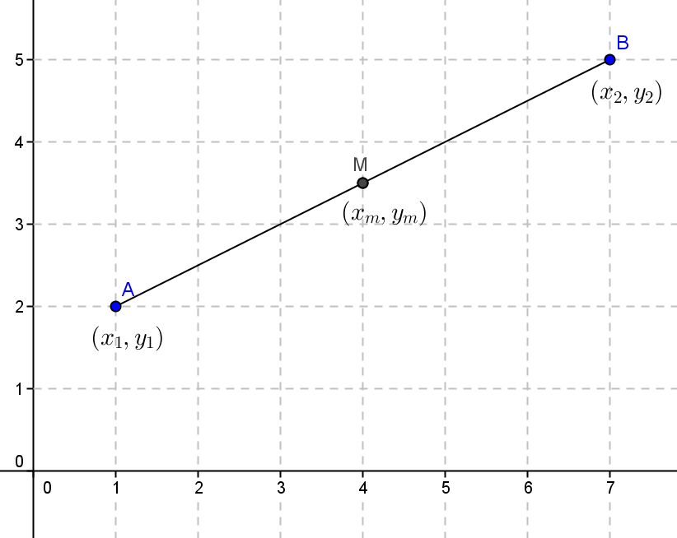
- Given $\overline{AB}$ with midpoint $M$ as shown, prove that the point on the directed segment from $A$ to $B$ that divides $\overline{AB}$ into a ratio of $1:3$ is the midpoint of $\overline{AM}$.

