Lesson 12: Dividing Segments Proportionately

Student Outcomes
- Students find midpoints of segments and points that divide segments into $3$, $4$, or more proportional, equal parts.

Classwork
Opening Exercise (15 minutes)
The students extend their understanding of the midpoint of a segment to partition segments into ratios other than $1:1$.
Scaffolding:
Suggest students translate the segment so that one endpoint lies at the origin.
$A'(0,0)$ and $B'(16, 8)$ using the translation vector $〈4, -5〉$ and then translate them back when all points are located using $〈-4, 5〉$. Provide students who are still struggling with an already-graphed translation on a coordinate grid.
Give each student a piece of graph paper, and do the following exercise as a class.
- Plot the points $A(-4,5)$ and $B(12,13)$.
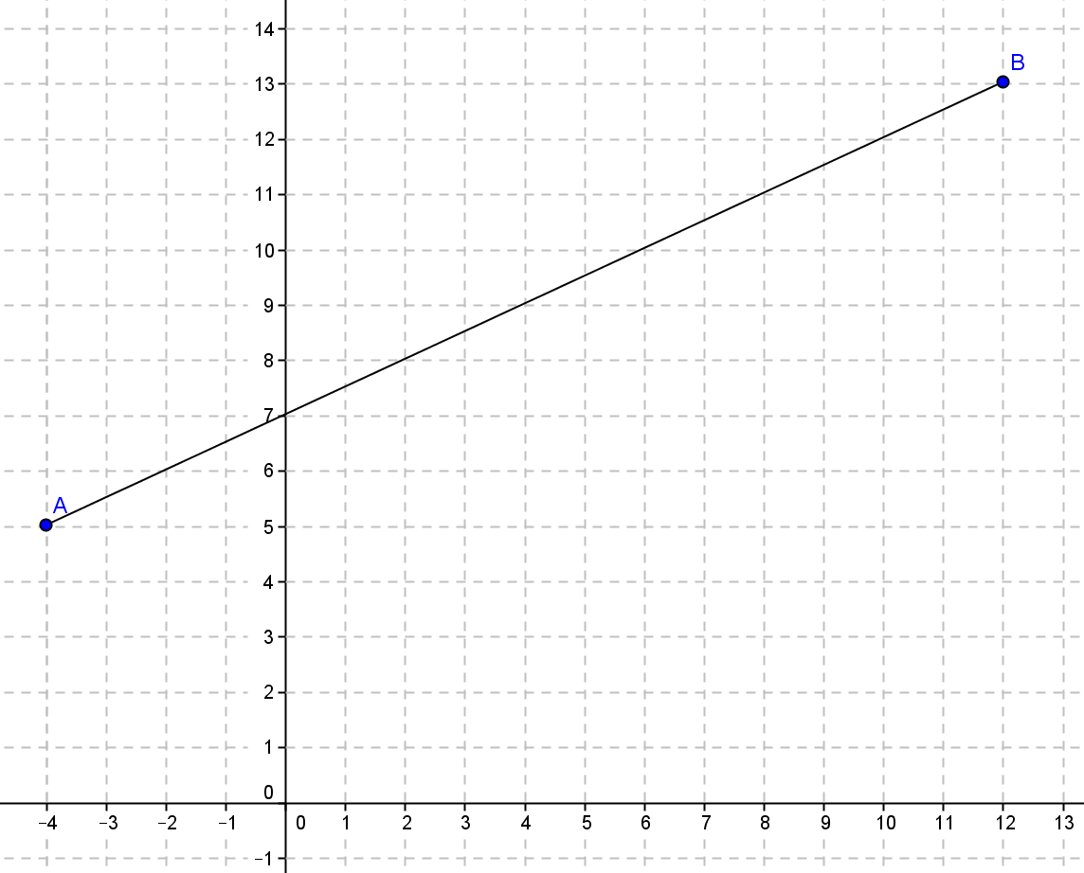

- Draw the “up an over” triangle. Label the point at the right angle $C$.
- What is the length of $\overline{AC}$?
  - $16$ units
- What is the length of $\overline{BC}$?
  - $8$ units
- Mark the halfway point on $\overline{AC}$ and label it point $P$. What are the coordinates of point $P$?
  - $(4, 5)$

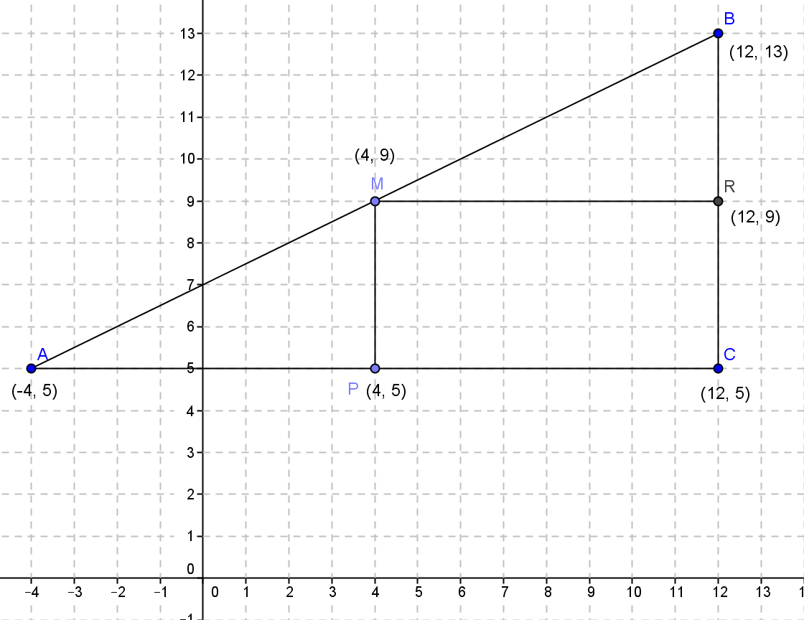
- Mark the halfway point on $\overline{BC}$ and label it point $R$. What are the coordinates of point $R$?
  - $(12, 9)$
- Draw a segment from $P$ to $\overline{AB}$ perpendicular to $\overline{AC}$. Mark the intersection point $M$. What are the coordinates of$M$?
  - $(4, 9)$
- Draw a segment from $R$ to $\overline{AB}$ perpendicular to $\overline{BC}$. What do you notice?
  - The intersection point is point $(4, 9)$.
- Describe to your neighbor how we found point $M$.
  - We found the halfway point of the $x$-distance and the halfway point of the $y$-distance and drew perpendicular segments to the segment joining $A$ and $B$.
- Point $M$ is called the “midpoint” of $\overline{AB}$.
- Ask students to verbally repeat this word and summarize its meaning to a neighbor. Call on students to share their definitions and record them in their notebooks.
- Look at the coordinates of the endpoints and the midpoint. Can you describe how to find the coordinates of the midpoint knowing the endpoints algebraically?
  - $4$ is the average of the $x$-coordinates: $\frac{-4+12}{2}=4$.
  - $9$ is the average of the $y$-coordinates: $\frac{5+13}{2}=9.$
- Let’s try to find the midpoint a slightly different way. Starting at point $A$, describe how to find the midpoint. Starting at point $A$ …
  - Starting at point $A$, find the horizontal distance from $A$to $B$ $\left(12-\left(-4\right)=16\right)$, divide by
$2(16÷2=8)$, and add that value to the $x$-coordinate value of $A(-4+8=4)$. To find the $y$-coordinate of the midpoint, find the vertical distance from $A$ to $B(13-5=8)$, divide by $2(8÷2=4)$, and add that value to the $y$-coordinate of $B(5+4=9).$
- Write this process as a formula.
  - $M\left(-4+\frac{1}{2}\left(12-\left(-4\right)\right), 5+\frac{1}{2}\left(13-5\right)\right)$
- Explain to your neighbor the two ways that we found the midpoint.
- How would this formula change if we started at endpoint $B$ instead of $A$?
  - Instead of adding half the distance between the two endpoints, we would subtract half the distance because we would be moving to the right on our segment.

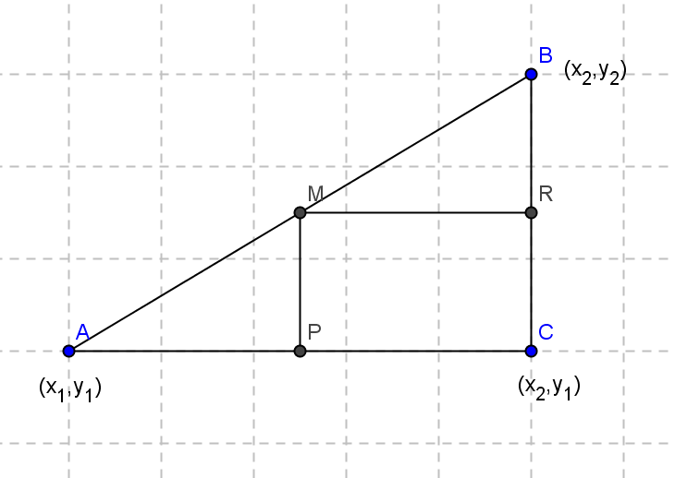
- Now write a general formula for the midpoint of a segment with endpoints $\left(x_{1}, y_{1}\right)$ and $(x_{2}, y_{2})$ using the average formula and then the formula starting with endpoint $A$.
  - $\left(\frac{x_{1}+x_{2}}{2}, \frac{y_{1}+y_{2}}{2}\right)$ or $\left(\frac{1}{2}\left(x_{1}+x_{2}\right), \frac{1}{2}\left(y_{1}+y_{2}\right)\right)$
  - $M\left(x_{1}+\frac{1}{2}\left(x_{2}-x_{1}\right), y_{1}+\frac{1}{2}\left(y_{2}-y_{1}\right)\right)$
- Why do you think all formulas have $\frac{1}{2}$ in them?
  - The midpoint is half way between the endpoints, so it makes sense that all formulas have $\frac{1}{2}$ in them.
- What if we wanted to find the point that is one-quarter of the way along segment $\overline{AB}$, closer to $A$ than $B$? How would the formula change? Can you find that point on the graph? Explain how to find that point.
MP.7
  - Instead of $\frac{1}{2}$ in the second formula, you would use $\frac{1}{4}$. Divide the horizontal and vertical distances into four equal segments, start at endpoint $A$ and count $\frac{1}{4}$ of the way from $A$ toward $B$. The coordinates of the point are $(0, 7)$.
- Can you write a formula using the endpoint to get this point?
  - $x$: $-4+\frac{\left(12-\left(-4\right)\right)}{4}=0$
  - $y$: $5+ QUOTE \frac{13-5}{4}=7$
- Another way to ask the question above would be to find the point on the directed segment from $(-4, 5)$ to $(12, 13)$ that divides it in the ratio of $1:3$. Explain to your neighbor how this is the same question.
  - A ratio of $1:3$ is the fraction $\frac{1}{4}$, so we find the point on the segment with the given endpoints $\frac{1}{4}$ the distance from $(-4, 5)$to $(12, 13)$, which is the same question as above.
- Now find the coordinates of the point that sit $\frac{1}{8}$ of the way along segment $\overline{AB}$ closer to $A$ than to$B$, and show how to get that point using a formula.
  - $x$:$-4+\frac{12-\left(-4\right)}{8}=-2$
  - $y$: $5+\frac{13-5}{8}=6$
  - $\left(-2, 6\right)$
- What is another way to state this problem using a ratio and the term directed segment?
  - Find the point on the directed segment from $(-4, 5)$ to $(12, 13)$ that divides it into a ratio of $1:7$.
- Find the point on the directed segment from $(-4, 5)$ to $(12, 13)$ that divides it into a ratio of $1:15$.
  - $x: -4+\frac{12-\left(-4\right)}{16}=-3$
  - $y: 5+\frac{13-5}{16}=5.5$
  - $(-3, 5.5)$

As students are working make a note of which students, if any, are calculating the coordinates using the given proportion and which are repeatedly calculating midpoints. When the students have finished finding the coordinates of the points, select two students to share their approaches. The student who used the midpoint approach should present first, followed by the student using the more direct approach.
MP.3
- Approach 1: The student finds the midpoint of each successive segment by calculating the mean of the ordinates and the abscissas.
- Approach 2: The student determines how the vertical and horizontal distances each point lies from point $A$ based upon the given fraction, calculates these distances and adds them to the ordinate and abscissa of point $A$.

Example 1 (6 minutes)
Students will now extend/apply the understanding of partitioning a segment proportionally to the next problem. Students will not be able to use the method of finding successive midpoints as they may have done in the Opening Exercise. Ask guiding questions as students work through the example.
Given points $A(-4,5)$ and $B(12,13)$, find the coordinates of the point, $C$, that sits $\frac{2}{5}$ of the way along the segment $\overline{AB}$, closer to $A$ than it is to $B$.
- Can we find the coordinates of this point by finding the coordinates of midpoints as many of you did in the Opening Exercise?
  - No. In the Opening Exercise we were finding points $\frac{1}{2}, \frac{1}{4}, \frac{1}{8}$, and $\frac{1}{16}$ of the way along a segment. Each of these fractions is a power of $\frac{1}{2}$, so we could use successive midpoints to identify the coordinates of these points. This method will not work if the point is $\frac{2}{5}$ of the way along the segment.
- Can we use proportions to find the coordinates of point $C$?
  - Yes. Use a diagram similar to that shown below. The coordinates of point $C$ are $(2.4, 8.2)$.
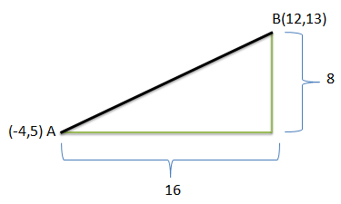
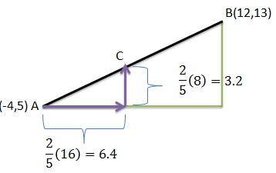

Students calculate $\frac{2}{5}$ of the horizontal and vertical distances (or vectors) between points $A$ and $B$ and add these values to the abscissa and ordinate respectively of point $A: (-4+6.4, 5+3.2)$.
- Can you use what you know about the slope to verify that point $C$ lies on segment $AB$?
  - Segment $AB$ lies on a line having a slope of $\frac{1}{2}$. We can move from any point on the line to another point on the line by moving to the right a certain distance and up half of that distance, or to the left a certain distance and down half of that distance. To locate point $C$ we moved to the right $6.4$ units and up half of that distance, $3.2$ units. Therefore, point $C$must lie on the line containing segment $AB$.
- How can you relate this idea to our work with similar right triangles?
  - Using the diagrams above, we can see that the perpendiculars to the horizontal base dropped from points $C$ and $B$ divide the original right triangle into two similar triangles whose sides are proportional and whose angles are congruent.
- The problem asked us to find the location of the point that sits $\frac{2}{5}$ of the way along segment $AB$, closer to $A$ than to $B$. How can we use the proportion $\frac{AC}{AB}=\frac{2}{5}$ to verify that point $C$ meets the original requirement?
  - If point $C$ lies $\frac{2}{5}$ of the way along segment $AB$ then the distance from $A$ to $C$ will be $\frac{2}{5}$distance from $A$ to $B$: $AC$ $=$ $\frac{2}{5} AB→$ $\frac{AC}{AB}=\frac{\frac{2}{5}AB}{AB}=\frac{2}{5}$. Using the distance formula we calculate the length of segments $AC$ and $AB$:
  - $AC=\sqrt{{\left(2.4-\left(-4\right)\right)}^{2}+{(8.2-5)}^{2}}=\sqrt{51.2}$ (We could also have just used the distances we calculated in part $1$, $6.4$, and $3.2.$)
  - $AB=\sqrt{{\left(12-\left(-4\right)\right)}^{2}+{(13-5)}^{2}}=\sqrt{320}$ (We could also have just used the distances we calculated in part $1$,$16$, and$8.$)
  - $\frac{AC}{AB}=\frac{\sqrt{51.2}}{\sqrt{320}}=\sqrt{\frac{51.2}{320}}=\sqrt{\frac{4}{25}}=\frac{2}{5}$
- Given points $A(-4,5)$and $B(12,13),$ find the coordinates of the point, $D$, that sits two-fifths of the way along $\overline{AB}$, closer to $B$ than it is to $A$.
  - $D\left(5.6, 9.8\right)$
  - Method 1: $\left(12-\frac{2}{5}\left(16\right), 13-\frac{2}{5} \left(8\right)\right)$
  - Method 2: $\left(-4+\frac{3}{5}\left(16\right), 5+\frac{3}{5} \left(8\right)\right)$
- Will point $D$ coincide with point $C$? Put another way, will the coordinates for point $D$ be the same as the coordinates for point $C$?
  - No. The only way the two points would occupy the same location is if they were $\frac{1}{2}$ the distance along the segment (i.e., midpoint).
- Can we use our work from Example 1 to locate point $D$?
  - Yes. We can do one of two things:
- We can still calculate $\frac{2}{5}$ of the vertical and horizontal distances traveled when moving from point $A$ to point $B$, but we should subtract these values from the abscissa and ordinate of point $B$.
- If the point is $\frac{2}{5}$ of the distance along segment $AB$ but closer to point $B$ than point $A$, then we will have to move $\frac{3}{5}$ of the length of the segment from point $A$ to reach the point. Therefore, we can calculate $\frac{3}{5}$ of the horizontal and vertical distances and add these values to the abscissa and ordinate of point $A$.

Example 2 (6 minutes)
Students further extend their work on partitioning a line segment to determine the location of a point on a segment that divides the segment into a given proportion. In Example 2, students divide the segment based on a part : part ratio instead of a part : whole ratio.
- Given points $P(10,10)$ and $Q(0,4),$ find point $R$ on $\overline{PQ}$ such that $\frac{PR}{RQ}=\frac{7}{3}$. Hint: Draw a picture.
- How does this problem differ from the previous examples?
  - In the previous examples, we were comparing the distance from the new point to the entire length of the segment. Now, we are comparing lengths of the two parts of the segment: the length of segment $PR$ and the length of segment$RQ$. Point $R$partitions segment $PQ$ such that $PR:RQ=7:3.$ This means $PR:PQ=7:10$and $RQ:PQ=3:10$.
- Just as we used two methods for finding point $D$ in Example 1 above, we can use either addition or subtraction to find the location of point $R$ here. Have half the class use addition and half use subtraction; then have volunteers from each group explain their procedure.
  - Since $R$is located $\frac{3}{10}$ of the way along segment $PQ$, closer to $Q$ than to $P$, we can calculate the coordinate of $R$ using one of the following methods:
- Method 1: Moving $\frac{3}{10}$ of the length of segment $PQ$ from point $Q$, $R\left(0+\frac{3}{10}\left(10\right), 4+\frac{3}{10}(6)\right).$
- Method 2: Moving $\frac{7}{10}$ of the length of segment $PQ$ from point $P$, $R\left(10-\frac{7}{10}\left(10\right), 10-\frac{7}{10}(6)\right).$
- What are the coordinates of point $R$?
  - $R(3, 5.8)$

Exercises 1–4 (10 minutes)
Exercise 4 is intended as an extension for students who complete Exercises 1–3 quickly.
Exercises 1–5
- Find the midpoint of $\overline{ST}$ given $S(-2, 8)$ and $T(10, -4)$.
$$M\left(\frac{1}{2}\left(-2+10\right), \frac{1}{2}\left(8-4\right)\right)=M\left(4,2\right)$$

- Find the point on the directed segment from $(-2,0)$ to $(5,8)$ that divides it in the ratio of $1:3$.
A ratio of $1:3$ means $\frac{1}{4}$ of the way from $(-2, 0)$ to $(5, 8)$.
$$\left(-2+ \frac{1}{4}\left(5-\left(-2\right)\right) , 0+ \frac{1}{4}\left(8-0\right)\right) =\left(-\frac{1}{4}, 2\right)$$

- Given $\overline{PQ}$ and point $R$ that lies on $\overline{PQ}$ such that point $R$ lies $\frac{7}{9}$ of the length of $\overline{PQ}$ from point $P$ along $\overline{PQ}$.
  - Sketch the situation described.
  - Is point $R$ closer to $P$ or closer to $Q$, and how do you know?
$R$ is closer to $Q$ because it lies more than halfway along the segment from point $P$.

  - Use the given information to determine the following ratios:
    - $PR:PQ$
$$PR:PQ=7:9$$

    - $RQ:PQ$
$$RQ:PQ=2:9$$

    - $PR:RQ$
$$PR:RQ=7:2$$

    - $RQ:PR$
$$RQ:PR=2:7$$

  - If the coordinates of point $P$ are $(0,0)$ and the coordinates of point $R$ are $(14,21)$, what are the coordinates of point $Q$?
$$(18,27)$$

- A robot is at position $A(40, 50)$ and is heading toward the point $B(2000, 2000)$along a straight line at a constant speed. The robot will reach point $B$ in $10$hours.
  - What is the location of the robot at the end of the third hour?
$(628, 635)$; The robot will be located $\frac{3}{10}$ of the length of $\overline{AB}$ away from point $A$ along $\overline{AB}$.
$$\left(40+\frac{3}{10}\left(2000-40\right), 50+\frac{3}{10}(2000-50)\right)$$

  - What is the location of the robot five minutes before it reaches point $B$?
$\left(1983\frac{1}{3}, 1983\frac{3}{4}\right)$; The robot will be located $\frac{595}{600}$ of the length of $\overline{AB}$ away from point $A$ along $\overline{AB}$.
$$\left(40+\frac{595}{600}\left(2000-40\right), 50+\frac{595}{600}(2000-50)\right)$$

  - If the robot keeps moving along the straight path at the same constant speed as it passes through point $B$, what will be its location at the twelfth hour?
$(2392, 2390)$; The robot will be located $\frac{12}{10}$ of the length of $\overline{AB}$ away from point $A$ along $\overline{AB}$.
$$\left(40+\frac{12}{10}\left(2000-40\right), 50+\frac{12}{10}(2000-50)\right)$$

  - Compare the value of the abscissa ($x$-coordinate) to the ordinate ($y$-coordinate) before, at, and after the robot passes point $B$?
Initially, the abscissa was greater than the ordinate. As the robot moved toward point $B$ these values got closer to being equal. At point $B$ they were equal and, for all points on the path beyond point $B$, the $y$-coordinate was greater than the $x$-coordinate.

  - Could you have predicted the relationship that you noticed in part (d) based on the coordinates of points $A$ and $B$?
Yes. If point $A$ was located at the origin, the path that the robot took would have been described by the equation$y=x$; then at each location the robot occupied, the $x$- and the $y$-coordinates would have been equal. Point $A$ actually lies above the origin, making the slope of the line that describes the robot’s actual path less than one. Initially, the $y$-coordinate of each point (location) is greater than the $x$-coordinate because the line has a $y$-intercept greater than zero. The slope of the line is less than $1$, so as the robot moves to the right, the “gap” closes because for each unit the robot moves to the right, it moves less than one unit up. When the robot reaches point $B\left(2000, 2000\right)$, the abscissa and the ordinate are equal. Beyond point $B$ the $x$-coordinate will be greater than the $y$-coordinate.

Closing (3 minutes)
- How did we extend our understanding of midpoint to divide segments proportionally?
  - When we find the location of the midpoint, we are dividing a segment into two congruent segments and, therefore, need to calculate half of the vertical and horizontal distances. We then added or subtracted these values from the coordinates of one of the endpoints of the segment. In this lesson we divided the segment into two segments of different lengths. We had to determine vertical and horizontal distances other than $\frac{1}{2}$ and then use these values to determine the location of the point. We could use either endpoint to do this, but we had to be careful to add and/or subtract depending on whether we were moving right/left or up/down along the segment and which endpoint the point was closest to.
- What is the midpoint formula? (See Opening Exercise.)
  - $\left(\frac{x_{1}+x_{2}}{2}, \frac{y_{1}+y_{2}}{2}\right)$
- If you need to partition a segment into fractional parts other than powers of $\frac{1}{2}$, you may use a vector approach. Simply multiply the horizontal and vertical vectors between the two points by the requested ratio and either add the results to the first point or subtract from the second point to obtain the coordinates of the partitioning point. (See Example 1.)

Exit Ticket (5 minutes)
Optional: Allow students to complete Problem 1, Problem 2, or both problems on the Exit Ticket.

Name Date
Lesson 12: Dividing Segments Proportionately

Exit Ticket

- Given points $A(3, -5)$ and $B(19, -1)$, find the coordinates of point $C$ that sit $\frac{3}{8}$ of the way along $\overline{AB}$, closer to $A$ than to $B$.

- Given points $A(3, -5)$ and $B(19, -1),$find the coordinates of point $C$ such that $\frac{CB}{AC}=\frac{1}{7}$.

Exit Ticket Sample Solutions

- Given points $A(3, -5)$ and$B(19, -1)$, find the coordinates of point $C$ that sit $\frac{3}{8}$ of the way along $\overline{AB}$, closer to $A$ than to $B$.
$$\left(3+\frac{3}{8}\left(19-3\right), -5+\frac{3}{8}\left(-1-\left(-5\right)\right)\right)= \left(3+\frac{3}{8}\left(16\right), -5+\frac{3}{8}\left(4\right)\right) \\ =\left(3+6, -5+1.5\right) \\ =\left(9, -3.5\right)$$

- Given points $A(3, -5)$ and $B(19, -1),$ find the coordinates of point $C$ such that $\frac{CB}{AC}=\frac{1}{7}$.
$$\left(3+\frac{7}{8}\left(19-3\right), -5+\frac{7}{8}\left(-1-\left(-5\right)\right)\right)= \left(3+\frac{7}{8}\left(16\right), -5+\frac{7}{8}\left(4\right)\right) \\ =\left(3+14, -5+3.5\right) \\ =\left(17, -1.5\right)$$

Problem Set Sample Solutions

- Given $F(0, 2)$ and $G(2, 6)$. If point $S$ lies $\frac{5}{12}$ of the way along $\overline{FG}$, closer to $F$ than to $G$, find the coordinates of $S$. Then verify that this point lies on $\overline{FG}$.
$$S\left(\frac{5}{6}, 3\frac{2}{3}\right)$$
$$\left(0+\frac{5}{12}\left(2-0\right), 2+\frac{5}{12}\left(6-2\right)\right)=\left(0+\frac{5}{12}\left(2\right), 2+\frac{5}{12}\left(4\right)\right) \\ =\left(\frac{5}{6}, 1\frac{2}{3}\right)$$
Verification that $S$ lies on $\overline{FG}$:
$\overline{FG}$ has a slope of $2$(i.e., $\frac{6-2}{2-0}$). The slopes of $\overline{FS}$ and $\overline{SG}$ must also have a slope of $2$ if the point $S$ lies on the line including segment $FG$. The slope of $\overline{FS}$ is $\frac{3\frac{2}{3}-2}{\frac{5}{6}-0}=\frac{\frac{5}{3}}{\frac{5}{6}}=2$, and the slope of $\overline{SG}$ is $\frac{6-3\frac{2}{3}}{2-\frac{5}{6}}=\frac{\frac{7}{3}}{\frac{7}{6}}=2$. Therefore, point $S$ does, in fact, lie on $\overline{FG}$.

- Point $C$ lies $\frac{5}{6}$ of the way along $\overline{AB}$, closer to $B$ than to$A$. If the coordinates of point $A$ are $(12, 5)$ and the coordinates of point $C$ are $\left(9.5, -2.5\right)$, what are the coordinates of point $B$?
$$B \left(9, -4\right)$$

- Find the point on the directed segment from $(-3, -2)$ to $(4, 8)$ that divides it into a ratio of $3:2$.
$$\left(\frac{6}{5}, 4\right)$$

- A robot begins its journey at the origin, point $O$, and travels along a straight line path at a constant rate. Fifteen minutes into its journey the robot is at $A(35, 80)$.
  - If the robot does not change speed or direction, where will it be $3$ hours into its journey (call this point $B$)?
$\left(35×12,80×12\right)=(420,960)$. Multiply by $12$ since there are twelve $15$-minute periods in $3$ hours.

  - The robot continues past point $B$ for a certain period of time until it has traveled an additional $\frac{3}{4}$ the distance it traveled in the first $3$ hours and stops.
    - How long did the robot’s entire journey take?
$3×1\frac{3}{4}=5\frac{1}{4}$ hours

    - What is the robot’s final location?
$$\left(420×1.75,960×1.75\right)=(735,1680)$$

    - What was the distance the robot traveled in the last leg of its journey?
$\sqrt{{(735-420)}^{2}+{(1680-960)}^{2}} \sim 785.9$units

- Given $\overline{LM}$ and point $R$ that lies on $\overline{LM}$, identify the following ratios given that point $R$ lies $\frac{a}{b}$ of the way along $\overline{LM}$, closer to $L$ than to$M$.
  - $LR:LM$
$$LR:LM=a:b$$

  - $RM:LM$
$$RM:LM=(b-a): b$$

  - $RL:RM$
$$RL:RM=a: (b-a)$$

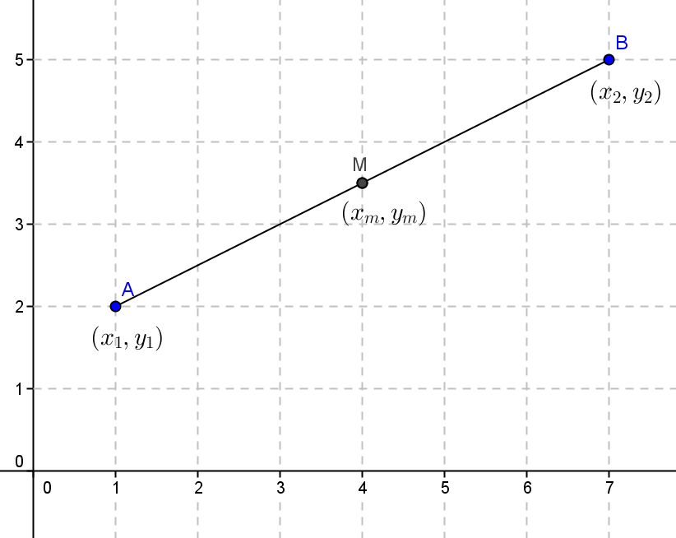
- Given $\overline{AB}$ with midpoint $M$ as shown, prove that the point on the directed segment from $A$ to $B$ that divides $\overline{AB}$ into a ratio of $1:3$ is the midpoint of $\overline{AM}$.
The point dividing the segment into a ratio of $1:3$ is $\left(x_{1}+\frac{1}{4}\left(x_{2}-x_{1}\right), y_{1}+\frac{1}{4}\left(y_{2}-y_{1}\right)\right)$. The midpoint of $\overline{AM}$ is $\left(\frac{1}{2}\left(x_{1}+x_{m}\right), \frac{1}{2}\left(y_{1}+y_{m}\right)\right)$. If $M$ is the midpoint of $\overline{AB}$, $x_{m}=\frac{1}{2}\left(x_{1}+x_{2}\right)$, and $y_{m}=\frac{1}{2}\left(y_{1}+y_{2}\right)$. Therefore, the $x$-coordinate of the midpoint of $\overline{AM}$ can be written as
$\frac{1}{2}\left(x_{1}+\frac{1}{2}\left(x_{1}+x_{2}\right)\right)=\frac{1}{2}\left(x_{1}+\frac{1}{2}x_{1}+\frac{1}{2}x_{2}\right)= \frac{1}{2}\left(\frac{3}{2}x_{1}+\frac{1}{2}x_{2}\right)= \frac{3}{4}x_{1}+\frac{1}{4}x_{2}$.
If we simplify $x_{1}+\frac{1}{4}\left(x_{2}-x_{1}\right)= x_{1}+\frac{1}{4}x_{2}-\frac{1}{4}x_{1}=\frac{3}{4}x_{1}+\frac{1}{4}x_{2}$. The $y$-coordinate can be similarly obtained, meaning they are the same point.

