Lesson 11: Perimeters and Areas of Polygonal Regions Defined by Systems of Inequalities

Classwork
Opening Exercise
Graph the following:
- $y≤7$ | - $x>-3$

- $y<\frac{1}{2}x-4$ | - $y≥-\frac{2}{3}x+5$

Example 1
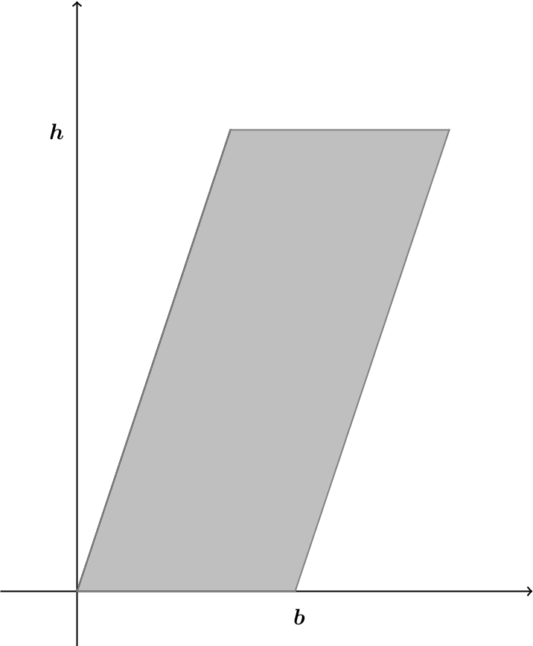
A parallelogram with base of length$b$ and height $h$ can be situated in the coordinate plane as shown. Verify that the shoelace formula gives the area of the parallelogram as $bh$.

Example 2
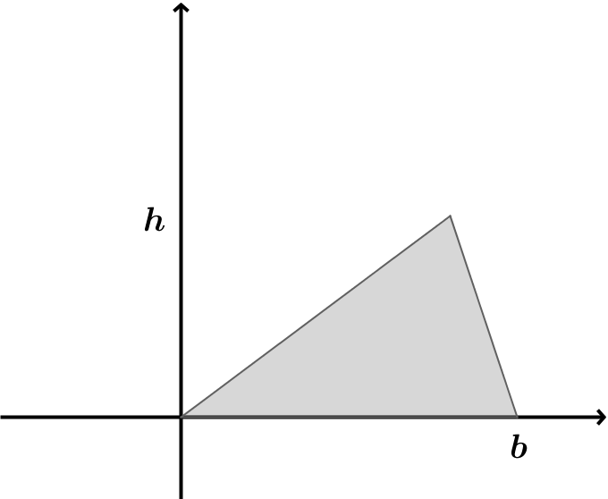
A triangle with base $b$ and height $h$ can be situated in the coordinate plane as shown. According to Green’s theorem, what is the area of the triangle?

Exercises 1–2
- A quadrilateral region is defined by the system of inequalities below:
$y≤x+6$ $y≤-2x+12$ $y≥2x-4$ $y≥-x+2$
  - Sketch the region.

  - Determine the vertices of the quadrilateral.
  - Find the perimeter of the quadrilateral region.

  - Find the area of the quadrilateral region.

- A quadrilateral region is defined by the system of inequalities below:
$y≤x+5$ $y≥x-4$ $y≤4$ $y≥-\frac{5}{4}x-4$
  - Sketch the region.

  - Determine the vertices of the quadrilateral.

  - Which quadrilateral is defined by these inequalities? How can you prove your conclusion?

  - Find the perimeter of the quadrilateral region.

  - Find the area of the quadrilateral region.

Problem Set

For Problems 1–2 below, identify the system of inequalities that defines the region shown.
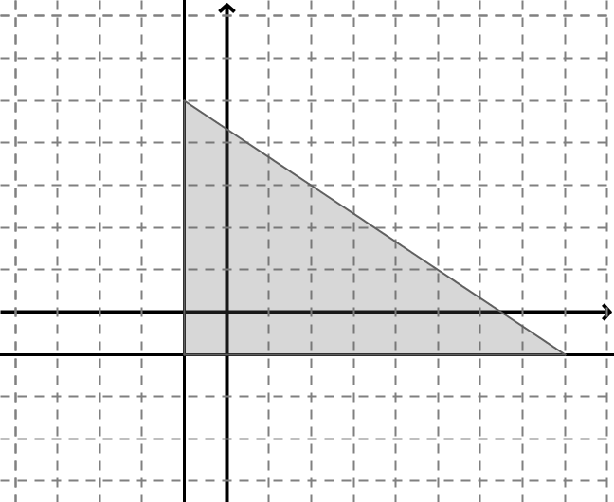

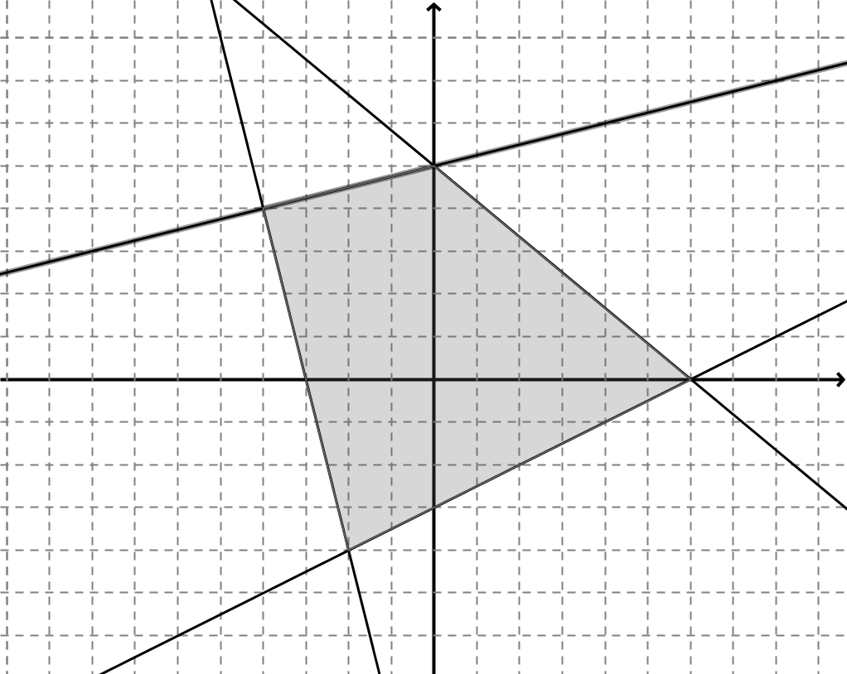

For Problems 3–5 below, a triangular or quadrilateral region is defined by the system of inequalities listed.
  - Sketch the region.
  - Determine the coordinates of the vertices.
  - Find the perimeter of the region rounded to the nearest hundredth if necessary.
  - Find the area of the region rounded to the nearest tenth if necessary.
- $8x-9y≥-22$ $x+y≤10$ $5x-12y≤-1$

- $x+3y≥0$ $4x-3y≥0$ $2x+y≤10$

- $2x-5y≥-14$ $3x+2y≤17$ $2x-y≤9$ $x+y≥0$

