Lesson 11: Perimeters and Areas of Polygonal Regions Defined by Systems of Inequalities
Student Outcomes
- Students find the perimeter of a triangle or quadrilateral in the coordinate plane given a description by inequalities.
- Students find the area of a triangle or quadrilateral in the coordinate plane given a description by inequalities by employing Green’s theorem.

Lesson Notes
In previous lessons, students found the area of polygons in the plane using the “shoelace” method. In this lesson, we give a name to this method—Green’s theorem. Students will draw polygons described by a system of inequalities, find the perimeter of the polygon, and use Green’s theorem to find the area.

Classwork
Opening Exercises (5 minutes)
The opening exercises are designed to review key concepts of graphing inequalities. The teacher should assign them independently and circulate to assess understanding.
Opening Exercises
Graph the following:
- $y ≤7$ | - $x> -3$
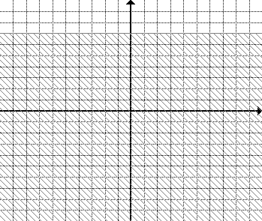

- $y<\frac{1}{2}x-4$ | - $y ≥-\frac{2}{3}x+5$
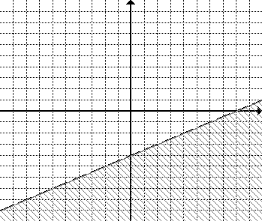
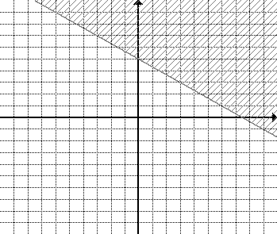

Example 1 (10 minutes)
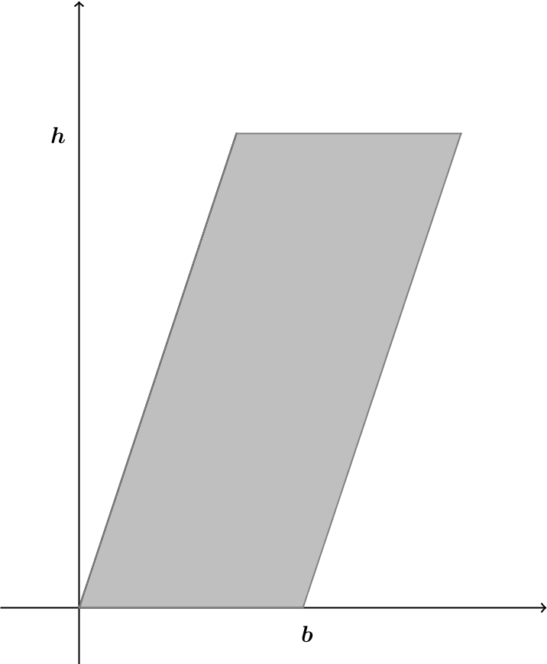
Example 1
A parallelogram with base of length $b$ and height$h$can be situated in the coordinate plane as shown. Verify that the shoelace formula gives the area of the parallelogram as $bh$.

- What is the area of a parallelogram?
  - Base $×$ height
- The distance from the $y$-axis to the top left vertex is some number $x$. What are the coordinates of that vertex?
Scaffolding:
- If students are confused about the coordinates provide either a graph of a parallelogram with the coordinates showing (more concrete) or a graph with at least tick marks so that students may count the distances for base and height.
  - $(x, h)$
- Can you determine the coordinates of the top right vertex? What do we know about opposite sides of a parallelogram?
  - They must be equal.
- What is the length of the bottom side?
  - $b$ units
- So what is the length of the top side?
  - $b$ units
- The bottom side starts at the origin (where $x=0$); where does the top side start? Hint: What is the $x$-coordinate of the top left vertex?
  - $x$

- So if the length is $b$ units, what would the $x$-coordinate of the top right vertex be?
  - $x+b$
- So what are the coordinates of the top right vertex?
  - $\left(x+b,h\right)$
- List the coordinates of the vertices starting at the origin and moving clockwise.
  - $(0, 0)$,$(x, h)$, $(x+b, h)$, and $(b, 0)$
- Use the shoelace formula (Green’s theorem) to find the area moving counterclockwise.
  - $\frac{1}{2}\left(0∙0+b∙h+\left(x+b\right)∙h+x∙0-0∙b-0\left(x+b\right)-h∙x-h∙0\right)=\frac{1}{2}\left(b∙h+x∙h+b∙h-h∙x\right)=\frac{1}{2}\left(2\left(b∙h\right)\right)=b∙h$

Example 2 (5 minutes)
Example 2

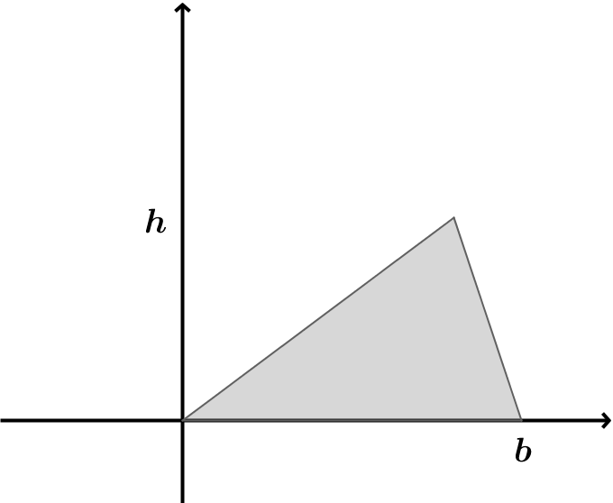
A triangle with base $b$ and height $h$ can be situated in the coordinate plane as shown. According to Green’s theorem, what is the area of the triangle?

Let students try to do this problem on their own following the steps used above. Scaffold with the following questions as necessary.
MP.1
- What is the area of a triangle?
  - $\frac{1}{2}$ base $×$ height
- Let the distance from the $y$-axis to the top vertex be some number $x$. What are the coordinates of that vertex?
  - $(x, h)$
- List the coordinates of the vertices starting at the origin and moving clockwise.
  - $(0,0)$, $(x,h)$, and $(b,0)$
- Use the shoelace formula (Green’s theorem) to find the area moving counterclockwise.
  - $\frac{1}{2}\left(0∙0+b∙h+x∙0-0∙b-0∙x-h∙0\right)=\frac{1}{2}\left(b∙h\right)$
- Summarize what you have learned so far with a partner.
  - We have verified well known formulas using Green’s theorem.

Exercises 1–2 (15 minutes)
In this exercise, students work with a partner to compute the area and perimeter of a quadrilateral region in the plane defined by a set of inequalities. Have each student do one problem, parts (a) and (b), then check in with their partner and check each other’s work. Then do parts (c) and (d) and check in again. Students should graph the inequalities, solve pairs of inequalities to find the coordinates of the vertices, use the distance formula to find the perimeter, and apply the shoelace formula (Green’s theorem) to find the area.
Exercises 1–2
- A quadrilateral region is defined by the system of inequalities below:
$y≤x+6$ $y≤-2x+12$ $y≥2x-4$ $y≥-x+2$
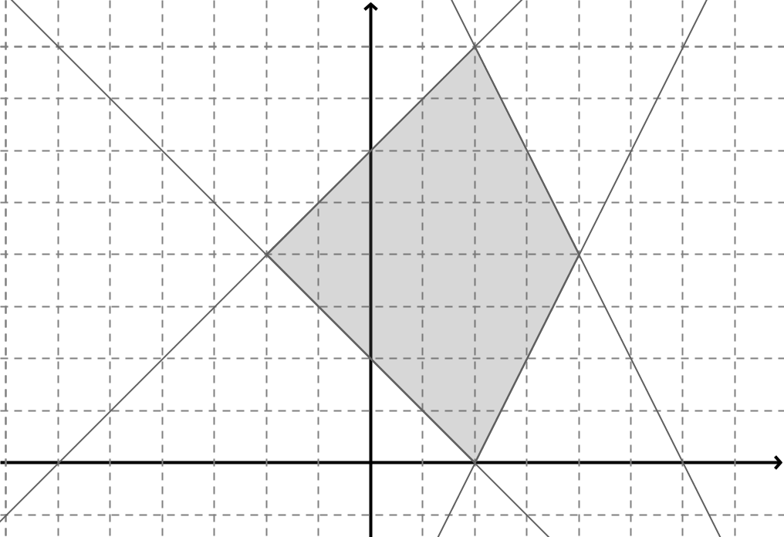
  - Sketch the region.

  - Determine the vertices of the quadrilateral.
$(2, 8)$,$(4, 4)$, $(2, 0)$,$(-2, 4)$. Ask students how they can verify the intersection points. (By showing that each set of coordinates satisfies the equations of both intersecting lines that determine the vertex.)

  - Find the perimeter of the quadrilateral region.
$≈20.26$ units

  - Find the area of the quadrilateral region.
$24$square units

- A quadrilateral region is defined by the system of inequalities below:
$y≤x+5$ $y≥x-4$ $y≤4$ $y≥-\frac{5}{4}x-4$
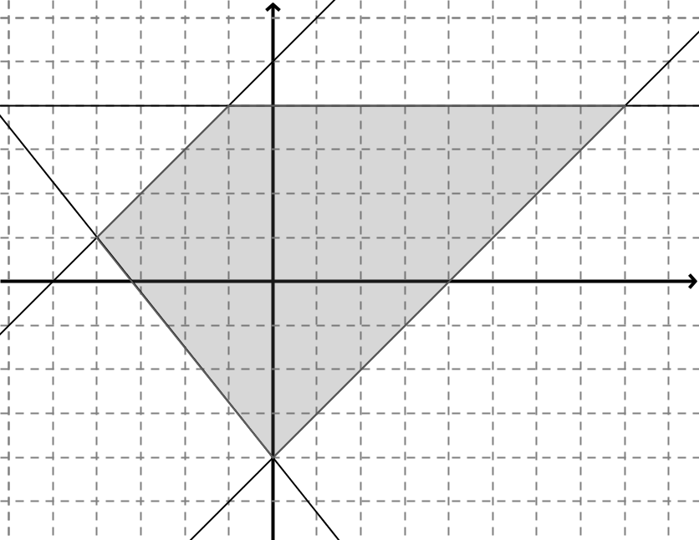
  - Sketch the region.
  - Determine the vertices of the quadrilateral.
$\left(-4,1\right)$,$\left(-1,4\right)$, $\left(8,4\right)$, $(0,-4)$

  - Which quadrilateral is defined by these inequalities? How can you prove your conclusion?
A trapezoid. We can prove that one pair of opposite sides is parallel.

  - Find the perimeter of the quadrilateral region.
$≈30.95$ units

  - Find the area of the quadrilateral region.
$50$ square units

Closing (2 minutes)
Gather the entire class and ask these questions. Have students share answers.
- The shoelace method for finding the area of a polygon is also known as?
  - Green’s theorem
- How did we verify the formulas for the area of a parallelogram and triangle?
  - We used Green’s theorem with variables as coordinates to verify the known formulas.

Exit Ticket (8 minutes)

Name Date
Lesson 11: Perimeters and Areas of Polygonal Regions Defined by Systems of Inequalities

Exit Ticket

A quadrilateral region is defined by the system of inequalities below:
$y≤5$ $y≥-3$ $y≤2x+1$ $y≥2x-7$

- Sketch the region.

- Determine the coordinates of the vertices.

- Find the area of the quadrilateral region.

Exit Ticket Sample Solutions

- A quadrilateral region is defined by the system of inequalities below:

$y≤5$ $y≥-3$ $y≤2x+1$ $y≥2x-7$

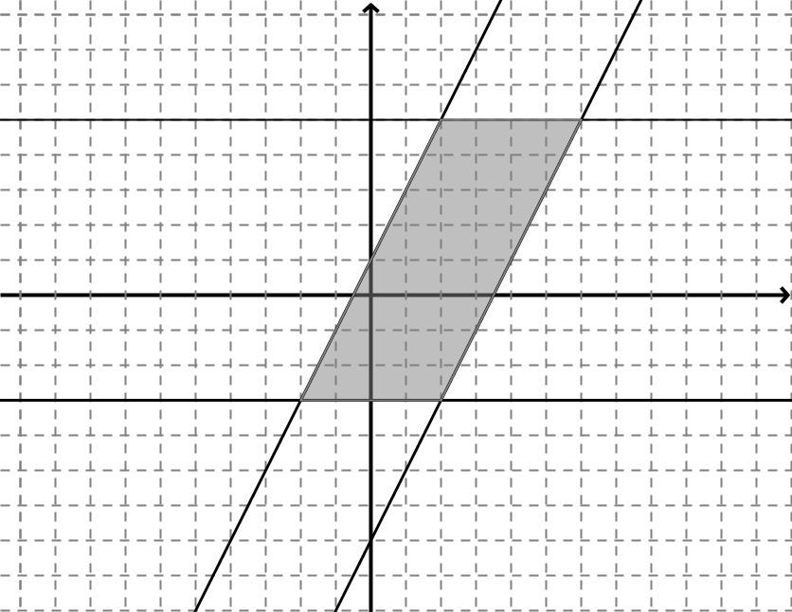
- Sketch the region.

- Determine the coordinates of the vertices.
$(2, 5)$,$(6, 5)$,$(2, -3)$,$(-2, -3)$

- Find the area of the quadrilateral region.
$32$ square units

Problem Set Sample Solutions

For Problems 1–2 below, identify the system of inequalities that defines the region shown.
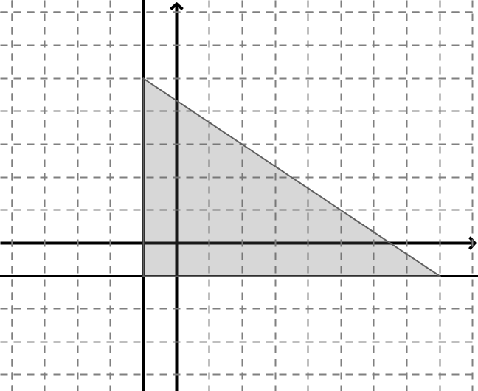

$y≥-1$, $x≥-1$, $y≤-\frac{2}{3}x+\frac{13}{3}$

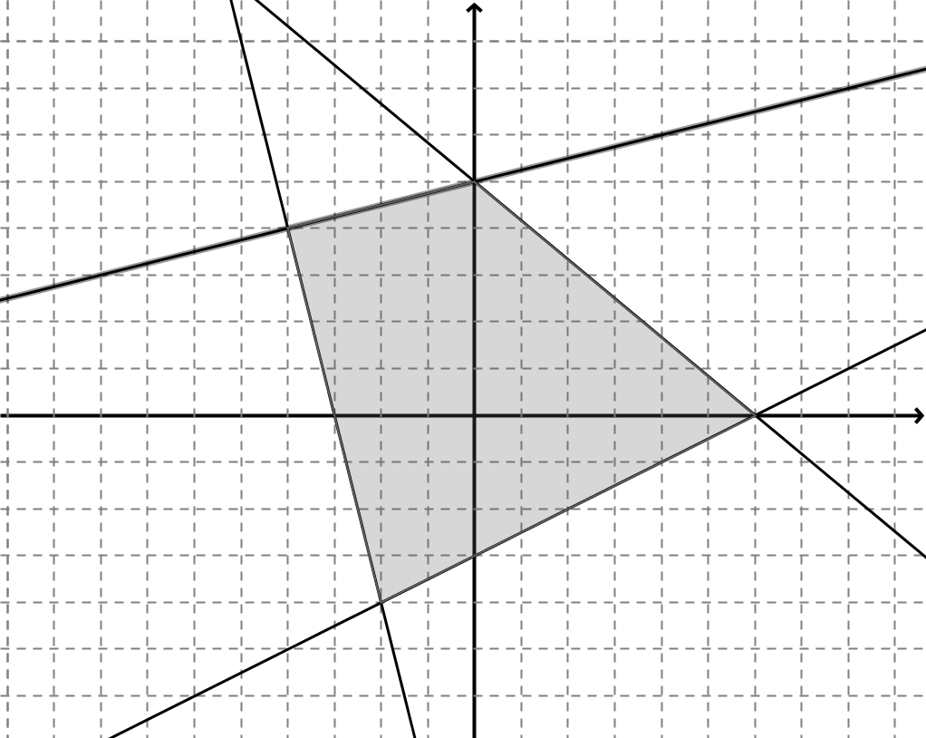

$y≥\frac{1}{2}x-3$ $y≤-\frac{5}{6}x+5$ $y≤\frac{1}{4}x+5$ $y≥-4x-12$

For Problems 3–5 below, a triangular or quadrilateral region is defined by the system of inequalities listed.
  - Sketch the region.
  - Determine the coordinates of the vertices.
  - Find the perimeter of the region rounded to the nearest hundredth if necessary.
  - Find the area of the region rounded to the nearest tenth if necessary.
- $8x-9y≥-22$ $x+y≤10$ $5x-12y≤-1$
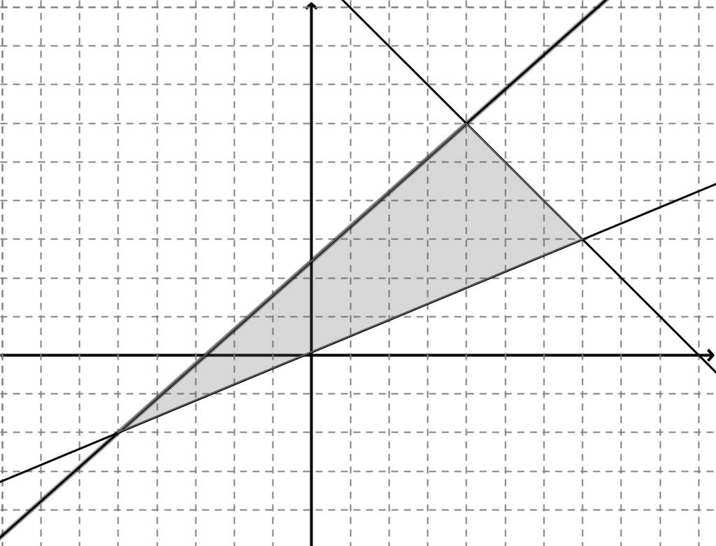

  - $(4,6)$,$(7,3)$,$(-5,-2)$
  - $≈29.28$ units
  - $25.5$ square units

- $x+3y≥0$ $4x-3y≥0$ $2x+y≤10$
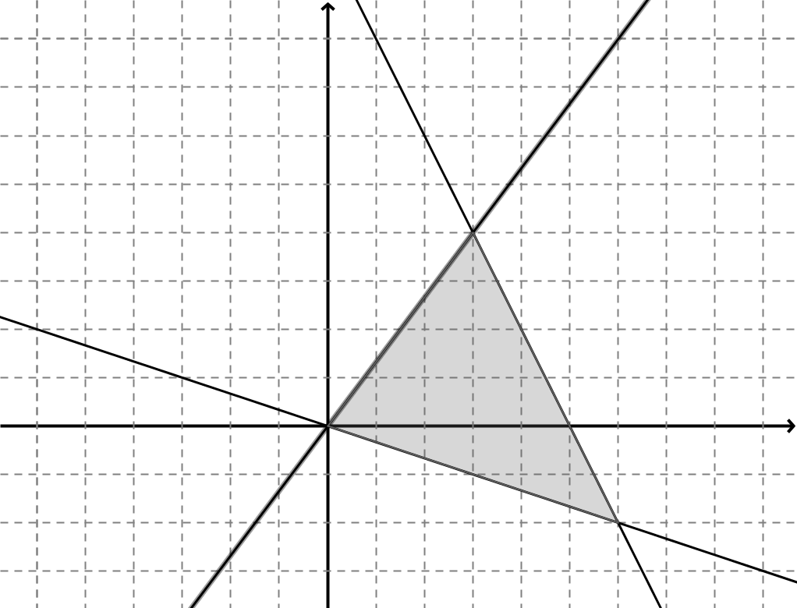

  - $\left(3, 4\right), \left(6, -2\right), \left(0, 0\right)$
  - $≈18.03$ units
  - $15$ square units

- $2x-5y≥-14$ $3x+2y≤17$ $2x-y≤9$ $x+y≥0$
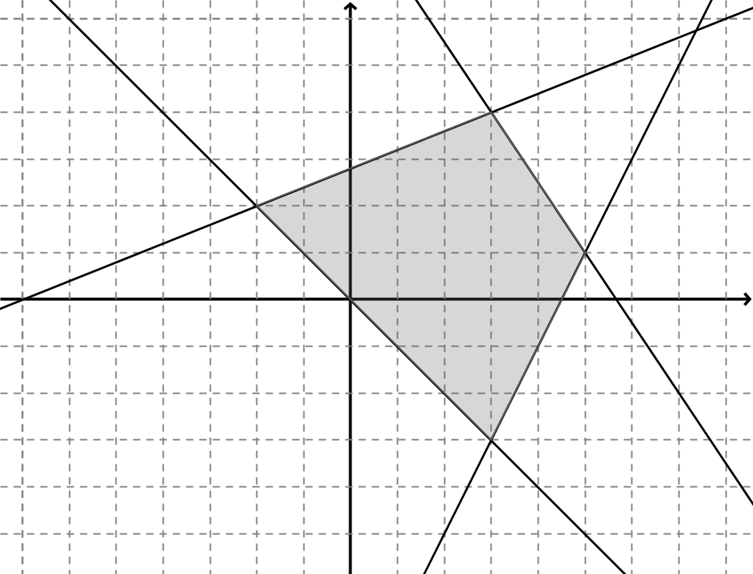

  - $\left(3, 4\right), \left(5, 1\right), \left(3, -3\right), \left(-2, 2\right)$
  - $≈20.53$ units
  - $24.5$ square units

