Lesson 10: Perimeter and Area of Polygonal Regions in the Cartesian Plane

Classwork
Opening Exercise
Find the area of the triangle given. Compare your answer and method to your neighbor’s and discuss differences.
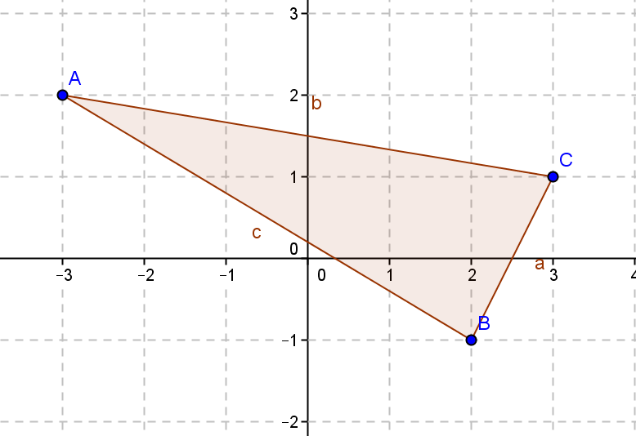

Exercises 1–6
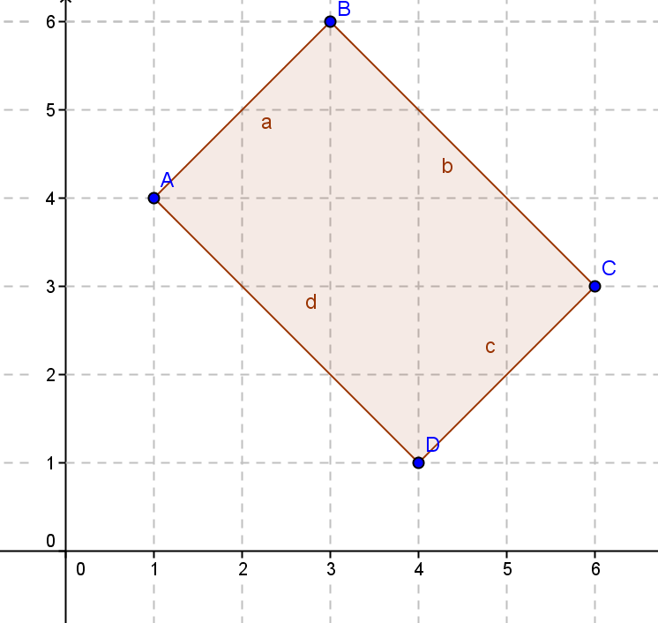
- Given rectangle $ABCD$:
  - Identify the vertices.

  - Find the perimeter using the distance formula.

  - Find the area using the area formula.

  - List the vertices starting with $A$ moving counterclockwise.

  - Verify the area using the shoelace formula.

- Calculate the area and perimeter of the given quadrilateral using the shoelace formula.
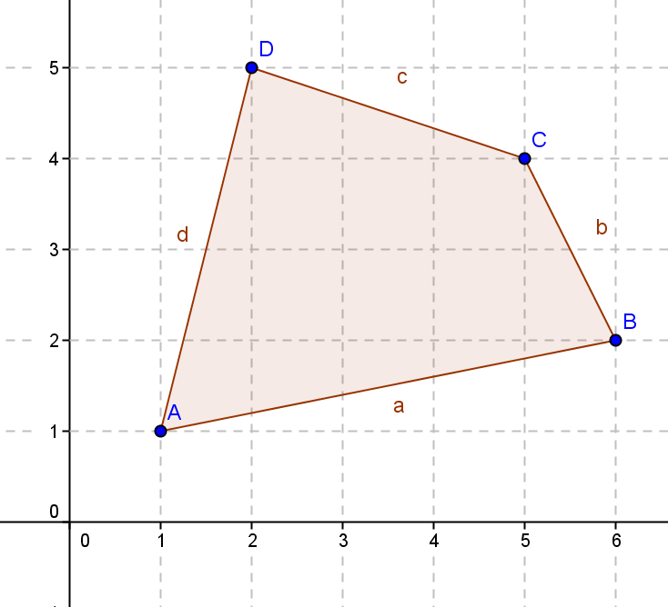

- Break up the pentagon to find the area using Green’s theorem. Compare your method with a partner.
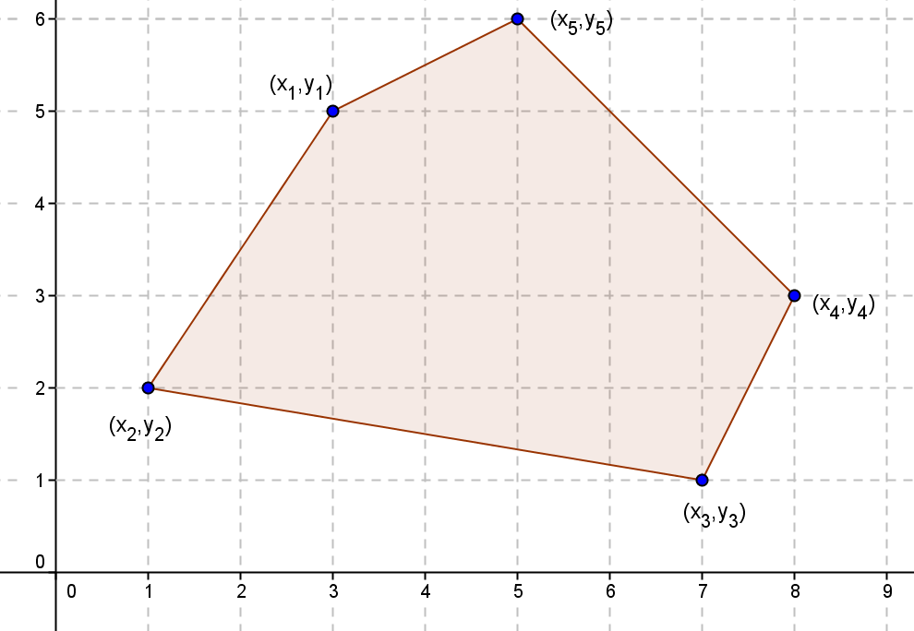

- Find the perimeter and the area of the quadrilateral with vertices $A(-3, 4), B(4, 6), C(2, -3),$ and $D(-4, -4)$.

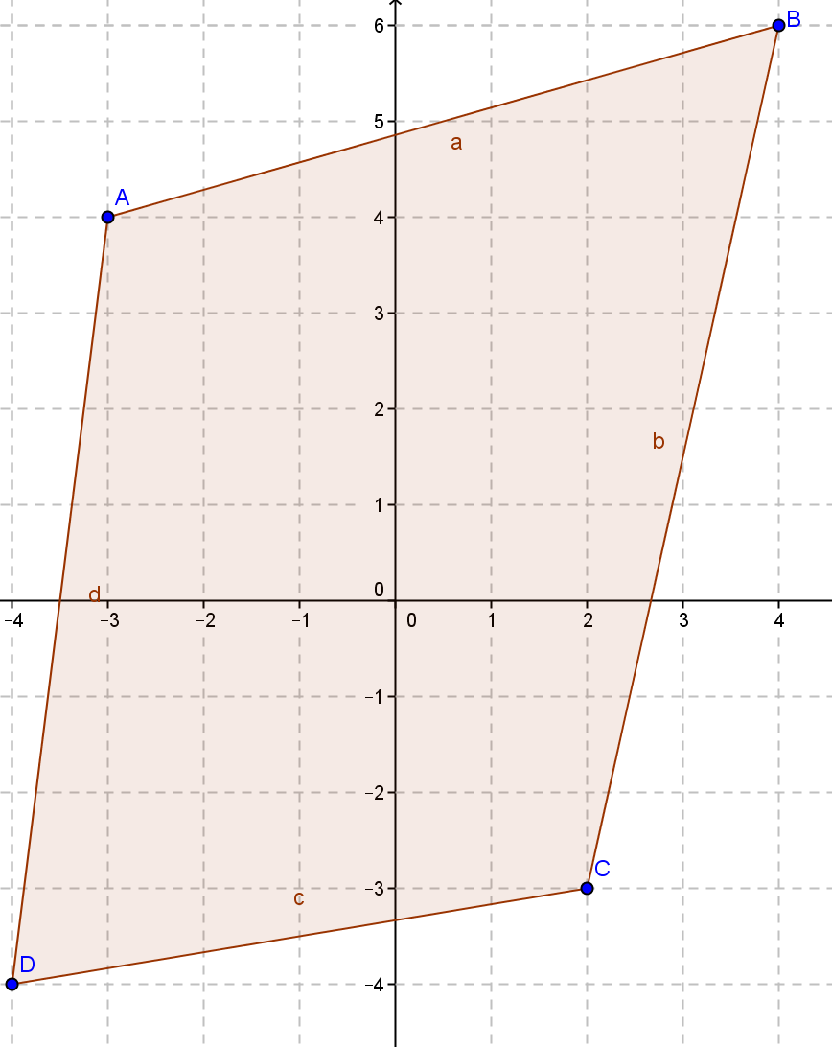

- Find the area of the pentagon with vertices $A(5, 8), B(4, -3), C(-1, -2), D(-2, 4),$ and$E(2, 6)$.

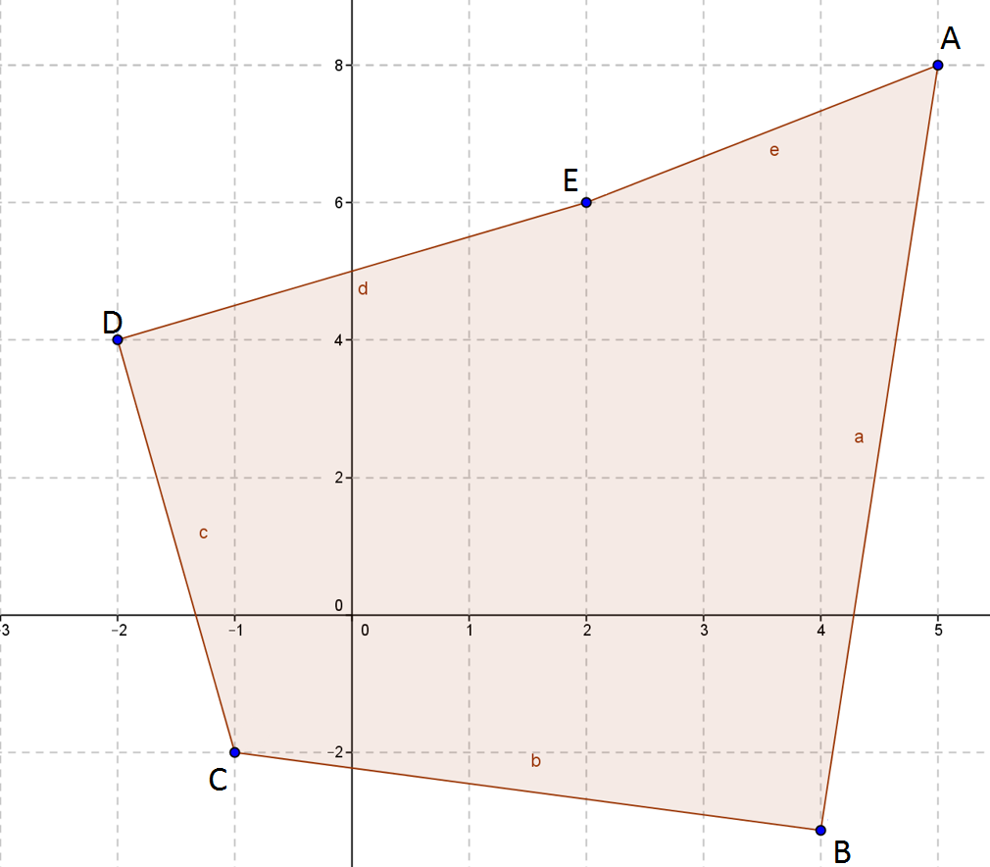

- Find the area and perimeter of the hexagon shown.
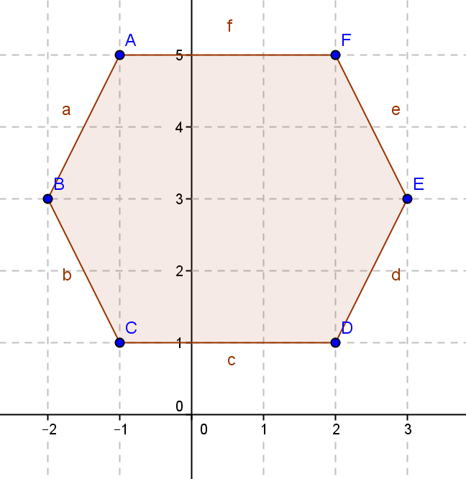

Problem Set

- Given triangle $ABC$ with vertices $(7, 4)$, $(1, 1)$, and $(9, 0)$:
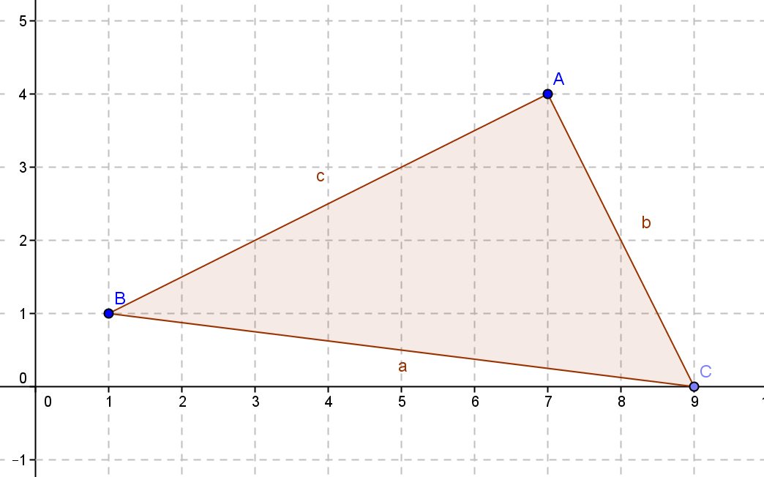

  - Calculate the perimeter using the distance formula.
  - Calculate the area using the traditional area formula.
  - Calculate the area using the shoelace formula.
  - Explain why the shoelace formula might be more useful and efficient if you were just asked to find the area.

- Given triangle $ABC$and quadrilateral $DEFG,$ describe how you would find the area of each and why you would choose that method, and then find the areas.
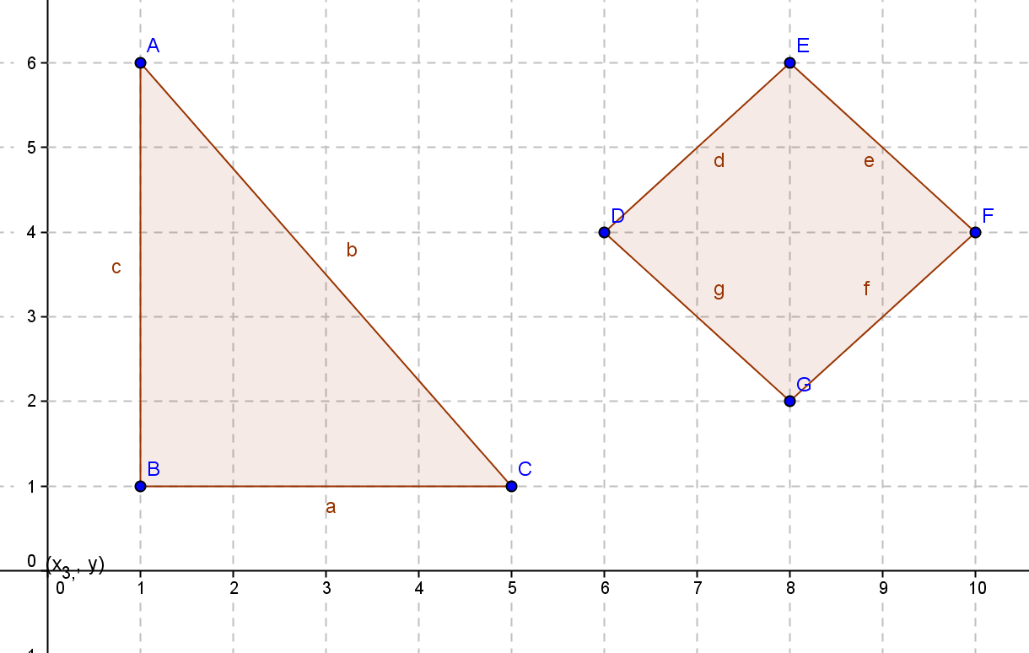

- Find the area and perimeter of quadrilateral $ABCD$ with vertices $A(6, 5), B(2, -4), C(-5, 2),$and$D(-3, 6).$
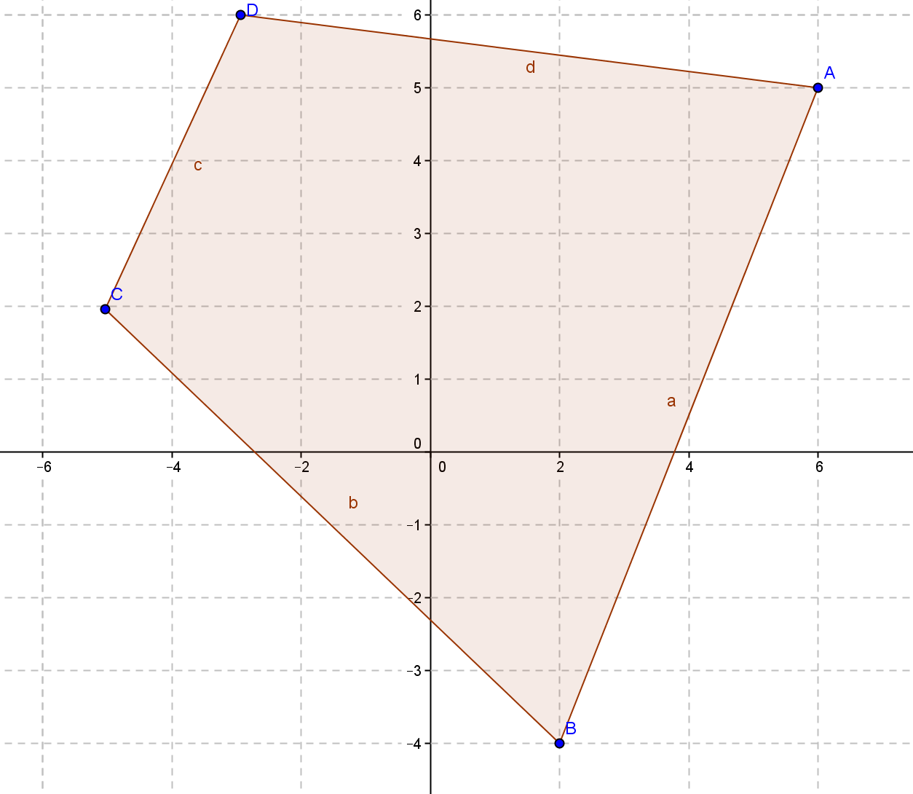

- Find the area and perimeter of pentagon $ABCDE$ with vertices $A(2, 6), B(7, 2), C(3, -4), D(-3, -2),$and$E(-2, 4).$
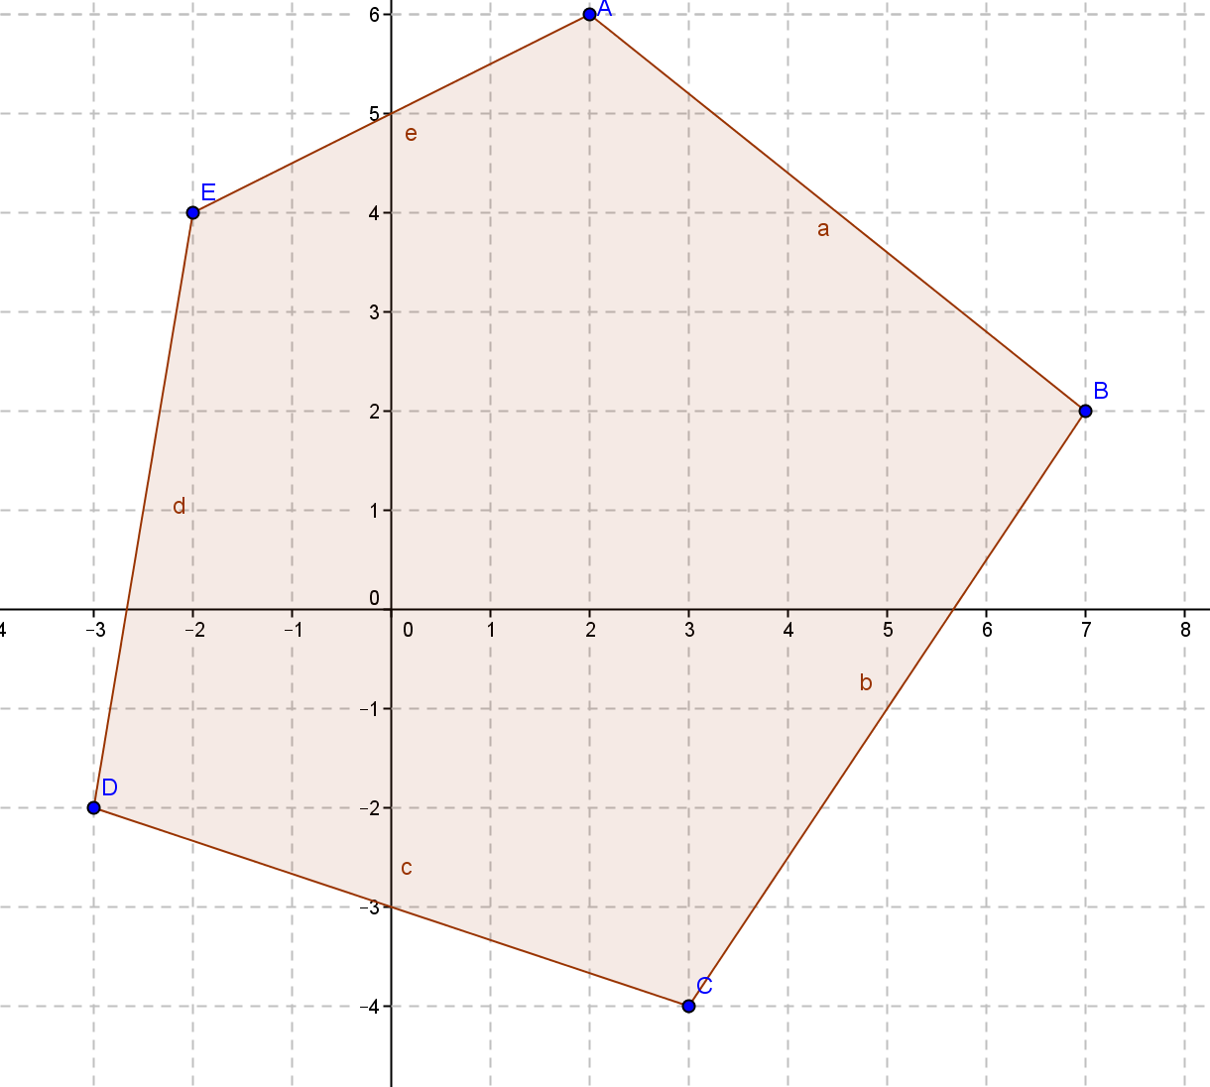

- Show that the shoelace formula (Green’s theorem) used on the trapezoid shown confirms the traditional formula for the area of a trapezoid $\frac{1}{2}\left(b_{1}+b_{2}\right)∙h.$
