|  |
| --- |
|  |

Lesson 10: Perimeter and Area of Polygonal Regions in the Cartesian Plane

Student Outcomes

* Students find the perimeter of a quadrilateral in the coordinate plane given its vertices and edges.
* Students find the area of a quadrilateral in the coordinate plane given its vertices and edges by employing Green’s theorem.

*Scaffolding:*

* Give students time to struggle with these questions. Add more questions as necessary to scaffold for struggling students.
* Consider providing students with pre-graphed quadrilaterals with axes on grid-lines.
* Go from concrete to abstract by starting with finding the area by decomposition, then translating one vertex to the origin, then using the shoelace formula.
* Post shoelace diagram and formula from Lesson 9.

Classwork

Opening Exercise (5 minutes)

The Opening Exercise allows students to practice the shoelace method of finding the area of a triangle in preparation for today’s lesson. Have students complete the exercise individually, and then compare their work with a neighbor’s. Pull the class back together for a final check and discussion.

If students are struggling with the shoelace method, they can use decomposition.

**Opening Exercise**

**Find the area of the triangle given. Compare your answer and method to your neighbor’s and discuss differences.**

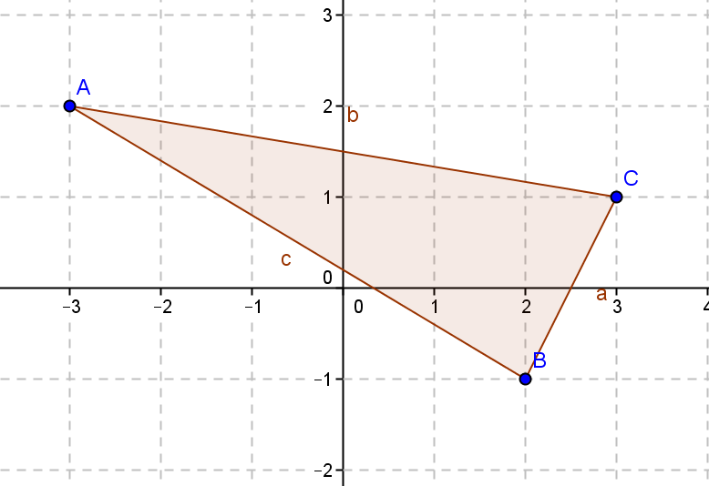

|  |  |
| --- | --- |
| **Shoelace Formula**  **Coordinates:**  **Area Calculation:**  **Area: square units** | **Decomposition**  **Area of Rectangle: square units**  **Area of Left Rectangle: square units**  **Area of Bottom Right Triangle: square unit**  **Area of Top Right Triangle: square units**  **Area of Shaded Triangle:**  **square units** |

Discussion (15 minutes)

In this lesson, students extend the area formulas for triangles studied in Lesson 9 to quadrilaterals and discover that the formula works for any polygonal region in the coordinate plane. Remind students that they should pick a starting point, and then initially move in a counterclockwise direction as they did in Lesson 9.

* 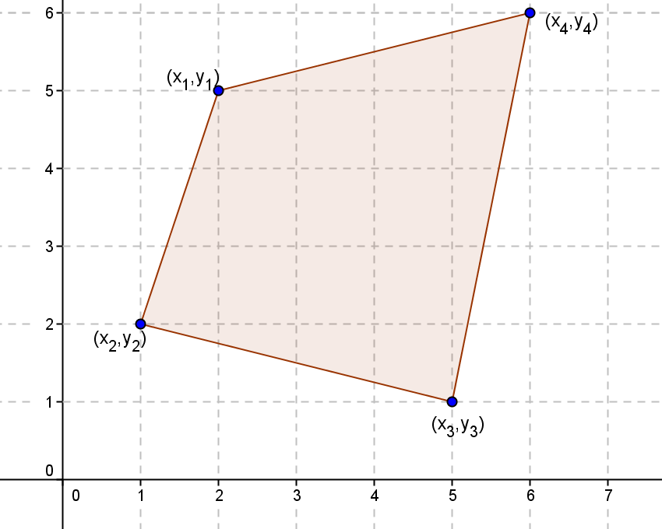Recall the question that we ended with last lesson: Does the shoelace area formula extend to help us find the areas of quadrilaterals in the plane? Look at the quadrilateral given—any thoughts?

Allow students time to come up with ideas, but try to lead them eventually to decomposing the quadrilateral into triangles so you can use the formula from Lesson 9. Have students each try the method they suggest initially and compare and contrast methods.

**MP.7**

* + *Answers will vary. Students may suggest enclosing the quadrilateral in a rectangle and subtracting triangles as we did in the beginning of Lesson 9. They may suggest measuring and calculating from traditional area formulas. Try to lead them to suggest that we can divide the quadrilateral into two triangles and use the formula from the last lesson to find each area, and then add the two areas.*
* Let’s try it and see if it works. We will assign the numerical values to the coordinates first, find the area of each triangle and add them together, then verify with the shoelace formula for the full quadrilateral. Once we determine that the formula extends, we will write the general formula. For consistency, let’s imagine we are walking around the polygon in a counterclockwise direction. This will help us be consistent with the order we list the vertices for the triangle and force us to be consistent in the direction that we apply the shoelace formula within each triangle.



* What are the vertices of the triangle on the left side?
* Find the area of that triangle using the shoelace formula.
  + *square units*
* What are the vertices of the triangle on the right side?
* Find the area of that triangle using the shoelace formula.
  + *square units*
* What is the area of the quadrilateral?
  + *square units*
* How do you think we could apply the shoelace theorem using four vertices?
  + *Pick one vertex, and apply the formula moving in a counterclockwise direction.*
* Now let’s try the shoelace formula on the quadrilateral without breaking it apart. Let’s start with the vertex labeled and move counterclockwise. Let’s start by listing the vertices in order.
* Now apply the formula using consecutive vertices.
  + *square units*
* What do you notice?
  + *The areas are the same; the formula works for quadrilaterals.*

The next part of the lesson will have students developing a general formula for the area of a quadrilateral. Put students in groups and allow them to work according to their understanding. Some groups will be able to follow procedures from today and yesterday and do the work alone. Others may need direct teacher assistance, get guidance only when they signal for it, or use the questions below to guide their thinking. Bring the class back together to summarize.

* Now let’s develop a general formula that we can use with coordinates listed as
* What is the area of the triangle on the left? Of the triangle on the right?
* *Area left:*



* *Area right:*



* Now add the two triangles. Do you see any terms that cancel?
  + *Those that involve just the coordinates cancel; that is, the terms that match the coordinates of the endpoints of the common line to the two triangles we created.*
* What is the formula for the area of the quadrilateral?
* Is there a shoelace formula?
* Summarize what you have learned so far in writing and share with your neighbor.
* The shoelace formula can also be called Green’s theorem. Green’s theorem is a high school Geometry version of the exact same theorem that students learn in Calculus III (along with Stokes’ theorem and the divergence theorem). Students only need to know that the shoelace formula can also be referred to as Green’s theorem.

The Problem Set in the previous lesson was important. It shows that if one chooses a direction to move around the polygon, and then moves in the same direction for the other triangle, then all areas calculated will have the same sign—they will both be either positive and correct, or they will each be incorrect by a minus sign. This means, when adding all the numbers we obtain, the total will either be the correct positive area or the correct value off by a minus sign. It is important to always move in a counterclockwise direction so that area is always positive.

Notice too that in choosing this direction for each triangle, the common interior line is traversed in one direction by one triangle and the opposite direction by the other.

The exercises are designed so that different students can be assigned different problems. All students should do Problem 1 so that they can see the value in the shoelace formula (Green’s theorem). After that, problems can be chosen to meet student needs. Some of these exercises can also be included as Problem Set problems.

Exercises 1–6 (17 minutes)

Exercises 1–6

1. 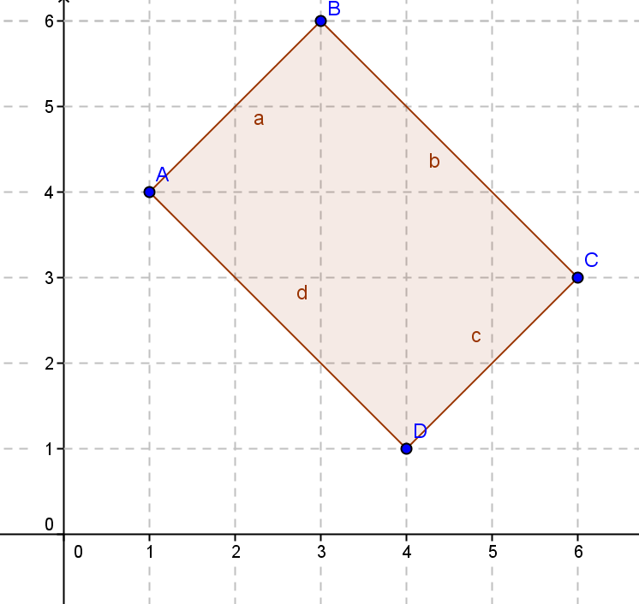Given rectangle :
   1. Identify the vertices.

,,,

* 1. Find the perimeter using the distance formula.

units

* 1. Find the area using the area formula.

square units

* 1. List the vertices starting with moving counterclockwise.

,, ,

* 1. Verify the area using the shoelace formula.

1. 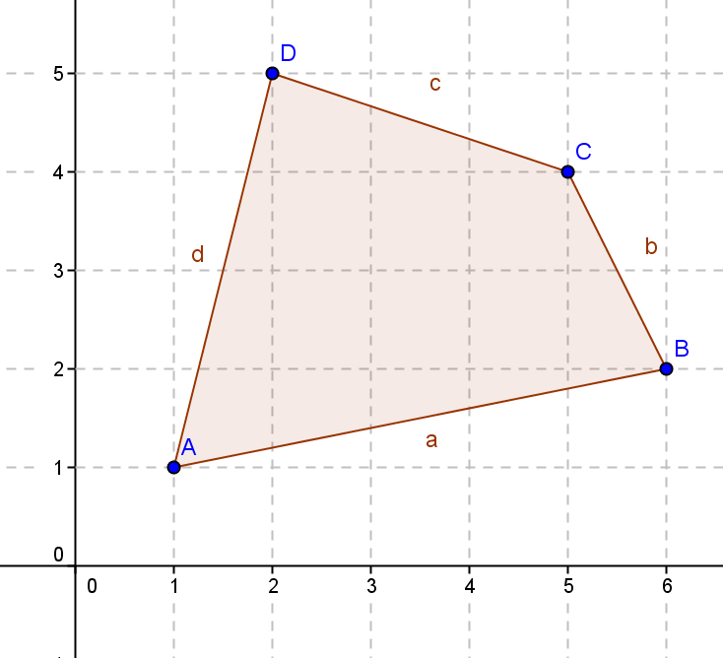Calculate the area and perimeter of the given quadrilateral using the shoelace formula.

Areasquare units

Perimeter units

1. Break up the pentagon to find the area using Green’s theorem. Compare your method with a partner.

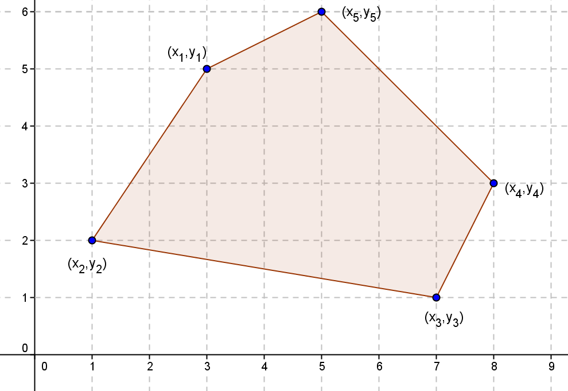

Answers will vary. If broken into a triangle with vertices,, and and a quadrilateral with vertices , ,, and, the formula would be

1. 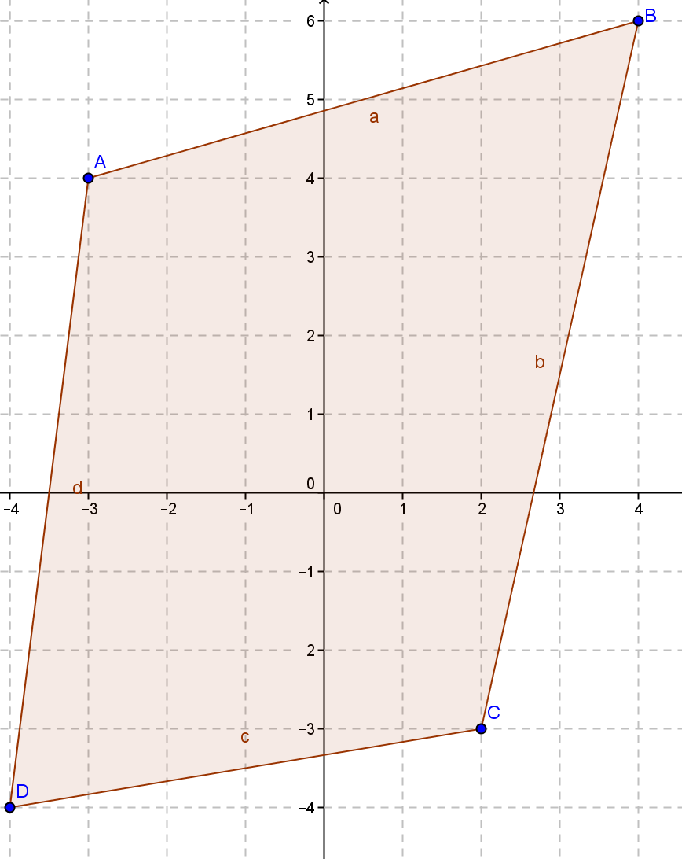Find the perimeter and the area of the quadrilateral with vertices , ,, and .

Perimeter units

Area square units

1. Find the area of the pentagon with vertices ,,,, and.

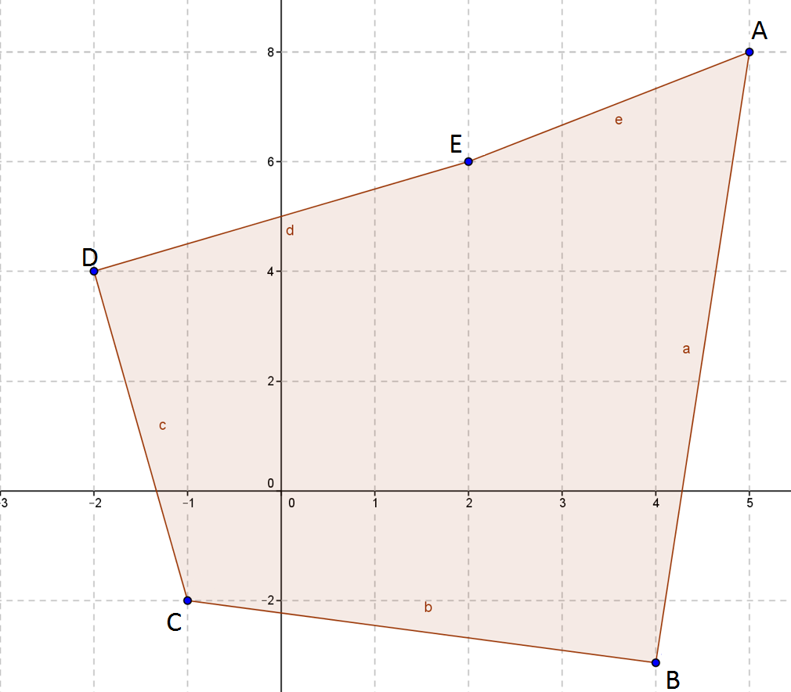

Area:

square units

1. Find the area and perimeter of the hexagon shown.

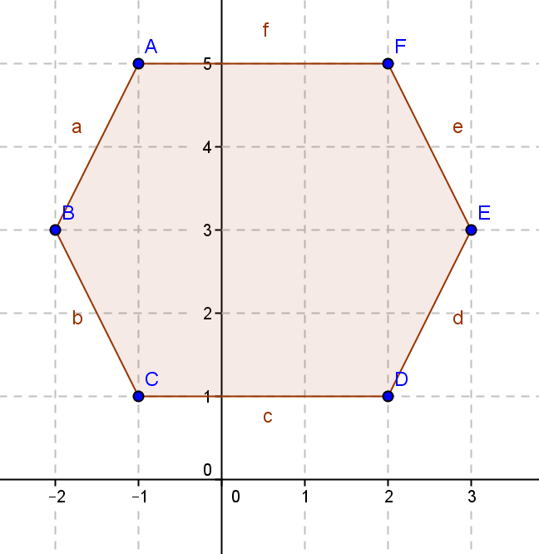Area:

square units

Perimeter: units

Closing (3 minutes)

Gather the class together and present the picture with the following question. Have a class discussion about the value and efficiency of the shoelace formula.

* Describe different ways of calculating the area of this figure. What are the advantages and disadvantages of each?



* + You could decompose the quadrilateral into two rectangles and use the area of a triangle formula. You could use the shoelace formula (Green’s theorem).
  + Decomposing allows you to find the area without memorizing a formula but may be time consuming. Green's theorem may be quicker but more prone to a computational error.

Exit Ticket (5 minutes)

Name Date

Lesson 10: Perimeter and Area of Polygonal Regions in the Cartesian Plane

Exit Ticket

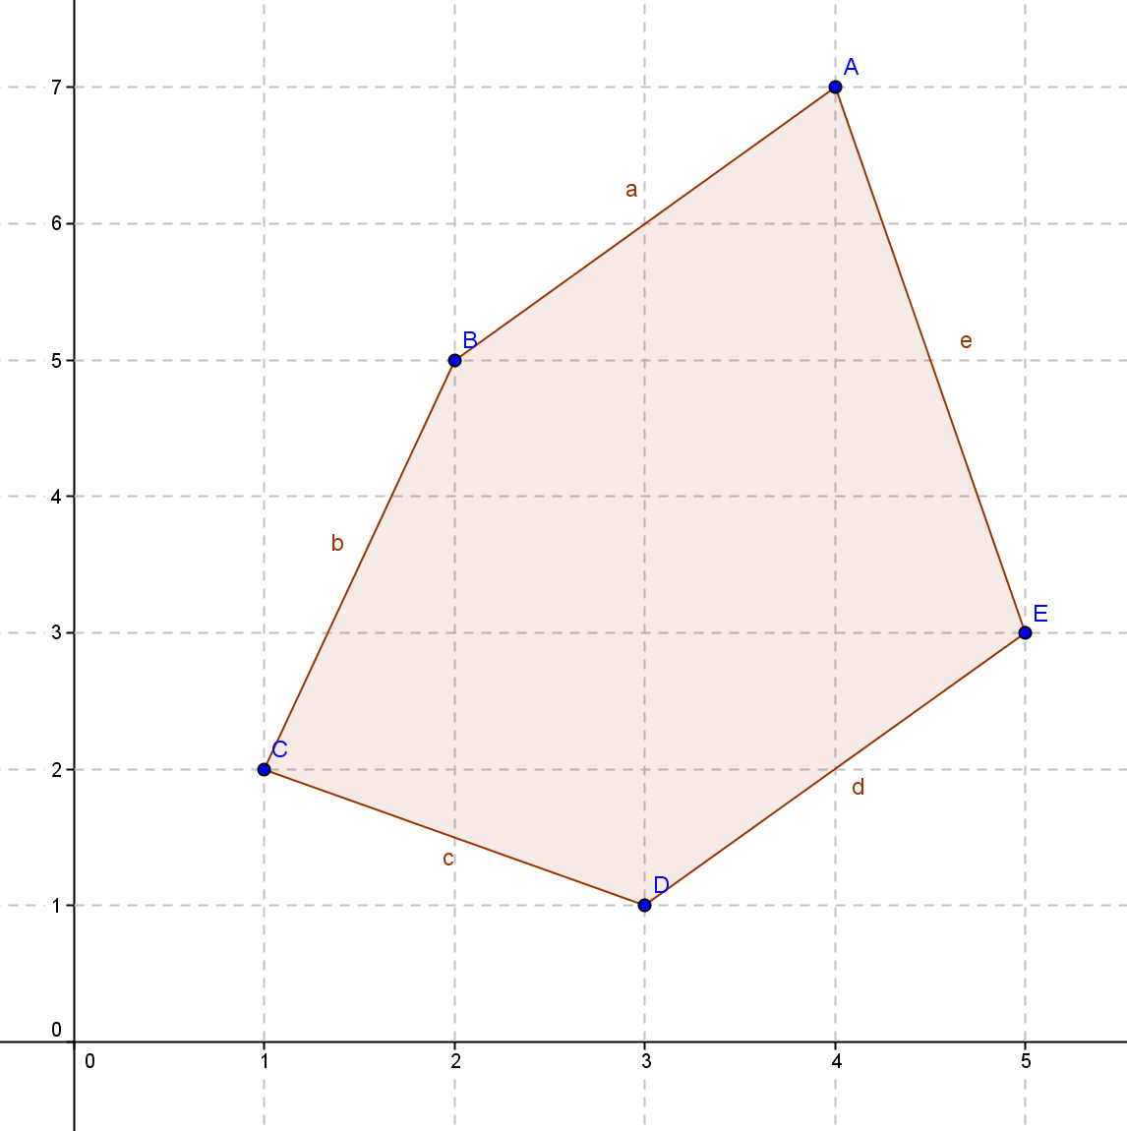Cory is using the shoelace formula to calculate the area of the pentagon shown. The pentagon has vertices , ,, , and . His calculations are below. Toya says his answer can’t be correct because the area in the region is more than square units. Can you identify and explain Cory’s error and help him calculate the correct area?

Cory’s work:

Exit Ticket Sample Solutions

Cory is using the shoelace formula to calculate the area of the pentagon shown. The pentagon has vertices , ,, , and . His calculations are below. Toya says his answer can’t be correct because the area in the region is more than square units. Can you identify and explain Cory’s error and help him calculate the correct area?

Cory’s work:

***Cory left out the last pair of calculations in both directions. He did not return to his starting point. The calculation should be square units***

Problem Set Sample Solutions

1. 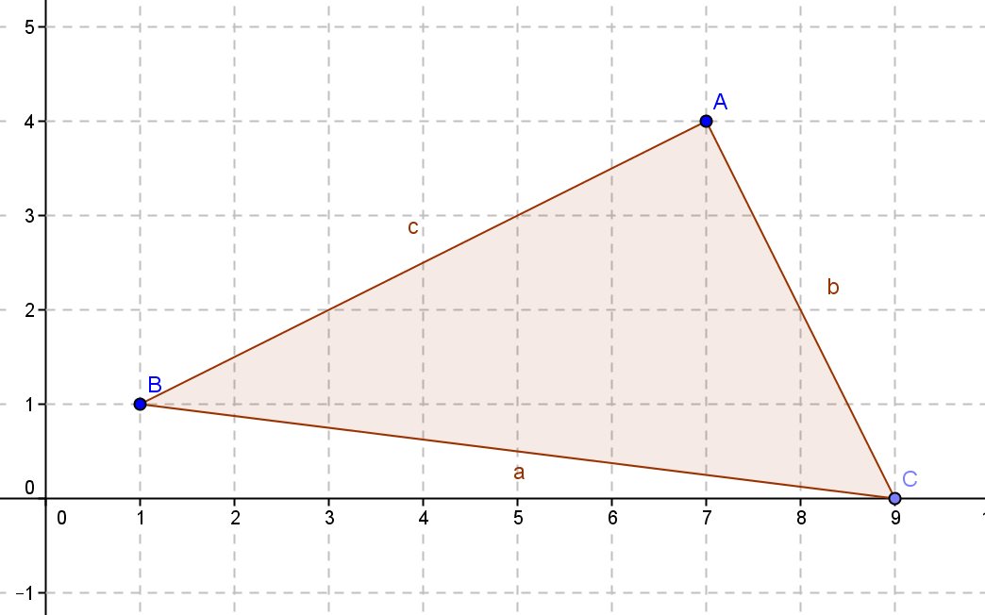Given triangle with vertices , , and :
   1. Calculate the perimeter using the distance formula.

Perimeter: units

* 1. Calculate the area using the traditional area formula.

Area: square units

* 1. Calculate the area using the shoelace formula.

Area: square units

* 1. Explain why the shoelace formula might be more useful and efficient if you were just asked to find the area.

To use the shoelace formula, all you need are the coordinates of the vertices; you would not have to use the distance formula.

1. Given triangle and quadrilateral , describe how you would find the area of each and why you would choose that method, and then find the areas.

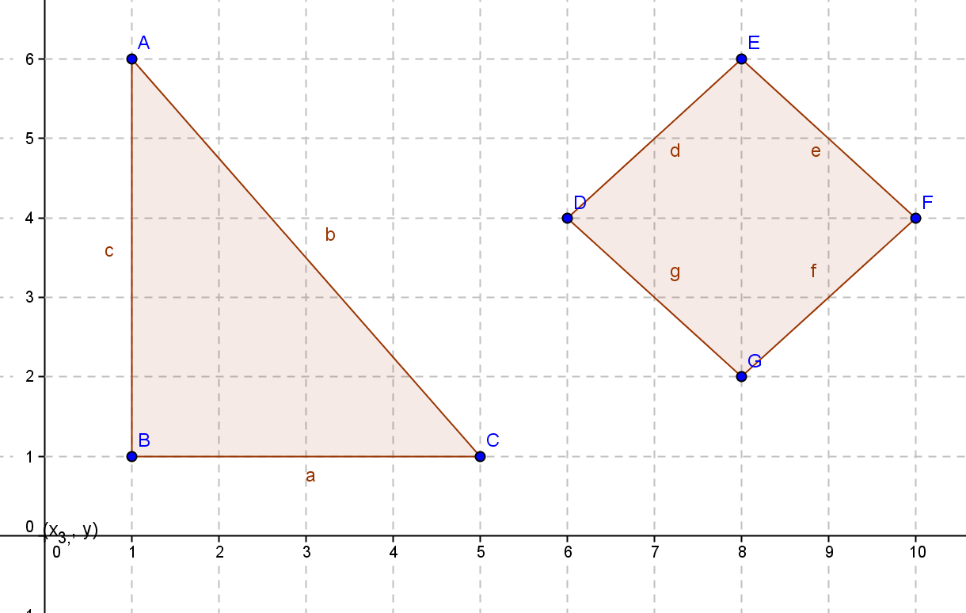

The triangle is a right triangle, and the length and height can be read from the graph, so it would be easiest to find its area by the traditional area formula. Area: square units

To find the area of the quadrilateral, I would use the shoelace formula because the traditional formula would require use of the distance formula first. Area: square units

1. 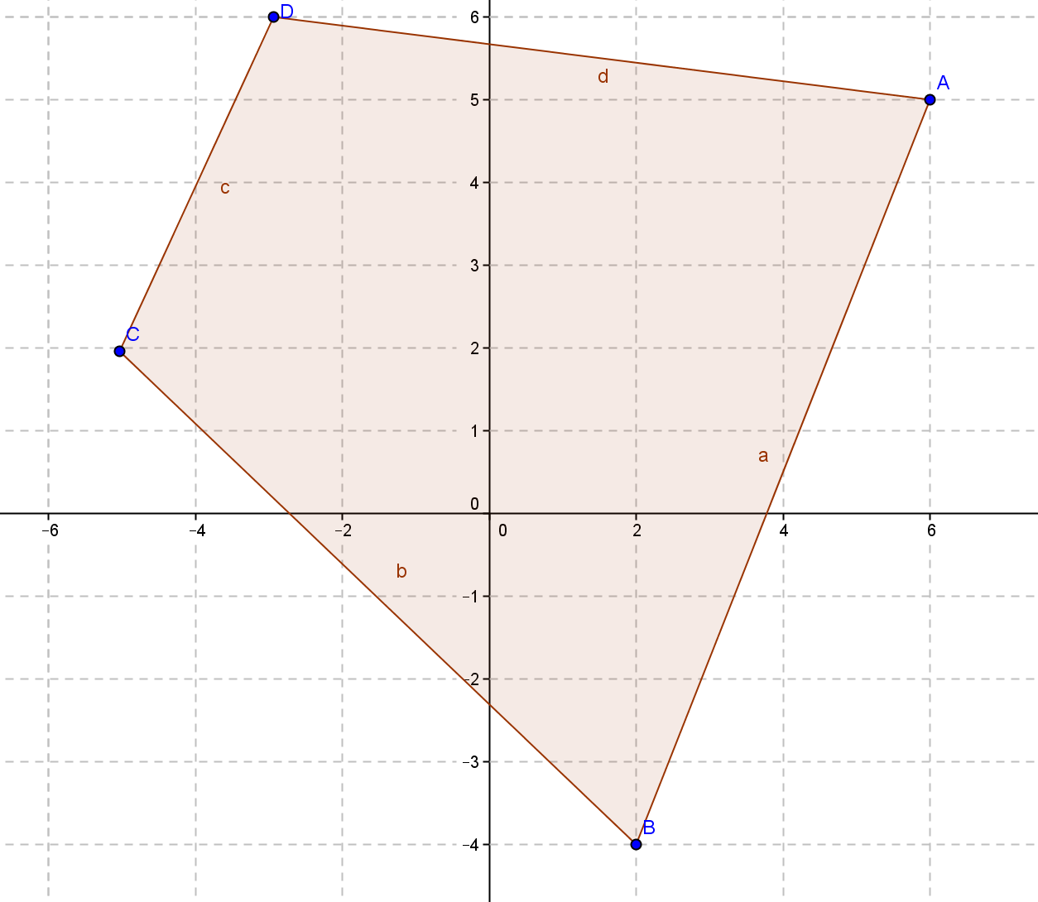Find the area and perimeter of quadrilateral with vertices , , , and.

Area: square units

Perimeter:

1. 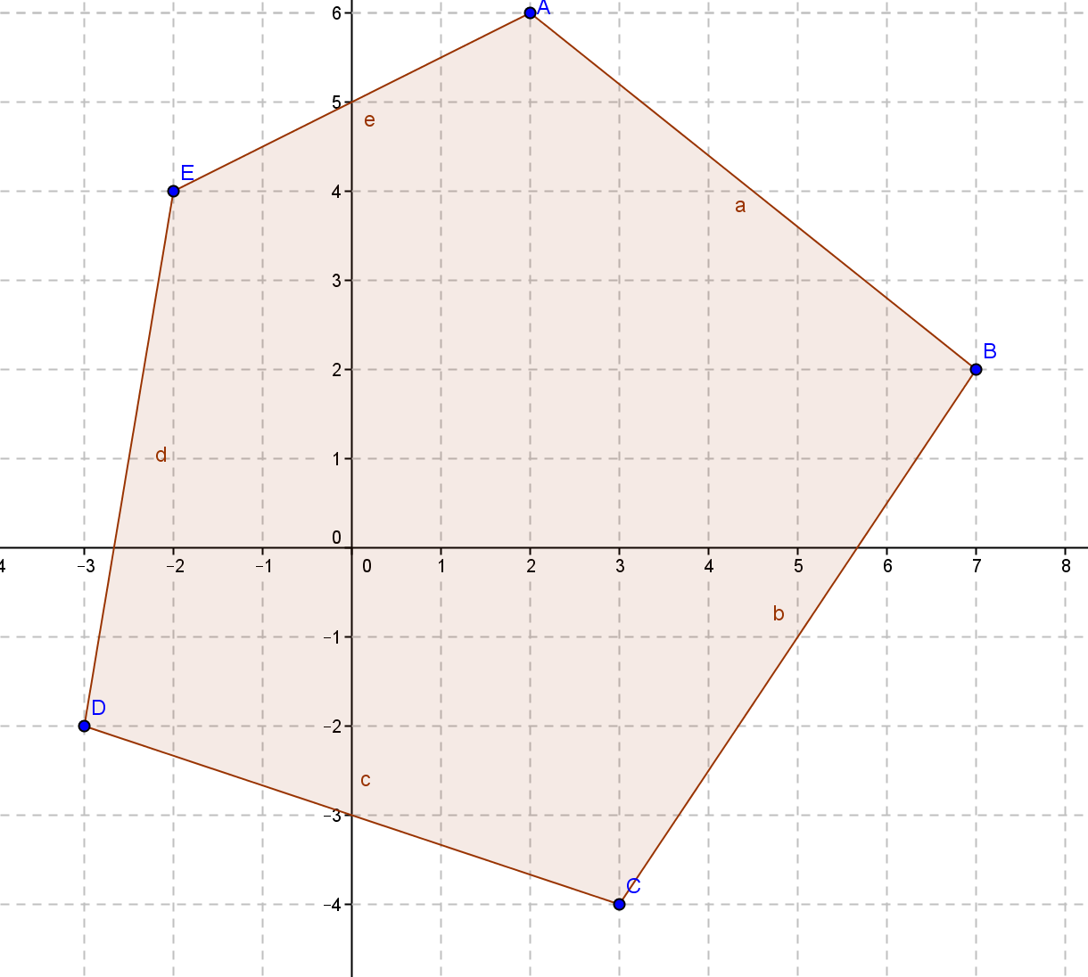Find the area and perimeter of pentagon with vertices , ,, , and.

Area: square units

Perimeter: units

1. Show that the shoelace formula (Green’s theorem) used on the trapezoid shown confirms the traditional formula for the area of a trapezoid

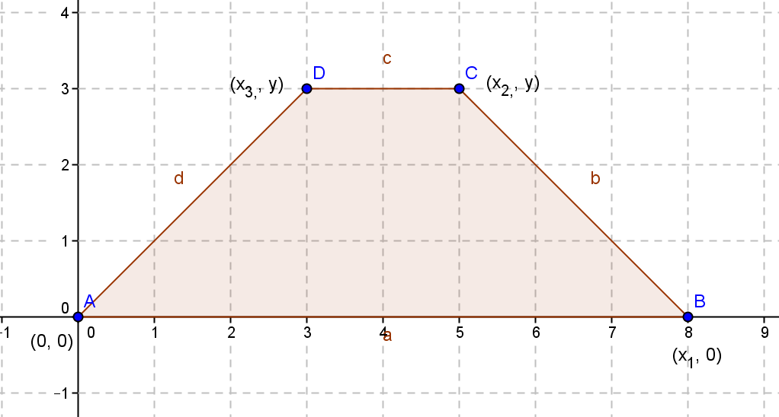

Traditional using coordinates listed:

,,

Shoelace formula: