Lesson 9: Perimeter and Area of Triangles in the Cartesian Plane

Classwork
Opening Exercises
Find the area of the shaded region.
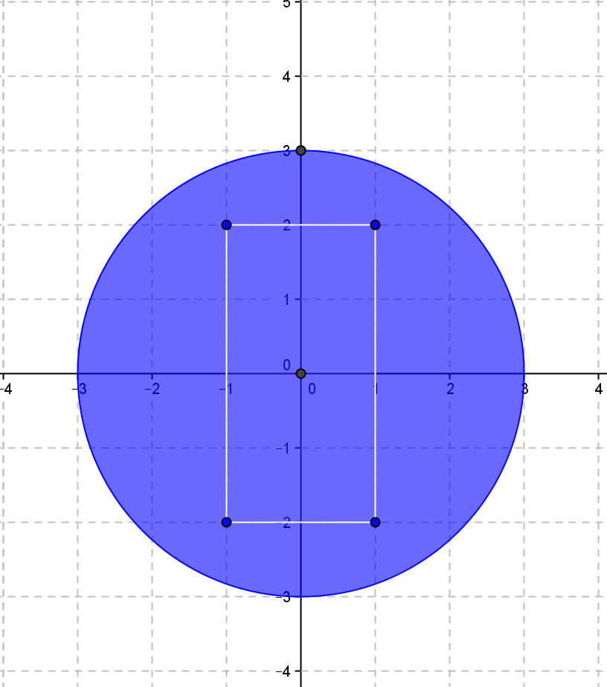
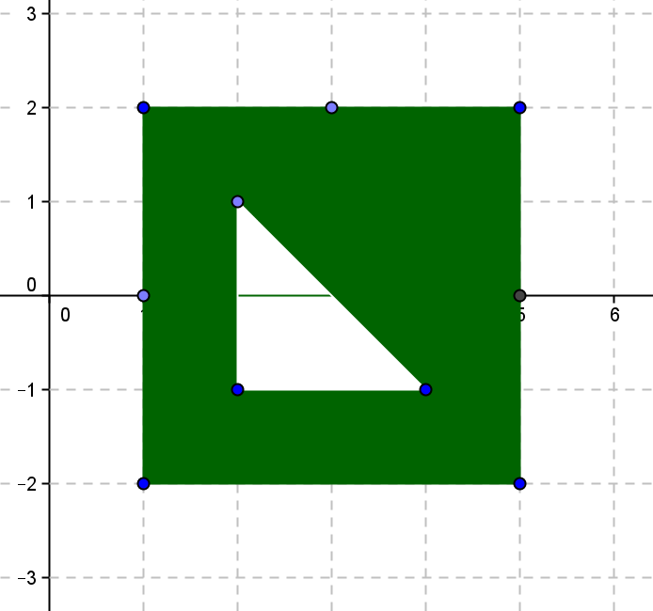
  - b.

Example 1
Consider a triangular region in the plane with vertices $O(0, 0)$,$A(5, 2)$, and $B(3, 4).$ What is the perimeter of the triangular region?

What is the area of the triangular region?

Find the general formula for the area of the triangle with vertices $O(0, 0)$,$A(x_{1},y_{1})$, and $B(x_{2}, y_{2})$ as shown.
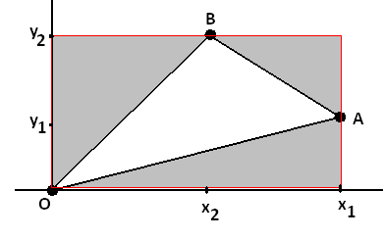

Does the formula work for this triangle?
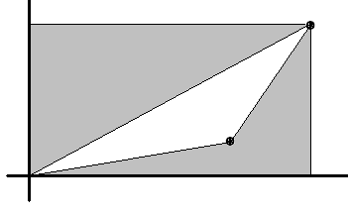

Exercise 1
Find the area of the triangles with vertices listed, first by finding the area of the rectangle enclosing the triangle and subtracting the area of the surrounding triangles, then by using the formula $\frac{1}{2}(x_{1}y_{2}-x_{2}y_{1})$.
  - $O(0, 0), A(5, 6), B(4, 1)$

  - $O(0, 0), A(3, 2), B (-2, 6)$

  - $O(0, 0), A(5, -3), B(-2, 6)$

Problem Set

- Use coordinates to compute the perimeter and area of each polygon.
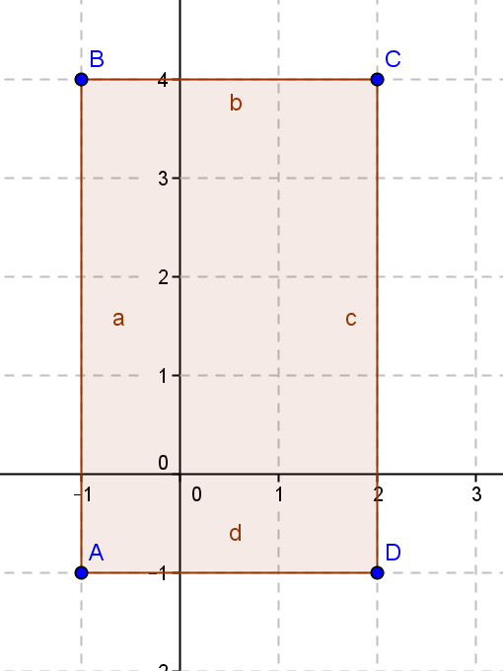 | 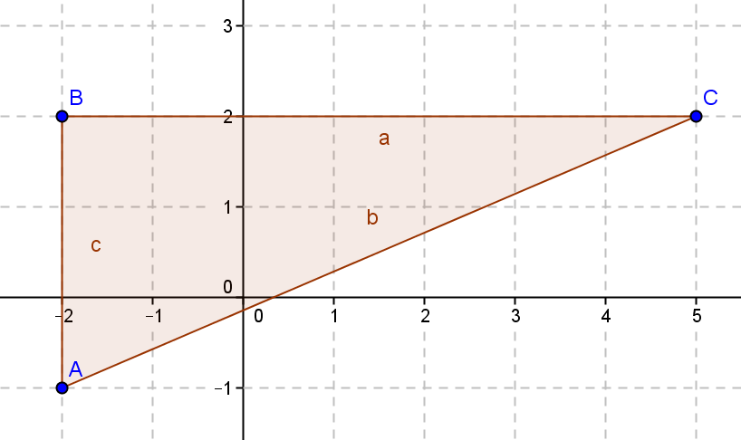

- Given the figures below, find the area by decomposing into rectangles and triangles.
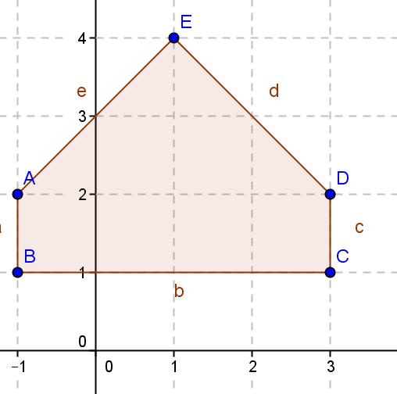
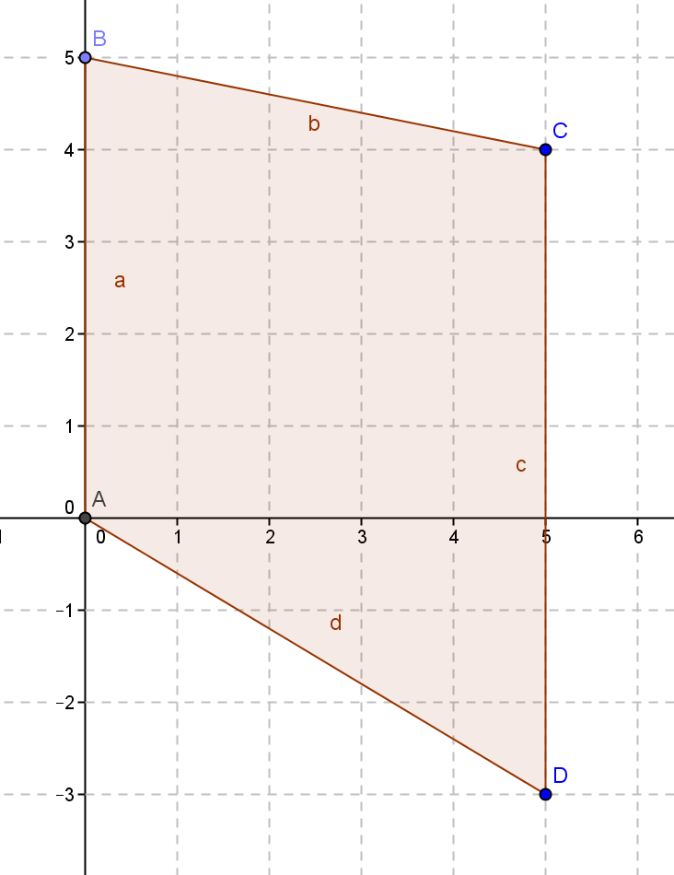

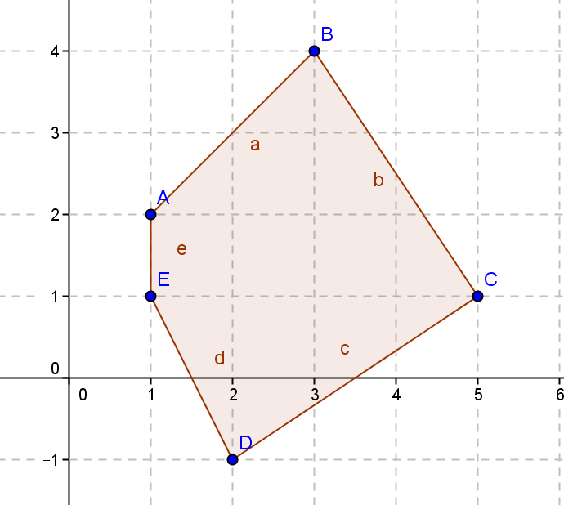
- Challenge: Find the area by decomposing the given figure into triangles.

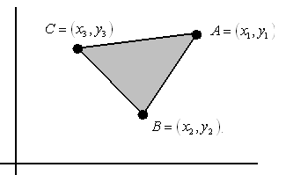
- When using the shoelace formula to work out the area of $△ABC$, we have some choices to make. For example, we can start at any one of the three vertices $A$, $B$, or $C$, and we can move either in a clockwise or counterclockwise direction. This gives six options for evaluating the formula.
Show that the shoelace formula obtained is identical for the three options that move in a clockwise direction ($A$ to $C$ to $B$ or $C$ to $B$ to $A$ or$B$ to$A$ to$C$) and identical for the three options in the reverse direction. Verify that the two distinct formulas obtained differ only by a minus sign.

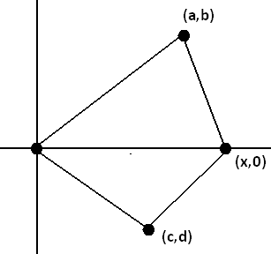
- Suppose two triangles share a common edge. By translating and rotating the triangles, we can assume that the common edge lies along the $x$-axis with one endpoint at the origin.
  - Show that if we evaluate the shoelace formula for each triangle, both calculated in the same clockwise direction, then the answers are both negative.
  - Show that if we evaluate them both in a counter-clockwise direction, then both are positive.
  - Explain why evaluating one in one direction and the second in the opposite direction, the two values obtained are opposite in sign.

- A textbook has a picture of a triangle with vertices $(3, 6)$ and $(5, 2)$. Something happened in printing the book and the coordinates of the third vertex are listed as $(-1, )$. The answers in the back of the book give the area of the triangle as $6$ square units.
  - What is the $y$-coordinate of the third vertex?
  - What if both coordinates were missing, but the area was known. Could you use algebra to find the third coordinate? Explain.

