|  |
| --- |
|  |

Lesson 9: Perimeter and Area of Triangles in the Cartesian Plane

Student Outcomes

* Students find the perimeter of a triangle in the coordinate plane using the distance formula.
* Students state and apply the formula for area of a triangle with vertices , , and .

Lesson Notes

In this lesson, students find the perimeter and area of triangles in the plane. Students realize that the distance formula is required to find perimeter. Finding the area will be more of a challenge, but the teacher will guide students to understand that surrounding the triangle by a rectangle allows students to compute the area of the rectangle and the three right triangles that surround it and subtract these quantities.

Classwork

Opening Exercises (5 minutes)

*Scaffolding:*

* If students are struggling with area, have them calculate the areas of the regions below and review how to find dimensions by counting.

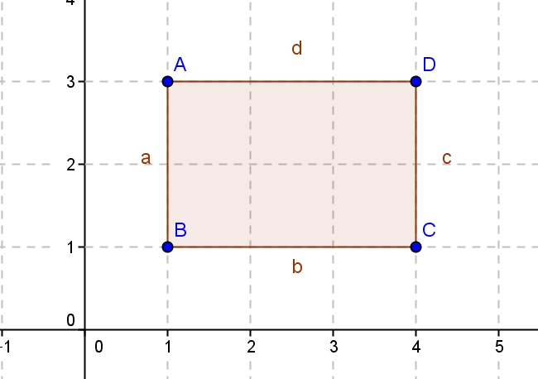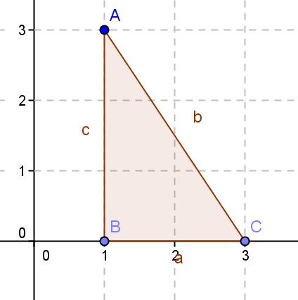

The Opening Exercise can be done as a whole-class modeling exercise, small-group work, or independent work. Students found area by decomposing in Grades 6 and 7 (Grade 6, Module 5, Lesson 5; Grade 7, Module 6, Lessons 21 and 22). This Opening Exercise reviews those concepts, allowing students to find dimensions by counting units and can be used as scaffolds for this lesson if needed.

Opening Exercises

Find the area of the shaded region.

|  |  |
| --- | --- |
|  |  |

**square units**  **square units**

**Example 1 (20 minutes)**

This is a guided example. Have all students find the perimeter of the area using the distance formula. When finding area, assign half the class to find the area of the given triangle using the area formula for a triangle (i.e., ). Ask the other half of the class to find the area by decomposing; in other words, ask students to find the area of the rectangle shown in the second drawing, and then subtract the shaded triangles to find the area of the unshaded triangle. Ask students to compare the process of each, and then come together for a class discussion. When assigning area, consider assigning the stronger students the area formula and struggling students the decomposition method.

Example 1

Consider a triangular region in the plane with vertices ,, and . What is the perimeter of the triangular region?

units

What is the area of the triangular region?

square units

* 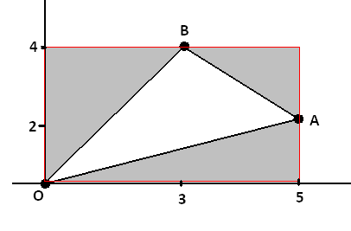Draw the triangle.

**MP.7**

* Can you find the perimeter of ?
  + *Yes, but we have to find the lengths of the sides.*
* Do you have any ideas how to find the side lengths?
  + *We can use the distance formula between each set of vertices.*
* What is the distance formula?
* Use the distance formula to find the length of , , and ?
  + *, 5, =*
* So what is the perimeter of ?
  + *units*
* Is a right triangle? Explain.
  + *No, .*
* Can you find the area of ?
  + *If we know the base and height perpendicular to the base, we can.*

Assign half the class to find the area by using the area formula and constructing the perpendicular height. Assign the other half of the class to think of another way (decomposition). Allow students to work in groups, and then proceed with the questions below as needed to help students using decomposition.

* Can you think of another way to find the area?

Scaffold with the following questions as needed to allow students to see that they can find the area by finding the area of the rectangle that encloses the triangle and then subtracting each of the surrounding right triangles.

* ****Can you draw a rectangle containing ? If so, draw it.
  + *See shaded rectangle to the right.*
* Can you find the area of the rectangle?

**MP.7**

* + *square units.*
* Can you see a way to find the area of ?
  + *Subtract the areas of the surrounding triangles.*
* Find the areas of each of the triangles.
  + *Left : square units*
  + *Right : square units*
  + *Bottom : square units*
* What is the area of ?
  + *square units*

Call groups back together, and allow both groups to present their solutions and compare methods. Have them discuss which method is easier to use and when it is easier to use the formula verses decomposition.

* Did we get the same answer with each method?
  + *Yes, both methods gave an area of square units.*
* Which method was easier to use and why?
  + *Decomposition was easier because constructing a rectangle around the triangle and finding the area of the rectangle was simple. Also, the triangles around the region were all right triangles, so again, the areas of the triangles were easy to find.*

*Scaffolding:*

* As students are developing general formulas for the area of triangles, let students struggle, and then ask only questions needed to move students to the next step.
* Students can try this numerical example to solidify this concept.

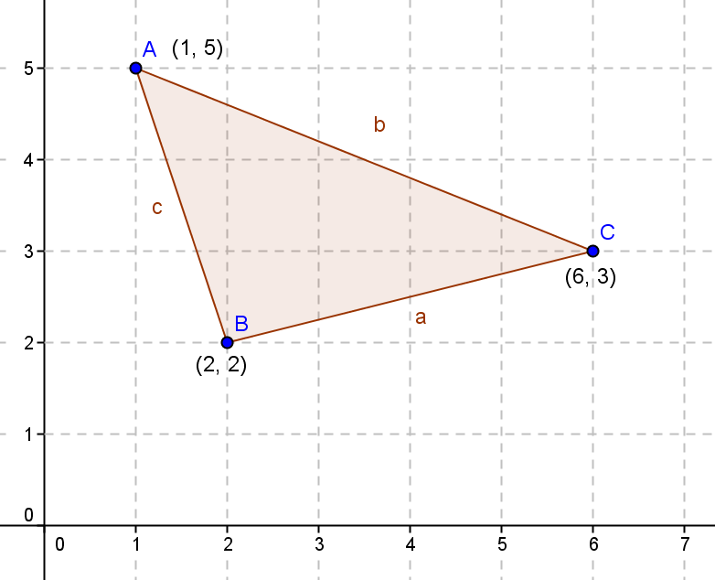

* When is it easier to use the area formula, and when is it easier to use decomposition?
  + *When the triangle is a right triangle, or when the base and height of the triangle are given, the area formula is easy to use. Otherwise, it is easier to use decomposition.*
* Can you help me develop a general formula for the area of any triangle with one vertex at using decomposition? Let’s call , , and .

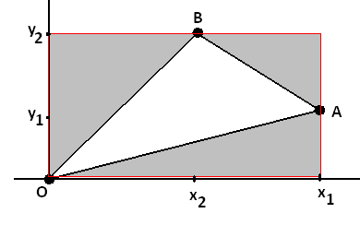Find the general formula for the area of the triangle with vertices ,, and as shown.

Let students struggle with this for a while following the steps modeled above. Scaffold as necessary.

* What is the area of the rectangle enclosing the triangle?
  + *square units*
* What is the area of the surrounding triangles?
  + *Left: square units*
  + *Right: square units*
  + *Bottom: square units*
* Write the general formula for the area of ?
* Expand the formula and simplify it.

Does the formula work for this triangle?

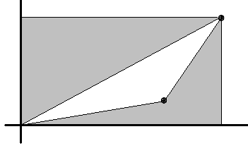

* Does the formula work for the triangle below?
  + *It does, but students may get either of these formulas: or depending on which point they labeled .*

These formulas differ by a minus sign. Let students compare their answer with their classmates. Make the point that the formulas depend on the choice of labeling the points but differ only by a minus sign. Students will always get a positive area if they order the points counterclockwise. The method that students should follow is (1) pick a starting point; (2) walk around the figure in a counterclockwise direction doing calculations with adjacent points; and (3) when they return to the starting point, reverse directions walking in a clockwise direction and completing the second half of the calculations.

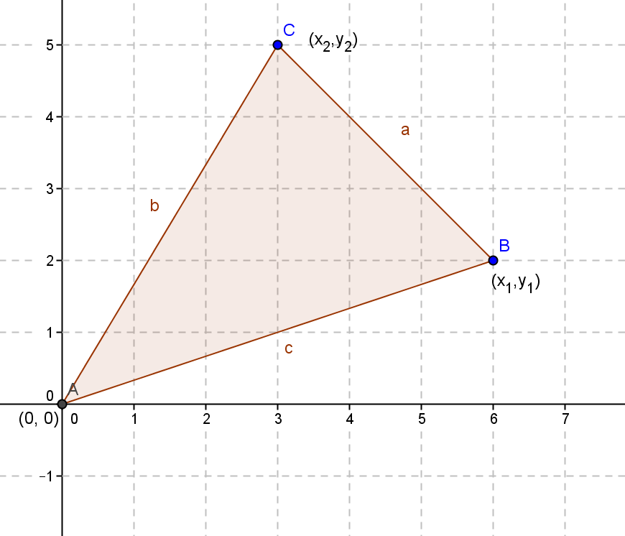

* Do you think this formula works for any triangle with one vertex at ? Does the quadrant matter?
  + *Answers will vary. Yes, it always works no matter the quadrant, and the area will be positive as long as is the next point in a counterclockwise direction.*
* Let’s try some problems and see if our formula always works.

Exercise 1 (5 minutes)

Students should find the area of the triangles by finding the area of the rectangle enclosing the triangle and subtracting the surrounding triangles. They should compare that area to the area derived by using the above formula.

Exercise 1

Find the area of the triangles with vertices listed, first by finding the area of the rectangle enclosing the triangle and subtracting the area of the surrounding triangles, then by using the formula .

square units

square units

square units

**Example 2 (8 minutes)**

This is a guided example.

* Did the formula work for all of the triangles?
  + *Yes, as long as one vertex was at .*
* 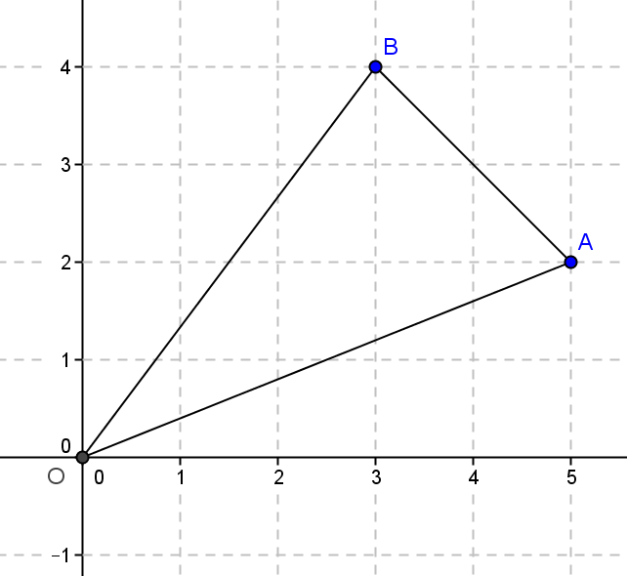In the Opening Exercise, we saw that the area of the triangle with vertices ,,and had an area of square units. Can you find the area of a triangle with vertices ,,and ?
  + *square units*
* How did you find it so quickly?
  + *All of the points were just translated right units and down units, so the area was the same.*

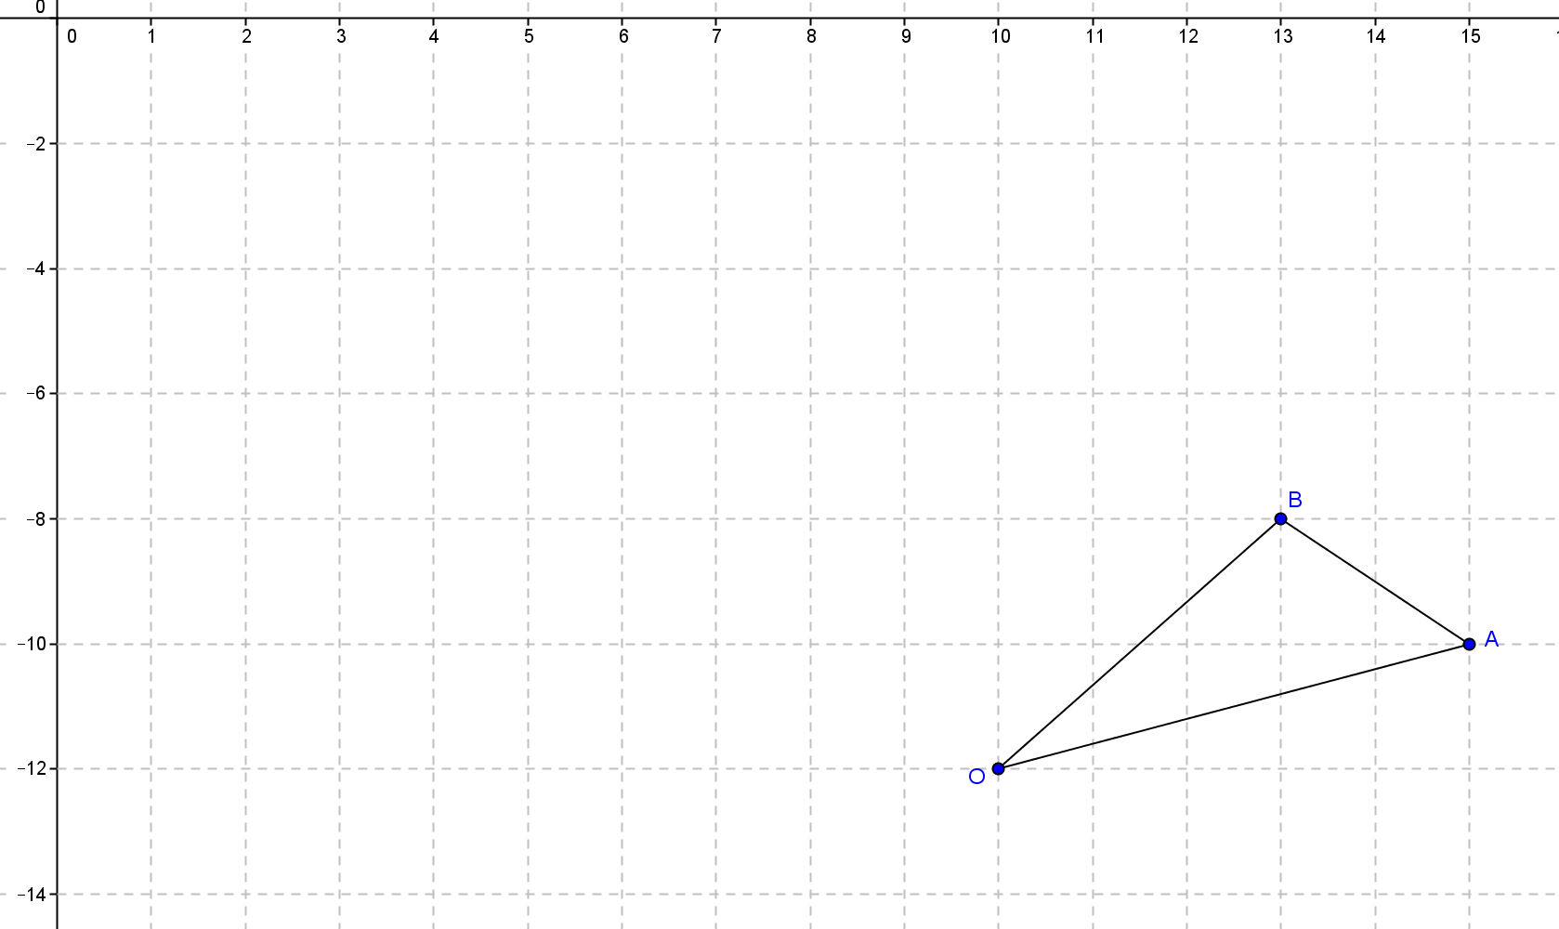

* Can you find a general formula for the area of a triangle with coordinates ,, and ? (Students should see that if we translate one vertex to , we can use our formula.)
  + 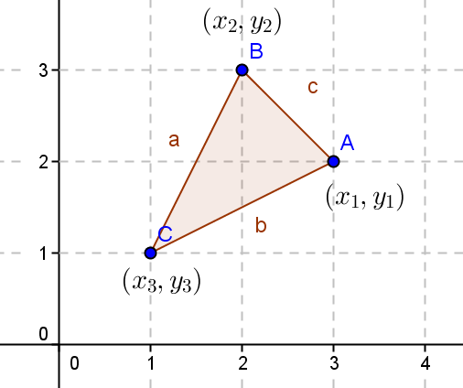*We can translate to .*
* What are the new coordinates of the vertices?
  + ,,
* Using our formula, what is the area?
* Use algebra and simplify this formula.
* This is called the “shoelace” area formula. Can you guess why?
  + *Answers will vary.*
* Let me show you. Do you see the pattern?

Note to teacher: To remember the formula, order the points going counterclockwise around the figure, then “walk around” the figure counterclockwise summing up the products of each -coordinate with the next point’s -coordinate, . Then “walk around” the figure clockwise doing the same thing, . Finally, subtract the second expression from the first.



Plus Terms

Minus Terms

* Now you can see why we call this the “shoelace” area formula!

Do you think this will work for figures with more than three vertices?

Closing (2 minutes)

Gather the class together and have a discussion about the following:

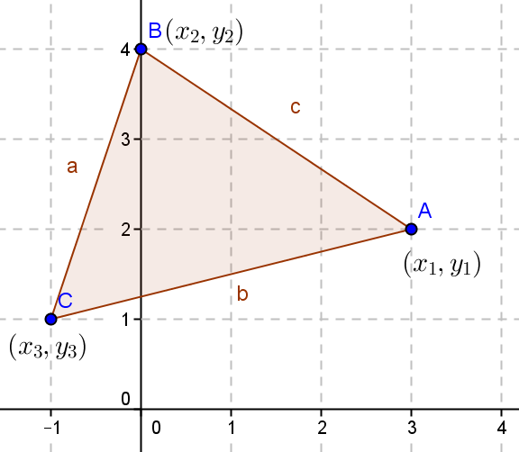

* How do you find the perimeter of this triangle?
  + *To find the perimeter of this triangle, use the distance formula to find the length of each segment and add the distances together.*
* Explain how you would find the area of this triangle.
  + *We could draw a rectangle around the triangle and then use the decomposition method to find the area. We could translate one vertex to the origin and use the formula , or use the shoelace formula to find the area:*

Exit Ticket (5 minutes)

Name Date

Lesson 9: Perimeter and Area of Triangles in the Cartesian Plane

Exit Ticket

Given the triangle below with vertices ,, and .

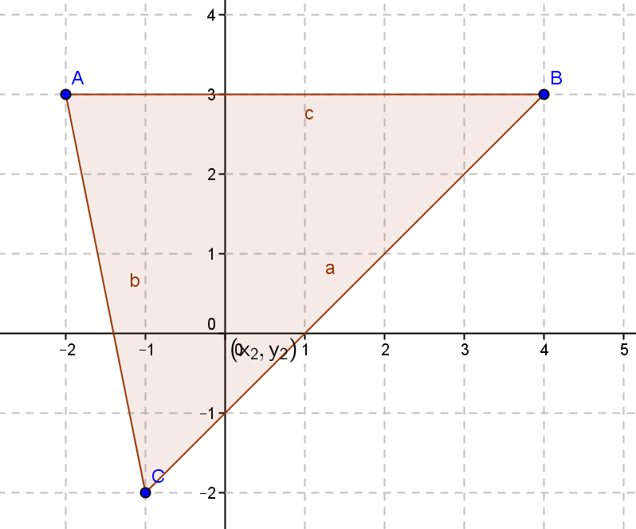

Azha calculated the area using ,

while Carson calculated the area using .

Explain the method each one used.

Exit Ticket Sample Solutions

Given the triangle below with vertices and .



Azha calculated the area using ,

while Carson calculated the area using .

Explain the method each one used.

Azha used the decomposition method. She first determined that the area of the rectangle around the triangle is , and then she subtracted the area of the right triangles surrounding the region. Carson used the “shoelace” method that we learned in this lesson.

Problem Set Sample Solutions

The Problem Set can be assigned as a whole, or problems can be selected to meet student progress.

1. Use coordinates to compute the perimeter and area of each polygon.

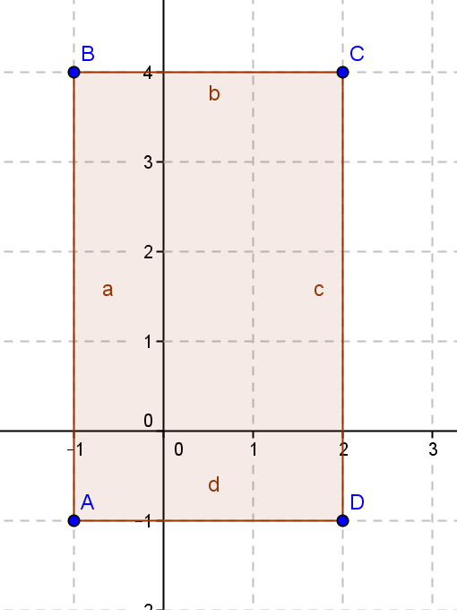

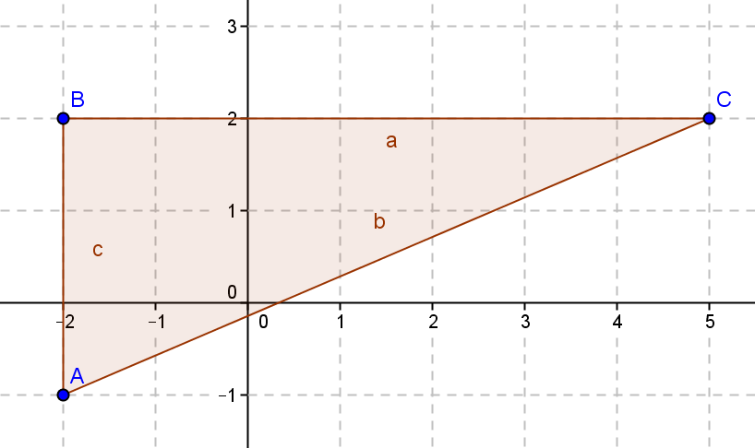a. b.

Perimeter units Perimeter units

Area square units Area square units

1. Given the figures below, find the area by decomposing into rectangles and triangles.

|  |  |
| --- | --- |
| a. | b. |

Area square units Area square units

1. 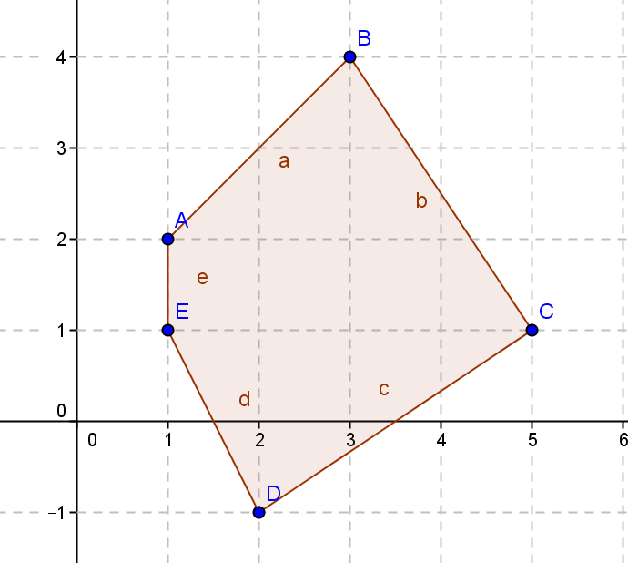Challenge: Find the area by decomposing the given figure into triangles.

square units

1. When using the shoelace formula to work out the area of , we have some choices to make. For example, we can start at any one of the three vertices , , or , and we can move either in a clockwise or counterclockwise direction. This gives six options for evaluating the formula.

Show that the shoelace formula obtained is identical for the three options that move in a clockwise direction ( to to or to to or to to ) and identical for the three options in the reverse direction. Verify that the two distinct formulas obtained differ only by a minus sign.

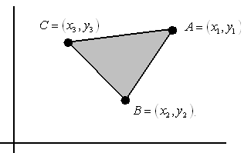Clockwise:

Counterclockwise:

1. Suppose two triangles share a common edge. By translating and rotating the triangles, we can assume that the common edge lies along the -axis with one endpoint at the origin.

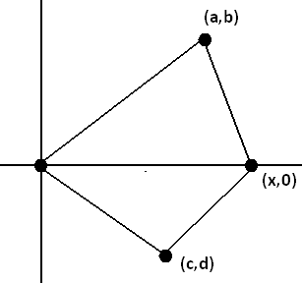

1. Show that if we evaluate the shoelace formula for each triangle, both calculated in the same clockwise direction, then the answers are both negative.

Top Triangle: , where.

Bottom Triangle: , where.

Both answers are negative when calculated in the clockwise direction.

1. Show that if we evaluate them both in a counter-clockwise direction, then both are positive.

Top Triangle: , where.

Bottom Triangle: , where.

Both answers are positive when calculated in the counterclockwise direction.

1. Explain why evaluating one in one direction and the second in the opposite direction, the two values obtained are opposite in sign.

If two triangles share a common edge, then evaluating the shoelace formula for each triangle in a consistent direction give answers that are the same sign; they are either each the positive areas of their respective triangles or each the negative versions of those areas.

1. A textbook has a picture of a triangle with vertices and . Something happened in printing the book and the coordinates of the third vertex are listed as . The answers in the back of the book give the area of the triangle as square units.
   1. What is the -coordinate of the third vertex?
   2. What if both coordinates were missing, but the area was known. Could you use algebra to find the third coordinate? Explain.

No, you would have an equation with two variables, so you could not solve for both algebraically unless you had a second equation with the same unknowns.