Lesson 8: Parallel and Perpendicular Lines

Student Outcomes
- Students recognize parallel and perpendicular lines from slope.
- Students create equations for lines satisfying criteria of the kind: “Contains a given point and is parallel/perpendicular to a given line.”

Lesson Notes
This lesson brings together several of the ideas from the last two lessons. In places where ideas from certain lessons are employed, these are identified with the lesson number underlined (e.g., Lesson 6).

Classwork
Opening (5 minutes)
Students will begin the lesson with the following activity using geometry software to reinforce the theorem studied in Lesson 6, which states that given points $A\left(a_{1,}a_{2}\right)$,$B\left(b_{1},b_{2}\right)$,$C\left(c_{1},c_{2}\right)$, and$D(d_{1},d_{2})$, $\overline{AB}⊥\overline{CD}$ if and only if
$$\left(b_{1}-a_{1}\right)\left(d_{1}-c_{1}\right)+\left(b_{2}-a_{2}\right)\left(d_{2}-c_{2}\right)=0.$$
- Construct two perpendicular segments and measure the abscissa (the $x$-coordinate) and ordinate (the
$y$-coordinate) of each of the endpoints of the segments. (You may extend this activity by asking students to determine whether the points used must be the endpoints. This is easily investigated using the dynamic geometry software by creating free moving points on the segment and watching the sum of the products of the differences as the points slide along the segments.)
- Calculate $\left(b_{1}-a_{1}\right)\left(d_{1}-c_{1}\right)+\left(b_{2}-a_{2}\right)\left(d_{2}-c_{2}\right)$.
- Note the value of the sum and observe what happens to the sum as they manipulate the endpoints of the perpendicular segments.
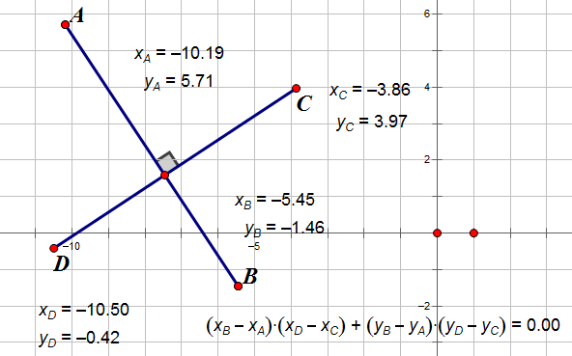
Example 1 (10 minutes)
Let $l_{1}$and$l_{2}$ be two non-vertical lines in the Cartesian plane. $l_{1}$and$l_{2}$ are perpendicular if and only if their slopes are negative reciprocals of each other (Lesson 7). Explain to students that negative reciprocals also means the product of the slopes is $-1$.
Proof:
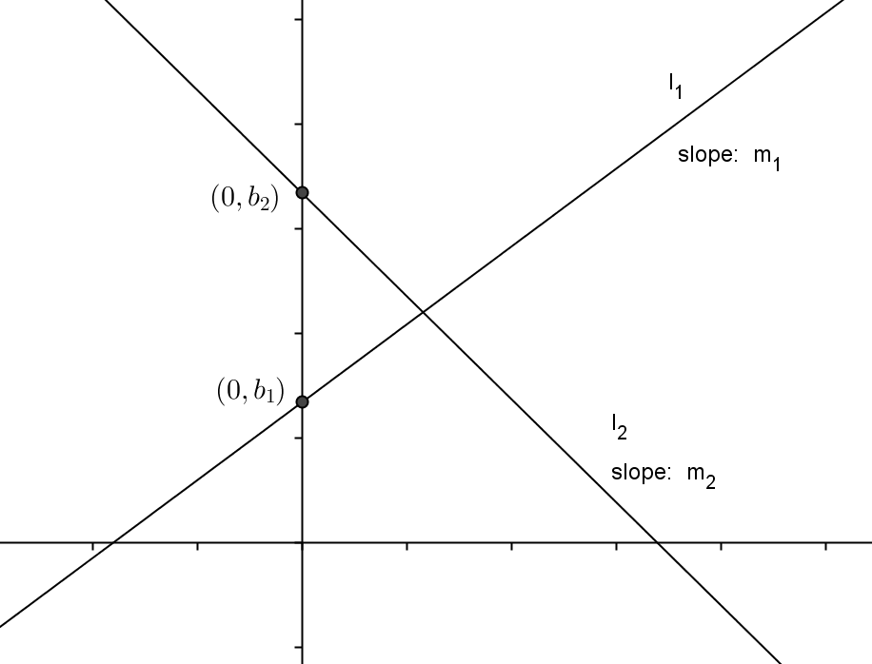
Suppose $l_{1}$ is given by the equation $y=m_{1}x+b_{1}$, and $l_{2}$ is given by the equation $y=m_{2}x+b_{2}$. We will start by assuming $m_{1}$, $m_{2}$,$b_{1}$, and $b_{2}$ are all not zero. We will revisit this proof for cases where one or more of these values is zero in the practice problems.
Let’s find two useful points on $l_{1}$: $A(0, b_{1})$ and
$B(1,m_{1}+b_{1})$.
- Why are these points on $l_{1}$?
  - $A$ is the $y$-intercept, and $B$ is the $y$-intercept plus the slope.
- Similarly, find two useful points on $l_{2}$. Name them $C$ and $D$.
  - $C(0, b_{2})$ and $D(1, m_{2}+b_{2}).$
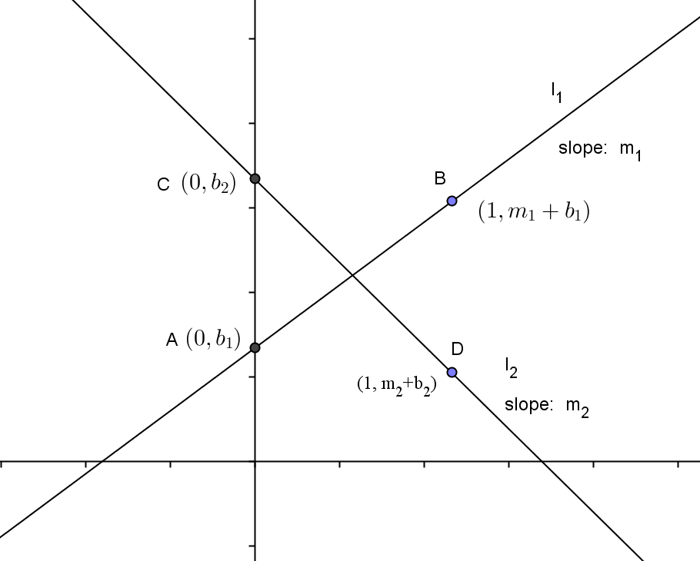
- Explain how you found them and why they are different from the points on $l_{1}$.
  - We used the $y$-intercept of $l_{2}$ to find $C$, then added the slope to the $y$-intercept to find point $D$. They are different points because the lines are different, and the lines do not intersect at those points.
- By the theorem from the Opening Exercise (and Lesson 6), write the equation that must be satisfied if $l_{1}$ and $l_{2}$ are perpendicular. Explain your answer
MP.7
Take a minute to write your answer, then explain your answer to your neighbor.
  - If $l_{1}$ is perpendicular to $l_{2},$ then we know from the theorem we studied in Lesson 6 and used in our Opening Exercise that this means
$\left(1-0\right)\left(1-0\right)+\left(m_{1}+b_{1}-b_{1}\right)\left(m_{2}+b_{2}-b_{2}\right)=0$
$$⟺1+m_{1}∙m_{2}=0$$
$$⟺m_{1}m_{2}=-1.$$
Summarize this proof and its result to a neighbor (Lessons 6 and 7).
If either $m_{1}$ or $m_{2}$ are 0, then $m_{1}m_{2}=-1$ is false, meaning $l_{1}⊥l_{2}$ is false, that is they cannot be perpendicular. We will study this case later.
Discussion (Optional)
- Working in pairs or groups of three, ask students to use this new theorem to construct an explanation of why $\left(b_{1}-a_{1}\right)\left(d_{1}-c_{1}\right)+\left(b_{2}-a_{2}\right)\left(d_{2}-c_{2}\right)=0$ when $\overline{AB}⊥\overline{CD}$ (Lesson 6).
As the students are constructing their arguments, circulate around the room listening to the progress that is being made with an eye to strategically selecting pairs or groups to share their explanations with the whole group in a manner that will build from basic arguments that may not be fully formed to more sophisticated and complete explanations.
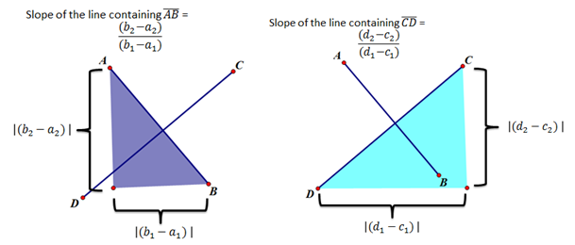
The explanations should include the following understandings:
  - $m_{AB}=\frac{b_{2}- a_{2}}{b_{1}- a_{1}}$and$m_{CD}=\frac{d_{2}- c_{2}}{d_{1}- c_{1}}.$
  - Because we constructed the segments to be perpendicular, we know that $m_{AB}m_{CD}=-1$ (Lesson 7).
  - $m_{AB}m_{CD}=-1 ⟺$ $\frac{b_{2}- a_{2}}{b_{1}- a_{1}}∙\frac{d_{2}- c_{2}}{d_{1}- c_{1}}=-1⟺\left(b_{2}-a_{2}\right)\left(d_{2}-c_{2}\right)=-\left(b_{1}-a_{1}\right)\left(d_{1}-c_{1}\right)$
$⟺\left(b_{1}-a_{1}\right)\left(d_{1}-c_{1}\right)+\left(b_{2}-a_{2}\right)\left(d_{2}-c_{2}\right)=0$ (Lesson 6).

Exercise 1 (5 minutes)
Exercise 1
- a. Write an equation of the line that passes through the origin that intersects the line $2x+5y=7$ to form a
right angle.
$$y = \frac{5}{2}x$$

  - Determine whether the lines given by the equations $2x+3y=6$ and $y=\frac{3}{2}x+4$ are perpendicular. Support your answer.
The slope of the first line is $–\frac{2}{3}$, and the slope of the second line is$\frac{3}{2}$. The product of these two slopes is $-1$; therefore, the two lines are perpendicular.

  - Two lines having the same $y$-intercept are perpendicular. If the equation of one of these lines is $y=-\frac{4}{5}x+6$, what is the equation of the second line?
$$y = \frac{5}{4}x+6$$
Example 2 (12 minutes)
Scaffolding:
- If students are struggling, change this example to specific lines. Give the coordinates of the two parallel lines and the perpendicular line. Calculate the slopes of each and compare.
- You may also have the students construct two lines that are parallel to a given line using dynamic geometry software and measure and compare their slopes.
In this example, we will study the relationship between a pair of parallel lines and the lines that they are perpendicular to. Students will use the angle congruence axioms developed in Geometry, Module 3 for parallelism.
We are going to investigate two questions in this example.
This example can be done using dynamic geometry software, or students can just sketch the lines and note the angle pair relationships.
Example 2
  - What is the relationship between two coplanar lines that are perpendicular to the same line?

- Have students draw a line and label it $k$.
- Students will now construct line $l_{1}$ perpendicular to line $k$.
- Finally, students construct line $l_{2}$ not coincident with line $l_{1}$, also perpendicular to line $k$.
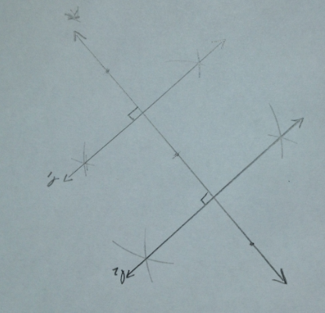
- What can we say about the relationship between lines $l_{1}$and$l_{2}$?
  - These lines are parallel because the corresponding angles that are created by the transversal $k$ are congruent.
- If the slope of line $k$ is $m$, what is the slope of $l_{1}$? Support your answer. (Lesson 7)
  - The slope of $l_{1}$ is $-\frac{1}{m}$ because the slopes of perpendicular lines are negative reciprocals of each other.
- If the slope of line k is m, what is the slope of $l_{2}$? Support your answer. (Lesson 7)
  - The slope of $l_{2}$ is $-\frac{1}{m}$ because the slopes of perpendicular lines are negative reciprocals of each other.
- Using your answers to the last two questions, what can we say about the slopes of lines $l_{1}$and$l_{2}$?
  - $l_{1}$and$l_{2}$ have equal slopes.
- What can be said about $l_{1}$and$l_{2}$ if they have equal slopes?
  - $l_{1}$and$l_{2}$ are parallel.
MP.3
- What is the relationship between two coplanar lines that are perpendicular to the same line?
  - If two lines are perpendicular to the same line, then the two lines are parallel, and if two lines are parallel, then their slopes are equal.
- Restate this to your partner in your own words and explain it by drawing a picture.

  - Given two lines, $l_{1}$and$l_{2}$, with equal slopes and a line $k$ that is perpendicular to one of these two parallel lines, $l_{1}$:
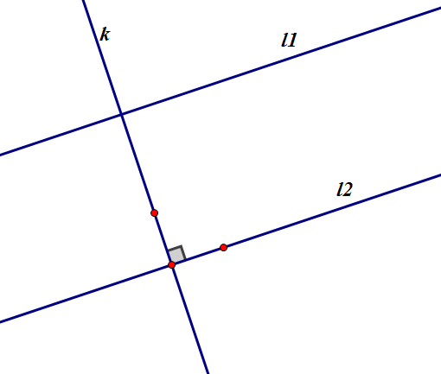
    - What is the relationship between line $k$ and the other line, $l_{2}$?
    - What is the relationship between$l_{1}$and$l_{2}$?

Ask students to:
- Construct two lines that have the same slope using construction tools or dynamic geometry software and label the lines $l_{1}$and$l_{2}$.
- Construct a line that is perpendicular to one of these lines and label this line $k$.
- If $l_{2}$ has a slope of $m$, what is the slope of line $y$? Support your answer. (Lesson 7)
  - Line $k$ must have a slope of $-\frac{1}{m}$ because line $k$ is perpendicular to line $l_{2}$, and the slopes of perpendicular lines are negative reciprocals of each other.
- $l_{2}$ also has a slope of $m$, so what is its relationship to line $k$? Support your answer. (Lesson 7)
  - Line $l_{1}$ must be perpendicular to line $k$ because their slopes are negative reciprocals of each other.
- Using your answers to the last two questions, what can we say about two lines that have equal slopes?
  - They must be parallel since they are both perpendicular to the same line.
- Have students combine the results of the two activities to form the following bi-conditional statement:
  - Two non-vertical lines are parallel if and only if their slopes are equal.
- Summarize all you know about the relationships between slope, parallel lines, and perpendicular lines. Share your ideas with your neighbor.

Exercises 2–7 (8 minutes)
Exercises 2–7
- Given a point $(-3, 6)$ and a line $y=2x-8:$
  - What is the slope of the line?
$$2$$

  - What is the slope of any line parallel to the given line?
$$2$$

  - Write an equation of a line through the point and parallel to the line.
$$2x-y=-12$$
  - What is the slope of any line perpendicular to the given line? Explain.
The slope is $-\frac{1}{2}$; perpendicular lines have slopes that are negative reciprocals of each other.

- Find an equation of a line through $(0, -7)$ and parallel to the line $y=\frac{1}{2}x+5$.
  - What is the slope of any line parallel to the given line? Explain your answer.
The slope is$\frac{1}{2}$; lines are parallel if and only if they have equal slopes.

  - Write an equation of a line through the point and parallel to the line.
$$x-2y=14$$

  - If a line is perpendicular to $y=\frac{1}{2}x+5$, will it be perpendicular to $x-2y=14$? Explain.
If a line is perpendicular to $y=\frac{1}{2}x+5$, it will also be perpendicular to $y=\frac{1}{2}x-7$because a line perpendicular to one line is perpendicular to all lines parallel to that line.

- Find an equation of a line through $\left(\sqrt{3}, \frac{1}{2}\right)$ parallel to the line:
  - $x=-9$
$x=\sqrt{3}$

  - $y=-\sqrt{7}$
$y=\frac{1}{2}$

  - What can you conclude about your answer in parts (a) and (b)?
They are perpendicular to each other. $x=\sqrt{3}$ is a vertical line, and $y=\frac{1}{2}$ is a horizontal line.

- Find an equation of a line through $\left(-\sqrt{2},π\right)$ parallel to the line $x-7y=\sqrt{5}$.
$$x-7y=\sqrt{2}+7π$$

- Recall that our search robot is moving along the line $y=3x-600$ and wishes to make a right turn at the point $(400, 600)$. Find an equation for the perpendicular line on which the robot is to move. Verify that your line intersects the $x$-axis at $(2200, 0)$.
$x+3y=2200$; when$y=0$,$x=2200$

- A robot, always moving at a constant speed of $2$ feet per second, starts at position $(20, 50)$ on the coordinate plane and heads in a south-east direction along the line $3x +4y=260$. After $15$seconds, it turns left $90°$ and travels in a straight line in this new direction.
  - What are the coordinates of the point at which the robot made the turn? What might be a relatively straightforward way of determining this point?
The coordinates are $\left(44, 32\right)$. We know the robot moves down $3$ units and right $4$ units, and the distance moved in $15$ seconds is $30$ feet. This gives us a right triangle with hypotenuse $5$, so we need to move this way $6$ times. From $\left(20, 50\right),$ move a total of down $18$ units and right $24$ units.

  - Find an equation for the second line on which the robot traveled.
$$4x-3y=80$$

  - If, after turning, the robot travels for $20$ seconds along this line and then stops, how far will it be from its starting position?
It will be at the point $\left(0, 20\right)$, $50$ units from its starting position.

  - What is the equation of the line the robot needs to travel along in order to now return to its starting position? How long will it take for the robot to get there?
$x=20$;$10$ seconds

Closing (2 minutes)
Ask students to respond to these questions in writing, with a partner, or as a class.
- Samantha claims the slopes of perpendicular lines are opposite reciprocals, while Jose says the product of the slopes of perpendicular lines is equal to $-1$. Discuss these two claims (Lesson 7).
  - Both are correct as long as the lines are not horizontal and vertical. If two lines have negative reciprocal slopes, $m$ and $-\frac{1}{m}$, the product $m∙-\frac{1}{m}= -1$.
  - If one of the lines is horizontal, then the other will be vertical, and the slopes will be zero and undefined, respectively. Therefore, these two claims will not hold.
- How did we use the relationship between perpendicular lines to demonstrate the theorem two non-vertical lines are parallel if and only if their slopes are equal, and why did we restrict this statement to non-vertical lines (Lesson 8)?
  - We restricted our discussion to non-vertical lines because the slopes of vertical linear are undefined.
  - We used the fact that the slopes of perpendicular lines are negative reciprocals of each other to show that if two lines are perpendicular to the same line, then they must not only be parallel to each other, but also have equal slopes.

Exit Ticket (3 minutes)
Teachers can administer the Exit Ticket in several ways, such as the following: assign the entire task; assign some students Problem 1 and others Problem 2; allow student choice.
Name Date
Lesson 8: Parallel and Perpendicular Lines

Exit Ticket

- Are the pairs of lines parallel, perpendicular, or neither? Explain.
- $3x+2y=74$ and $9x-6y=15$

- $4x-9y=8$ and $18x+8y=7$

- Write the equation of the line passing through $\left(-3, 4\right)$ and perpendicular to $-2x+7y=-3.$
Exit Ticket Sample Solutions

- Are the pairs of lines parallel, perpendicular, or neither? Explain.
  - $3x+2y=74$ and $9x-6y=15$
The lines are neither, and the slopes are $-\frac{3}{2}$and$\frac{3}{2}.$

  - $4x-9y=8$ and $18x+8y=7$
The lines are perpendicular, and the slopes are$\frac{4}{9}$ and $-\frac{9}{4}.$

- Write the equation of the line passing through $(-3, 4)$ and normal to $-2x+7y=-3.$
$$7x+2y=-13$$

Problem Set Sample Solutions

- Write the equation of the line through $(-5, 3)$ and:
  - Parallel to $x=-1$.
$$x=-5$$

  - Perpendicular to $x=-1$.
$$y=3$$

  - Parallel to $y=\frac{3}{5}x+2$.
$$3x-5y=-30$$

  - Perpendicular to $y=\frac{3}{5}x+2$.
$$5x+3y=-16$$

- Write the equation of the line through $\left(\sqrt{3}, \frac{5}{4}\right)$and:
  - Parallel to $y=7$.
$$y=\frac{5}{4}$$

  - Perpendicular to $y=7$.
$$x= \sqrt{3}$$

  - Parallel to $\frac{1}{2}x-\frac{3}{4}y=10$.
$$8x+12y=15+8\sqrt{3}$$
  - Perpendicular to $\frac{1}{2}x-\frac{3}{4}y=10$.
$$6x-4y=-5+6\sqrt{3}$$

- A vacuum robot is in a room and charging at position $(0, 5)$. Once charged, it begins moving on a northeast path at a constant sped of $\frac{1}{2}$ foot per second along the line $4x-3y=-15$. After $60$ seconds, it turns right $90°$ and travels in the new direction.
  - What are the coordinates of the point at which the robot made the turn?
$$(18, 29)$$

  - Find an equation for the second line on which the robot traveled.
$$3x +4y=194$$

  - If after turning, the robot travels $80$ seconds along this line, how far has it traveled from its starting position?
$50$ feet

  - What is the equation of the line the robot needs to travel along in order to return and recharge? How long will it take the robot to get there?
$y=50$; $100$ seconds

- Given the statement $\overset{⃡}{AB}$ is parallel to $\overset{⃡}{DE}$, construct an argument for or against this statement using the two triangles shown.
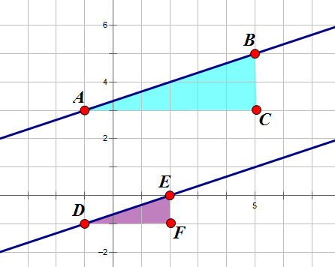
The statement $\overset{⃡}{AB}$ is parallel to $\overset{⃡}{DE}$ is true.
The slope of $\overset{⃡}{AB}$ is equal to $\frac{2}{6}$, the ratio of the lengths of the legs of the right triangle $ABC$.
The slope of $\overset{⃡}{DE}$ is equal to $\frac{1}{3}$, the ratio of the lengths of the legs of the right triangle $DEF$.
$\frac{2}{6}=\frac{1}{3}↔m_{AB}=m_{DE}$, and therefore, $\overset{⃡}{AB}$ is parallel to $\overset{⃡}{DF}$.

- Recall the proof we did in Example 1: Let $l_{1}$ and$l_{2}$ be two non-vertical lines in the Cartesian plane. $l_{1}$and$l_{2}$ are perpendicular if and only if their slopes are negative reciprocals of each other. In class, we looked at the case where both $y$-intercepts were not zero. In Lesson 5, we looked at the case where both $y$-intercepts were equal to zero, when the vertex of the right angle was at the origin. Reconstruct the proof for the case where one line has a
$y$-intercept of zero, and the other line has a non-zero $y$-intercept.
Scaffolding:
- Provide students who were absent or who do not take notes well with class notes showing Example 1 with steps clearly explained.
Suppose $l_{1}$ passes through the origin; then, it will be given by the equation $y=m_{1}x$, and $l_{2}$ is given by the equation $y=m_{2}x+b_{2}$. Here, we are assuming $m_{1}$,$m_{2}$, and$b_{2}$ are not zero.
We can still use the same two points on $l_{2}$ as we used in Example 1, $\left(0,b_{2}\right)$ and$\left(-\frac{b_{2}}{m_{2}},0\right)$. We will have to find an additional point to use on $l_{2},$ as the $x$- and $y$-intercepts are the same point because this line passes through the origin, $\left(0,0\right)$. Let’s let our second point be $(1, m_{2})$.
$$l_{1}⊥l_{2}↔\left(1-0\right)\left(0-\left(-\frac{b_{2}}{m_{2}}\right)\right)+\left(m_{2}-0\right)\left(b_{2}-0\right)=0$$
$$↔ \frac{b_{2}}{m_{2}}+m_{2}b_{2}=0$$
$$↔ \frac{b_{2}}{m_{2}}=-m_{2}b_{2}$$
$↔ -\frac{1}{m_{1}}=m_{2}$ since $b_{2}≠0$

- Challenge: Reconstruct the proof we did in Example 1 if one line has a slope of zero.
If $m_{1}=0$, then $l_{1}$ is given by the equation $y=b_{1}$, and $l_{2}$ is given by the equation $y=m_{2}x+b_{2}$. Here we are assuming $m_{2}$,$b_{1}$, and$b_{2}$ are not zero.
Choosing the points $\left(0,b_{1}\right)$and$\left(1,b_{1}\right)$ on $l_{1}$ and $\left(0,b_{2}\right)$and$\left(1,{m_{2}+b}_{2}\right)$ on $l_{2}$,
$l_{1}⊥l_{2}$ $↔$ $\left(1-0\right)\left(1-0\right)+\left(b_{1}-b_{1}\right)\left({m_{2}+b}_{2}-b_{2}\right)=0$
$$↔ 1+0=0$$
$↔ 1=0$. This is a false statement. If one of the perpendicular lines is horizontal, their slopes cannot be negative reciprocals.

