Lesson 7: Equations for Lines Using Normal Segments

Student Outcomes
- Students state the relationship between previously used formats for equations for lines and the new format
$a$₁$x+a$₂$y=c$, recognizing the segments from $(0, 0)$ to $(a_{1}, a_{2})$ as a normal and $-\frac{a_{2}}{a_{1}}$ as a slope.
- Students solve problems that are dependent upon making such interpretations.

Lesson Notes
This lesson focuses on MP.4 because students work extensively to model robot behavior using coordinates.

Classwork
Opening Exercise (5 minutes)
This exercise can be modeled by the teacher with the whole class, given to groups to present solutions to the class, or used as a supplement to the lesson.
Opening Exercise
The equations given are in standard form. Put each equation in slope-intercept form. State the slope and the
$y$-intercept.
Scaffolding:
Provide visuals to reinforce standard and slope-intercept forms:
- Standard form is $Ax+By=C$ where $A$, $B$, and $C$ are integers.
- Slope-intercept form is $y=mx+b$ where $m$ is the slope, and $b$ is the $y$-intercept.
- $6x+3y=12$ | - $5x+7y=14$ | - $2x-5y=-7$
$$y=-2x+4$$ | $$y=-\frac{5}{7}x+2$$ | $$y=\frac{2}{5}x+\frac{7}{5}$$
slope $=-2$ | slope $=-\frac{5}{7}$ | slope $=\frac{2}{5}$
$y$-intercept $=4$ | $y$-intercept $=2$ | $y$-intercept $=\frac{7}{5}$

Discussion (20 minutes)
Scaffolding:
Plotting points will help students visualize the problems and understand the translations required.
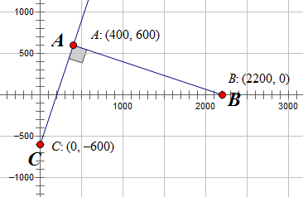
Let’s revisit the robot from Lesson 4. Recall that it is moving along the line
$y=3x-600$. At the point $\left(400, 600\right),$ it detected the loudest “ping,” and the programmers had the robot change direction at that point and move along a linear path that was perpendicular to his original path.

At the end of Lesson 6, we learned that the beacon happens to lie on the $x$-axis and is located at the point $(2200, 0)$.
- How did we determine the location of the beacon?
  - We had to find the point $B$ on the $x$-axis so that $\overline{AB}$ and $\overline{AC}$ were perpendicular. We knew $A(400, 600)$ and $C\left(0, -600\right)$and that the $y$-coordinate of point $B$ was $0$ since point $B$ was on the
$x$-axis. Using $B(b, 0)$, we eventually determined that $B=2200$.
- Let’s push this idea a little further. Suppose $P(x, y)$is any point on the line containing segment $\overline{AC}$. What can you say about $\overline{AP}$ and $\overline{AB}$?
  - They are also perpendicular.
- Using$A(400, 600)$, $B(2200, 0$), and $P(x, y)$, translate the points so that $A$ is at the origin. What are the new coordinates?
  - If we translate all points in the figure using the translation vector $〈-400, -600〉$ that takes $A$ to the origin $A'=O(0, 0)$, then $B$ becomes $B'(1800, -600)$, and $P$ becomes $P'(x-400, y-600)$.
- If the condition for perpendicularity is $ab+cd=0$, how could we write an equation involving $x$ and $y$?
  - The condition that $\overline{OA'}$ and $\overline{OP'}$ are perpendicular becomes:
$$1800(x-400)+(-600)(y-600)=0 \\ 1800x-720,000-600y+360,000=0 \\ 1800x-600y=360,000.$$
- This is the equation in standard form: $Ax+By=C$. Look at the values of $A$ and $B$ and at the work above. Do you see a relationship between $A$ and $B$ and the work above?
  - The coordinates of $B'$ (the translation of $B$) are $(1800, -600)$, which are the same values as $A$ and $B$.

- Let’s say that in a more specific way. I will state the relationship, and you repeat it and explain it to your partner.
  - $A$ is the $x$-coordinate (abscissa) of the image of the point of the perpendicular segment that does not lie on the line when the point of perpendicularity is at the origin.
  - $B$ is the $y$-coordinate (ordinate) of the image of the point of the perpendicular segment that does not lie on the line when the point of perpendicularity is at the origin.
- Now, let’s put the equation in slope-intercept form.
  - $-600y=-1800x+360,000.$
  - $y=3x-600$, which is the equation of $\overset{⃡}{AB}$.
MP.7
- What does the equation you wrote represent?
  - $\overline{AP}$ will be perpendicular to $\overline{AB}$ as long as point $P$ lies on the line containing $\overline{AC}$, which is given by the equation $y=3x-600.$
In the next part of this lesson, we generalize what we just discovered. This can be done in several ways.
- Present the question and explain that we are trying to make this process work for any points with coordinates
$A(a, b)$,$B(c, d)$, and $P(x, y)$. Allow time for students to think and talk to their neighbors for a few minutes; then, show the diagrams and give them more time to talk. Finally, pull everyone together and discuss each step as a class.
- Assign some groups the task with no leading questions, and let them work independently while other groups are getting different levels of help, some even being directly instructed by the teacher.

- How can we generalize this finding?
- Given point $A\left(a,b\right)$ which lies on line $l$, point $B\left(c,d\right)$ not on line $l$, and $\overline{AB}$ perpendicular to line $l$, then any point $P(x, y)$ on line $l$ will satisfy the relationship $\overline{AP}⊥\overline{AB}$. Draw the picture described.
$$P$$
$$A$$
$$B$$
$$(a, b)$$
$$(c, d)$$
$$(x, y)$$

- Translate the points. Which point should be on the origin? What is the translation used? What are the coordinates of the translated points?
  - $A$ is the common point and should be translated to the origin. The translation is $〈-a, -b〉$, or left a and down $b$. The translated points are $A'=O (0, 0)$, $B'(c-a, d-b)$, and $P'(x-a, y-b)$.
$$P'$$
$$A'$$
$$B'$$
$$(0, 0)$$
$$(c-a, d-b)$$
$$(x-a, y-b)$$

- If the segments are perpendicular, write the equation that must hold true.
  - $(c-a)(x-a)+(d-b)(y-b)=0.$
- If $A=(c-a)$ and $B=(d-b)$, write this equation substituting in $A$ and $B$. Which line have we written the equation of?
Scaffolding:
- Have students leave the equations in standard form.
- Provide these steps:
$$(8-5)(x-5)+(2+7)(y+7)=0$$

Simplify the parentheses without variables.
$$3(x-5)+9(y+7)=0$$
Separate the variables—put $x$ on one side and $y$ on the other.
$$9(y+7)=-3(x-5)$$
Distribute the coefficients.
$$9y+63=-3x+15$$
Bring the constant on the right to the left.
$$9y=-3x-48$$
Divide by the coefficient of y.
$$y=-\frac{3}{9}x-\frac{48}{9}$$
Simplify if necessary.
$$y=-\frac{1}{3}x-\frac{16}{3}$$
  - We end up with the equation of the line that passes through point $A$ that is perpendicular to $\overline{AB}$: $A\left(x-a\right)+B(y-b)=0.$
- What do $A$ and $B$ represent graphically?
  - $A$ is the abscissa, and $B$ is the ordinate of the image of $B$.
- We call segment $\overline{AB}$ a normal segment to line $l$ because it has one endpoint on the line and is perpendicular to the line.
  - Explain to your neighbor what a normal segment is, and write your own definition.

Definition: A line segment with one endpoint on a line and perpendicular to the line is called a normal segment to the line.

Example 1 (5 minutes)
Example 1
Given $A(5, -7)$ and $B\left(8, 2\right)$:
  - Find an equation for the line through $A$ and perpendicular to $\overline{AB}$.
$A^{'}\left(0,0\right)$,$B^{'}\left(8-5, 2-\left(-7\right)\right)$, and$P^{'}\left(x-5, y-\left(-7\right)\right)$
$$\left(8-5\right)\left(x-5\right)+\left(2+7\right)\left(y+7\right)=0 \\ 3\left(x-5\right)=-9(y+7) \\ 3x-15=-9y-63 \\ y=-\frac{1}{3}x-\frac{16}{3}$$

  - Find an equation for the line through $B$ and perpendicular to $\overline{AB}$.
$B^{'}\left(0,0\right)$,${ A}^{'}\left(5-8,-7-2\right)$, and$P'(x-8,y-2)$
$$\left(5-8\right)\left(x-8\right)+\left(-7-2\right)\left(y-2\right)=0 \\ -3\left(x-8\right)=9(y-2) \\ -3x+24=9y-18 \\ y=-\frac{1}{3}x+ \frac{14}{3}$$

Exercises 1–2 (8 minutes)
Have students plot points to aid in solving problems.

- Given $U\left(-4, -1\right)$and$V\left(7, 1\right)$:
  - Write an equation for the line through $U$ and perpendicular to $\overline{UV}$.
$U^{'}\left(0,0\right)$,$V^{'}\left(7-\left(-4\right), 1-\left(-1\right)\right)$,$P^{'}\left(x-\left(-4\right), y-\left(-1\right)\right)$
$$\left(7+4\right)\left(x+4\right)+\left(1+1\right)\left(y+1\right)=0 \\ 11x+44=-2y-2 \\ y=-\frac{11}{2}x-23$$

  - Write an equation for the line through $V$ and perpendicular to $\overline{UV}$.
$V^{'}\left(0,0\right)$,$U^{'}\left(-4-7, -1-1\right)$,$P'(x-7, y-1)$
$$\left(-7-4\right)\left(x-7\right)+\left(-1-1\right)\left(y-1\right)=0 \\ -11x+77=2y-2 \\ y=-\frac{11}{2}x+\frac{79}{2}$$

- Given $S\left(5, -4\right)$and$T\left(8, 12\right)$:
  - Write an equation for the line through $S$ and perpendicular to $\overline{ST}$.
$S^{'}\left(0,0\right)$,$T^{'}\left(-8-5, 12-\left(-4\right)\right)$,$P^{'}\left(x-5, y-\left(-4\right)\right)$
$$\left(-8-5\right)\left(x-5\right)+\left(12-\left(-4\right)\right)\left(y-\left(-4\right)\right) =0 \\ -13x+65=-16y-64 \\ y= \frac{13}{16}x -\frac{129}{16}$$

  - Write an equation for the line through $T$ and perpendicular to $\overline{ST}$.
$$T^{'}\left(0,0\right), S^{'}\left(5-(-8), -4-12\right), P'(x-(-8), y-12)$$
$$\left(5-\left(-8\right)\right) \left(x-\left(-8\right)\right)+\left(-4-12\right)\left(y-12\right)=0 \\ 13x+104=16y-192 \\ y= \frac{13}{16}x+ \frac{37}{2}$$

Closing (2 minutes)

Describe the characteristics of a normal segment.
A line segment with one endpoint on a line and perpendicular to the line is called a normal segment to the line.
Every equation of a line through a given point $(a, b)$ has the form $A\left(x-a\right)+B\left(y-b\right)=0$. Explain how the values of $A$ and $B$ are obtained.
A is the value of the abscissa of the image of the endpoint of the normal segment that does not lie on the line after the figure has been translated so that the image of the endpoint that does lie on the line, the point of perpendicularity, is at the origin.
B is the value of the ordinate of the image of the endpoint of the normal segment that does not lie on the line after the figure has been translated so that the image of the endpoint that does lie on the line, the point of perpendicularity, is at the origin.

Exit Ticket (5 minutes)

Name Date
Lesson 7: Equations for Lines Using Normal Segments

Exit Ticket

Given $A\left(-5, -3\right)$,$B\left(-1, 6\right)$, and$C\left(x, y\right):$
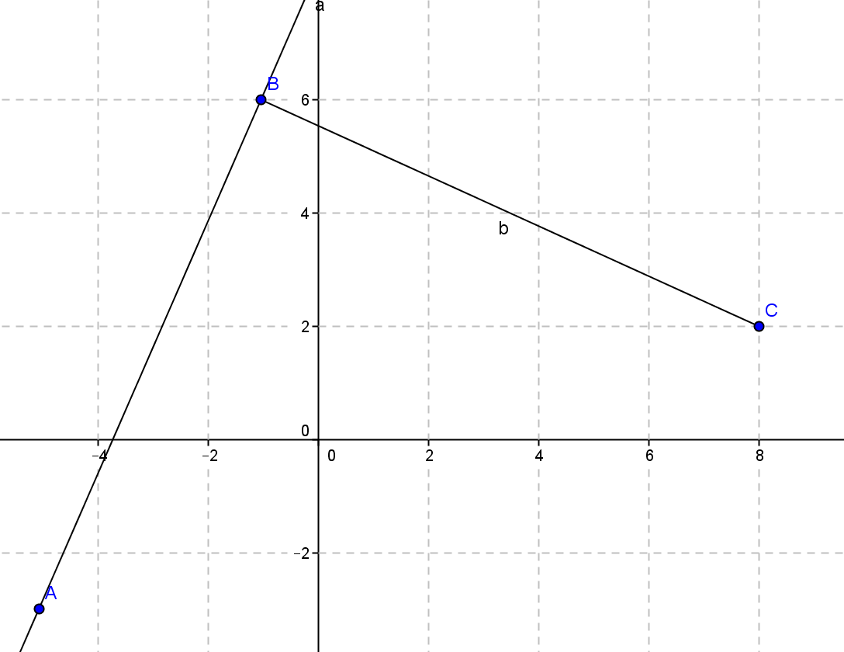

- What are the coordinates of the translated points if $B$ moves to the origin?

- Write the condition for perpendicularity equation.

- Write the equation for the normal line.

Exit Ticket Sample Solutions

Given $A\left(-5, -3\right), B\left(-1, 6\right),$and$C\left(x, y\right)$:

  - What are the coordinates of the translated points if $B$ moves to the origin?
$A'(-4, -9)$,$B'(0, 0)$,$C'(x+1, y-6)$

  - Write the condition for perpendicularity equation.
$$-4(x+1)-9(y-6)=0$$

  - Write the equation for the normal line in slope-intercept form.
$$y=-\frac{4}{9}x+\frac{50}{9}$$

Problem Set Sample Solutions

- Given points$C\left(-4,3\right)$and$D\left(3, 3\right)$:
  - Write the equation of the line through $C$ and perpendicular to $\overline{CD}$.
$$x=-4$$

  - Write the equation of the line through $D$ and perpendicular to $\overline{CD}$.
$$x=3$$

- Given points $N\left(7, 6\right)$and$M\left(7, -2\right)$:
  - Write the equation of the line through $M$ and perpendicular to $\overline{MN}$.
$$y=-2$$

  - Write the equation of the line through $N$ and perpendicular to $\overline{MN}$.
$$y=6$$

- The equation of a line is given by the equation $8\left(x-4\right)+3\left(y+2\right)=0.$
  - What are the coordinates of the image of the endpoint of the normal segment that does not lie on the line? Explain your answer.
$(8, 3)$ because $A(x–4)+B(y+2)=0$ is the original formula, and $(A, B)$ are the coordinates of the image of the endpoint of the normal segment not on the line.

  - What translation occurred to move the point of perpendicularity to the origin?
$〈-4, 2〉$, or left $4$ up $2$

  - What were the coordinates of the original point of perpendicularity? Explain your answer.
$(4,-2)$ because the translation of $〈-4, 2〉$ was required to move the point of perpendicularity to the origin.

  - What were the endpoints of the original normal segment?
$8=c-4↔c=12$, and $3=d-\left(-2\right)↔d=1$.
The endpoints of a normal segment to the given line are $A\left(4,-2\right)$and$B\left(12,1\right)$.

- A coach is laying out lanes for a race. The lands are perpendicular to a segment of the track such that one endpoint of the segment is $\left(2, 50\right)$ and the other is $\left(20, 65\right)$. What are the equations of the lines through the endpoints?
$$y=-\frac{6}{5}x+\frac{786}{15}\text{;} y=-\frac{6}{5}x+89$$

