|  |
| --- |
|  |

Lesson 6: Segments That Meet at Right Angles

Student Outcomes

* Students generalize the criterion for perpendicularity of two segments that meet at a point to any two segments in the Cartesian plane.
* Students apply the criterion to determine if two segments are perpendicular.

Classwork

Opening Exercise (2 minutes)

**MP.3**

As a class, present each problem and have students determine an answer and justify it.

Opening Exercise

Carlos thinks that the segment having endpoints and is perpendicular to the segment with endpoints and . Do you agree? Why or why not?

No, the two segments are not perpendicular. If they were perpendicular, then would be true.

Working with a partner, given and, find the coordinates of a point so that .

Let the other endpoint be . If , then . This means that as long as we choose values for and that satisfy the equation , will be perpendicular to .

Answers may vary but may include ,, and or any other coordinates that meet the requirement stated above.

*Scaffolding:*

* Graphing each exercise will help students picture the problem.
* It will be helpful to display posters of the previous day’s findings around the room.

Example 1 (10 minutes)

In this example, we are trying to get students to see that translating segments may help us determine whether the lines containing the segments are perpendicular.

Example 1

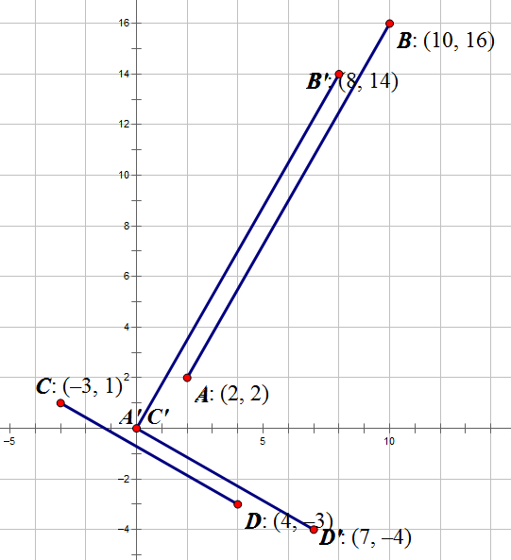Given points ,,, and, are segments and perpendicular? Are the lines containing the segments perpendicular? Explain.

One possible solution would be to translate so that is on the origin (using the vector , or left down ) and to translate so that is on the origin (using the vector , rightdown):

,,, and.

will be perpendicular to if is perpendicular to .

; therefore, is perpendicular to , which means .

*,,, and.*

*.*

* Working in pairs, each student selects two points to be the endpoint of a segment. One partner identifies the coordinates of points and , and the other partner chooses coordinates for points and . Although the likelihood of this happening is low, students may choose one of the same points, but not both. The students then plot the points on the same coordinate plane and construct segments and .
* The students must now determine whether the segments are perpendicular.
  + *Answers will vary. Some students will say no because they do not intersect. Students should recognize that, unless the segments are parallel, if we extend the segments, the lines containing the segments will intersect.*
* How do your segments differ from those we worked with in Lesson 5?
  + *In that lesson, both segments had one endpoint located at the origin.*
* Would translating your two segments change their orientation?
  + *No. If we translate the segments, thereby translating the lines containing the segments, the angles formed by the two lines will not change. If the lines were perpendicular, the images of the lines under translation will also be perpendicular.*

**MP.1**

**&**

**MP.3**

* With your partner, translate each of your segments so that they have an endpoint at the origin. Then, use the results of yesterday’s lesson to determine whether the two segments are perpendicular
  + *Answers will vary.*
* Switch papers with another pair of students and confirm their results.

Exercise 1 (5 minutes)

Have students try Exercise 1 using the example just completed as a template. You may pull aside some groups for targeted instruction.

Exercise 1

1. Given ,,, and , find a general formula in terms of , , , , , , , and that will let us determine whether segments and are perpendicular.

After translating the segments so that the image of points and lie on the origin, we get ,   
, , and.

Example 2 (7 minutes)

In this example, we are going to have students use the formula they derived in Exercise 1 to find the location of one endpoint of a segment given the other endpoint and the coordinates of the endpoints of a perpendicular segment. Because there are an infinite number of possible endpoints, we will only ask students to determine one unknown coordinate given the other.

* Given and ,, , and, find the value of . While we will be using the formula that we derived in Exercise 1, it will be helpful if you explain each of the steps as you are solving the problem.
  + *Using the formula we derived in the previous exercise, we can write the equation*
  + *We translated to so that is located at the origin. We moved three units to the left and down two units giving us .*
  + *We translated to so that is located at the origin. We moved two units to the right and up three units giving us .*

Teachers can assign different exercises to different students or groups and then bring the class back together to share. Some students may be able to complete all exercises while others may need more guidance.

Exercises 2–4 (14 minutes)

1. Recall the Opening Exercise of Lesson 4 in which a robot is traveling along a linear path given by the equation . The robot hears a ping from a homing beacon when it reaches the point and turns to travel along a linear path given by the equation. If the homing beacon lies on the -axis, what is its exact location? (Use your own graph paper to visualize the scenario.)

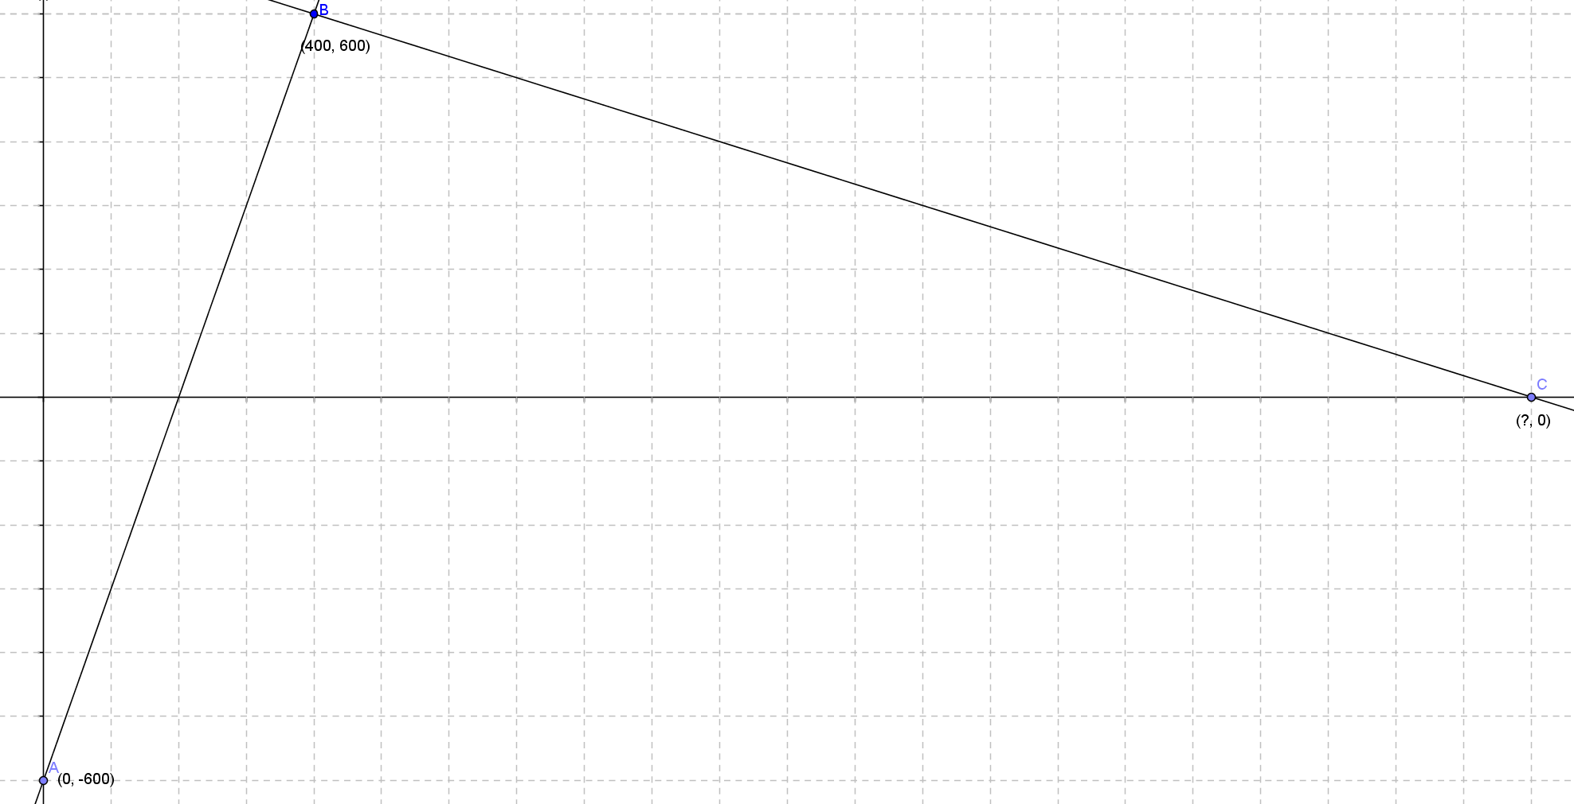

* 1. If point is the -intercept of the original equation, what are the coordinates of point ?
  2. What are the endpoints of the original segment of motion?

and

* 1. If the beacon lies on the -axis, what is the -value of this point, ?
  2. Translate point to the origin. What are the coordinates of , , and ?

,, and

* 1. Use the formula derived in this lesson to determine the coordinates of point .

We know that , so

1. A triangle in the coordinate plane has vertices , , and . Is it a right triangle? If so, at which vertex is the right angle? (Hint: Plot the points and draw the triangle on a coordinate plane to help you determine which vertex is the best candidate for the right angle.)

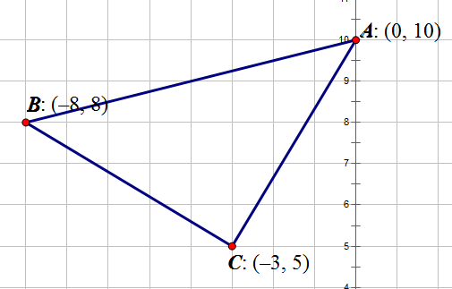The most likely candidate appears to be vertex . By translating the figure so that is mapped to the origin, we can use the formula

Yes, segments and are perpendicular. The right angle is .

1. *,,,* and are vertices of a quadrilateral. If bisects , but does not bisect , determine whether is a kite.

We can show is a kite if .

Translating so that the image of point lies on the origin and translating so that the image of point lies at the origin leads to the equation:

is a true statement; therefore, , and is a kite.

Closing (2 minutes)

As a class, revisit the two theorems of today’s lesson and have students explain the difference between them.

* Given points ,,,, and ,

;

Exit Ticket (5 minutes)

Name Date

Lesson 6: Segments That Meet at Right Angles

Exit Ticket



Given points ,,, and :

1. Translate segments and so that the image of each segment has an endpoint at the origin.
2. Are the segments perpendicular? Explain.
3. Are the lines and perpendicular? Explain.

Exit Ticket Sample Solutions

**Given points ,,, and :**

* 1. 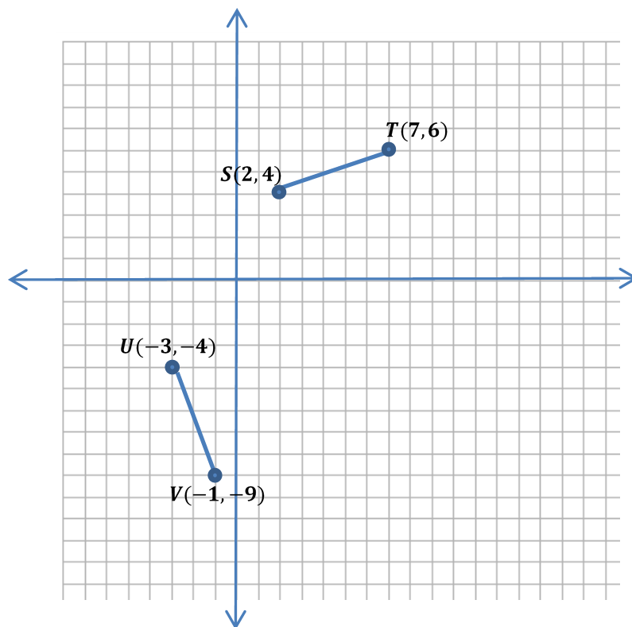Translate segments and so that the image of each segment has an endpoint at the origin.

Answers can vary slightly. Students will have to choose one of the first two and one of the second two.

If we translate so that the image of is at the origin, we get , .

If we translate so that the image of is at the origin, we get ,.

If we translate so that the image of is at the origin, we get , .

If we translate so that the image of is at the origin, we get ,.

* 1. **Are the segments perpendicular? Explain.**

Yes. By choosing any two of the translated segment and , we determine whether the equation yields a true statement: .

For example, using ,, and ,:

is a true statement; therefore, and .

* 1. **Are the lines and perpendicular? Explain.**

Yes, lines containing perpendicular segments are also perpendicular.

Problem Set Sample Solutions

*Scaffolding:*

Give students steps to follow to make problems more accessible.

1. Plot the points.
2. Find the common endpoint.
3. Translate that to .
4. Translate the other points.
5. Use the formula to determine perpendicularity.
6. Are the segments through the origin and the points listed perpendicular? Explain.
   1. ,

No; .

* 1. ,

Yes; .

1. Given ,, and listed below, are segments andperpendicular? Translate to the origin, write the coordinates of the images of the points, then explain without using slope.

,,

Yes;

, ,

Yes;

,,

No;

1. Is triangle , where ,, and , a right triangle? If so, which angle is the right angle? Justify your answer.

Yes. If the points are translated to ,, and , , meaning the segments are perpendicular. The right angle is .

1. A quadrilateral has vertices ,,,and. Prove that the quadrilateral is a rectangle.

Answers will vary, but it is a rectangle because it has right angles.

1. Given points ,, and , find the -coordinate of point with -coordinate so that the lines and are perpendicular.
2. A robot begins at position and moves on a path to . It turns counterclockwise.
   1. What point with -coordinate is on this path?
   2. Write an equation of the line after the turn.
   3. If it stops to charge on the -axis, what is the location of the charger?
3. Determine the missing vertex of a right triangle with vertices and if the third vertex is on the -axis. Verify your answer by graphing.
4. Determine the missing vertex for a rectangle with vertices , , and , and verify by graphing. Then, answer the questions that follow.
   1. What is the length of the diagonal?

Approximately units

* 1. What is a point on both diagonals in the interior of the figure?

1. A right triangle has vertices and and a third vertex located in Quadrant IV.
   1. Determine the coordinates of the missing vertex.
   2. Reflect the triangle across the -axis. What are the new vertices?

, , and

* 1. If the original triangle is rotated counterclockwise about the vertex , what are the coordinates of the other vertices?

,

* 1. Now rotate the original triangle clockwise about . What are the coordinates of the other vertices?

,

* 1. What do you notice about both sets of vertices? Explain what you observe.

One rotated vertex moves onto one of the original vertices, and the third vertex is different. This is because we are rotating the triangle about the right angle.