|  |
| --- |
|  |

Lesson 5: Criterion for Perpendicularity

Student Outcomes

* Students explain the connection between the Pythagorean theorem and the criterion for perpendicularity.

Lesson Notes

It is the goal of this lesson to justify and prove the following:

**Theorem:** Given three points on a coordinate plane ,, and, ⏊ if and only if   
.

The proof of this theorem relies heavily on the Pythagorean theorem and its converse. This theorem and its generalization, which will be studied in the next few lessons, will give students an efficient method to prove slope criterion for perpendicular and parallel lines (**G-GPE.B.5**). An explanation using similar triangles was done in Grade 8, Module 4, Lesson 26. The proof we give in geometry has the additional benefit of directly addressing **G-GPE.B.5** in the context of **G-GPE.B.4**. That is, the proof uses coordinates to prove a generic theorem algebraically.

Classwork

*Scaffolding:*

* It would be helpful to have posters of the Pythagorean theorem and its converse displayed in the classroom or to allow students to use a graphic organizer containing this information.
* For advanced students, use lengths that are radical expressions.

Opening Exercise (4 minutes)

Opening Exercise

In right triangle , find the missing side.

* 1. I**f and, what is ? Explain how you know.**

Because triangle is a right triangle, and we know the length of two of the three sides, we can us the Pythagorean theorem to find the length of the third side, which in this case is the hypotenuse.

* 1. If and, what is ?
  2. If and, what is (and )?

, and since , as well.

Example 1 (9 minutes)

This is a guided example where students are realizing that segments are perpendicular because they form a triangle whose sides satisfy the criterion of the Pythagorean theorem . The entire focus of this example is that if the sides of a triangle satisfy the Pythagorean theorem, then two of the sides of the triangle meet at right angles (the converse of the Pythagorean theorem).

Pose the following question so that students remember that it is important that “” is the longest side of the right triangle or the hypotenuse.

* Mrs. Stephens asks the class to prove the triangle with sides , 5, and is a right triangle. Lanya says the triangle is not a right triangle because . Is she correct? Explain.
  + *Lanya is not correct. is greater than , so it should be the hypotenuse of the right triangle. The equation should be thus, the triangle is right.*

At the beginning of this guided example, give students the following information and ask them if the triangle formed by the three segments is a right triangle. Students may work in pairs and must justify their conclusion.

**MP.3**

* ,, and; is triangle a right triangle? If so, name the right angle. Justify your answer.
  + *Students will need to use the converse of the Pythagorean theorem to answer this question. Does   
    ? ; therefore, triangle is not a right triangle.*
* Select at least one pair of students to present their answer and rationale. Because we only gave the side lengths and not the coordinates of the vertices, students will have to use the converse of the Pythagorean theorem, not slope, to answer this question.

Plot the following points on a coordinate plane: , , and

* Construct triangle . Do you think triangle is a right triangle?
  + *Students will guess either yes or no.*
* How do you think we can determine which of you are correct?
  + *Since we just finished working with the Pythagorean theorem and its converse, most students will probably suggest using the converse of the Pythagorean theorem. Some students may suggest comparing the slopes of the segments. If they do, explain that while this is certainly an appropriate method, the larger goals of the lesson will be supported by the use of the converse of the Pythagorean theorem.*
* We know the coordinates of the vertices of triangle . What additional information do we need?
  + *We need the lengths of the three sides of the triangle, , , and .*
* Do we have enough information to determine those lengths, and if so, how will we do this?
  + *Yes, we will use the distance formula. , , and*
* If triangle is a right triangle, which side would be the hypotenuse?
  + *The hypotenuse is the longest side of a right triangle. So, if triangle were a right triangle, its hypotenuse would be side .*
* What equation will we use to determine whether triangle is a right triangle?
* Use the side lengths and the converse of the Pythagorean theorem to determine whether triangle is a right triangle. Support your findings.
  + *Yes, triangle is a right triangle because .*
* Which angle is the right angle?

*Scaffolding:*

* Provide students with a handout with triangle already plotted.
* *is the right angle. It is the angle opposite the hypotenuse .*
* If is a right angle, what is the relationship between the legs of the right triangle, and ?
* ⏊

Have students summarize to a partner what they learned in this example. In Exercise 1, we will use what we just learned to determine if segments are perpendicular and if triangles are right.

Exercise 1 (3 minutes)

Have students work with a partner, but remind them that each student should record the work on his own student page. Select one pair of students to share their answer and rationale.

Exercise 1

1. 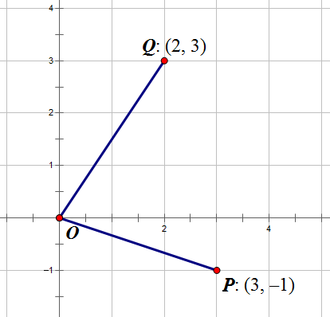Use the grid at the right.
   1. Plot points , , and on the coordinate plane.
   2. Determine whether and are perpendicular. Support your findings. No, and are not perpendicular.

Using the distance formula, we determined that , , and

; therefore, triangle is not a right triangle, is not a right angle, and and are not perpendicular.

Example 2 (9 minutes)

In this example, we will develop the general condition for perpendicularity between two segments and with endpoints ,, and.

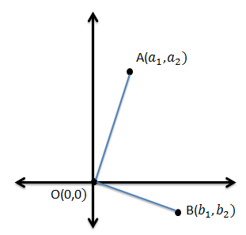  
Example 2

* Refer to triangle. What must be true about if is perpendicular to ?
  + *would be a right triangle, so it must satisfy the Pythagorean theorem.*
* Determine the expressions that define, , and .
  + *, , and.*
* If , the distances will satisfy the Pythagorean theorem.
  + , and by substituting in the expressions that represent the distances we get:
* We have just demonstrated that if two segments, and that have a common endpoint at the origin and other endpoints of and , are perpendicular, then .
* Let’s revisit Example 1 and verify our formula with a triangle that we have already proven is right. Triangle has vertices ,, and. Verify that it is right () using the formula.
  + *; the segments are perpendicular.*
* In Exercise 1, we found that triangle was not right. Let’s see if our formula verifies that conclusion. Triangle has vertices ,, and.
  + *; the segments are not perpendicular.*

Exercises 2–3 (9 minutes)

*Scaffolding:*

* Provide students with a handout that includes these points already plotted.
* Provide students with a list of the pairs of points/segments to explore to make sure they do all of them.
* Provide advanced students with coordinates that are not whole numbers.

In Example 2, we demonstrated that if two segments, and that have a common endpoint at the origin and other endpoints of and , are perpendicular, then . We did not demonstrate the converse of this statement, so you will need to explain to students that the converse holds as well: If two segments, and having a common endpoint at the origin and other endpoints of and such that , then . Students will use this theorem frequently during the remainder of this lesson and in upcoming lessons.

In pairs or groups of three, students will determine which pairs of segments are perpendicular. Have students split up the work and then, as they finish, check each other’s work.

Exercises 2–3

1. Given points ,, ,, ,,, and, find all pairs of segments from the list below that are perpendicular. Support your answer.

,,,,,,,and

because .

because .

because .

because .

because .

because .

because .

because .

1. The points ,,, and are the vertices of parallelogram . Is this parallelogram a rectangle? Support you answer.

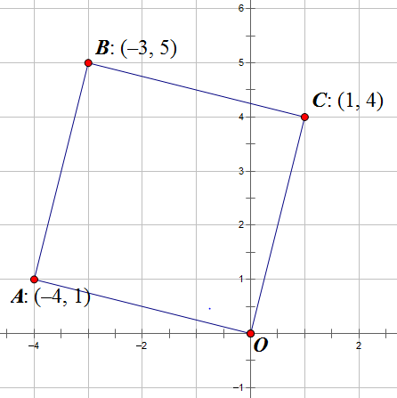We are given that the figure is a parallelogram with the properties that the opposite angles are congruent, and the adjacent angles are supplementary. To prove the quadrilateral is a rectangle, we only need to show that one of the four angles is a right angle.

because . Therefore, parallelogram is a rectangle.

Example 3 (4 minutes)

In this example, we will use the theorem students discovered in Example 2 and their current knowledge of slope to define the relationship between the slopes of perpendicular lines (or line segments). The teacher should present the theorem and then the diagram as well as the first two sentences of the proof. Also, consider showing the statements and asking the class to generate the reasons or asking students to try to come up with their own proof of the theorem with a partner.

**Theorem:** Let and be two non-vertical lines in the Cartesian plane such that both pass through the origin. The lines and are perpendicular if and only if their slopes are negative reciprocals of each other.



**Proof.** Suppose that is given by the graph of the equation , and by the equation .

Then and are points on , and and are points on .

* By the theorem that we learned in Exercise 2, what can we state?
  + *By the theorem of Exercise 2, and are perpendicular (⟺ means “if and only if”).*
* Let’s simplify that.

⟺

* Now isolate the variables on one side of the equation.

⟺

* Solve for .

⟺

* Now, with your partner, restate the theorem and explain it to each other.

Closing (2 minutes)

Ask students to respond to these questions in writing, with a partner, or as a class.

* Given ,, and, how do we know when ?
* How did we derive this formula?
  + *First, we had to think about the three points as the vertices of a triangle and assume that the triangle is a right triangle with a right angle at the origin. Next, we used the distance formula to calculate the lengths of the three sides of the triangle. Finally we used the Pythagorean theorem to relate the tree lengths. The formula simplified to .*
* What is true about the slopes of perpendicular lines?
  + *Their slopes are negative reciprocals of each other.*

Exit Ticket (5 minutes)

Name Date

Lesson 5: Criterion for Perpendicularity

Exit Ticket

1. 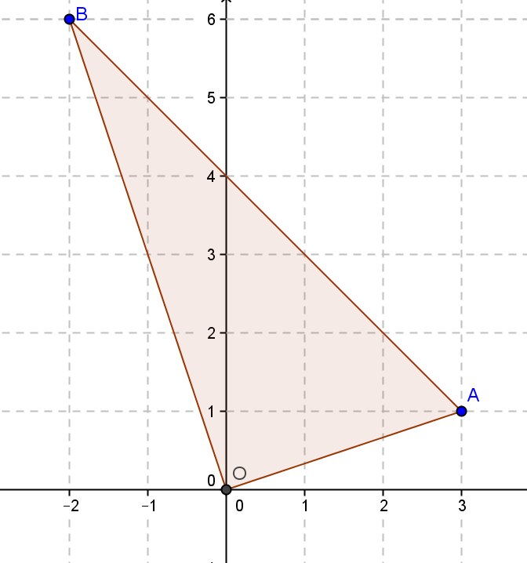Given points , , and , prove is perpendicular to .
2. 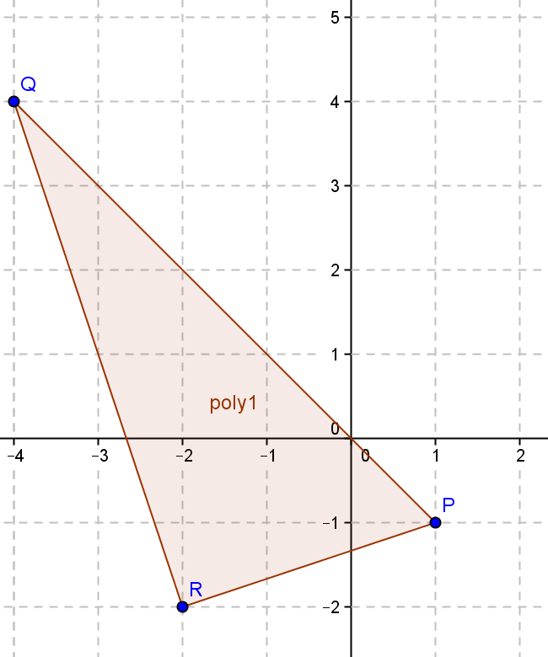Given points , , and , prove is perpendicular to without the Pythagorean theorem.

Exit Ticket Sample Solutions

1. 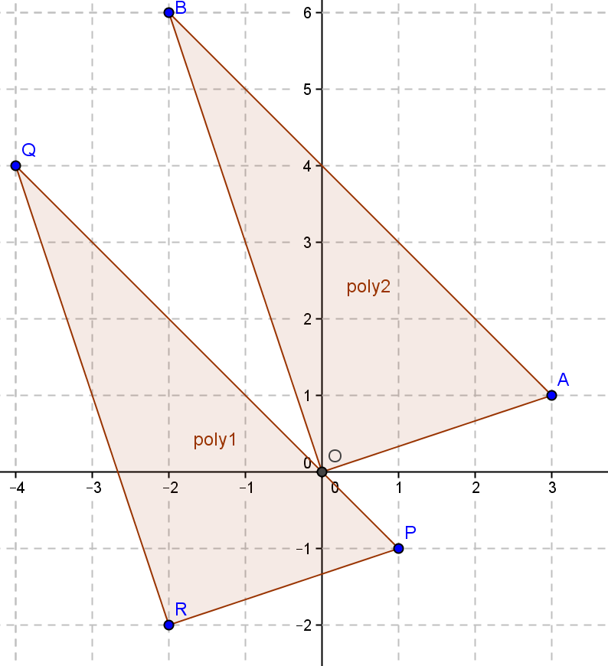**Given points and, prove is perpendicular to .**

Since both segments are through the origin, ; therefore, the segments are perpendicular. Students can also prove by the Pythagorean theorem that , or .

1. **Given points , , and, prove is perpendicular to without the Pythagorean theorem.**

The points given are translated points of the point given in Problem 1. Points ,, and have all been translated left and down . Since and are perpendicular, translating will not change the angle relationships, so perpendicularity is conserved.

Problem Set Sample Solutions

1. Prove using the Pythagorean theorem that is perpendicular to given and

,, and. If triangle is right, , and ; therefore, the segments are perpendicular.

1. Using the general formula for perpendicularity of segments through the origin and , determine if segments and are perpendicular.
2. ,

; therefore, the segments are not perpendicular.

1. ,

; therefore, the segments are perpendicular.

1. Given points , , and , where is perpendicular to , will the images of the segments be perpendicular if the three points , , and are translated four units to the right and eight units up? Explain your answer.

,,

Yes, the points are all translated units right and units up; since the original segments were perpendicular, the translated segments are perpendicular.

1. In Example 1, we saw that was perpendicular to for ,, and. Suppose ,, and. Are segments and perpendicular? Explain without using triangles or the Pythagorean theorem.

Yes, the segments are perpendicular. We proved in Example 1 that was perpendicular to . , , and are translations of , , and . The original coordinates have been translated right and up.

1. Challenge: Using what we learned in Exercise 2, if ,,and, what is the general condition of,,,,,andthat ensures segments and are perpendicular?

To translate to the origin, we move left and down . That means and   
. The condition of perpendicularity is , meaning that   
.

1. A robot that picks up tennis balls is on a straight path from towards a ball at . The robot picks up a ball at , then turns right. What are the coordinates of a point that the robot can move towards to pick up the last ball?

Answer will vary. A possible answer is .

1. Gerry thinks that the points and form a line perpendicular to a line with slope . Do you agree? Why or why not?

**MP.3**

I do not agree with Gerry. The segment through the two points has a slope of . If it was perpendicular to a line with slope , the slope of the perpendicular line would be .