Lesson 4: Designing a Search Robot to Find a Beacon

Student Outcomes
- Given a segment in the coordinate plane, students find the segments obtained by rotating the given segment by $90°$ counterclockwise and clockwise about one endpoint.

Lesson Notes
In Lesson 4, students are introduced to the idea of finding the equation of a line perpendicular to a given line through a given point. Students are led to the notion of the slopes of perpendicular lines being negative reciprocals by showing the $90°$ rotation of a slope triangle. This idea is first demonstrated by having students sketch a perpendicular line to make sense of how the slope triangle of the original line is related to the slope triangle of the perpendicular line. Once students understand the idea of how the slope of a line is related to the slope of its perpendicular, it is applied to the rotation of a segment in order to predict where one endpoint moves to after a $90°$ rotation clockwise or counterclockwise about the other endpoint. This is generalized to $90°$ rotations of a point clockwise or counterclockwise about the origin.

Classwork
Opening Exercise (5 minutes)
The goal of these exercises is to reactivate students’ knowledge of lines, slope, and $y$-intercepts.
Opening Exercise
Write the equation of the line that satisfies the following conditions:
  - Has a slope of $m=-\frac{1}{4}$ and passes through the point $(0,-5)$.
$$y =-\frac{1}{4}x-5$$

  - Passes through the points $(1, 3)$and $(-2, -1)$.
$$y-3=\frac{4}{3}\left(x-1\right) \text{or} y+2=\frac{4}{3}\left(x+2\right)$$

Exploratory Challenge (15 minutes)
The following prompt is meant to introduce students to the idea of determining the equation of a line perpendicular to a given line, through a given point. The context of the prompt mimics the coordinate plane, and students should find entry to the problem by sketching the known information on graph paper. Read the prompt as a class, and allow students a minute to process their ideas before asking them to proceed with the initial sketch of the situation. Then, proceed to the Discussion, where students will fine tune the approximate southeast direction ping to be the shortest distance from the line, i.e., along the line perpendicular to the line the robot is traveling.
Expect to spend 5–6 minutes on the prompt and the portion of the Discussion that leads to students’ understanding that we are trying to establish the equation of the perpendicular line through $(400, 600)$.
Exploratory Challenge
A search robot is sweeping through a flat plane in search of the homing beacon that is admitting a signal. (A homing beacon is a tracking device that sends out signals to identify the location). Programmers have set up a coordinate system so that their location is the origin, the positive $x$-axis is in the direction of east, and the positive $y$-axis is in the direction of north. The robot is currently $600$ units south of the programmers’ location and is moving in an approximate northeast direction along the line $y=3x-600$.
Along this line, the robot hears the loudest “ping” at the point $(400, 600)$. It detects this ping coming from approximately a southeast direction. The programmers have the robot return to the point $(400, 600)$. What is the equation of the path the robot should take from here to reach the beacon?
MP.4
Begin by sketching the location of the programmers and the path traveled by the robot on graph paper; then, shade the general direction the ping is coming from.
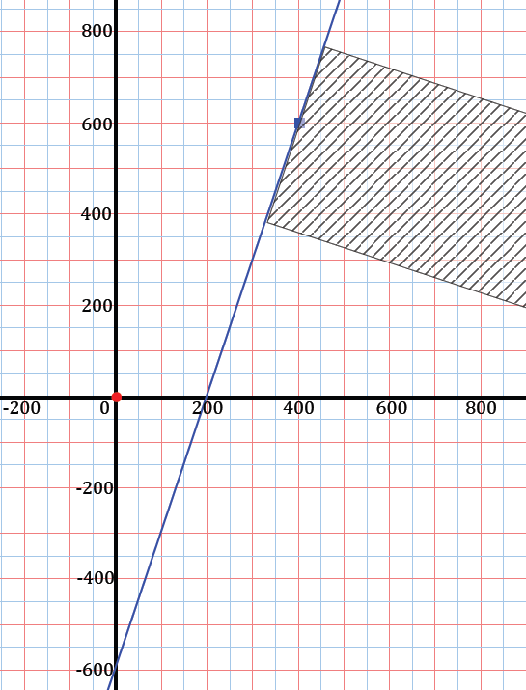
A student response may look something like the following:

Once students have formulated a rough idea of where the ping is coming from, they need to be convinced that the loudest sound will come from the shortest distance to the line the robot is on. You can compare the situation to the following using visuals as described below.
- Imagine a bystander on a sidewalk. A car with music playing passes by. Sketch a model of this.
- At what point do you think the music will sound the loudest to the bystander on the sidewalk?
  - It will sound loudest when the car is directly in front of the bystander.
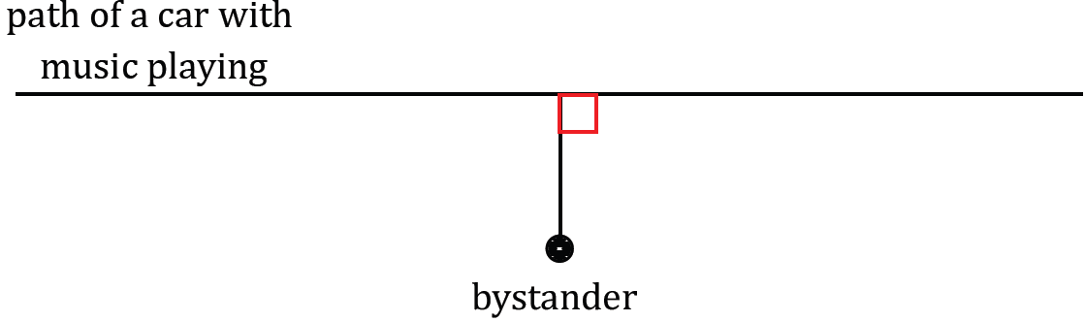
Confirm that this is true and that the shortest distance away is when the car is on the line perpendicular from the bystander.

Here is the crux of what students need to know about the question being posed:
Scaffolding:
- Looking at this problem graphically will help students see the location of the robot and the direction of the ping. Show the “rise-over-run” triangles and explain that the robot is originally moving three units north and then one unit east. Draw that triangle. Students can then see the turn will require one unit south for three units east.
- For advanced learners, pose the question: How are the slopes of perpendicular lines related?
- Similarly, if the loudest ping is heard at $(400, 600)$ on the line $y=3x-600$, we need to find the line perpendicular to the path of the robot that passes through $(400, 600)$. Now, the challenge is to find the equation of this line.
Students should be able to express the objective of the problem:
  - We need to find the equation of the line perpendicular to the robot’s path through $(400, 600)$.
- To find the equation of this line, we need to establish the slope of the perpendicular line.
- With the slope and the point $(400, 600)$, we can find the equation of the line.
- How can we find the slope of the perpendicular line?
In the remaining 9–10 minutes, consider student ability and either let students develop their own informal methods for doing this, or use the prompts below (provided after the following paragraph) to guide the conversation as a whole class.
Students who are able to construct an argument as to how to determine the perpendicular may use the following line of reasoning. By looking at the “rise-over-run triangle” for the line $y=3x-600$, they may say, “one step east gives three steps north.” Students might also argue, for example, that the perpendicular line requires “three steps east gives one step south” and, therefore, has a slope of$-\frac{1}{3}.$ The equation of the perpendicular line is $y-600=-\frac{1}{3}(x-400)$.
Use the following prompts to do either whole class discussion or frame student discussion for small-groups.
- What is the slope of the original line?
  - The slope is $3.$
- What does this mean in terms of direction?
  - For every three units the robot moves north, it moves one unit east.

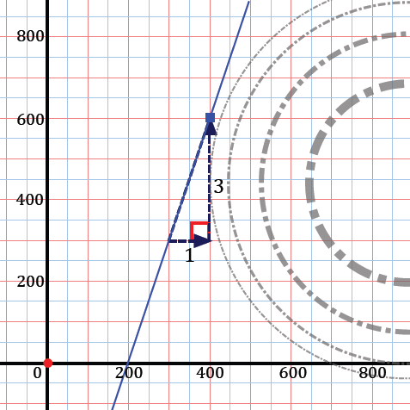
Share the following image once the slope of the robot’s path has been discussed. The goal is to guide students to the idea of using the slope triangle to help find the value of the perpendicular slope. Consider asking them to sketch a guess of the line by using the fact that it forms a $90°$ angle with the robot’s path.
- Since we know to look for a line perpendicular to the robot’s path and, therefore, forms a $90°$ angle with the path, how can we use the slope triangle to guide us?
Allow time for students to wrestle with the question before presenting the next image. Ask students to describe what they observe in the image and what it implies about the slope of the perpendicular line. Be sure that they note that in marking the right angle formed by the two lines, the edges of the angle coincide with the hypotenuse of each slope triangle.
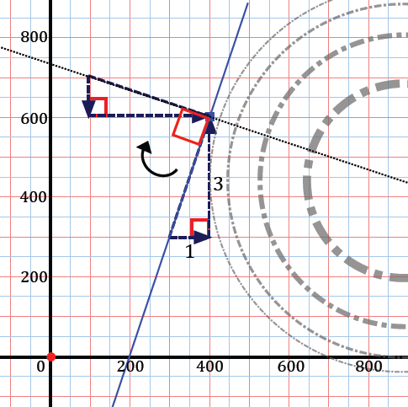
- Has the up and over (slope) triangle been distorted in any way?
  - No, the rotation preserves lengths and angles.
- Using what you know about the existing slope triangle, what must the slope of the perpendicular line be?
  - The slope must be $-\frac{1}{3}$, or down one unit for every three units moved to the right.
- Is this perpendicular slope algebraically related in any way to the original line’s slope?
Consider writing the two slopes side by side on the board for comparison
  - It is the negative reciprocal of the original slope.
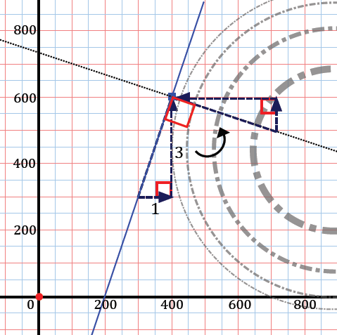
- Would it matter if the slope triangle were rotated $90°$ counterclockwise as opposed to $90°$ clockwise?
Students may have a difficult time visualizing this; be sure to share the next image and show that the direction of rotation does not impact the discovery of the slope.
- Now that we have established the slope of the perpendicular line, what else is needed to establish the equation of the line?
  - We have the slope, so we can use the known point of $(400, 600)$ to write the equation of the line.
- Write the equation of that line.
  - $y-600=-\frac{1}{3}\left(x-600\right)$
- We have now achieved our objective of finding the equation of the line perpendicular to the robot’s path through the point $(400, 600)$.
Students should be asked to summarize to their neighbor what they learned from this exercise. Teachers can use this activity to informally assess understanding so far.

Example 1 (13 minutes)
In this example, students are rotating line segments about one of the end points $90°$counterclockwise and then$90°$ clockwise.
Example 1
The line segment connecting $(3,7)$ to $(10,1)$ is rotated counterclockwise $90°$ about the point $(3,7)$.
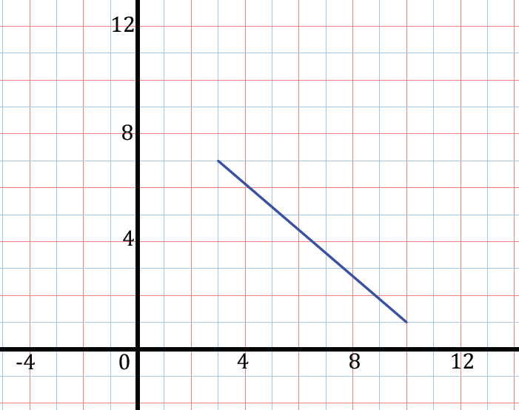
- Plot the points.

- Build a right triangle around the segment so that the segment is the hypotenuse of the right triangle.
- What are the lengths of the legs of the triangle?
  - The triangle has leg lengths of $6$ and $7$.
- What is the slope of the segment (i.e., the hypotenuse)?
  - The slope is $-\frac{6}{7}.$

- Where will the rotated endpoint land?
$$(-3, 0)$$
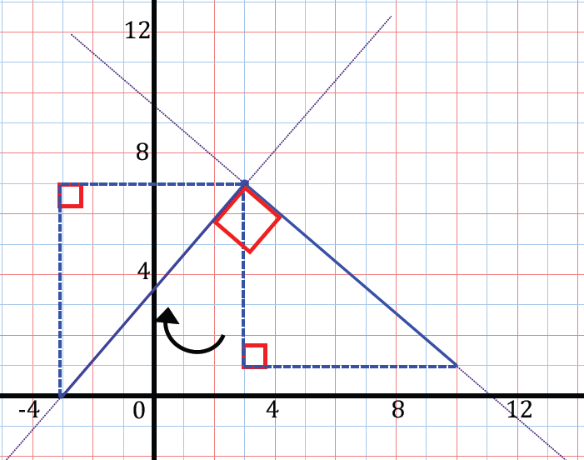

Just as in the Exploratory Challenge, consider asking students to sketch where they think the rotated segment will fall; for more than just a sketch, provide students with a setsquare and ruler.
- As we saw in the Exploratory Challenge, use this right triangle and the $90°$ angle of the original segment and rotated segment form to your advantage.
Allow time for students to attempt this independently before reviewing the rotation with them.
Scaffolding:
- If students are having trouble seeing the rotation, use a compass and protractor to show the circle with the center as the point of rotation, and divide the circles into $4$ congruent segments. You can also cut out a triangle, attach it to the center with a brad, and show the actual rotation.
- Patty paper can also be used to trace figures, rotate, and fold.
- Where does the endpoint land?
  - $(-3, 0)$
- What is the slope of the rotated segment?
  - $\frac{7}{6}$
- How is this slope related algebraically to the original segment’s slope?
  - It is the negative reciprocal of the original slope.
- If we know that the perpendicular slope is the negative reciprocal of the slope of the original segment, could we have avoided a sketch of the perpendicular line and determined the location of the rotated point? How?
  - We know that the rotated segment has to have a slope of $\frac{7}{6}$, so we can move $7$ units down and $6$ units left, or alternatively, subtract $7$from the $y$-coordinate and $6$ from the $x$-coordinate of the point $(3, 7)$.
Emphasize this by writing $(-3, 0)$ next to $(3, 7)$ on the board and showing the difference between the $x$-coordinates and $y$-coordinates.

- Now rotate the original segment $90°$ clockwise. Before using a sketch, predict the coordinates of the rotated endpoint using what you know about the perpendicular slope of the rotated segment.
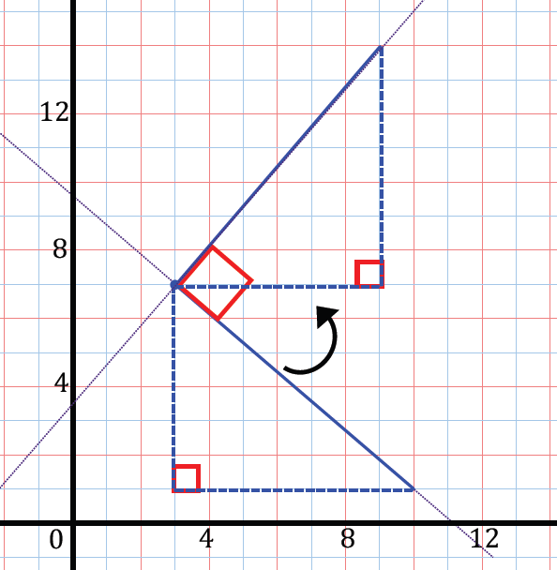

- What do you predict the coordinates of the rotated endpoint to be? Explain how you know.
  - We know that the rotated segment will have a slope of $\frac{7}{6}$, so we can add $7$ to the $y$-coordinate an add $6$ to the $x$-coordinate of $(3, 7)$ to get $(9, 14)$.
Have students verify their prediction by drawing the rotation.

- Let us summarize. Describe how you can use the rise and run values, or the leg lengths of the right triangle built around the segment, to predict the coordinates of a rotated point (clockwise or counterclockwise) relative to the center of rotation.
  - For either a $90°$ rotation clockwise or counterclockwise, I took the negative reciprocal of the slope of the segment and used what I knew about the general position of the rotated point to accordingly add or subtract the “rise” value from the $y$-coordinate and the “run” value from the $x$-coordinate of the center.

Exercise 1 (5 minutes)
Scaffolding:
- If scaffolding is needed, provide sketches like the following and have students fill in the missing information.
- Initial drawing:
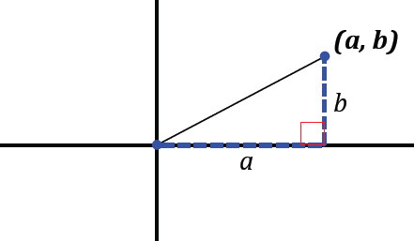
- Part (a):
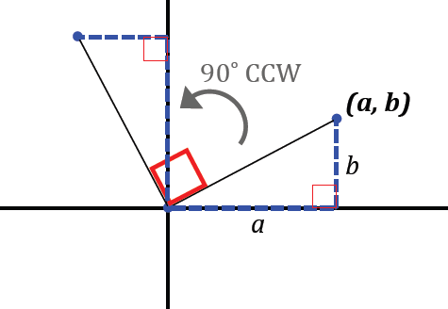
- Part (b):
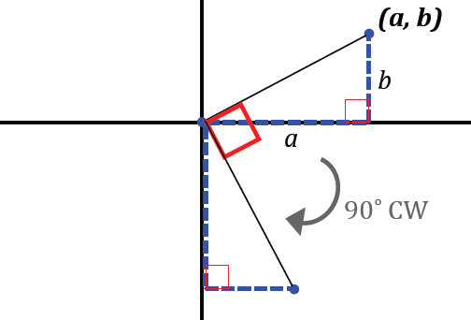
Students should be given an opportunity to work this in pairs. Have them graph the point and rotate it; students should think of it as a segment between the point and the origin using triangles as in Example 1.
Consider pulling a small group aside for targeted instruction while others are working.
Exercise 1
The point $(a, b)$ is labeled below:

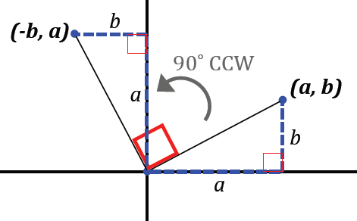
  - Using $a$ and $b$, describe the location of $(a, b)$ after a $90°$ counterclockwise about the origin. Draw a rough sketch to justify your answer.
$$(-b, a)$$

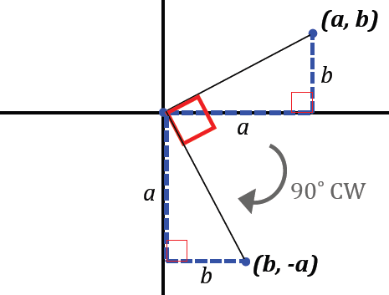
  - If the rotation was clockwise about the origin, what is the rotated location of $(a, b)$ in terms of $a$ and $b$? Draw a rough sketch to justify your answer.
$$(b,-a)$$
  - What is the slope of the line through the origin and $(a, b)$? What is the slope of the perpendicular line through the origin?
MP.7
$$\frac{b}{a}\text{;} -\frac{a}{b}$$

  - What do you notice about the relationship between the slope of the line through the origin and $(a,b)$ and the slope of the perpendicular line?
The slopes are negative reciprocals of each other. Their product is $-1$.

Closing (2 minutes)
Ask students to respond to these questions in writing, with a partner, or as a class.
- What is the relationship between the slope of a line and the slope of a line perpendicular to it?
  - The slopes are negative reciprocals of each other.
- How do you predict the coordinates of a point to be rotated $90°$ clockwise or counterclockwise with respect to the center?
  - For either a $90°$ rotation clockwise or counterclockwise, I took the negative reciprocal of the slope of the segment and used what I knew about the general position of the rotated point to add or subtract the “rise” value from the $y$-coordinate and the “run” value from the $x$-coordinate of the center accordingly.
- How is this special to a rotation about the origin?
  - Rotating a point $90°$ counterclockwise about the origin changes the coordinates of $(a, b)$ to $(-b, a)$.
  - Rotating a point $90°$ clockwise about the origin changes the coordinates of $(a, b)$ to $(b,- a)$.

Exit Ticket (5 minutes)

Name Date
Lesson 4: Designing a Search Robot to Find a Beacon

Exit Ticket

If the line segment connecting point $P(5, 2)$ to $R(3, 6)$is rotated $90°$ counterclockwise about point $R:$
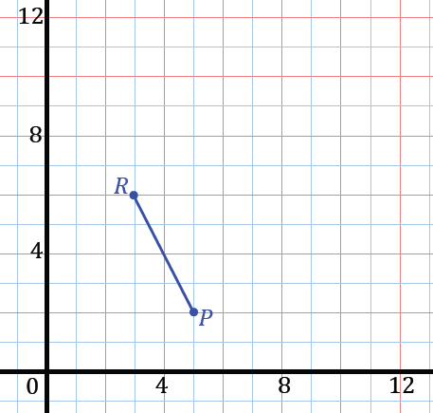
  - Where will point $P$land?

  - What is the slope of the original segment, $\overline{PR}$?

  - What is the slope of the rotated segment? Explain how you know.

Exit Ticket Sample Solutions

If the line segment connecting point $P(5, 2)$ to $R(3, 6)$ is rotated $90°$ counterclockwise about point$R:$
  - Where will point $P$ land?
$$(7, 8)$$

  - What is the slope of the original segment, $\overline{PR}$?
$$-2$$

  - What is the slope of the rotated segment? Explain how you know.
The slope is $\frac{1}{2}$; a $90°$ rotation means the segments are perpendicular, so the slopes are negative reciprocals of each other.

Problem Set Sample Solutions

- Find the new coordinates of point $(0, 4)$ if it rotates:
  - $90°$ counterclockwise.
$$(-4, 0)$$

  - $90°$ clockwise.
$$(4, 0)$$

  - $180°$ counterclockwise.
$$(0,-4)$$

  - $270°$ clockwise.
$$(-4, 0)$$

- What are the new coordinates of the point$(-3, -4)$ if it is rotated about the origin:
  - Counterclockwise $90°$?
$$(4,-3)$$

  - Clockwise $90°$?
$$(-4, 3)$$

- Line segment $\overline{ST}$ connects points $S(7,1)$ and $T(2, 4)$.
  - Where does point $T$ land if the segment is rotated $90˚$ counterclockwise about $S$?
$$(4,-4)$$
  - Where does point $T$ land if the segment is rotated $90°$ clockwise about $S$?
$$(10, 6)$$

  - What is the slope of the original segment?
$$-\frac{3}{5}$$

  - What is the slope of the rotated segments?
$$\frac{5}{3}$$

- Line segment $\overline{VW}$ connects points $V(1, 0)$and $W(5, -3)$.
  - Where does point $W$ land if the segment is rotated $90°$ counterclockwise about $V$?
$$(4, 4)$$

  - Where does point $W$ land if the segment is rotated $90°$ clockwise about $V$?
$$(-2,-4)$$

  - Where does point $V$ land if the segment is rotated $90°$ counterclockwise about $W$?
$$(2,-7)$$

  - Where does point $V$ land if the segment is rotated $90°$ clockwise about $W$?
$$(8, 1)$$

- If the slope of a line is $0$, what is the slope of a line perpendicular to it? If the line has slope $1$, what is the slope of a line perpendicular to it?
undefined; $-1$

- If a line through the origin has a slope of $2$, what is the slope of the line through the origin that is perpendicular to it?
$$-\frac{1}{2}$$

- A line through the origin has a slope of $\frac{1}{3}$. Carlos thinks the slope of a perpendicular line at the origin will be $3$. Do you agree? Explain why or why not.
I disagree with Carlos. The slope of the perpendicular line would have a slope of $-3$ because it should be the negative reciprocal of the original slope.

- Could a line through the origin perpendicular to a line through the origin with slope $\frac{1}{2}$ pass through the point $(-1 ,4)$? Explain how you know.
No, the equation of the line through the origin perpendicular to the line through the origin with slope $\frac{1}{2}$ has an equation of $y=-2x$. $(-1, 4)$ is not a solution to this equation.

