Lesson 3: Lines That Pass Through Regions

Classwork
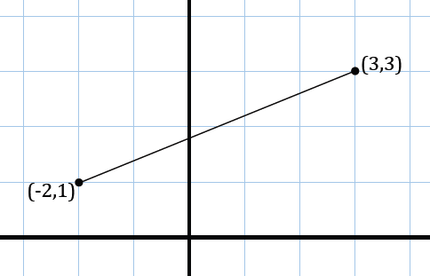
Opening Exercise
How can we use the Pythagorean theorem to find the length of $\overline{AB}$, or in other words, the distance between $A(-2,1)$ and $B(3,3)$? Find the distance between $A$ and $B$.

Example 1
Consider the rectangular region:
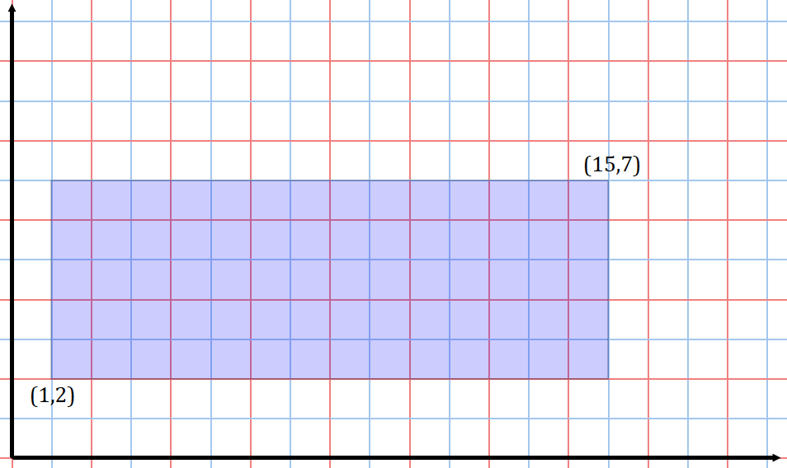

  - Does a line of slope $2$ passing through the origin intersect this rectangular region? If so, which boundary points of the rectangle does it intersect? Explain how you know.

  - Does a line of slope $\frac{1}{2}$ passing through the origin intersect this rectangular region? If so, which boundary points of the rectangle does it intersect?

  - Does a line of slope $\frac{1}{3}$ passing through the origin intersect this rectangular region? If so, which boundary points of the rectangle does it intercect?

  - A line passes through the lower right vertex of the rectangle? Does the line pass through the interior of the rectangular region or the boundary of the rectangular region? Does the line pass through both?

  - For which values of $m$ would a line of slope $m$ through the origin intersect this region?

  - For which values of $m$ would a line of slope $m$ through the point $(0, 1)$ intersect this region?

Example 2
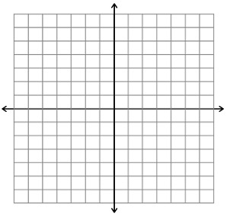
Consider the triangular region in the plane given by the triangle with vertices $A(0, 0)$, $B(2, 6)$, and $C(4, 2)$.
$$A$$
$$B$$
$$C$$
  - The horizontal line $y=2$ intersects this region. What are the coordinates of the two boundary points it intersects? What is the length of the horizontal segment within the region along this line?

  - Graph the line $3x-2y=5$. Find the points of intersection with the triangular region and label them as $X$ and $Y$.

  - What is the length of the segment $\overline{XY}$?

  - A robot starts at position $(1,3)$ and moves vertically downward towards the $x$-axis at a constant speed of $0.2$ units per second. When will it hit the lower boundary of the triangular region that falls in its vertical path?

Exercise
Consider the given rectangular region:
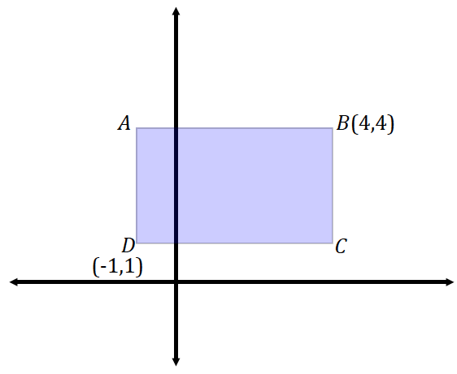

  - Draw lines that pass through the origin and through each of the vertices of the rectangular region. Do each of the four lines cross multiple points in the region? Explain.

  - Write the equation of a line that does not intersect the rectangular region at all.

  - A robot is positioned at $D$ and begins to move in a straight line with slope $m=1$. When it intersects with a boundary, it then reorients itself and begins to move in a straight line with a slope of $m=-\frac{1}{2}$. What is the location of the next intersection the robot makes with the boundary of the rectangular region?

  - What is the approximate distance of the robot’s path in part (c)?

Problem Set

- A line intersects a triangle at least once, but not at any of its vertices. What is the maximum number of sides that a line can intersect a triangle? Similarly, a square? A convex quadrilateral? A quadrilateral, in general?

- Consider the rectangular region:
  - What boundary points does a line through the origin with a slope of $-2$intersect? What is the length of the segment within this region along this line?
$$(-3, -1)$$
$$(5, -4)$$
  - What boundary points does a line through the origin with a slope of $3$ intersect? What is the length of the segment within this region along this line?
  - What boundary points does a line through the origin with a slope of $-\frac{1}{5}$ intersect?
  - What boundary points does a line through the origin with a slope of $\frac{1}{4}$ intersect?
- Consider the triangular region in the plane given by the triangle $(-1, 3)$, $(1, -2)$, and $(-3, -3)$.
  - The horizontal line $y=1$ intersects this region. What are the coordinates of the two boundary points it intersects? What is the length of the horizontal segment within the region along this line?
  - What is the length of the section of the line $2x+3y=-4$ that lies within this region?
  - If a robot starts at $(1, -2)$and moves vertically downward at a constant speed of $0.75$ units per second, when will it hit the lower boundary of the triangular region?
  - If the robot starts at $(1, -2)$ and moves horizontally left at a constant speed of $0.6$ units per second, when will it hit the left boundary of the triangular region?

- A computer software exists so that the cursor of the program begins and ends at the origin of the plane. A program is written to draw a triangle with vertices $A (1, 4)$, $B(6, 2)$, and $C(3, 1)$ so that the cursor only moves in straight lines and travels from the origin to $A$, then to $B$, then to $C$, then to $A$, and then back “home” to the origin.
  - Sketch the cursor’s path, i.e., sketch the entire path from when it begins until when it returns “home.”
  - What is the approximate total distance traveled by the cursor?
  - Assume the cursor is positioned at $B$ and is moving horizontally towards the $y$-axis at $\frac{2}{3}$ units per second. How long will it take to reach the boundary of the triangle?

- An equilateral triangle with side length $1$ is placed in the first quadrant so that one of its vertices is at the origin and another vertex is on the $x$-axis. A line passes through the point half the distance between the endpoints on one side and half the distance between the endpoints on the other side.
  - Draw a picture that satisfies these conditions.
  - Find the equation of the line that you drew.

