Lesson 3: Lines That Pass Through Regions

Student Outcomes
- Given two points in the coordinate plane and a rectangular or triangular region, students determine whether the line through those points meets the region, and if it does, they describe the intersections as a segment and name the coordinates of the endpoints.

Lesson Notes
Give students graph paper and rulers to begin this lesson. Remind students to graph points as carefully and accurately as possible. Playing with the scale on the axes will also make intersection points more obvious and easier to read.

Classwork
Opening Exercise (7 minutes)
The objective in the Opening Exercise is to reactivate student knowledge on how to find the distance between two points in the coordinate plane (refer to Grade 8, Module 7, Topic C, Lesson 17) using the Pythagorean Theorem.
Opening Exercise
How can we use the Pythagorean theorem to find the length of $\overline{AB}$, or in other words, the distance between $A(-2,1)$ and $B(3,3)$? Find the distance between $A$ and $B$.
The distance between $A$ and $B$ is $\sqrt{29}$. By treating the length between the provided points as the hypotenuse of a right triangle, we can build a right triangle and determine the leg lengths in order to apply the Pythagorean Theorem and calculate the length of the hypotenuse, which is the length we were trying to find.

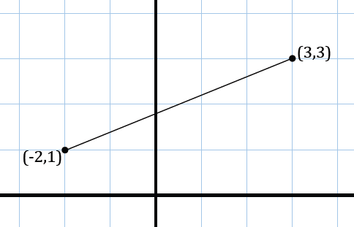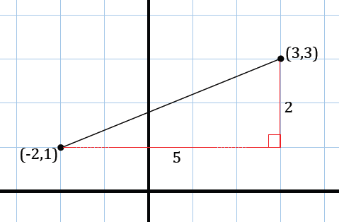
A
B
A
B

Prompt students with the following hint if needed: Treat $AB$ as the hypotenuse of a right triangle and build the appropriate right triangle around the segment.
- Notice that in using the Pythagorean theorem, we are taking both the horizontal and vertical distances between the provided points, squaring each distance, and taking the square root of the sum.
- Using the Pythagorean theorem to find the distance between two points can be summarized in the following formula:
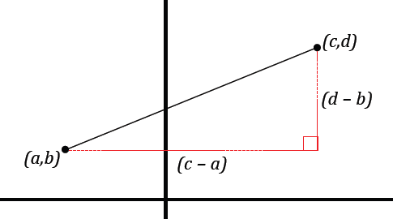
Scaffolding:
- Consider providing struggling students with the second image of the graph with the grid of the coordinate plane and have them label the axes.
$$d\left[\left(a,b\right), \left(c,d\right)\right]=\sqrt{{(c-a)}^{2}+{(d-b)}^{2}.}$$
- This formula is referred to as the distance formula.
Have students summarize what they learned in the Opening Exercise and use this to informally assess student progress before moving on with the lesson.

Example 1 (10 minutes)
For each part below, give students two minutes to graph and find the points of intersection on their own. After two minutes, graph (or have a student come up to graph) the line on the board and discuss the answer as a whole class.
Example 1
Consider the rectangular region:
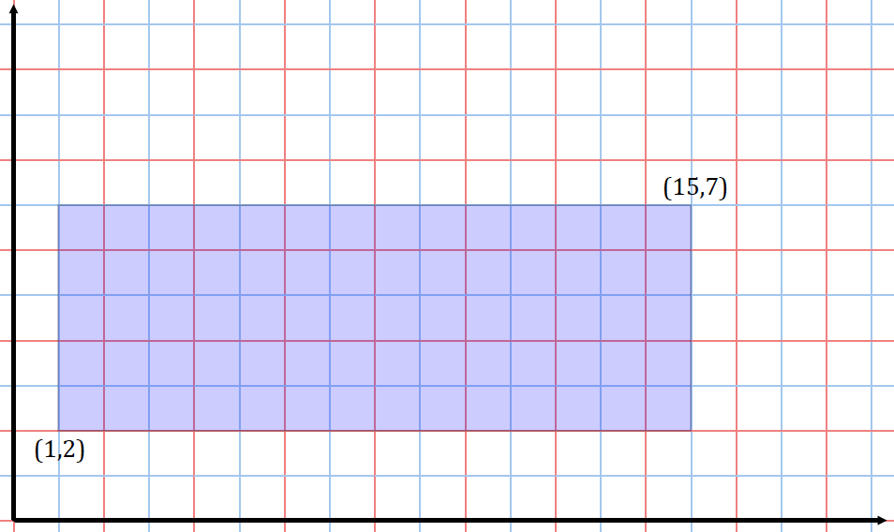

  - Does a line of slope $2$ passing through the origin intersect this rectangular region? If so, which boundary points of the rectangle does it intersect? Explain how you know.
MP.3
Yes, it intersects twice, at $(1, 2)$ and $(3.5, 7)$. Student justification may vary. One response may include the use of the algebraic equation $y=2x$, or students may create a table of values using their understanding of slope and compare the $y$-values of their table against the $y$-values of the boundary points of the rectangle.

  - Does a line of slope $\frac{1}{2}$ passing through the origin intersect this rectangular region? If so, which boundary points of the rectangle does it intersect?
Yes, it intersects twice, at $(4, 2)$ and $(14, 7)$.

  - Does a line of slope $\frac{1}{3}$ passing through the origin intersect this rectangular region? If so, which boundary points of the rectangle does it intercect?
Yes, it intersects twice, at $(6, 2)$ and $(15, 5)$.

Part (d) is meant to encourage a discussion about the interior versus boundary of the rectangular region; have students talk in pairs before sharing out in a whole class debate. Once opinions are discussed, confirm that points that lie on the segments that join the vertices of the rectangle make up the boundary of the rectangle, whereas the interior of the region consists of all other points within the rectangle.

  - A line passes through the lower right vertex of the rectangle? Does the line pass through the interior of the rectangular region or the boundary of the rectangular region? Does the line pass through both?
The line passes through the boundary of the rectangular region.

  - For which values of $m$ would a line of slope $m$ through the origin intersect this region?
$$\frac{2}{15}≤m≤7$$

Take time to explore the slopes of the lines above and their intersection points. The more you explore, the more students will start to see what happens as slopes get bigger and smaller to the points of intersection of the region. Project the figure on the board and color code each line with the slope listed on it so students have a visual to see the change in relation to other slopes. This activity can be started with the blank rectangle; as you proceed, ask the following questions:
- Let’s draw a line through the origin with slope $1$. What other point will it pass through? How many times does it intersect the boundary of the rectangle?
  - Answers will vary, but possible answers include $\left(1, 1\right)$ and $(2, 2)$. It intersects twice.
- Let’s draw a line through the origin with slope $2$. Will it go through the same point as the previous line? What point will it pass through? How many times does it intersect the boundary of the rectangle?
  - It will not pass through the same points as the previous line. Answers will vary, but possible answers include $(1, 2)$ and $(2, 4)$. It intersects twice.
Continue this line of questioning and ask students about the differences between the lines.

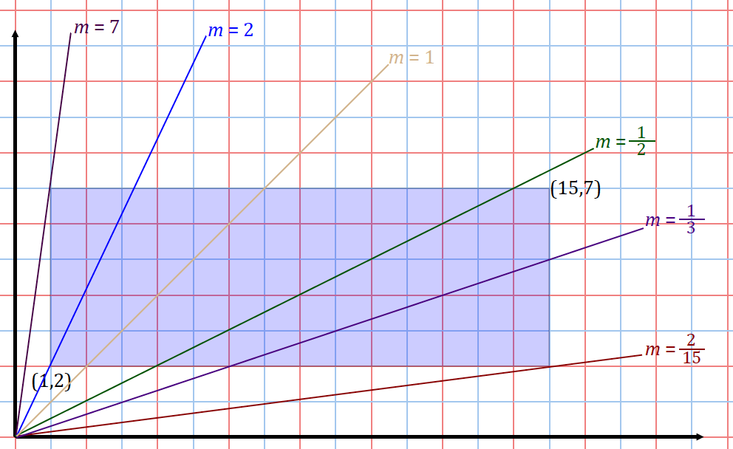

- Describe how the point or points of intersection change as the slope decreases from $m=7$ to $m=\frac{2}{15}$.
MP.7
  - As the slope decreases, the points of intersection occur further and further to the right of the rectangular region.
  - As the slope decreases, the $x$-coordinate of each intersection point is increasing for all the points that have a $y$-coordinate of $7$, and then the $y$-coordinate of each intersection point is decreasing for all the points that have an $x$-coordinate of $15$.
- What would be the slope of a line passing through the origin that only intersected one point of the region and did not pass through the region?
  - If the intersection point was the top left corner, $(1, 7)$, the slope of the line through the origin would be $7$. If the point of intersection was the bottom right, $(15, 2)$, the slope would be $\frac{2}{15}$.
- What can you say about the slopes of lines through the origin that don’t intersect the region?
  - They are either greater than $7$ or less than $\frac{2}{15}$.

  - For which values of $m$ would a line of slope $m$ through the point $(0, 1)$ intersect this region?
$$\frac{1}{15}≤m≤6$$

- What changes in the previous problem if we shift the $y$-intercept from the origin to $(0, 1)$?
  - The graph moves up $1$ unit.
- How does that affect the slope?
  - The rise of the slope decreases by $1$; so, instead of going up $7$ and over $1$ from the origin, you would go up $6$ and over $1$ to get to the point $(1, 7)$ if the $y$-intercept is$\left(0, 1\right),$ changing the slope from $7$ to $6$. The same is true for the slope to the point $(15, 2)$. Instead of moving up $2$ and right $15$, we move up $1$ and right $15$, changing the slope.

Example 2 (15 minutes)
Depending on student ability, consider working on Example 2 as a whole class. Allow students one minute after reading each question to process and begin considering a strategy before continuing with guided prompts.
Example 2
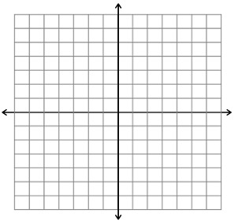
Consider the triangular region in the plane given by the triangle with vertices $A(0, 0)$, $B(2, 6)$, and $C(4, 2)$.
$$A$$
$$B$$
$$C$$
  - The horizontal line $y=2$ intersects this region. What are the coordinates of the two boundary points it intersects? What is the length of the horizontal segment within the region along this line?
The coordinates are $\left(\frac{2}{3}, 2\right)$ and $\left(4, 2\right)$; the length of the segment is $3\frac{1}{3}$.

- How many times does the line $y=2$ intersect the boundary of the triangle?
$$A$$
$$B$$
$$C$$
  - It intersects $2$ times.
- Is it easy to find these points from the graph? What can you do to find these points algebraically?
  - No, it is not easy because one of the intersection points does not have whole number coordinates.
  - We can find the equation of the line that passes through $(0, 0)$ and $(2, 6)$, and set the equation equal to $2$ and solve for $x$. This gives us the $x$-coordinate $\frac{2}{3}$ of the point $\left(\frac{2}{3},2\right)$.

  - Graph the line $3x-2y=5$. Find the points of intersection with the triangular region and label them as $X$ and $Y$.
Scaffolding:
- Depending on student ability, consider using the equation $-3x+y=5$ for part (b) in order to ensure whole-number coordinate intersections.
- In this case, the intersections are $\left(2,1\right)$and $\left(3,4\right),$ and the distance between then them is approximately $3.2$.
The points of intersection are $(1.25,0.625)$ and $\left(\frac{25}{7},\frac{20}{7}\right)$.

- How will you find the points of intersection of the line with the triangular region?
  - From graphing the line, we know that the given line intersects $\overset{⃡}{AC}$ and $\overset{⃡}{BC}$. We need to find the equations of $\overset{⃡}{AC}$ and $\overset{⃡}{BC}$ and put them, as well as the provided equation of the line $3x –2y=5,$ into slope intercept form.
$$A$$
$$B$$
$$C$$
$$X$$
$$Y$$
$\overset{⃡}{AC}$ $y=\frac{1}{2}x.$
$\overset{⃡}{BC}$ $y=10-2x.$
$3x-2y=5$ $y=1.5x-2.5.$

  - The $x$-coordinates of the points of intersection can be found by setting each of $\overset{⃡}{AC}$ and $\overset{⃡}{BC}$ with the provided equation of the line:
(1) $\frac{1}{2}x=1.5x-2.5$  $x=1.25$, $y=0.625.$ | (2) $10-2x=1.5x-2.5$  $x=\frac{25}{7}$, $y=\frac{20}{7}.$

  - What is the length of the segment $\overline{XY}$?
$$d\left[\left(1.25,0.625\right),\left(\frac{25}{7},\frac{20}{7}\right)\right]=\sqrt{{\left(\frac{25}{7}-1.25\right)}^{2}+{\left(\frac{20}{7}-0.625\right)}^{2}}≈3.2$$

  - A robot starts at position $(1,3)$ and moves vertically downward towards the $x$-axis at a constant speed of $0.2$ units per second. When will it hit the lower boundary of the triangular region that falls in its vertical path?
Scaffolding:
- Depending on student ability, consider using vertex $B$ for (d) to facilitate the idea behind the question.
- In this case, the robot would hit the lower boundary (at $(2,1)$) in $30$ seconds.
$$\frac{2.5 units}{0.2\frac{units}{s}}=12.5 s$$

- What do you have to calculate before you find the time it hits the boundary?
  - Find the point of intersection between the vertical path and the lower boundary of the triangular region:
    - $x$-coordinate of intersection must be $1$ and equation of $\overset{⃡}{AC}$:
$$y=\frac{1}{2}x.$$
    - By substituting for $x$, the point of intersection must happen at $\left(1,0.5\right).$
  - Find the distance between $(1,3)$ and the point of intersection.
    - The distance between $(1,3)$ and $(1,0.5)$ is $2.5$.

Exercise (6 minutes)
Exercise
Consider the given rectangular region:
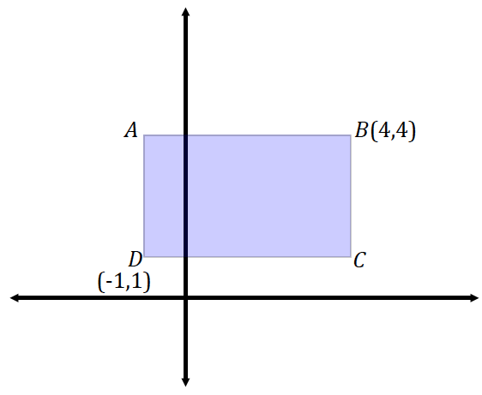

  - Draw lines that pass through the origin and through each of the vertices of the rectangular region. Do each of the four lines cross multiple points in the region? Explain.
Out of the four lines that pass through the origin and each of the vertices, only the lines that pass through $A$ and $B$ pass through multiple points in the region. The lines that pass through $C$ and $D$ do not intersect any other points belonging to the region.

  - Write the equation of a line that does not intersect the rectangular region at all.
Responses will vary; one example is $x=-2$.

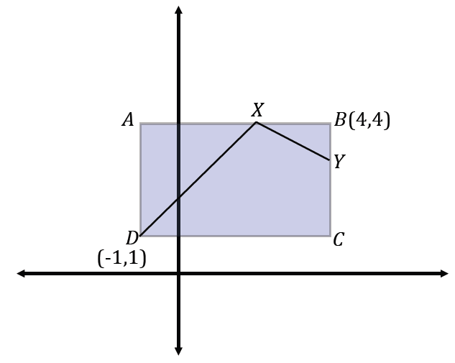
  - A robot is positioned at $D$ and begins to move in a straight line with slope $m=1$. When it intersects with a boundary, it then reorients itself and begins to move in a straight line with a slope of $m=-\frac{1}{2}$. What is the location of the next intersection the robot makes with the boundary of the rectangular region?
$$(4, 3)$$

  - What is the approximate distance of the robot’s path in part (c)?
$distance\left(\overline{DX}\right)+distance\left(\overline{XY}\right)=distance(path)$
$\sqrt{{\left(2-4\right)}^{2}+{\left(4-3\right)}^{2}}+\sqrt{{(-1-2)}^{2}+{(1-4)}^{2}}≈6.5$

Closing (2 minutes)
Gather the class and discuss one or both of the following. Use this as an informal assessment of student understanding.
- What is the difference between a rectangle and a rectangular region (or a triangle and a triangular region)?
  - A rectangle (triangle) only includes the segments forming the sides. A rectangular (triangular) region includes the segments forming the sides of the figure and the area inside.
- We have found points of intersection in this lesson. Some situations involved the intersection of two non-vertical/non-horizontal lines, and some situations involved the intersection of one non-vertical/non-horizontal line with a vertical or horizontal line. Does one situation require more work than the other? Why?
  - Finding the intersection of two non-vertical/non-horizontal lines takes more work because neither variable value is obvious and, therefore, a system of equations must be solved.

Exit Ticket (5 minutes)

Name Date
Lesson 3: Lines That Pass Through Regions

Exit Ticket

Consider the rectangular region:
$$(1, 1)$$
$$(4, 4)$$

a. Does a line with slope $\frac{1}{2}$ passing through the origin intersect this region? If so, what are the boundary points it intersects? What is the length of the segment within the region?

b. Does a line with slope $3$ passing through the origin intersect this region? If so, what are the boundary points it intersects?

Exit Ticket Sample Solutions

Consider the rectangular region:
$$(1, 1)$$
$$(4, 4)$$

a. Does a line with slope $\frac{1}{2}$ passing through the origin intersect this region? If so, what are the boundary points it intersects? What is the length of the segment within the region?
Yes, it intersects at $(2, 1)$ and$(4, 2)$; the length is approximately $2.24.$

b. Does a line with slope $3$ passing through the origin intersect this region? If so, what are the boundary points it intersects?
Yes, it intersects at $(1, 3)$ and $\left(1\frac{1}{3}, 4\right).$

Problem Set Sample Solutions
Problems should be completed with graph paper and a ruler.

- A line intersects a triangle at least once, but not at any of its vertices. What is the maximum number of sides that a line can intersect a triangle? Similarly, a square? A convex quadrilateral? A quadrilateral, in general?
For any convex polygon, the maximum number of sides a line can intersect the polygon is $2$. For a general quadrilateral, the line could intersect up to all $4$ sides.

- Consider the rectangular region:
  - What boundary points does a line through the origin with a slope of $-2$ intersect? What is the length of the segment within this region along this line?
It intersects at $\left(\frac{1}{2}, -1\right)$ and $\left(2, -4\right)$; the length is
approximately $3.35$.
$$(-3, -1)$$
$$(5, -4)$$

  - What boundary points does a line through the origin with a slope of $3$ intersect? What is the length of the segment within
this region along this line?
It intersects at $\left(-\frac{1}{3}, -1\right)$ and $\left(-1\frac{1}{3}, -4\right)$; the length is approximately $3.2$.
  - What boundary points does a line through the origin with a slope of $-\frac{1}{5}$ intersect?
It intersects at $(5, -1)$ only.

  - What boundary points does a line through the origin with a slope of $\frac{1}{4}$ intersect?
The line does not intersect the rectangular region.

- Consider the triangular region in the plane given by the triangle $(-1, 3)$, $(1, -2)$, and $(-3, -3)$.
  - The horizontal line $y=1$ intersects this region. What are the coordinates of the two boundary points it intersects? What is the length of the horizontal segment within the region along this line?
It intersects at $\left(-1\frac{2}{3}, 1\right)$ and$\left(-\frac{1}{5}, 1\right)$; the length is approximately $1.47$

  - What is the length of the section of the line $2x+3y=-4$ that lies within this region?
The length is approximately $3.6.$

  - If a robot starts at $(1, -2)$and moves vertically downward at a constant speed of $0.75$ units per second, when will it hit the lower boundary of the triangular region?
It will hit in approximately$7.3$ seconds.

  - If the robot starts at $(1, -2)$ and moves horizontally left at a constant speed of $0.6$ units per second, when will it hit the left boundary of the triangular region?
It will hit in approximately $6.1$ seconds.

- A computer software exists so that the cursor of the program begins and ends at the origin of the plane. A program is written to draw a triangle with vertices $A(1, 4)$, $B(6, 2)$, and $C(3, 1)$ so that the cursor only moves in straight lines and travels from the origin to $A$, then to $B$, then to $C$, then to $A$, and then back “home” to the origin.
  - Sketch the cursor’s path, i.e., sketch the entire path from when it begins until when it returns “home.”
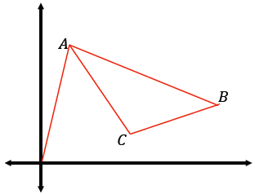

  - What is the approximate total distance traveled by the cursor?
$$\sqrt{17}+\sqrt{29}+\sqrt{10}+\sqrt{13}+\sqrt{17}≈20.4$$

  - Assume the cursor is positioned at $B$ and is moving horizontally towards the $y$-axis at $\frac{2}{3}$ units per second. How long will it take to reach the boundary of the triangle?
Equation of $\overset{⃡}{AC}$: $y=-1.5x+5.5$
$x$-coordinate on $\overset{⃡}{AC}$ at $y=2$: $\frac{7}{3}$
Distance from $B(6,2)$ to $\left(\frac{7}{3},2\right)$: $\frac{11}{3}$
Time needed to reach $\left(\frac{7}{3},2\right)$: $\frac{11}{3} units÷\frac{2}{3} units/s=5.5 s$

- An equilateral triangle with side length $1$ is placed in the first quadrant so that one of its vertices is at the origin and another vertex is on the $x$-axis. A line passes through the point half the distance between the endpoints on one side and half the distance between the endpoints on the other side.
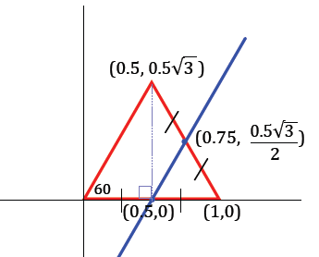
  - Draw a picture that satisfies these conditions.
Students can use trigonometry to find the vertex at $(0.5,0.5\sqrt{3)}$. Then, average the coordinates of the endpoints, and $\left(0.75,\frac{0.5\sqrt{3}}{2}\right)$ can be established.

  - Find the equation of the line that you drew.
The line through $(0.5,0)$ and $\left(0.75,\frac{0.5\sqrt{3}}{2}\right)$ is
$y=\sqrt{3}x-0.5\sqrt{3}.$

