Lesson 2: Finding Systems of Inequalities That Describe Triangular and Rectangular Regions

Classwork
Opening Exercise
Graph each system of inequalities.
- $\left\{\begin{aligned}y≥1 \\ x≤5 \end{aligned}\right.$
  - Is $(1, 2)$ a solution? Explain.

  - Is $(1, 1)$a solution? Explain.
MP.7

  - The region is the intersection of how many half-planes? Explain how you know.

- $\left\{\begin{aligned}y<2x+1 \\ y≥-3x-2\end{aligned}\right.$
  - Is $(-2, 4)$in the solution set?

  - Is $(1, 3)$ in the solution set?

  - The region is the intersection of how many half-planes? Explain how you know.

Example 1
$$(1, 2)$$
$$(15, 7)$$

Exercises 1–3
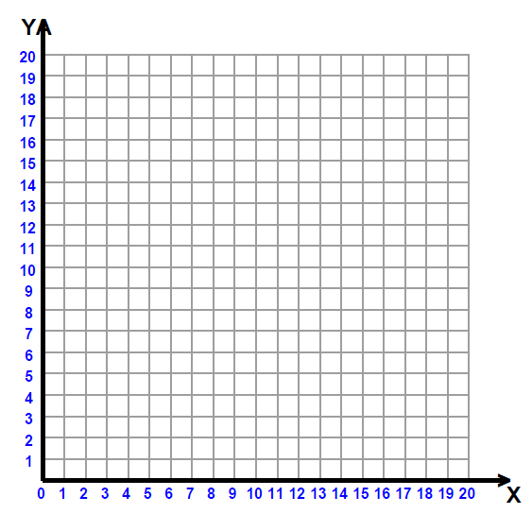
- Given the region shown to the right:
  - Name three points in the region.

  - Name three points on the boundary.

  - Explain in words the points in the region.

  - Write the inequality describing the $x$-values.

  - Write the inequality describing the $y$-values.

  - Write this as a system of equations.

  - Will the lines $x=4$ and $y=1$ pass through the region? Draw them.

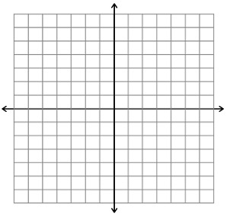
- Given the region that continues unbound to the right as shown to the right:
  - Name three points in the region.

  - Describe in words the points in the region.

  - Write the system of inequalities that describe the region.

  - Name a horizontal line that passes through the region.

- Given the region that continues down without bound as shown to the right:
  - Describe the region in words.

  - Write the system of inequalities that describe the region.

  - Name a vertical line that passes through the region.

Example 2
Draw the triangular region in the plane given by the triangle with vertices $(0, 0)$, $(1, 3)$, and $(2, 1)$. Can we write a set of inequalities that describes this region?

Exercises 4–5
- Given the triangular region shown, describe this region with a system of inequalities.

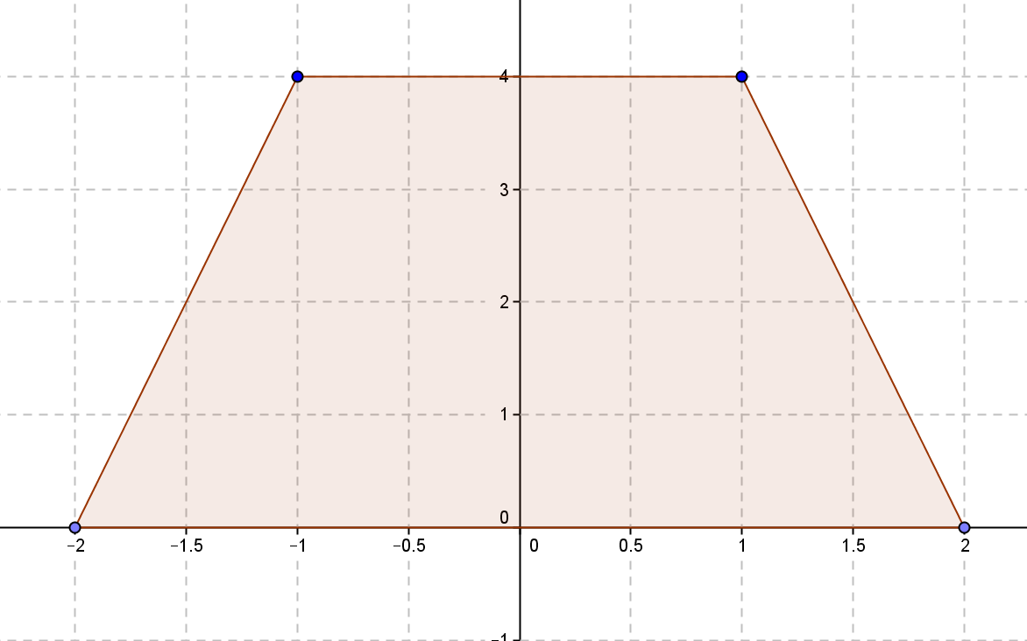
- Given the trapezoid with vertices $(-2, 0)$, $(-1, 4)$, $(1, 4)$, and $(2, 0)$, describe this region with a system of inequalities.

Problem Set
- Given the region shown:
  - How many half-planes intersect to form this region?
  - Name three points on the boundary of the region.
  - Describe the region in words.

- Region $T$ is shown to the right.
  - Write the coordinates of the vertices.
  - Write an inequality that describes the region.
  - What is the length of the diagonals?
  - Give the coordinates of a point that is both in the region and on one of the diagonals.

- Jack wants to plant a garden in his back yard. His yard is $120$ feet wide and $80$ feet deep. He wants to plant a garden that is $20$ feet by $30$ feet.
  - Set up a grid for the backyard and place the garden on the grid. Explain why you placed your garden in its place on the grid.
  - Write a system of inequalities to describe the garden.
  - Write the equation of three lines that would go through the region that he could plant on, and explain your choices.

- Given the trapezoidal region shown to the right:
  - Write the system of inequalities describing the region.
  - Translate the region to the right $3$ units and down $2$ units. Write the system of inequalities describing the translated region.

Challenge Problems:
- Given the triangular region shown with vertices $A(-2, -1)$, $B(4, 5)$, and $C(5, -1)$:
$$A$$
$$B$$
$$C$$
  - Describe the systems of inequalities that describe the region enclosed by the triangle.
  - Rotate the region $90°$ counterclockwise about Point $A$. How will this change the coordinates of the vertices?
  - Write the system of inequalities that describe the region enclosed in the rotated triangle.

- Write a system of inequalities for the region shown.

