Lesson 2: Finding Systems of Inequalities That Describe Triangular and Rectangular Regions

Student Outcomes
- Students describe rectangles (with edges parallel to the axes) and triangles in the coordinate plane by means of inequalities. For example, the rectangle in the coordinate plane with lower left vertex $(1, 2)$ and upper right vertex $(10, 15)$ is $\left\{\left(x,y\right)│1≤x≤10 \& 2≤y≤15\right\}$; the triangle with vertices at $(0, 0)$, $(1, 3)$, and $(2, 1)$ is $\left\{\left(x, y\right)│\frac{x}{2}≤y≤3x \& y≤-2x+5\right\}$.

Lesson Notes
In Algebra I, students graphed the solutions of linear inequalities in two variables as half-planes and the solution sets of a system of linear inequalities as the intersection of corresponding half-planes (A-REI.D.12). In this lesson, students are given the region in the plane and write systems to describe the regions, reversing the process studied in Algebra I.
Scaffolding:
- If students need more practice graphing, have students graph the following:
$y=2x+1$,
$y=-3x–1$,
$y<2x+1$, and
$y≥2x+1$.
- Advanced learners should be asked to write a system of equations where $(-1, 2)$ is a solution, but $(5, -3)$ is not.

Classwork
Opening Exercises (5 minutes)
The purpose of the Opening Exercises is to review the basics of graphing the solution sets of systems of inequalities in two variables. Teachers can model these exercises or use them to supplement instruction as necessary.
Opening Exercises
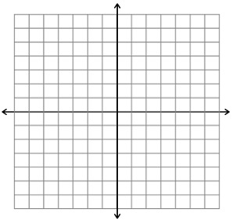
Graph each system of inequalities.
- $\left\{\begin{aligned}y ≥1 \\ x ≤5 \end{aligned}\right.$
  - Is $(1, 2)$ a solution? Explain.
Yes, $(1, 2)$is inside the region.

  - Is $(1, 1)$ a solution? Explain.
Yes, $(1, 1)$ is on the border of the region and included in the region.
MP.7
  - The region is the intersection of how many half-planes? Explain how you know.
It is the intersection of $2$ half planes, $x ≤5$and$y≥1$. $x ≤5$ splits the plane in half at the vertical line
$x=5$ and to the left. $y≥1$ cuts the plane in half horizontally from the line $y=1$ and above.
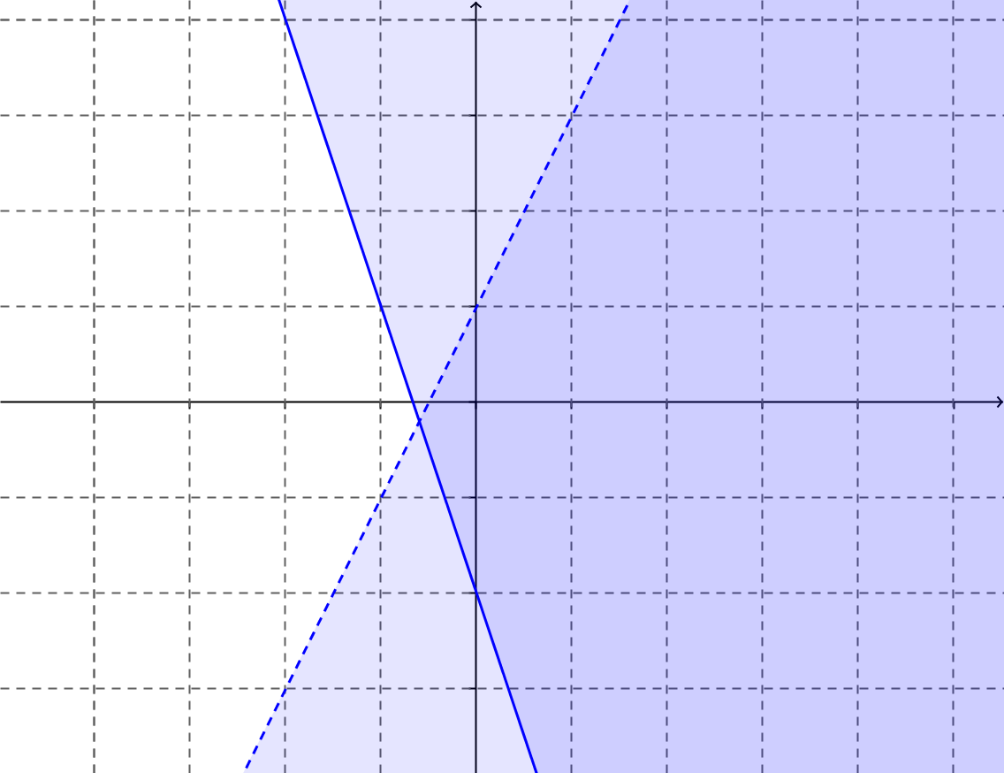
- $\left\{\begin{aligned}y <2x+1 \\ y≥-3x-2\end{aligned}\right.$
  - Is $(-2, 4)$ in the solution set?
No, it is out of the shaded region.

  - Is $(1, 3)$ in the solution set?
No, $(1,3)$ is not in the solution set because it is on the boundary, but the boundary is not included.

  - The region is the intersection of how many half-planes? Explain how you know.
It is the intersection of $2$ half planes. $y<2x+1$ cuts the plane in half diagonally at the line $y=2x+1$ and below. $y≥-3x-2$ also cuts the plane in half vertically, but at $y=-3x–2$ and above.

Teachers may consider the open-ended question in the example and let students struggle and problem-solve before asking the leading questions.
MP.1
Scaffolding:
If students are struggling, have them name the point in the top left corner, $(1, 7)$, and in the bottom right corner, $(15, 2)$. They could also list points between corners, but on boundaries. This should help them see that all points on the boundaries have the same $x$- or the same $y$-coordinates.
- Post a visual of the distance formula:
$$d=\sqrt{{(x_{2}-x_{1})}^{2}+{(y_{2}-y_{1})}^{2}}$$

Example 1 (8 minutes)
- Let’s explore how we might describe regions in the coordinate plane mathematically. Here is a rectangular region in the plane. (Project the image below onto the screen or draw it on the board.)
This image is in the student materials, but the questions are not.
Example 1
$$(1, 2)$$
$$(15, 7)$$

Suppose a point $(x, y)$ is within this rectangular region, or possibly on its boundary.
- Name three points inside the rectangular region.
  - Answers will vary. Possible answers include $(2, 2)$, $(5, 4)$, and $(14, 6)$.
- Name three points on the boundary of the rectangular region.
  - Answers will vary. Possible answers include $(3, 2)$, $(15, 6)$, and $(7, 7)$.

- What if we want to know all of the points in the region and on the boundary? How can I describe those points?
  - Let students brainstorm and do a $30$-second Quick Write; then, share ideas with the class before asking the following.
- Can you say anything about the possible value of $x$?
  - The $x$-values are to the right of $1$ but to the left of $15$; the $x$-values are greater than or equal to $1;$ the $x$-values are less than or equal to $15$; $x≥1$ and$x≤15$; $1≤x≤15$.
- Can you say anything about the possible value of $y$?
  - The $y$-values are above $2$ but below $7$; the $y$-values are greater than or equal to $2$; the $y$-values are less than or equal to $7$; $y≥2$ and $y≤7$; $2≤y≤7$.
- What can you say about the coordinates of points that lie on the left side of this rectangular region?
  - The points on the left border of this rectangle all have $x$-coordinates of $1$.
- On the top side?
  - The points on the top border of this rectangle all have $y$-coordinates of $7$.
- The region is a rectangle. Let’s review the properties of a rectangle. (Have students share ideas on the board.)
  - All rectangles have opposite sides parallel, opposite sides congruent, $4$ right angles, and diagonals congruent.
- What is the length of a diagonal of the rectangular region?
  - The diagonal is approximately $14.9$.
- Does it matter which of the two diagonals you work with?
  - No, the diagonals of a rectangle are the same length.
- Can you give the coordinates of a point within the rectangular region that lies on the diagonal that connects$(1, 2)$ to $(15, 7)$?
  - There are an infinite number of points on the diagonal. Students may find the point lying in the middle by averaging the values and get $(8, 4.5)$, or they could use the rise over run triangle and find other points such as $(3.8, 3)$.
Students can do the exercises below in pairs while the teacher walks around to provide support. The exercises can be scaffolded; give students problems of the appropriate difficulty for their level of knowledge. Another option is to assign different problems to different groups and bring the class together to share after.

Exercises 1–3 (10 minutes)

Exercises 1–3
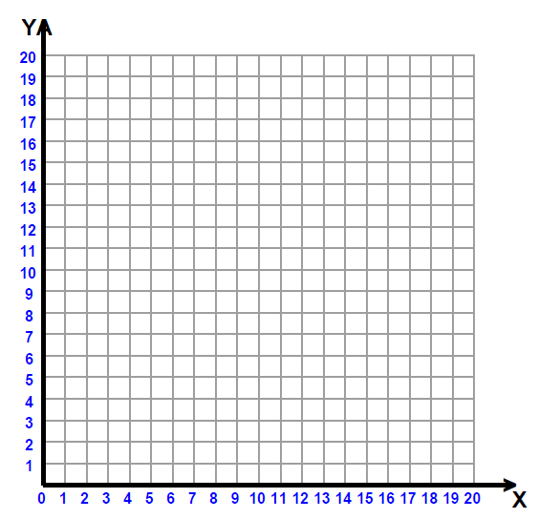
- Given the region shown to the right:
  - Name three points in the region.
Answers will vary but could include $(4, 3)$, $(3.5, 7)$, and $(4.5, 19)$.

  - Name three points on the boundary.
Answers will vary but could include $(4, 2)$, $(3, 15)$, and $(5, 18)$.

  - Explain in words the points in the region.
All $x$-coordinates are greater than or equal to $3$, and less than or equal to $5$, and all $y$-coordinates are greater than or equal to $2$, and less than or equal to $20$.

  - Write the inequality describing the $x$-values.
$x≥3$,$x≤5$

  - Write the inequality describing the $y$-values.
$y≥2$, $y≤20$

  - Write this as a system of equations.
$$\left\{(x, y) | 3≤x≤5, 2≤y≤20\right\}$$

  - Will the lines $x=4$ and $y=1$ pass through the region? Draw them.
$x=4$ vertically cuts the region in half. $y=1$is below the region and horizontal.

- Given the region that continues unbound to the right as shown to the right:
  - Name three points in the region.
Answers will vary but could include $(2, 2)$, $(4, 3)$, and $(5, 4)$.

  - Describe in words the points in the region.
The region is above $y=1$ and below $y=5.$ It starts at $x=0$ and continues to the right without bound.

  - Write the system of inequalities that describe the region.
$\left\{(x, y) | x≥0, 1≤y≤5\right\}$

  - Name a horizontal line that passes through the region.
Answers will vary but may include $y=4$.
- Given the region that continues down without bound as shown to the right:
  - Describe the region in words.
The region is to the right of $x=-2$ and to the left of
$x=3$. It starts at $y=0$and continues down without bound.

  - Write the system of inequalities that describe the region.
$\left\{(x, y) | -2≤x≤3, y≤0\right\}$

  - Name a vertical line that passes through the region.
Answers will vary but may include $x=-1$.

Example 2 (10 minutes)
This example can be done as a whole class or in groups. Allow students time to study the triangular region and problem-solve before asking the leading questions.
MP.1
Example 2
Draw the triangular region in the plane given by the triangle with vertices $(0, 0)$, $(1, 3)$, and $(2, 1)$. Can we write a set of inequalities that describes this region?
$$y≤3x$$
$$y≥\frac{1}{2}x$$
$$y≤-2x+5$$

Scaffolding:
- If students need support finding slope, model the process of drawing “slope” triangles.
- Model substituting the value of the slope for $m$ in $y=mx+b$ and determining the value of $b$.
- For students in need of a challenge, use a triangular region with vertices located at non-whole number coordinates.
- This region is formed by the intersection of how many half-planes?
  - $3$
  - Name the endpoints of the left most segment.
  - $(0, 0)$, $(1, 3)$
- Find the slope of the line containing this segment.
  - $3$
- Write the equation of the line containing this segment.
  - $y=3x$

- Write the equations of the lines that containing the other two segments that are the sides of the triangle.
  - The line containing $(0,0)$ and $(2,1)$ is $y=\frac{1}{2}x.$
  - The line containing $(1,3)$ and $(2,1)$ is $y=-2x+5$.
- What would we do to these equations to indicate shading?
  - Make them inequalities.
Have students turn to a partner and summarize what they have learned. Use this as an opportunity to informally assess understanding.

Exercises 4–5 (5 minutes)
Exercises 4–5
- Given the triangular region shown, describe this region with a system of inequalities.
$$x≥0$$
$$y≥\frac{2}{3}x-4$$
$$y≤-\frac{2}{3}x+4$$

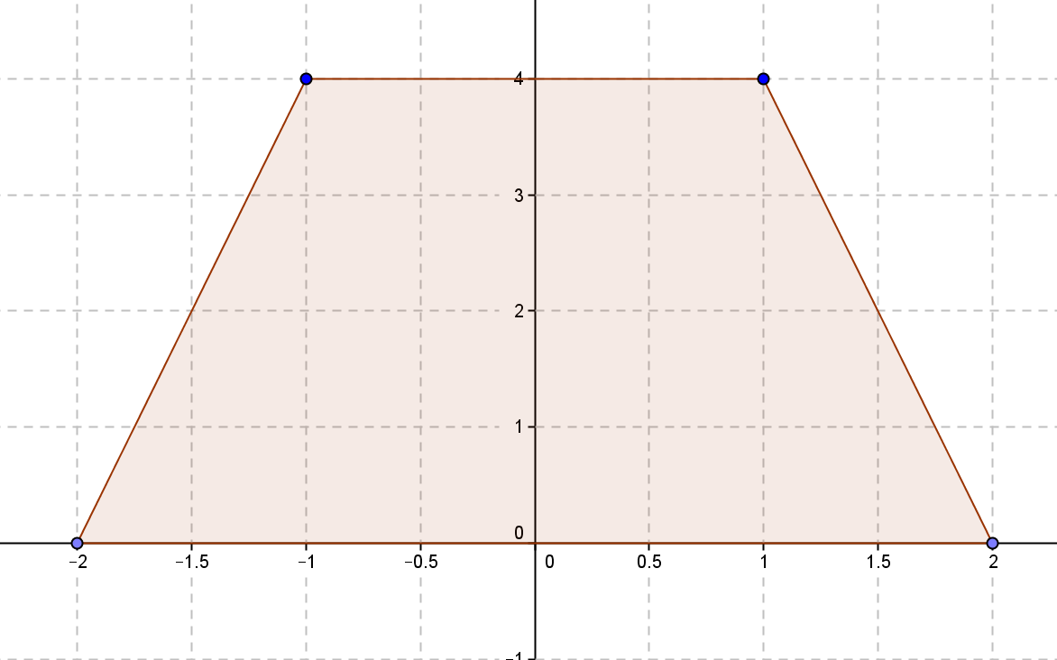
- Given the trapezoid with vertices $(-2, 0)$, $(-1, 4)$, $(1, 4)$, and $(2, 0)$, describe this region with a system of inequalities.
$$y≥0$$
$$y≤4$$
$$y≥4x+8$$
$$y≤-4x+8$$

Closing (2 minutes)
Discuss the following as a class.
- Describe the process of writing the system of inequalities to describe a triangular region in the plane.
  - Identify the endpoints of each segment and find the slope. Write the equation of the line containing each segment. Identify the segment of the line by restricting the domain. Make the equations inequalities that include points inside the region.
- What if I needed to describe a vertical segment? What is the general equation of a vertical line, and which variable would we restrict?
  - $x=c$, where $c$ is a constant. The $y$-values would have to be restricted.

Exit Ticket (5 minutes)
Name Date
Lesson 2: Finding Systems of Inequalities That Describe Triangular and Rectangular Regions

Exit Ticket

Given the region shown:

a. Name three points in the region.

b. Identify the coordinates of the four vertices.

c. Write the system of inequalities describing this region.
Exit Ticket Sample Solutions

Given the region shown:

  - Name three points in the region.
Answers will vary but may include $\left(0,0\right),\left(-2,3\right),(4,-1)$

  - Identify the coordinates of the four vertices.
$(-4, -2), (-4, 3), (5, 3)$, and $(5, -2)$

  - Write the system of inequalities describing the region
$$\left\{(x,y) | -4≤x≤5, -2≤y≤3\right\}$$

Problem Set Sample Solutions
This Problem Set contains two challenge problems. You do not have to assign all problems to all students.

- Given the region shown:
  - How many half-planes intersect to form this region?
$$2$$

  - Name three points on the boundary of the region.
$(-1, -1)$,$(-3, 4)$, and $(5, -1)$

  - Describe the region in words.
The region is above and includes $y=-1$, is to the right of and includes $x=-3$, and extends without bound to the top and right.

- Region $T$ is shown to the right.
  - Write the coordinates of the vertices.
$(-1, -4), (-1, 6), (3, 6)$, and $(3, -4)$

  - Write an inequality that describes the region.
$$\left\{(x,y) | -1≤x≤3, -4≤y≤6\right\}$$

  - What is the length of the diagonals?
The diagonal is approximately $10.8$ units long.

  - Give the coordinates of a point that is both in the region and on one of the diagonals.
Answers will vary. $(1, 1)$ lies on the diagonal and in the interior of region $T$.

- Jack wants to plant a garden in his back yard. His yard is $120$ feet wide and $80$ feet deep. He wants to plant a garden that is $20$ feet by $30$ feet.
  - Set up a grid for the backyard and place the garden on the grid. Explain why you placed your garden in its place on the grid.
Answers will vary, but the backyard should be on the grid with length $120$ feet in the $x$-direction and $80$ feet in the $y$-direction, or this can be set up in the other direction with $80$ feet in the $x$-direction and $120$ feet in the $y$-direction. The garden should form a rectangle somewhere on the grid.

  - Write a system of inequalities to describe the garden.
Answers will vary.

  - Write the equation of three lines that would go through the region that he could plant on, and explain your choices.
Answers will vary.

- Given the trapezoidal region shown to the right:
  - Write the system of inequalities describing the region.
$$y≤4x+12$$
$$y≤4$$
$$y≤-4x+16$$
$$y≥0$$

  - Translate the region to the right $3$ units and down $2$ units. Write the system of inequalities describing the translated region.
$$y≤4x-2$$
$$y≤2$$
$$y≤-4x+26$$
$$y≥-2$$
Challenge Problems:
$$A$$
$$B$$
$$C$$
- Given the triangular region shown with vertices $A(-2, -1)$, $B(4, 5)$, and $C(5, -1)$:
  - Describe the systems of inequalities that describe the region enclosed by the triangle.
$$y≤x+1$$
$$y≤-6x+29$$
$$y≥-1$$

  - Rotate the region $90°$ counterclockwise about Point $A$. How will this change the coordinates of the vertices?
$A(-2, -1)$,$B(-8, 5)$, and$C(-2, 6)$

  - Write the system of inequalities that describe the region enclosed in the rotated triangle.
$$y≥-x-3$$
$$y≤\frac{1}{6}x+\frac{19}{3}$$
$$x≤-1$$

- Write a system of inequalities for the region shown.
$y≤\left|x\right|$
$$y≥0$$
$$\left|x\right|≤3$$

