Lesson 1: Searching a Region in the Plane

Classwork
Exploratory Challenge
Students in a robotics class must program a robot to move about an empty rectangular warehouse. The program specifies location at a given time,$t$, seconds. The room is twice as long as it is wide. Locations are represented as points in a coordinate plane with the southwest corner of the room deemed the origin, $(0,0)$, and the northeast corner deemed the point $(2000 ft., 1000 ft.)$, as shown in the diagram below.

$$(0,0)$$
$$(2000 ft.,1000 ft.)$$

The first program written has the robot moving at a constant speed in a straight line. At time $t=1$ second, the robot is at position $(30, 45)$, and at $t=3$ seconds, it is at position $(50, 75)$. Complete the exercises and answer the questions below to program the robot’s motion.
  - Where is the location of impact?

  - At what speed will the robot hit the wall?

  - At what time will the robot hit the wall?

Exercises 1–8
- Plot the points on a coordinate plane.

- Draw the line connecting the segments.
- How much did the $x$-coordinate change in $2$ seconds?

- How much did the $y$-coordinate change in $2$ seconds?

- What is the ratio of change in $y$ to change in $x$?

- What is the equation of the line of motion?

- What theorem could be used to find the distance between the points?

- How far did the robot travel in $2$ seconds?

Problem Set

- The robot in the video is moving around an empty $100$ ft. by $100$ ft. storage room at a constant speed. If the robot crosses $(10, 10)$ at $1$ second and $(30, 30)$ at $6$ seconds:
  - Plot the points and draw the segment connecting the points.
  - What was the change in the $x$-coordinate?
  - What was the change in the $y$-coordinate?
  - What is the ratio of the change in $y$ to the change in $x$?
  - How far did the robot travel between the two points?
  - What was the speed of the robot?
  - Where did the robot start?

- Your mother received a robot vacuum cleaner as a gift and wants you to help her program it to clean a vacant $30$ ft. by $30$ ft. room. If the vacuum is at position $(12, 9)$at time $t=2$ seconds and at position $(24, 18)$ at $t=5$seconds, answer the following:
  - How far did the robot travel over $3$ seconds?
  - What is the speed?
  - What is the ratio of the change in the $x$-coordinate to the change in the $y$-coordinate?
  - Where did the robot start?
  - Where will the robot be at $t=3$ seconds? Explain how you know.
  - What is the location of impact?
  - At what time will the robot hit the wall?
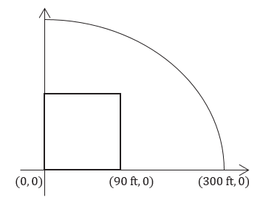
- A baseball player hits a ball at home plate at position $(0, 0)$. It travels at a constant speed across first base at position $(90, 0)$ in $2$ seconds.
  - What was the speed of the ball?
  - When will it cross the fence at position $(300, 0)$? Explain how you know.

- The tennis team has a robot that picks up tennis balls. The tennis court is $36$ feet wide and $78$ feet long. The robot starts at position $(8, 10)$and is at position $(16, 20)$at $t=4$ seconds. When will it pick up the ball located at position $(28, 35)$?

