Lesson 14: Graphing the Tangent Function

Student Outcomes
- Students graph the tangent function.
- Students use the unit circle to express the values of the tangent function for $π-x$, $π+x$, and $2π-x$ in terms of $tan(x)$, where $x$ is any real number in the domain of the tangent function.

Lesson Notes
Working in groups, students prepare graphs of separate branches of the tangent function, combining them into a single graph. In this way, the periodicity of the tangent function becomes apparent. We then recall the slope interpretation of the tangent function from Lesson 6 and use it to develop trigonometric identities involving the tangent function. Emphasize to students that a trigonometric identity consists of a statement that two functions are equal and a specification of a domain on which the statement is valid. That is, the statement “$\tan\left(x+π\right)=tan(x)$” is not an identity, but the statement “$\tan\left(x+π\right)+\tan\left(x\right),$ for $x≠\frac{π}{2}+kπ,$ for all integers $k$” is an identity. In this lesson, we use both $x$ and $θ$ to represent the independent variables of the tangent function; we use $θ$ when working with a circle and $x$ when working in the $xy$-plane. The concavity of the graph of the tangent function is explored in the Problem Set.

Classwork
Opening (3 minutes)
In Lessons 6 and 7, the tangent function was introduced as a function of a number of degrees of rotation. Hold a quick discussion about how we are now using radians for the independent variable of the tangent function just as we do for the sine and cosine functions, and discuss how that changes the domain of the tangent function from $\left\{θ∈R \right| θ≠90+180k, for all integers k\}$ to $\left\{θ∈R \right| θ≠\frac{π}{2}+kπ, for all integers k\}$.
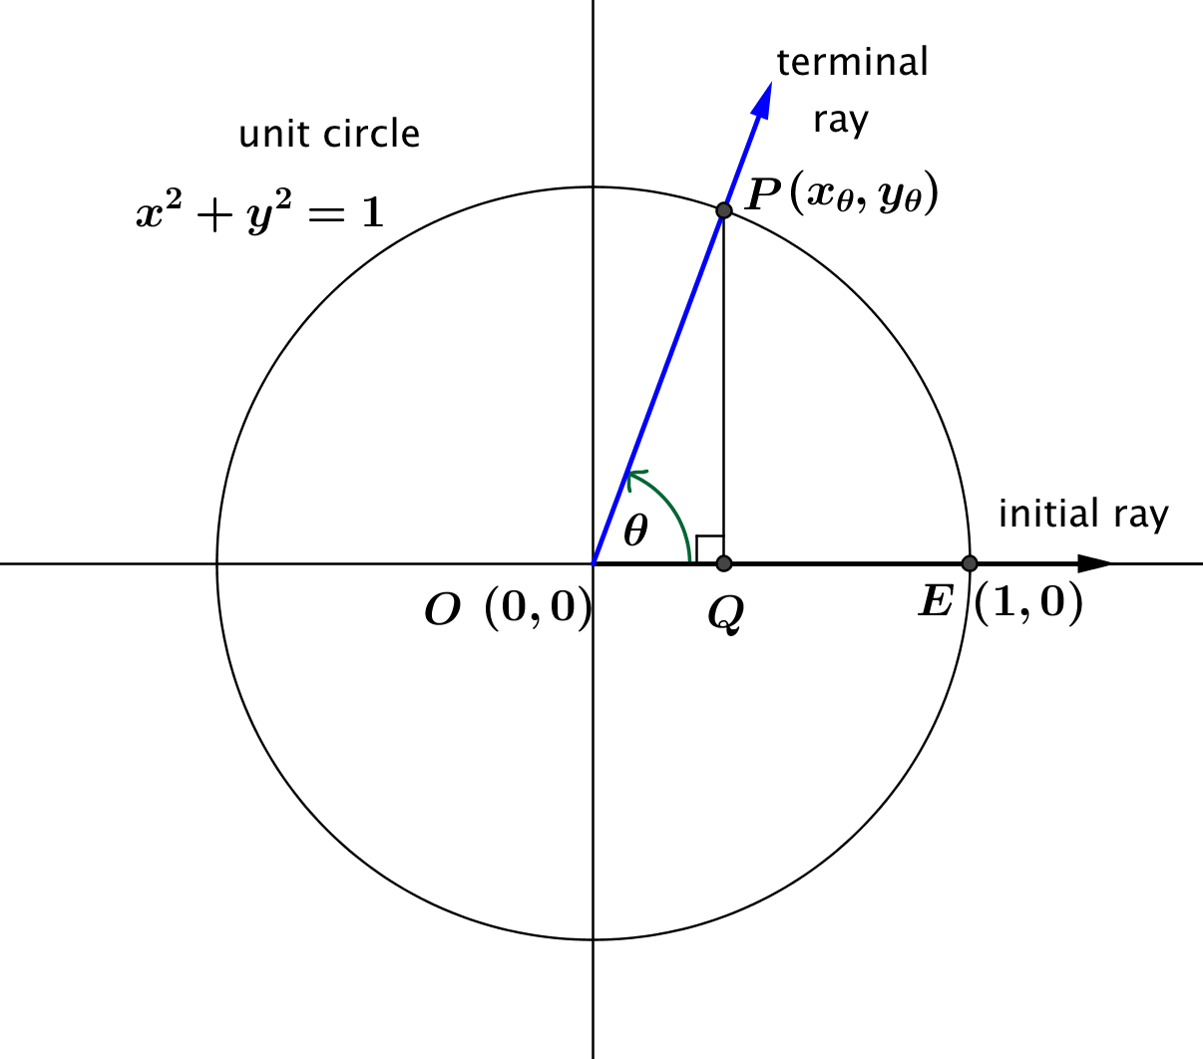
Take the opportunity to recall the working definition of the tangent function: $\tan\left(x\right)=\frac{\sin\left(x\right)}{\cos\left(x\right)}$ for $\cos\left(x\right)≠0$. In this lesson, we will also use the slope interpretation of the tangent function from Lesson 6, so remind students that $tan(θ)$ is the value of the slope of the line through the terminal ray after being rotated by $θ$ radians.
Tangent Function (description). The tangent function,
$$tan: \left\{θ∈R \right| θ≠\frac{π}{2}+kπ, for all integers k\}→R,$$
can be defined as follows: Let $θ$ be any real number such that $θ≠\frac{π}{2}+kπ$, for all integers $k$. In the Cartesian plane, rotate the initial ray by $θ$ radians about the origin. Intersect the resulting terminal ray with the unit circle to get a point $(x_{θ},y_{θ})$. The value of $tan(θ)$ is $\frac{y_{θ}}{x_{θ}}$.
Thus, $\tan{(θ)}=\frac{\sin{(θ)}}{\cos{(θ)}}$ for all $θ≠\frac{π}{2}+kπ,$ for all integers $k$.
Have students express their understanding of the tangent function definition in their own words and discuss how to find a few specific values of the tangent function, for instance, $\tan\left(\frac{π}{4}\right)$ and $\tan\left(\frac{π}{3}\right)$, to ensure understanding before continuing.
Scaffolding:
- You may want to demonstrate Exercise 1 for the interval $\left(-\frac{π}{2},\frac{π}{2}\right)$. Alternatively, consider giving this interval to a group that may struggle.
- Ask students who are above grade level, “How do you think these intervals were chosen?”
Discuss other possibilities such as $[0,π)$, excluding $\frac{π}{2}$.
Exploratory Challenge 1/Exercises 1–5 (10 minutes)
Break the class into eight groups and hand out one copy of the axes at the end of this lesson to each group. Each group will be assigned one interval
$$…, \left(-\frac{5π}{2},-\frac{3π}{2}\right),\left(-\frac{3π}{2},-\frac{π}{2}\right),\left(-\frac{π}{2},\frac{π}{2}\right),\left(\frac{π}{2},\frac{3π}{2}\right), \left(\frac{3π}{2},\frac{5π}{2}\right),…$$
and will use a calculator to generate approximate values of the tangent function in the tables below. Each group will create a graph of a portion of the tangent function on their set of axes using bold markers if possible. Affix each group’s graph on the board so that students can see multiple branches of the tangent function at once.
Exploratory Challenge1/Exercises 1–5
- Use your calculator to calculate each value of $tan(x)$ to two decimal places in the table for your group.
Group 1  $$\left(-\frac{π}{2},\frac{π}{2}\right)$$ |  |  | Group 2  $$\left(\frac{π}{2},\frac{3π}{2}\right)$$ |  |  | Group 3  $$\left(-\frac{3π}{2},-\frac{π}{2}\right)$$ |  |  | Group 4  $$\left(\frac{3π}{2},\frac{5π}{2}\right)$$
$$x$$ | $$tan\left(x\right)$$ |  | $$x$$ | $$tan\left(x\right)$$ |  | $$x$$ | $$tan\left(x\right)$$ |  | $$x$$ | $$tan\left(x\right)$$
$$-\frac{11π}{24}$$ |  |  | $$\frac{13π}{24}$$ |  |  | $$-\frac{35π}{24}$$ |  |  | $$\frac{37π}{24}$$
$$-\frac{5π}{12}$$ |  |  | $$\frac{7π}{12}$$ |  |  | $$-\frac{17π}{12}$$ |  |  | $$\frac{19π}{12}$$
$$-\frac{4π}{12}$$ |  |  | $$\frac{8π}{12}$$ |  |  | $$-\frac{16π}{12}$$ |  |  | $$\frac{20π}{12}$$
$$-\frac{3π}{12}$$ |  |  | $$\frac{9π}{12}$$ |  |  | $$-\frac{15π}{12}$$ |  |  | $$\frac{21π}{12}$$
$$-\frac{2π}{12}$$ |  |  | $$\frac{10π}{12}$$ |  |  | $$-\frac{14π}{12}$$ |  |  | $$\frac{22π}{12}$$
$$-\frac{π}{12}$$ |  |  | $$\frac{11π}{12}$$ |  |  | $$-\frac{13π}{12}$$ |  |  | $$\frac{23π}{12}$$
$$0$$ |  |  | $$π$$ |  |  | $$-π$$ |  |  | $$2π$$
$$\frac{π}{12}$$ |  |  | $$\frac{13π}{12}$$ |  |  | $$-\frac{11π}{12}$$ |  |  | $$\frac{25π}{12}$$
$$\frac{2π}{12}$$ |  |  | $$\frac{14π}{12}$$ |  |  | $$-\frac{10π}{12}$$ |  |  | $$\frac{26π}{12}$$
$$\frac{3π}{12}$$ |  |  | $$\frac{15π}{12}$$ |  |  | $$-\frac{9π}{12}$$ |  |  | $$\frac{27π}{12}$$
$$\frac{4π}{12}$$ |  |  | $$\frac{16π}{12}$$ |  |  | $$-\frac{8π}{12}$$ |  |  | $$\frac{28π}{12}$$
$$\frac{5π}{12}$$ |  |  | $$\frac{17π}{12}$$ |  |  | $$-\frac{7π}{12}$$ |  |  | $$\frac{29π}{12}$$
$$\frac{11π}{24}$$ |  |  | $$\frac{35π}{24}$$ |  |  | $$-\frac{13π}{24}$$ |  |  | $$\frac{59π}{24}$$

Group 5  $$\left(-\frac{5π}{2},-\frac{3π}{2}\right)$$ |  |  | Group 6  $$\left(\frac{5π}{2},\frac{7π}{2}\right)$$ |  |  | Group 7  $$\left(-\frac{7π}{2},-\frac{5π}{2}\right)$$ |  |  | Group 8  $$\left(\frac{7π}{2},\frac{9π}{2}\right)$$
$$x$$ | $$tan\left(x\right)$$ |  | $$x$$ | $$tan\left(x\right)$$ |  | $$x$$ | $$tan\left(x\right)$$ |  | $$x$$ | $$tan\left(x\right)$$
$$-\frac{59π}{24}$$ |  |  | $$\frac{61π}{24}$$ |  |  | $$-\frac{83π}{24}$$ |  |  | $$\frac{37π}{24}$$
$$-\frac{29π}{12}$$ |  |  | $$\frac{31π}{12}$$ |  |  | $$-\frac{41π}{12}$$ |  |  | $$\frac{43π}{12}$$
$$-\frac{28π}{12}$$ |  |  | $$\frac{32π}{12}$$ |  |  | $$-\frac{40π}{12}$$ |  |  | $$\frac{44π}{12}$$
$$-\frac{27π}{12}$$ |  |  | $$\frac{33π}{12}$$ |  |  | $$-\frac{39π}{12}$$ |  |  | $$\frac{45π}{12}$$
$$-\frac{26π}{12}$$ |  |  | $$\frac{34π}{12}$$ |  |  | $$-\frac{38π}{12}$$ |  |  | $$\frac{46π}{12}$$
$$-\frac{25π}{12}$$ |  |  | $$\frac{35π}{12}$$ |  |  | $$-\frac{37π}{12}$$ |  |  | $$\frac{47π}{12}$$
$$-2π$$ |  |  | $$3π$$ |  |  | $$-3π$$ |  |  | $$4π$$
$$-\frac{23π}{12}$$ |  |  | $$\frac{37π}{12}$$ |  |  | $$-\frac{35π}{12}$$ |  |  | $$\frac{49π}{12}$$
$$-\frac{22π}{12}$$ |  |  | $$\frac{38π}{12}$$ |  |  | $$-\frac{34π}{12}$$ |  |  | $$\frac{50π}{12}$$
$$-\frac{21π}{12}$$ |  |  | $$\frac{39π}{12}$$ |  |  | $$-\frac{33π}{12}$$ |  |  | $$\frac{51π}{12}$$
$$-\frac{20π}{12}$$ |  |  | $$\frac{40π}{12}$$ |  |  | $$-\frac{32π}{12}$$ |  |  | $$\frac{52π}{12}$$
$$-\frac{19π}{12}$$ |  |  | $$\frac{41π}{12}$$ |  |  | $$-\frac{31π}{12}$$ |  |  | $$\frac{53π}{12}$$
$$-\frac{37π}{24}$$ |  |  | $$\frac{83π}{24}$$ |  |  | $$-\frac{61π}{24}$$ |  |  | $$\frac{107π}{24}$$

- The tick marks on the axes provided are spaced in increments of $\frac{π}{12}$. Mark the horizontal axis by writing the number of the left endpoint of your interval at the left-most tick mark, the multiple of $π$ that is in the middle of your interval at the point where the axes cross, and the number at the right endpoint of your interval at the right-most tick mark. Fill in the remaining values at increments of $\frac{π}{12}$.
The $x$-axis from one such set of marked axes on the interval $\left(\frac{π}{2},\frac{3π}{2}\right)$ is shown below.

- On your plot, sketch the graph of $y=tan\left(x\right)$ on your specified interval by plotting the points in the table and connecting the points with a smooth curve. Draw the graph with a bold marker.
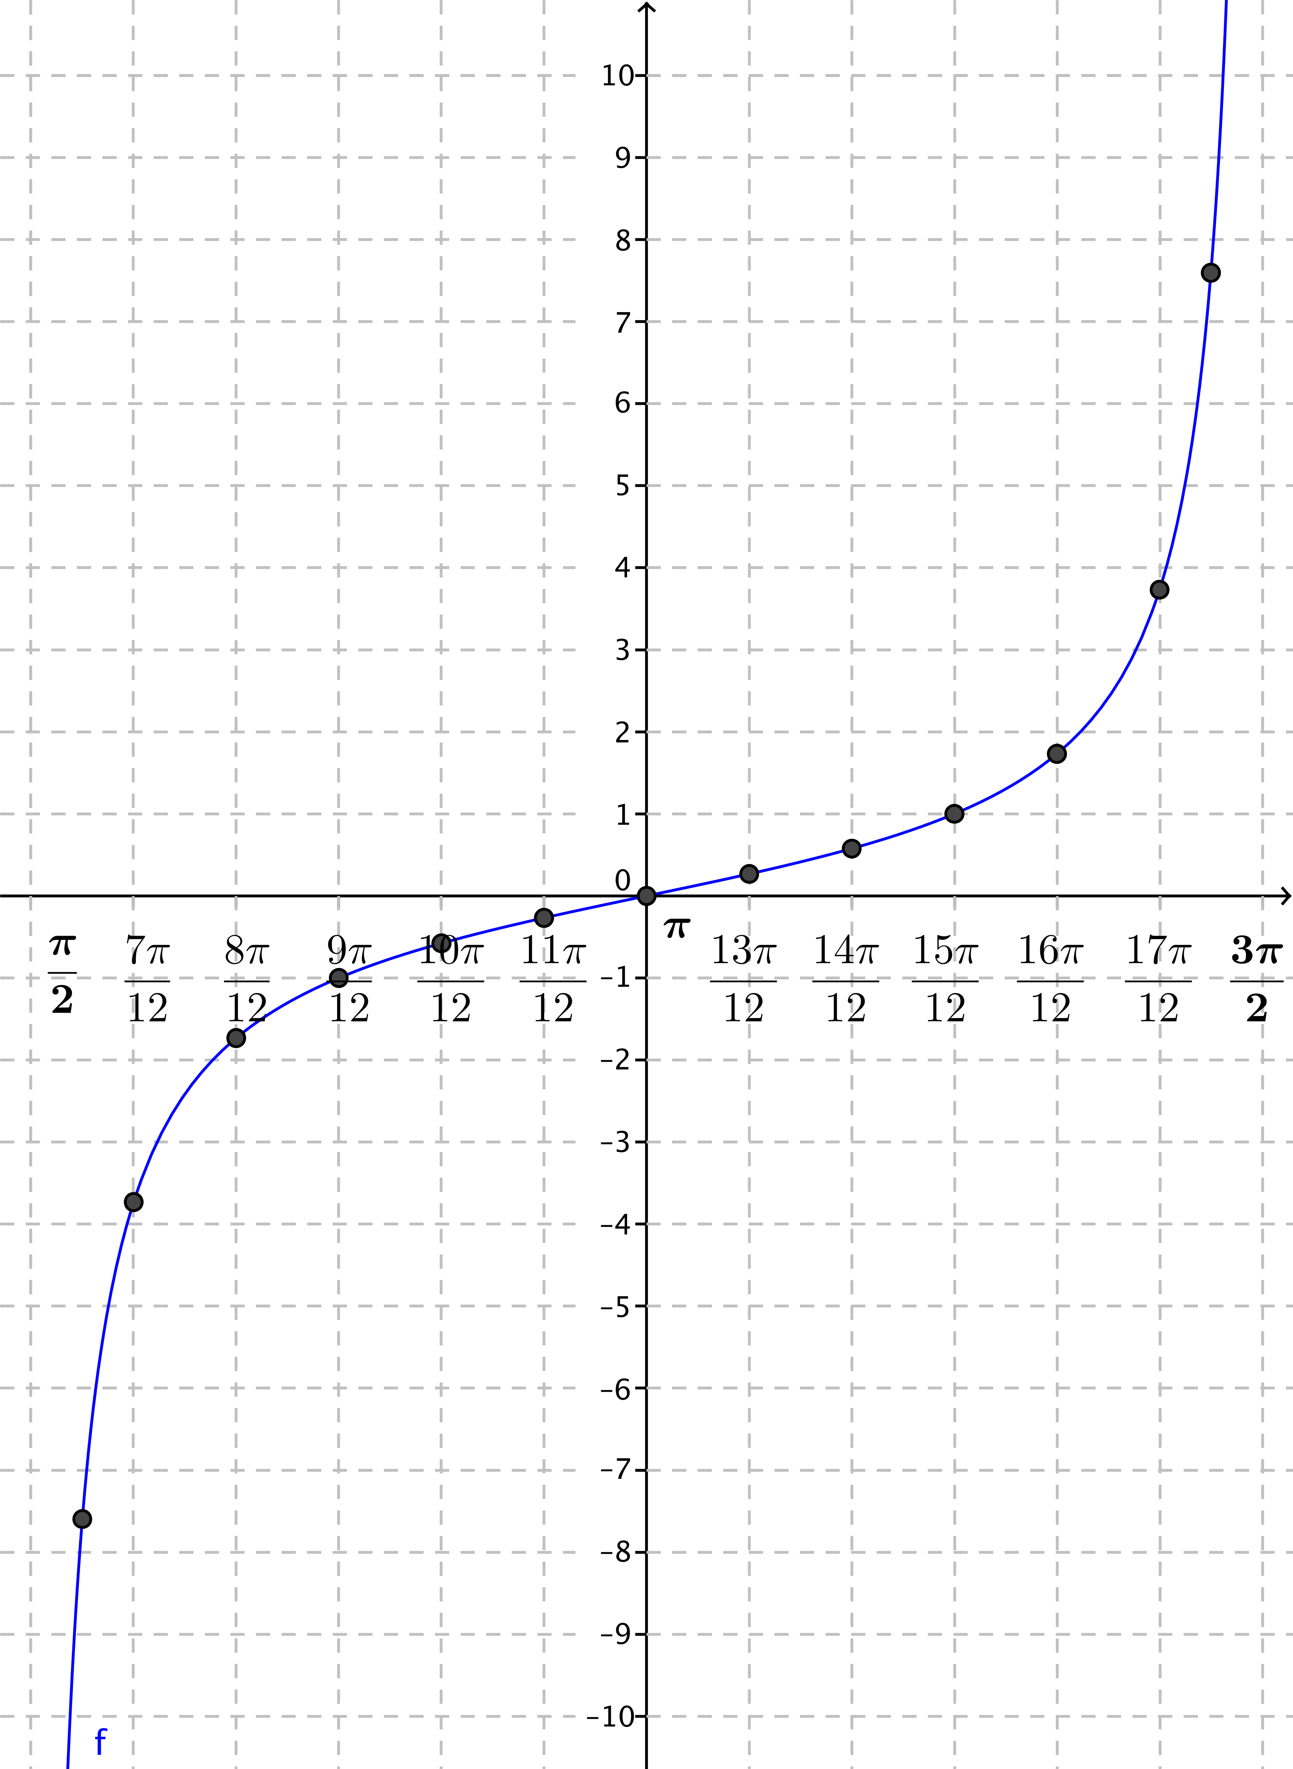
An example on the interval $\left(\frac{π}{2},\frac{3π}{2}\right)$ is shown to the right.

- What happens to the graph near the edges of your interval? Why does this happen?
Near the edges of the interval, $x$ approaches a value where the tangent function is undefined. Since
$cos\left(\frac{π}{2}+kπ\right)=0$ for any integer $k$, the tangent is undefined at the edges of the interval we are graphing. As $x$ gets near the edge of the interval, $sin\left(x\right)$ gets close to either $1$ or $-1$, and $cos(x)$ gets close to $0$. Thus,
$tan\left(x\right)=\frac{sin\left(x\right)}{cos\left(x\right)}$ gets very far from zero, either in the positive or negative direction.

- When you are finished, affix your graph to the board in the appropriate place, matching endpoints of intervals.
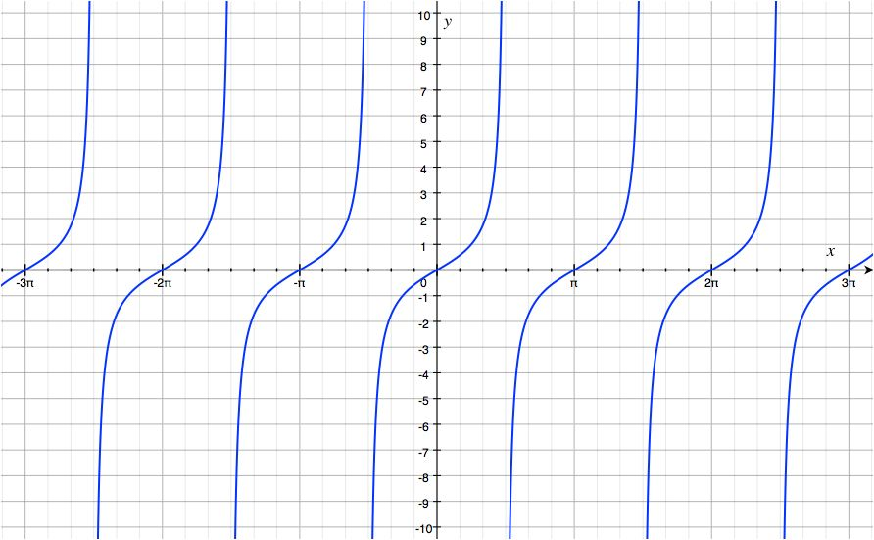
Discussion (2 minutes)
- What do you notice about the graph of the tangent function?
  - It repeats every $π$ units; i.e., the function has period $π$ and frequency $\frac{1}{π}$.
  - It is broken into pieces that are the same.
MP.8
  - It breaks when $x=\frac{π}{2}+kπ,$ for some integer $k$.
  - Each piece has rotational symmetry by $180°$.
  - The entire graph has translational symmetry by a horizontal translation by $π$ units.
  - The entire graph has rotational symmetry by $180°.$
- The breaks in the graph are examples of vertical asymptotes. These lines that the graph gets very close to but does not cross often occur at a value $x=a$, where the function is undefined to prevent division by zero.
Scaffolding:
- For struggling students, consider working through Exercise 6 as a class before asking students to complete Exercises 7–16 in groups.
- Targeted instruction with a small group while other students work on problems independently may help struggling students.
- Consider also giving each group their choice of five problems in such a way that each problem will be covered. If this is done, then tell students to be prepared to present their results and debrief the class at the end.
Exploratory Challenge 1/Exercises 6–16 (15 minutes)
This is a discovery exercise for students to establish many facts or identities about the tangent function using the unit circle with the slope interpretation. The identities will be verified using $\tan\left(x\right)=\frac{\sin\left(x\right)}{\cos\left(x\right)}$ in the Problem Set and should be discussed in the context of the graph of $y=tan⁡(x)$ that was just made.
Exploratory Challenge 2/Exercises 6–17
For each exercise below, let $m=\tan\left(θ\right)$ be the slope of the terminal ray in the definition of the tangent function, and let $P=(x_{0},y_{0})$ be the intersection of the terminal ray with the unit circle after being rotated by $θ$ radians for $0<θ<\frac{π}{2}$. We know that the tangent of $θ$ is the slope $m$ of $\overset{⃡}{OP}$.
- Let $Q$ be the intersection of the terminal ray with the unit circle after being rotated by $θ+π$ radians.
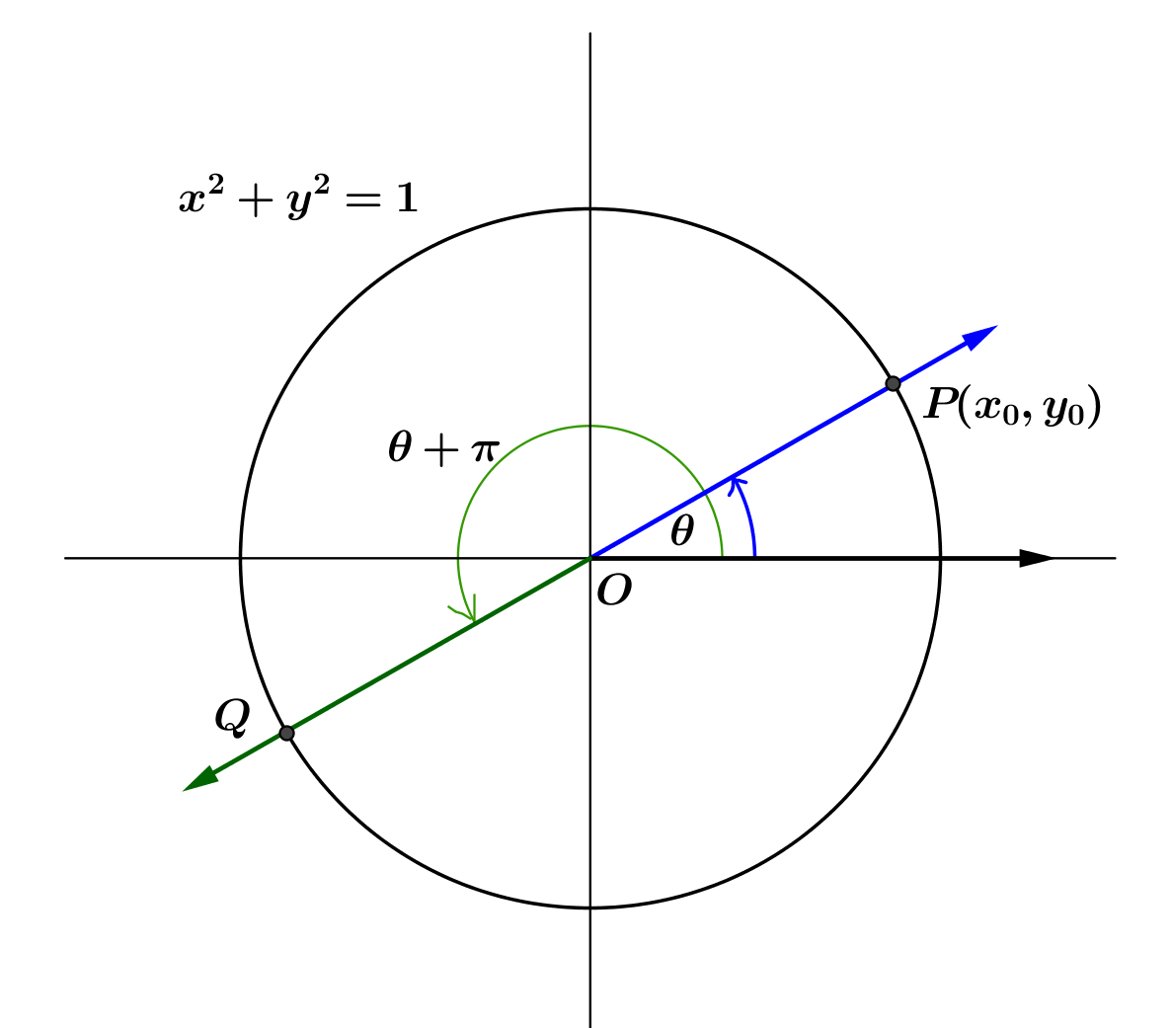
  - What is the slope of $\overset{⃡}{OQ}$?
Points $P$, $O$, and $Q$ are collinear, so the slope of $\overset{⃡}{OQ }$is the same as the slope of $\overset{⃡}{OP}$. Thus, the slope of $\overset{⃡}{OQ }$ is also $m$. Another approach would be to find that the coordinates of $Q$ are $(-x_{0},-y_{0})$, so the slope of ray $\overset{⃡}{OQ }$ is $\frac{y_{0}}{x_{0}}$, which is $m$.

  - Find an expression for $tan(θ+π)$ in terms of $m.$
$$tan\left(θ+π\right)=m$$

  - Find an expression for $tan\left(θ+π\right)$ in terms of $tan(θ)$.
$$tan\left(θ+π\right)=tan\left(θ\right)$$

  - How can the expression in part (c) be seen in the graph of the tangent function?
The pieces of the tangent function repeat every $π$ units because $tan\left(θ+π\right)=tan(θ)$.
At this time, students should have strong evidence for why the period for the tangent function is $π$ and not $2π$, but they may not be connecting the value of the tangent function from the slope interpretation to the graphs drawn at the beginning of the lesson. Continue to stress the interrelationship between the different interpretations and that information gathered from one interpretation can help students understand the function in a different interpretation.

- Let $Q$ be the intersection of the terminal ray with the unit circle after being rotated by $-θ$ radians.
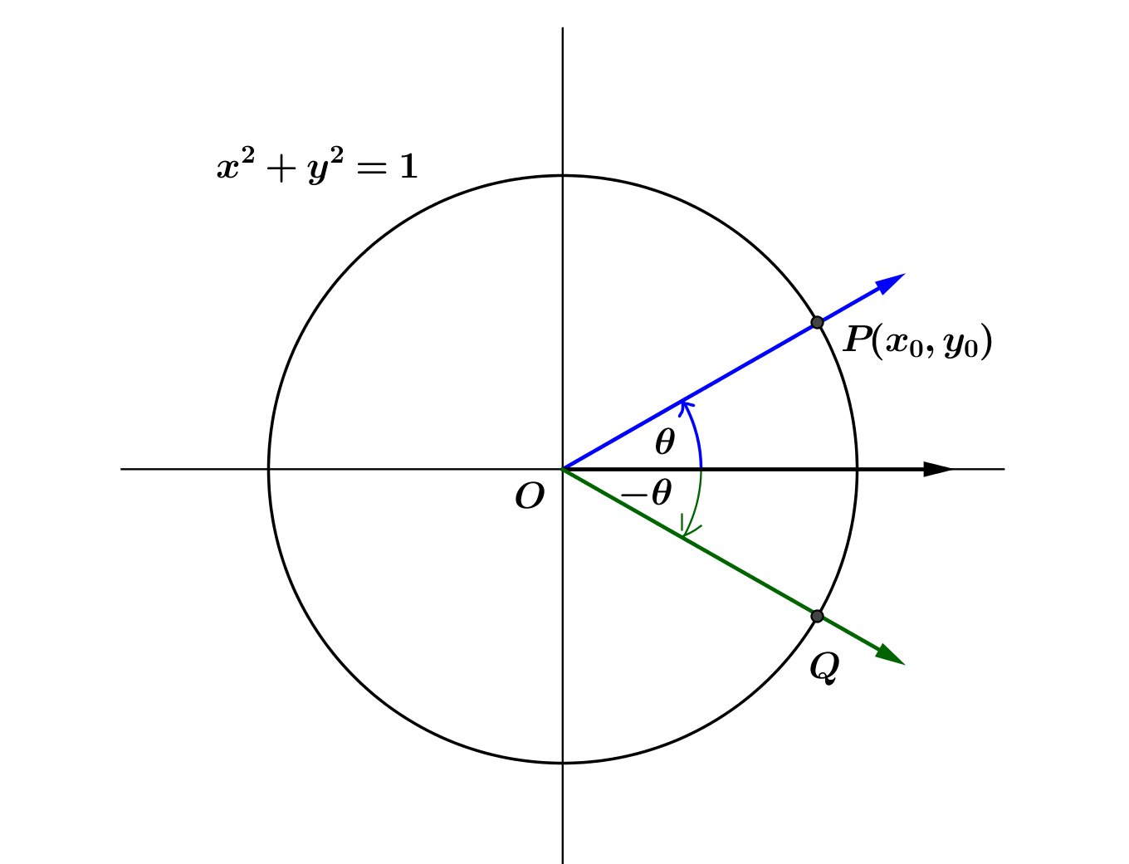
  - What is the slope of $\overset{⃡}{OQ}$?
Ray $\vec{OQ}$ is the reflection of ray $\vec{OP}$ across the $x$-axis, so the coordinates of $Q$ are $\left(x_{0}, -y_{0}\right)$. Thus, the slope of $\overset{⃡}{OQ }$is the opposite of the slope of $\overset{⃡}{OP}$. Thus, the slope of $\overset{⃡}{OQ }$ is $-m$.

  - Find an expression for $tan(-θ)$ in terms of $m.$
$$tan\left(-θ\right)=-m$$

  - Find an expression for $tan\left(-θ\right)$ in terms of $tan(θ)$.
$$tan\left(-θ\right)=-tan(θ)$$

  - How can the expression in part (c) be seen in the graph of the tangent function?
The graph of the tangent function has rotational symmetry about the origin.

- Is the tangent function an even function, an odd function, or neither? How can you tell your answer is correct from the graph of the tangent function?
Because $tan\left(-θ\right)=-tan(θ)$, the tangent function is odd. If the graph of the tangent function is rotated $π$ radians about the origin, there will appear to be no change in the graph.

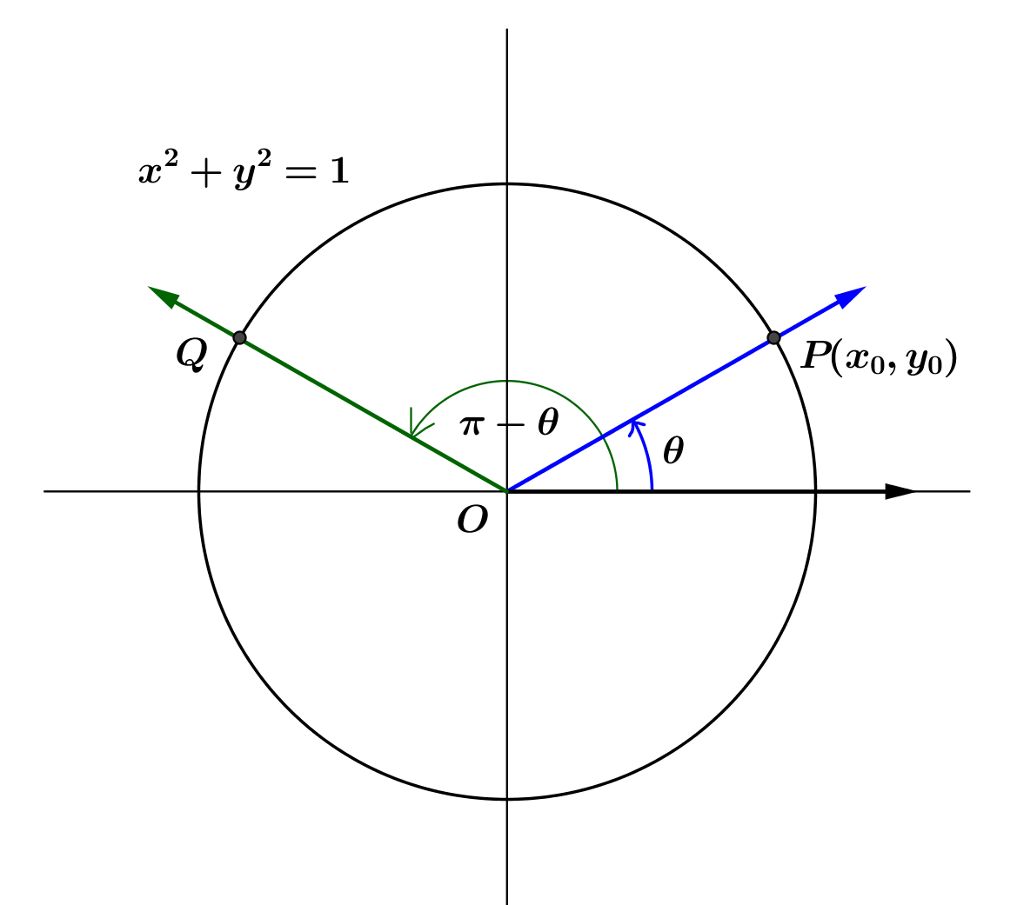
- Let $Q$ be the intersection of the terminal ray with the unit circle after being rotated by $π-θ$ radians.
  - What is the slope of $\overset{⃡}{OQ}$?
Ray $\vec{OQ}$ is the reflection of ray $\vec{OP}$ across the $y$-axis, so the coordinates of $Q$ are $\left({-x}_{0}, y_{0}\right)$. Then, the slope of $\overset{⃡}{OQ }$is the opposite of the slope of $\overset{⃡}{OP;}$ so, the slope of $\overset{⃡}{OQ }$ is $-m$.

  - Find an expression for $tan(π-θ)$ in terms of $m.$
$$tan\left(π-θ\right)=-m$$

  - Find an expression for $tan\left(π-θ\right)$ in terms of $tan(θ)$.
$$tan\left(π-θ\right)=-tan\left(θ\right)$$

- Let $Q$ be the intersection of the terminal ray with the unit circle after being rotated by $\frac{\text{π}}{2}+θ$ radians.
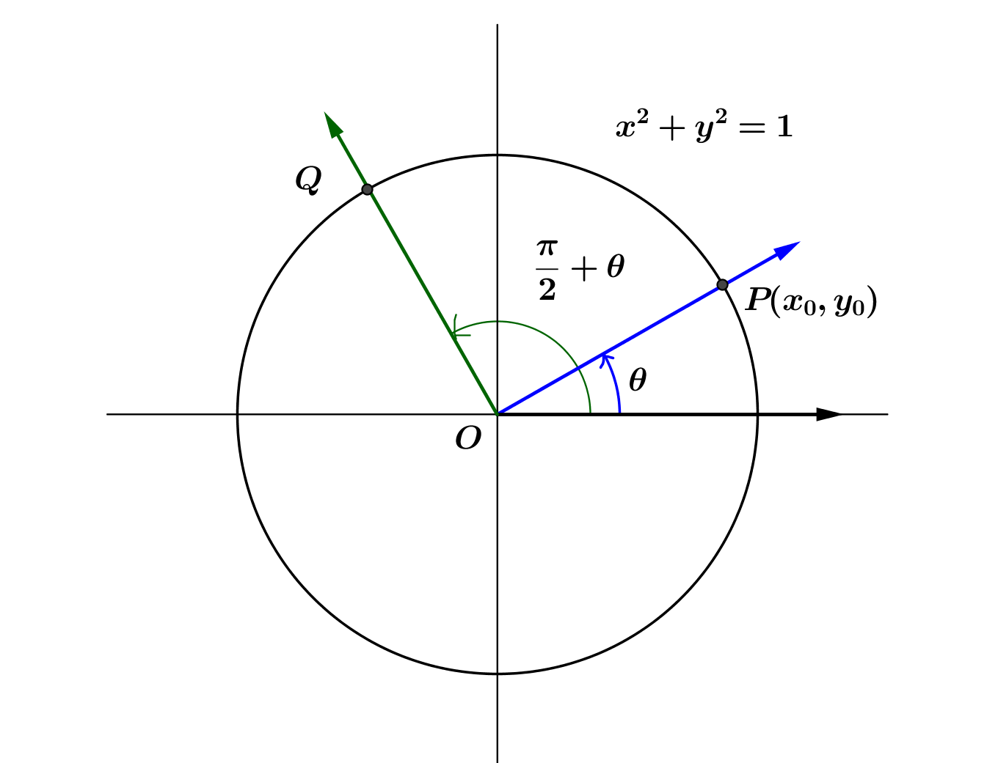
  - What is the slope of $\overset{⃡}{OQ}$?
Ray $\vec{OQ}$ is the rotation of ray $\vec{OP}$ by $90°$ counterclockwise, so line $\overset{⃡}{OQ}$ is perpendicular to line $\overset{⃡}{OP}.$ Thus, the slopes of$\overset{⃡}{OQ}$ and $\overset{⃡}{OP}$ are opposite reciprocals. Thus, the slope of $\overset{⃡}{OQ }$ is $–\frac{1}{m}$.

  - Find an expression for $tan\left(\frac{π}{2}+θ\right)$ in terms of $m$.
$$tan\left(\frac{π}{2} +θ \right)=-\frac{1}{m}$$

  - Find an expression for $tan\left(\frac{π}{2}+θ \right)$ first in terms of $tan(θ)$ and then in terms of $cot\left(θ\right)$.
$$tan\left(\frac{π}{2} +θ\right)=-\frac{1}{tan\left(θ\right)}=-cot\left(θ\right)$$

- Let $Q$ be the intersection of the terminal ray with the unit circle after being rotated by $\frac{π}{2}-θ$ radians.
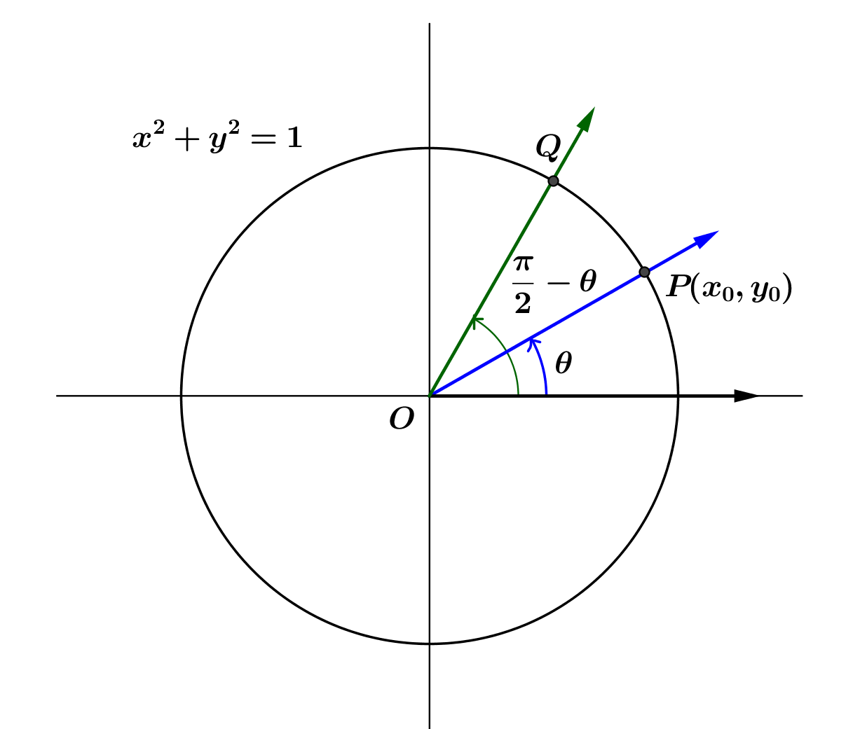
  - What is the slope of $\overset{⃡}{OQ}$?
Ray $\vec{OQ}$ is the reflection of ray $\vec{OP}$ across the diagonal line $y=x$, so the coordinates of $Q$ are $\left(y_{0}, x_{0}\right)$. Then, the slope of $\overset{⃡}{OQ }$ is $\frac{1}{m}$.

  - Find an expression for $tan\left(\frac{π}{2}-θ\right)$ in terms of $m.$
$$tan\left(\frac{π}{2}-θ\right)=\frac{1}{m}$$

  - Find an expression for $tan\left(\frac{π}{2}-θ\right)$ in terms of $tan\left(θ\right)$ or other trigonometric functions.
$$tan\left(\frac{π}{2}-θ\right)=\frac{1}{tan\left(θ\right)}=cot\left(θ\right)$$

- Summarize your results from Exercises 6, 7, 9, 10, and 11.
For $0<θ<\frac{π}{2}$:
$$tan\left(θ+π\right)=tan\left(θ\right)\text{;}$$
$$tan\left(-θ\right)=-tan\left(θ\right)\text{;}$$
$$tan\left(π-θ\right)=-tan\left(θ\right)\text{;}$$
$$tan\left(\frac{π}{2}+θ\right)=-\frac{1}{tan\left(θ\right)}\text{;}$$
$$tan\left(\frac{π}{2}-θ\right)=\frac{1}{tan\left(θ\right)}\text{.}$$
- We have only demonstrated that the identities in Exercise 12 are valid for $0<θ<\frac{π}{2}$ because we only used rotations that left point $P$ in the first quadrant. Argue that $tan\left(-\frac{2π}{3}\right)=-tan\left(\frac{2π}{3}\right)$. Then, using similar logic, we could argue that all of the above identities extend to any value of $θ$ for which the tangent (and cotangent for the last two) are defined.
By the property developed in Exercise 3, $tan\left(\frac{π}{3}\right)=-tan\left(π-\frac{π}{3}\right)=-tan\left(\frac{2π}{3}\right)$. Because the terminal ray of a rotation through $-\frac{2π}{3}$ radians is collinear with the terminal ray of a rotation through $\frac{π}{3}$ radians,
$tan\left(\frac{π}{3}\right)=tan\left(-\frac{2π}{3}\right)$. Thus, by transitivity, we have $tan\left(-\frac{2π}{3}\right)=-tan\left(\frac{2π}{3}\right)$.

- For which values of $θ$ are the identities in Exercise 12 valid?
Using a process similar to the one we used in Exercise 13, we can show that the value of $θ$ can be any real number that does not cause a zero in the denominator. The tangent function is only defined for $θ≠\frac{π}{2}+πk$, for all integers $k$. Also, for those identities involving $cot\left(θ\right)$, we need to have $θ≠πk$, for all integers $k$.

- Derive an identity for $tan⁡(2π+θ)$ from the graph.
Because the terminal ray for a rotation by $2π+θ$ and the terminal ray for a rotation by $θ$ coincide, we see that $tan\left(2π+θ\right)=tan\left(θ\right),$ where $θ≠\frac{π}{2}+kπ$, for all integers $k$.

- Use the identities you summarized in Exercise 12 to show $tan\left(2π-θ\right)=-tan\left(θ\right)$ where $θ≠\frac{π}{2}+kπ$, for all integers $k$.
From Exercise 6, $tan\left(2π-θ\right)=tan\left(π+\left(π-θ\right)\right)=tan\left(π-θ\right)=tan\left(-θ\right)$.
From Exercise 7, $tan\left(-θ\right)=-tan\left(θ\right)$.
Thus, $tan\left(2π-θ\right)=-tan\left(θ\right)$ for $θ≠\frac{π}{2}+kπ$, for all integers $k$.

Discussion (3 minutes)
Use this opportunity to reinforce the major results of the Opening Exercise and to check for understanding of key concepts. Debrief the previous set of exercises with students and discuss the identities for the tangent function derived in Exercises 6, 7, 9, 10, 11, 15, and 16. Be sure that every student has the correct identities recorded before moving on.
- What is the period of the tangent function?
  - $π$
- What is the value of the tangent function at $θ+π$? For which values of $θ$ is this an identity?
  - $\tan\left(θ+π\right)=tan⁡(θ)$ for $θ≠\frac{π}{2}+kπ$, for all integers $k$.
- What is the value of the tangent function at $π-θ$? For which values of $θ$ is this an identity?
  - $\tan\left(π-θ\right)=-\tan\left(θ\right)$ for $θ≠\frac{π}{2}+kπ$, for all integers $k$.
- What is the value of the tangent function at $\frac{π}{2}-θ$? For which values of $θ$ is this an identity?
  - $\tan\left(\frac{π}{2}-θ\right)=\cot\left(θ\right)$ for $θ≠\frac{π}{2}+kπ$ and $θ≠kπ,$ for all integers $k$.
- What is the value of the tangent function at $2π-θ$? For which values of $θ$ is this an identity?
  - $\tan\left(2π-θ\right)=-\tan\left(θ\right)$ for $θ≠\frac{π}{2}+kπ$, for all integers $k$.
Example (4 minutes)
Part of the Problem Set for this lesson includes analytically justifying some of the tangent identities that we developed geometrically in the exercises. Lead the class through the following discussion to demonstrate similarities between some identities of the sine, cosine, and tangent functions.
- Compare these three identities.
$$\sin\left(θ+2π\right)=\sin\left(θ\right), for all real numbers θ \\ \cos\left(θ+2π\right)=\cos\left(θ\right), for all real numbers θ \\ \tan\left(θ+π\right)=\tan\left(θ\right),for θ≠\frac{π}{2}+kπ, \text{for all integers} k$$
  - These identities come from the fundamental period of each of the three main trigonometric functions. The period of sine and cosine are $2π,$ and the period of tangent is $π$. These identities demonstrate that if you rotate the initial ray through $θ$ radians, the values of the sine and cosine are the same whether or not you rotate through an additional $2π$ radians. For tangent, the value of the tangent function is the same whether you rotate the initial ray through $θ$ radians or rotate through an additional half-turn of $π$ radians.

- Compare these three identities.
$$\sin\left(-θ\right)=-\sin\left(θ\right), for all real numbers θ \\ \cos\left(-θ\right)=\cos\left(θ\right), for all real numbers θ \\ \tan\left(-θ\right)=-\tan\left(θ\right),for θ≠\frac{π}{2}+kπ, \text{for all integers} k$$
  - Both the sine and tangent functions are odd functions, while the cosine function is an even function. The first two identities yield the third because $\tan\left(-θ\right)=\frac{\sin\left(-θ\right)}{\cos\left(-θ\right)}=-\frac{\sin\left(θ\right)}{\cos\left(θ\right)}=-\tan{(θ)}$.

Consider presenting other identities and having the class compare and contrast them as time permits. Another possibility would be the following identities.
$$\sin\left(θ+π\right)=-\sin\left(θ\right),for all real numbers θ \\ \cos\left(θ+π\right)=-\cos\left(θ\right),for all real numbers θ \\ \tan\left(θ+π\right)=\tan\left(θ\right),for θ≠\frac{π}{2}+kπ, for all integers k$$

Closing (3 minutes)
Have students summarize the new identities they learned for the tangent function both in words and symbolic notation with a partner or in writing. Have students draw a graph of $y=\tan\left(x\right)$, including at least two full periods. Use this as an opportunity to check for any gaps in understanding.
Lesson Summary
The tangent function $tan\left(x\right)=\frac{sin\left(x\right)}{cos\left(x\right)}$ is periodic with period $π$. We have established the following identities:
- $tan\left(x+π\right)=tan(x)$ for all $θ≠\frac{π}{2}+kπ$, for all integers $k$.
- $tan\left(-x\right)=-tan(x)$ for all $θ≠\frac{π}{2}+kπ$, for all integers $k$.
- $tan\left(π-x\right)=-tan\left(x\right)$for all $θ≠\frac{π}{2}+kπ$, for all integers $k$.
- $tan\left(\frac{π}{2}+x\right)=-cot\left(x\right)$ for all $θ≠kπ$, for all integers $k$.
- $tan\left(\frac{π}{2}-x\right)=cot\left(x\right)$ for all $θ≠kπ$, for all integers $k$.
- $tan(2π +x)=tan(x)$ for all $θ≠\frac{π}{2}+kπ$, for all integers $k$.
- $tan\left(2π-x\right)=-tan(x)$ for all $θ≠\frac{π}{2}+kπ$, for all integers $k$.

Exit Ticket (5 minutes)
Name Date
Lesson 14: Graphing the Tangent Function

Exit Ticket

- Use a tangent identity to explain why the tangent function is periodic.

- Given $tan\left(x\right)=7$, find the following function values:
  - $tan(π-x)$

  - $tan\left(π+x\right)$

  - $tan(2π-x)$
Exit Ticket Sample Solutions

- Use a tangent identity to explain why the tangent function is periodic.
We developed the formula $tan\left(θ+π\right)= tan\left(θ\right)$, so the tangent function is periodic with period $π$.

- Given $tan\left(x\right)=7$, find the following function values:
  - $tan(π-x)$
$$tan\left(π-x\right)=-tan\left(x\right)=-7$$

  - $tan\left(π+x\right)$
$$tan\left(π+x\right)=tan\left(x\right)=7$$

  - $tan(2π-x)$
$$tan\left(2π-x\right)=tan\left(π-x\right)=-tan\left(x\right)=-7$$

Problem Set Sample Solutions
In Lesson 10, we considered the general form of a sinusoid function $f\left(x\right)=A\sin\left(ω\left(x-h\right)\right)+k$. In the first problem in this Problem Set, students will construct the graph of the cotangent function. In the second problem, students graph transformed tangent functions, learning how the parameters in the general tangent function $f\left(x\right)=A\tan\left(ω\left(x-h\right)\right)+k$ affect the shape of the graph, leading to finding parameters to align the graphs of a transformed tangent function and the cotangent function.

- Recall that the cotangent function is defined by $cot\left(x\right)=\frac{cos\left(x\right)}{\text{sin}\left(x\right)}=\frac{1}{tan\left(x\right)}$, where $sin\left(x\right)≠0$.
  - What is the domain of the cotangent function? Explain how you know.
Since the cotangent function is given by $cot\left(x\right)=\frac{cos\left(x\right)}{\text{sin}\left(x\right)}$, the cotangent function is undefined at values of $x$, where $sin\left(x\right)=0$. This happens at values of $θ$ that are multiples of $π$.

  - What is the period of the cotangent function? Explain how you know.
Since the cotangent function is the reciprocal of the tangent function, they will have the same period, $π$. That is,
$$cot\left(x+π\right)=\frac{1}{tan\left(x+π\right)}=\frac{1}{tan\left(x\right)}=cot\left(x\right).$$

  - Use a calculator to complete the table of values of the cotangent function on the interval $\left(0,π\right)$ to two decimal places.
$$x$$ | $$cot\left(x\right)$$ |  | $$x$$ | $$cot\left(x\right)$$ |  | $$x$$ | $$cot\left(x\right)$$ |  | $$x$$ | $$cot\left(x\right)$$
$$\frac{π}{24}$$ | $$7.60$$ |  | $$\frac{4π}{12}$$ | $$0.50$$ |  | $$\frac{7π}{12}$$ | $$-0.27$$ |  | $$\frac{10π}{12}$$ | $$-1.73$$
$$\frac{π}{12}$$ | $$3.73$$ |  | $$\frac{5π}{12}$$ | $$0.27$$ |  | $$\frac{8π}{12}$$ | $$-0.50$$ |  | $$\frac{11π}{12}$$ | $$-3.73$$
$$\frac{2π}{12}$$ | $$1.73$$ |  | $$\frac{π}{2}$$ | $$0.00$$ |  | $$\frac{9π}{12}$$ | $$-1.00$$ |  | $$\frac{23π}{24}$$ | $$-7.60$$
$$\frac{3π}{12}$$ | $$1.00$$

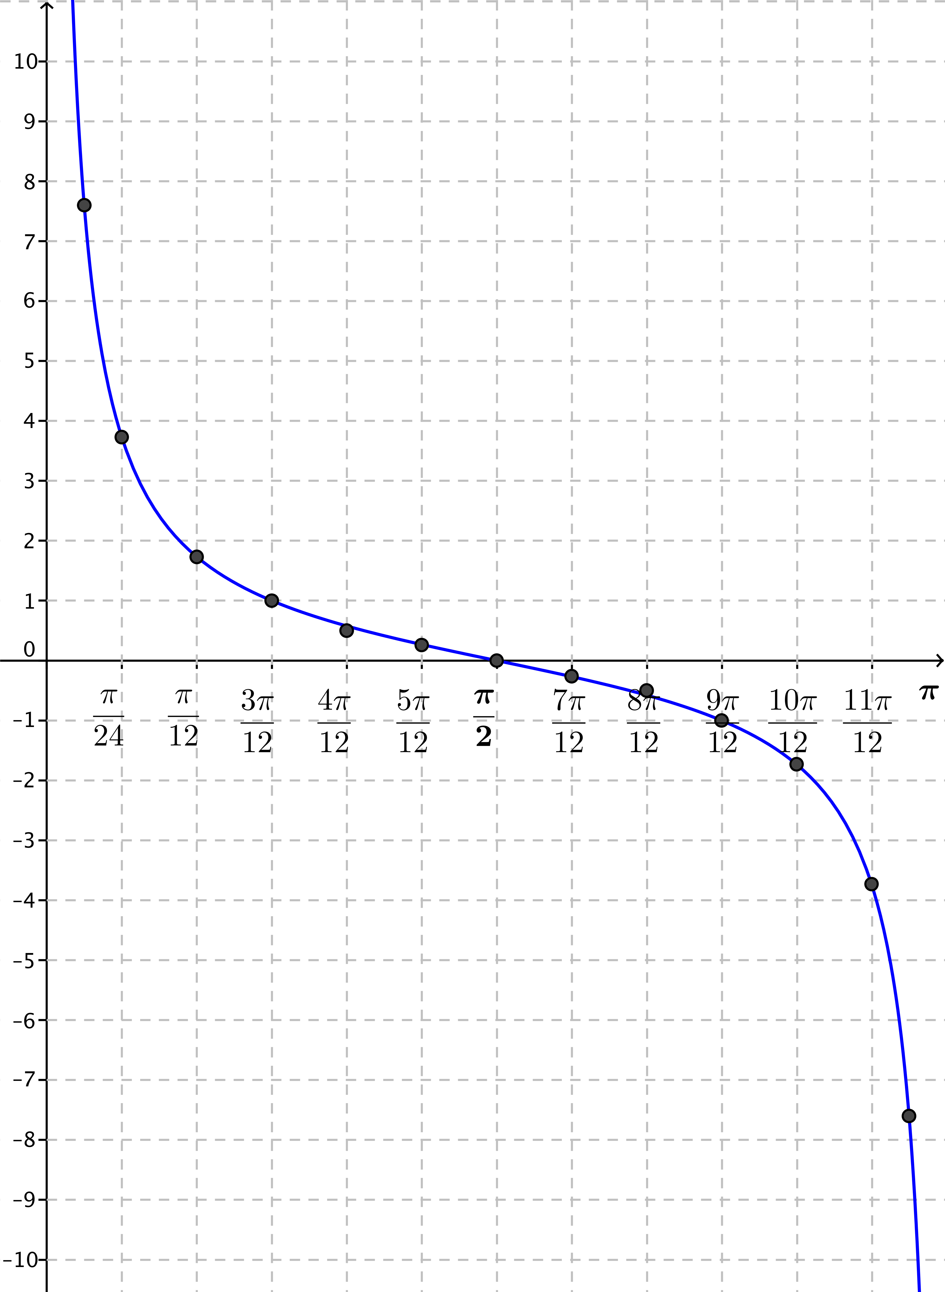
  - Plot your data from part (c) and sketch a graph of $y=cot\left(x\right)$ on $(0, π)$.

  - Sketch a graph of $y=cot(x)$ on $(-2π, 2π)$ without plotting points.
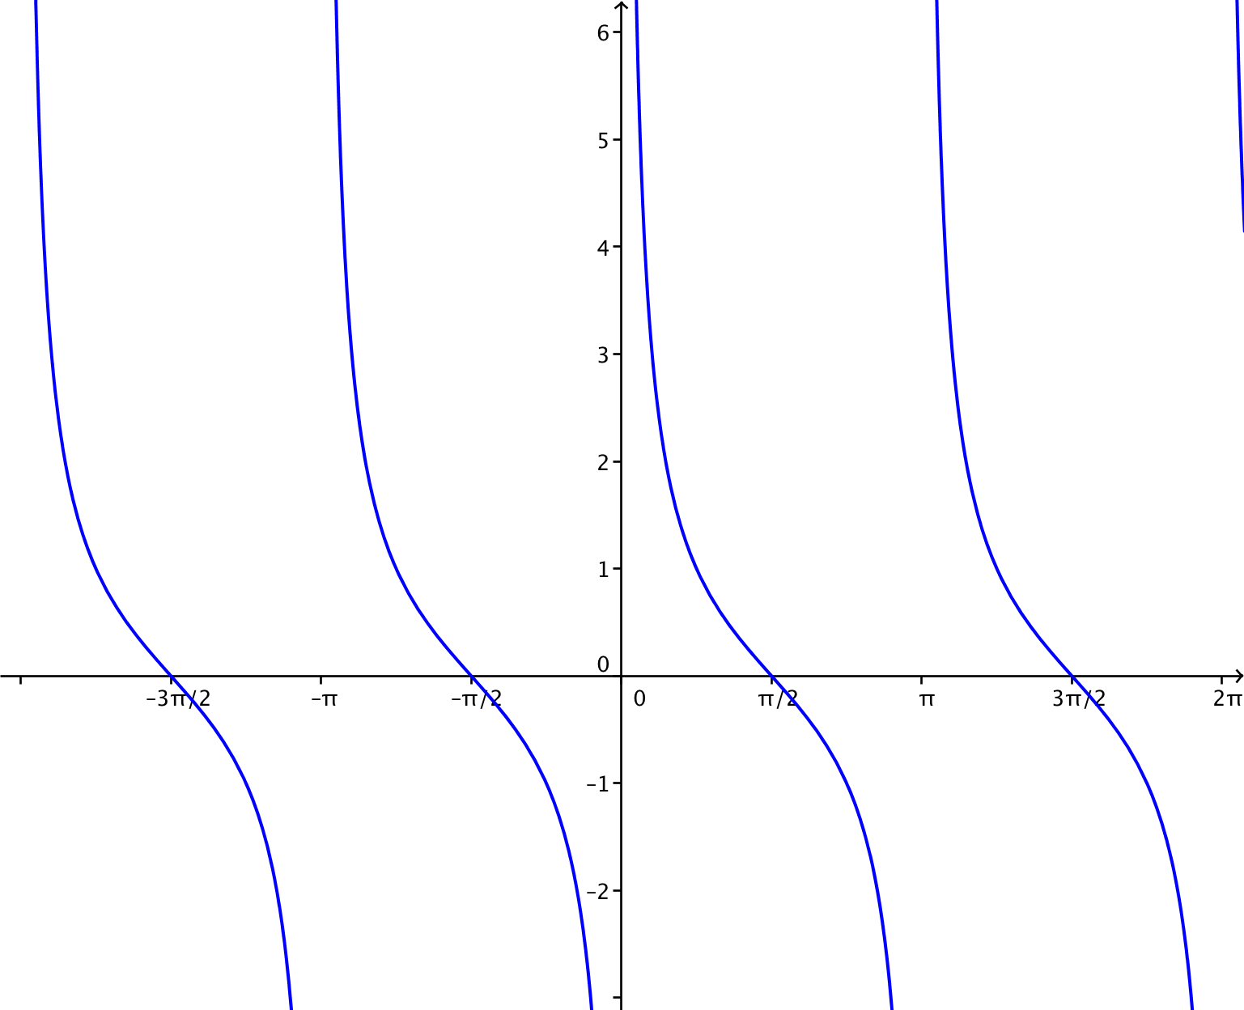

  - Discuss the similarities and differences between the graphs of the tangent and cotangent functions.
Both the tangent and cotangent functions have vertical asymptotes; the cotangent graph has vertical asymptotes at $x=kπ$, for integers $k$, and the tangent has vertical asymptotes at $x=\frac{π}{2}+kπ$, for integers $k$. The values of the tangent function increase as we look at each piece of the graph from left to right, and the values of the cotangent function decrease as we look at each piece from left to right.

  - Find all $x$-values where $tan\left(x\right)=cot(x)$ on the interval $(0,2π)$.
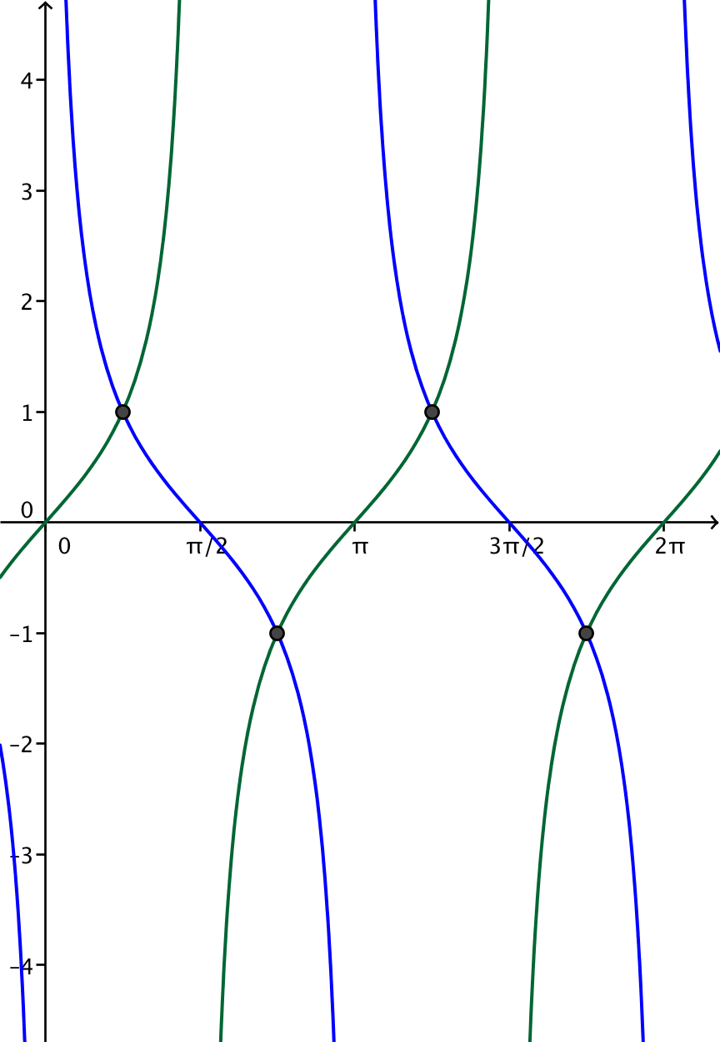
Suppose that $tan\left(x\right)=cot(x)$. Then, $\frac{sin\left(x\right)}{\text{cos}\left(\text{x}\right)}=\frac{cos\left(x\right)}{sin\left(x\right)}$. Cross multiplying gives
$${\left(sin\left(x\right)\right)}^{2}={\left(cos\left(x\right)\right)}^{2} \\ {\left(sin\left(x\right)\right)}^{2}-{\left(cos\left(x\right)\right)}^{2}=0 \\ \left(sin\left(x\right)-cos\left(x\right)\right)\left(sin\left(x\right)+cos\left(x\right)\right)=0 \\ sin\left(x\right)=cos\left(x\right)\text{ or} sin\left(x\right)=-cos\left(x\right).$$
The solutions are $\frac{π}{4}$, $\frac{3π}{4}$, $\frac{5π}{4}$, and $\frac{7π}{4}$. These are the $x$-values of the points of intersection of the graphs of the two functions shown to the right.

- Each set of axes below shows the graph of $f\left(x\right)=tan(x)$. Use what you know about function transformations to sketch a graph of $y=g\left(x\right)$ for each function $g$ on the interval $(0,2π)$.
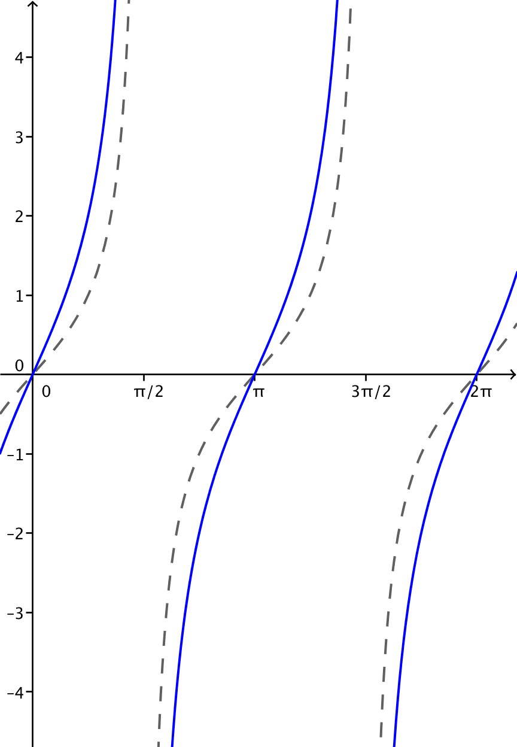
  - $g\left(x\right)=2 tan\left(x\right)$

  - $g\left(x\right)=\frac{1}{3}tan(x)$
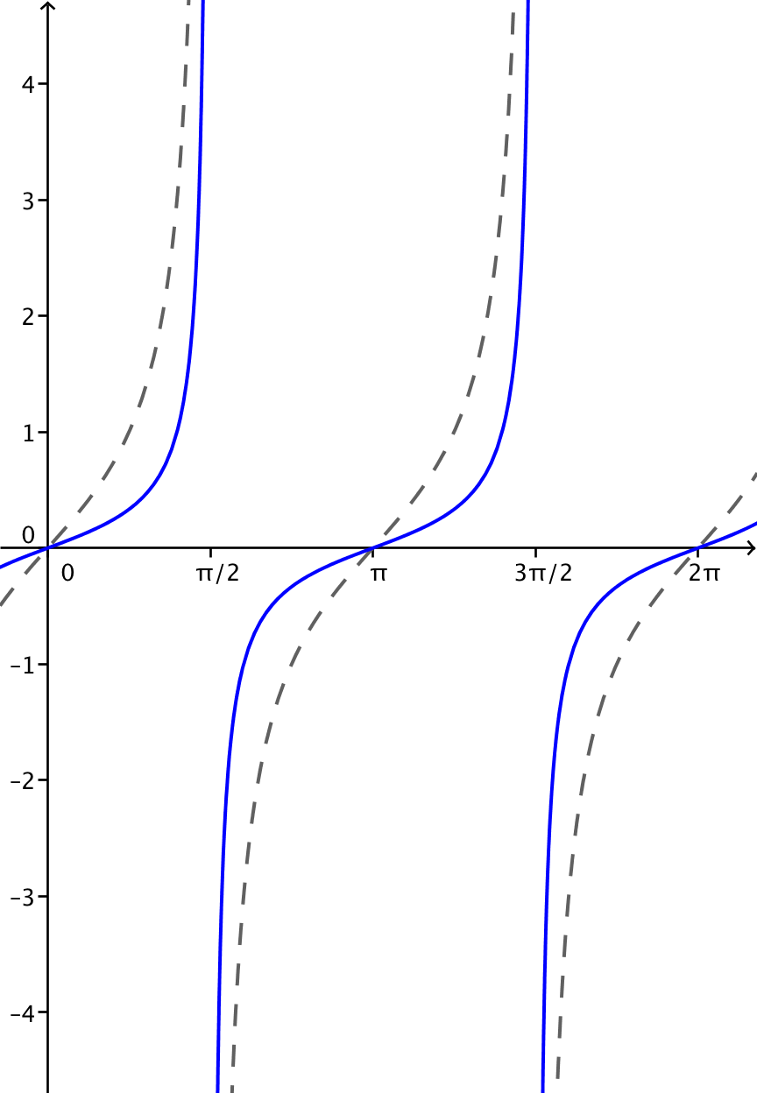

  - $g\left(x\right)=-2 tan(x)$
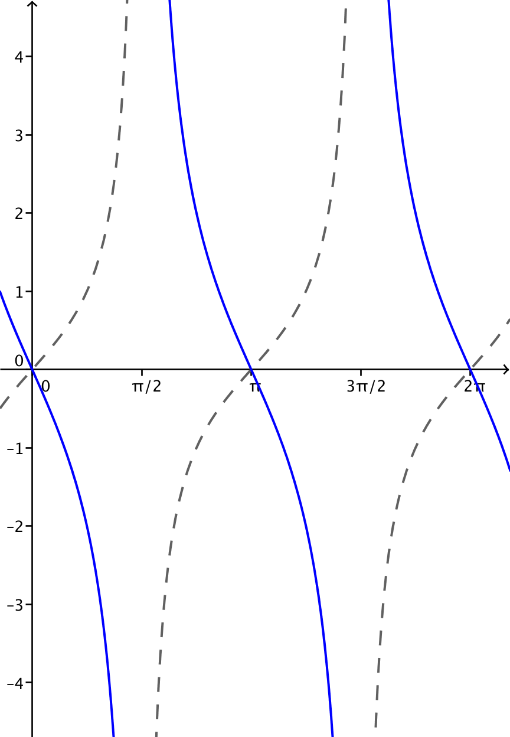

  - How does changing the parameter $A$ affect the graph of $g\left(x\right)=A tan(x)$?
If $A$ is positive, the graph is scaled vertically by a factor of $A$. If $A$ is negative, then the graph is reflected over the $x$-axis and scaled vertically by a factor of $\left|A\right|$.

- Each set of axes below shows the graph of $f\left(x\right)=tan(x)$. Use what you know about function transformations to sketch a graph of $y=g\left(x\right)$ for each function $g$ on the interval $(0,2π)$.
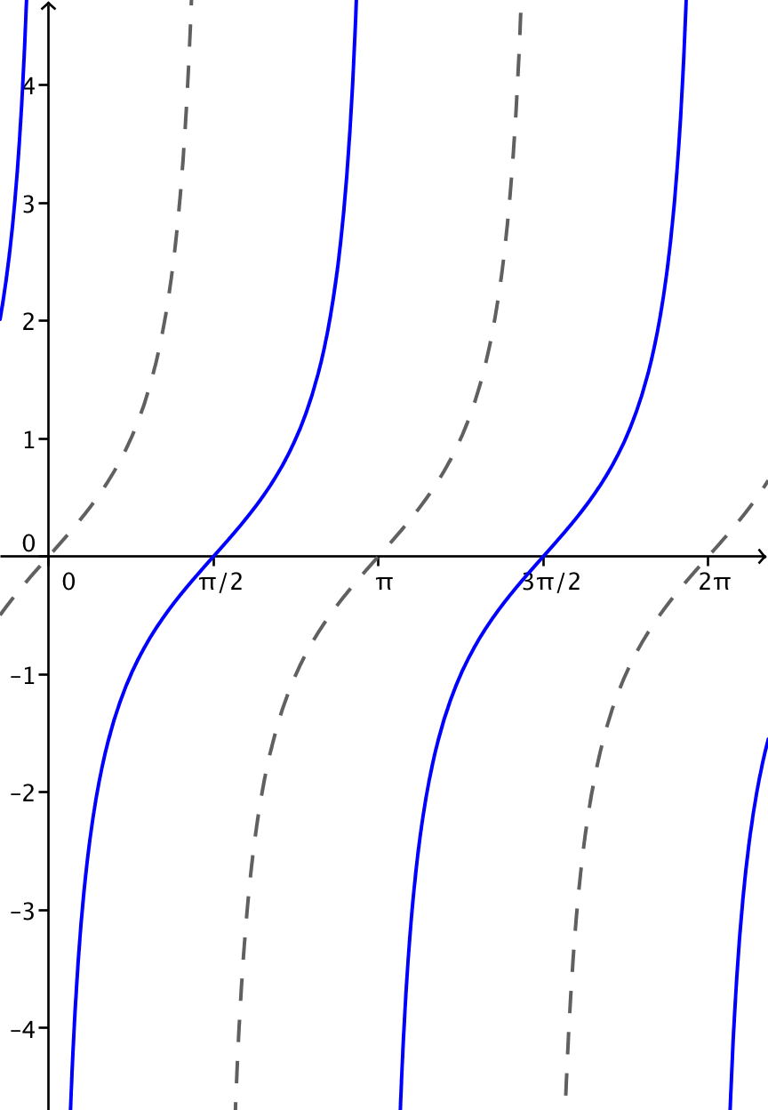
  - $g\left(x\right)=tan\left(x-\frac{π}{2}\right)$

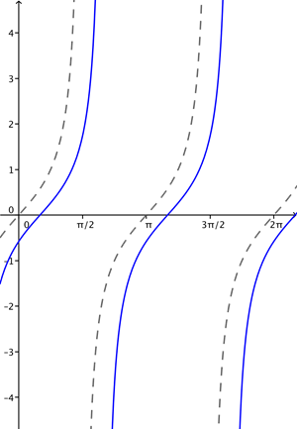
  - $g\left(x\right)=tan\left(x-\frac{π}{6}\right)$

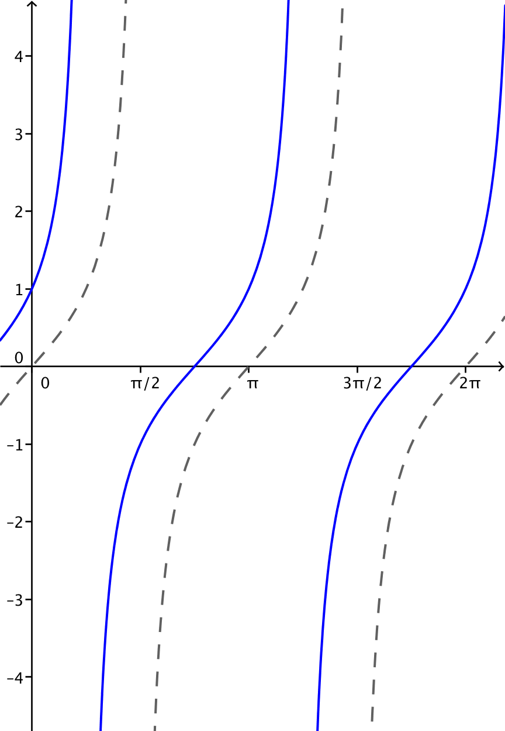
  - $g\left(x\right)=tan\left(x+\frac{π}{4}\right)$

  - How does changing the parameter $h$ affect the graph of $g\left(x\right)=tan\left(x-h\right)$?
If $h>0$, the graph is translated horizontally to the right by $h$ units, and if $h<0$, the graph is translated horizontally to the left by $h$ units.

- Each set of axes below shows the graph of $f\left(x\right)=tan(x)$. Use what you know about function transformations to sketch a graph of $y=g\left(x\right)$ for each function $g$ on the interval $(0,2π)$.
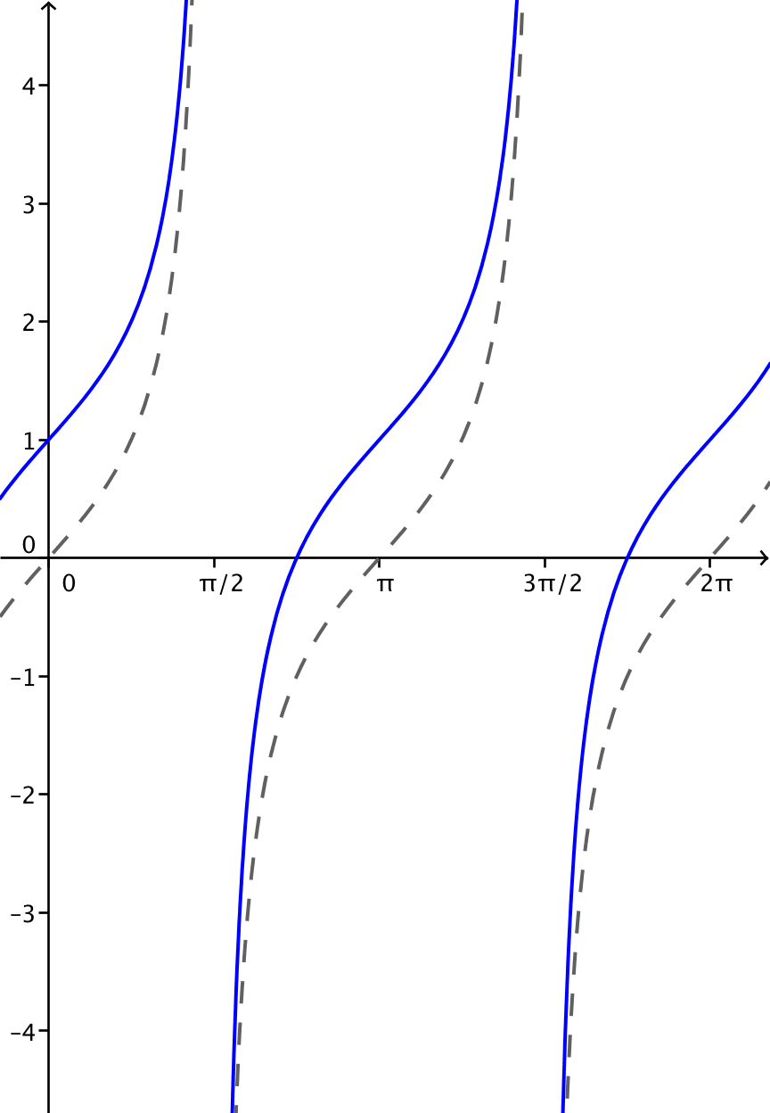
  - $g\left(x\right)=tan\left(x\right)+1$

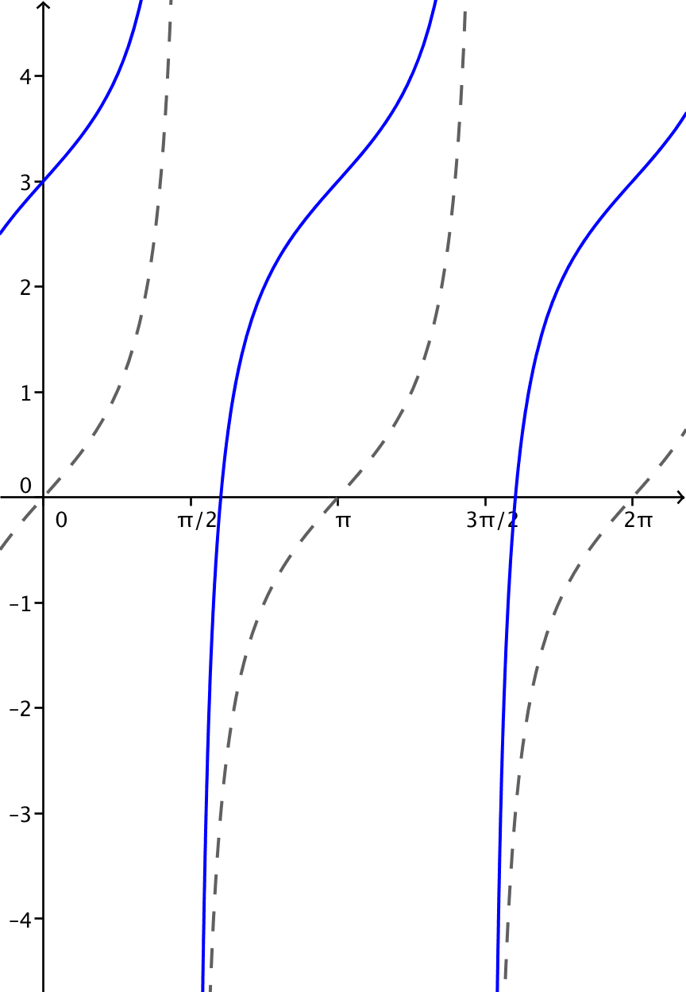
  - $g\left(x\right)=tan\left(x\right)+3$

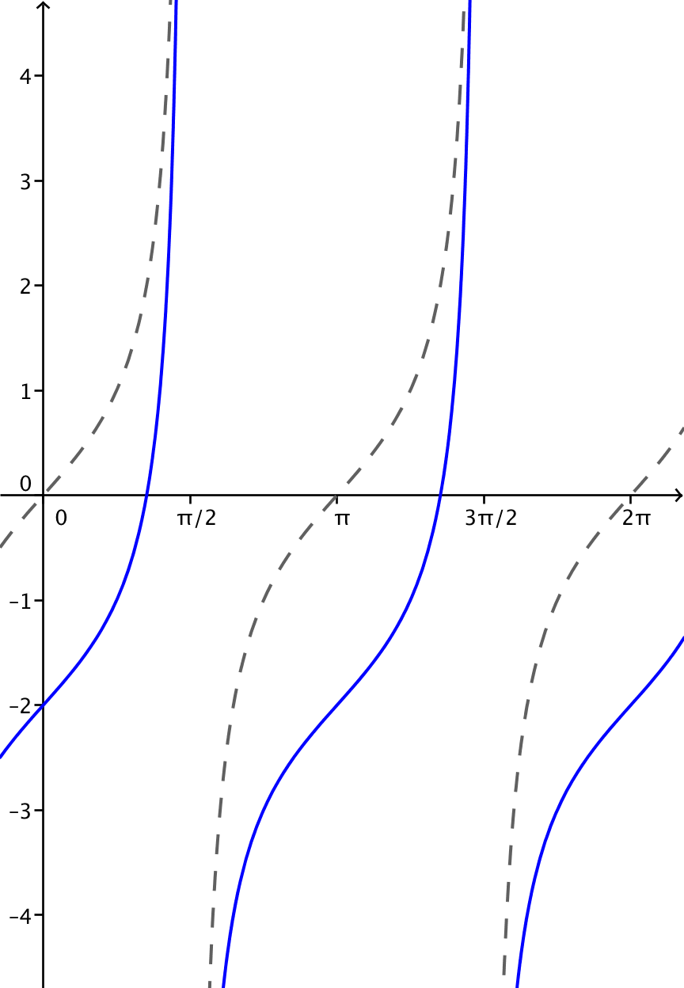
  - $g\left(x\right)=tan\left(x\right)-2$

  - How does changing the parameter $k$ affect the graph of $g\left(x\right)=tan\left(x\right)+k$?
If $k>0$, the graph is translated vertically upward by $k$ units, and if $k<0$, the graph is translated vertically downward by $k$ units.

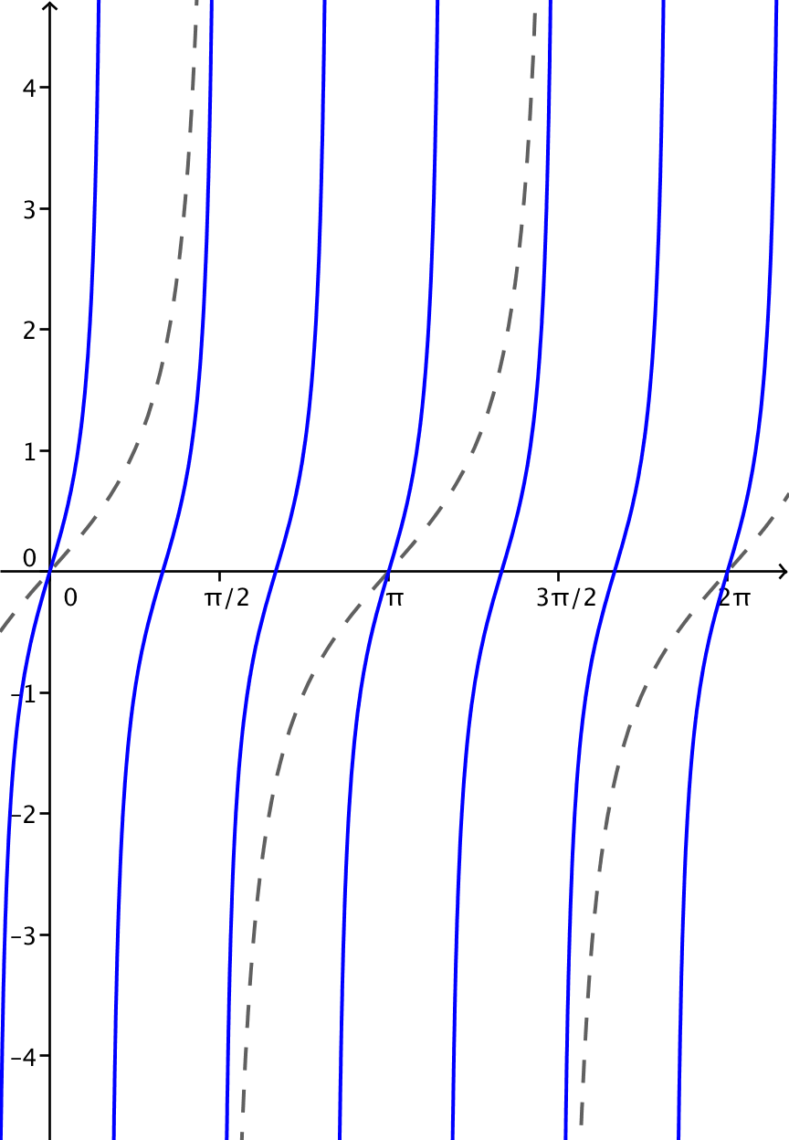
- Each set of axes below shows the graph of $f\left(x\right)=tan(x)$. Use what you know about function transformations to sketch a graph of $y=g\left(x\right)$ for each function $g$ on the interval $(0,2π)$.
  - $g\left(x\right)=tan\left(3x\right)$

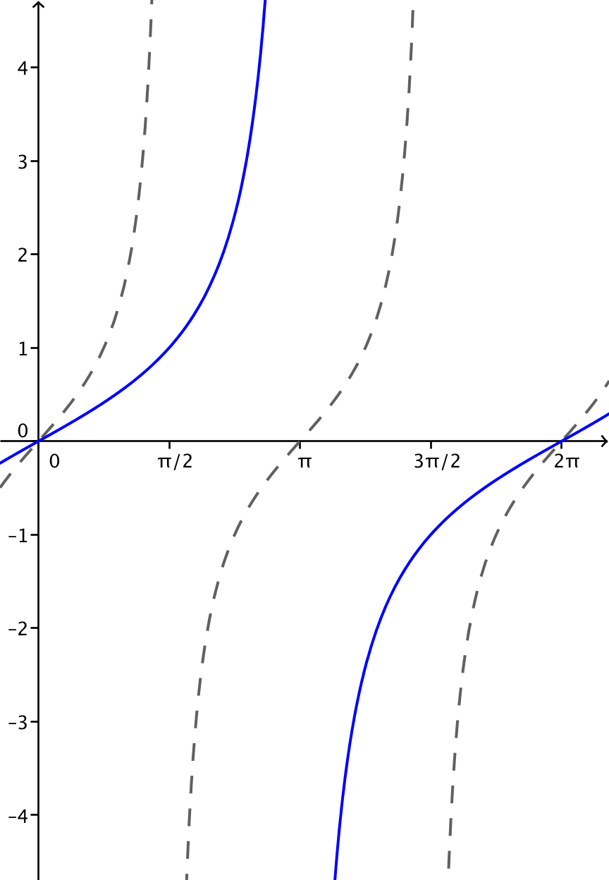
  - $g(x)=tan\left(\frac{x}{2}\right)$

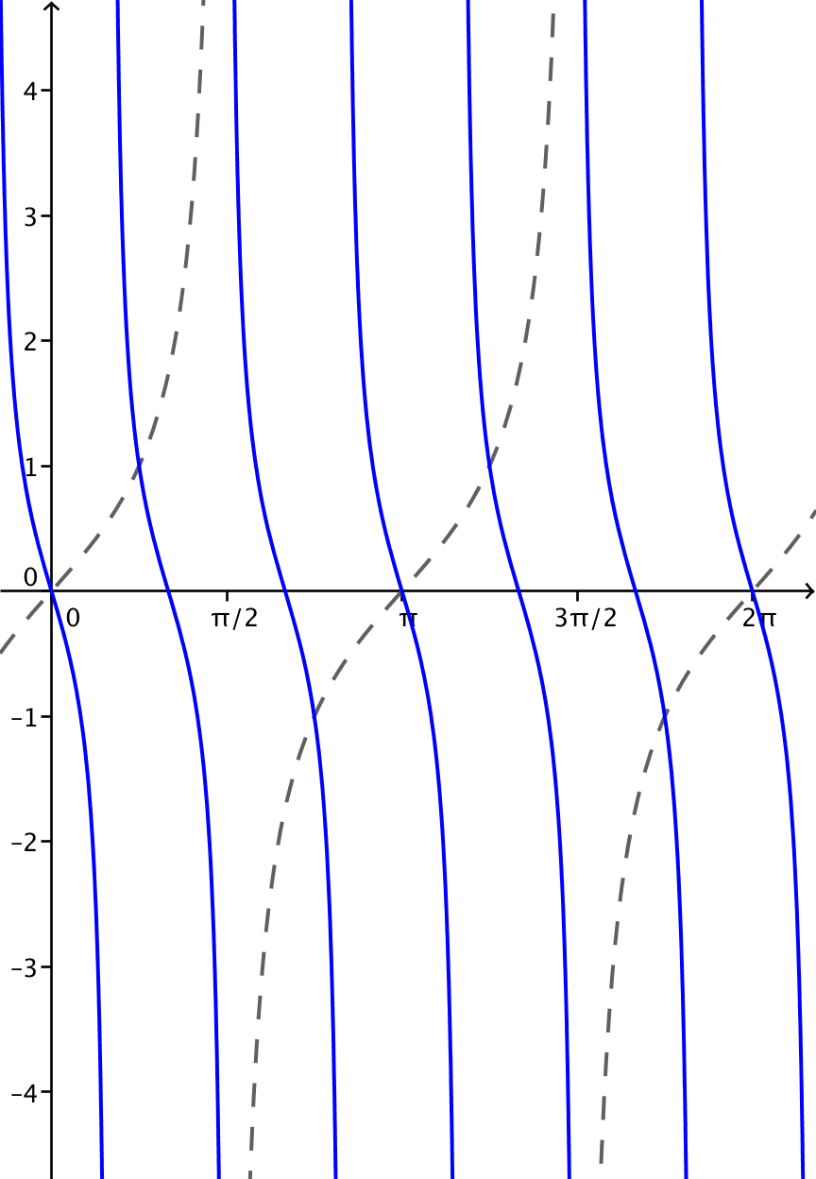
  - $g\left(x\right)=tan(-3x)$

  - How does changing the parameter $ω$ affect the graph of $g\left(x\right)=tan\left(ωx\right)$?
Changing $ω$ changes the period of the graph. The period is $\frac{π}{|ω|}$.

- Use your knowledge of function transformation and the graph of $y=tan\left(x\right)$ to sketch graphs of the following transformations of the tangent function.
  - $y=tan\left(2x\right)$
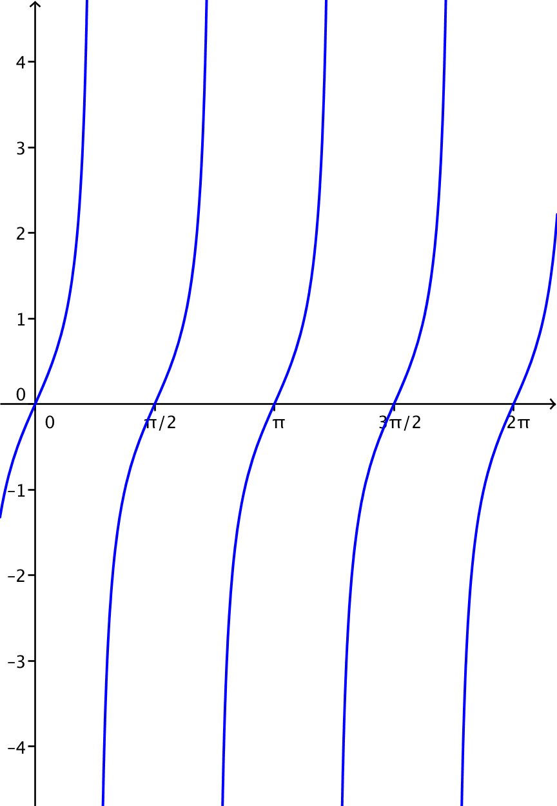
  - $y=tan\left(2\left(x-\frac{π}{4}\right)\right)$
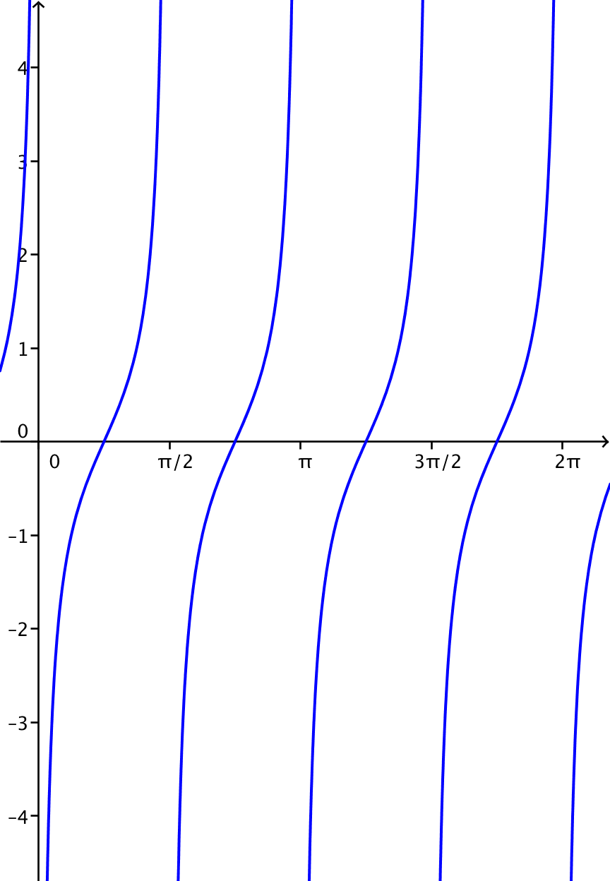

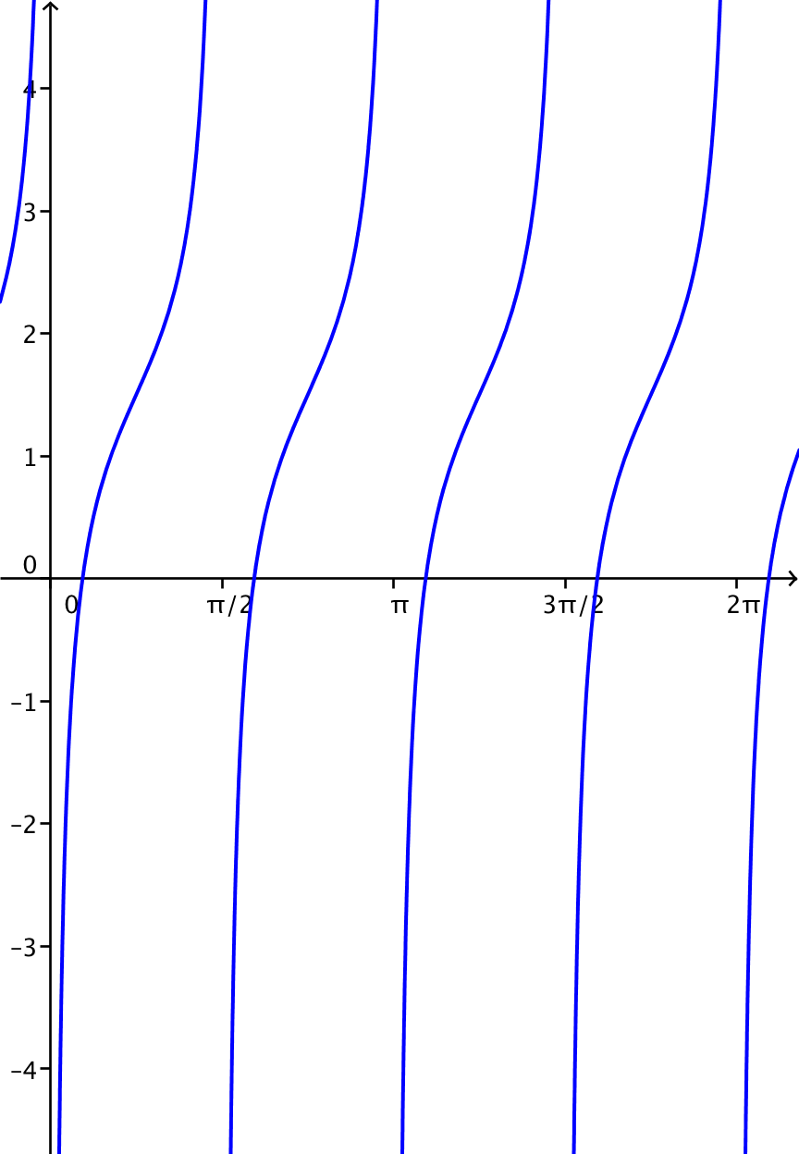
  - $y=tan\left(2\left(x-\frac{π}{4}\right)\right)+1.5$

- Find parameters $A$, $ω$,$h$, and $k$ so that the graphs of $f\left(x\right)=A tan \left(ω\left(x-h\right)\right)+k$ and $g\left(x\right)=cot\left(x\right)$ are the same.
The graphs of $f\left(x\right)=-tan\left(x-\frac{π}{2}\right)$ and $g\left(x\right)=cot(x)$ are the same graph.
