Lesson 14: Graphing the Tangent Function

Classwork
Exploratory Challenge/Exercises 1–5
- Use your calculator to calculate each value of $tan(x)$ to two decimal places in the table for your group.
Group 1  $$\left(-\frac{π}{2},\frac{π}{2}\right)$$ |  |  | Group 2  $$\left(\frac{π}{2},\frac{3π}{2}\right)$$ |  |  | Group 3  $$\left(-\frac{3π}{2},-\frac{π}{2}\right)$$ |  |  | Group 4  $$\left(\frac{3π}{2},\frac{5π}{2}\right)$$
$$x$$ | $$tan\left(x\right)$$ |  | $$x$$ | $$tan\left(x\right)$$ |  | $$x$$ | $$tan\left(x\right)$$ |  | $$x$$ | $$tan\left(x\right)$$
$$-\frac{11π}{24}$$ |  |  | $$\frac{13π}{24}$$ |  |  | $$-\frac{35π}{24}$$ |  |  | $$\frac{37π}{24}$$
$$-\frac{5π}{12}$$ |  |  | $$\frac{7π}{12}$$ |  |  | $$-\frac{17π}{12}$$ |  |  | $$\frac{19π}{12}$$
$$-\frac{4π}{12}$$ |  |  | $$\frac{8π}{12}$$ |  |  | $$-\frac{16π}{12}$$ |  |  | $$\frac{20π}{12}$$
$$-\frac{3π}{12}$$ |  |  | $$\frac{9π}{12}$$ |  |  | $$-\frac{15π}{12}$$ |  |  | $$\frac{21π}{12}$$
$$-\frac{2π}{12}$$ |  |  | $$\frac{10π}{12}$$ |  |  | $$-\frac{14π}{12}$$ |  |  | $$\frac{22π}{12}$$
$$-\frac{π}{12}$$ |  |  | $$\frac{11π}{12}$$ |  |  | $$-\frac{13π}{12}$$ |  |  | $$\frac{23π}{12}$$
$$0$$ |  |  | $$π$$ |  |  | $$-π$$ |  |  | $$2π$$
$$\frac{π}{12}$$ |  |  | $$\frac{13π}{12}$$ |  |  | $$-\frac{11π}{12}$$ |  |  | $$\frac{25π}{12}$$
$$\frac{2π}{12}$$ |  |  | $$\frac{14π}{12}$$ |  |  | $$-\frac{10π}{12}$$ |  |  | $$\frac{26π}{12}$$
$$\frac{3π}{12}$$ |  |  | $$\frac{15π}{12}$$ |  |  | $$-\frac{9π}{12}$$ |  |  | $$\frac{27π}{12}$$
$$\frac{4π}{12}$$ |  |  | $$\frac{16π}{12}$$ |  |  | $$-\frac{8π}{12}$$ |  |  | $$\frac{28π}{12}$$
$$\frac{5π}{12}$$ |  |  | $$\frac{17π}{12}$$ |  |  | $$-\frac{7π}{12}$$ |  |  | $$\frac{29π}{12}$$
$$\frac{11π}{24}$$ |  |  | $$\frac{35π}{24}$$ |  |  | $$-\frac{13π}{24}$$ |  |  | $$\frac{59π}{24}$$
Group 5  $$\left(-\frac{5π}{2},-\frac{3π}{2}\right)$$ |  |  | Group 6  $$\left(\frac{5π}{2},\frac{7π}{2}\right)$$ |  |  | Group 7  $$\left(-\frac{7π}{2},-\frac{5π}{2}\right)$$ |  |  | Group 8  $$\left(\frac{7π}{2},\frac{9π}{2}\right)$$
$$x$$ | $$tan\left(x\right)$$ |  | $$x$$ | $$tan\left(x\right)$$ |  | $$x$$ | $$tan\left(x\right)$$ |  | $$x$$ | $$tan\left(x\right)$$
$$-\frac{59π}{24}$$ |  |  | $$\frac{61π}{24}$$ |  |  | $$-\frac{83π}{24}$$ |  |  | $$\frac{37π}{24}$$
$$-\frac{29π}{12}$$ |  |  | $$\frac{31π}{12}$$ |  |  | $$-\frac{41π}{12}$$ |  |  | $$\frac{43π}{12}$$
$$-\frac{28π}{12}$$ |  |  | $$\frac{32π}{12}$$ |  |  | $$-\frac{40π}{12}$$ |  |  | $$\frac{44π}{12}$$
$$-\frac{27π}{12}$$ |  |  | $$\frac{33π}{12}$$ |  |  | $$-\frac{39π}{12}$$ |  |  | $$\frac{45π}{12}$$
$$-\frac{26π}{12}$$ |  |  | $$\frac{34π}{12}$$ |  |  | $$-\frac{38π}{12}$$ |  |  | $$\frac{46π}{12}$$
$$-\frac{25π}{12}$$ |  |  | $$\frac{35π}{12}$$ |  |  | $$-\frac{37π}{12}$$ |  |  | $$\frac{47π}{12}$$
$$-2π$$ |  |  | $$3π$$ |  |  | $$-3π$$ |  |  | $$4π$$
$$-\frac{23π}{12}$$ |  |  | $$\frac{37π}{12}$$ |  |  | $$-\frac{35π}{12}$$ |  |  | $$\frac{49π}{12}$$
$$-\frac{22π}{12}$$ |  |  | $$\frac{38π}{12}$$ |  |  | $$-\frac{34π}{12}$$ |  |  | $$\frac{50π}{12}$$
$$-\frac{21π}{12}$$ |  |  | $$\frac{39π}{12}$$ |  |  | $$-\frac{33π}{12}$$ |  |  | $$\frac{51π}{12}$$
$$-\frac{20π}{12}$$ |  |  | $$\frac{40π}{12}$$ |  |  | $$-\frac{32π}{12}$$ |  |  | $$\frac{52π}{12}$$
$$-\frac{19π}{12}$$ |  |  | $$\frac{41π}{12}$$ |  |  | $$-\frac{31π}{12}$$ |  |  | $$\frac{53π}{12}$$
$$-\frac{37π}{24}$$ |  |  | $$\frac{83π}{24}$$ |  |  | $$-\frac{61π}{24}$$ |  |  | $$\frac{107π}{24}$$

- The tick marks on the axes provided are spaced in increments of $\frac{π}{12}$. Mark the horizontal axis by writing the number of the left endpoint of your interval at the left-most tick mark, the multiple of $π$ that is in the middle of your interval at the point where the axes cross, and the number at the right endpoint of your interval at the right-most tick mark. Fill in the remaining values at increments of $\frac{π}{12}$.

- On your plot, sketch the graph of $y=tan\left(x\right)$ on your specified interval by plotting the points in the table and connecting the points with a smooth curve. Draw the graph with a bold marker.

- What happens to the graph near the edges of your interval? Why does this happen?

- When you are finished, affix your graph to the board in the appropriate place, matching endpoints of intervals.

Exploratory Challenge 2/Exercises 6–16
For each exercise below, let $m=\tan\left(θ\right)$ be the slope of the terminal ray in the definition of the tangent function, and let $P=(x_{0},y_{0})$ be the intersection of the terminal ray with the unit circle after being rotated by $θ$ radians for $0<θ<\frac{π}{2}$. We know that the tangent of $θ$ is the slope $m$ of $\overset{⃡}{OP}$.

- Let $Q$ be the intersection of the terminal ray with the unit circle after being rotated by $θ+π$ radians.
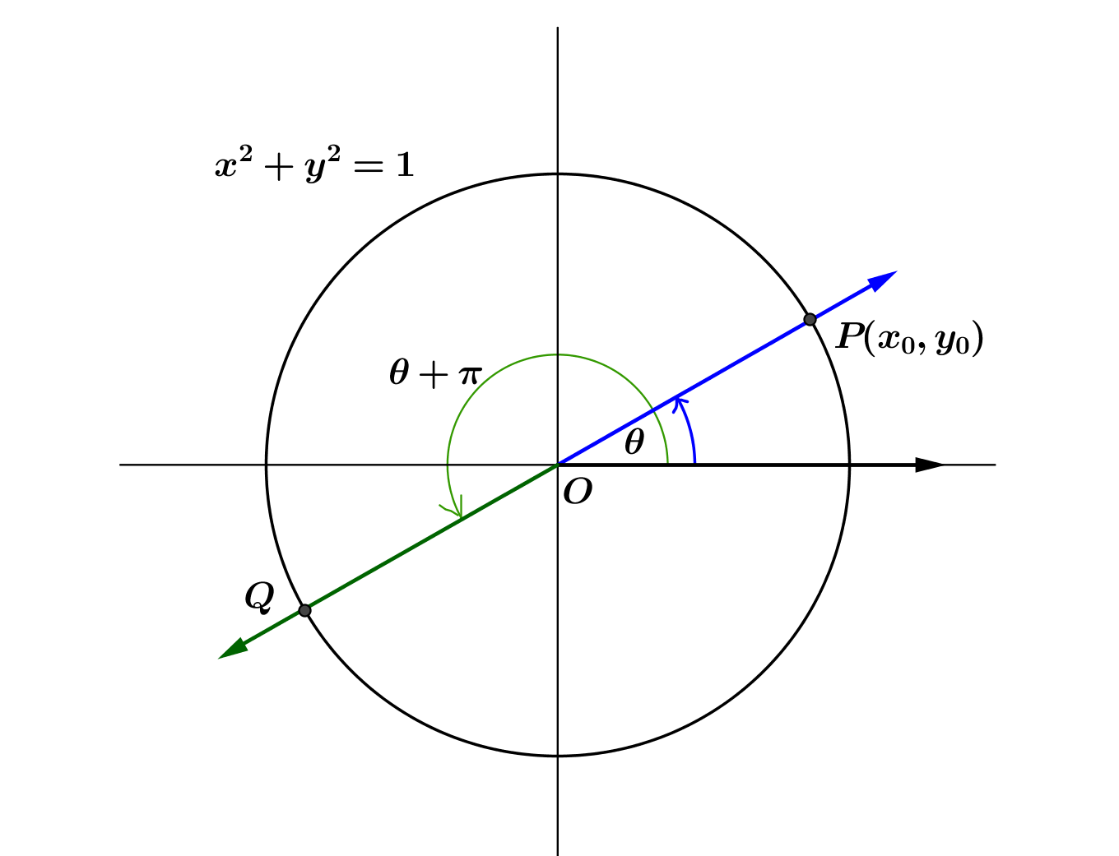
  - What is the slope of $\overset{⃡}{OQ}$?

  - Find an expression for $tan(θ+π)$ in terms of $m.$

  - Find an expression for $tan\left(θ+π\right)$ in terms of $tan(θ)$.

  - How can the expression in part (c) be seen in the graph of the tangent function?

- Let $Q$ be the intersection of the terminal ray with the unit circle after being rotated by $-θ$ radians.
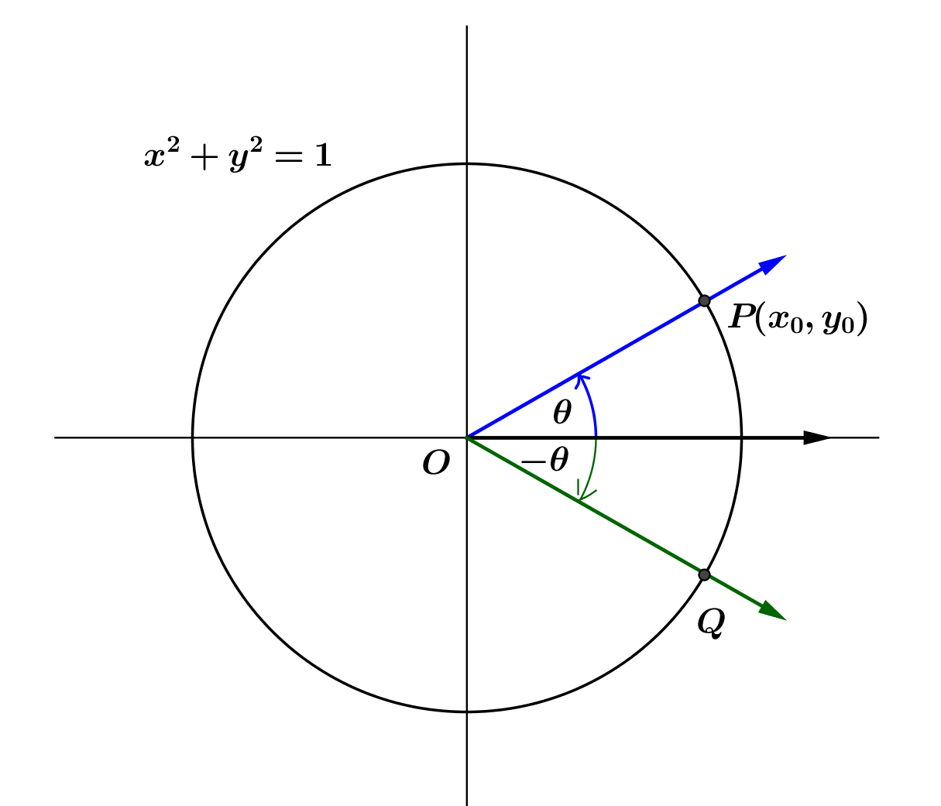
  - What is the slope of $\overset{⃡}{OQ}$?

  - Find an expression for $tan(-θ)$ in terms of $m.$

  - Find an expression for $tan\left(-θ\right)$ in terms of $tan(θ)$.

  - How can the expression in part (c) be seen in the graph of the tangent function?

- Is the tangent function an even function, an odd function, or neither? How can you tell your answer is correct from the graph of the tangent function?

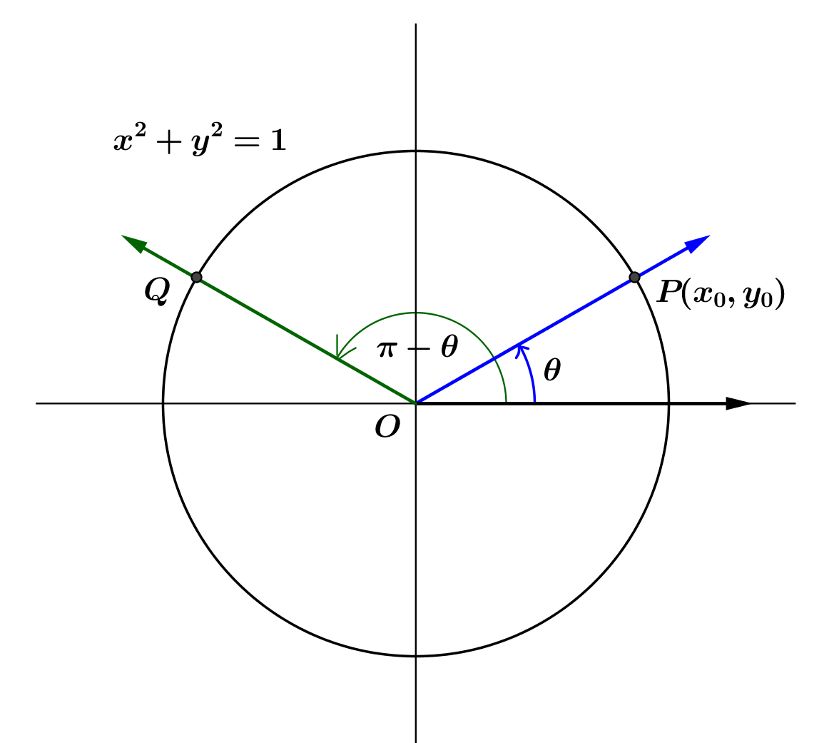
- Let $Q$ be the intersection of the terminal ray with the unit circle after being rotated by $π-θ$ radians.
  - What is the slope of $\overset{⃡}{OQ}$?

  - Find an expression for $tan(π-θ)$ in terms of $m.$

  - Find an expression for $tan\left(π-θ\right)$ in terms of $tan(θ)$.

- Let $Q$ be the intersection of the terminal ray with the unit circle after being rotated by $\frac{π}{2}+θ$ radians.
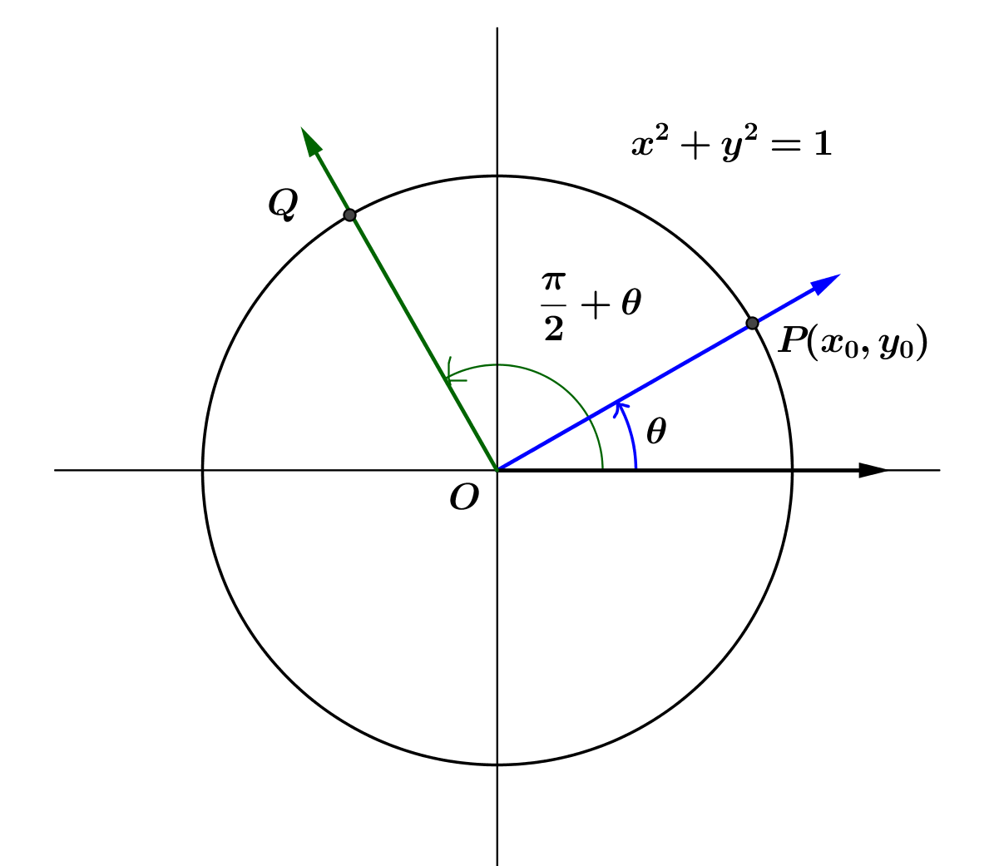
  - What is the slope of $\overset{⃡}{OQ}$?

  - Find an expression for $tan\left(\frac{π}{2}+θ\right)$ in terms of $m.$

  - Find an expression for $tan\left(\frac{π}{2}+θ \right)$ first in terms of $tan(θ)$ and then in terms of $cot\left(θ\right)$.

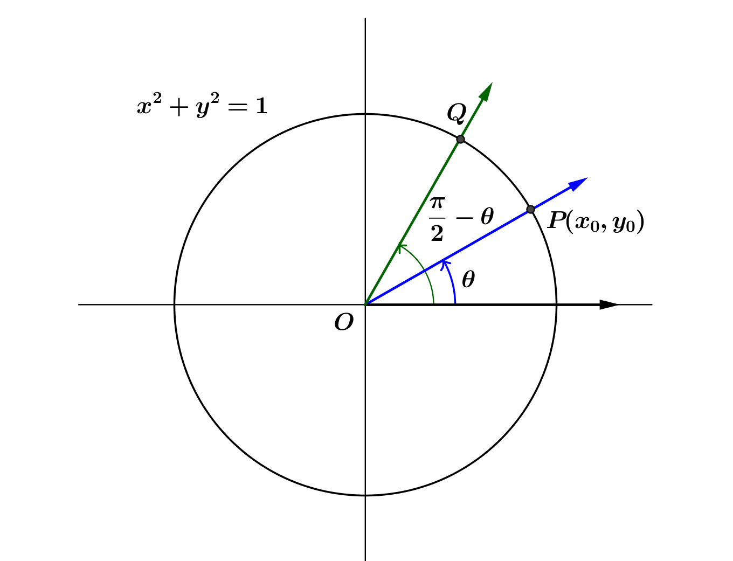
- Let $Q$ be the intersection of the terminal ray with the unit circle after being rotated by $\frac{π}{2}-θ$ radians.
  - What is the slope of $\overset{⃡}{OQ}$?

  - Find an expression for $tan\left(\frac{π}{2}-θ\right)$ in terms of $m.$

  - Find an expression for $tan\left(\frac{π}{2}-θ\right)$ in terms of $tan\left(θ\right)$ or other trigonometric functions.

- Summarize your results from Exercises 6, 7, 9, 10, and 11.

- We have only demonstrated that the identities in Exercise 12 are valid for $0<θ<\frac{π}{2}$ because we only used rotations that left point $P$ in the first quadrant. Argue that $tan\left(-\frac{2π}{3}\right)=-tan\left(\frac{2π}{3}\right).$ Then, using similar logic, we could argue that all of the above identities extend to any value of $θ$ for which the tangent (and cotangent for the last two) are defined.

- For which values of $θ$ are the identities in Exercise 7 valid?

- Derive an identity for $tan⁡(2π+θ)$ from the graph.

- Use the identities you summarized in Exercise 7 to show $tan\left(2π-θ\right)=-tan\left(θ\right)$ where $θ≠\frac{π}{2}+kπ$, for all integers $k$.

Problem Set
Lesson Summary
The tangent function $tan\left(x\right)=\frac{sin\left(x\right)}{cos\left(x\right)}$ is periodic with period $π.$ We have established the following identities:
- $tan\left(x+π\right)=tan(x)$ for all $θ≠\frac{π}{2}+kπ$, for all integers $k$.
- $tan\left(-x\right)=-tan(x)$ for all $θ≠\frac{π}{2}+kπ$, for all integers $k$.
- $tan\left(π-x\right)=-tan\left(x\right)$for all $θ≠\frac{π}{2}+kπ$, for all integers $k$.
- $tan\left(\frac{π}{2}+x\right)=-cot\left(x\right)$ for all $θ≠kπ$, for all integers $k$.
- $tan\left(\frac{π}{2}-x\right)=cot\left(x\right)$ for all $θ≠kπ$, for all integers $k$.
- $tan(2π +x)=tan(x)$ for all $θ≠\frac{π}{2}+kπ$, for all integers $k$.
- $tan\left(2π-x\right)=-tan(x)$ for all $θ≠\frac{π}{2}+kπ$, for all integers $k$.

- Recall that the cotangent function is defined by $cot\left(x\right)=\frac{cos\left(x\right)}{sin\left(x\right)}=\frac{1}{tan\left(x\right)}$, where $sin\left(x\right)≠0$.
  - What is the domain of the cotangent function? Explain how you know.
  - What is the period of the cotangent function? Explain how you know.
  - Use a calculator to complete the table of values of the cotangent function on the interval $\left(0,π\right)$ to two decimal places.
$$x$$ | $$cot\left(x\right)$$ |  | $$x$$ | $$cot\left(x\right)$$ |  | $$x$$ | $$cot\left(x\right)$$ |  | $$x$$ | $$cot\left(x\right)$$
$$\frac{π}{24}$$ |  |  | $$\frac{4π}{12}$$ |  |  | $$\frac{7π}{12}$$ |  |  | $$\frac{10π}{12}$$
$$\frac{π}{12}$$ |  |  | $$\frac{5π}{12}$$ |  |  | $$\frac{8π}{12}$$ |  |  | $$\frac{11π}{12}$$
$$\frac{2π}{12}$$ |  |  | $$\frac{π}{2}$$ |  |  | $$\frac{9π}{12}$$ |  |  | $$\frac{23π}{24}$$
$$\frac{3π}{12}$$
  - Plot your data from part (c) and sketch a graph of $y=cot\left(x\right)$ on $(0, π)$.
  - Sketch a graph of $y=cot(x)$ on $(-2π, 2π)$ without plotting points.
  - Discuss the similarities and differences between the graphs of the tangent and cotangent functions.
  - Find all $x$-values where $tan\left(x\right)=cot(x)$ on the interval $(0,2π)$.
- Each set of axes below shows the graph of $f\left(x\right)=tan(x)$. Use what you know about function transformations to sketch a graph of $y=g\left(x\right)$ for each function $g$ on the interval $(0,2π)$.
  - $g\left(x\right)=2 tan\left(x\right)$
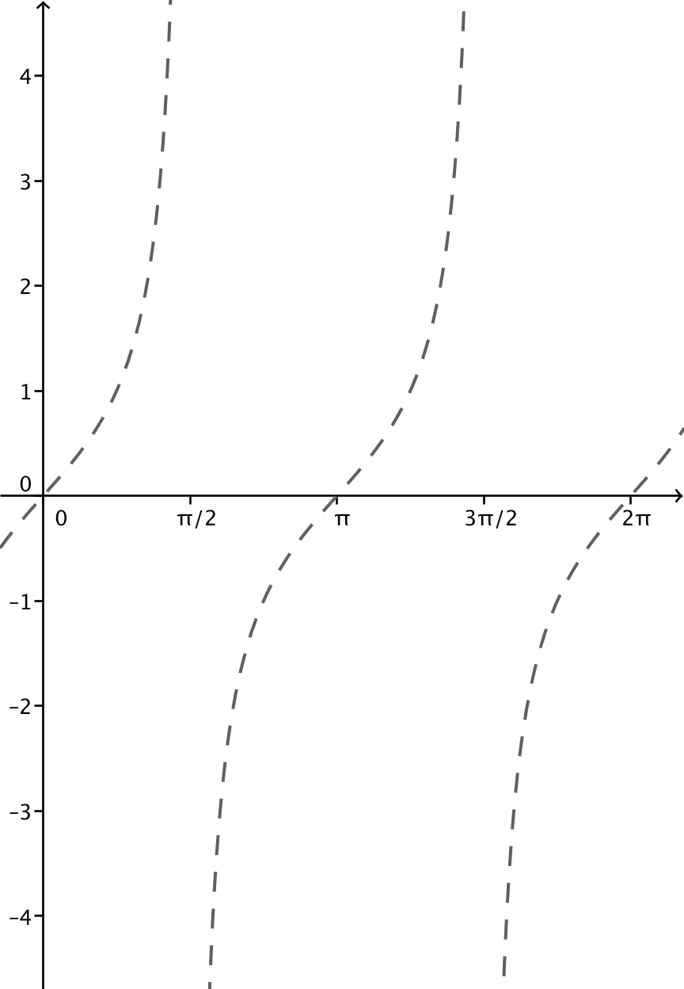

  - $g\left(x\right)=\frac{1}{3}tan(x)$

  - $g\left(x\right)=-2 tan(x)$

  - How does changing the parameter $A$ affect the graph of $g\left(x\right)=A tan(x)$?

- Each set of axes below shows the graph of $f\left(x\right)=tan(x)$. Use what you know about function transformations to sketch a graph of $y=g\left(x\right)$ for each function $g$ on the interval $(0,2π)$.
  - $g\left(x\right)=tan\left(x-\frac{π}{2}\right)$
  - $g\left(x\right)=tan\left(x-\frac{π}{6}\right)$

  - $g\left(x\right)=tan\left(x+\frac{π}{4}\right)$

  - How does changing the parameter $h$ affect the graph of $g\left(x\right)=tan\left(x-h\right)$?

- Each set of axes below shows the graph of $f\left(x\right)=tan(x)$. Use what you know about function transformations to sketch a graph of $y=g\left(x\right)$ for each function $g$ on the interval $(0,2π)$.
  - $g\left(x\right)=tan\left(x\right)+1$

  - $g\left(x\right)=tan\left(x\right)+3$

  - $g\left(x\right)=tan\left(x\right)-2$

  - How does changing the parameter $k$ affect the graph of $g\left(x\right)=tan\left(x\right)+k$?

- Each set of axes below shows the graph of $f\left(x\right)=tan(x)$. Use what you know about function transformations to sketch a graph of $y=g\left(x\right)$ for each function $g$ on the interval $(0,2π)$.
  - $g\left(x\right)=tan\left(3x\right)$
  - $g\left(x\right)=tan\left(\frac{x}{2}\right)$

  - $g\left(x\right)=tan(-3x)$

  - How does changing the parameter $ω$ affect the graph of $g\left(x\right)=tan\left(ωx\right)$?

- Use your knowledge of function transformation and the graph of $y=tan\left(x\right)$ to sketch graphs of the following transformations of the tangent function.
  - $y=tan\left(2x\right)$
  - $y=tan\left(2\left(x-\frac{π}{4}\right)\right)$
  - $y=tan\left(2\left(x-\frac{π}{4}\right)\right)+1.5$

- Find parameters $A$, $ω$,$h,$ and $k$ so that the graphs of $f\left(x\right)=A tan \left(ω\left(x-h\right)\right)+k$ and $g\left(x\right)=cot\left(x\right)$ are the same.

