|  |
| --- |
|  |

Lesson 13: Tides, Sound Waves, and Stock Markets

Student Outcomes

* Students model cyclical phenomena from biological and physical science using trigonometric functions.
* Students understand that some periodic behavior is too complicated to be modeled by simple trigonometric functions.

Lesson Notes

Together, the examples in the lesson help students see the ways in which some periodic data can be modeled by sinusoidal functions. These examples offer students the opportunity to solve real-world problems (MP.1) to experience ways in which modeling data with sinusoidal functions is valuable. Each example supports the main objective of exploring the usefulness and limitations of sinusoidal functions using the most well-known contexts of such functions. Throughout the lesson, students employ MP.4 in creating models of real-world contexts. Additionally, these models offer opportunities to engage in MP.2, MP.5, and MP.6.

In Lessons 11 and 12, students found sinusoidal equations to model phenomena that were clearly periodic, such as the height of a moving passenger car on a Ferris wheel. The focus of this lesson is on fitting a function to given data, as specified by S-ID.6a. Students are asked to find functions that could be used to model data which appears to be periodic in nature, requiring them to make multiple choices about approximating the amplitude, period, and midline of a graph that approximates the data points. As a result, there are multiple correct responses based on how students choose to model the data. Be sure to accept and discuss these different results, because this is an important part of the modeling process. If two students (or groups of students) create different formulas, that does not necessarily mean that one of them made a mistake; they both could have created valid though different, models.

There are many options for incorporating technology into this particular lesson. Graphing calculators or online graphing programs such as Desmos can help students create a scatter plot very quickly. On a graphing calculator, enter the data into lists, make a scatter plot, and then use the sinusoidal regression feature to determine a function that fits the data. To save time, you can pre-load the data into the calculators or have students enter the data on their own the night before. If students are using online graphing tools such as Desmos, they can enter the data into a table, graph it, and then write the equation to check that it corresponds to their graph. You can also create scatter plots quickly in a spreadsheet. Depending on your students’ familiarity with technology, this lesson may take more or less time than indicated.

Opening Exercise (5 minutes)

Briefly review the text that begins this lesson by doing a close read. Have students read the section once independently and then again as you or a volunteer reads the passage aloud. While the passage is read aloud, have students underline any important information, such as the meaning of the MLLW. Check for understanding of this term by asking students to explain to a partner why the height at a.m. on Wednesday was feet and then having several students report out briefly with the entire class.

Students will need access to graphing technology or graph paper to create their scatter plots. If working in small groups, each group could create the scatter plot on a piece of gridded chart paper as well. Watch carefully as students scale their graphs and translate the times from the table to the time since midnight on May 21. For example, the first time at a.m. would be hours since midnight. Encourage students to discuss what would be an appropriate level of precision to get an accurate representation of the tidal data. If groups make different decisions regarding precision of the time measurement, then you can highlight the slight differences in their graphs and functions at the end of Example 1.

**MP.5**

**&**

**MP.6**

Opening Exercise

Anyone who works on or around the ocean needs to have information about the changing tides to conduct their business safely and effectively. People who go to the beach or out onto the ocean for recreational purposes also need information about tides when planning their trip. The table below shows tide data for Montauk, NY, for May 21–22, 2014. The heights reported in the table are relative to the Mean Lower Low Water (MLLW). The MLLW is the average height of the lowest tide recorded at a tide station each day during the recording period. This reference point is used by the National Oceanic and Atmospheric Administration (NOAA) for the purposes of reporting tidal data throughout the United States. Each different tide station throughout the United States has its own MLLW. High and low tide levels are reported relative to this number. Since it is an average, some low tide values can be negative. The MLLW values are reset approximately every years by the NOAA.

MONTAUK, NY TIDE CHART

|  |  |  |  |  |
| --- | --- | --- | --- | --- |
| Date | Day | Time | Height in Feet | High/Low |
| 2014/05/21 | Wed. | a.m. |  | H |
| 2014/05/21 | Wed. | a.m. |  | L |
| 2014/05/21 | Wed. | p.m. |  | H |
| 2014/05/21 | Wed. | p.m. |  | L |
| 2014/05/22 | Thurs. | a.m. |  | H |
| 2014/05/22 | Thurs. | a.m. |  | L |
| 2014/05/22 | Thurs. | p.m. |  | H |
| 2014/05/22 | Thurs. | p.m. |  | L |

* 1. 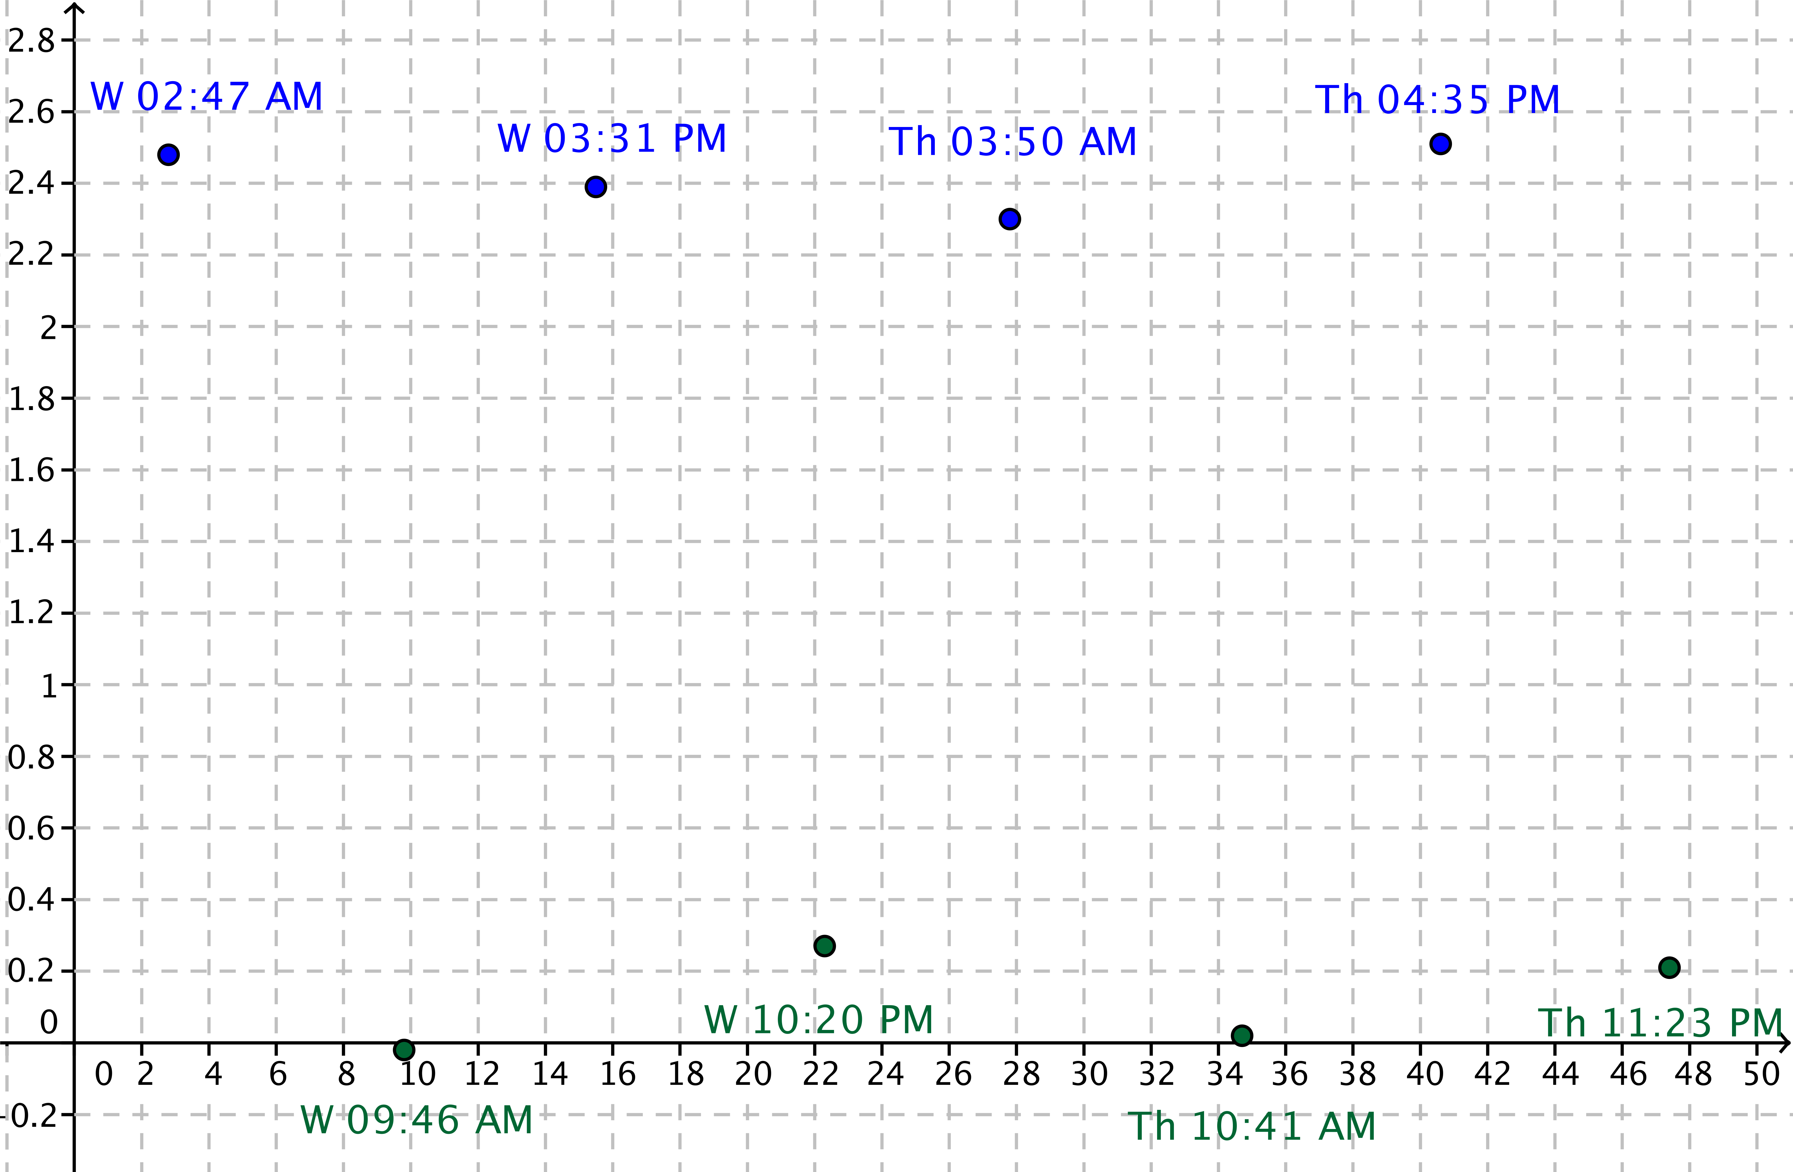Create a scatter plot of the data with the horizontal axis representing time since midnight on May 21 and the vertical axis representing the height in feet relative to the MLLW.

*Scaffolding:*

For struggling students:

* Provide graph paper with the axes and scales already labeled.
* Model the process of converting times in hours and minutes to decimals.
  1. What type of function would best model this set of data? Explain your choice.

Even though the maximum points do not all have the same value, a sinusoidal function would best model this data because the data repeats the pattern of high point, low point, high point, low point, over fairly regular intervals of time—roughly every hours.

Example 1 (5 minutes): Write a Sinusoidal Function to Model a Set of Data

Tidal data are not perfectly sinusoidal, but the heights vary in a predictable pattern. The tidal data chosen for this example appears to be very sinusoidal. If you investigate tide charts (which often include graphical representations) for different locations, you can see a great deal of variation. Depending on the location where the height of the tide is measured, the cycle of the moon, and the season, tides vary from one cycle to the next. The intent of the Opening Exercise and this example is to use a sinusoidal function as a model for the tides and to recognize the limitations of this type of model when students are presented with additional data.

Depending on their skill level, students could work through this problem in small groups, or you can use a more direct approach to demonstrate how to identify the key features of the graph of a sinusoid, which are used to determine the parameters in the corresponding function. The difference between this example and previous examples is that the data here are not perfect. Students will have to make some decisions about where to place the midline, amplitude, and period of the graph. If you are demonstrating this for the class, projecting an image of the scatter plot on a whiteboard or having a hand drawn graph on the board or chart paper to work from would be beneficial.

Example 1: Write a Sinusoidal Function to Model a Set of Data

* 1. On the scatter plot you created in the Opening Exercise, sketch the graph of a sinusoidal function that could be used to model the data.

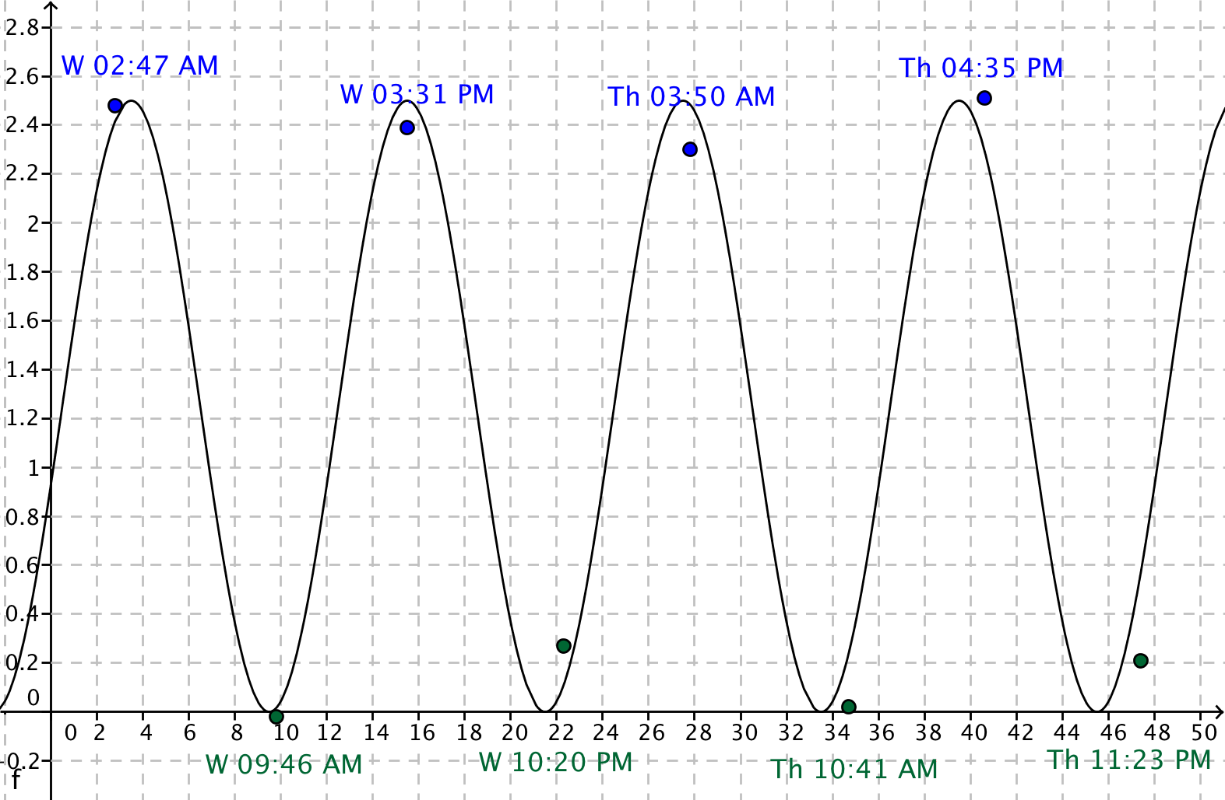

* 1. What are the midline, amplitude, and period of the graph?

Answers will vary depending on student graphs but should be close to those listed below.

Midline:

Amplitude:

Period:

* 1. Estimate the horizontal distance between a point on the graph that crosses the midline and the vertical axis.

The distance is about hours.

* 1. Write a function of the form to model these data where is the hours since midnight on May 21 and is the height in feet relative to the MLLW.

Discussion (5 minutes)

**MP.2**

Use this brief discussion to clarify the relationship between the features on the graph and the parameters in the sinusoidal function. Students will likely struggle most with recalling that the period is *not* equal to ; rather, where is the period of the function. Another difficulty would be determining an appropriate value for . Since this is a periodic function, several values would work; the simplest way is to select the first instance when the graph is near the midline and increasing. Then, the value of will represent a horizontal translation of the function when and are positive. If you are using technology to create the sinusoidal function, then the discussion that follows will be even more critical to allow students to fully process how the features of the graph and the parameters in the function are related.

* How do the answers to parts (b) and (c) relate to the parameters in the function you wrote?
  + *The length is the amplitude, is the midline, is the distance the graph of was translated horizontally, and is related to the frequency and period. This functions graph is a vertical scaling by a factor of and a horizontal scaling by a factor of of the graph of the sine function that has then been translated horizontally and vertically units.*
* How do parameters in the function relate to the tides at Montauk?
  + *The difference between the maximum value and minimum value of the function gives the fluctuation in the tides. The maximum value is height of the high tide, and the minimum value is the height of the low tide relative to the MLLW. These height variations are less than ft. If we take half of the period, we can estimate the time between the high and low tides.*

Exercise 1 (5 minutes)

Give students an opportunity to respond to this exercise in small groups; then, have groups share their findings with the whole class. Close this section of the lesson with a whole class discussion around the questions that appear below. Have students discuss their responses with a partner before calling on one or two students to answer the questions with the entire class. Students who are familiar with ocean tides may adapt more readily to the variation in tidal heights and times. Encourage students to look up the data for the tides at Montauk on the day you teach this lesson to see how they compare to the data given here.

Exercise 1

1. 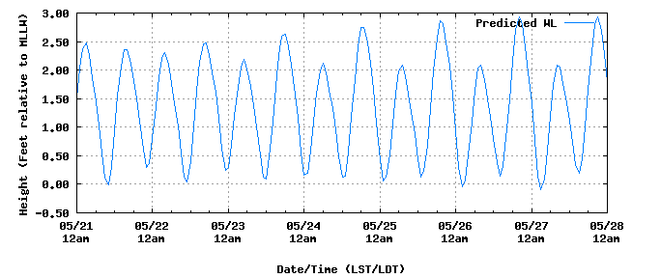The graph of the tides at Montauk for the week of May 21–28 is shown below. How accurately does your model predict the time and height of the high tide on May 28?

Source: [http://tidesandcurrents.noaa.gov/](http://tidesandcurrents.noaa.gov/noaatidepredictions/NOAATidesFacade.jsp?timeZone=2&dataUnits=1&datum=MLLW&timeUnits=2&interval=highlow&Threshold=greaterthanequal&thresholdvalue=&format=Submit&Stationid=8510560&&bmon=05&bday=21&byear=2014&edate=&timelength=weekly)

The maximum value of is . The high tide on May 28 was almost feet above MLLW. The model is off by approximately inches.

* Are tides an example of periodic phenomena? Why do you suppose this is true?
  + *Yes, to some degree, but they are not perfectly modeled by a sinusoidal function. Tides are influenced by the moon’s gravitational field. Because the moon orbits earth at a regular interval of time, the influence of the moon on tidal heights would be periodic up to a point since there will be ongoing variation in heights due to a wide variety of natural factors.*
* What are the limitations of using a sinusoidal function to model the height of tides over a long period of time at a particular location?
  + *At different times during the year, the height of a tide varies widely. Additionally, not all tides are perfectly symmetric.*

In the Exit Ticket, students examine tidal data near New Orleans, Louisiana. The data for one location has two different maximum and minimum values, so it would definitely not be modeled by a sinusoidal function. Emphasize to students that mathematical models that we create are often only valid for the set of data provided and may or may not be good predictors of future or past behavior.

Example 2 (5 minutes): Digital Sampling of Sound

When we hear a musical note, our ear drums are sensing pressure waves that are modeled by sinusoids, or combinations of sinusoids. As the amplitude of the wave increases, the note sounds louder. As the frequency of the wave increases (which means the period is decreasing), the pitch of the note increases. A pure tone of the note A has a frequency of Hz, which means the graph of this function would complete cycles in one second. The sinusoidal function that represents this pure tone would have a period of seconds. If you increase the sampling rate, the sound quality improves. To avoid distortion of the sound that is perceptible to the human ear, you must use a sampling rate that is more than twice the frequency of the tone. If you increase the resolution (represented by the vertical scaling), you also improve the quality of the digital sample. In reality, analog sounds are converted to digital at a sampling rate of thousands of times per second. A typical resolution is bit, which means the difference between the highest and lowest values will be divided into equal sections, and the actual tone will be assigned to the closest of those values at each sampling point. This example is a very simplified version with a much lower sampling rate and resolution to allow students to understand the concept and keep the total number of data points manageable.

In this example, be sure to include at least part (a). If time permits, you can have students enter the two sets of data into a graphing calculator and use the sinusoidal regression feature of the graphing calculator to create the function that fits the sampled data points. Have students compare and contrast the actual parameters of the actual function graphed below and the parameters in the models generated by their graphing calculator. Alternately, present the three equations as directed below, and then ask students to compare those parameters to confirm or refute their conjectures in part (a).

Example 2: Digital Sampling of Sound

When sound is recorded or transmitted electronically, the continuous waveform is sampled to convert it to a discrete digital sequence. If you increase the sampling rate (represented by the horizontal scaling) or the resolution (represented by the vertical scaling), the sound quality of the recording or transmission improves.

The data graphed below represent two different samples of a pure tone. One is sampled times per unit of time at a -bit ( equal intervals in the vertical direction) resolution, and the other is sampled times per unit of time at a -bit ( equal intervals in the vertical direction) resolution. The graph of the actual sound wave is also shown.

Which sample points would produce a better model of the actual sound wave? Explain your reasoning.



Figure 2: Sample rate = 16, 4-bit resolution



Figure 2: Sample rate = 8, 2-bit resolution

You will get a better model with the sample points in Figure 1 because with greater sampling rate and a greater resolution, the points will more closely fit the actual values of the pure tone.

If students do not create the models based on the data points due to time constraints, you can share the following functions with the class and have them compare and contrast the parameters in each equation. If time permits, students can graph all three functions to visually illustrate the differences and begin to understand why a digital sample is not exactly the same as the pure tone. Note that making use of available technology to create sinusoidal functions and to graph the functions will greatly affect the timing of this lesson.

Actual sinusoidal function:

Figure 1 sinusoidal function based on sample points:

Figure 2 sinusoidal function based on sample points:

Exercises 2–6 (10 minutes)

In these exercises, students explore data that could be modeled by the sum of two functions and are once again asked to consider what happens to the validity of this model over a longer time period. These data are roughly a periodic waveform that also includes the historic trend that stock prices increase over time. Given the financial crisis in 2008 and the Great Recession, even an algebraic function that takes into account steady increases over time would not accurately predict future stock values during that time-period. As you debrief these questions, take time to again reinforce that models have limitations, especially when many factors are contributing to the variability of the quantities involved in any given situation. Note that this is actual data from MSFT (Microsoft) stock.

Exercises 2–6

Stock prices have historically increased over time, but they also vary in a cyclical fashion. Create a scatter plot of the data for the monthly stock price for a -month time period since January 1, 2003.

|  |  |
| --- | --- |
| Months Since  Jan. 1, 2003 | Price at Close  in dollars |
|  |  |
|  |  |
|  |  |
|  |  |
|  |  |
|  |  |
|  |  |
|  |  |
|  |  |
|  |  |
|  |  |
|  |  |
|  |  |
|  |  |
|  |  |

1. Would a sinusoidal function be an appropriate model for this data? Explain your reasoning.

A sinusoidal function would not be appropriate because the data is trending upward as time passes.

We can model the slight upward trend in this data with the linear function .

If we add a sinusoidal function to this linear function, we can model this data with an algebraic function that displays an upward trend but also varies in a cyclical fashion.

1. Find a sinusoidal function, , that when added to the linear function will model this data.
2. Let be the stock price function that is the sum of the linear function listed above and the sinusoidal function in Exercise 3.

__________________________________________.

1. Add the graph of this function to your scatter plot. How well does it appear to fit the data?

The scatter plot with the function is shown below for the first months. In general, it appears to model this data, but there are a few outliers such as the stock value two months after data was reported.

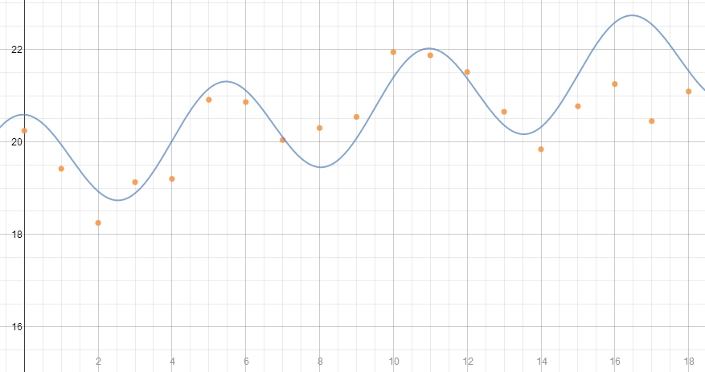

After students complete Exercises 2–5, share the extended graph of the data with them and have them respond in small groups to the last exercise. Conclude by briefly discussing the financial crisis in 2008–2009. Have students who are interested plot the additional data and compare the price their model would predict to the value of the stock in 2013. This particular stock recovered quite well from the financial crisis. The additional data is provided below for students wishing to extend their work on this problem.

|  |  |  |  |  |  |  |
| --- | --- | --- | --- | --- | --- | --- |
| Months Since Jan. 2003 | Adjusted Price at Close ($) | Date |  | Months Since Jan. 2003 | Adjusted Price at Close ($) | Date |
|  |  |  |  |  |  |  |
|  |  |  |  |  |  |  |
|  |  |  |  |  |  |  |
|  |  |  |  |  |  |  |
|  |  |  |  |  |  |  |
|  |  |  |  |  |  |  |
|  |  |  |  |  |  |  |
|  |  |  |  |  |  |  |
|  |  |  |  |  |  |  |
|  |  |  |  |  |  |  |
|  |  |  |  |  |  |  |
|  |  |  |  |  |  |  |
|  |  |  |  |  |  |  |
|  |  |  |  |  |  |  |
|  |  |  |  |  |  |  |
|  |  |  |  |  |  |  |
|  |  |  |  |  |  |  |
|  |  |  |  |  |  |  |
|  |  |  |  |  |  |  |
|  |  |  |  |  |  |  |
|  |  |  |  |  |  |  |
|  |  |  |  |  |  |  |
|  |  |  |  |  |  |  |
|  |  |  |  |  |  |  |

|  |  |  |  |  |  |  |
| --- | --- | --- | --- | --- | --- | --- |
| Months Since Jan. 2003 | Adjusted Price at Close ($) | Date |  | Months Since Jan. 2003 | Adjusted Price at Close ($) | Date |
|  |  |  |  |  |  |  |
|  |  |  |  |  |  |  |
|  |  |  |  |  |  |  |
|  |  |  |  |  |  |  |
|  |  |  |  |  |  |  |
|  |  |  |  |  |  |  |
|  |  |  |  |  |  |  |
|  |  |  |  |  |  |  |
|  |  |  |  |  |  |  |
|  |  |  |  |  |  |  |
|  |  |  |  |  |  |  |
|  |  |  |  |  |  |  |
|  |  |  |  |  |  |  |
|  |  |  |  |  |  |  |
|  |  |  |  |  |  |  |
|  |  |  |  |  |  |  |
|  |  |  |  |  |  |  |
|  |  |  |  |  |  |  |
|  |  |  |  |  |  |  |
|  |  |  |  |  |  |  |
|  |  |  |  |  |  |  |
|  |  |  |  |  |  |  |
|  |  |  |  |  |  |  |
|  |  |  |  |  |  |  |
|  |  |  |  |  |  |  |
|  |  |  |  |  |  |  |
|  |  |  |  |  |  |  |
|  |  |  |  |  |  |  |
|  |  |  |  |  |  |  |

1. Here is a graph of the same stock through December 2009.
   1. Will your model do a good job of predicting stock values past the year 2005?

It will not do a very good job of predicting the value of the stock because it rises sharply and then plummets before starting to rise in price after a low in 2009.

* 1. What event occurred in 2008 to account for the sharp decline in the value of stocks?

There was a financial crisis in the stock markets that marked the start of a recession.

* 1. What are the limitations of using any function to make predictions regarding the value of a stock at some point in the future?

There are many variables that can affect the price of a stock, so a function that only relates to variables. In this case, time and stock price will have limitations in its ability to predict future events due to unforeseen circumstances.

Closing (5 minutes)

Use the discussion questions to close this lesson. Have students respond individually or share with a partner before discussing them as a whole class. These questions will give you an opportunity to determine whether students understand the inherent limitations, in addition to the benefits of using mathematical functions to represent real-world situations.

* How confident are you that mathematical models can help us to make predictions about future values of a particular quantity?
* When creating a function to represent a data set, what are some of the limitations in using this function?
* Mathematical models are used frequently to represent real-world situations like these. Even given the limitations, why would scientists and economists find it useful to have a function to represent the relationship between the data they are studying?

Finally, ask students to summarize the important parts of the lesson, either in writing, to a partner, or as a class. Use this as an opportunity to informally assess understanding of the lesson. The following are some important summary elements.

Lesson Summary

**We can model periodic data with either a sine or a cosine function by extrapolating values of the parameters , , and from the data and defining a function or , as appropriate.**

**Sine or cosine functions may not perfectly fit most data sets from actual measurements; therefore, there are often multiple functions used to model a data set.**

**If possible, plot the data together with the function that appears to fit the graph. If it is not a good fit, adjust the model and try again.**

Exit Ticket (5 minutes)

Name Date

Lesson 13: Tides, Sound Waves, and Stock Markets

Exit Ticket

Tidal data for New Canal Station, located on the shore of Lake Pontchartrain, LA, and Lake Charles, LA are shown below.

New Canal Station on Lake Pontchartrain, LA Tide Chart

|  |  |  |  |  |
| --- | --- | --- | --- | --- |
| Date | Day | Time | Height | High/Low |
|  | Wed. | a.m. |  | L |
|  | Wed. | p.m. |  | H |
|  | Thurs. | a.m. |  | L |
|  | Thurs. | p.m. |  | H |

Lake Charles, LA Tide Chart

|  |  |  |  |  |
| --- | --- | --- | --- | --- |
| Date | Day | Time | Height | High/Low |
|  | Wed. | a.m. |  | L |
|  | Wed. | a.m. |  | H |
|  | Wed. | p.m. |  | L |
|  | Wed. | p.m. |  | H |
|  | Thurs. | a.m. |  | L |
|  | Thurs. | a.m. |  | H |
|  | Thurs. | p.m. |  | L |
|  | Thurs. | p.m. |  | H |

1. Would a sinusoidal function of the form be appropriate to model the given data for each location? Explain your reasoning.
2. Write a sinusoidal function to model the data for New Canal Station.

Exit Ticket Sample Solutions

Tidal data for New Canal Station, located on the shore of Lake Pontchartrain, LA, and Lake Charles, LA are shown below.

New Canal Station on Lake Pontchartrain, LA Tide Chart

|  |  |  |  |  |
| --- | --- | --- | --- | --- |
| Date | Day | Time | Height | High/Low |
|  | Wed. | a.m. |  | L |
|  | Wed. | p.m. |  | H |
|  | Thurs. | a.m. |  | L |
|  | Thurs. | p.m. |  | H |

Lake Charles, LA Tide Chart

|  |  |  |  |  |
| --- | --- | --- | --- | --- |
| Date | Day | Time | Height | High/Low |
|  | Wed. | a.m. |  | L |
|  | Wed. | a.m. |  | H |
|  | Wed. | p.m. |  | L |
|  | Wed. | p.m. |  | H |
|  | Thurs. | a.m. |  | L |
|  | Thurs. | a.m. |  | H |
|  | Thurs. | p.m. |  | L |
|  | Thurs. | p.m. |  | H |

1. Would a sinusoidal function of the form be appropriate to model the given data for each location? Explain your reasoning.

The data for New Canal Station could be modeled with a sinusoidal function, but the other data would not work very well since there appears to be two different low tide values that vary by approximately a foot.

1. Write a sinusoidal function to model the data for New Canal Station.

The amplitude is . The period appears to be approximately hours. The midline is . Since the graph starts at its lowest value at a.m., use a negative cosine function with a horizontal shift of approximately .

Problem Set Sample Solutions

1. Find equations of both a sine function and a cosine function that could each represent the graph given below.

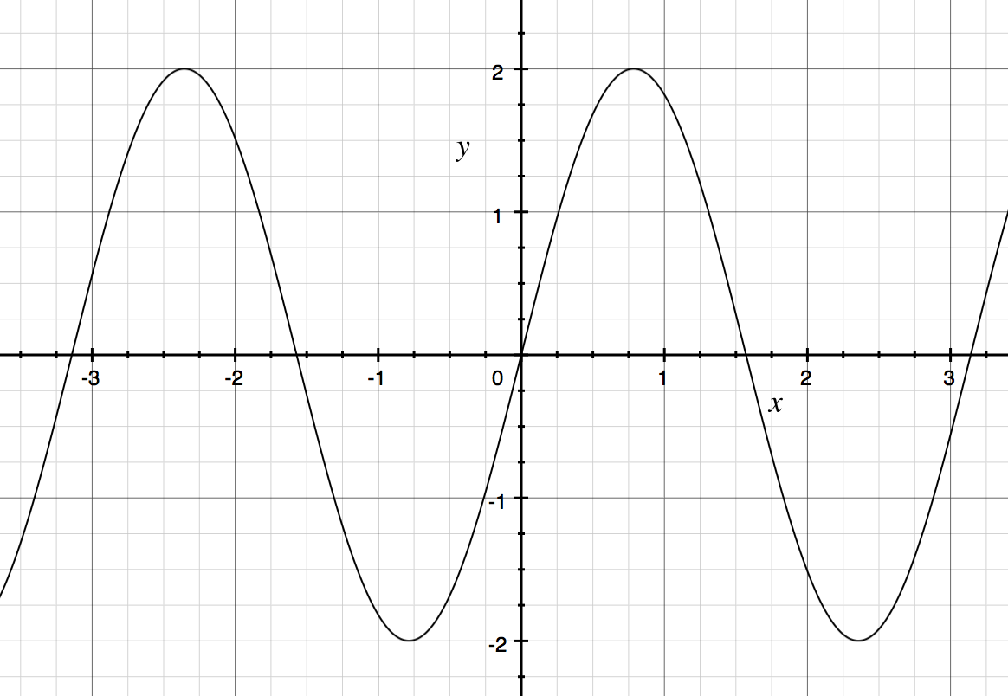

1. Find equations of both a sine function and a cosine function that could each represent the graph given below.

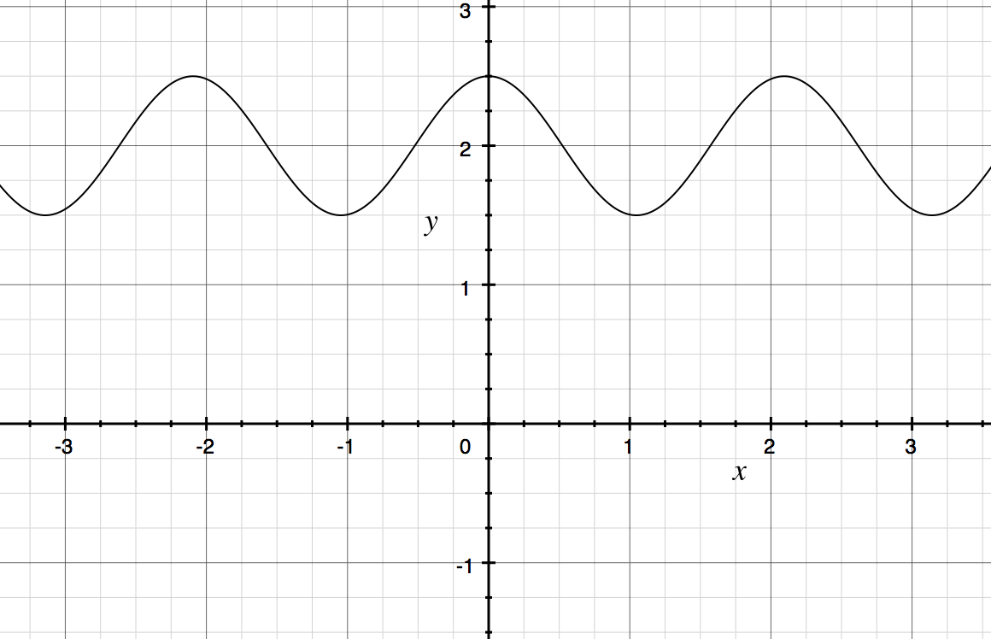

1. Rapidly vibrating objects send pressure waves through the air which are detected by our ears and then interpreted by our brains as sound. Our brains analyze the amplitude and frequency of these pressure waves.

A speaker usually consists of a paper cone attached to an electromagnet. By sending an oscillating electric current through the electromagnet, the paper cone can be made to vibrate. By adjusting the current, the amplitude and frequency of vibrations can be controlled.

The following graph shows the pressure intensity () as a function of time (), in seconds, of the pressure waves emitted by a speaker set to produce a single pure tone.

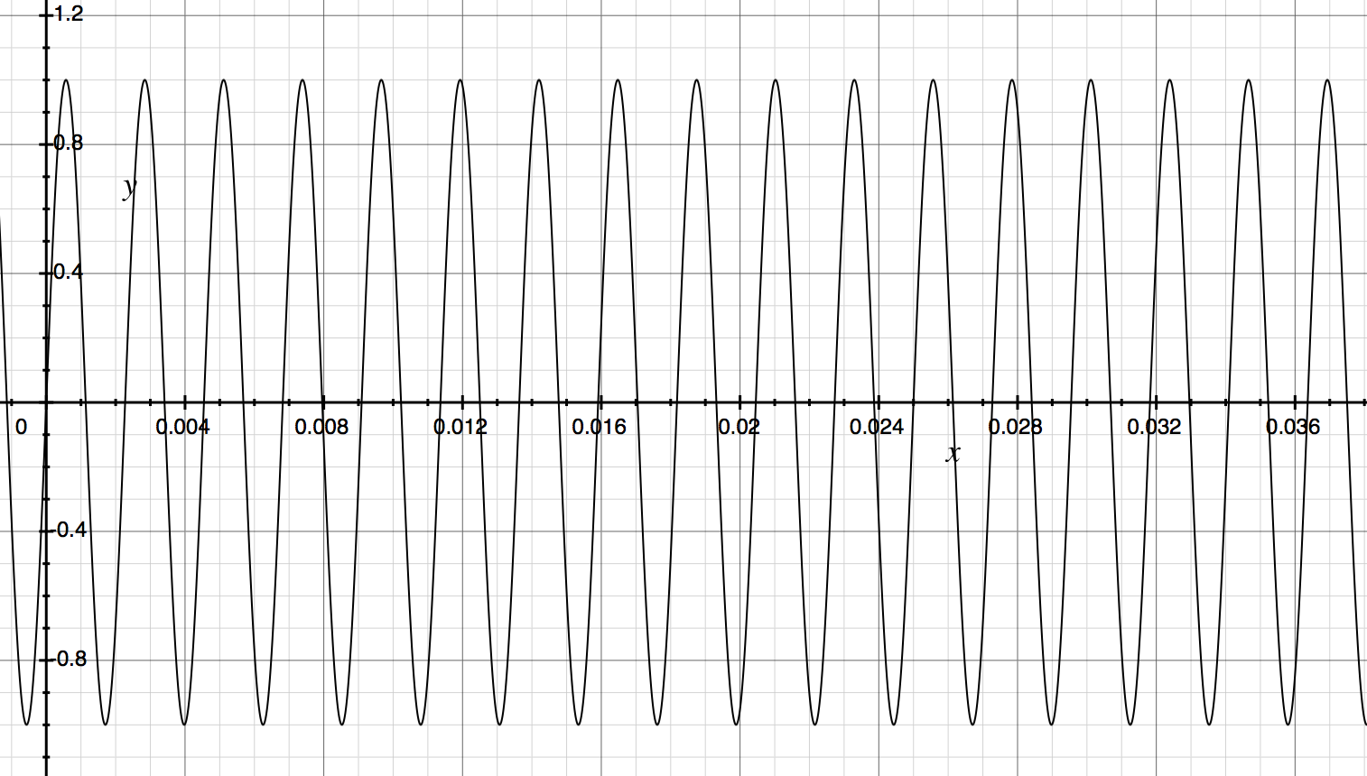

* 1. Does it seem more natural to use a sine or a cosine function to fit to this graph?

Either a sine or a cosine function could be used, but since the graph passes through the origin, it is natural to use a sine function.

* 1. Find the equation of a trigonometric function that fits this graph.

***Reading from the graph, we have , , , and (because the graph has an -intercept at approximately after two full periods). Then, , so gives  
Thus, an equation that models the graph presented here is .***

1. Suppose that the following table represents the average monthly ambient air temperature, in degrees Fahrenheit, in some subterranean caverns in southeast Australia for each of the twelve months in a year. We wish to model this data with a trigonometric function. (Notice that the seasons are reversed in the Southern Hemisphere, so January is in summer and July is in winter.)

|  |  |  |  |  |  |  |  |  |  |  |  |  |
| --- | --- | --- | --- | --- | --- | --- | --- | --- | --- | --- | --- | --- |
| Month | Jan. | Feb. | Mar. | Apr. | May | June | July | Aug. | Sept. | Oct. | Nov. | Dec. |
|  |  |  |  |  |  |  |  |  |  |  |  |  |

* 1. Does it seem reasonable to assume that this data, if extended beyond the one year, should be roughly periodic?

Yes.

* 1. What seems to be the amplitude of the data?

*There are a number of ways to approximate the amplitude. We can simply take half of the difference of the highest and lowest temperatures, or we can take half of the difference of the highest temperature and the one six months later (or half of the difference of the lowest temperature and the one that is six months earlier). The highest temperature is ; the lowest temperature is . Using these temperatures, we approximate the amplitude to be .*

* 1. What seems to be the midline of the data (equation of the line through the middle of the graph)?

The average of and six months later is . Thus, the midline would be ; so, we have

* 1. Would it be easier to use sine or cosine to model this data?

Cosine would be easier because we can pinpoint a peak of the function more easily than where it should cross the midline.

* 1. What is a reasonable approximation for the horizontal shift?

It appears that the peak of the function would be between January and February, so let’s use for the horizontal shift. (This assumes that we have labeled January as month 1 and February as month 2)

* 1. Write an equation for a function that could fit this data.

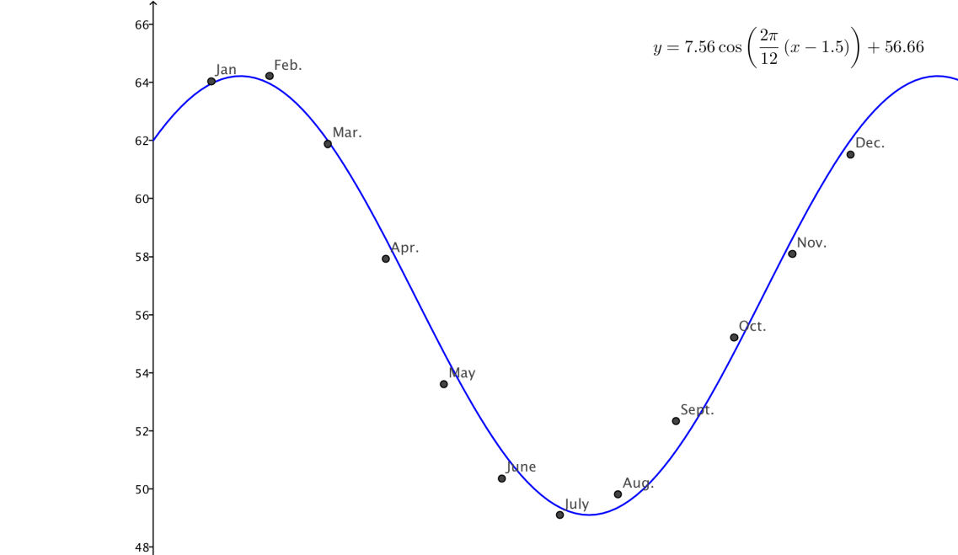

1. The table below provides data for the number of daylight hours as a function of day of the year, where day 1 represents January 1st. Graph the data and determine if it could be represented by a sinusoidal function. If it can, determine the period, amplitude, and midline of the function, and find an equation for a function that models the data.

|  |  |  |  |  |  |  |  |  |  |
| --- | --- | --- | --- | --- | --- | --- | --- | --- | --- |
| Day of Year |  |  |  |  |  |  |  |  |  |
| Hours |  |  |  |  |  |  |  |  |  |

***The data appears sinusoidal, and the easiest function to model it with is a cosine function. The period would be days, so the frequency would be . The amplitude is , and the midline is , where . We want the highest value at the peak, so the horizontal shift is***

1. 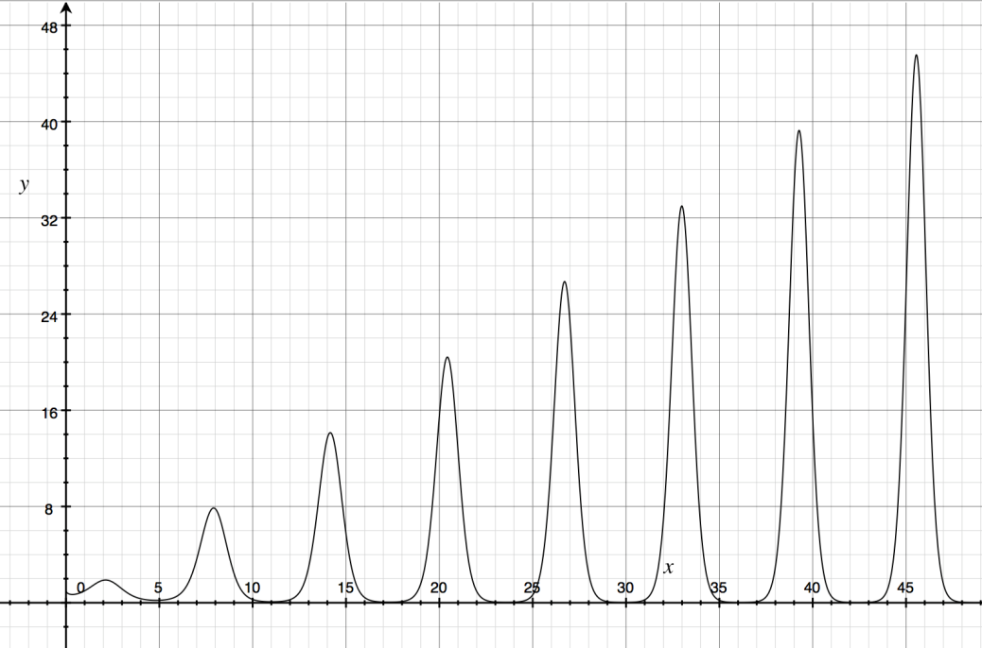The function graphed below is . Blake says, “The function repeats on a fixed interval, so it must be a sinusoidal function.” Respond to his argument.

**MP.3**

While the equation for the function includes a sine function within it, the function itself is not a sinusoidal function. It does not have a constant amplitude or midline, though it does appear to become zero at fixed increments; it does not have a period because the function values do not repeat. Thus, it is not a periodic function and is not sinusoidal.