Lesson 13: Tides, Sound Waves, and Stock Markets

Classwork

Opening Exercise

Anyone who works on or around the ocean needs to have information about the changing tides to conduct their business safely and effectively. People who go to the beach or out onto the ocean for recreational purposes also need information about tides when planning their trip. The table below shows tide data for Montauk, NY, for May 21–22, 2014. The heights reported in the table are relative to the Mean Lower Low Water (MLLW). The MLLW is the average height of the lowest tide recorded at a tide station each day during the recording period. This reference point is used by the National Oceanic and Atmospheric Administration (NOAA) for the purposes of reporting tidal data throughout the United States. Each different tide station throughout the United States has its own MLLW. High and low tide levels are reported relative to this number. Since it is an average, some low tide values can be negative. The MLLW values are reset approximately every years by the NOAA.

MONTAUK, NY TIDE CHART

|  |  |  |  |  |
| --- | --- | --- | --- | --- |
| Date | Day | Time | Height in Feet | High/Low |
| 2014/05/21 | Wed. | a.m. |  | H |
| 2014/05/21 | Wed. | a.m. |  | L |
| 2014/05/21 | Wed. | p.m. |  | H |
| 2014/05/21 | Wed. | p.m. |  | L |
| 2014/05/22 | Thurs. | a.m. |  | H |
| 2014/05/22 | Thurs. | a.m. |  | L |
| 2014/05/22 | Thurs. | p.m. |  | H |
| 2014/05/22 | Thurs. | p.m. |  | L |

* 1. Create a scatter plot of the data with the horizontal axis representing time since midnight on May 21 and the vertical axis representing the height in feet relative to the MLLW.

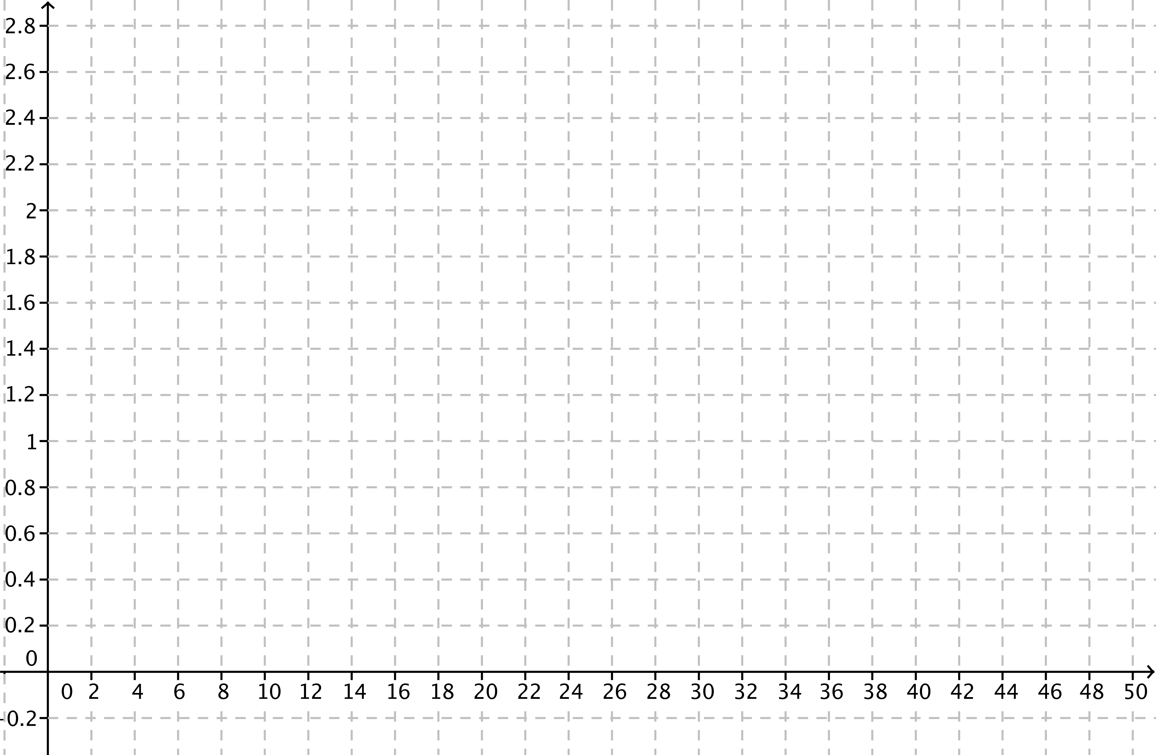

* 1. What type of function would best model this set of data? Explain your choice.

Example 1: Write a Sinusoidal Function to Model a Set of Data

* 1. On the scatter plot you created in the Opening Exercise, sketch the graph of a sinusoidal function that could be used to model the data.
  2. What are the midline, amplitude, and period of the graph?
  3. Estimate the horizontal distance between a point on the graph that crosses the midline and the vertical axis.
  4. Write a function of the form to model these data where is the hours since midnight on May 21 and is the height in feet relative to the MLLW.

Exercise 1

1. The graph of the tides at Montauk for the week of May 21–28 is shown below. How accurately does your model predict the time and height of the high tide on May 28?

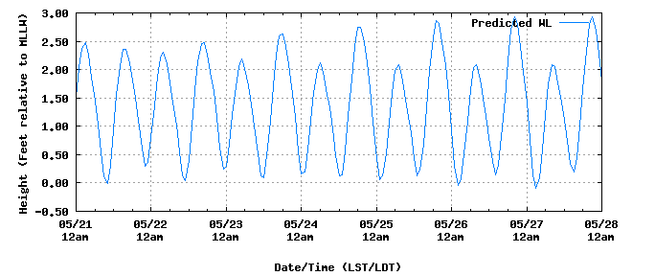

Source: [http://tidesandcurrents.noaa.gov/](http://tidesandcurrents.noaa.gov/noaatidepredictions/NOAATidesFacade.jsp?timeZone=2&dataUnits=1&datum=MLLW&timeUnits=2&interval=highlow&Threshold=greaterthanequal&thresholdvalue=&format=Submit&Stationid=8510560&&bmon=05&bday=21&byear=2014&edate=&timelength=weekly)

Example 2: Digital Sampling of Sound

When sound is recorded or transmitted electronically, the continuous waveform is sampled to convert it to a discrete digital sequence. If you increase the sampling rate (represented by the horizontal scaling) or the resolution (represented by the vertical scaling), the sound quality of the recording or transmission improves.

The data graphed below represent two different samples of a pure tone. One is sampled times per unit of time at a -bit ( equal intervals in the vertical direction) resolution, and the other is sampled 8 times per unit of time at a -bit ( equal intervals in the vertical direction) resolution. The graph of the actual sound wave is also shown.

Which sample points would produce a better model of the actual sound wave? Explain your reasoning.



Figure 2: Sample rate = 16, 4-bit resolution



Figure 2: Sample rate = 8, 2-bit resolution

Exercises 2–6

Stock prices have historically increased over time, but they also vary in a cyclical fashion. Create a scatter plot of the data for the monthly stock price for a -month time period since January , .

|  |  |
| --- | --- |
| Months Since  Jan. 1, 2003 | Price at Close  in dollars |
|  |  |
|  |  |
|  |  |
|  |  |
|  |  |
|  |  |
|  |  |
|  |  |
|  |  |
|  |  |
|  |  |
|  |  |
|  |  |
|  |  |
|  |  |

1. Would a sinusoidal function be an appropriate model for this data? Explain your reasoning.

We can model the slight upward trend in this data with the linear function .

If we add a sinusoidal function to this linear function, we can model this data with an algebraic function that displays an upward trend but also varies in a cyclical fashion.

1. Find a sinusoidal function, , that when added to the linear function will model this data.
2. Let be the stock price function that is the sum of the linear function listed above and the sinusoidal function in Exercise 3.

__________________________________________.

1. Add the graph of this function to your scatter plot. How well does it appear to fit the data?
2. Here is a graph of the same stock through December 2009.
   1. Will your model do a good job of predicting stock values past the year 2005?
   2. What event occurred in 2008 to account for the sharp decline in the value of stocks?
   3. What are the limitations of using any function to make predictions regarding the value of a stock at some point in the future?

Problem Set

1. 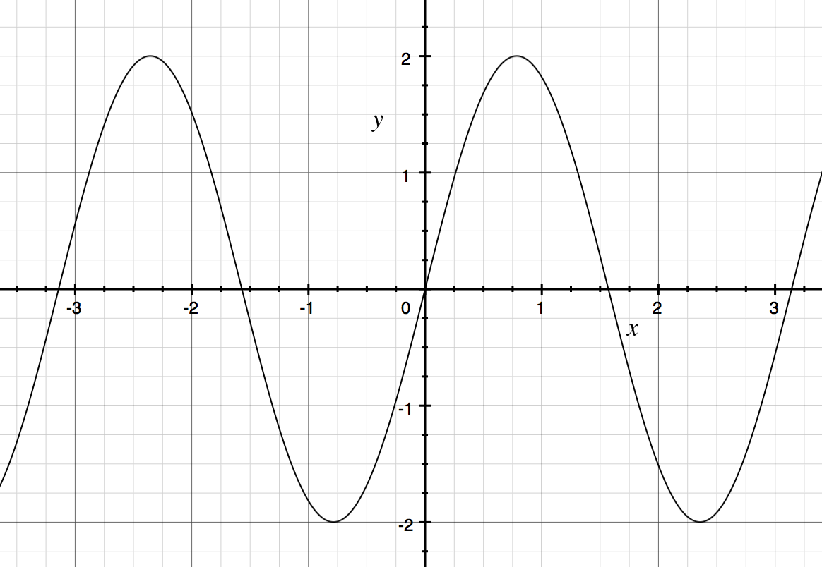Find equations of both a sine function and a cosine function that could each represent the graph given below.

Lesson Summary

We can model periodic data with either a sine or a cosine function by extrapolating values of the parameters , , and from the data and defining a function or , as appropriate.

Sine or cosine functions may not perfectly fit most data sets from actual measurements; therefore, there are often multiple functions used to model a data set.

If possible, plot the data together with the function that appears to fit the graph. If it is not a good fit, adjust the model and try again.

1. Find equations of both a sine function and a cosine function that could each represent the graph given below.

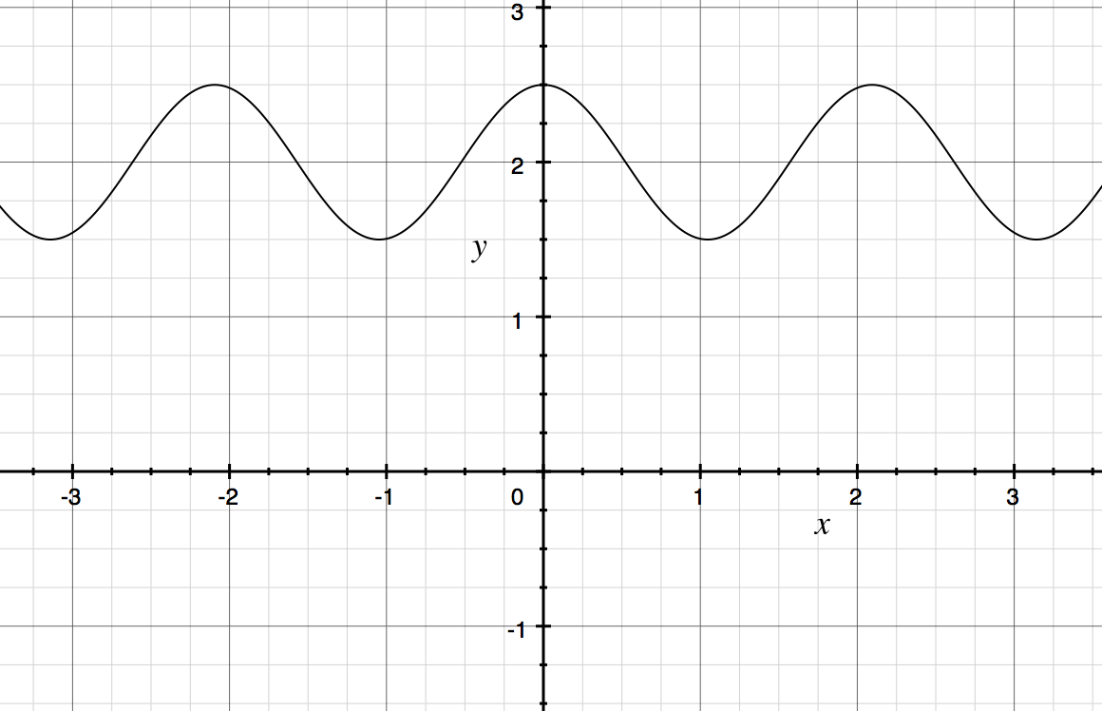

1. Rapidly vibrating objects send pressure waves through the air which are detected by our ears and then interpreted by our brains as sound. Our brains analyze the amplitude and frequency of these pressure waves.

A speaker usually consists of a paper cone attached to an electromagnet. By sending an oscillating electric current through the electromagnet, the paper cone can be made to vibrate. By adjusting the current, the amplitude and frequency of vibrations can be controlled.

The following graph shows the pressure intensity () as a function of time (), in seconds, of the pressure waves emitted by a speaker set to produce a single pure tone.

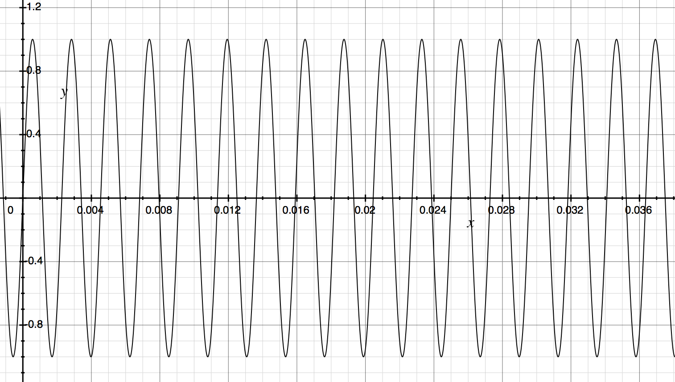

* 1. Does it seem more natural to use a sine or a cosine function to fit to this graph?
  2. Find the equation of a trigonometric function that fits this graph.

1. Suppose that the following table represents the average monthly ambient air temperature, in degrees Fahrenheit, in some subterranean caverns in southeast Australia for each of the twelve months in a year. We wish to model this data with a trigonometric function. (Notice that the seasons are reversed in the Southern Hemisphere, so January is in summer and July is in winter.)

|  |  |  |  |  |  |  |  |  |  |  |  |  |
| --- | --- | --- | --- | --- | --- | --- | --- | --- | --- | --- | --- | --- |
| Month | Jan. | Feb. | Mar. | Apr. | May | June | July | Aug. | Sept. | Oct. | Nov. | Dec. |
|  |  |  |  |  |  |  |  |  |  |  |  |  |

* 1. Does it seem reasonable to assume that this data, if extended beyond the one year, should be roughly periodic?
  2. What seems to be the amplitude of the data?
  3. What seems to be the midline of the data (equation of the line through the middle of the graph)?
  4. Would it be easier to use sine or cosine to model this data?
  5. What is a reasonable approximation for the horizontal shift?
  6. Write an equation for a function that could fit this data.

1. The table below provides data for the number of daylight hours as a function of day of the year, where day 1 represents January st. Graph the data and determine if it could be represented by a sinusoidal function. If it can, determine the period, amplitude, and midline of the function, and find an equation for a function that models the data.

|  |  |  |  |  |  |  |  |  |  |
| --- | --- | --- | --- | --- | --- | --- | --- | --- | --- |
| Day of Year |  |  |  |  |  |  |  |  |  |
| Hours |  |  |  |  |  |  |  |  |  |

1. 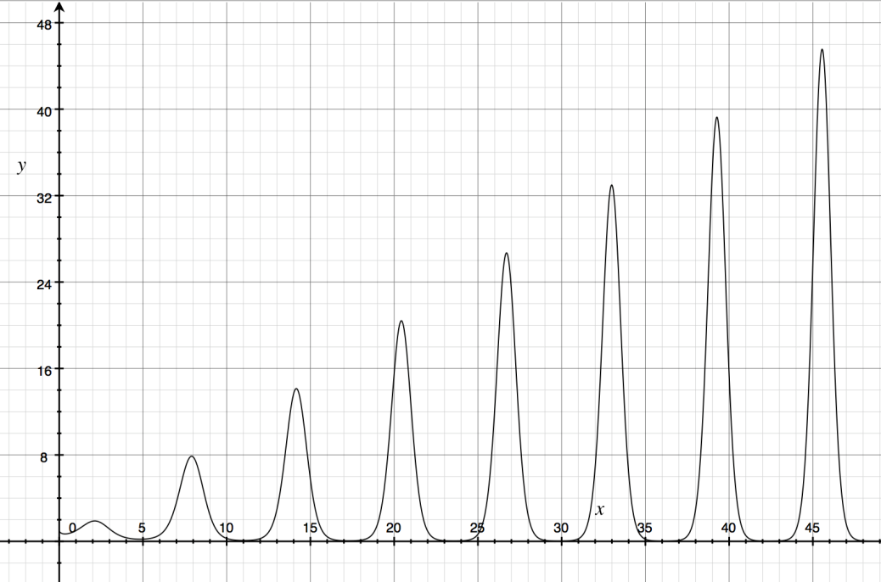The function graphed below is . Blake says, “The function repeats on a fixed interval, so it must be a sinusoidal function.” Respond to his argument.