Lesson 12: Ferris Wheels—Using Trigonometric Functions to Model Cyclical Behavior

Classwork
Opening Exercise
Ernesto thinks that this is the graph of $f(x)=4\sin\left(x-\frac{π}{2}\right).$ Danielle thinks it is the graph of $f(x)=4cos\left(x\right).$
Who is correct, and why?
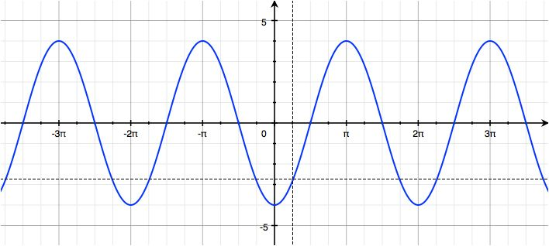

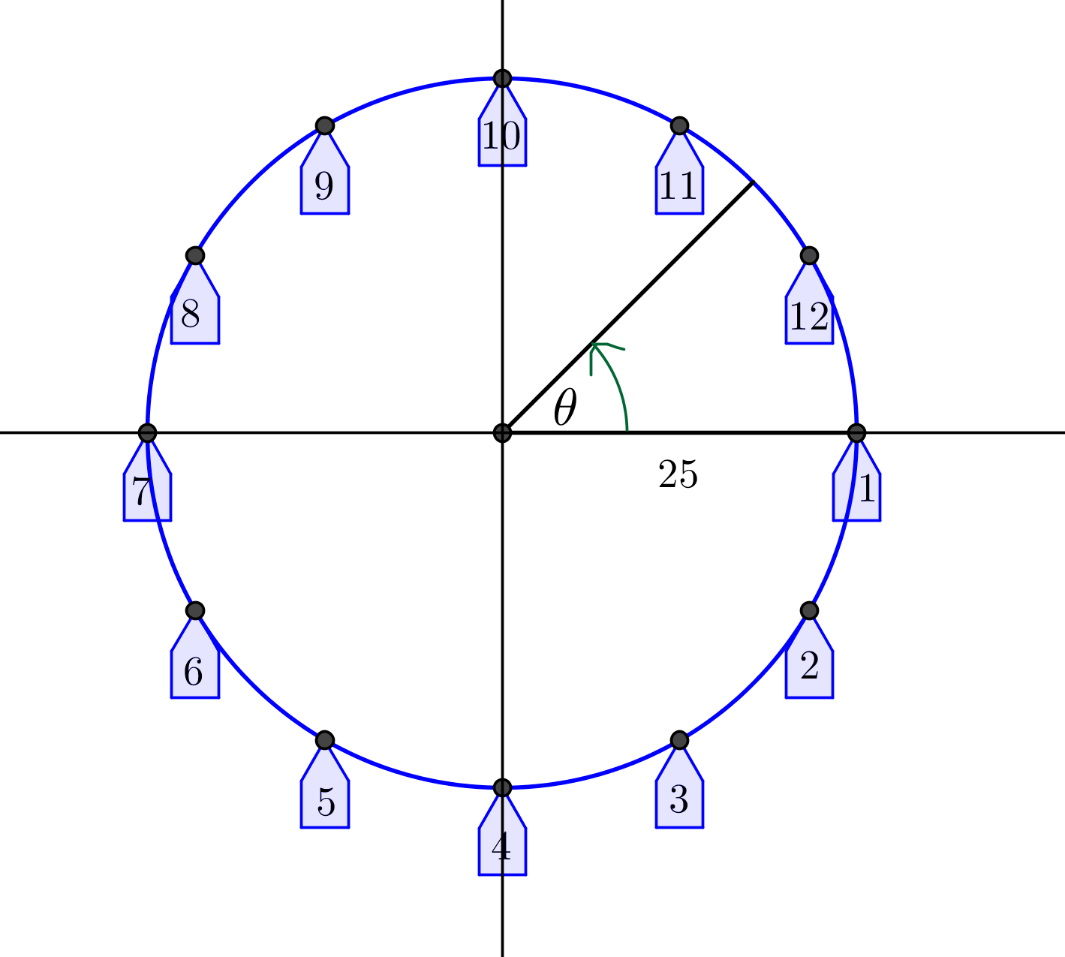
Exploratory Challenge
Exercises 1–5
A carnival has a Ferris wheel that is $50$ feet in diameter with $12$ passenger cars. When viewed from the side where passengers board, the Ferris wheel rotates counterclockwise and makes two full turns each minute. Riders board the Ferris wheel from a platform that is $15$ feet above the ground. We will use what we have learned about periodic functions to model the position of the passenger cars from different mathematical perspectives. We will use the points on the circle in the diagram at right to represent the position of the cars on the wheel.

- For this exercise, we will consider the height of a passenger car to be the vertical displacement from the horizontal line through the center of the wheel, and the co-height of a passenger car to be the horizontal displacement from the vertical line through the center of the wheel.
  - Let $θ=0$ represent the position of car 1 in the diagram at right. Sketch the graphs of the co-height and the height of car 1 as functions of $θ$, the number of radians through which the car has rotated.

  - What is the amplitude, $|A|$, of the height and co-height functions for this Ferris wheel?

  - Let $X\left(θ\right)$ represent the co-height function after rotation by $θ$ radians, and let $Y(θ)$ represent the height function after rotation by $θ$ radians. Write functions $X$ for the co-height and $Y$ for the height in terms of $θ.$

  - Graph the functions $X$ and $Y$ from part (c) on a graphing calculator set to parametric mode. Use a viewing window $[-48,48] × [-30,30].$ Sketch the graph below.

  - Why did we choose the symbols $X$ and $Y$ to represent the co-height and height functions?

  - Evaluate $X\left(0\right)$ and $Y(0)$ and explain their meaning in the context of the Ferris wheel.

  - Evaluate $X\left(\frac{π}{2}\right)$ and $Y\left(\frac{π}{2}\right)$ and explain their meaning in the context of the Ferris wheel.

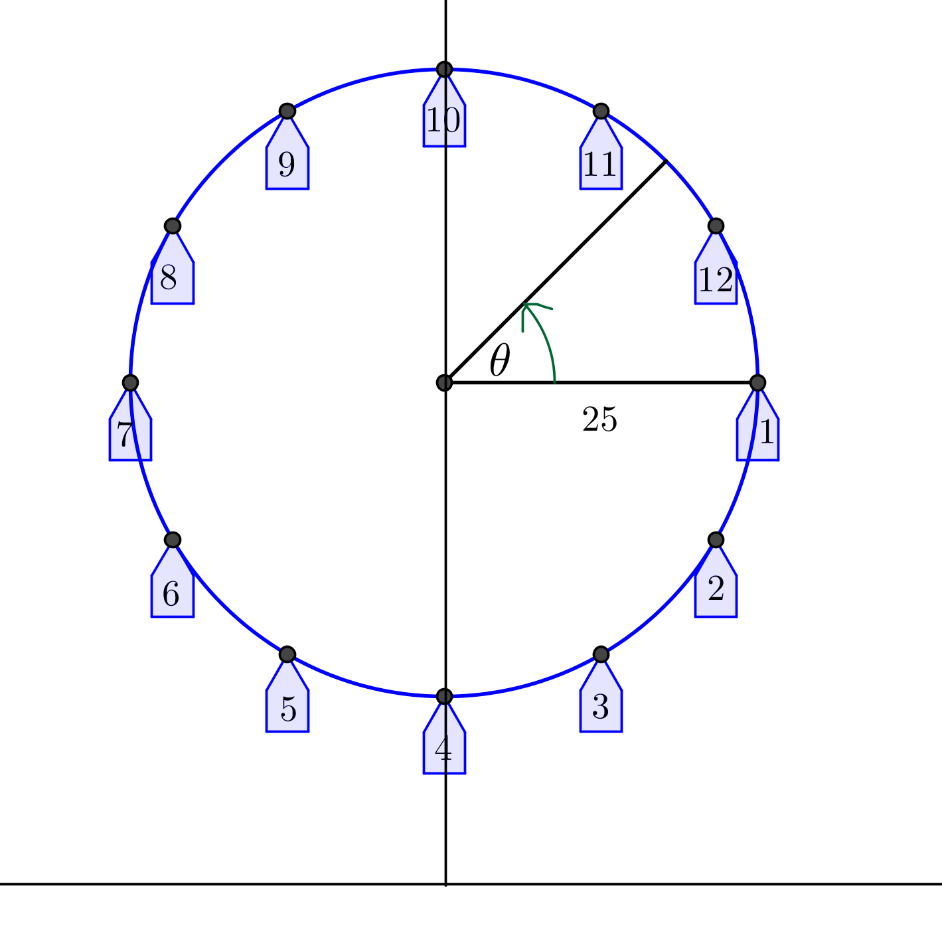
- The model we created in Exercise 1 measures the height of car 1 above the horizontal line through the center of the wheel. We now want to alter this model so that it measures the height of car 1 above the ground.
  - If we measure the height of car 1 above the ground instead of above the horizontal line through the center of the wheel, how will the functions $X$ and $Y$ need to change?

  - Let $θ=0$ represent the position of car 1 in the diagram at right. Sketch the graphs of the co-height and the height of car 1 as functions of the number of radians through which the car has rotated, $θ$.

  - How are the graphs from Exercise 2(b) related to the graphs from Exercise 1(a)?

  - From this perspective, find the equations for the functions $X$ and $Y$ that model the position of car 1 with respect to the number of radians the car has rotated.

  - Change the viewing window on your calculator to $\left[-60,60\right]×[-5,70]$, and graph the functions $X$ and $Y$ together. Sketch the graph.

  - Evaluate $X\left(0\right)$ and $Y\left(0\right)$ and explain their meaning in the context of the Ferris wheel.

  - Evaluate $X\left(\frac{π}{2}\right)$ and $Y\left(\frac{π}{2}\right)$ and explain their meaning in the context of the Ferris wheel.

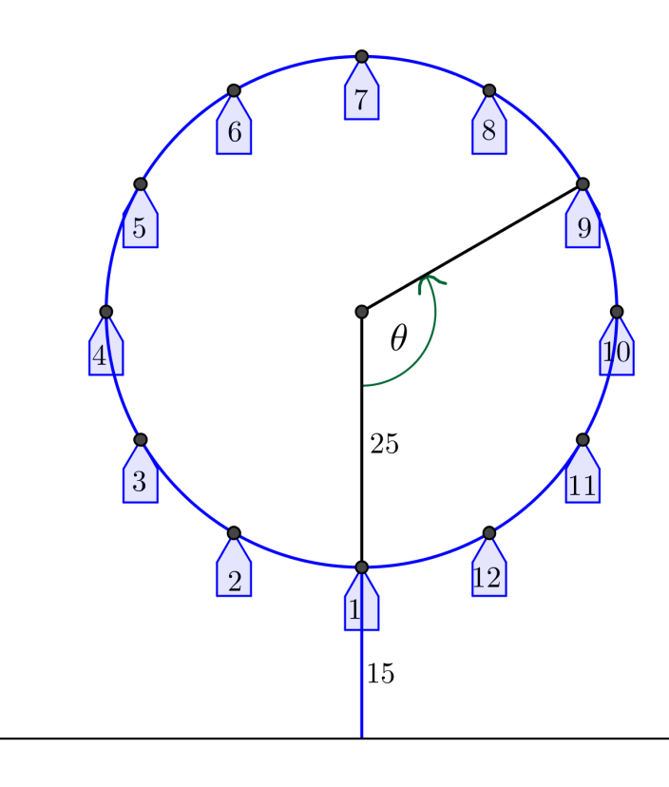
- In reality, no one boards a Ferris wheel halfway up; passengers board at the bottom of the wheel. To truly model the motion of a Ferris wheel, we need to start with passengers on the bottom of the wheel. Refer to the diagram below.

  - Let $θ=0$ represent the position of car 1 at the bottom of the wheel in the diagram at right. Sketch the graphs of the height and the co-height of car 1 as functions of $θ$, the number of radians through which the car has rotated from the position at the bottom of the wheel.

  - How are the graphs from Exercise 3$($a) related to the graphs from Exercise 2(b)?

  - From this perspective, find the equations for the functions $X$ and $Y$ that model the position of car 1 with respect to the number of radians the car has rotated.

  - Graph the functions $X$ and $Y$ from part (c) together on the graphing calculator. Sketch the graph. How is this graph different from the one from Exercise 2(d)?

  - Evaluate $X\left(0\right)$ and $Y(0)$ and explain their meaning in the context of the Ferris wheel.

  - Evaluate $X\left(\frac{π}{2}\right)$ and $Y\left(\frac{π}{2}\right)$ and explain their meaning in the context of the Ferris wheel.

- Finally, it is not very useful to track the position of a Ferris wheel as a function of how much it has rotated. It would make more sense to keep track of the Ferris wheel as a function of time. Recall that the Ferris wheel completes two full turns per minute.
  - Let $θ=0$ represent the position of car 1 at the bottom of the wheel. Sketch the graphs of the co-height and the height of car 1 as functions of time.

  - The co-height and height functions from part (a) can be written in the form $X\left(t\right)=A cos\left(ω\left(t-h\right)\right)+k$ and $Y\left(t\right)=A sin\left(ω\left(t-h\right)\right)+k$. From the graphs in part (a), identify the values of $A$, $ω$, $h$, and $k$ for each function $X$ and $Y$.

  - Write the equations $X(t)$ and $Y(t)$ using the values you identified in part (b).

  - In function mode, graph your functions from part (c) on a graphing calculator for $0<t<2$ and compare against your sketches in part (a) to confirm your equations.

  - Explain the meaning of the parameters in your equation for $X$ in terms of the Ferris wheel scenario.

  - Explain the meaning of the parameters in your equation for $Y$ in terms of the Ferris wheel scenario.

- In parametric mode, graph the functions $X$ and $Y$ from Exercise 3(c) on a graphing calculator for $0≤t≤\frac{1}{2}$.
  - Sketch the graph. How is this graph different from the graph in Exercise 3(d)?

  - What would the graph look like if you graphed the functions $X$ and $Y$ from Exercise 3(c) for $0≤t≤\frac{1}{4}$? Why?

  - Evaluate $X\left(0\right)$ and $Y(0)$ and explain their meaning in the context of the Ferris wheel.

  - Evaluate $X\left(\frac{1}{8}\right)$ and $Y\left(\frac{1}{8}\right)$ and explain their meaning in the context of the Ferris wheel.

Exercise 6–9
- You are in in car 1, and you see your best friend in car 3. How much higher than your friend are you when you reach the top?

- Find an equation of the function $H$ that represents the difference in height between you in car 1 and your friend in car 3 as the wheel rotates through $θ$ radians, beginning with $θ=0$ at the bottom of the wheel.

- Find an equation of the function that represents the difference in height between car 1 and car 3 with respect to time, $t$, in minutes. Let $t=0$ minutes correspond to a time when car 1 is located at the bottom of the Ferris wheel. Assume the wheel is moving at a constant speed starting at $t=0$.

- Use a calculator to graph the function $H$ in Exercise 8 for $0≤t≤2$. What type of function does this appear to be? Does that make sense?

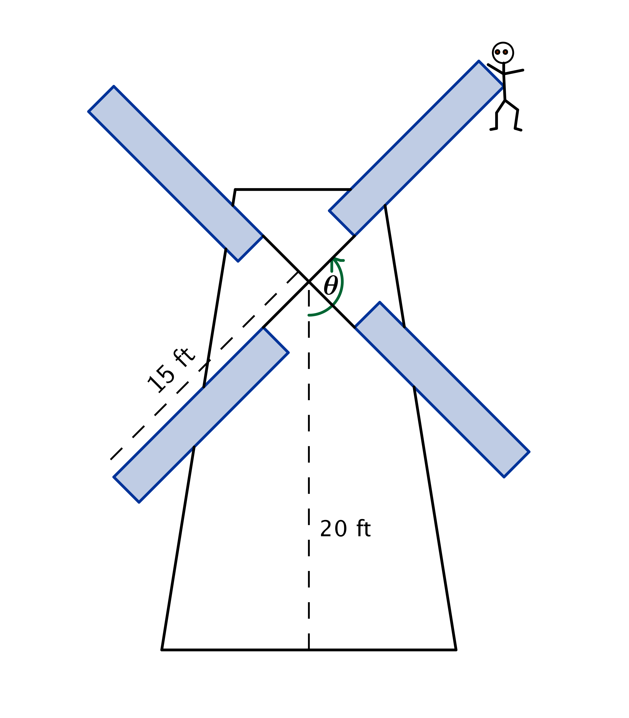
Problem Set

- In the classic novel, Don Quixote, the title character famously battles a windmill. In this problem, you will model what happens when Don Quixote battles a windmill, and the windmill wins. Suppose the center of the windmill is $20$ feet off the ground, and the sails are$15$ feet long. Don Quixote is caught on a tip of one of the sails. The sails are turning at a rate of one counterclockwise rotation every $60$ seconds.
  - Explain why a sinusoidal function could be used to model Don Quixote’s height above the ground as a function of time.
  - Sketch a graph of Don Quixote’s height above the ground as a function of time. Assume $t=0$ corresponds to a time when he was closest to the ground. What are the amplitude, period, and midline of the graph?
  - Model Don Quixote’s height $H$ above the ground as a function of time $t$ since he was closest to the ground.
  - After $1$ minute and $40$ seconds, Don Quixote fell off the sail and straight down to the ground. How far did he fall?

- The High Roller, a Ferris wheel in Las Vegas, Nevada, opened in March $2014$. The $550$ ft. tall wheel has a diameter of $520$feet. A ride on one of its $28$ passenger cars lasts $30$ minutes, the time it takes the wheel to complete one full rotation. Riders board the passenger cars at the bottom of the wheel. Assume that once the wheel is in motion, it maintains a constant speed for the $30$ minute ride and is rotating in a counterclockwise direction.
  - Sketch a graph of the height of a passenger car on the High Roller as a function of the time the ride began.
  - Write a sinusoidal function $H$ that represents the height of a passenger car $t$ minutes after the ride begins.
  - Explain how the parameters of your sinusoidal function relate to the situation.
  - If you were on this ride, how high would you be above the ground after $20$ minutes?
  - Suppose the ride costs $\$25$. How much does $1$ minute of riding time cost? How much does $1$ foot of riding distance cost? How much does $1$ foot of height above the ground cost?
  - What are some of the limitations of this model based on the assumptions that we made?

- Once in motion, a pendulum’s distance varies sinusoidally from $12$ feet to $2$ feet away from a wall every $12$ seconds.
  - Sketch the pendulum’s distance $D$ from the wall over a $1$ minute interval as a function of time $t$. Assume $t=0$ corresponds to a time when the pendulum was furthest from the wall.
  - Write a sinusoidal function for $D$, the pendulum’s distance from the wall, as a function of the time since it was furthest from the wall.
  - Identify two different times when the pendulum was $10$ feet away from the wall. (Hint: Write an equation and solve it graphically.)

- The height in meters relative to the starting platform height of a car on a portion of a roller coaster track is modeled by the function $H\left(t\right)=3\sin\left(\frac{π}{4}\left(t-10\right)\right)-7$. It takes a car $24$seconds to travel on this portion of the track, which starts $10$ seconds into the ride.
  - Graph the height relative to the starting platform as a function of time over this time interval.
  - Explain the meaning of each parameter in the height function in terms of the situation.

- Given the following function, use the parameters to formulate a real world situation involving one dimension of circular motion that could be modeled using this function. Explain how each parameter of the function relates to your situation.
$$f\left(x\right)=10\sin\left(\frac{π}{8}\left(x-3\right)\right)+15$$

