Lesson 11: Transforming the Graph of the Sine Function

Student Outcomes
- Students formalize the periodicity, frequency, phase shift, midline, and amplitude of a general sinusoidal function by understanding how the parameters $A$, $ω$,$h$, and $k$ in the formula
$$f(x)=A\sin\left(ω\left(x-h\right)\right)+k$$
are used to transform the graph of the sine function, and how variations in these constants change the shape and position of the graph of the sine function.
- Students learn the relationship among the constants $A$, $ω$,$h$, and $k$ in the formula
$f(x)=A\sin\left(ω\left(x-h\right)\right)+k$ and the properties of the sine graph. In particular, they learn that:
- $|A|$ is called the amplitude of the function. The amplitude is the distance between a maximal point of the graph of the sinusoidal function and the midline, i.e., $A=f_{max}-k$ or $A=\frac{f_{max}-f_{min}}{2}$.
- $\frac{2π}{|ω|}$ is the period of the function. The period $P$ is the distance between two consecutive maximal points (or two consecutive minimal points) on the graph of the sinusoidal function. Thus, $ω=\frac{2π}{P}.$
- $\frac{|ω|}{2π}$ is the frequency of the function (the frequency is the reciprocal of the period).
- $h$ is called the phase shift.
- The graph of $y=k$ is called the midline.
- Furthermore, the graph of the sinusoidal function $f$ is obtained by vertically scaling the graph of the sine function by $A$, then horizontally scaling the resulting graph by $\frac{1}{ω}$, and then horizontally and vertically translating the resulting graph by $h$ and $k$ units, respectively.

Lesson Notes
The lesson is planned for one day, but the teacher may choose to extend it to two days. The Ferris wheel exploration in Lesson 12 continues to expand on the ideas introduced in this lesson, as do the modeling problems in Lesson 13. In this lesson, we explore the effects of changing the parameters on the graphs of sinusoidal functions, and in the next lessons we work backward to write a formula for sinusoidal function given its graph and to fit a sinusoidal function to data. Students will work in groups to discover the effects of changing each of the parameters $A$,$ω$,$h$, and $k$ in the generalized sine function $f(x)=A\sin\left(ω\left(x-h\right)\right)+k$. Note that the parameters $h$ and $k$ in the formula
$f(x)=A\sin\left(ω\left(x-h\right)\right)+k$ play a similar role as the $h$ and $k$ in the vertex form $p\left(x\right)=a{(x-h)}^{2}+k$ of a quadratic function.
This lesson draws heavily on MP.7 and MP.8. Students graph functions repeatedly (MP.8) to generalize the effect of the parameters (MP.7) on the graph. During this lesson, students are grouped twice. First, they are arranged into the four teams that discover the effects of each parameter on the graph of the sine function, and then those teams are scrambled to new groups that contain at least one member of each original team. You may want to carefully plan these groups in advance so that each time the groups are scrambled, they contain students at different levels of ability.

The following background information provides a formal definition of terms associated with periodic functions and how the features of the graph of a sinusoidal function relate to the parameters in the generalized function,
$f\left(x\right)=A\sin\left(ω\left(x-h\right)\right)+k$.
Periodic Function. A function $f$ whose domain is a subset of the real numbers is said to be periodic with period $P>0$ if the domain of $f$ contains $x+P$ whenever it contains $x$, and if $f\left(x+P\right)=f(x)$ for all real numbers $x$ in its domain.
If a least positive number $P$ exists that satisfies this equation, it is called the fundamental period, or if the context is clear, just the period of the function.
Cycle. Given a periodic function, a cycle is any closed interval of the real numbers of length equal to the period of the function.
When a periodic function or the graph of a periodic function is said to “repeat,” it means that the graph of the function over a cycle is congruent to the graph of the periodic function over any translation of that cycle to the left or right by multiples of the period. Because a periodic function repeats predictably, one can ask how many repetitions of the function occur in an interval of a given length. The answer is a proportional relationship between lengths of intervals and the cycles in them (thought of as subintervals that intersect only at their endpoints). For example, there are $8$ cycles of the function $g\left(x\right)=\sin{(8x)}$ occurring in the interval $[0, 2π]$, which can be written as $8$ cycles per $2π$ units, or as the rate $\frac{8}{2π}$ cycles/unit. The unit rate of this rate, $\frac{8}{2π}$, is called the frequency.
Frequency. The frequency of a periodic function is the unit rate of the constant rate defined by the number of cycles per unit length.
In practice, the frequency is often calculated by choosing an interval of a convenient length. For example, we can easily calculate the period and frequency for function $g\left(x\right)=\sin{(ωx)}$ from the definitions above in terms of $ω$. Let $P$ be the period of the function and $f$ its frequency. Since the period of the sine function is $2π$, the period of $g$ is $\frac{2π}{|ω|}$ (because the graph of $g$ is a horizontal scale of the graph of the sine function by $\frac{1}{ω}$). Thus,
$P=\frac{2π}{|ω|}$. Since the length of any cycle is $\frac{2π}{|ω|}$, there are clearly $|ω|$ cycles in the interval $[0, 2π]$. The relationship of $|ω|$ cycles per $2π$ units can be used to calculate the number of cycles in any interval of any length; therefore, the proportional relationship can be written as the rate: $\frac{|ω|}{2π}$ cycles/unit. The frequency is then $f=\frac{|ω|}{2π}$. From the equations $P=\frac{2π}{|ω|}$ and $f=\frac{|ω|}{2π}$, we see that period and frequency are reciprocals of each other; that is,
$P=\frac{1}{f}$.
Sinusoidal functions are useful for modeling simple harmonic motions.
Sinusoidal Function. A periodic function $f: R→R$ is sinusoidal if it can be written in the form
$f\left(x\right)=A\sin{(ω(}x-h))+k$ for real numbers $A$,$ω$,$h$, and $k$.
In this form,
  - $|A|$ is called the amplitude of the function.
  - $\frac{2π}{|ω|}$ is the period of the function, and $\frac{|ω|}{2π}$ is the frequency of the function (the frequency is the reciprocal of the period).
  - $h$ is called the phase shift, and the graph of $y=k$ is called the midline.

Furthermore, we see that the graph of the sinusoidal function $f$ is obtained by vertically scaling the graph of the sine function by $A$, then horizontally scaling the resulting graph by $\frac{1}{ω}$, and then horizontally and vertically translating the resulting graph by $h$ and $k$ units, respectively.
To determine the amplitude, period, phase shift, and midline from a graph of a sinusoidal function (or data given as ordered pairs), let $f_{max}$ be the maximum value of the function and $f_{min}$ be the minimum value of the function ($f$ has global maximums and minimums because the values of the sine function are bounded between $-1$ and $1$). A sinusoidal function oscillates between two horizontal lines, the minimal line given by the graph of $y=f_{min}$ and the maximal line given by the graph of $y=f_{max}$. Then:
- The midline is the horizontal line that is halfway between the maximal line and the minimal line, i.e., it is the graph of the equation $y=\frac{f_{max}+f_{min}}{2}$. Thus, the value of $k$ can be found by $k=\frac{f_{max}+f_{min}}{2}.$
- The amplitude is the distance between a maximal point of the graph of the sinusoidal function and the midline, i.e., $|A|=f_{max}-k$ or $|A|=\frac{f_{max}-f_{min}}{2}$.
- The period $P$ is the distance between two consecutive maximal points (or two consecutive minimal points) on the graph of the sinusoidal function. Thus, $ω=\frac{2π}{P}$.
Note that the process outlined above for determining the parameters in a sinusoidal function guarantees that both $A$ and $ω$ are both positive. Vertical and horizontal translations can then be used to fit the graph of the sinusoidal function to the data.
Many sources provide the following formula for a generalized sine function:
$f\left(x\right)=A\sin\left(Bx+C\right)+D$. This formula is introduced in a later lesson.
Graphing calculators or another graphing utility are required for the Opening Exercise but should not be allowed for the exercises near the end of the lesson. Remind students to set the calculator to radian mode.

Classwork
Scaffolding:
- Be sure that each team has a diverse collection of students with different talents. You may want to have several stronger students on the $ω$ team since this is typically the most difficult parameter for students to understand.
- If a team is having trouble, give a hint about what the team should observe; e.g., ask a struggling team what are the values for $A,ω,h,$and $k$ for the function
$$f\left(x\right)=\sin\left(2x-π\right)+5.$$
Then, ask students from the various teams to make conjectures about how changing the parameter values changes the appearance of the graphs of the function.
Opening Exercise (15 minutes)
Remind students what the graph of the function $f(x)= \sin{(x)}$ looks like; then, post the following equation of the generalized sine function:
$$f\left(x\right)=A\sin\left(ω\left(x-h\right)\right)+k.$$
This formula defines a family of functions that have the same properties but different graphs for different choices of the parameters $A, ω, h,$ and $k$. The parameters remain constant for a particular function, so they are not variables, but their values can change from one function to another. That is, one function that has this form is $f\left(x\right)=3\sin\left(2\left(x-π\right)\right)+6$ and another is
$g\left(x\right)=100\sin\left(1.472\left(x-0.0024\right)\right)-17$.
You have seen parameters in other equations for graphs; for example, the equation $y=mx+b$ describes a line with parameters $m$ and $b$ that represent the slope and $y$-intercept of the line. As another example, recall what the parameters $a, h,$and$k$ tell us about the graph of a quadratic function in the form $p\left(x\right)=a{\left(x-h\right)}^{2}+k$.
Divide the class into four teams called the $A$-team, the $h$-team, the $k$-team, and the $ω$-team. Each team will be responsible for discovering the effect of changing the group’s parameter on the graph of the sine function by graphing the function for several different values of the parameter using a graphing calculator or other graphing utility. Be sure that students try positive and negative values for the parameter as well as values that are close to zero. Each student on each team will be responsible for teaching students from the other teams what effects changing the team’s parameter has on the basic graph of $f\left(x\right)=\sin{(x)}$, so every student needs to fully participate and understand the group’s conclusions. Students should keep a graph of $f\left(x\right)=sin⁡(x)$ entered into their calculators and graph a second function where they change their assigned parameter. For the parameter $h$, encourage teams to work with multiples of fractions of $π$ before moving on to rational numbers. That way, it will be easier for them to identify the horizontal scaling and translations compared to the graph of $f\left(x\right)=\sin\left(x\right).$
- The $A$-team experiments by changing the parameter $A$ in the function $f(x)=A\sin\left(x\right)$. Examine how different values for $A$ change the graph of the sine function by using a graphing calculator to produce a graph of $f$. Recommended starting values for team $A$ are$$A∈\left\{2, 3, 10, 0,-1, -2,\frac{1}{2},\frac{1}{5}, -\frac{1}{3}\right\}.$$
All group members should be prepared to report to the other groups their conclusions about how amplitude is affected by different values of $A$.
- The $h$-team experiments by changing the parameter $h$ in the function $f(x)=sin(x-h)$. Examine how different values for $h$ change the graph of the sine function by using a graphing calculator to produce a graph of $f$. Recommended starting values for team $h$ are
MP.7
&
MP.8
$$h∈\left\{ π, -π,\frac{π}{2},-\frac{π}{4},2π,2, 0,-1, -2, 5, -5\right\}.$$
All group members should be prepared to report to the other groups their conclusions about how the graph of the function is affected by different values of $h$.
- The $k$-team experiments by changing the parameter $k$ in the function $f(x)=\sin{(x)}+k$. Examine how different values for $k$ change the graph of the sine function by using a graphing calculator to produce a graph of $f$. Recommended starting values for team $k$ are $$k∈\left\{2, 3, 10, 0,-1, -2,\frac{1}{2},\frac{1}{5}, -\frac{1}{3}\right\}.$$All group members should be prepared to report to the other groups their conclusions about how the graph of the function is affected by different values of $k$.
- The $ω$-team experiments by changing the parameter $ω$ in the function $f(x)=sin⁡(ωx)$. Examine how different values for $ω$ change the graph of the sine function by using a graphing calculator to produce a graph of $f$. Recommended starting values for team $ω$ are
$$ω∈\left\{2,3,5,\frac{1}{2},\frac{1}{4}, 0,-1, -2,π, 2π, 3π,\frac{π}{2},\frac{π}{4}\right\}.$$All group members should be prepared to report to the other groups their conclusions about how the the graph of the function is affected by different values of $ω$.
Sample student responses are included below.

Opening Exercise
Explore your assigned parameter in the sinusoidal function $f\left(x\right)=A\sin\left(ω\left(x-h\right)\right)+k$. Select several different values for your assigned parameter and explore the effects of changing the parameter’s value on the graph of the function compared to the graph of $f\left(x\right)=\sin{(x)}$. Record your observations in the table below. Include written descriptions and sketches of graphs.
$A$-Team  $$f\left(x\right)=A\sin\left(x\right)$$  Suggested $A$ values: $$2, 3, 10, 0,-1, -2,\frac{1}{2},\frac{1}{5}, -\frac{1}{3}$$  The graph is a vertical scaling of the graph of  $f\left(x\right)=\sin{(x)}$ by a factor of $A$.  When $A>1$, the graph is a vertical “stretch” of the graph of the sine function.  When $0<A<1$, the graph is a vertical “compression” of the graph of the sine function.  When $A$ is negative, the graph is also a reflection about the horizontal axis of the sine function.  When $A=1$, the graph is the graph of the sine function.  Changing $A$ changes the distance between the maximum and minimum points on the graph of the function.  The maximum and minimum values of the graph of $f\left(x\right)=A\sin{(x)}$ are $A$ and $-A$ when $A≠0$. The value of $|A|$ is the distance between the maximum point and the horizontal axis or half the distance between the maximum and minimum points. If $A<0$, the graph is reflected across the horizontal axis.  If $A=0$, then the function is constant, not sinusoidal, and the graph is the same as the graph of the line $y=0$. | $ω$-Team  $$f\left(x\right)=\sin\left(ωx\right)$$  Suggested $ω$ values:  $$2,3,5,\frac{1}{2},\frac{1}{4}, 0,-1, -2,π, 2π, 3π,\frac{π}{2},\frac{π}{4}$$  The graph is a horizontal scaling of the graph of  $f\left(x\right)=\sin{(x)}$ by a scale factor of $\frac{1}{ω}$.  When $ω>1$, the graph is a horizontal “compression” of the graph of the sine function.  When $0<ω<1$, the graph is a horizontal “stretch” of the graph of the sine function.  When $ω$ is negative, the graph is also a reflection about the vertical axis of the sine function.  When $ω=1$, the graph is the graph of the sine function.  Changing $ω$ changes the length of the period of the graph of the function.  The number $ω$ counts the number of cycles of the graph in the interval $\left[0,2π\right].$ If $ω$ is a non-negative integer, the graph will repeat $ω$ times on the closed interval $[0,2π]$. The length of the period of this function is $\frac{2π}{ω}$.  If $ω=0$, then the function is constant, not sinusoidal, and the graph is the same as the graph of the line $y=0$.

$k$-Team  $$f\left(x\right)=\sin\left(x\right)+k$$  Suggested $k$ values:  $$2, 3, 10, 0,-1, -2,\frac{1}{2},\frac{1}{5}, -\frac{1}{3}$$  The value of $k$ controls the vertical translation of the graph of $f$ compared to the graph of the sine function.  The graph of $f$ is the graph of the sine function translated vertically by $k$ units.  If $k>0$, then the graph is translated in the positive direction (to the right) compared to the graph of the sine function.  If $k<0$, then the graph is translated in the negative direction (to the left) compared to the graph of the sine function.  If $k=0$, then the graph is not translated when compared to the graph of the sine function. | $h$-Team  $$f\left(x\right)=\sin\left(x-h\right)$$  Suggested $h$ values:  $$π, -π,\frac{π}{2},-\frac{π}{4},2π,2, 0,-1, -2, 5, -5$$  The value of $h$ controls the horizontal translation of the graph of $f$ compared to the graph of the sine function.  The graph of $f$ is the graph of the sine function translated horizontally by $h$ units.  If $h>0$, then the graph is translated in the positive direction (to the right) compared to the graph of the sine function.  If $h<0$, then the graph is translated in the negative direction (to the left) compared to the graph of the sine function.  If $h=0$, then the graph is not translated when compared to the graph of the sine function.

After the different teams have had an opportunity to explore their assigned parameter, re-group students so that each new team has at least one student who is an “expert” on each parameter. Each “expert” should share the results regarding the originally assigned parameter within the new group, while the other group members take notes on the graphic organizer. When this activity is completed, all students should have notes, including written descriptions and sketches, recorded on their graphic organizers for each of the four parameters.

Discussion (6 minutes)
To ensure that students have recorded accurate information and to transition to the vocabulary of sinusoidal functions that is the focus on this lesson, lead a short discussion, making sure to define the terms below for the entire class. Have one or two student volunteers describe their findings on the effect of changing their parameter on the graph of the basic sine function. Students will not likely know the right mathematical terms for amplitude, horizontal shift, midline, and period, so, after the students present their conclusions, reiterate each group’s results using the correct vocabulary. Students should take notes on these terms. A precise definition of each term can be found in the Lesson Notes.
Conclude the discussion with the following information so that all students begin to associate the vocabulary with features of the graphs of sinusoidal functions.
- The amplitude is $|A|$. We need to use the absolute value of $A$ since amplitude is a length. In terms of the maximum value of the function, $f_{max}$, and the minimum value of the function, $f_{min}$, the amplitude is given by the formula:
$$\left|A\right|=\frac{f_{max}-f_{min}}{2}.$$

- The phase shift is $h$. The graph of $f\left(x\right)=A\sin\left(ω\left(x-h\right)\right)+k$ is a horizontal translation of the graph of the sine function by $h$ units. When a sinusoidal function is written in the form $f\left(x\right)=A\sin\left(Bx+C\right)+D$, the phase shift is the solution to the equation $Bx+C=0$. This expression $Bx+C$ can also be rewritten as $B\left(x-\left(-\frac{C}{B}\right)\right),$ where $B=ω$, and $-\frac{C}{B}=h$in the general sinusoidal function.
- The graph of $y=k$ is the midline. The graph of $f\left(x\right)=A\sin\left(ω\left(x-h\right)\right)+k$ is a vertical translation of the graph of the sine function by $k$ units. In terms of the maximum value of the function, $f_{max}$, and the minimum value of the function, $f_{min}$, the value of $k$ is given by the formula:
$$k=\frac{f_{max}+f_{min} }{2}.$$
- The period is $P=\frac{2π}{\left|ω\right|}$. This period is the horizontal distance between two consecutive maximal points of the graph of $f$ (or two consecutive minimal points).
- The frequency describes the number of cycles of the graph in the interval $[0,2π]$. The frequency $f$ is related to $ω$ by $f=\frac{|ω|}{2π}=\frac{1}{P}$.
Help students notice that the period is inversely proportional to the value of $ω$. Students should notice that the frequency and period of any sinusoidal function are reciprocals. In general, for any periodic function, the period $P$ will be the smallest positive number $P$ for which $f\left(x\right)=f(x+P)$ for all $x$.

Example (8 minutes)
In this example, walk through a series of four graphs, changing one parameter at a time, to create the final graph of $f\left(x\right)=3\sin\left(4\left(x-\frac{π}{6}\right)\right)+2$. An ordered progression that works well is $ω$, $h$, $A$, $k$. Ask representatives from the $ω$-team to describe the change brought by $ω=4$, representatives from the $h$-team to describe the change brought by
$h=\frac{π}{6}$, etc., for all four parameters. At each step, show the graph from the previous step together with the new graph so that students can see the change brought about by each of the parameters. If you have not discussed terms such as cycle, period, and frequency with your class, this would be an appropriate point to introduce those terms.
Example
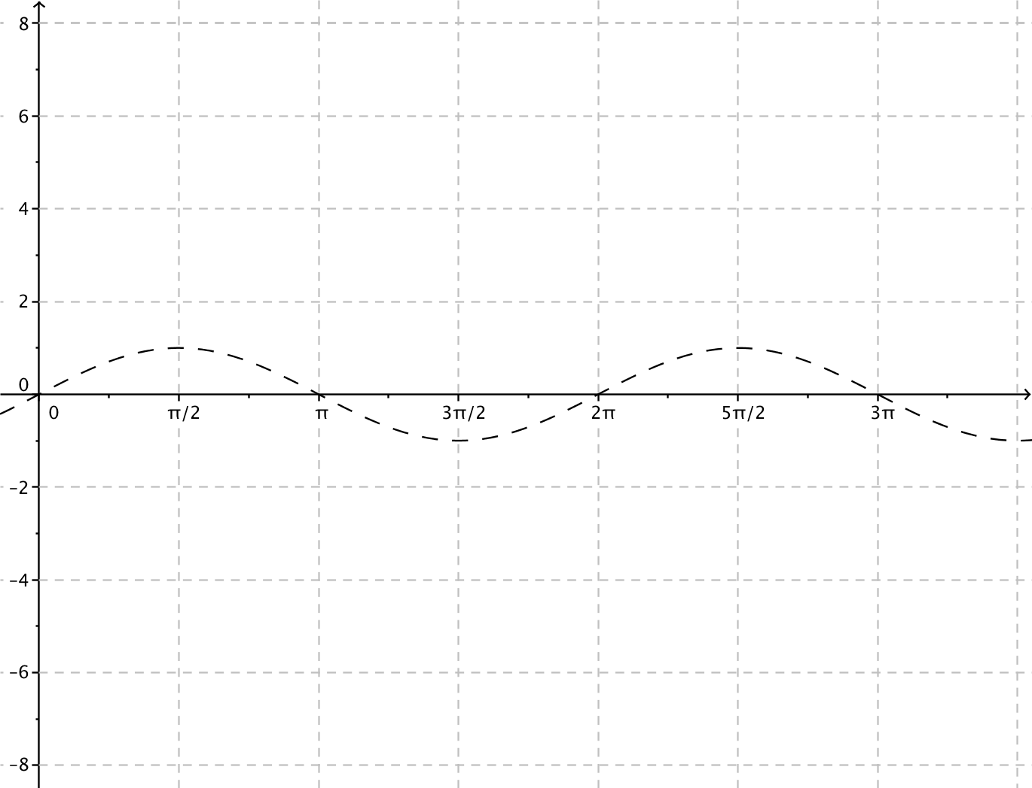
Graph the following function:
$$f\left(x\right)=3\sin\left(4\left(x-\frac{π}{6}\right) \right)+2.$$
- What are the values of the parameters $ω$, $h$, $A$, and $k$, and what do they mean?
  - $ω=4$, $h=\frac{π}{6}$, $A=3$, and $k=2$.
  - The value of $ω$ affects the period. The period is $P=\frac{2π}{|ω|}=\frac{π}{2}.$ The graph of this function is a horizontal scaling of the graph of the sine function by a factor of $\frac{1}{4}$. The graph of this function has four cycles in the closed interval $[0,2π]$.
  - The phase shift is $\frac{π}{6}$. Thus, the graph of this function is horizontal translation $\frac{π}{6}$ units to the right of the graph of the sine function.
  - The amplitude is $3$. The graph of this function is a vertical scaling of the graph of the sine function by a factor of 3. The vertical distance between the maximal and minimal points on the graph of this function is $6$ units.
  - The graph of the equation $y=2$ is the midline. The graph of this function is a vertical translation up $2$ units of the graph of the sine function.
Model the effects of each parameter compared to the graph of the sine function by sketching by hand, using a graphing calculator, or using other graphing software. If, when you question them, students are still using colloquial phrases such as “the graph will squish inward,” then take time to correct their terminology as modeled in the answers below.
- First, we change the frequency $ω$. What happens when $ω=4$?
  - The period is smaller than the period of the sine function. The graph will be a horizontal scaling of the original graph by a scale factor of $\frac{1}{4}$.
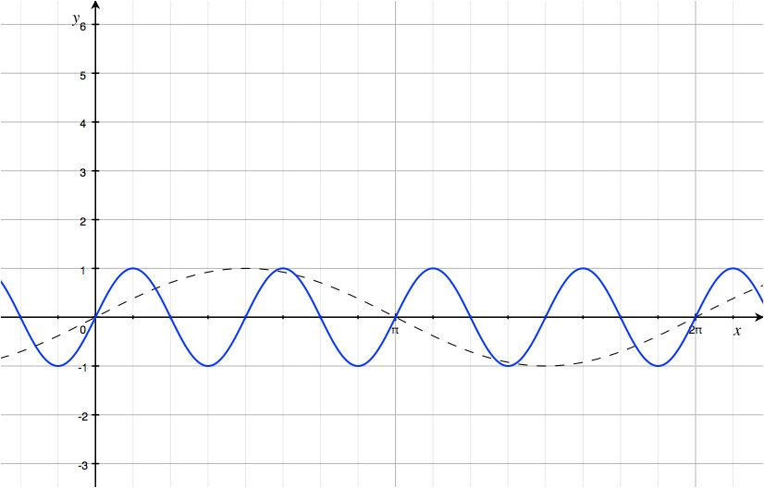

The blue curve is the graph of $y=\sin\left(4x\right).$ Be sure to point out the length of the period and that there are four cycles of the graph on the interval $\left[0,2π\right]$ because $ω=4$.
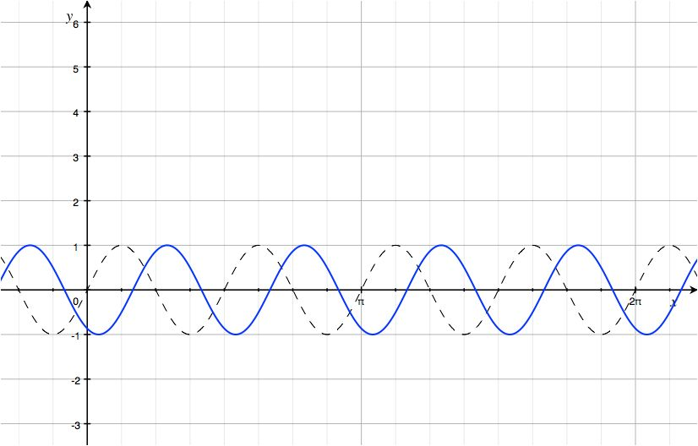
- Next, we examine the horizontal translation by $h=\frac{π}{6}$. What effect will that have on the graph?
  - The new graph is the old graph shifted $\frac{π}{6}$ units to the right.
The blue curve is the graph of $y=sin\left(4\left(x-\frac{π}{6}\right)\right).$Notice that the point that used to be $(0,0)$ has now been shifted to $\left(\frac{π}{6},0\right)$.
- The next step is to look at the effect of $A=3$. What will that do to our graph? How does it compare to the previous graph?
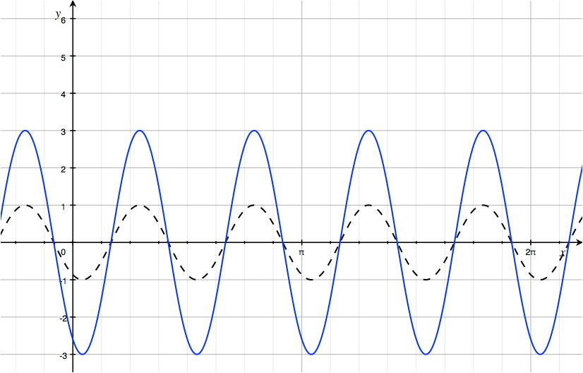
  - The amplitude will be $3$, so the distance between the maximum points and the minimum points will be $6$ units. The graph of this function is the graph of the previous function scaled vertically by a factor of $3$.
The blue curve is the graph of $y=3sin\left(4\left(x-\frac{π}{6}\right)\right)$.
- What happens to the zeros of a sinusoidal function with midline along the horizontal axis when the amplitude is changed? How about when the other parameters are changed? Support your claim with evidence.
MP.3
  - The zeros of the function do not change when we change the amplitude because $\sin\left(ω\left(x-h\right)\right)=0$ and $A\sin\left(ω\left(x-h\right)\right)=0$ have the same solution sets. You can observe this by comparing graphs of functions $f\left(x\right)=A sin⁡(ω\left(x-h\right))$ for different values of $A$. When you change the other parameters, the zeros change unless the changed parameter causes the graph of the new function to be a reflection of the original function, or the changed parameter causes the graph of the new function to be a horizontal translation of the original function that shifts the zeros onto themselves.
- The final change is to consider the effect of $k=2$. This will give us the final graph, which is the graph of the function $f\left(x\right)=3\sin\left(4\left(x-\frac{π}{6}\right) \right)+2$. What happens to the graph of this function when $k=2$?
  - The new graph is the previous graph translated vertically by $2$ units.
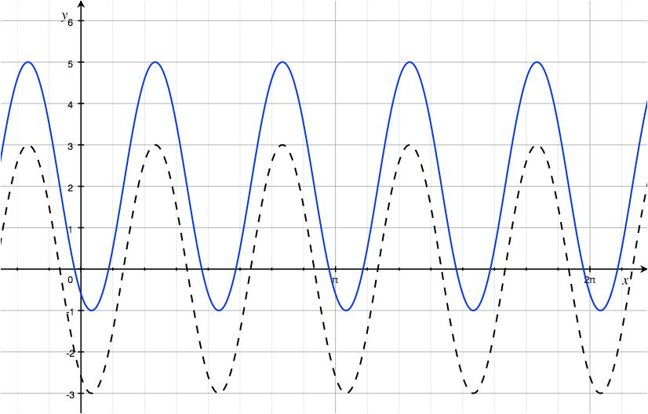
The blue curve is the graph of the function we wanted: $f\left(x\right)=3\sin\left(4\left(x-\frac{π}{6}\right) \right)+2$.

Exercise (10 minutes)
Scaffolding:
For struggling students:
- Provide larger size graph paper, or consider providing each group with graph paper on which the sine function is provided. In advance, select appropriate scaling for groups based on their function.
- Create an anchor chart and post it in a prominent location to provide visual support for how to determine each feature of the graph along with its formula.
Students should now be in mixed groups with at least one “expert” on each parameter in each group. Assign one of the following exercises to each group. In addition to each student recording his or her work on the student handout, the groups should record their graphs and responses in a format that will enable presentation to the class after this exercise, either on portable white boards, on chart paper, or on a clean sheet of paper. Graph paper, if available, would help students to create their graphs more precisely.
After each group presents the assigned function, students can work any remaining problems or try them on their own if time permits. Otherwise, some of these problems could be either included as homework exercises or used on the second day should you choose to extend this lesson to two class periods.
Exercise
For each function, indicate the amplitude, frequency, period, phase shift, vertical translation, and equation of the midline. Graph the function together with a graph of the sine function $f\left(x\right)=sin(x)$ on the same axes. Graph at least one full period of each function.

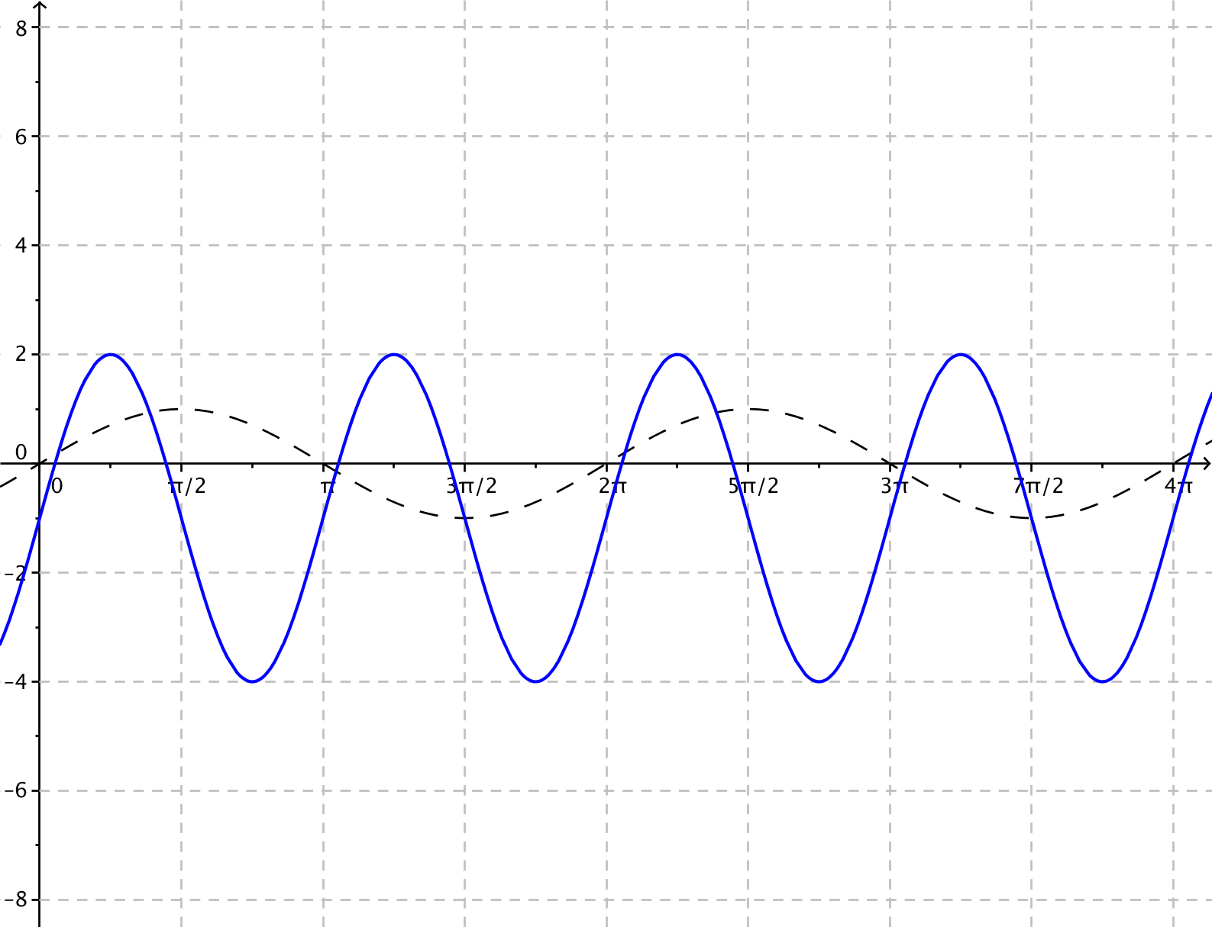
  - $g\left(x\right)=3\sin\left(2x\right)-1$
Since $A=3$, the amplitude is $3.$
Since $ω=2$, the frequency is $f=\frac{\left|ω\right|}{2π}=\frac{1}{π}$.
The period is $P=\frac{2π}{\left|ω\right|}=π$.
Since $h=0$, the phase shift is $0$, and there is no horizontal translation.
Vertical translation is $1$ unit downward since $k=-1$.
The midline has equation $y=-1$.

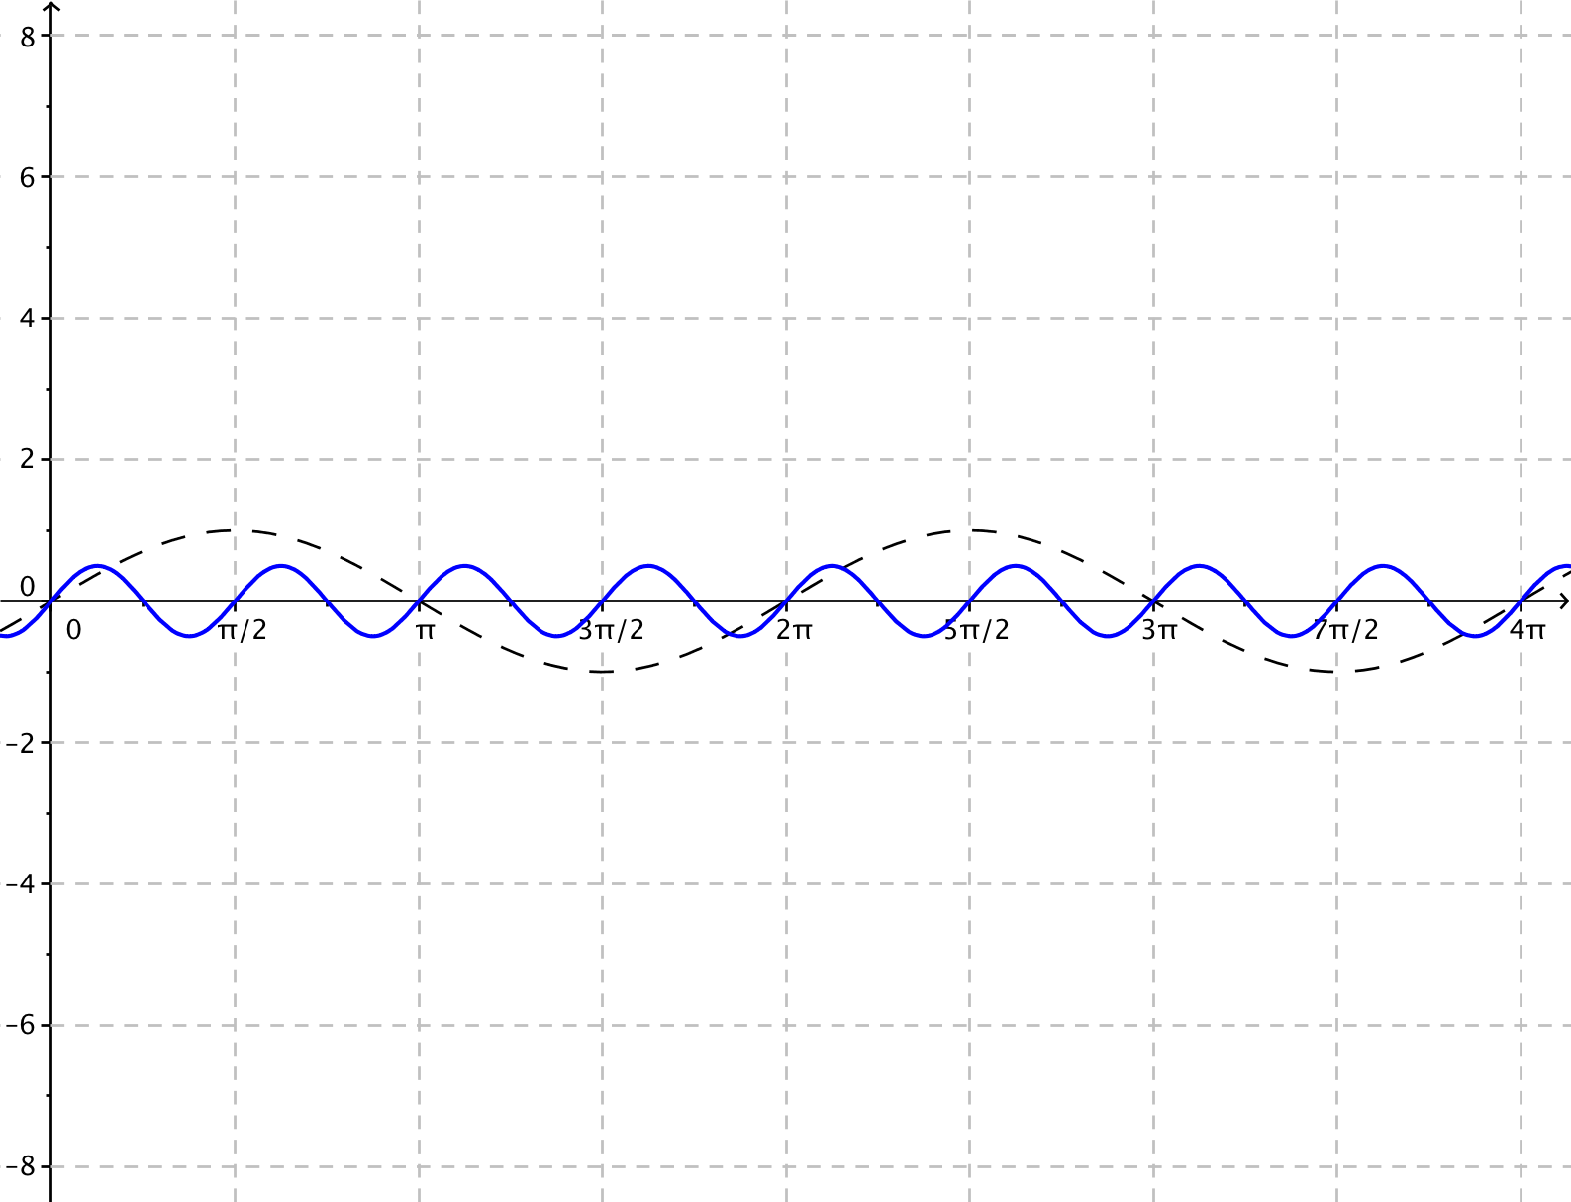
  - $g\left(x\right)=\frac{1}{2}\sin\left(\frac{1}{4}(x+π)\right)$
Since $A=\frac{1}{2}$, the amplitude is $\frac{1}{2}.$
Since $ω=\frac{1}{4}$, the frequency is $f=\frac{\left|ω\right|}{2π}=\frac{1}{8π}.$
The period is $P=\frac{2π}{\left|ω\right|}=8π$.
Since $=-π$ , the phase shift is $–π$. Thus, the graph is translated horizontally $π$ units to the left.
There is no vertical translation since $k=0.$
The midline is the graph of $y=0.$

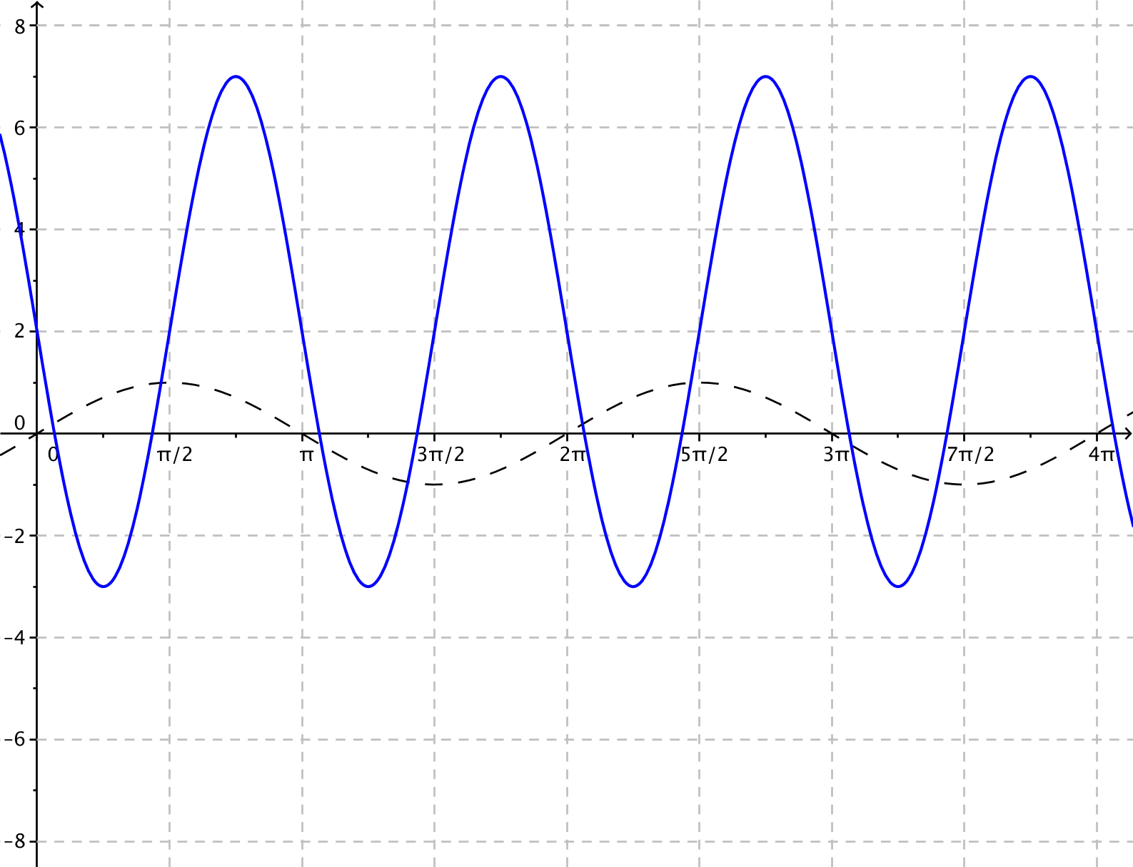
  - $g\left(x\right)=5\sin\left(-2x\right)+2$
Since $A=5$, the amplitude is $5$.
Since $ω=2$, the frequency is $f=\frac{\left|ω\right|}{2π}=\frac{1}{π}$.
The period is $P=\frac{2π}{\left|ω\right|}=π$.
Since the phase shift is $h=0$, there is no horizontal translation.
Since $k=2$, the vertical translation is $2$ units upward.
The midline is the graph of $y=2$.
The graph is reflected across the vertical axis since $ω<0$.

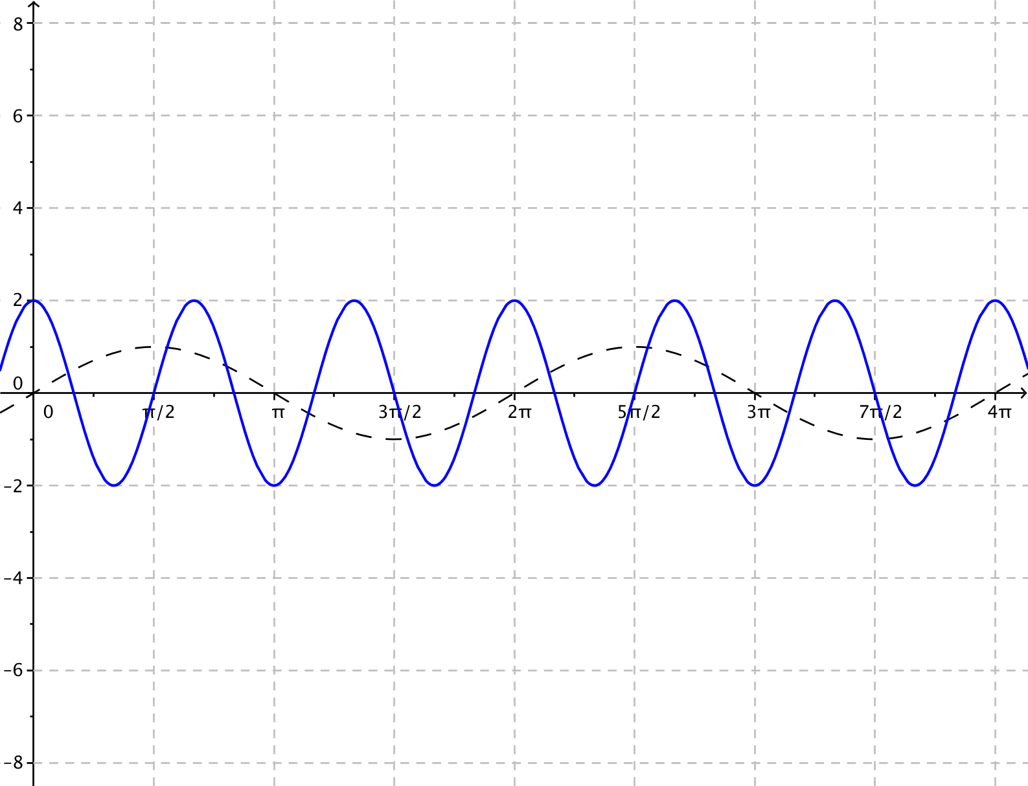
  - $g\left(x\right)=-2\sin\left(3\left(x+\frac{π}{6}\right)\right)$
Since $A=-2$, the amplitude is $\left|-2\right|=2$.
Since $ω=3$, the frequency is $f=\frac{\left|ω\right|}{2π}=\frac{3}{2π}$.
The period is $P=\frac{2π}{|ω|}=\frac{2π}{3}$.
Since $h=\frac{π}{6}$, the phase shift is $\frac{π}{6}.$ Thus, the graph is translated horizontally $\frac{π}{6}$ units to the right.
There is no vertical translation since $k=0.$
The midline is the graph of $y=0.$
The graph is reflected across the horizontal axis
since $A<0$.

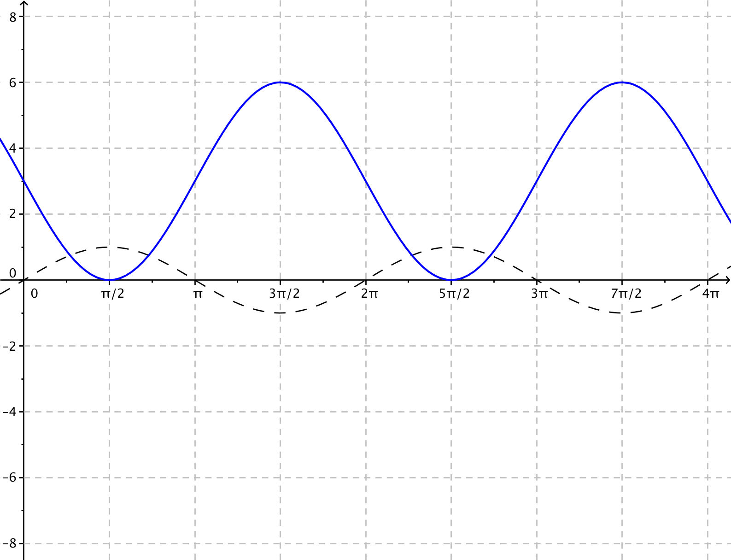
  - $g\left(x\right)=3\sin\left(x+π\right)+3$
Since $A=3$, the amplitude is$3$.
Since $ω=1$, the frequency is $f=\frac{\left|ω\right|}{2π}=\frac{1}{2π}$.
The period is $P=\frac{2π}{|ω|}=2π$.
Since $h=-π,$ the phase shift is $-π.$ Thus, the graph is translated horizontally $π$ units to the left.
Since $k=3$, the graph is translated vertically $3$ units upward.
The midline is the graph of $y=3$.

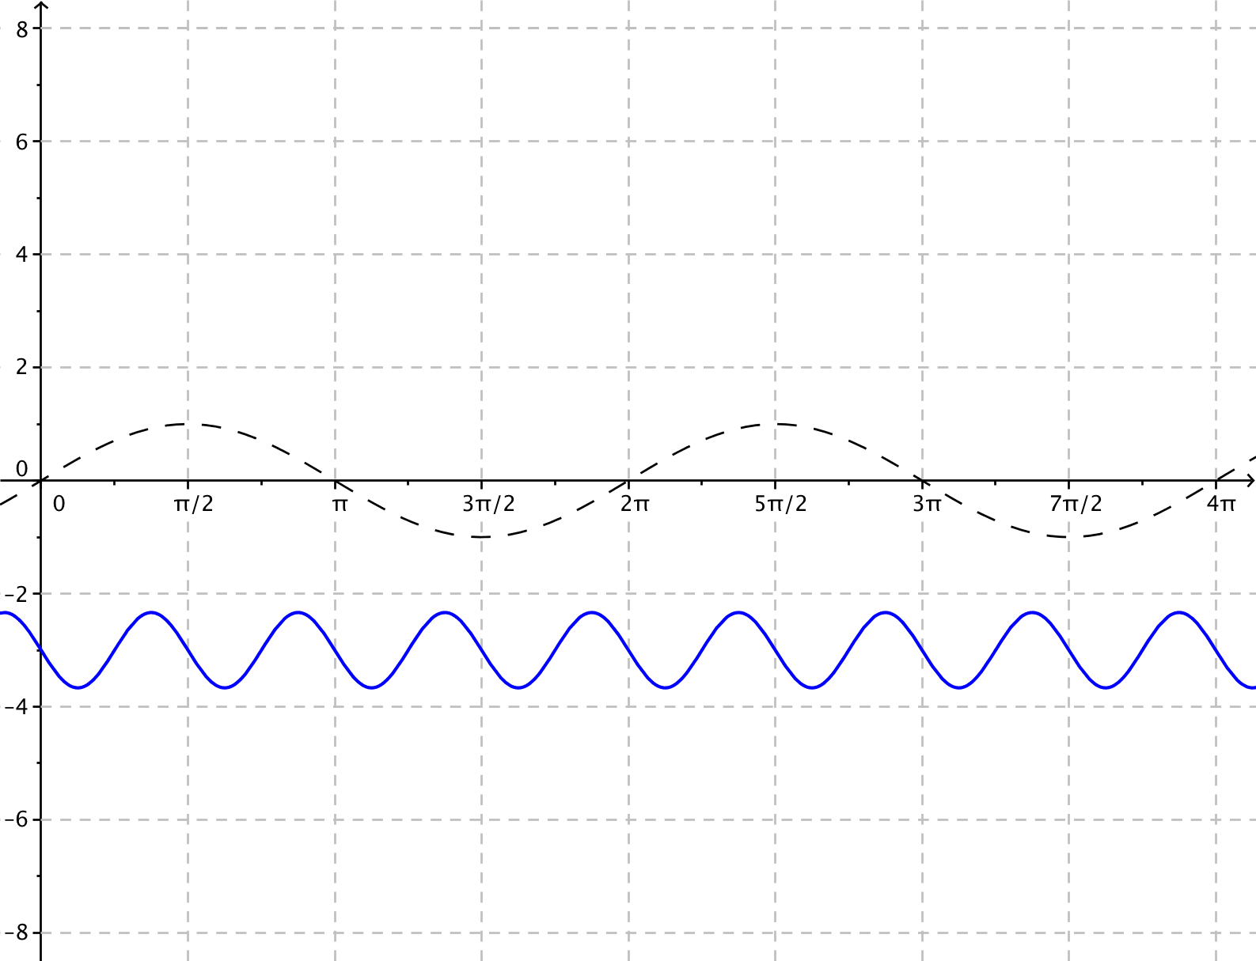
  - $g\left(x\right)=-\frac{2}{3}\sin\left(4x\right)-3$
Since $A=-\frac{2}{3}$, the amplitude is $\left|-\frac{2}{3}\right|=\frac{2}{3}.$
Since $ω=4$, the frequency is$f=\frac{\left|ω\right|}{2π}=\frac{2}{π}$.
The period is $P=\frac{2π}{|ω|}=\frac{π}{2}$.
Since $h=0$, the phase shift is $0,$ and there is no horizontal translation.
Since $k=-3$, the vertical translation is $3$ units downward.
The midline is the graph of $y=-3$.
Since $A<0$, the graph is reflected about the
horizontal axis$.$

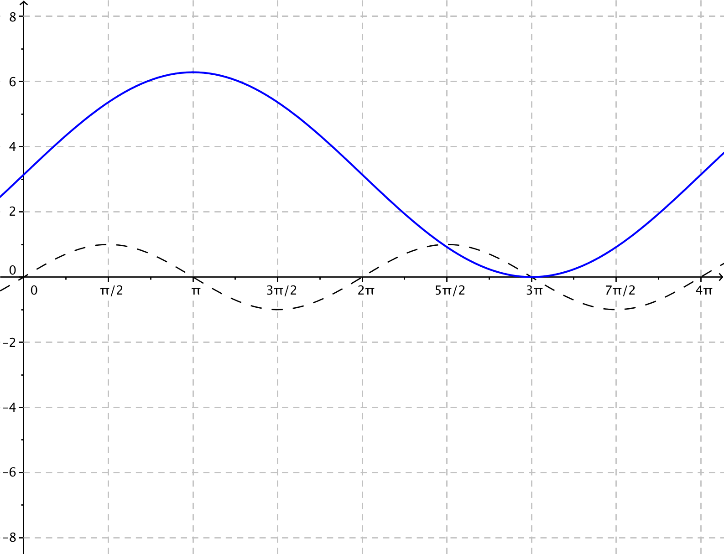
  - $g\left(x\right)=π\sin\left(\frac{x}{2}\right)+π$
Since $A=π$, the amplitude is $π$.
Since $ω=\frac{1}{2}$, the frequency is $f=\frac{\left|ω\right|}{2π}=\frac{1}{4π}.$
The period is $P=\frac{2π}{\left|ω\right|}=4π.$
Since $h=0$, the phase shift is $0$, and there is no horizontal translation.
Since $k=π$, the graph is translated vertically $π$ units upward.
The midline is the graph of $y=π.$

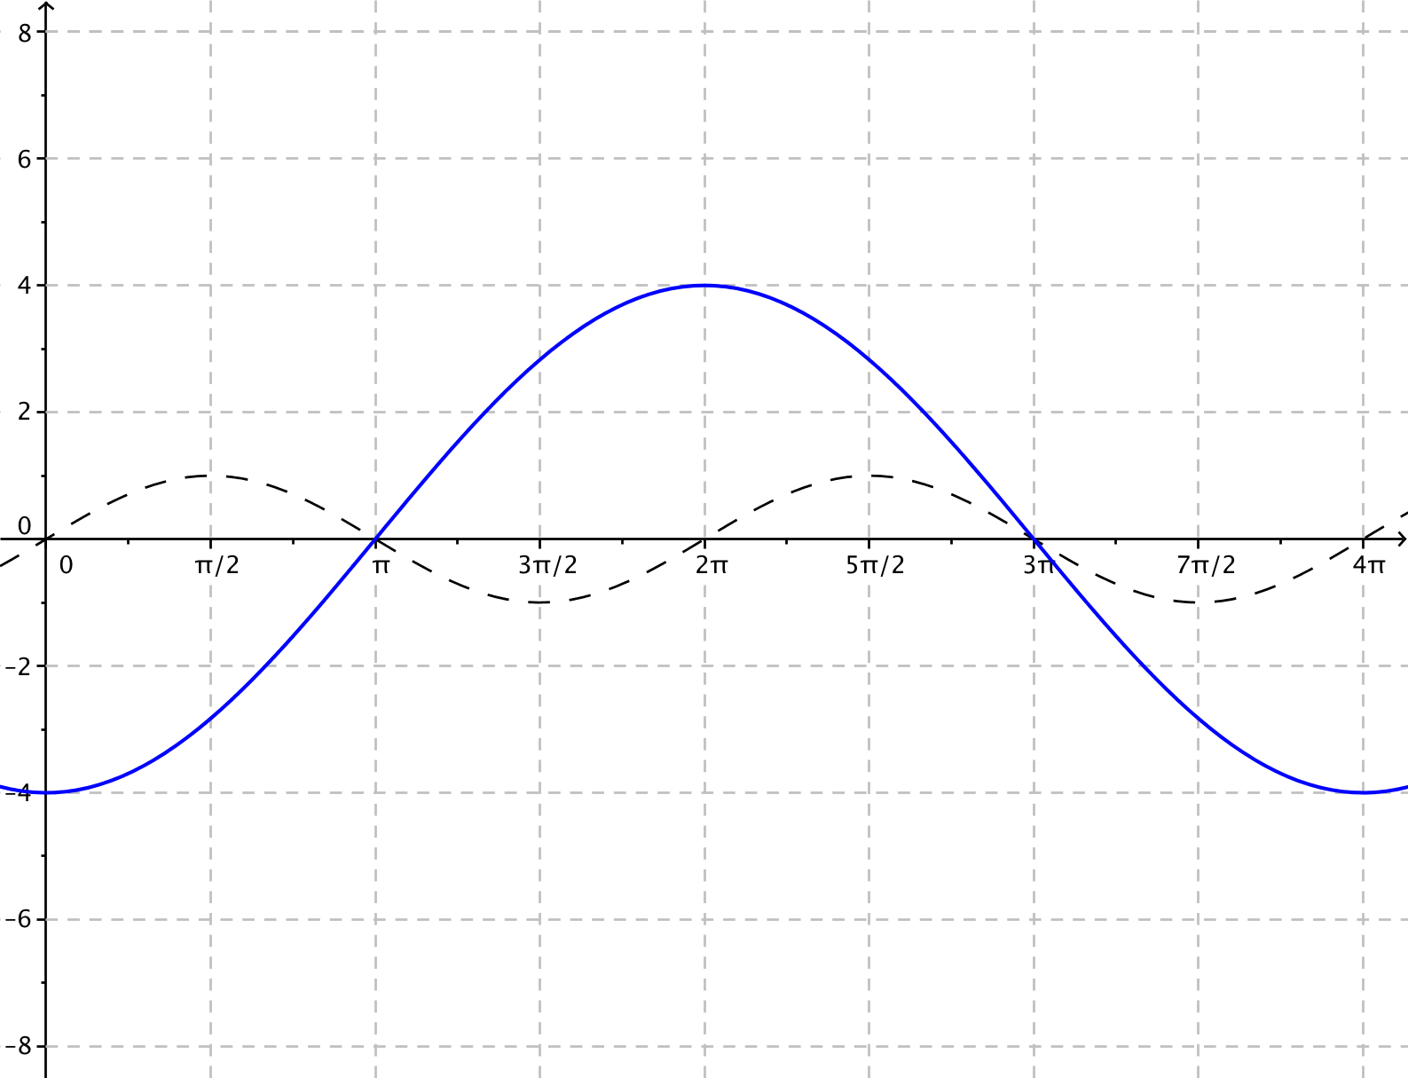
  - $g\left(x\right)=4\sin\left(\frac{1}{2}\left(x-5π\right)\right)$
Since $A=4$, the amplitude is $4$.
Since $ω=\frac{1}{2}$, the frequency is$f=\frac{\left|ω\right|}{2π}=\frac{1}{4π}$.
The period is $P=\frac{2π}{\left|ω\right|}=4π$.
Since $=5π$ , the phase shift is $5π$. Thus, the graph is translated horizontally $5π$ units to the right.
Since $k=0$, there is no vertical translation$.$
The midline is the graph of $y=0.$

Presentation (Optional - 6 minutes)
Have one or two representatives from each group present the graphs from Exercise 1 to the class, explaining the value of the four parameters, $A$, $ω$, $h$, and $k,$ from their function and how the graph of the sine function $f\left(x\right)=sin(x)$was affected by each parameter.

Closing (2 minutes)
Indicate to students that this reasoning extends to the graphs of the generalized cosine function $f(x)=A\cos\left(ω\left(x-h\right)\right)+k$, except that the cosine graph is even and the sine graph is odd. Thus, the graph of $y=cos(-ωx)$ and the graph of $y=cos(ωx)$ are the same graph. To sketch the graph of a cosine function, you would start with a graph of the cosine function $f\left(x\right)=cos(x)$ and apply a series of transformations based on the values of the parameters to its graph to generate the graph of the given function.
Ask students to summarize the important parts of the lesson, either in writing, to a partner, or as a class. Use this as an opportunity to assess understanding of the lesson informally. The following are some important summary elements.
Lesson Summary
In this lesson, we investigated the effects of the parameters $A$, $ω$, $h$, and $k$ on the graph of the function $f\left(x\right)=A sin\left(ω\left(x-h\right)\right)+k$.
- The graph of $y=k$ is the midline. The value of $k$ determines the vertical translation of the graph compared to the graph of the sine function. If $k>0$, then the graph shifts $k$ units upwards. If $k<0$, then the graph shifts $k$ units downward.
- The amplitude of the function is $|A|$; the vertical distance from a maximum point to the midline of the graph is $|A|$.
- The phase shift is $h$. The value of $h$ determines the horizontal translation of the graph from the graph of the sine function. If $h>0$, the graph is translated $h$ units to the right, and if $h<0,$ the graph is translated $h$ units to the left.
- The frequency of the function is $f=\frac{\left|ω\right|}{2π}$, and the period is $P=\frac{2π}{\left|ω\right|}$. The period is the vertical distance between two consecutive maximal points on the graph of the function.
These parameters affect the graph of $f\left(x\right)=A\cos\left(ω\left(x-h\right)\right)+k$ similarly.
Exit Ticket (4 minutes)
Name Date
Lesson 11: Transforming the Graph of the Sine Function

Exit Ticket

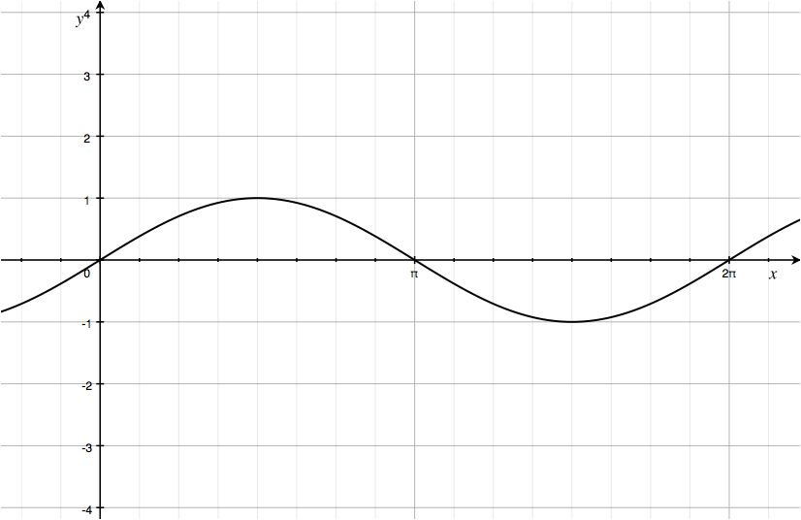
- Given the graph of $y=sin(x)$ below, sketch the graph of the function $f\left(x\right)=\sin{(4x)}$ on the same set of axes. Explain the similarities and differences between the two graphs.

- Given the graph of $y=sin\left(\frac{x}{2}\right)$ below, sketch the graph of the function $g\left(x\right)=3sin\left(\frac{x}{2}\right)$ on the same set of axes. Explain the similarities and differences between the two graphs.
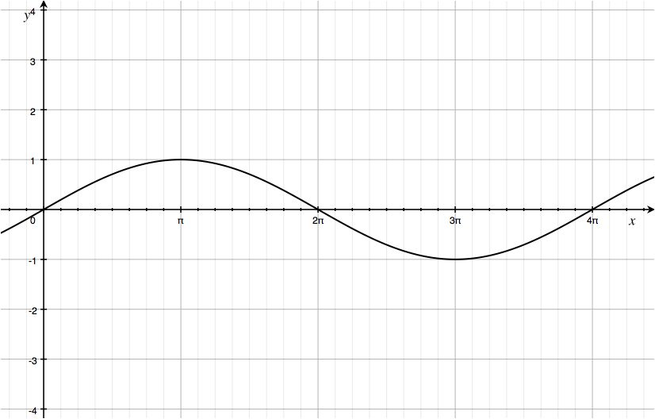
Exit Ticket Sample Solutions

- Given the graph of $y=sin(x)$ below, sketch the graph of the function $f\left(x\right)=\sin{(4x)}$ on the same set of axes. Explain the similarities and differences between the two graphs.
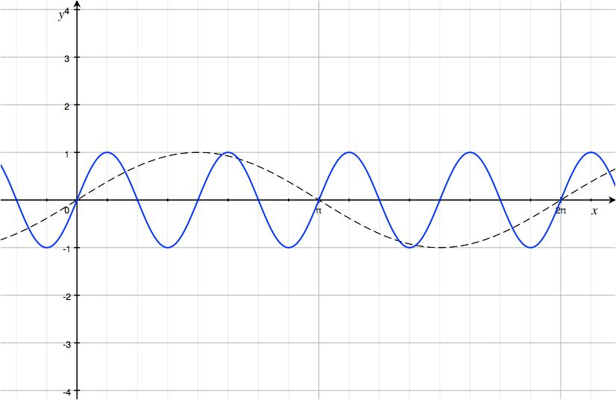
The curve shown in blue is the graph of $f\left(x\right)=sin\left(4x\right),$ and the dashed curve is the graph of $y=sin(x)$. The graph of $f$ is a horizontal scaling of the graph of the sine function by a factor of $\frac{1}{4}$. The graph of $f\left(x\right)=\sin{(4x)}$ has a different period and frequency than the sine function, which changes the values of the $x$-intercepts, maximum, and minimum points, and the increasing and decreasing intervals for this function. The amplitudes of the two graphs are the same, with $\left|A\right|=1$.

- Given the graph of $y=sin\left(\frac{x}{2}\right)$ below, sketch the graph of the function $g\left(x\right)=3sin\left(\frac{x}{2}\right)$ on the same set of axes. Explain the similarities and differences between the two graphs.
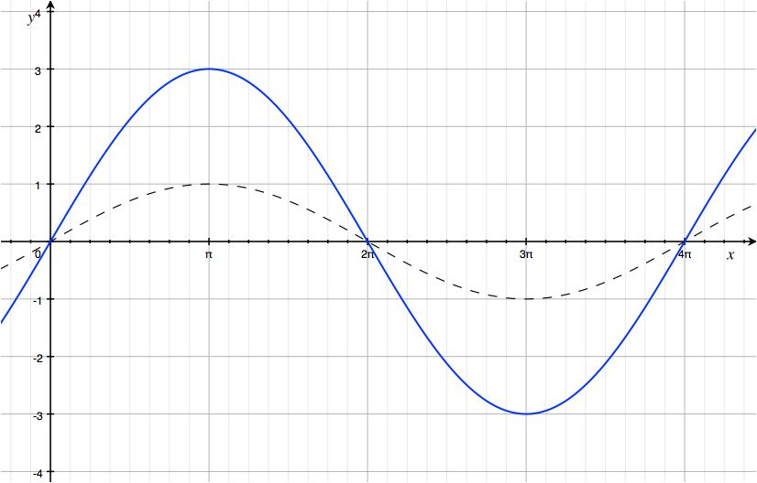
The curve shown in blue is the graph of $y=sin\left(\frac{x}{2}\right),$ and the dashed curve is the graph of $y=3sin\left(\frac{x}{2}\right).$ The graphs have different amplitudes. The graph of $g$ is a vertical scaling of the graph of the sine function by a factor of $3$. The $y$-coordinates of the maximum and minimum points are different for these two graphs. The two graphs have the same horizontal intercepts because the period of each function is $4π$.

Problem Set Sample Solutions

- For each function, indicate the amplitude, frequency, period, phase shift, horizontal, and vertical translations, and equation of the midline. Graph the function together with a graph of the sine function $f\left(x\right)=sin(x)$ on the same axes. Graph at least one full period of each function. No calculators allowed.
  - $g\left(x\right)=3 sin\left(x-\frac{π}{4}\right)$
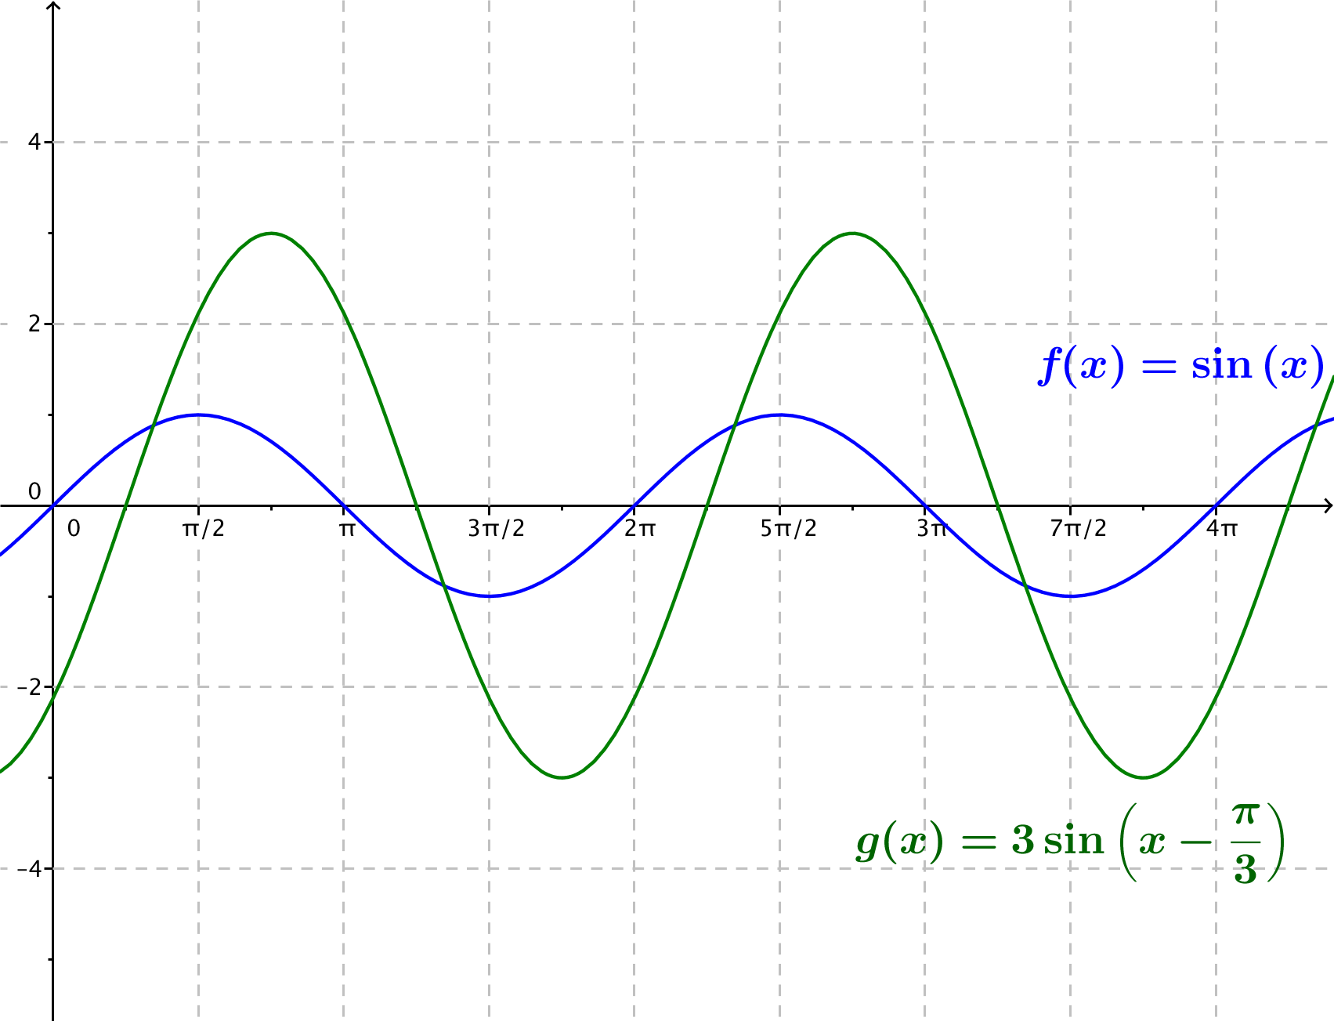
The amplitude is $3$, the frequency is $\frac{1}{2π}$, the period is $2π$, and the phase shift is $\frac{π}{4}$. The graph is translated horizontally $\frac{π}{4}$ units to the right; there is no vertical translation, and the equation of the midline is $y=0$.

  - $g\left(x\right)=5 sin(4x)$
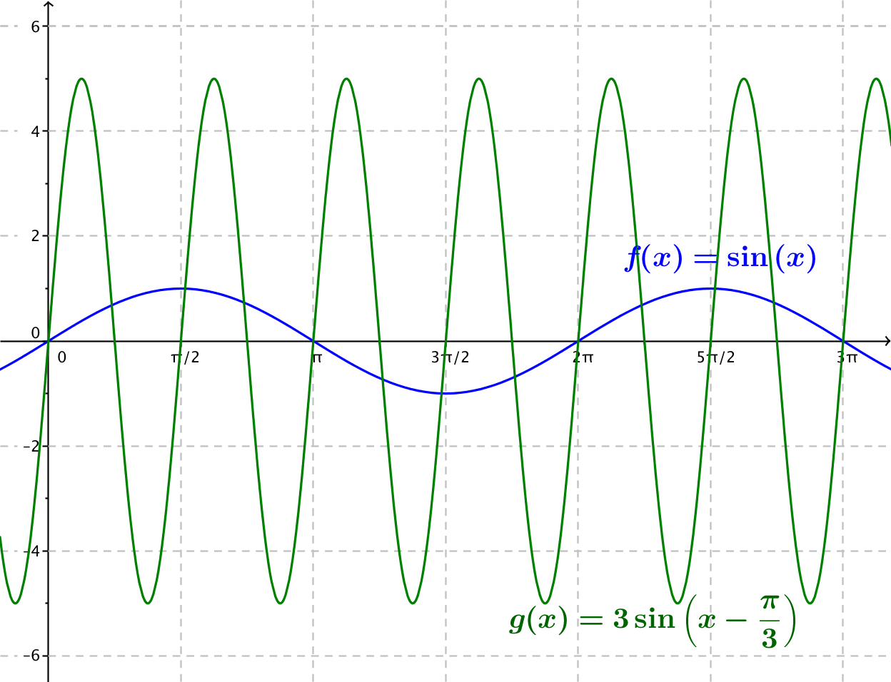
The amplitude is $5$, the frequency is $\frac{2}{π}$, the period is $\frac{π}{2}$, and the phase shift is $0$. There are no horizontal or vertical translations, and the equation for the midline is $y=0$. The graph is a vertical scaling of the graph of the sine function by a factor of $5$ and a horizontal scaling of the sine function by a factor of $\frac{1}{4}$.
  - $g\left(x\right)=4 sin\left(3\left(x+\frac{π}{2}\right)\right)$
The graph of $f$ is the graph of the sine function scaled vertically by a factor of $4$, horizontally by a factor of $\frac{1}{3}$, and translated $\frac{π}{2}$ to the left. The amplitude is $4$, the frequency is $\frac{3}{2π}$, the period is $\frac{2π}{3}$, the phase shift is $-\frac{π}{2}$, and the equation for the midline is $y=0$.
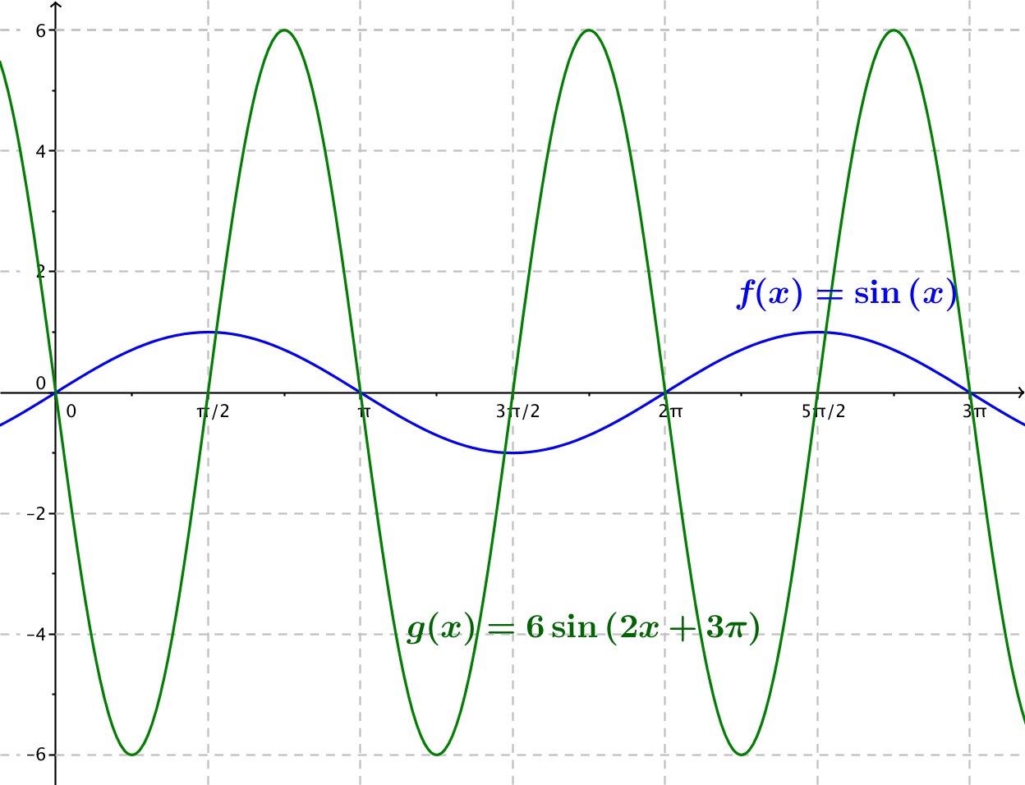
  - $g\left(x\right)=6 sin(2x+3π)$ (Hint: First, rewrite the function in the form $g\left(x\right)=A sin\left(ω\left(x-h\right)\right).$)
Rewriting the expression for $g$, we get $6 sin\left(2x+3π\right)=6 sin\left(2\left(x+\frac{3}{2}π\right)\right)$. The graph of $g$ is the graph of the sine function scaled vertically by a factor of $6$, horizontally by a factor of $\frac{1}{2}$, and translated horizontally $\frac{3}{2}π$ to the left. Thus, the amplitude is $6$, the frequency is $\frac{1}{π}$, the period is$π$, the phase shift is $–\frac{3}{2}π$, and the equation for the midline is $y=0$.

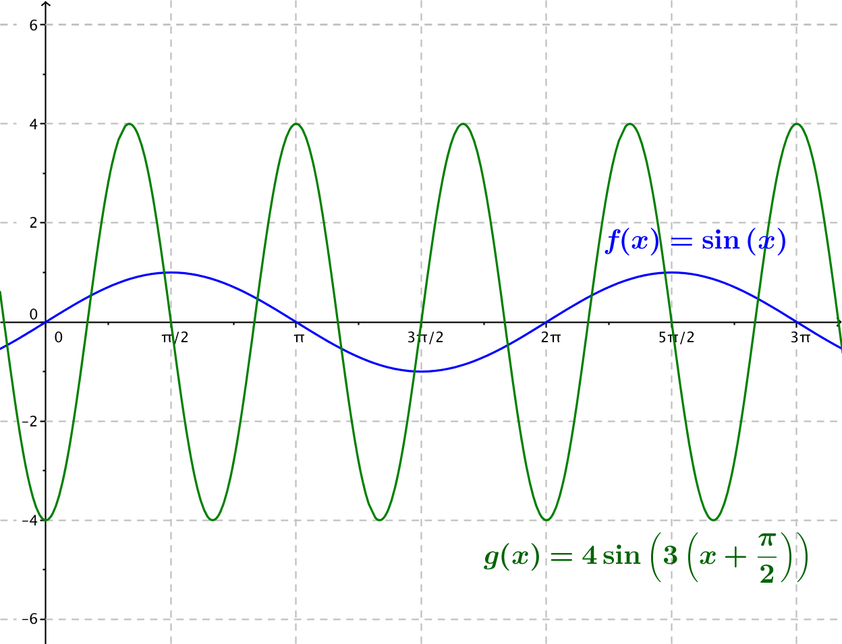

- For each function, indicate the amplitude, frequency, period, phase shift, horizontal, and vertical translations, and equation of the midline. Graph the function together with a graph of the sine function $f\left(x\right)=cos(x)$ on the same axes. Graph at least one full period of each function. No calculators allowed.
  - $g\left(x\right)=cos(3x)$
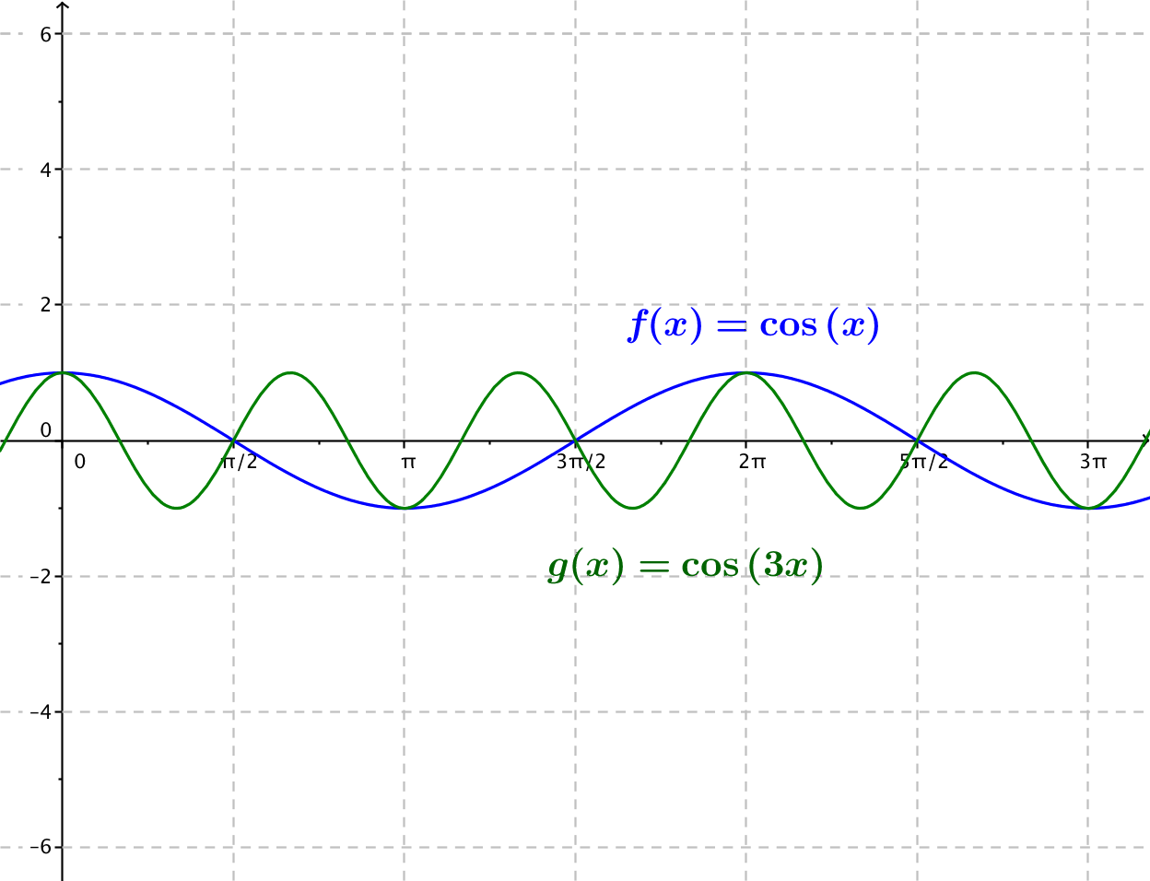
The amplitude is $1$, the frequency is $\frac{3}{2π}$, the period is $\frac{2}{3}π$, and the phase shift is $0$. There are no horizontal or vertical translations, and the equation of the midline is $y=0$.

  - $g\left(x\right)=cos\left(x-\frac{3π}{4}\right)$
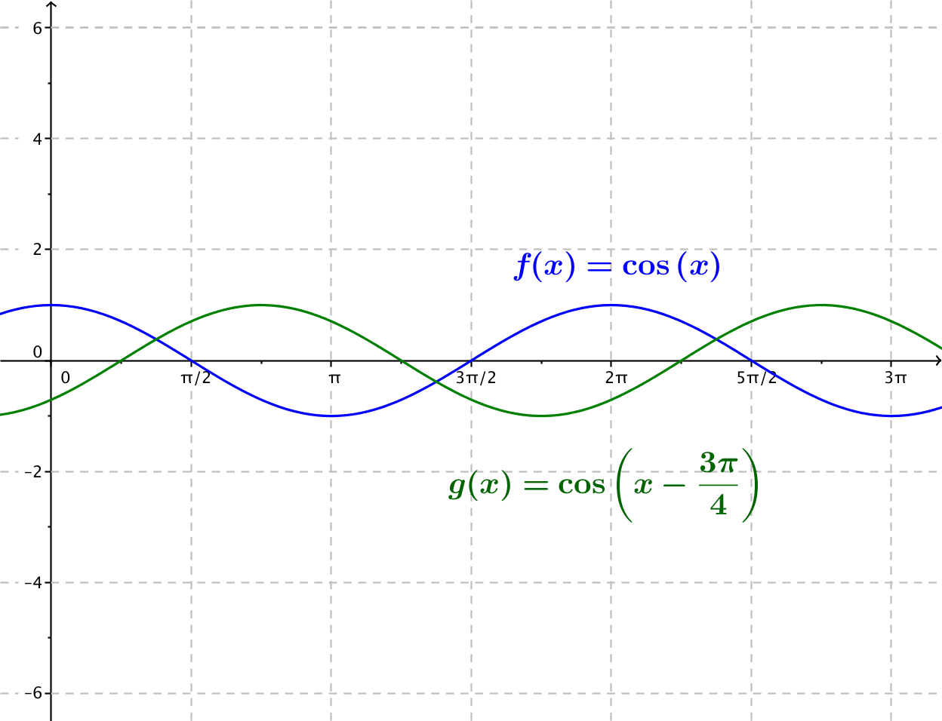
The amplitude is $1$, the frequency is $\frac{1}{2π}$, the period is $2π$, and the phase shift is $\frac{3π}{4}.$ The horizontal translation is $\frac{π}{3}$ units to the right, there is no vertical translation, and the equation of the midline is $y=0$.

  - $g\left(x\right)=3 cos\left(\frac{x}{4}\right)$
The amplitude is $3$, the frequency is $\frac{1}{8π}$, the period is $8π$, and the phase shift is $0.$ There are no horizontal or vertical translations, and the equation for the midline is $y=0$. The graph of $g$ is a vertical scaling of the graph of the cosine function by a factor of $3$ and a horizontal scaling of the graph of the cosine function by a factor of $4.$

  - $g\left(x\right)=3 cos\left(2x\right)-4$
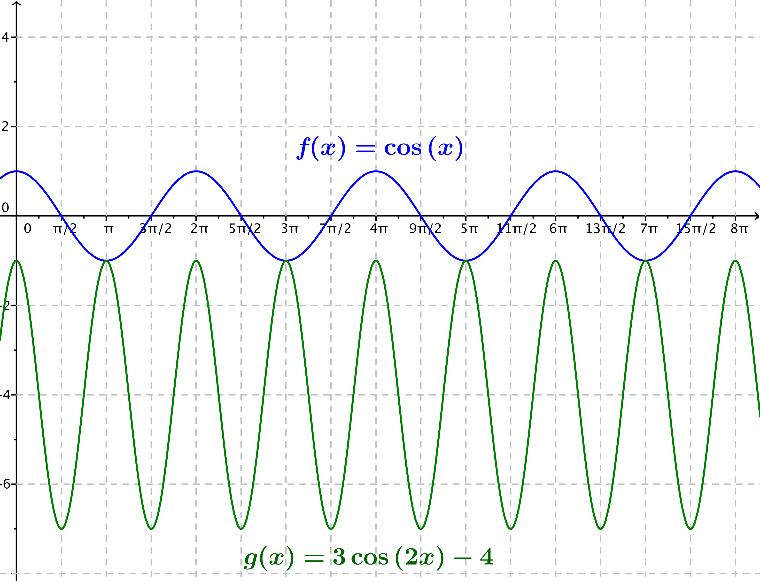
The amplitude is $3$, the frequency is $\frac{1}{π}$, the period is $π$, and the phase shift is $0$. There is no horizontal translation, the graph is translated vertically down $4$ units, and the equation for the midline is $y=-4$.

  - $g\left(x\right)=4 cos\left(\frac{π}{4}-2x\right)$ (Hint: First, rewrite the function in the form $g\left(x\right)=A cos\left(ω\left(x-h\right)\right).$)
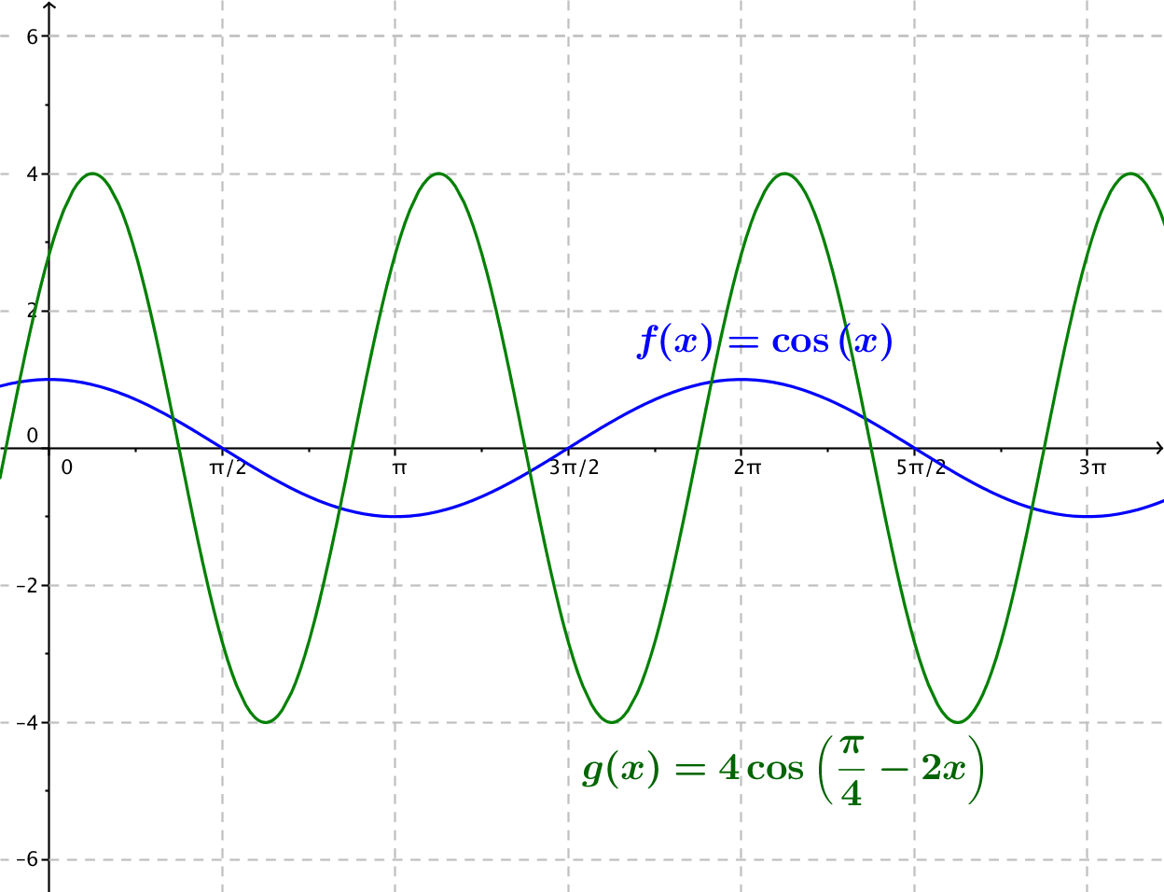
Rewriting the expression, we see that $4 cos\left(\frac{\text{π}}{\text{4}}-2x\right)=4 cos\left(-2\left(x-\frac{\text{π}}{\text{8}}\right)\right)=4 cos\left(2\left(x-\frac{\text{π}}{\text{8}}\right)\right)$. The graph of $g$ is the graph of the cosine function scaled vertically by a factor of $4$, horizontally by a factor of $\frac{1}{2}$, and then translated horizontally $\frac{π}{8}$ units to the right. This tells us that the amplitude is $4$, the frequency is $\frac{1}{π}$, the period is $π$, the phase shift is $\frac{π}{8}$, and the equation for the midline is $y=0$.

- For each problem, sketch the graph of the pairs of indicated functions on the same set of axes without using a calculator or other graphing technology.
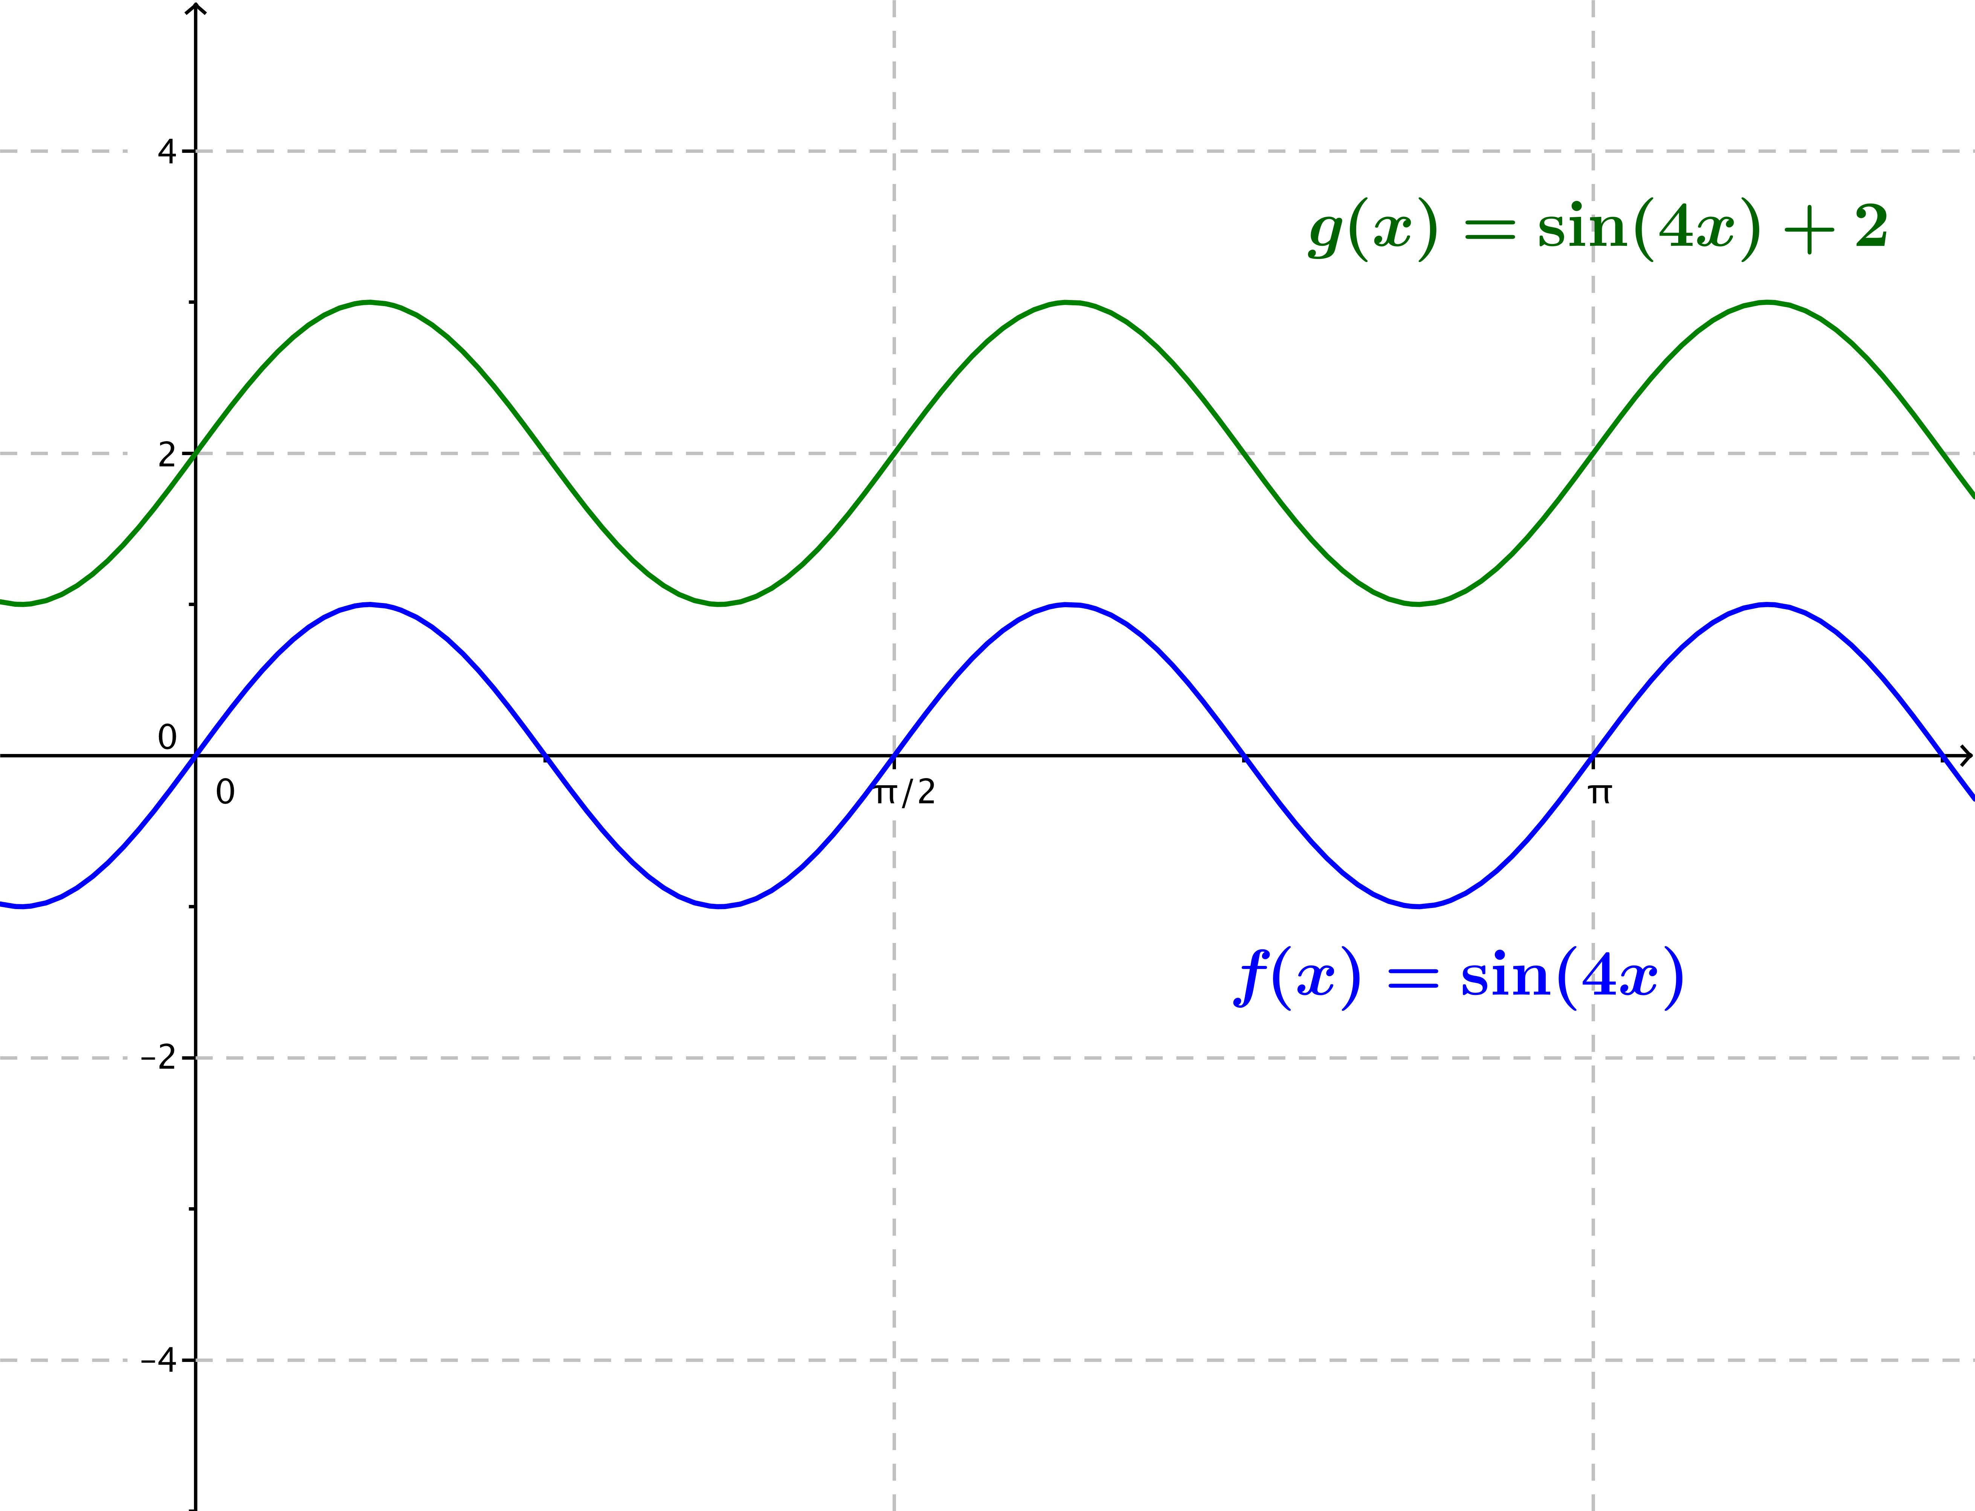
  - $f(x)=\sin{(4x)}$, $g(x)=\sin\left(4x\right)+2$

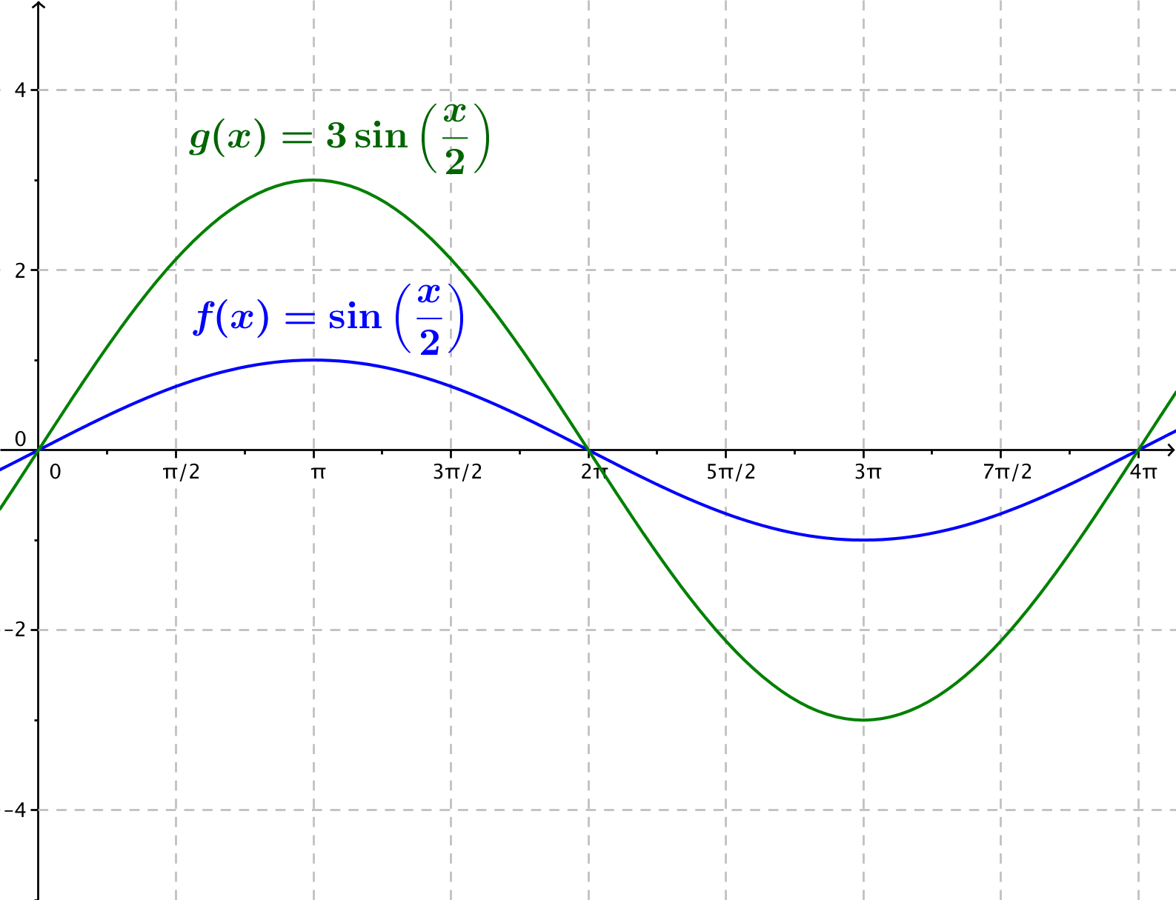
  - $f(x)=\sin\left(\frac{1}{2}x\right)$, $g(x)=3 sin\left(\frac{1}{2}x\right)$

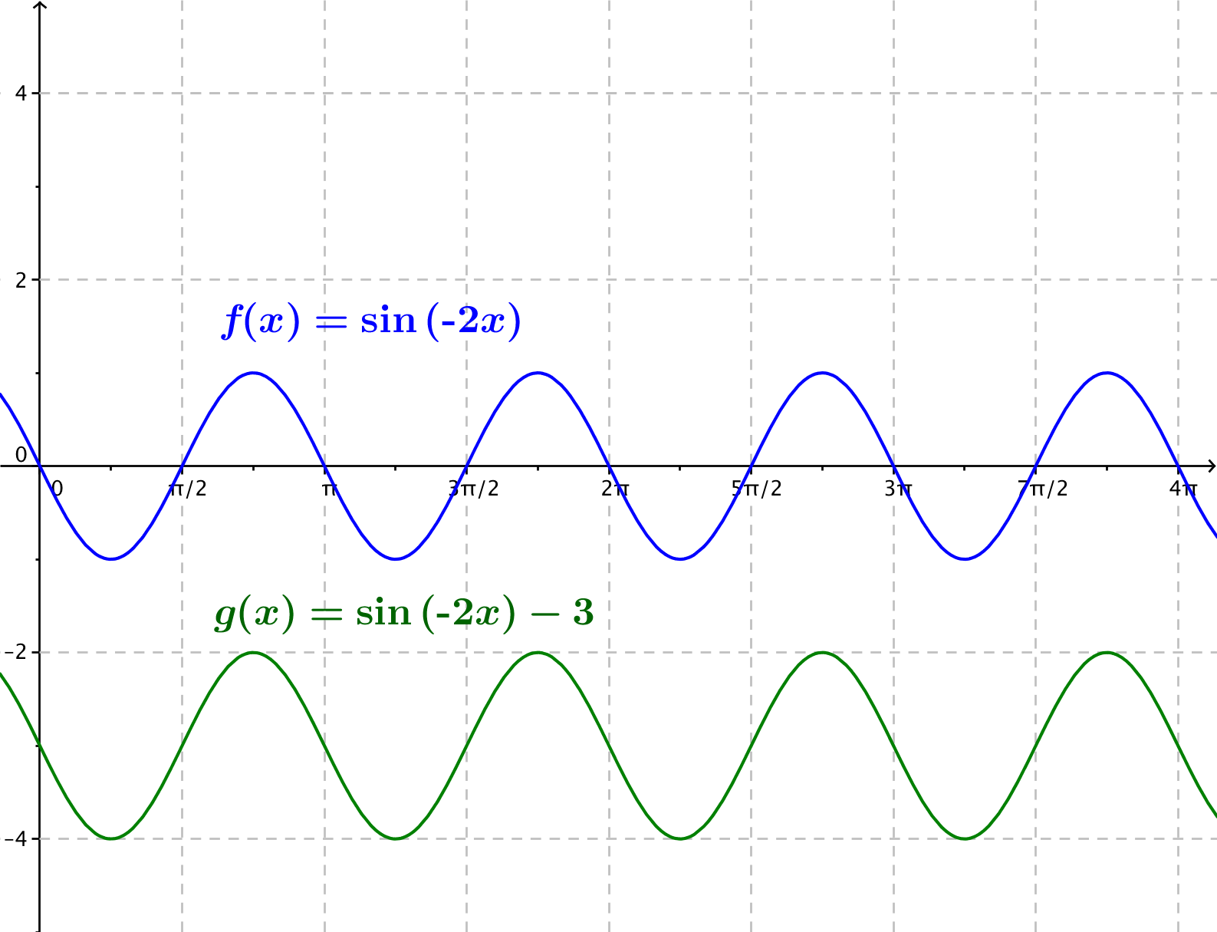
  - $f(x)=\sin{(-2x)}$ , $g(x)=\sin\left(-2x\right)-3$

  - $f(x)=3\sin\left(x\right)$, $g(x)=3\sin\left(x-\frac{π}{2}\right)$
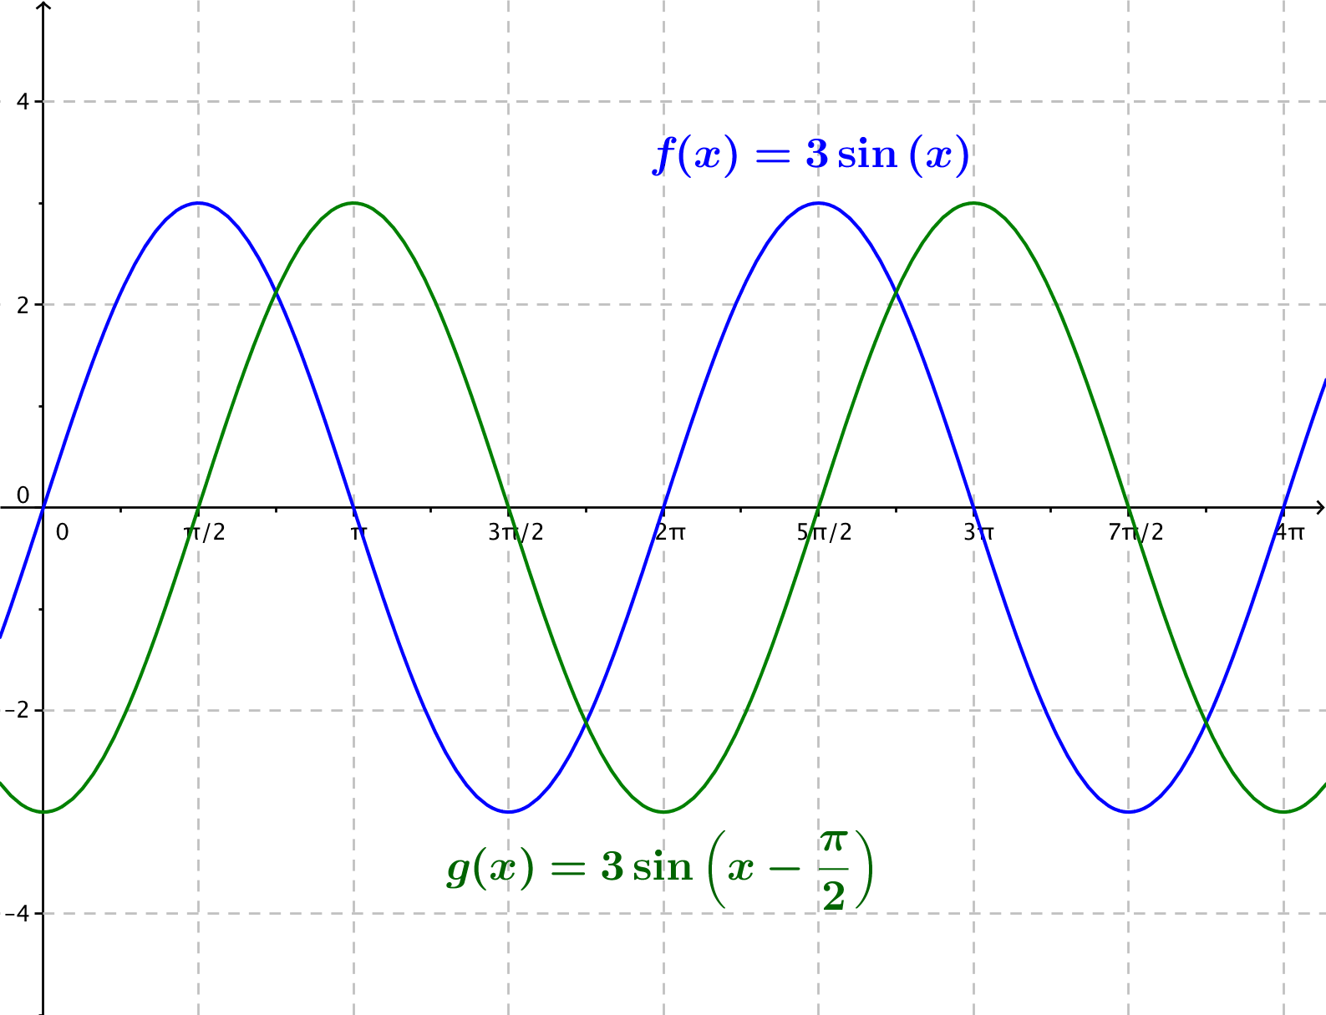
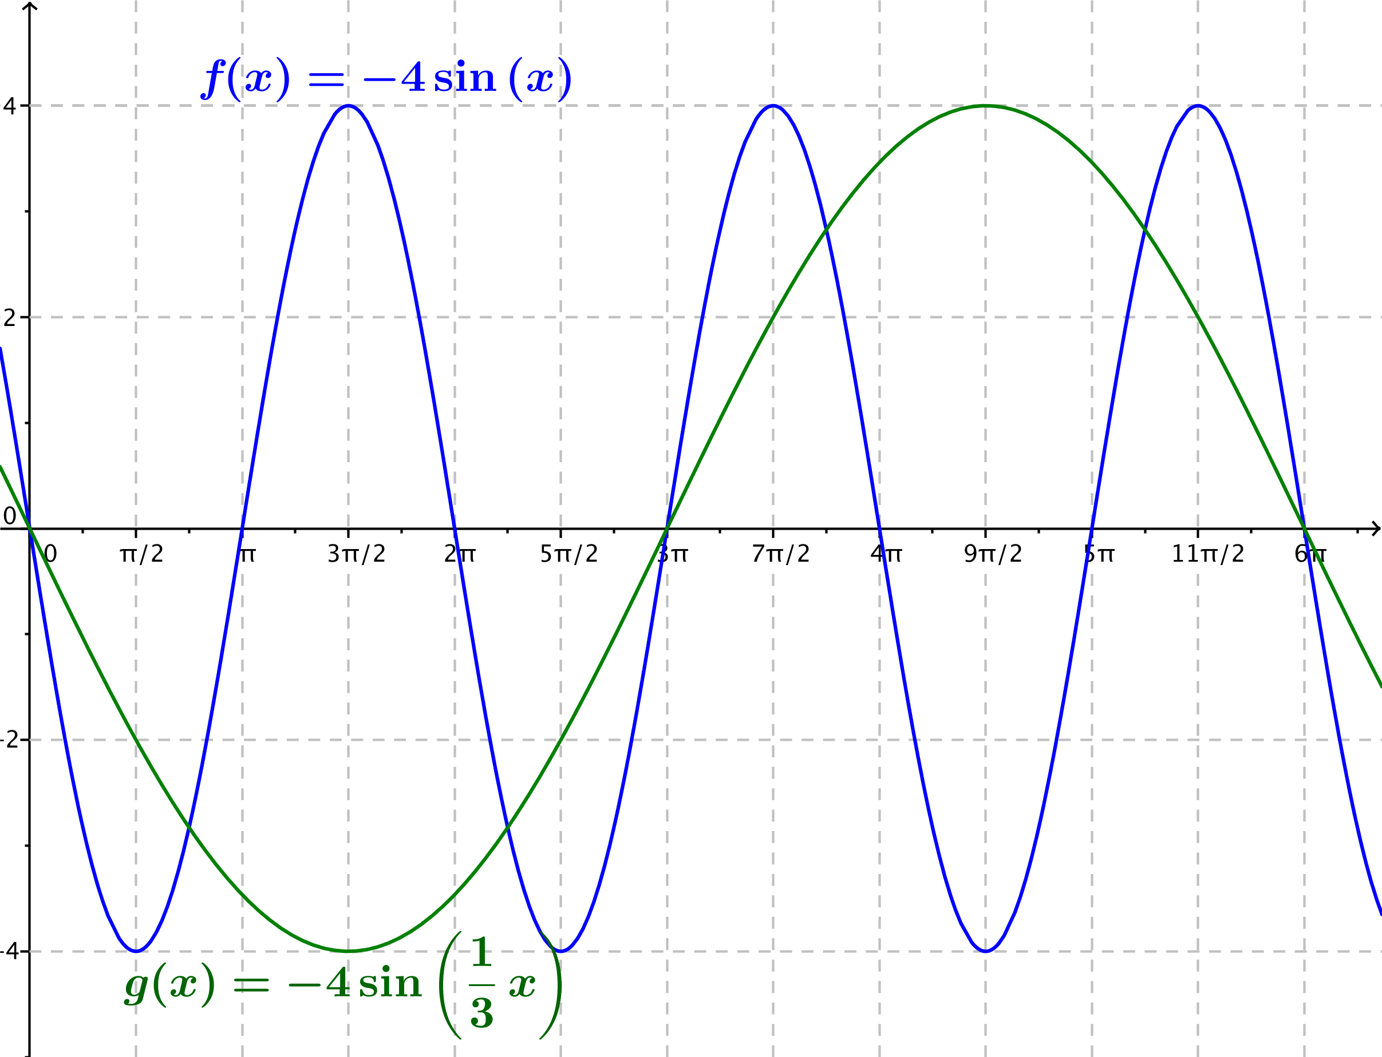
  - $f(x)=-4\sin\left(x\right)$, $g(x)=-4\sin\left(\frac{1}{3}x\right)$

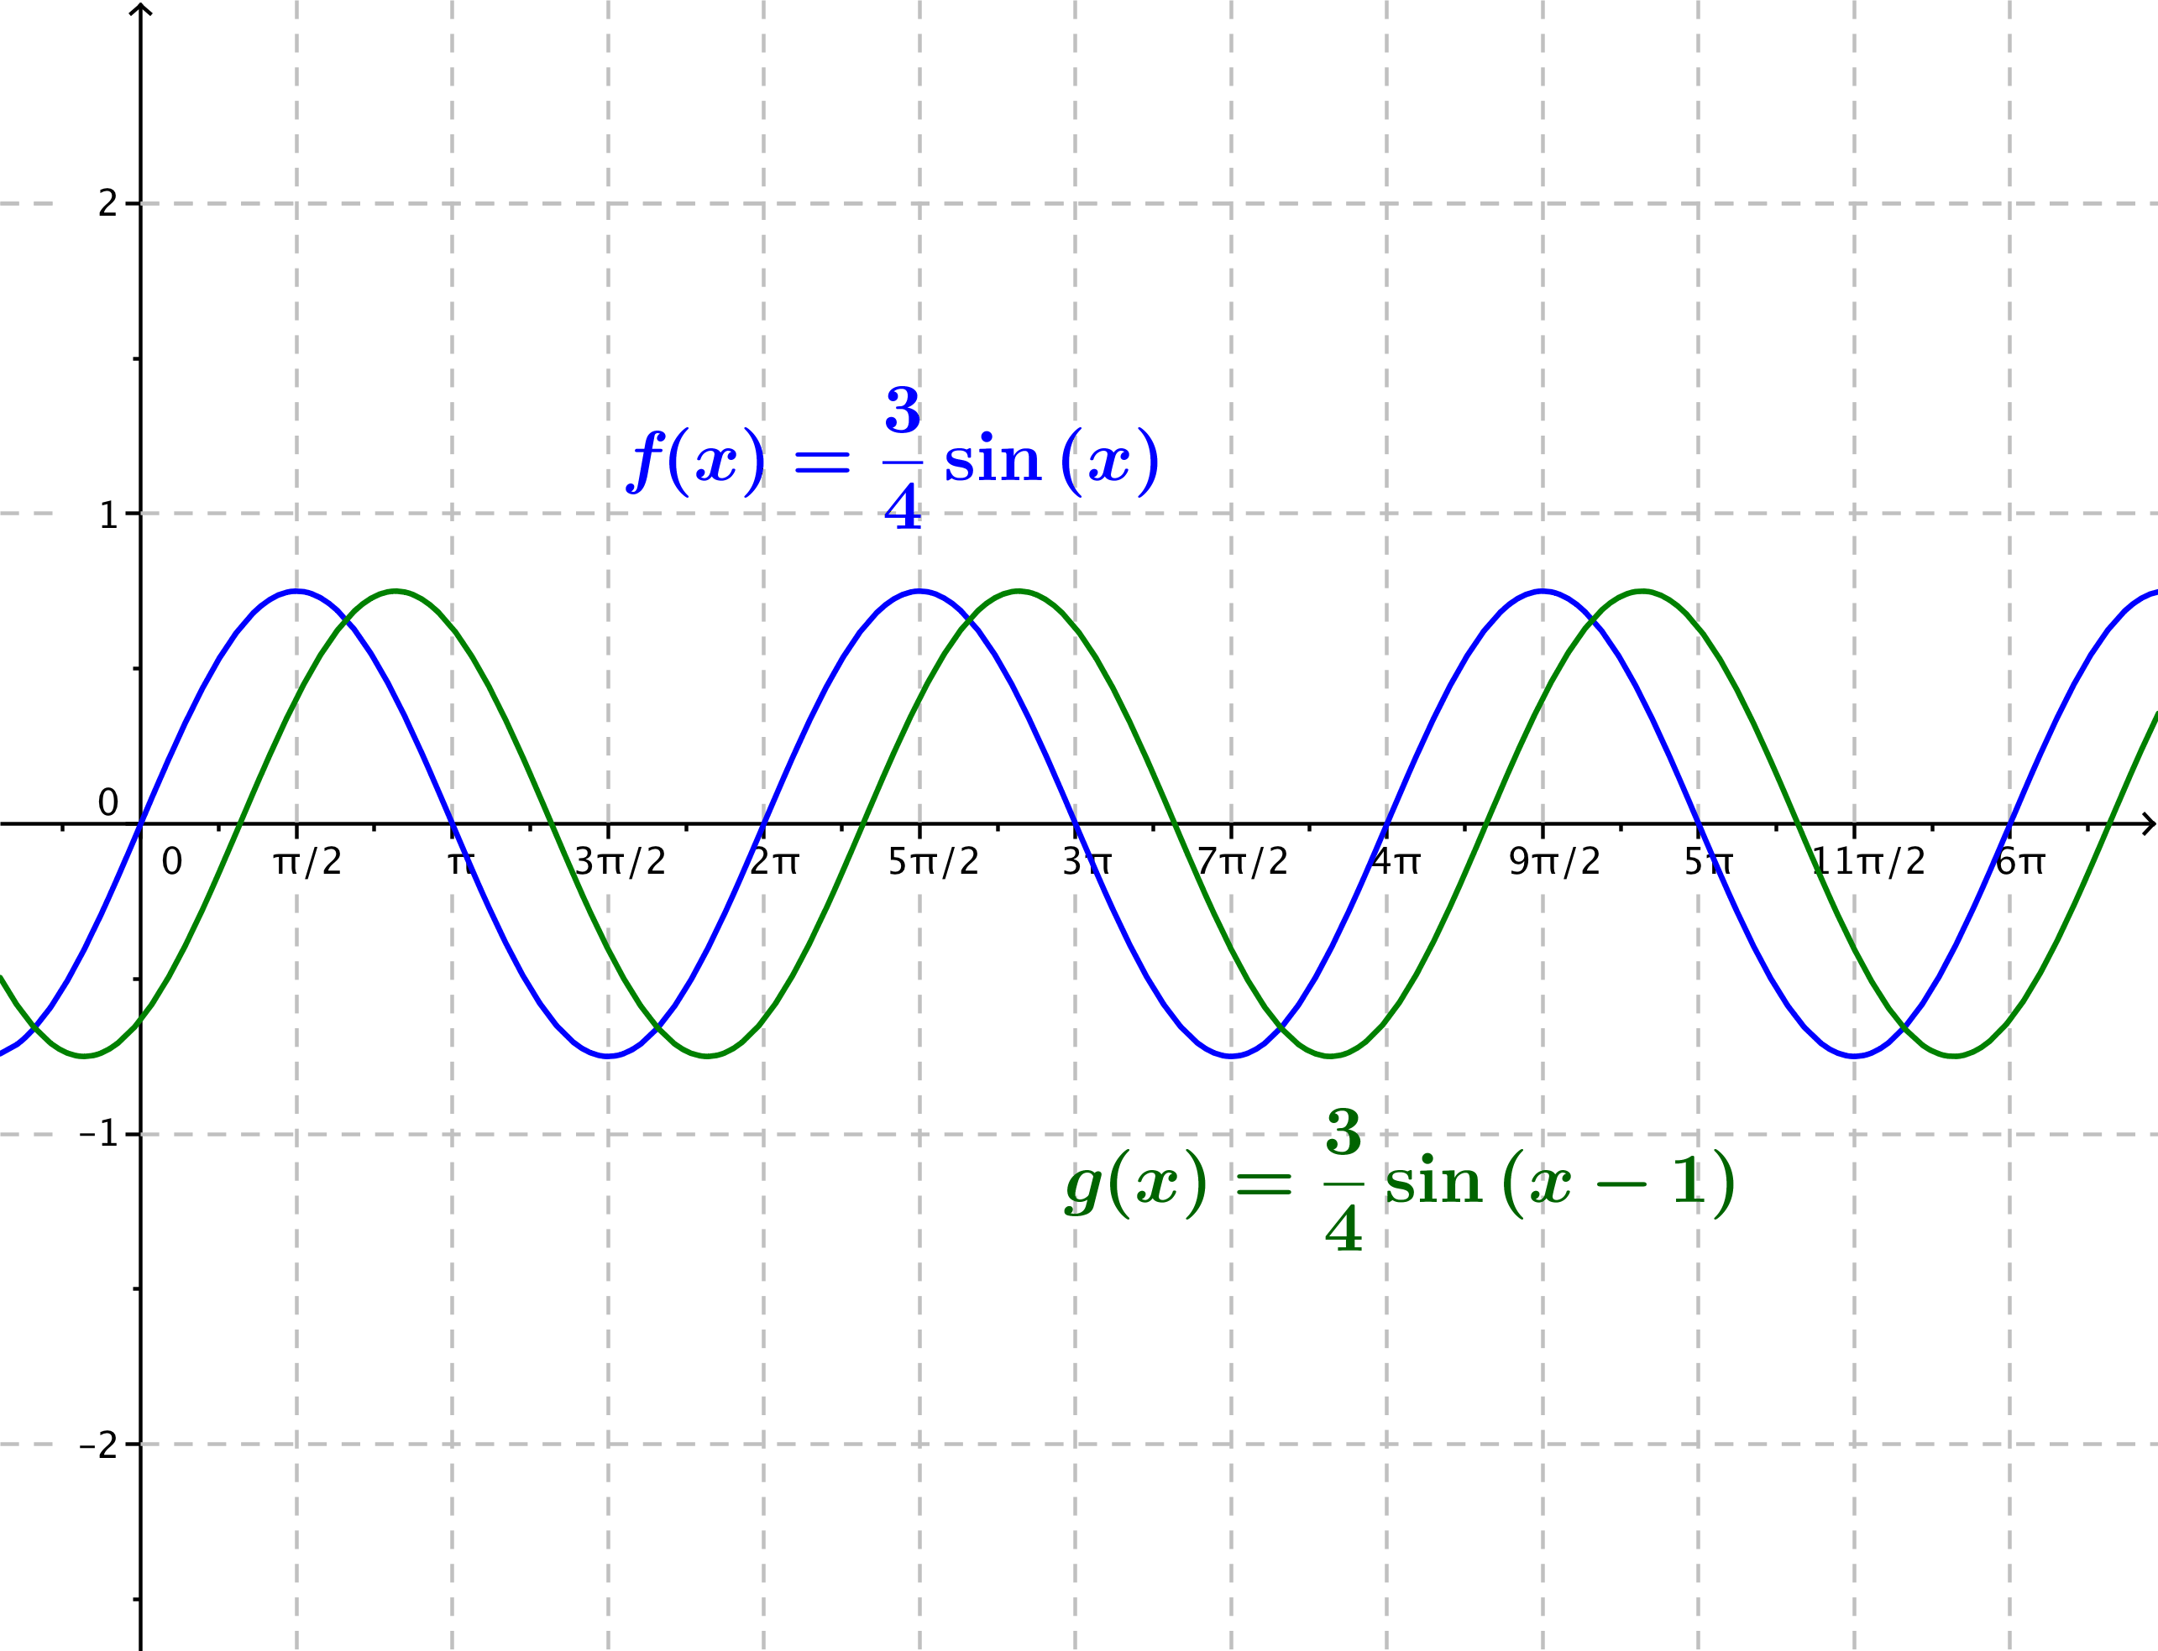
  - $f(x)=\frac{3}{4}\sin{(x)}$, $g(x)=\frac{3}{4}\sin{(x-1)}$

  - $f\left(x\right)=\sin\left(2x\right)$, $g\left(x\right)=\sin\left(2\left(x-\frac{π}{6}\right)\right)$
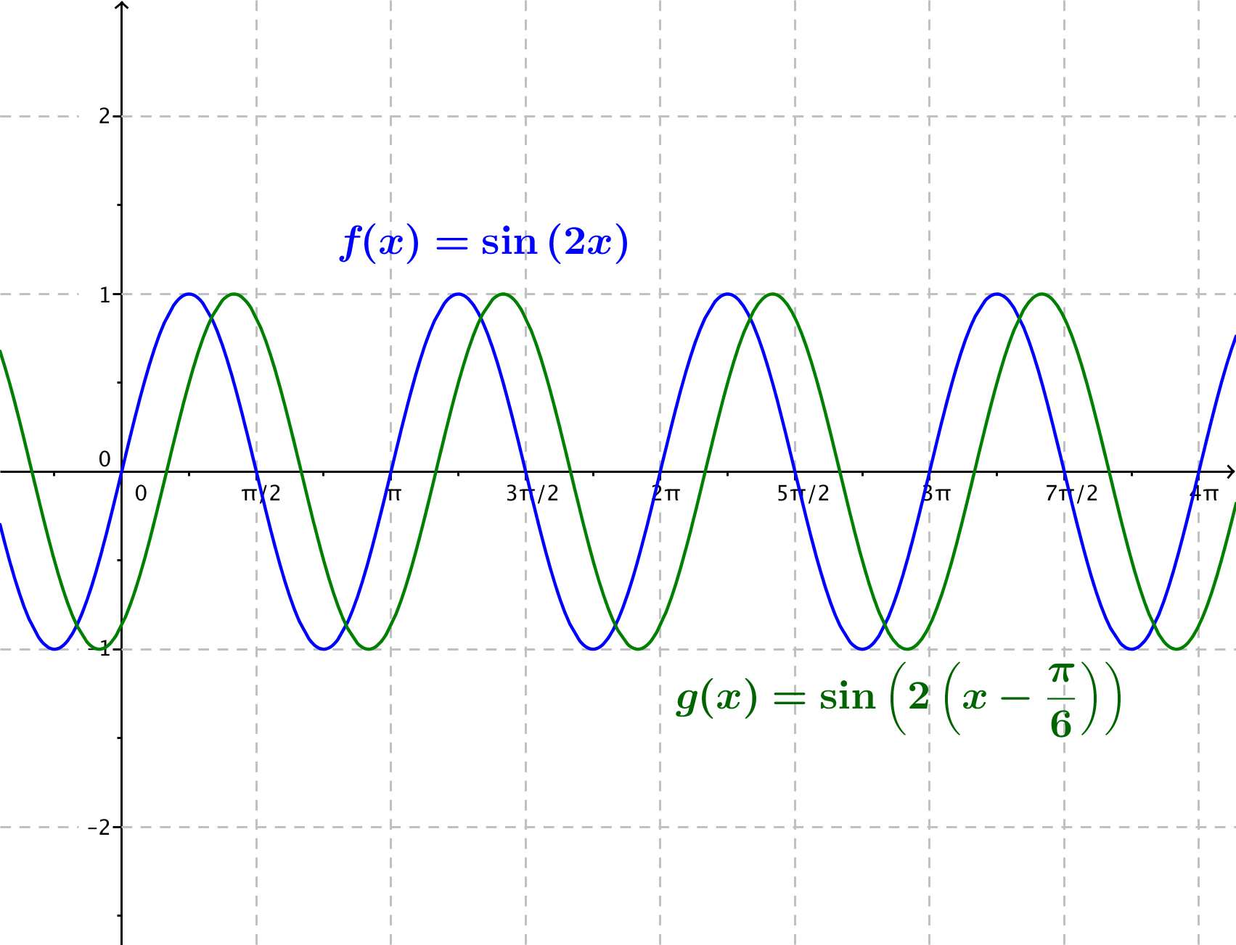

  - $f(x)=4sin\left(x\right)-3$, $g(x)=4\sin\left(x-\frac{π}{4}\right)-3$
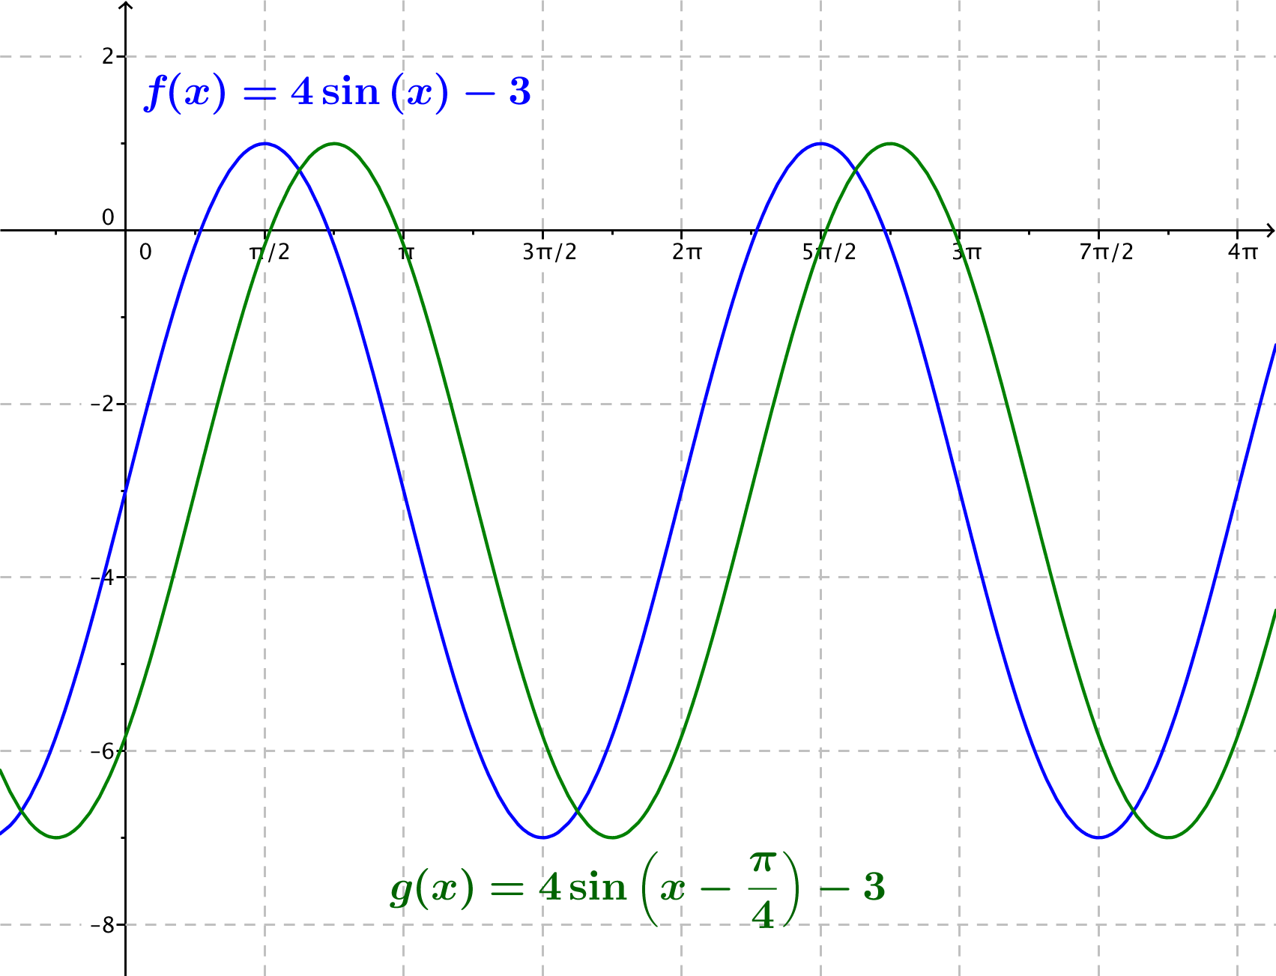

Extension Problems:
- Show that if the graphs of the functions $f(x)=A\sin\left(ω\left(x- h_{1}\right)\right)+k$ and $g(x)=A\sin\left(ω\left(x- h_{2}\right)\right)+k$ are the same, then $h_{1}$ and $h_{2}$ differ by an integer multiple of the period.
Outline of proof: Since functions $f$ and $g$ have the same graph, the functions have the same period $P$. For all values of$x$, the fact that the sine graphs are the same gives
$$A sin\left(ω\left(x-h_{1}\right)\right)=A sin(ω\left(x-h_{2}\right)) \\ sin\left(ω\left(x-h_{1}\right)\right)=sin(ω\left(x-h_{2}\right)) \\ ω\left(x-h_{1}\right)-ω\left(x-h_{2}\right)=n2π \\ \frac{2π}{P}\left(x-h_{1}\right)-\frac{2π}{P}\left(x-h_{2}\right)=n2π \\ \left(x-h_{1}\right)-\left(x-h_{2}\right)=nP \\ h_{1}-h_{2}=nP.$$

- Show that if $h_{1}$ and $h_{2}$ differ by an integer multiple of the period, then the graphs of $f(x)=A\sin\left(ω\left(x-h_{1}\right)\right)+k$ and $g(x)=A\sin\left(ω\left(x-h_{2}\right)\right)+k$ are the same graph.
Outline of proof:
Since $h_{1}$ and $h_{2}$ differ by an integer multiple of the period $P$, there is an integer $n$ so that $h_{2}-h_{1}=nP$.
$$h_{2}-h_{1}=nP \\ \left(x-h_{1}\right)-\left(x-h_{2}\right)=nP \\ \frac{2π}{P}\left(x-h_{1}\right)-\frac{2π}{P}\left(x-h_{2}\right)=n2π \\ ω\left(x-h_{1}\right)-ω\left(x-h_{2}\right)=n2π \\ ω\left(x-h_{1}\right)=ω\left(x-h_{2}\right)+n2π \\ \sin\left(ω\left(x-h_{1}\right)\right)= \sin\left(ω\left(x-h_{2}\right)+n2π\right)$$
But, the sine function is periodic with period $2π$, so$\sin\left(w\left(x-h_{2}\right)+n2π\right)=sin\left(w\left(x-h_{2}\right)\right).$
$$\sin\left(ω\left(x-h_{1}\right)\right)= \sin\left(ω\left(x-h_{2}\right)\right)$$
$$A sin\left(ω\left(x-h_{1}\right)\right)= A\sin\left(ω\left(x-h_{2}\right)\right)$$

- Find the $x$-intercepts of the graph of the function $f\left(x\right)=A sin\left(ω\left(x-h\right)\right)$ in terms of the period $P$, where $ω>0$.
The $x$-intercepts occur when $\sin\left(ω\left(x-h\right)\right)=0$. This happens when $ω\left(x-h\right)=nπ$ for integers $n$.
So, $x-h=\frac{nπ}{ω}$, and then $x=\frac{nπ}{ω}+h.$
Since $P=\frac{2π}{ω}$, this becomes $x=\frac{nP}{2}+h$. Thus, the graph of $f\left(x\right)=A sin(ω\left(x-h\right))$ has $x$-intercepts at $x=\frac{nπ}{\text{ω}}+h$ for integer values of $n$.

