Lesson 11: Transforming the Graph of the Sine Function

Classwork
Opening Exercise
Explore your assigned parameter in the sinusoidal function $f\left(x\right)=A\sin\left(ω\left(x-h\right)\right)+k$. Select several different values for your assigned parameter and explore the effects of changing the parameter’s value on the graph of the function compared to the graph of $f\left(x\right)=\sin{(x)}$. Record your observations in the table below. Include written descriptions and sketches of graphs.

$A$-Team  $$f\left(x\right)=A\sin\left(x\right)$$  Suggested $A$ values:  $$2, 3, 10, 0,-1, -2,\frac{1}{2},\frac{1}{5}, -\frac{1}{3}$$ | $ω$-Team  $$f\left(x\right)=\sin\left(ωx\right)$$  Suggested $ω$ values:  $$2,3,5,\frac{1}{2},\frac{1}{4}, 0,-1, -2,π, 2π, 3π,\frac{π}{2},\frac{π}{4}$$
$k$-Team  $$f\left(x\right)=\sin\left(x\right)+k$$  Suggested $k$ values:  $$2, 3, 10, 0,-1, -2,\frac{1}{2},\frac{1}{5}, -\frac{1}{3}$$ | $h$-Team  $$f\left(x\right)=\sin\left(x-h\right)$$  Suggested $h$ values:  $$π, -π,\frac{π}{2},-\frac{π}{4},2π,2, 0,-1, -2, 5, -5$$

Example
Graph the following function:
$$f\left(x\right)=3\sin\left(4\left(x-\frac{π}{6}\right)\right)+2.$$

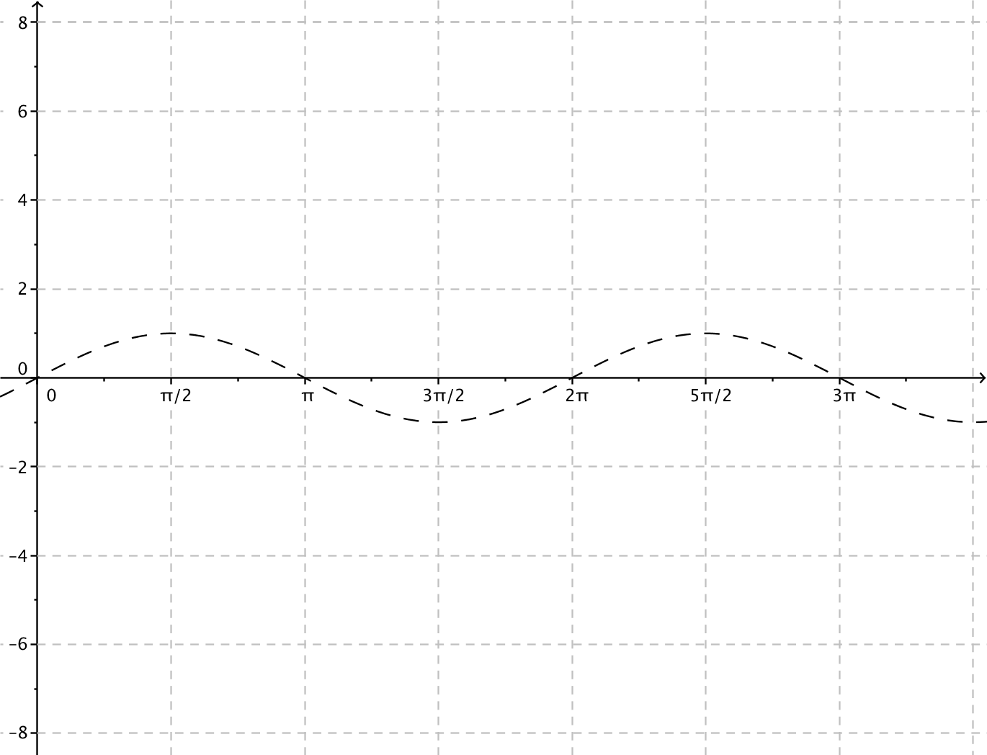

Exercise
For each function, indicate the amplitude, frequency, period, phase shift, vertical translation, and equation of the midline. Graph the function together with a graph of the sine function $f\left(x\right)=sin(x)$ on the same axes. Graph at least one full period of each function.
  - $g\left(x\right)=3\sin\left(2x\right)-1$

  - $g\left(x\right)=\frac{1}{2}\sin\left(\frac{1}{4}(x+π)\right)$

  - $g\left(x\right)=5\sin{(-2x)}+2$

  - $g\left(x\right)=-2\sin\left(3\left(x+\frac{π}{6}\right)\right)$

  - $g\left(x\right)=3\sin\left(x+π\right)+3$

  - $g\left(x\right)=-\frac{2}{3}\sin\left(4x\right)-3$

  - $g\left(x\right)=π\sin\left(\frac{x}{2}\right)+π$

  - $g\left(x\right)=4\sin\left(\frac{1}{2}\left(x-5π\right)\right)$

Problem Set
Lesson Summary
In this lesson, we investigated the effects of the parameters $A$, $ω$, $h$, and $k$ on the graph of the function
$f\left(x\right)=A sin\left(ω\left(x-h\right)\right)+k$.
- The graph of $y=k$ is the midline. The value of $k$ determines the vertical translation of the graph compared to the graph of the sine function. If $k>0$, then the graph shifts $k$ units upwards. If $k<0$, then the graph shifts $k$ units downward.
- The amplitude of the function is $|A|$; the vertical distance from a maximum point to the midline of the graph is $|A|$.
- The phase shift is $h$. The value of $h$ determines the horizontal translation of the graph from the graph of the sine function. If $h>0$, the graph is translated $h$ units to the right, and if $h<0,$ the graph is translated $h$ units to the left.
- The frequency of the function is $f=\frac{\left|ω\right|}{2π}$, and the period is $P=\frac{2π}{|ω|}$. The period is the vertical distance between two consecutive maximal points on the graph of the function.
These parameters affect the graph of $f\left(x\right)=A\cos\left(ω\left(x-h\right)\right)+k$ similarly.

- For each function, indicate the amplitude, frequency, period, phase shift, horizontal, and vertical translations, and equation of the midline. Graph the function together with a graph of the sine function $f\left(x\right)=sin(x)$ on the same axes. Graph at least one full period of each function. No calculators allowed.
  - $g\left(x\right)=3 sin\left(x-\frac{π}{4}\right)$
  - $g\left(x\right)=5 sin(4x)$
  - $g\left(x\right)=4 sin\left(3\left(x+\frac{π}{2}\right)\right)$
  - $g\left(x\right)=6 sin(2x+3π)$ (Hint: First, rewrite the function in the form $g\left(x\right)=A sin\left(ω\left(x-h\right)\right).$)

- For each function, indicate the amplitude, frequency, period, phase shift, horizontal, and vertical translations, and equation of the midline. Graph the function together with a graph of the sine function $f\left(x\right)=cos(x)$ on the same axes. Graph at least one full period of each function. No calculators allowed.
  - $g\left(x\right)=cos(3x)$
  - $g\left(x\right)=cos\left(x-\frac{3π}{4}\right)$
  - $g\left(x\right)=3 cos\left(\frac{x}{4}\right)$
  - $g\left(x\right)=3 cos\left(2x\right)-4$
  - $g\left(x\right)=4 cos\left(\frac{π}{4}-2x\right)$ (Hint: First, rewrite the function in the form $g\left(x\right)=A cos\left(ω\left(x-h\right)\right).$)

- For each problem, sketch the graph of the pairs of indicated functions on the same set of axes without using a calculator or other graphing technology.
  - $f(x)=\sin{(4x)}$, $g(x)=\sin\left(4x\right)+2$
  - $f(x)=\sin\left(\frac{1}{2}x\right)$, $g(x)=3 sin\left(\frac{1}{2}x\right)$
  - $f(x)=\sin{(-2x)}$, $g(x)=\sin\left(-2x\right)-3$
  - $f(x)=3\sin\left(x\right)$, $g(x)=3\sin\left(x-\frac{π}{2}\right)$
  - $f(x)=-4\sin\left(x\right)$, $g(x)=-4\sin\left(\frac{1}{3}x\right)$
  - $f(x)=\frac{3}{4}\sin{(x)}$, $g(x)=\frac{3}{4}\sin{(x-1)}$
  - $f\left(x\right)=\sin\left(2x\right)$, $g\left(x\right)=\sin\left(2\left(x-\frac{π}{6}\right)\right)$
  - $f(x)=4sin\left(x\right)-3$, $g(x)=4\sin\left(x-\frac{π}{4}\right)-3$

Extension Problems
- Show that if the graphs of the functions $f(x)=A\sin\left(ω\left(x- h_{1}\right)\right)+k$ and $g(x)=A\sin\left(ω\left(x- h_{2}\right)\right)+k$ are the same, then $h_{1}$ and $h_{2}$ differ by an integer multiple of the period.

- Show that if $h_{1}$ and $h_{2}$ differ by an integer multiple of the period, then the graphs of $f(x)=A\sin\left(ω\left(x- h_{1}\right)\right)+k$ and $g(x)=A\sin\left(ω\left(x- h_{2}\right)\right)+k$ are the same graph.

- Find the $x$-intercepts of the graph of the function $f\left(x\right)=A sin\left(ω\left(x-h\right)\right)$ in terms of the period $P$, where $ω>0$.

