Lesson 10: Basic Trigonometric Identities from Graphs

Student Outcomes
- Students observe identities from graphs of sine and cosine basic trigonometric identities and relate those identities to periodicity, even and odd properties, intercepts, end behavior, and cosine as a horizontal translation of sine.

Lesson Notes
Students have previous experience with graphing the sine and cosine functions in degrees and have been introduced to radian measure in the previous lesson. For the remainder of the module, students will use radians to work with and graph trigonometric functions. The purpose of this lesson is to increase the students’ comfort with radians and to formalize the characteristics of periodicity, end behavior, intercepts, and relative extrema of the sine and cosine functions through the observation and conjecture of some basic trigonometric identities. As students work through the lesson, make sure that they grasp the following identities that are valid for all real numbers $x$
$$\sin\left(x+2π\right)=\sin\left(x\right)$$ | $$\sin\left(x+π\right)=-\sin\left(x\right)$$ | $$\sin\left(-x\right)=-sin\left(x\right)$$
$$\cos\left(x+2π\right)=\cos\left(x\right)$$ | $$\cos\left(x+π\right)=-\cos\left(x\right)$$ | $$\cos\left(-x\right)=\cos\left(x\right)$$
and that they know how to use these identities to evaluate sine and cosine for a variety of values of $x$. While these six trigonometric identities are the focus of this lesson, other identities will be proven in Lessons 15, 16, and 17 of this module.
It is important to note that an identity is a statement that two functions are equal on a common domain. Thus, to specify an identity, we need to specify both an equation and a set of values for the variable for which the statement is true. That is, the statement “$\sin\left(-x\right)=-sin⁡(x)$” itself is not an identity, but the statement “$\sin\left(-x\right)=-sin⁡(x)$ for all real numbers $x$” is an identity.

Materials
Supply students with colored pencils for the activity.

Classwork
Opening (2 minutes)
Students should be able to largely work through these explorations in groups without too much assistance. You may want to help students get started in constructing their table of values by reminding them of the values where the sine and cosine functions take on the values $0$, $1$, and $-1$. Also, remind students that they have seen these graphs earlier in the module, but the graphs were constructed using degree measures. Today (and for the remainder of the module) we will be graphing using radian measures.

Exploratory Challenge 1 (18 minutes)
Allow students to work in groups through this problem. Because students are repeating a similar process to discover three different identities, you could assign groups different parts of the Exploratory Challenge and then have them report their results to the class. If students are having trouble with the table, help them get started by reminding them that the maximum and minimum values and $x$-intercepts can be found by evaluating sine at the extreme points on the circle. Circulate the room to ensure that students are comfortable working with the radian values and that they are using the graph to discover the identities. Debrief after this activity to ensure that students have discovered the identities correctly.
Exploratory Challenge 1
Consider the function $f(x)=sin(x)$ where $x$ is measured in radians.
Graph $f(x)=sin(x)$ on the interval $[-π, 5π]$by constructing a table of values. Include all intercepts, relative maximum points, and relative minimum points of the graph. Then, use the graph to answer the questions that follow.

$$x$$
$$f(x)$$
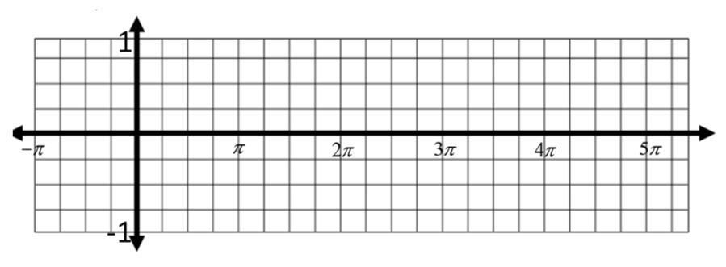
Scaffolding:
- This could also be accomplished using technology. Students could observe these identities by using the table or graph feature of a graphing calculator.
- Advanced learners could be asked to write similar identities for the cosecant function. For example, since $sin⁡(x+π)=-sin(x)$, does it follow that $csc(x+π)=-csc(x)$? Test it either by using test values or exploring the graph of cosecant.
- Using one of your colored pencils, mark the point on the graph at each of the following pairs of $x$-values.
$x=-\frac{π}{2}$ and $x=-\frac{π}{2}+2π$
$x=π$ and $x=π+2π$
$x=\frac{7π}{4}$ and $x=\frac{7π}{4}+2π$

- What can be said about the $y$-values for each pair of $x$-values marked on the graph?
For each pair of $x$-values, the $y$-values are the same.
MP.8
- Will this relationship hold for any two $x$-values that differ by $2π$? Explain how you know.
Yes. Since the sine function repeats every $2π$ units, then the relationship described in part (b) will hold for any two $x$-values that differ by $2π$.

- Based on these results, make a conjecture by filling in the blank below.
MP.8
For any real number $x$, $\sin\left(x+2π\right)=_______________.$
$$sin\left(x+2π\right)=\sin{(x)}$$

- Test your conjecture by selecting another $x$-value from the graph and demonstrating that the equation from part (d) holds for that value of $x$.
$\sin\left(\frac{5π}{2}\right)=\sin\left(\frac{π}{2}+2π\right)=\sin\left(\frac{π}{2}\right)=1$ (Answers will vary).

- How does the conjecture in part (d) support the claim that the sine function is a periodic function?
The sine function repeats every $2π$ units because $2π$ radians is one full turn. Thus, if we rotate the initial ray through $x+2π$ radians, the terminal ray is in the same position as if we had rotated by $x$ radians.

- Use this identity to evaluate $sin\left(\frac{13π}{6}\right)$.
$$\sin\left(\frac{13π}{6}\right)=\sin\left(\frac{π}{6}+2π\right)=\sin\left(\frac{π}{6}\right)=\frac{1}{2}$$

- Using one of your colored pencils, mark the point on the graph at each of the following pairs of $x$-values.
$x=-\frac{π}{4}$ and $x=-\frac{π}{4}+π$
$x=2π$ and $x=2π+π$
$x=\frac{5π}{2}$ and $x=\frac{5π}{2}+π$

- What can be said about the $y$-values for each pair of $x$-values marked on the graph?
For each pair of $x$-values, the $y$-values have the same magnitude but opposite sign.

- Will this relationship hold for any two $x$-values that differ by $π$? Explain how you know.
Yes. Since rotating by an additional $π$ radians produces a point in the opposite quadrant with the same reference angle, the sine of the two numbers will have the same magnitude and opposite sign.

- Based on these results, make a conjecture by filling in the blank below.
For any real number$x$, $\sin\left(x+π\right)=_______________$.
$sin\left(x+π\right)=-sin(x)$

- Test your conjecture by selecting another $x$-value from the graph and demonstrating that the equation from part (k) holds for that value of $x$.
$$\sin\left(\frac{3π}{2}\right)=\sin\left(\frac{π}{2}+π\right)=-\sin\left(\frac{π}{2}\right)=-1$$

- Is the following statement true or false? Use the conjecture from (k) to explain your answer.
$sin\left(\frac{4π}{3}\right)=-sin⁡\left(\frac{π}{3}\right)$
This statement is true: $sin\left(\frac{4π}{3}\right)=sin\left(\frac{π}{3}+ π\right)=-\sin\left(\frac{π}{3}\right).$
- Using one of your colored pencils, mark the point on the graph at each of the following pairs of $x$-values.
$x=-\frac{3π}{4}$ and $x=\frac{3π}{4}$
$x=-\frac{π}{2}$ and $x=\frac{π}{2}$

- What can be said about the $y$-values for each pair of $x$-values marked on the graph?
For each pair of $x$-values, the $y$-values have the same magnitude but with the opposite sign.

- Will this relationship hold for any two $x$-values with the same magnitude but opposite sign? Explain how you know.
Yes. If rotation by $x$ radians produces the point $(a,b)$ on the unit circle, then rotation by $-x$ radians will produce a point $(a,-b)$ on the unit circle.

- Based on these results, make a conjecture by filling in the blank below.
For any real number $x$, $\sin\left(-x\right)=_______________.$
$$\sin\left(-x\right)=-sin(x)$$

- Test your conjecture by selecting another $x$-value from the graph and demonstrating that the equation from part (q) holds for that value of $x$.
For example, $sin\left(-\frac{3π}{4}\right)=-\frac{\sqrt{2}}{2}$ and $sin\left(\frac{3π}{4}\right)=\frac{\sqrt{2}}{2}$, so $sin\left(-\frac{3π}{4}\right)=-sin\left(\frac{3π}{4}\right)$.

- Is the sine function an odd function, even function, or neither? Use the identity from part (q) to explain.
The sine function is an odd function because $sin\left(-x\right)=-sin(x)$ and because the graph is symmetric with respect to the origin.

- Describe the$x$-intercepts of the graph of the sine function.
The graph of the sine function has $x$-intercepts at all $x$-values such that $x=nπ$, where $n$ is an integer.

- Describe the end behavior of the sine function.
As $x$ increases to $∞$ or as $x$ decreases to $-∞$, the sine function cycles between the values of $-1$ and $1.$

During the debriefing, record (or have students record) the key results on the board.
For all $x$: $\sin\left(x+2π\right)=\sin\left(x\right) \sin\left(x+π\right)=-\sin\left(x\right) \sin\left(-x\right)=-sin\left(x\right)$

Exploratory Challenge 2 (10 minutes)
Allow students to work in groups through this problem. This exploration should go more quickly as it is the same process that students went through in Exploratory Challenge 1. As suggested above, you could assign groups different parts of the Exploratory Challenge and then have them report their results to the class. Debrief after this activity to ensure that students have completed the identities correctly.
Exploratory Challenge 2
Consider the function $g(x)=cos(x)$where $x$ is measured in radians.
Graph$g(x)=cos(x)$on the interval $[-π,5π]$by constructing a table of values. Include all intercepts, relative maximum points, and relative minimum points. Then, use the graph to answer the questions that follow.

$$x$$
$$g(x)$$

  - Using one of your colored pencils, mark the point on the graph at each of the following pairs of $x$-values.
$x = -\frac{π}{2}$ and $x = -\frac{π}{2}+2π$
$x = π$ and $x = π+2π$
$x = \frac{7π}{4}$ and$x = \frac{7π}{4}+2π$

  - What can be said about the $y$-values for each pair of $x$-values marked on the graph?
For each pair of$x$-values, the$y$-values are the same.

  - Will this relationship hold for any two $x$-values that differ by $2π$? Explain how you know.
Yes. Since the sine function repeats every $2π$ units, then the relationship in part (b) will hold for any two
$x$-values that differ by $2π$.

  - Based on these results, make a conjecture by filling in the blank below.
For any real number $x$, $\cos\left(x+2π\right)=_______________$.
$$cos\left(x+2π\right)=cos(x)$$

  - Test your conjecture by selecting another $x$-value from the graph and demonstrating that the equation from part (d) holds for that value of $x$.
$cos\left(0\right)=cos\left(0+2π\right)=1$ (Answers will vary)

  - How does the conjecture from part (d) support the claim that the cosine function is a periodic function?
Like the sine function, the cosine function repeats every $2π$ units because $2π$ radians is one full turn. Thus, if we rotate the initial ray through $x+2π$ radians, the terminal ray is in the same position as if we had rotated by $x$ radians.

  - Use this identity to evaluate$cos\left(\frac{9π}{4}\right)$.
$$cos\left(\frac{9π}{4}\right)=cos\left(\frac{π}{4}+2π\right)=cos\left(\frac{π}{4}\right)=\frac{\sqrt{2}}{2}$$

  - Using one of your colored pencils, mark the point on the graph at each of the following pairs of $x$-values.
$x = -\frac{π}{4}$and $x = -\frac{π}{4}+π$
$x = 2π$ and $x = 2π+π$
$x = \frac{5π}{2}$ and $x = \frac{5π}{2}+π$

  - What can be said about the$y$-values for each pair of $x$-values marked on the graph?
For each pair of$x$-values, the$y$-values have the same magnitude but opposite sign.

  - Will this relationship hold for any two $x$-values that differ by $π$? Explain how you know.
Yes. Since rotating by an additional $π$ radians produces a point in the opposite quadrant with the same reference angle, the sine of the two numbers will have the same magnitude and opposite sign.

  - Based on these results, make a conjecture by filling in the blank below.
For any real number $x$, $cos⁡(x+π)=_______________$.
$$cos\left(x+π\right)=-cos\left(x\right)$$

  - Test your conjecture by selecting another $x$-value from the graph and demonstrating that the equation from part (k) holds for that value of $x$.
$cos\left(3π\right)=cos\left(2π+ π\right)=-cos\left(2π\right)=-1$

  - Is the following statement true or false? Use the identity from part (k) to explain your answer.
$cos\left(\frac{5π}{3}\right)=-cos\left(\frac{2π}{3}\right)$
This statement is true: $cos\left(\frac{5π}{3}\right)=cos\left(\frac{2π}{3}+π\right)=-cos\left(\frac{2π}{3}\right)$.

  - Using one of your colored pencils, mark the point on the graph at each of the following pairs of $x$-values.
$x = -\frac{3π}{4}$ and $x = \frac{3π}{4}$
$x = -π$ and $x = π$
  - What can be said about the $y$-values for each pair of $x$-values marked on the graph?
For each pair of $x$-values, the$y$-values have the same magnitude and the same sign.

  - Will this relationship hold for any two $x$-values with the same magnitude and same sign? Explain how you know.
Yes. If rotation by $x$ radians produces the point $(a,b)$ on the unit circle, then rotation by $-x$ radians will produce a point $(a,-b)$ on the unit circle.

  - Based on these results, make a conjecture by filling in the blank below.
For any real number $,$ $\cos\left(-x\right)=_______________$.
$cos\left(-x\right)=cos(x)$
Scaffolding:
Advanced learners could be asked to write similar identities for the tangent function. For example, does $tan(-x)$ equal $tan(x)$or $tan(-x)$ or neither? Prove it by applying the properties of sine and cosine.

  - Test your conjecture by selecting another $x$-value from the graph and demonstrating that the identity is true for that value of $x$.
$$cos\left(-2π\right)=cos\left(2π\right)=1$$

  - Is the cosine function an odd function, even function, or neither? Use the identity from part (n) to explain.
The cosine function is an even function because $cos\left(-x\right)=cos(x)$ and because the graph is symmetric with respect to the$y$-axis.

  - Describe the $x$-intercepts of the graph of the cosine function.
The graph of the cosine function has $x$-intercepts at all $x$-values such that$x = \frac{π}{2}+nπ$, where $n$is an integer.

  - Describe the end behavior of $g(x)=cos(x)$.
As $x$ increases to $∞$ or as $x$ decreases to $-∞$, the cosine function cycles between the values of $-1$ and $1.$

During the debriefing, record (or have students record) the key results on the board.
For all $x$: $\cos\left(x+2π\right)=\cos\left(x\right)\cos\left(x+π\right)=-\cos\left(x\right)\cos\left(-x\right)=\cos\left(x\right)$

Exploratory Challenge 3 (8 minutes)
Allow students to work in groups through this problem. To save time, you could choose to provide students with a paper that already has the two functions graphed together. Debrief after this exercise to ensure that students have completed the identities correctly.

Exploratory Challenge 3
Graph both $f(x)=sin(x)$ and$g(x)=cos(x)$ on the graph below. Then, use the graphs to answer the questions that follow.
  - List ways in which the graphs of the sine and cosine functions are alike.
Both functions are periodic and have a period of $2π$. Both functions have a domain of all real numbers and a range of$[-1,1]$. Both functions cycle between $-1$ and $1$ as $x$ increases to $∞$ or as $x$ decreases to $-∞$.
Both have similar identities such as $\sin\left(x+2π\right)=\sin\left(x\right)$and $\cos\left(x+2π\right)=\cos\left(x\right)$.

  - List ways in which the graphs of the sine and cosine functions are different.
We stated above that$f(x)=sin(x)$is an odd function, and $g(x) = cos(x)$ is an even function. Where the sine function is at a maximum or minimum point, the cosine function has an $x$-intercept and vice versa.

  - What type of transformation would be required to make the graph of the sine function coincide with the graph of the cosine function?
A horizontal shift

  - What is the smallest possible horizontal translation required to make the graph of $f(x)=sin(x)$ coincide with the graph of $g(x)=cos(x)$?
A horizontal shift $\frac{π}{2}$units to the left

  - What is the smallest possible horizontal translation required to make the graph of$g(x)=cos(x)$ coincide with the graph of $f\left(x\right)=sin(x)$?
A horizontal shift $\frac{π}{2}$units to the right

  - Use your answers from parts (d) and (e) to fill in the blank below.
For any real number $x$,$__________=\cos\left(x-\frac{π}{2}\right)$.
For any real number $x$, ________$=\sin\left(x+\frac{π}{2}\right)$.
$$\sin\left(x\right)=\cos\left(x-\frac{π}{2}\right) \\ \cos{(x)}=\sin\left(x+\frac{π}{2}\right)$$

Note during the debriefing that there are many different horizontal shifts that could be used in order to make the sine function coincide with the cosine function or vice versa. Ask students for other examples.
Closing (2 minutes)
Ask the students to explain to a partner or record an explanation on paper. If time permits, ask them to demonstrate using a specific example.
- Explain how the identities “For all real numbers $x$, $\cos\left(x+2π\right)=\cos\left(x\right)$” and “For all real numbers $x$, $\sin\left(x+2π\right)=\sin\left(x\right)$” support the idea that both sine and cosine are periodic.
  - These identities both state that if $2π$ is added to the value of $x$, the value of sine or cosine does not change. This confirms that the functions are periodic and repeat every $2π$ units.
MP.2
- How do these identities help us to evaluate sine and cosine for various $x$-values? For example, how can we use the fact that $\sin\left(\frac{π}{4}\right)=\frac{\sqrt{2}}{2}$ to find $sin\left(\frac{5π}{4}\right)$?
  - $sin⁡\left(\frac{5π}{4}\right)=\sin\left(\frac{π}{4}+π\right)=-\sin\left(\frac{π}{4}\right)=-\frac{\sqrt{2}}{2}$

Exit Ticket (5 minutes)

Name Date
Lesson 10: Basic Trigonometric Identities from Graphs

Exit Ticket

- Demonstrate how to evaluate $\cos\left(\frac{8π}{3}\right)$ by using a trigonometric identity. Explain how you used the identity.

- Determine if the following statement is true or false, without using a calculator.
$\sin\left(\frac{8π}{7}\right)=\sin\left(\frac{π}{7}\right)$

- If the graph of the cosine function is translated to the right $\frac{π}{2}$ units, the resulting graph is that of the sine function, which leads to the identity: For all $x$, $sin⁡(x)=cos\left(x-\frac{π}{2}\right)$. Write another identity for $sin(x)$using a different horizontal shift.
Exit Ticket Sample Solutions

- Demonstrate how to evaluate $\cos\left(\frac{8π}{3}\right)$ by using a trigonometric identity.
$cos\left(\frac{8π}{3}\right)=cos\left(\frac{2π}{3}+2π\right)=cos\left(\frac{2π}{3}\right)=-\frac{1}{2}$

- Determine if the following statement is true or false, without using a calculator.
$\sin\left(\frac{8π}{7}\right)=\sin\left(\frac{π}{7}\right)$
False. $sin\left(\frac{8π}{7}\right)=sin\left(\frac{π}{7}+π\right)=-sin\left(\frac{π}{7}\right)≠sin\left(\frac{π}{7}\right)$

- If the graph of the cosine function is translated to the right $\frac{π}{2}$ units, the resulting graph is that of the sine function, which leads to the identity: For all $x$, $sin(x)=cos\left(x - \frac{π}{2}\right)$. Write another identity for $sin(x)$using a different horizontal shift.
$$sin\left(x\right)=cos\left(x+\frac{3π}{2}\right)$$

Problem Set Sample Solutions

- Describe the values of $x$ for which each of the following is true.
  - The cosine function has a relative maximum.
The cosine function has a relative maximum at all $x=2πn$, where $n$ is an integer.

  - The sine function has a relative maximum.
The sine function has a relative maximum at all $x=\frac{π}{2}+2πn$, where $n$ is an integer.

- Without using a calculator, rewrite each of the following in order from least to greatest. Use the graph to explain your reasoning.
$sin\left(\frac{π}{2}\right)$ $sin\left(-\frac{2π}{3}\right)$ $sin\left(\frac{π}{4}\right)$ $sin\left(-\frac{π}{2}\right)$
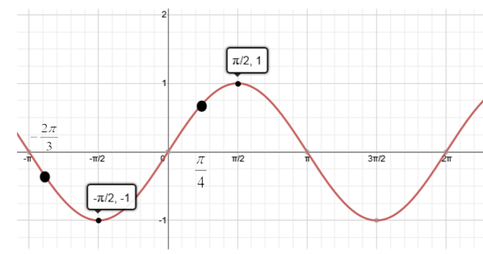
At $-\frac{π}{2}$ , the sine function takes on its smallest value, and at $\frac{π}{2}$ the sine function takes on its largest value. Additionally, $sin\left(-\frac{2π}{3}\right)$ is negative and $sin\left(\frac{π}{4}\right)$ is positive. Then, these four values in increasing order are
$sin\left(-\frac{π}{2}\right), sin\left(-\frac{2π}{3}\right),$ $sin\left(\frac{π}{4}\right), sin\left(\frac{π}{2}\right)$.

- Without using a calculator, rewrite each of the following in order from least to greatest. Use the graph to explain your reasoning.
$cos\left(\frac{π}{2}\right)$ $cos\left(\frac{5π}{4}\right)$ $cos\left(\frac{π}{4}\right)$ $cos\left(5π\right)$
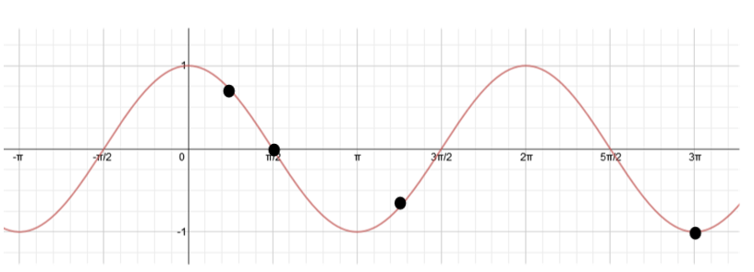
At $5π$, the cosine function takes on its smallest value because $5π=2π+2π+π,$ so $cos\left(5π\right)=cos\left(π\right)=-1$.
We can see that $cos\left(\frac{5π}{4}\right)$ is negative, $cos\left(\frac{π}{2}\right)=0$, and $cos\left(\frac{π}{4}\right)$ is positive. Then, these four values in increasing order are
$cos\left(5π\right)$, $cos\left(\frac{5π}{4}\right)$, $cos\left(\frac{π}{2}\right)$, $cos\left(\frac{π}{4}\right)$.

- Evaluate each of the following without a calculator using a trigonometric identity when needed.
$$cos\left(\frac{π}{6}\right)$$ | $$cos\left(-\frac{π}{6}\right)$$ | $$cos\left(\frac{7π}{6}\right)$$ | $$cos\left(\frac{13π}{6}\right)$$
$$\frac{\sqrt{3}}{2}$$ | $$\frac{\sqrt{3}}{2}$$ | $$-\frac{\sqrt{3}}{2}$$ | $$\frac{\sqrt{3}}{2}$$

- Evaluate each of the following without a calculator using a trigonometric identity when needed.
$$sin\left(\frac{3π}{4}\right)$$ | $$sin\left(\frac{11π}{4}\right)$$ | $$sin\left(\frac{7π}{4}\right)$$ | $$sin\left(\frac{-5π}{4}\right)$$
$$\frac{\sqrt{2}}{2}$$ | $$\frac{\sqrt{2}}{2}$$ | $$-\frac{\sqrt{2}}{2}$$ | $$\frac{\sqrt{2}}{2}$$

- Use the rotation through $θ$ radians shown to answer each of the following questions.
  - Explain why $sin(-θ)=- sin(θ)$ for all real numbers $θ$.
If the initial ray is rotated through $-θ$ radians, it is rotated $θ$ radians in the clockwise direction. If the terminal ray of a rotation through $θ$ radians intersects the unit circle at the point $(a,b)$, then the terminal ray of rotation through $-θ$ radians will intersect the unit circle at the point $\left(a, -b\right).$ Then, $sin\left(θ\right)=b$ and $sin\left(-θ\right)=-b$, so $sin\left(-θ\right)=-sin\left(θ\right).$

  - What symmetry does this identity demonstrate about the graph of $y = sin(x)$?
It demonstrates that the graph of $y=sin(x)$ is symmetric with respect to the origin because if the point $(x,y)$ is on the graph, then the point $(-x,-y)$ is also on the graph.

- Use the same rotation shown in Problem 6 to answer each of the following questions.
  - Explain why$cos(-θ)=cos(θ)$.
If the initial ray is rotated through $-θ$ radians, it is rotated $θ$ radians in the clockwise direction. If the terminal ray of a rotation through $θ$ radians intersects the unit circle at the point $\left(a,b\right)$, then the terminal ray of rotation through $-θ$ radians will intersect the unit circle at the point $\left(a, -b\right).$ Then, $cos\left(θ\right)=a$ and $cos\left(-θ\right)=a$, so $cos\left(-θ\right)=cos\left(θ\right).$

  - What symmetry does this identity demonstrate about the graph of $y=cos(x)$?
It demonstrates that the graph of $y=cos(x)$ is symmetric with respect to the$y$-axis because if the point $(x,y)$ is on the graph, then the point $(-x,y)$ is also on the graph.

- Find equations of two different functions that can be represented by the graph shown below—one sine and one cosine—using different horizontal transformations.
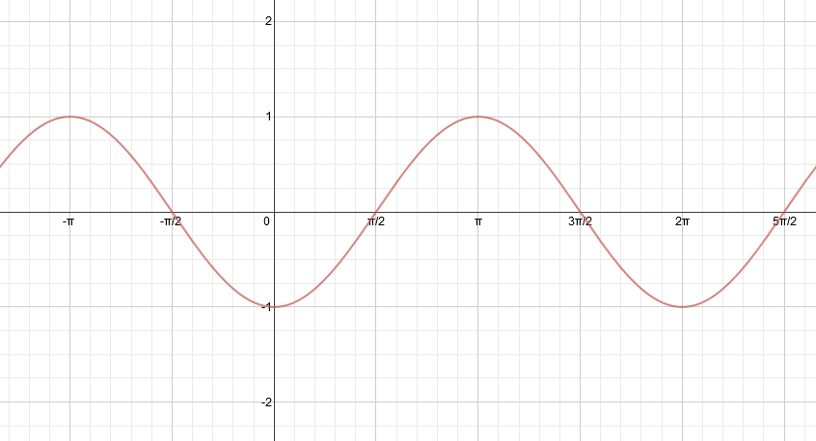
$y = sin\left(x - \frac{π}{2}\right)$ $y = cos(x - π)$ (Other correct answers are possible.)

- Find equations of two different functions that can be represented by the graph shown below—one sine and one cosine—using different horizontal translations.
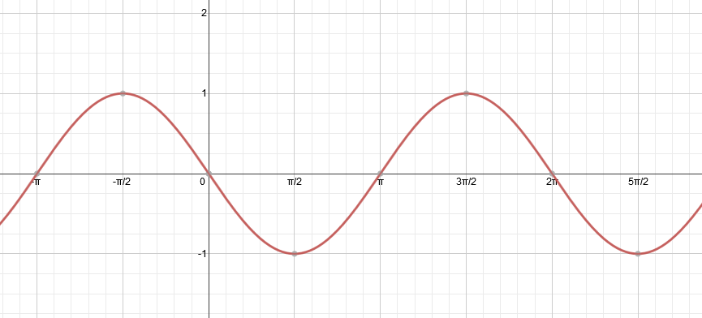
$y= cos\left(x + \frac{π}{2}\right)$ $y = sin(x - π)$ (Other correct answers are possible.)

