Lesson 10: Basic Trigonometric Identities from Graphs

Classwork
Exploratory Challenge 1
Consider the function $f(x)=sin(x)$ where $x$ is measured in radians.
Graph $f(x)=sin(x)$ on the interval $[-π, 5π]$by constructing a table of values. Include all intercepts, relative maximum points, and relative minimum points of the graph. Then, use the graph to answer the questions that follow.

$$x$$
$$f(x)$$
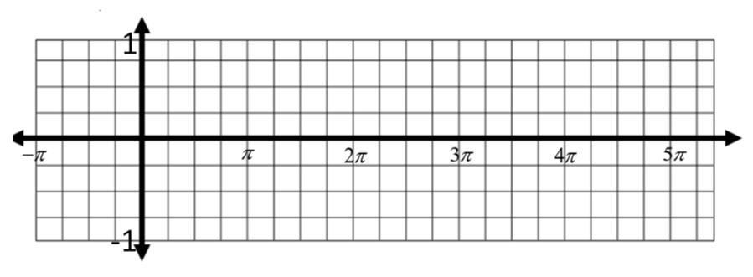

  - Using one of your colored pencils, mark the point on the graph at each of the following pairs of $x$-values.
$x=-\frac{π}{2}$ and $x=-\frac{π}{2}+2π$
$x=π$ and $x=π+2π$
$x=\frac{7π}{4}$ and $x=\frac{7π}{4}+2π$

  - What can be said about the $y$-values for each pair of $x$-values marked on the graph?

  - Will this relationship hold for any two $x$-values that differ by $2π$? Explain how you know.

  - Based on these results, make a conjecture by filling in the blank below.

For any real number $x$, $\sin\left(x+2π\right)=___________________________.$

  - Test your conjecture by selecting another $x$-value from the graph and demonstrating that the equation from part (d) holds for that value of $x$.

  - How does the conjecture in part (d) support the claim that the sine function is a periodic function?

  - Use this identity to evaluate $sin\left(\frac{13π}{6}\right)$.

  - Using one of your colored pencils, mark the point on the graph at each of the following pairs of $x$-values.
$x=-\frac{π}{4}$ and $x=-\frac{π}{4}+π$
$x=2π$ and $x=2π+π$
$x=\frac{5π}{2}$ and $x=\frac{5π}{2}+π$

  - What can be said about the $y$-values for each pair of $x$-values marked on the graph?

  - Will this relationship hold for any two $x$-values that differ by $π$? Explain how you know.

  - Based on these results, make a conjecture by filling in the blank below.

For any real number$x$, $\sin\left(x+π\right)=_______________________$.

  - Test your conjecture by selecting another $x$-value from the graph and demonstrating that the equation from part (k) holds for that value of $x$.

  - Is the following statement true or false? Use the conjecture from (k) to explain your answer.
$$sin\left(\frac{4π}{3}\right)=-sin⁡\left(\frac{π}{3}\right)$$

  - Using one of your colored pencils, mark the point on the graph at each of the following pairs of $x$-values.
$x=-\frac{3π}{4}$ and $x=\frac{3π}{4}$
$x=-\frac{π}{2}$ and $x=\frac{π}{2}$

  - What can be said about the $y$-values for each pair of $x$-values marked on the graph?

  - Will this relationship hold for any two $x$-values with the same magnitude but opposite sign? Explain how you know.

  - Based on these results, make a conjecture by filling in the blank below.

For any real number $x$, $\sin\left(-x\right)=______________________.$

  - Test your conjecture by selecting another $x$-value from the graph and demonstrating that the equation from part (q) holds for that value of $x$.

  - Is the sine function an odd function, even function, or neither? Use the identity from part (q) to explain.

  - Describe the$x$-intercepts of the graph of the sine function.

  - Describe the end behavior of the sine function.

Exploratory Challenge 2
Consider the function $g(x)=cos(x)$where $x$ is measured in radians.
Graph$g(x)=cos(x)$on the interval $[-π,5π]$by constructing a table of values. Include all intercepts, relative maximum points, and relative minimum points. Then, use the graph to answer the questions that follow.

$$x$$
$$g(x)$$

  - Using one of your colored pencils, mark the point on the graph at each of the following pairs of $x$-values.
$x = -\frac{π}{2}$ and $x = -\frac{π}{2}+2π$
$x = π$ and $x = π+2π$
$x = \frac{7π}{4}$ and$x = \frac{7π}{4}+2π$

  - What can be said about the $y$-values for each pair of $x$-values marked on the graph?

  - Will this relationship hold for any two $x$-values that differ by $2π$? Explain how you know.

  - Based on these results, make a conjecture by filling in the blank below.

For any real number $x$, $\cos\left(x+2π\right)=_______________$.

  - Test your conjecture by selecting another $x$-value from the graph and demonstrating that the equation from part (d) holds for that value of $x$.

  - How does the conjecture from part (d) support the claim that the cosine function is a periodic function?

  - Use this identity to evaluate$cos\left(\frac{9π}{4}\right)$.

  - Using one of your colored pencils, mark the point on the graph at each of the following pairs of $x$-values.
$x = -\frac{π}{4}$and $x = -\frac{π}{4}+π$
$x = 2π$ and $x = 2π+π$
$x = \frac{5π}{2}$ and $x = \frac{5π}{2}+π$

  - What can be said about the$y$-values for each pair of $x$-values marked on the graph?

  - Will this relationship hold for any two $x$-values that differ by $π$? Explain how you know.

  - Based on these results, make a conjecture by filling in the blank below.

For any real number $x$, $cos⁡(x+π)=_______________$.

  - Test your conjecture by selecting another $x$-value from the graph and demonstrating that the equation from part (k) holds for that value of $x$.

  - Is the following statement true or false? Use the identity from part (k) to explain your answer.
$$cos\left(\frac{5π}{3}\right)=-cos\left(\frac{2π}{3}\right)$$

  - Using one of your colored pencils, mark the point on the graph at each of the following pairs of $x$-values.
$x = -\frac{3π}{4}$ and $x = \frac{3π}{4}$
$x = -π$ and $x = π$

  - What can be said about the $y$-values for each pair of $x$-values marked on the graph?

  - Will this relationship hold for any two $x$-values with the same magnitude and same sign? Explain how you know.

  - Based on these results, make a conjecture by filling in the blank below.

For any real number $,$ $\cos\left(-x\right)=_______________$.

  - Test your conjecture by selecting another $x$-value from the graph and demonstrating that the identity is true for that value of $x$.

  - Is the cosine function an odd function, even function, or neither? Use the identity from part (n) to explain.

  - Describe the $x$-intercepts of the graph of the cosine function.

  - Describe the end behavior of $g(x)=cos(x).$

Exploratory Challenge 3
Graph both $f(x)=sin(x)$ and$g(x)=cos(x)$ on the graph below. Then, use the graphs to answer the questions that follow.

  - List ways in which the graphs of the sine and cosine functions are alike.

  - List ways in which the graphs of the sine and cosine functions are different.

  - What type of transformation would be required to make the graph of the sine function coincide with the graph of the cosine function?

  - What is the smallest possible horizontal translation required to make the graph of $f(x)=sin(x)$ coincide with the graph of $g(x)=cos(x)$?

  - What is the smallest possible horizontal translation required to make the graph of$g(x)=cos(x)$ coincide with the graph of $f\left(x\right)=sin(x)$?

  - Use your answers from parts (d) and (e) to fill in the blank below.

For any real number $x$,$________________=\cos\left(x-\frac{π}{2}\right)$.

For any real number $x$, $________________\sin\left(x+\frac{π}{2}\right)$.

Problem Set

- Describe the values of $x$ for which each of the following is true.
  - The cosine function has a relative maximum.
  - The sine function has a relative maximum.

- Without using a calculator, rewrite each of the following in order from least to greatest. Use the graph to explain your reasoning.
$sin\left(\frac{π}{2}\right)$ $sin\left(-\frac{2π}{3}\right)$ $sin\left(\frac{π}{4}\right)$ $sin\left(-\frac{π}{2}\right)$
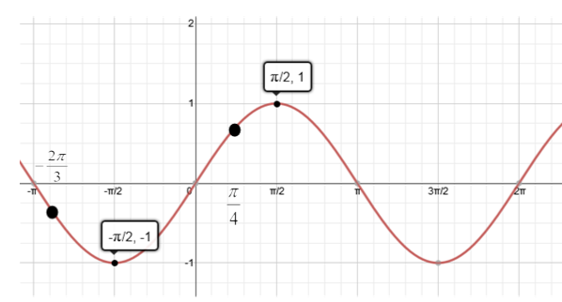

- Without using a calculator, rewrite each of the following in order from least to greatest. Use the graph to explain your reasoning.
$cos\left(\frac{π}{2}\right)$ $cos\left(\frac{5π}{4}\right)$ $cos\left(\frac{π}{4}\right)$ $cos\left(5π\right)$
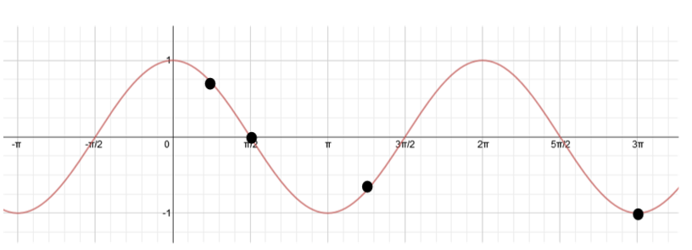

- Evaluate each of the following without a calculator using a trigonometric identity when needed.
$$cos\left(\frac{π}{6}\right)$$ | $$cos\left(-\frac{π}{6}\right)$$ | $$cos\left(\frac{7π}{6}\right)$$ | $$cos\left(\frac{13π}{6}\right)$$

- Evaluate each of the following without a calculator using a trigonometric identity when needed.
$$sin\left(\frac{3π}{4}\right)$$ | $$sin\left(\frac{11π}{4}\right)$$ | $$sin\left(\frac{7π}{4}\right)$$ | $$sin\left(\frac{-5π}{4}\right)$$

- Use the rotation through $θ$ radians shown to answer each of the following questions.
  - Explain why $sin(-θ) = - sin(θ)$ for all real numbers $θ$.
  - What symmetry does this identity demonstrate about the graph of
$y=sin(x)$?

- Use the same rotation shown in Problem 6 to answer each of the following questions.
  - Explain why$cos(-θ)=cos(θ)$.
  - What symmetry does this identity demonstrate about the graph of $y = cos(x)$?
- Find equations of two different functions that can be represented by the graph shown below—one sine and one cosine—using different horizontal transformations.

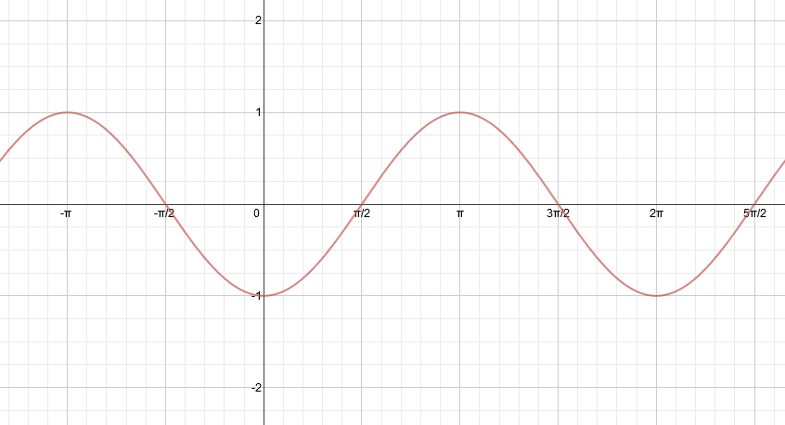

- Find equations of two different functions that can be represented by the graph shown below—one sine and one cosine—using different horizontal translations.

