Lesson 9: Awkward! Who Chose the Number 360, Anyway?

Classwork

Opening Exercise

Let’s construct the graph of the function , where is the measure of degrees of rotation. In Lesson 5, we decided that the domain of the sine function is all real numbers and the range is . Use your calculator to complete the table below with values rounded to one decimal place, and then graph the function on the axes below. Be sure that your calculator is in degree mode.

|  |  |  |  |  |  |  |  |
| --- | --- | --- | --- | --- | --- | --- | --- |
|  |  |  |  |  |  |  |  |
|  |  |  |  |  |  |  |  |
|  |  |  |  |  |  |  |  |
|  |  |  |  |  |  |  |  |
|  |  |  |  |  |  |  |  |
|  |  |  |  |  |  |  |  |
|  |  |  |  |  |  |  |  |

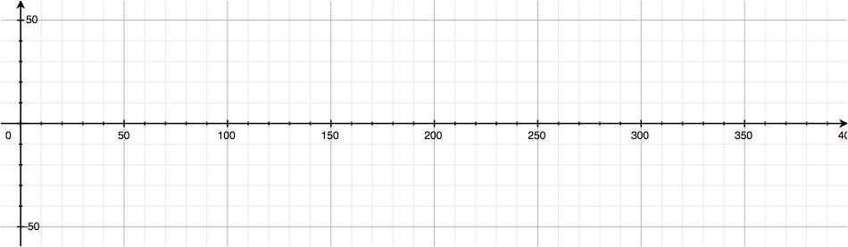

Exercises 1–5

Set your calculator’s viewing window to and , and be sure that your calculator is in degree mode. Plot the following functions in the same window:

1. This viewing window was chosen because it has close to the same scale in the horizontal and vertical directions. In this viewing window, which of the five transformed sine functions most clearly shows the behavior of the sine function?
2. Describe the relationship between the steepness of the graph near the origin and the value of .
3. Since we can control the steepness of the graph near the origin by changing the value of , how steep might we want this graph to be? What is your “favorite” positive slope for a line through the origin?
4. In the same viewing window on your calculator, plot and for some value of *.* Experiment with your calculator to find a value of so that the steepness of matches the slope of the line near the origin. You may need to change your viewing window to and to determine the best value of .

* A circle is defined by a point and a radius. If we start with a circle of any radius, and look at a sector of that circle with an arc length equal to the length of the radius, then the central angle of that sector is always the same size. We define a *radian* to be the measure of that central angle and denote it by .

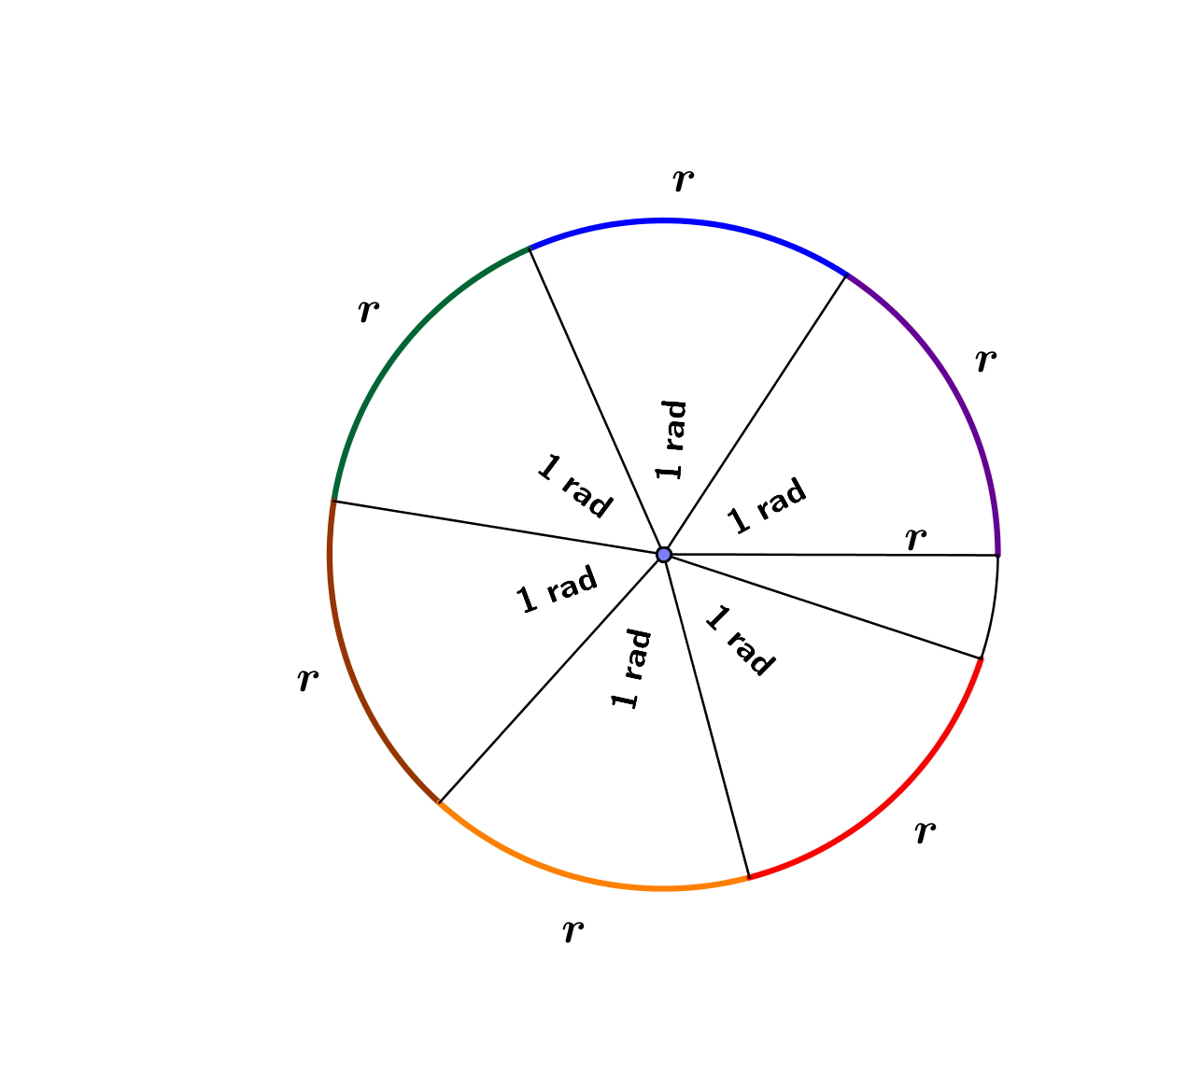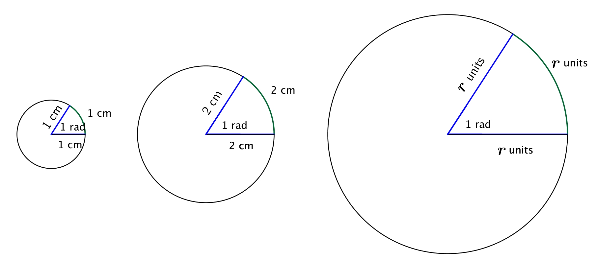

* Thus, a radian measures how far one radius will “wrap around” the circle. For any circle, it takes radius lengths to wrap around the circumference. In the figure at right, radius lengths are shown around the circle, with roughly radius lengths left over.

1. Use a protractor that measures angles in degrees to find an approximate degree measure for an angle with measure. Use one of the figures above.

Examples 1–4

1. Convert from degrees to radians:
2. Convert from degrees to radians:
3. Convert from radians to degrees:
4. Convert from radians to degrees:

Exercises 6–7

1. Complete the table below, converting from degrees to radians or from radians to degrees as necessary. Leave your answers in exact form, involving .

|  |  |
| --- | --- |
| **Degrees** | **Radians** |
|  |  |
|  |  |
|  |  |
|  |  |
|  |  |
|  |  |
|  |  |

1. On your calculator, graph the functions and . What do you notice near the origin? What is the decimal approximation to the constant to one decimal place? Explain how this relates to what we’ve done in Exercise 4.

Lesson Summary

* A *radian* is the measure of the central angle of a sector of a circle with arc length of one radius length.
* There are radians in a rotation, also known as a *turn*, so we convert degrees to radians and radians to degrees by:
* Sine Function (description). The *sine function*, , can be defined as follows: Let be any real number. In the Cartesian plane, rotate the initial ray by radians about the origin. Intersect the resulting terminal ray with the unit circle to get a point . The value of is .
* Cosine Function (Description). The *cosine function*, , can be defined as follows: Let be any real number. In the Cartesian plane, rotate the initial ray by radians about the origin. Intersect the resulting terminal ray with the unit circle to get a point . The value of is .



Problem Set

1. Use a radian protractor to measure the amount of rotation in radians of ray to in the indicated direction. Measure to the nearest 0.1 radian. Use negative measures to indicate clockwise rotation.

|  |  |
| --- | --- |
| a. | b. |
| c. | d. |
| e. | f. |
| g. | h. |

1. Complete the table below, converting from degrees to radians. Where appropriate, give your answers in the form of a fraction of .

|  |  |
| --- | --- |
| **Degrees** | **Radians** |
|  |  |
|  |  |
|  |  |
|  |  |
|  |  |
|  |  |
|  |  |
|  |  |

1. Complete the table below, converting from radians to degrees.

|  |  |
| --- | --- |
| **Radians** | **Degrees** |
|  |  |
|  |  |
|  |  |
|  |  |
|  |  |
|  |  |
|  |  |
|  |  |

1. Use the unit circle diagram from the end of the lesson and your knowledge of the six trigonometric functions to complete the table below. Give your answers in exact form, as either rational numbers or radical expressions.

|  |  |  |  |  |  |  |
| --- | --- | --- | --- | --- | --- | --- |
|  |  |  |  |  |  |  |
|  |  |  |  |  |  |  |
|  |  |  |  |  |  |  |
|  |  |  |  |  |  |  |
|  |  |  |  |  |  |  |
|  |  |  |  |  |  |  |
|  |  |  |  |  |  |  |
|  |  |  |  |  |  |  |

1. Use the unit circle diagram from the end of the lesson and your knowledge of the sine, cosine, and tangent functions to complete the table below. Select values of so that .

|  |  |  |  |
| --- | --- | --- | --- |
|  |  |  |  |
|  |  |  |  |
|  |  |  |  |
|  |  |  |  |
|  |  |  |  |
|  |  |  |  |
|  |  |  |  |

1. How many radians does the minute hand of a clock rotate through over minutes? How many degrees?
2. How many radians does the minute hand of a clock rotate through over half an hour? How many degrees?
3. How many radians is an angle subtended by an arc of a circle with radius cm if the intercepted arc has length cm? How many degrees?
4. How many radians is the angle formed by the minute and hour hands of a clock when the clock reads ? How many degrees? (Hint: you must take into account that the hour hand is not directly on the ‘’.)
5. How many radians is the angle formed by the minute and hour hands of a clock when the clock reads ? How many degrees?
6. How many degrees does the earth revolve on its axis each hour? How many radians?
7. The distance from the Equator to the North Pole is almost exactly km.
   1. Roughly how many kilometers is degree of latitude?
   2. Roughly how many kilometers is radian of latitude?