|  |
| --- |
|  |

Lesson 9: Awkward! Who Chose the Number 360, Anyway?

Student Outcomes

* Students explore horizontal scalings of the graph of .
* Students convert between degrees and radians.

Lesson Notes

In this lesson, we need to justify why we are changing from using degree measure for rotation to radian measure. The main argument for this change is that the graph of the sine and cosine functions are ridiculously flat if graphed on a square grid, so we want to change the horizontal scale. Graphing calculators are used to investigate different re-scalings of the sine graph, and we see that the graph of aligns with the diagonal line near the origin.

This reason given above may seem somewhat artificial, and from the students’ perspective it is. It is true that the reason we choose to use radians instead of degrees is that when using radians, the function has slope near the origin, but this is not the entire story. The fact is that leads to the derivative formula , which greatly simplifies derivative calculations with the sine and cosine functions in calculus and beyond. It’s your decision whether to discuss these reasons with your students; use your own judgment about their readiness for these advanced ideas.

In any case, in Exercises - in this lesson, students graph various functions , looking for a function whose graph is diagonal near the origin. This provides the students with an opportunity to employ MP.8 as they make generalizations about by repeatedly graphing these functions. This exploration gives the students a head start on the work in Lesson 11, in which the students explore the effects of the parameters , , and on the graph of general sinusoidal functions of the form .

In this lesson, we will finally be equipped to give definitions of the sine and cosine function in terms of radians.

**Sine Function (description).** The *sine function*, , can be defined as follows: Let be any real number. In the Cartesian plane, rotate the initial ray by radians about the origin. Intersect the resulting terminal ray with the unit circle to get a point . The value of is .

**Cosine Function (description).** The *cosine function*, , can be defined as follows: Let be any real number. In the Cartesian plane, rotate the initial ray by radians about the origin. Intersect the resulting terminal ray with the unit circle to get a point . The value of is .

In the definitions of the trigonometric functions above, you may have noticed that is always a real number. That is, the input for the sine function is a number and not a quantity like degrees or radians. How the real number is used is actually part of the definition: The rule for finding states to rotate the initial ray by radians about the origin. The number is given a quantitative meaning (radians) by the definition.

Because we have two measurement systems for rotational measure, degrees and radians, we therefore have two different definitions of each trigonometric function—one for degrees and one for radians. The rigorous thing to do in this situation is to notate each definition differently, say by to refer to a rotation by degrees and to refer to a rotation by 40 radians. Using two notations, of course, is unforgivably pedantic, and mathematicians long ago decided to notate the difference between the definitions of these two functions in a subtle way.

Here’s the rule of thumb: always refers to the value of the sine function after rotating the initial ray by radians. Once radians are defined in Algebra II, this becomes the standard way to refer to almost all rotational measures and sine functions from that point on (including in pre-calculus and university-level calculus). To refer to the degree definition of the sine function, we indicate the degree symbol on the number, as in . Note, however, that the degree symbol in this notation refers to which definition of the sine function is being used, not that the sine function is accepting a quantity of as input. In this notation, we still think of the sine function as accepting a number, say , but we are putting into the blank in the notation . The degree symbol is referring to the definition and isn’t really part of the input. Subtle? Yes. But it is also so natural that students will never really question its use. Teachers do not need to explicitly explain this subtlety; teachers just have to be clear themselves about how to use and apply the notation correctly and consistently.

Materials

For the Problem Set, students need access to a radian protractor. An inexpensive way to obtain these is to copy the images from the last page onto transparencies, cut out the protractors, and distribute to students.

Classwork

Opening Exercise (8 minutes)

The first step in understanding why we want to change how we measure angles of rotation is to try to graph the sine function on a grid with the same horizontal and vertical scale. Allow the students to struggle with this task and to come to the conclusion that either the horizontal or the vertical scale needs to change in order to be able to even see the graph of .

*Scaffolding:*

Students above grade level can plot points in -increments to get a better image of the graph.

Opening Exercise

Let’s construct the graph of the function , where is the measure of degrees of rotation. In Lesson 5, we decided that the domain of the sine function is all real numbers and the range is . Use your calculator to complete the table below with values rounded to one decimal place, and then graph the function on the axes below. Be sure that your calculator is in degree mode.

|  |  |  |  |  |  |  |  |
| --- | --- | --- | --- | --- | --- | --- | --- |
|  |  |  |  |  |  |  |  |
|  |  |  |  |  |  |  |  |
|  |  |  |  |  |  |  |  |
|  |  |  |  |  |  |  |  |
|  |  |  |  |  |  |  |  |
|  |  |  |  |  |  |  |  |
|  |  |  |  |  |  |  |  |

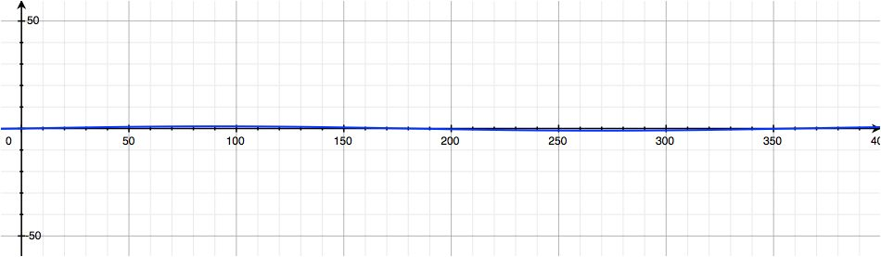

**Discussion (4 minutes)**

This discussion should lead to the conclusion that the best way to “fix” the problem of graphing while retaining a one-to-one ratio of the scales on the axes would be to perform a horizontal scaling to compress the graph along the horizontal axis. The first step is to guide students to recognize the nature of the problem we’re facing.

* What do you notice about the graph that you created in the Opening Exercise?
  + *Creating a useful graph is impossible on the set of axes provided.*
* In Lesson 30 of Module 1, we performed transformations on a parabola that changed its horizontal scale. How did we do that?
  + *When we graphed and , the second graph was stretched horizontally by a factor of .*
* What horizontal scaling can we perform to compress the parabola to make the graph twice as narrow as the original graph?
* What might be a reasonable transformation to perform on the sine function to make the graph narrower?
  + *Any transformation of the form for will work; students may suggest or .*
* Do we really know which transformation would be the best? Maybe we should stop to think about what we want to transform this graph into before we proceed.

Exercises 1–4 (8 minutes)

Place students in small groups and keep them working in these groups for all of the exercises in this lesson.

Exercises 1–5

Set your calculator’s viewing window to and , and be sure that your calculator is in degree mode. Plot the following functions in the same window:

1. This viewing window was chosen because it has close to the same scale in the horizontal and vertical directions. In this viewing window, which of the five transformed sine functions most clearly shows the behavior of the sine function?

***Students may answer or (either answer is reasonable).***

**MP.8**

1. Describe the relationship between the steepness of the graph near the origin and the value of .

***As we increase , the steepness of the graph near the origin increases.***

1. Since we can control the steepness of the graph near the origin by changing the value of , how steep might we want this graph to be? What is your “favorite” positive slope for a line through the origin?

It would make sense to try to get the steepness at the origin to be the same as the diagonal line , which has slope .

1. In the same viewing window on your calculator, plot and for some value of *.* Experiment with your calculator to find a value of so that the steepness of matches the slope of the line near the origin. You may need to change your viewing window to and to determine the best value of .

***The graph of has nearly the same steepness as the diagonal line with equation .***

**Discussion (4 minutes)**

* Which value(s) of produce graphs of that are close to the graph of near the origin?
  + *Responses will vary; they should be near*
* It looks like choosing is close to what we want. But why ? Something is strange here! And, indeed, there is something both surprising and natural about what the value of truly is.
* First, let’s review our basic system of measurement for rotation. We could take the entire circle as the unit of rotational measure; this is known as a *turn*. Then, a rotation can be expressed as a fraction of a turn. For example, turn would correspond to a right angle, and of a turn would correspond to a straight angle.
* Instead, we more commonly use a small unit called a *degree*. We divide the circle into arcs of equal length, and then the central angle subtended by one of these arcs has measure degree. Then, a turn measures .
* 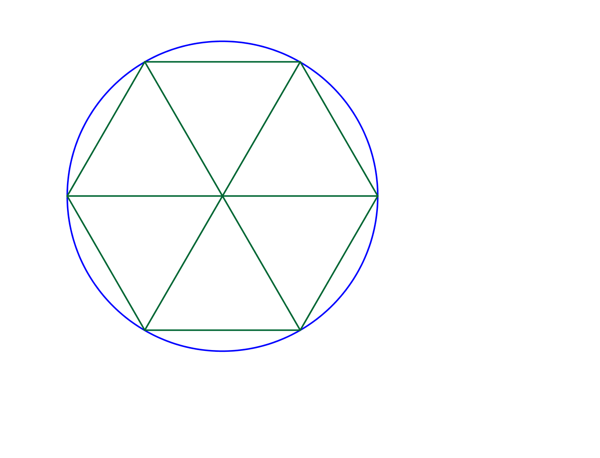Who came up with our current system of using in a turn? Remember the ancient Babylonians who made all of those astronomical observations that led to the discovery of trigonometry? They are also the ones responsible for our system of measuring rotations and angles. It appears that the Babylonians subdivided the circle using the angle of an equilateral triangle as the basic unit. Since they used a base- number system, they divided each angle of the equilateral triangle into smaller units, each with measure degree, giving degrees in a turn. Each degree is subdivided into minutes, and each minute is subdivided into seconds.
* For our purposes now, using in a turn is cumbersome. Instead of basing our measurement system on an arbitrary number like , we will instead use a system in which angles and rotations are measured related to the length of the corresponding arc.
* 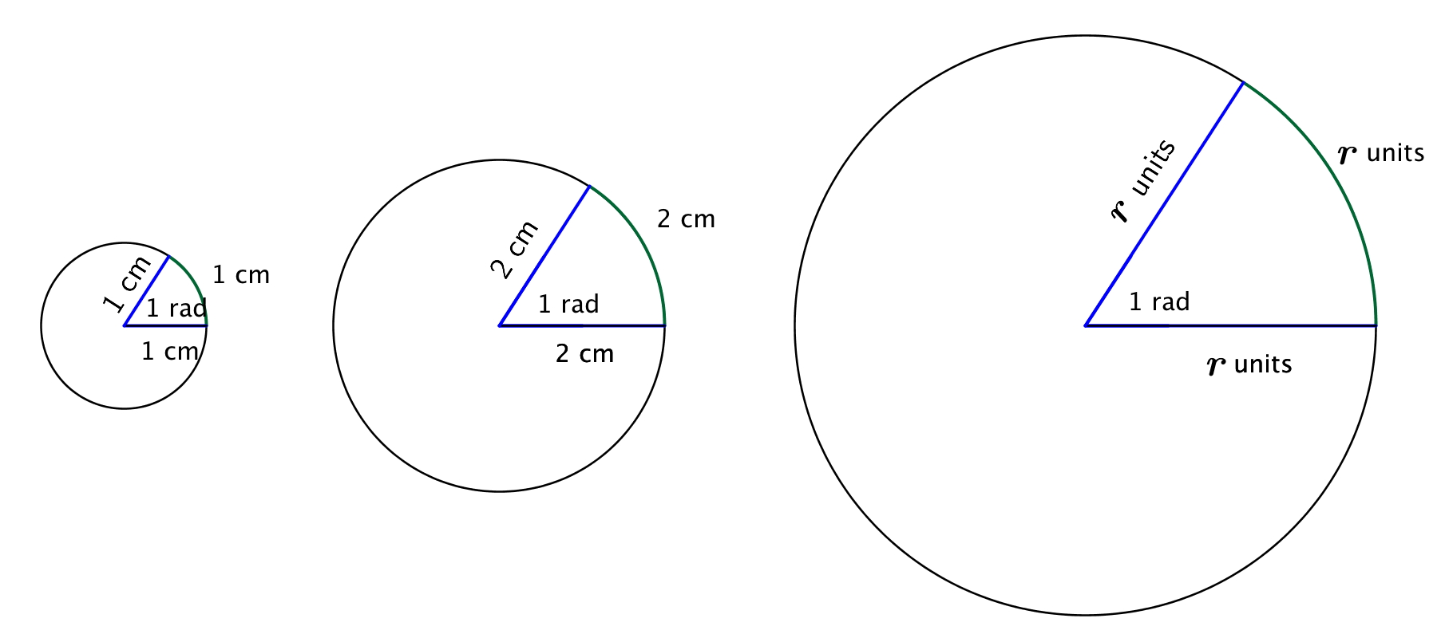A circle is defined by a point and a radius. If we start with a circle of any radius, and look at a sector of that circle with an arc length equal to the length of the radius, then the central angle of that sector is always the same size. We define a *radian* to be the measure of that central angle and denote it by .

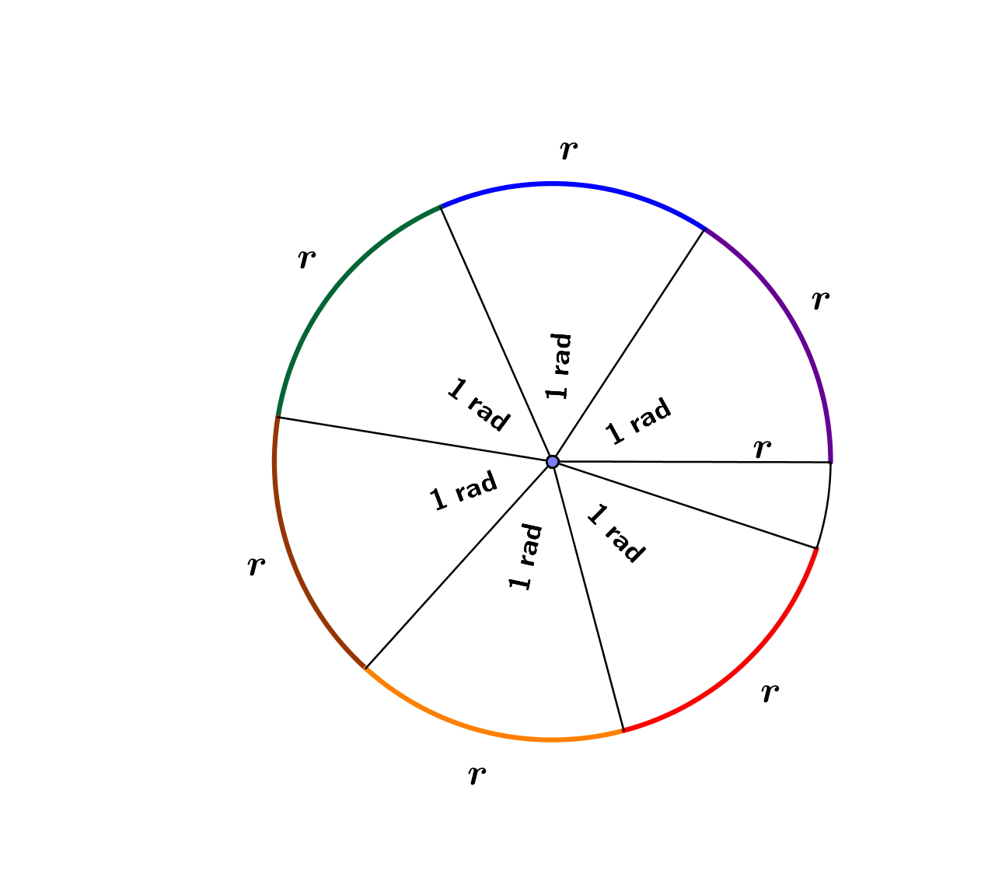

* Thus, a radian measures how far one radius will “wrap around” the circle. For any circle, it takes radius lengths to wrap around the circumference. In the figure at right, radius lengths are shown around the circle, with roughly radius lengths left over.

**Exercise 5 (2 minutes)**

Allow students time to discuss this with a partner in order to make the connection between the measured in this exercise and the scale factor that was discovered in Exercise 4.

1. Use a protractor that measures angles in degrees to find an approximate degree measure for an angle with measure. Use one of the figures from the previous discussion.

***We find that the degree measure of an angle that has measure is approximately .***

Examples 1–4 (4 minutes)

Instead of emphasizing conversion formulas for switching between degrees and radians, emphasize that both systems can be thought of as fractions of a turn. Thus, a rotation is of a turn, which is radians, and radians is a half-turn, which is .

**Examples 1–4**

1. Convert from degrees to radians:
2. Convert from degrees to radians:
3. Convert from radians to degrees:
4. Convert from radians to degrees:

Exercise 6 (3 minutes)

Have students perform the following conversions either alone or in small groups to complete this chart. Circulate around the room to monitor student progress, especially for the last conversion that is critical to the conclusion students should make in this lesson.

Exercises 6–7

1. Complete the table below, converting from degrees to radians or from radians to degrees as necessary. Leave your answers in exact form, involving .

|  |  |
| --- | --- |
| Degrees | Radians |
|  |  |
|  |  |
|  |  |
|  |  |
|  |  |
|  |  |
|  |  |

Exercise 7 (3 minutes)

This question ties together the previous exploration looking for a transformed sine function that is diagonal near the origin and our newly defined radian measure for angles. Allow students to continue to work in their groups on these questions.

1. On your calculator, graph the functions and . What do you notice near the origin? What is the decimal approximation to the constant to one decimal place? Explain how this relates to what we’ve done in Exercise 4.

***The graph of is nearly identical to the graph of near the origin. On the calculator, we see that so that . This is the function we were looking for in Exercise 4.***

Discussion (2 minutes)

If we change our units from degrees to radians, then the expression where is measured in degrees, becomes , where is measured in radians. Then one period of the graph of on a grid with the same scale on the horizontal and vertical axes now looks like this:

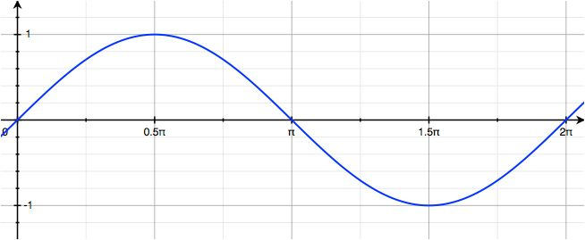

From this point forward, we will always graph our trigonometric functions using radians for measuring rotation instead of degrees. Besides our discovery that the graph of the sine function is much easier to create and use in radians, it turns out that radians make many calculations much easier in later work in mathematics.

Closing (3 minutes)

Ask students to summarize the main points of the lesson either in writing, to a partner, or as a class.

* A *radian* is the measure of the central angle of a sector of a circle with arc length of one radius length.
* If there is no degree symbol or specification, then the use of radians is implied.
* There are radians in a rotation, also known as a *turn*, so we convert degrees to radians and radians to degrees by:
* From this point forward, we will be working exclusively with radian measures for rotation and as the independent variables in the trigonometric functions. The diagram at right is nearly the same as the one we saw for the sine and cosine functions in Lesson , but this time it is labeled with angles measured in radians.
* Use the diagram to find
* Use the diagram to find

Lesson Summary

* A *radian* is the measure of the central angle of a sector of a circle with arc length of one radius length.
* There are radians in a rotation, also known as a *turn*, so we convert degrees to radians and radians to degrees by:
* Sine Function (description). The *sine function*, , can be defined as follows: Let be any real number. In the Cartesian plane, rotate the initial ray by radians about the origin. Intersect the resulting terminal ray with the unit circle to get a point . The value of is .
* Cosine Function (Description). The *cosine function*, , can be defined as follows: Let be any real number. In the Cartesian plane, rotate the initial ray by radians about the origin. Intersect the resulting terminal ray with the unit circle to get a point . The value of is .



Exit Ticket (4 minutes)

Name Date

Lesson 9: Awkward! Who Chose the Number 360, Anyway?

Exit Ticket

1. Convert to radians.
2. Convert to degrees.
3. Explain how radian measure is related to the radius of a circle. Draw and label an appropriate diagram to support your response.

Exit Ticket Sample Solutions

1. Convert to radians.

1. Convert to degrees.
2. 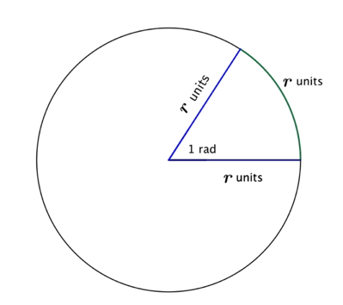Explain how radian measure is related to the radius of a circle. Draw and label an appropriate diagram to support your response.

If we take one radius from the circle and wrap it part of the way around the circle, the central angle with the arc length of one radius has measure one radian.

Problem Set Sample Solutions

For Problem 1, the students need to have access to a protractor that measures in radians. The majority of the problems in this problem set are designed to build fluency with radians and encourage the shift from thinking in terms of degrees to thinking in terms of radians. For Problem 12, ask students to compare the lengths they calculate to the lengths found at <http://en.wikipedia.org/wiki/Latitude>.

1. Use a radian protractor to measure the amount of rotation in radians of ray to in the indicated direction. Measure to the nearest radian. Use negative measures to indicate clockwise rotation.

|  |  |
| --- | --- |
| a. | b. |
| rad | rad |

|  |  |
| --- | --- |
| c. | d. |
| rad | rad |
| e. | f. |
| rad | rad |
| g. | h. |
| rad | rad |

1. Complete the table below, converting from degrees to radians. Where appropriate, give your answers in the form of a fraction of .

|  |  |
| --- | --- |
| Degrees | Radians |
|  |  |
|  |  |
|  |  |
|  |  |
|  |  |
|  |  |
|  |  |
|  |  |

1. Complete the table below, converting from radians to degrees.

|  |  |
| --- | --- |
| Radians | Degrees |
|  |  |
|  |  |
|  |  |
|  |  |
|  |  |
|  |  |
|  |  |
|  |  |

1. Use the unit circle diagram from the end of the lesson and your knowledge of the six trigonometric functions to complete the table below. Give your answers in exact form, as either rational numbers or radical expressions.

|  |  |  |  |  |  |  |
| --- | --- | --- | --- | --- | --- | --- |
|  |  |  |  |  |  |  |
|  |  |  |  |  |  |  |
|  |  |  |  |  |  |  |
|  |  |  |  |  |  |  |
|  |  |  |  | undefined |  | undefined |
|  |  |  |  |  |  |  |
|  |  |  |  |  |  |  |
|  |  |  |  |  |  |  |

1. Use the unit circle diagram from the end of the lesson and your knowledge of the sine, cosine, and tangent functions to complete the table below. Select values of so that .

|  |  |  |  |
| --- | --- | --- | --- |
|  |  |  |  |
|  |  |  |  |
|  |  |  |  |
|  |  |  |  |
|  |  |  |  |
|  |  |  | undefined |
|  |  |  |  |

1. How many radians does the minute hand of a clock rotate through over minutes? How many degrees?

In minutes, the minute hand makes of a rotation, so it rotates through radians. This is equivalent to

1. How many radians does the minute hand of a clock rotate through over half an hour? How many degrees?

In minutes, the minute hand makes of a rotation, so it rotates through radians. This is equivalent to

1. How many radians is an angle subtended by an arc of a circle with radius cm if the intercepted arc has length cm? How many degrees?

The intercepted arc is the length of radii, so the angle subtended by that arc measures radians. This is equivalent to

1. How many radians is the angle formed by the minute and hour hands of a clock when the clock reads ? How many degrees? (Hint: you must take into account that the hour hand is not directly on the .)

At , the hour hand is half-way between the and the , and the minute hand is on the . A hand on the clock rotates through of a rotation as it moves from one number to the next. Since there are of these increments between the two hands of the clock at , the angle formed by the two clock hands is radians. In degrees, this is .

1. How many radians is the angle formed by the minute and hour hands of a clock when the clock reads ? How many degrees?

At , the hour hand is of the way between the and on the clock face, and the minute hand is on the . Then there are increments of of a rotation between the two hands of the clock at , so the angle formed by the two clock hands is radians. This is equivalent to .

1. How many degrees does the earth revolve on its axis each hour? How many radians?

The earth revolves through in hours, so it revolves each hour.

1. The distance from the Equator to the North Pole is almost exactly km.
   1. Roughly how many kilometers is degree of latitude?

There are degrees of latitude between the Equator and the North Pole, so each degree of latitude is km.

* 1. Roughly how many kilometers is radian of latitude?

**There are radians of latitude between the Equator and the North Pole, so each radian of latitude is km**.

Supplementary Transparency Materials

