of
Lesson 8: Graphing the Sine and Cosine Functions

Student Outcomes
- Students graph the sine and cosine functions and analyze the shape of these curves.
- For the sine and cosine functions, students sketch graphs showing key features, which include intercepts; intervals where the function is increasing, decreasing, positive, or negative; relative maxima and minima; symmetries; end behavior; and periodicity.

Lesson Notes
Students will spend this lesson exploring the graphs of the sine and cosine functions. The lesson opens with an Exploratory Challenge where students create the graphs of the sine and cosine functions using spaghetti. The purpose of this activity is to allow students to discover the key features of the sine and cosine functions and to connect the graphs to the measurements on the unit circle. If time does not permit, Exploratory Challenge 1 could be omitted. Throughout the lesson, an emphasis should be placed on the shape of these curves that they have seen before when creating the graphs of the height and co-height functions in Lessons 1 and 2. For example, the arcs are not semicircular or parabolic; $sin(45°)$ is not halfway between $sin(0°)$ and $sin(90°)$, etc. Students should spend time comparing and contrasting the key features of the two graphs. In this lesson, we are still working with measuring rotations in degrees. Emphasize to students that the graphs they are creating are not being drawn to scale – the horizontal axis and vertical axis have wildly different scales so that we can get a good sense of the shape of the sine and cosine graphs. This is critical for the development of radian measure in the next lesson. We are still using $θ$ to represent the degrees of rotation that locate the point $(x_{θ}, y_{θ})$ on the unit circle that define the values of sine and cosine; this is primarily to avoid using the variable $x$ to represent both the coordinate $x_{θ}$ on the unit circle and the independent variable of our trigonometric functions.

Classwork
Exploratory Challenge 1 (18 minutes)
Students will work in groups to create either the graph of the sine function or the cosine function using pieces of uncooked spaghetti. Each group will need the following supplies:
Scaffolding:
If students are struggling, provide some additional support.
- Model the activity for the class or for a small group.
- Read the directions aloud to the class and ask students to summarize.
- Blank unit circle
- Yarn
- Marker
- Spaghetti (roughly $30$ strands, allowing extra for breakage, per group, uncooked)
- Piece of paper or poster board that measures at least $9"×30"$
- Glue stick
Assign groups either the sine or cosine function by circling one of the two on the instruction sheet before distributing to the groups. Encourage the groups to divide the work in order to complete the activity.

As students work in groups, circulate to monitor their progress. As groups get to the part where they measure the sine or cosine, make sure they understand what the pieces of spaghetti represent. Remind them that for a point on the unit circle that has been rotated through $θ$ degrees, $\cos\left(θ\right)$ is the $x$-coordinate of the point, and $\sin\left(θ\right)$ is the $y$-coordinate of the point. Watch that students are remembering to measure distance along the perpendicular and to place negative values below the $x$-axis. Then, allow students to present the graphs to the class. Graphs can be displayed on the walls of your classroom.
Exploratory Challenge 1
Your group will be graphing: $f\left(θ\right)= sin(θ)$ $g\left(θ\right)=cos(θ)$
The circle on the next page is a unit circle, meaning that the length of the radius is one unit.
- Mark axes on the poster board, with a horizontal axis in the middle of the board and a vertical axis near the left edge, as shown.

- Measure the radius of the circle using a ruler. Use the length of the radius to mark $1$ and $-1$ on the vertical axis.
- Wrap the yarn around the circumference of the circle starting at $0$. Mark each $15°$ increment on the yarn with the marker. Unwind the yarn and lay it on the horizontal axis. Transfer the marks on the yarn to corresponding increments on the horizontal axis. Label these marks as $0$, $15$, $30$, …, $360$.
- We will record the number of degrees of rotation $θ$ on the horizontal axis of the graph, and we will record the value of either $sin(θ)$ or $\cos\left(θ\right)$ on the vertical axis. Notice that the scale is wildly different on the vertical and horizontal axes.
- If you are graphing $g\left(θ\right)=cos(θ)$: For each $θ$ marked on your horizontal axis, beginning at $0$, use the spaghetti to measure the horizontal displacement from the vertical axis to the relevant point on the unit circle. The horizontal displacement is the value of the cosine function. Break the spaghetti to mark the correct length, and place it vertically at the appropriate tick mark on the horizontal axis.
- If you are graphing $f\left(θ\right)=sin(θ)$: For each $θ$ marked on your horizontal axis, beginning at $0$, use the spaghetti to measure the vertical displacement from the horizontal to the relevant point on the unit circle. The vertical displacement is the value of the sine function. Break the spaghetti to mark the correct length, and place it vertically at the appropriate tick mark on the horizontal axis.
- Remember to place the spaghetti below the horizontal axis when the value of the sine function or the cosine function is negative. Glue each piece of spaghetti in place.
- Draw a smooth curve that connects the points at the end of each piece of spaghetti.

Discussion (4 minutes)
After the groups have presented their graphs, have the following discussion. Much of this will be formalized in Exploratory Challenge 2. The purpose here is to informally examine the graphs. You could use Wolfram Alpha or desmos.com (a free on-line graphing calculator) to display the graphs and compare to the ones made by the students.
- How are the graphs of the sine and cosine functions alike?
  - They have the same basic shape. They have the same maximum and minimum values.
- Could I get the graph of the sine function by shifting the graph of the cosine function?
  - Yes. I could get the graph of the sine function by shifting the graph of the cosine function to the right by $90$.
- If we extended the horizontal axis, what would the graph of the sine function look like between $360$ and $720$? What about from $720$ to $1080$?
  - The graph would look the same as it did from $0$ to $360$ because the values of sine (or cosine) will just repeat.
MP.7
- What if we extended the graph in the negative direction?
  - Again, the graph would continue to repeat the same pattern every $360$ units.

Exploratory Challenge 2 (15 minutes)
Students will now work in groups to graph $f\left(θ\right)=sin(θ)$ and $g\left(θ\right)=cos(θ)$ by making a table of values and then analyzing the two graphs. If time is short, assign the group who graphed the sine function in the last exercise to graph the cosine function now and vice-versa. Ensure students have access to technology to assist with completing the table.
Exploratory Challenge 2
Part I: Consider the function $f\left(θ\right)=sin(θ)$.
  - Complete the following table by using the special values learned in Lesson 4. Give values as approximations to one decimal place.

$$θ$$ | $$0$$ | $$30$$ | $$45$$ | $$60$$ | $$90$$ | $$120$$ | $$135$$ | $$150$$ | $$180$$
$$sin(θ)$$ | $$0$$ | $$0.5$$ | $$0.7$$ | $$0.9$$ | $$1$$ | $$0.9$$ | $$0.7$$ | $$0.5$$ | $$0$$
$$θ$$ | $$210$$ | $$225$$ | $$240$$ | $$270$$ | $$300$$ | $$315$$ | $$330$$ | $$360$$
$$sin(θ)$$ | $$-0.5$$ | $$-0.7$$ | $$-0.9$$ | $$-1$$ | $$-0.9$$ | $$-0.7$$ | $$-0.5$$ | $$0$$

  - Using the values in the table, sketch the graph of the sine function on the interval $[0,360]$.
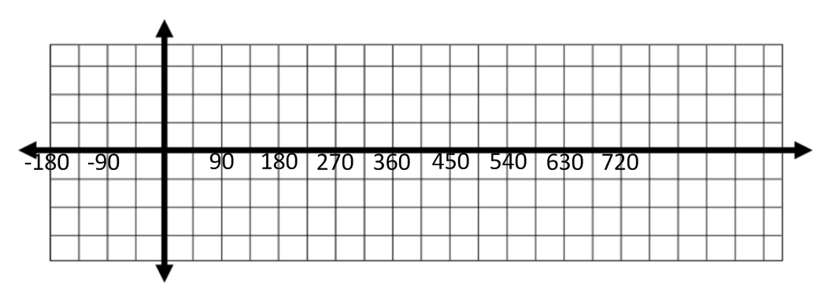
Scaffolding:
If students are struggling, start with a series of easier questions once they have completed the graph.
- What do you notice about the graph?
- What features does it have?
- How would you describe it to someone who can't see it?
As an extension, ask
- How would the graph of cosine be different?

What do you notice about the graph? What features does it have? How would you describe it to someone who can't see it?"

What do you notice about the graph? What features does it have? How would you describe it to someone who can't see it?"

  - Extend the graph of the sine function above so that it is graphed on the interval from $[-180,720]$.

  - For the interval $[-180,720]$, describe the values of $θ$ at which the sine function has relative maxima and minima.
Maxima occur at $90$and $450$. Minima occur at $-90, 270,$and $630$.
  - For the interval $[-180,720]$, describe the values of $θ$ for which the sine function is increasing and decreasing.
Increasing: $-90<θ<90$, $270<θ<450$, and$630<θ<720$
Decreasing:$-180<θ<-90$,$90<θ<270$, and$450<θ<630$

  - For the interval $[-180,720]$, list the values of $θ$ at which the graph of the sine function crosses the horizontal axis.
$$-180, 0, 180, 360, 540, 720$$

  - Describe the end behavior of the sine function.
The sine function will continue to oscillate between $-1$ and $1$ as $θ→∞$ or $θ→-∞$.

  - Based on the graph, is sine an odd function, even function, or neither? How do you know?
Sine is an odd function because the graph is symmetric with respect to the origin.

  - Describe how the sine function repeats.
The sine function repeats the same pattern every $360$ units because $360°$ is one full turn. After that, the values of sine just continue to repeat.

Debrief to make sure students have correctly graphed the sine function and identified its key features.
- At which values of $θ$ is the sine function at a maximum?
  - $90, 450,-270$ (Answers may vary.)
- Are the values you listed the only places where the sine function is at a maximum?
  - No, the graph will continue to repeat. Every time we get to a rotation value that produces a point that is at the top of the circle, the graph will reach a maximum point.
- How could we write the answer in general terms to include all values of $θ$ at which the sine function is at a maximum?
  - The sine function is at a maximum every $360$units starting at$θ=90$, which is $θ$ plus or minus some multiple of $360$.
- Lead students to the equation$θ=90+360n$ for all integers $n$.

Ask groups to now do the same for the values of $θ$for which the sine function is at a minimum and where the graph of the sine function crosses the horizontal axis. Then, share responses.
- At which values of $θ$ is the sine function at a minimum?
  - At $θ=270+360n$ for all integers $n$ (or, $θ=-90+360n)$
- At which values of $θ$ does the graph of the sine function cross the horizontal axis?
  - At $θ=360n$ for all integers $n$

- How could we describe the end behavior of the sine function?
  - As $θ→∞$, the sine function does not approach a specific value or go up towards $∞$or down towards$-∞$. It just keeps repeating the same pattern over and over. The same thing happens as $θ→-∞$.
MP.2
- How far do you have to go on the graph before the pattern repeats? Why?
  - The pattern repeats after $360$ units because ${360}^{o}$is one full turn. After that we are just repeating the same values around the circle.
Before students begin to work on Part II of this challenge, ask them to make a conjecture about how the graph of the cosine function will be the same as the sine function and how it will be different. Discuss as a class or ask students to share with a partner. As they begin to work on Part II, instruct them to list the answers to (d) and (f) that are apparent from the graph and then to write the answer in general terms.

Part II: Consider the function $g\left(θ\right)=cos(θ)$.
  - Complete the following table giving answers as approximations to one decimal place.
$$θ$$ | $$0$$ | $$30$$ | $$45$$ | $$60$$ | $$90$$ | $$120$$ | $$135$$ | $$150$$ | $$180$$
$$cos(θ)$$ | $$1$$ | $$0.9$$ | $$0.7$$ | $$0.5$$ | $$0$$ | $$-0.5$$ | $$-0.7$$ | $$-0.9$$ | $$-1$$
$$θ$$ | $$210$$ | $$225$$ | $$240$$ | $$270$$ | $$300$$ | $$315$$ | $$330$$ | $$360$$
$$cos(θ)$$ | $$-0.9$$ | $$-0.7$$ | $$-0.5$$ | $$0$$ | $$0.5$$ | $$0.7$$ | $$0.9$$ | $$1$$

  - Using the values in the table, sketch the graph of the cosine function on the interval $[0,360]$.
  - Extend the graph of the cosine function above so that it is graphed on the interval from $[-180,720]$.

  - For the interval $[-180,720]$, describe the $θ$-values at which the cosine function has relative maxima and minima.
Maxima occur at $0, 360, 720$. Minima occur at $-180, 180, 540$.

  - For the interval $[-180,720]$, describe the values of $θ$ for which the cosine function is increasing and decreasing.
Increasing: $-180<θ<0$,$180<θ<360$, and$540<θ<720$
Decreasing: $0<θ<180$ and$360<θ<540$

  - For the interval $[-180,720]$, list the values of $θ$ at which the graph of the cosine function crosses the horizontal axis.
$$-90, 90, 270, 450, 630$$

  - Describe the end behavior of the graph of the cosine function.
The cosine function will continue to oscillate between $-1$ and $1$ as $θ→∞$ or $θ→-∞$.

  - Based on the graph, is cosine an odd function, even function, or neither? How do you know?
Cosine is an even function because the graph is symmetric with respect to the vertical axis.

  - Describe how the cosine function repeats.
The cosine function repeats the same pattern every $360$ units because $360°$ is one full turn. After that, the values of cosine just continue to repeat.

  - How are the sine function and cosine function related to each other?
The two functions are horizontal translations of each other. If the graph of the sine function is shifted left or the graph of the cosine function is shifted right, the two graphs would match up.

- At which values of $θ$ is the cosine function at a maximum?
  - At $θ=360n$ for all integers $n$
- At which values of $θ$ is the cosine function at a minimum?
  - At $θ=180+360n$ for all integers $n$
- Where does the graph of the cosine function cross the horizontal axis?
  - At $θ=90+360n$ and $θ=270+360n$ for all integers $n$. This can also be expressed as
$θ=90+180n$, for all integers $n$.
- What are some ways in which the graphs of the sine and cosine functions are alike?
  - They have the same type of end behavior, they both repeat every $360°$, they have the same basic shape, and they are horizontal shifts of each other.
- If we wanted to do a quick graph of the sine or cosine function showing all the key points, what values of $θ$ would be the most important to use? Why?
  - It would be important to use the values of $θ$ that correspond to points located on the $x$-axis and $y$-axis of the unit circle. They are the relative maxima and minima of sine and cosine and also where the graphs of sine and cosine will cross the horizontal axis.

Closing (4 minutes)
Have the students read the definitions in the lesson summary. Ask them to identify the period and amplitude of the sine and cosine functions and then share responses with a partner. Mastery of these terms is not expected at this point. The intent is to begin to use the vocabulary associated with the sine and cosine functions.
- Why are sine and cosine examples of periodic functions?
- What is the period of each function? Why?
- How is amplitude measured? What is the amplitude of each function?
Lesson Summary
- A function $f$ whose domain is a subset of the real numbers is said to be periodic with period $P>0$ if the domain of $f$ contains $x+P$ whenever it contains $x$, and if $f\left(x+P\right)=f(x)$ for all real numbers $x$ in its domain.
- If a least positive number $P$ exists that satisfies this equation, it is called the fundamental period or, if the context is clear, just the period of the function.
- The amplitude of the sine or cosine function is the average of the maximum value and the minimum value of the function.
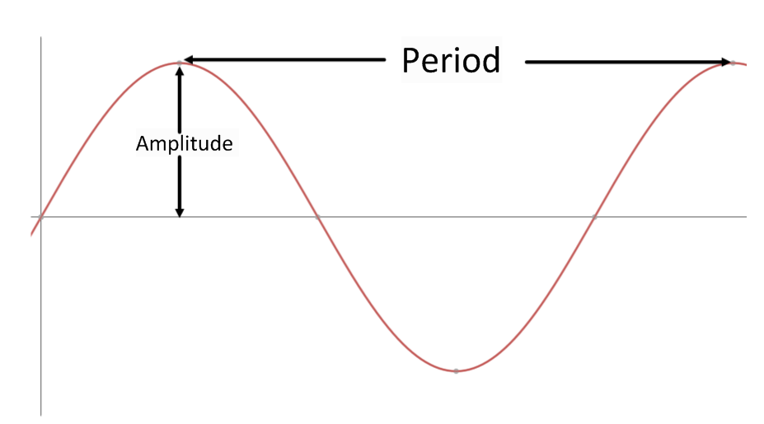
Exit Ticket (4 minutes)
Name Date
Lesson 8: Graphing the Sine and Cosine Functions

Exit Ticket

- Sketch a graph of the sine function on the interval [$0, 360$] showing all key points of the graph (horizontal and vertical intercepts and maximum and minimum points). Mark the coordinates of the maximum and minimum points and the intercepts.

- Sketch a graph of the cosine function on the interval [$0, 360$] showing all key points of the graph (horizontal and vertical intercepts and maximum and minimum points). Mark the coordinates of the maximum and minimum points and the intercepts.
Exit Ticket Sample Solutions

- Sketch a graph of the sine function on the interval [$0, 360$] showing all key points of the graph (horizontal and vertical intercepts and maximum and minimum points). Mark the coordinates of the maximum and minimum points and the intercepts.
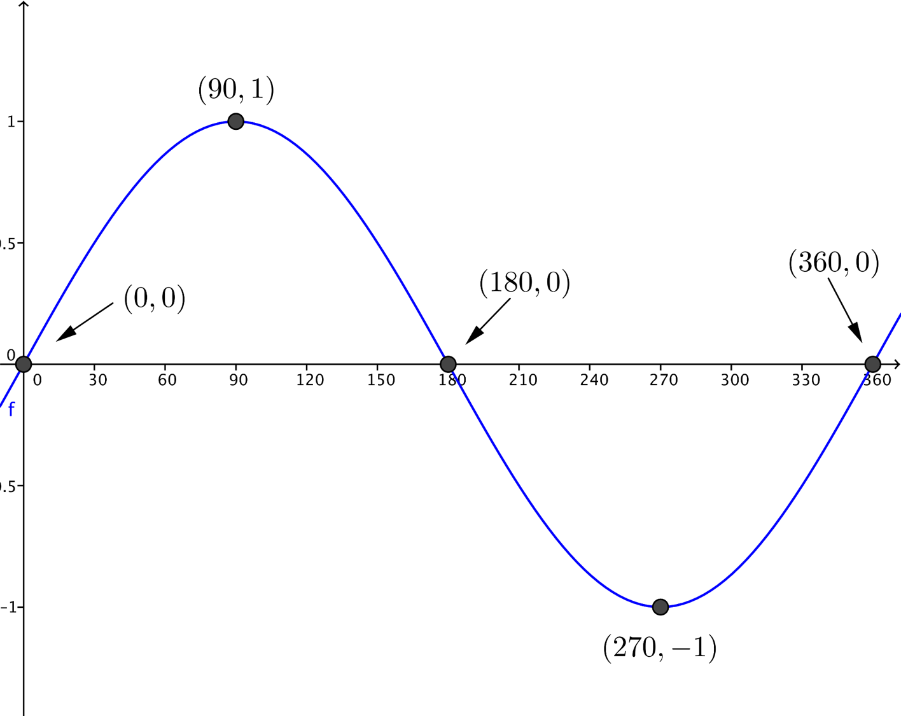

- Sketch a graph of the cosine function on the interval [$0, 360$] showing all key points of the graph (horizontal and vertical intercepts and maximum and minimum points). Mark the coordinates of the maximum and minimum points and the intercepts.
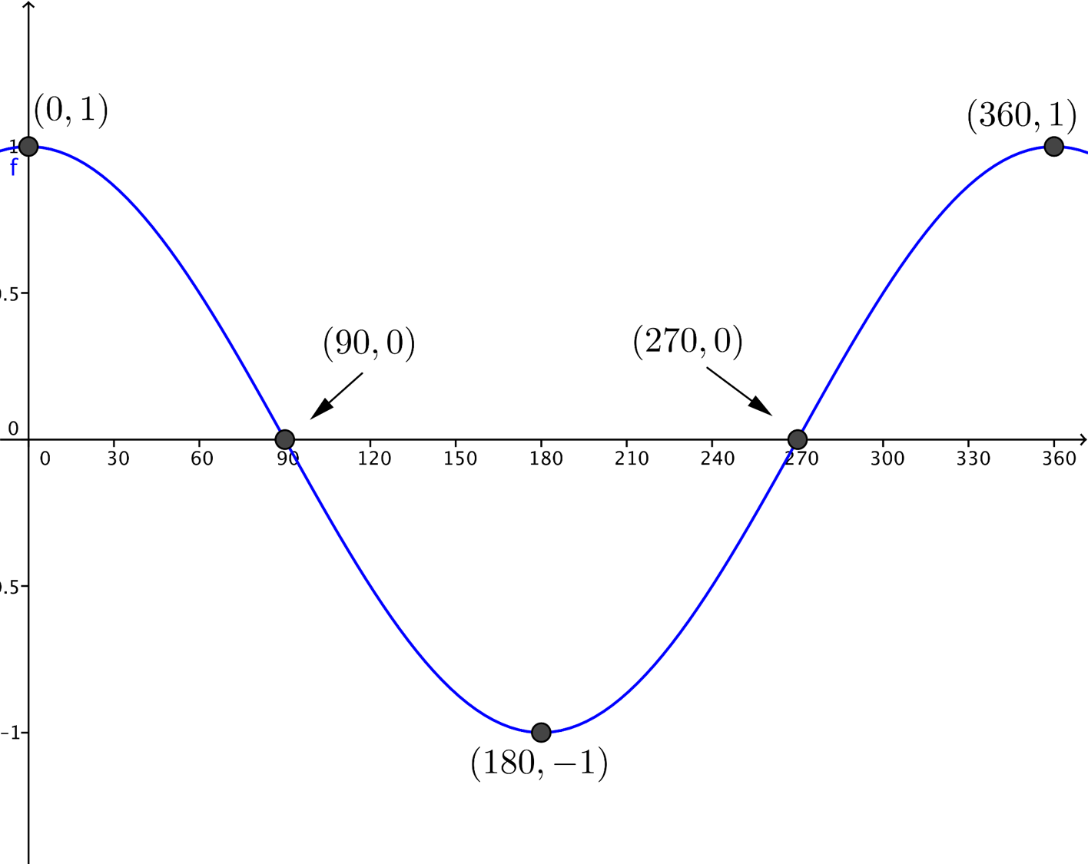

Problem Set Sample Solutions

- Graph the sine function on the interval [$-360, 360$] showing all key points of the graph (horizontal and vertical intercepts and maximum and minimum points). Then, use the graph to answer each of the following questions.
  - On the interval $[-360,360]$, what are the relative minima of the sine function? Why?
The sine function has relative minima at $-90$ and $270$ because when rotated by $-90°$ or $270°$, the initial ray intersects the unit circle at the bottom of the circle; therefore, the sine is at its smallest possible value.

  - On the interval $[-360,360],$ what are the relative maxima of the sine function? Why?
The sine function has relative maxima at $-270$and $90$ because when rotated by $-270°$ or $90°$, the initial ray intersects the unit circle at the top of the circle; therefore, the sine is at its largest possible value.

  - On the interval [$-360, 360$], for what values of $θ$ is $sin(θ)=0$? Why?
The sine function is equal to $0$ at $-360$, $-180$,$0$, $180$, and $360$ because when rotated by any of these degree measurements, the initial ray intersects the unit circle at a point on the $x$-axis; therefore, $sin(θ)$, which measures the height of the point on the circle, is equal to $0$.

  - If we continued to extend the graph in either direction, what would it look like? Why?
It would repeat the same pattern every $360$ units in either direction. So, from $360$ to $720$, the graph would look exactly like it does from $0$ to $360$, as it also would from $720$ to $1080$, and so on. Also, from $-360$ to $0$, the graph would look the same as it does from $0$ to $360$, as it also would from $-720$ to $-360$, and so on.

  - Arrange the following values in order from smallest to largest by using their location on the graph.
$$sin(170°)$$ | $$sin(85°)$$ | $$sin(-85°)$$ | $$sin(200°)$$
$$sin(-85°)$$ | $$sin(200°)$$ | $$sin(170°)$$ | $$sin(85°)$$

  - On the interval$(90, 270)$, is the graph of the sine function increasing or decreasing? Based on that, name another interval not included in $(90, 270)$ where the sine function must have the same behavior.
Decreasing;$(450, 630)$

- Graph the cosine function on the interval [$-360, 360$] showing all key points of the graph (horizontal and vertical intercepts and maximum and minimum points). Then, use the graph to answer each of the following questions.
  - On the interval $[-360,360],$ what are the relative minima of the cosine function? Why?
The cosine function has relative minima at $-180$ and $180$ because when rotated by $–180°$ or $180°$, the initial ray intersects the unit circle at the left-most point of the circle; therefore, the cosine is at its smallest possible value.

  - On the interval $[-360,360],$ what are the relative maxima of the cosine function? Why?
The cosine function has relative maxima at $-360$, $0$, and $360$ because when rotated by $–360°, 0°,$ or $360°$, the initial ray intersects the unit circle at the right-most point of the circle; therefore, the cosine is at its largest possible value.

  - On the interval [$-360, 360$], for what values of $θ$ is $cos(θ)=0$? Why?
The cosine function is equal to $0$ at $-270$, $-90$ $90$, and $270$ because when rotated by any of these degree measurements, the initial ray intersects the unit circle at a point on the $y$-axis; therefore, $cos(θ)$, which measures the horizontal position of the point on the circle, is equal to $0$.

  - If we continued to extend the graph in either direction, what would it look like? Why?
It would repeat the same pattern every $360$ units in either direction. So from $360$ to $720,$ the graph would look exactly like it does from $0$ to $360$, as it also would from $720$ to $1080$, and so on. Also, from $-360$ to $0$, the graph would look the same as it does from $0$ to $360$, as it also would from $-720$ to $-360$, and so on.

  - What can be said about the end behavior of the cosine function?
Like the sine function, the cosine function continues to oscillate between the values of $-1$ and $1$ as $θ$ approaches $∞$ or $-∞$.

  - Arrange the following values in order from smallest to largest by using their location on the graph.
$$cos(135°)$$ | $$cos(85°)$$ | $$cos(-15°)$$ | $$cos(190°)$$
$$cos(190°)$$ | $$cos(135°)$$ | $$cos(85°)$$ | $$cos(-15°)$$

- Write a paragraph comparing and contrasting the sine and cosine functions using their graphs and end behavior.
The graphs of sine and cosine have the same domain, range, amplitude, and period. Neither graph has end behavior because both oscillate between the values of $-1$ and $1$ as $θ$ approaches $∞$ or $-∞$. The graphs have different $y$-intercepts (“starting points”) because at $0°$ sine is $0$ and cosine is $1$. When sine is at its maximum or minimum, the cosine function is $0$ and has a horizontal intercept. The graphs are horizontal translations of each other, so the graph of cosine can be made to look like sine by using a horizontal shift and vice versa.

- Use the graph of the sine function given below to answer the following questions.
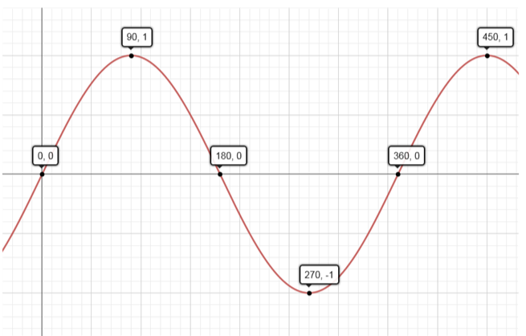

  - Desmond is trying to determine the value of $sin(45°)$. He decides that since 45 is halfway between $0$ and $90$, $sin(45°)=\frac{1}{2}$. Use the graph to show him that he is incorrect.
Using the graph, the $y$-value at $θ=45$ is above $0.5$, so $sin\left(45°\right)>\frac{1}{2}.$
That is, the graph is not linear between the point $(0,0)$ and the point $(90,1)$.

  - Using the graph, complete each sentence by filling in $>, <,$or $=$.

i. | $$sin(250°)$$ | $$=$$ | $sin(290°)$
ii. | $sin(25°)$ | $$<$$ | $sin(85°)$
iii. | $sin(140°)$ | $$>$$ | $sin(160°)$

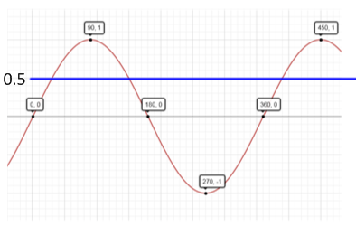
  - On the interval $[0,450]$, list the values of $θ$ such that $sin(θ)=\frac{1}{2}$.
$$30,150,390$$

  - Explain why there are no values of $θ$ such that $sin(θ)=2$.
The sine function ranges in values from $-1$ to $1$. Since the maximum value of the sine function is $1$ (when the terminal ray of the rotation intersects the top of the circle), it is impossible for there to be a value $θ$ such that $sin(θ)=2$.

Exploratory Challenge Unit Circle Diagram

