Lesson 8: Graphing the Sine and Cosine Functions

Classwork
Exploratory Challenge 1
Your group will be graphing: $f\left(θ\right)= sin(θ)$ $g\left(θ\right)=cos(θ)$
The circle on the next page is a unit circle, meaning that the length of the radius is one unit.
- Mark axes on the poster board, with a horizontal axis in the middle of the board and a vertical axis near the left edge, as shown.

- Measure the radius of the circle using a ruler. Use the length of the radius to mark $1$ and $-1$ on the vertical axis.
- Wrap the yarn around the circumference of the circle starting at 0. Mark each $15°$ increment on the yarn with the marker. Unwind the yarn and lay it on the horizontal axis. Transfer the marks on the yarn to corresponding increments on the horizontal axis. Label these marks as $0$, $15$, $30$, …, $360$.
- We will record the number of degrees of rotation $θ$ on the horizontal axis of the graph, and we will record the value of either $sin(θ)$ or $\cos\left(θ\right)$ on the vertical axis. Notice that the scale is wildly different on the vertical and horizontal axes.
- If you are graphing $g\left(θ\right)=cos(θ)$: For each $θ$ marked on your horizontal axis, beginning at $0$, use the spaghetti to measure the horizontal displacement from the vertical axis to the relevant point on the unit circle. The horizontal displacement is the value of the cosine function. Break the spaghetti to mark the correct length, and place it vertically at the appropriate tick mark on the horizontal axis.
- If you are graphing $f\left(θ\right)=sin(θ)$: For each $θ$ marked on your horizontal axis, beginning at $0$, use the spaghetti to measure the vertical displacement from the horizontal to the relevant point on the unit circle. The vertical displacement is the value of the sine function. Break the spaghetti to mark the correct length, and place it vertically at the appropriate tick mark on the horizontal axis.
- Remember to place the spaghetti below the horizontal axis when the value of the sine function or the cosine function is negative. Glue each piece of spaghetti in place.
- Draw a smooth curve that connects the points at the end of each piece of spaghetti.

Exploratory Challenge 2
Part I: Consider the function $f\left(θ\right)=sin(θ)$.
  - Complete the following table by using the special values learned in Lesson 4. Give values as an approximation to one decimal place.
$$θ$$ | $$0$$ | $$30$$ | $$45$$ | $$60$$ | $$90$$ | $$120$$ | $$135$$ | $$150$$ | $$180$$
$$sin(θ)$$
$$θ$$ | $$210$$ | $$225$$ | $$240$$ | $$270$$ | $$300$$ | $$315$$ | $$330$$ | $$360$$
$$sin(θ)$$

  - Using the values in the table, sketch the graph of the sine function on the interval $[0,360]$.
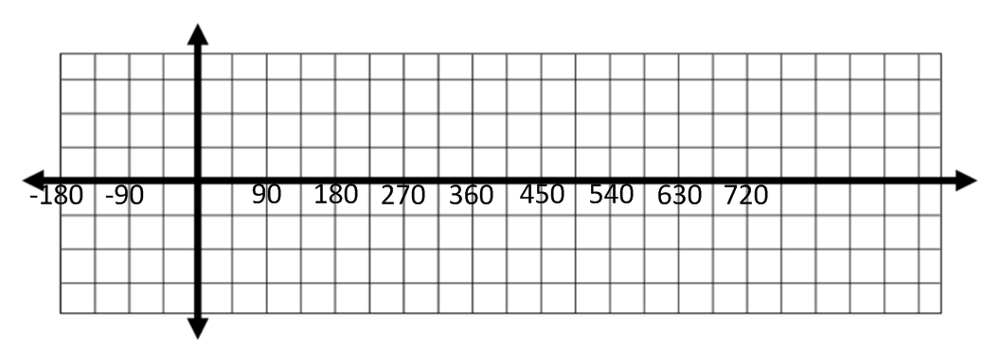
  - Extend the graph of the sine function above so that it is graphed on the interval from $[-180,720]$.

  - For the interval $[-180,720]$, describe the values of $θ$ at which the sine function has relative maxima and minima.

  - For the interval $[-180,720]$, describe the values of $θ$ for which the sine function is increasing and decreasing.

  - For the interval $[-180,720]$, list the values of $θ$ at which the graph of the sine function crosses the horizontal axis.

  - Describe the end behavior of the sine function.

  - Based on the graph, is sine an odd function, even function, or neither? How do you know?

  - Describe how the sine function repeats.

Part II: Consider the function $g\left(θ\right)=cos(θ)$.
  - Complete the following table giving answers as approximations to one decimal place.
$$θ$$ | $$0$$ | $$30$$ | $$45$$ | $$60$$ | $$90$$ | $$120$$ | $$135$$ | $$150$$ | $$180$$
$$cos(θ)$$
$$θ$$ | $$210$$ | $$225$$ | $$240$$ | $$270$$ | $$300$$ | $$315$$ | $$330$$ | $$360$$
$$cos(θ)$$

  - Using the values in the table, sketch the graph of the cosine function on the interval $\left[0,360\right].$
  - Extend the graph of the cosine function above so that it is graphed on the interval from $[-180, 720]$.

  - For the interval $\left[-180, 270\right]$, describe the values of $θ$ at which the cosine function has relative maxima and minima.

  - For the interval $[-180, 720]$, describe the values of $θ$ for which the cosine function is increasing and decreasing.

  - For the interval $[-180, 720]$, list the values of $θ$ at which the graph of the cosine function crosses the horizontal axis.

  - Describe the end behavior of the graph of the cosine function.

  - Based on the graph, is cosine an odd function, even function, or neither? How do you know?

  - Describe how the cosine function repeats.

  - How are the sine function and the cosine function related to each other?

Problem Set
Lesson Summary
- A function $f$ whose domain is a subset of the real numbers is said to be periodic with period $P>0$ if the domain of $f$ contains $x+P$ whenever it contains $x$, and if $f\left(x+P\right)=f(x)$ for all real numbers $x$ in its domain.
- If a least positive number $P$ exists that satisfies this equation, it is called the fundamental period or, if the context is clear, just the period of the function.
- The amplitude of the sine or cosine function is the average of the maximum value and the minimum value of the function.
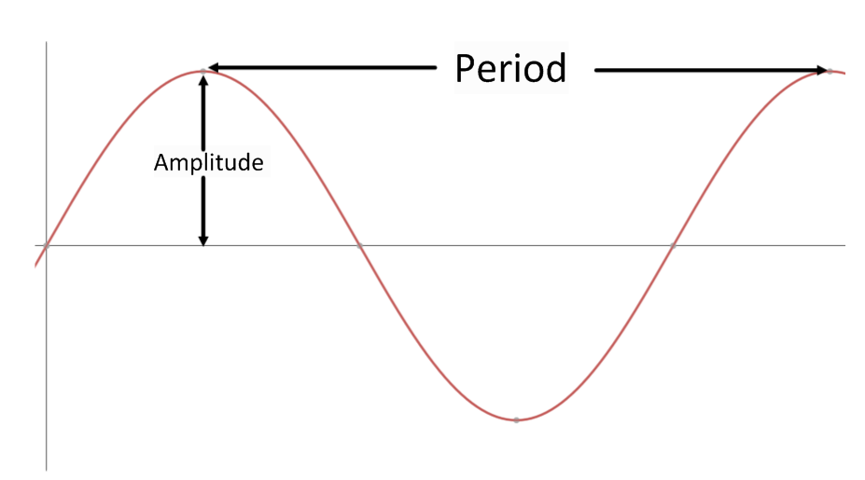

- Graph the sine function on the interval [$-360, 360$] showing all key points of the graph (horizontal and vertical intercepts and maximum and minimum points). Then, use the graph to answer each of the following questions.
  - On the interval $[-360,360]$, what are the relative minima of the sine function? Why?
  - On the interval $[-360,360],$ what are the relative maxima of the sine function? Why?
  - On the interval [$-360, 360$], for what values of $θ$ is $sin(θ)=0$? Why?
  - If we continued to extend the graph in either direction, what would it look like? Why?
  - Arrange the following values in order from smallest to largest by using their location on the graph.
$$sin(170°)$$ | $$sin(85°)$$ | $$sin(-85°)$$ | $$sin(200°)$$
  - On the interval$(90, 270)$, is the graph of the sine function increasing or decreasing? Based on that, name another interval not included in $(90, 270)$ where the sine function must have the same behavior.

- Graph the cosine function on the interval [$-360, 360$] showing all key points of the graph (horizontal and vertical intercepts and maximum and minimum points). Then, use the graph to answer each of the following questions.
  - On the interval $[-360,360],$what are the relative minima of the cosine function? Why?
  - On the interval $[-360,360],$ what are the relative maxima of the cosine function? Why?
  - On the interval [$-360, 360$], for what values of $θ$ is $cos(θ)=0$? Why?
  - If we continued to extend the graph in either direction, what would it look like? Why?
  - What can be said about the end behavior of the cosine function?
  - Arrange the following values in order from smallest to largest by using their location on the graph.
$$cos(135°)$$ | $$cos(85°)$$ | $$cos(-15°)$$ | $$cos(190°)$$

- Write a paragraph comparing and contrasting the sine and cosine functions using their graphs and end behavior.

- Use the graph of the sine function given below to answer the following questions.
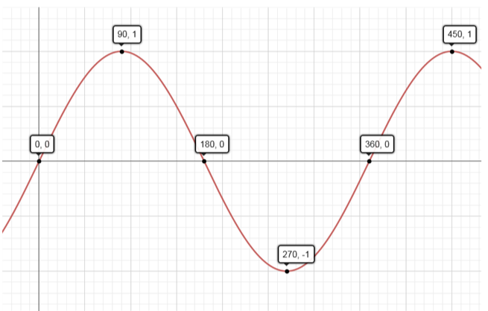

  - Desmond is trying to determine the value of $sin(45°)$. He decides that since $45$ is halfway between $0$ and $90$ that $sin(45°)=\frac{1}{2}$. Use the graph to show him that he is incorrect.
  - Using the graph, complete each sentence by filling in $>, <,$or $=$.
i. | $$sin(250°)$$ |  | $sin(290°)$
ii. | $sin(25°)$ |  | $sin(85°)$
iii. | $sin(140°)$ |  | $sin(160°)$
  - On the interval $[0,450]$, list the values of $θ$ such that $sin(θ)=\frac{1}{2}$.
  - Explain why there are no values of $θ$ such that $sin(θ)=2$.

