Lesson 9

Objective: Arrange and count 6 and 7 objects in varied configurations.

Suggested Lesson Structure

 Fluency Practice (5 minutes)

 Application Problem (3 minutes)

 Concept Development (14 minutes)

 Student Debrief (3 minutes)

**Total Time (25 minutes)**

Fluency Practice (5 minutes)

* Clap, Stomp, and Count to 8 **PK.CC.1** (2 minutes)
* Touch and Count to 7  **PK.CC.3a** (3 minutes)

Clap, Stomp, and Count to 8 (2 minutes)

Note: Rote counting to 7 and 8 prepares students for the upcoming objective of touching and counting to 8 in Topic C.

T: Let’s clap 7 times and count our claps! Join in when you are ready. 1, 2, 3, 4, 5, 6, 7. (Repeat until most are either clapping, counting, or ideally, clapping and counting. Pause between counts.)

T: Let’s stomp 7 times and count our stomps! 1, 2, 3, 4, 5, 6, 7. (Follow the same process as above.)

T: Let’s clap 8 times and count our claps! 1, 2, 3, 4, 5, 6, 7, 8.

T: Let’s stomp 8 times and count our stomps! 1, 2, 3, 4, 5, 6, 7, 8.

Touch and Count to 7 (3 minutes)

Materials: (S) 7-stick (5 cubes one color, 2 cubes another color)

Note: This fluency activity focuses on counting to 7 in anticipation of introducing the number 8 as 7 and 1 more in Topic C. By using the color change after the fifth cube, the number 7 becomes more accessible, comprised of two familiar numbers, although in this activity the composition of those parts is not analyzed as students simply count past the color change to 7.

T: Stand your stick up to make a tower like this. (Demonstrate 5 on the bottom and the 2 at the top.) Start at the bottom to touch and count the number of cubes in your stick.

S: 1, 2, 3, 4, 5, 6, 7.

T: This time, when you count, use a whisper voice for the bottom color and a big voice for the top color.

S: (Use whisper voice) 1, 2, 3, 4, 5, (change to big voice) 6, 7.

T: Good. Now, use a big voice for the bottom color and whisper voice for the top color.

S: (Use big voice) 1, 2, 3, 4, 5, (change to whisper voice) 6, 7.

T: This time, use a growling voice for the bottom color and a high voice for the top color.

S: (Use growling voice) 1, 2, 3, 4, 5, (change to high voice) 6, 7.

Have students use a high voice for the bottom color and a growling voice for the top color.

Application Problem (3 minutes)

Materials: (S) Paper plate, 7-stick from Touch and Count to 7

Instruct the students to pretend each cube in their 7-stick is a friend waiting in line to go on a merry-go-round. Have them move their friends from the line onto the merry-go-round (the paper plate), and then count their friends. Direct them to gently turn their plates as the merry-go-round starts to move. After you direct them to stop the spinning, have them put the friends in a line again and recount.

Note: This fluency activity gives students additional practice counting in a circular formation. The color change may make it easier for them: “I started with the red cube that is next to a yellow one, so I’ll stop counting when I get back there.” However, they still must determine whether to include the cube they started with in the count. Take note of this possible point of confusion. There are 7 cubes, not 8!

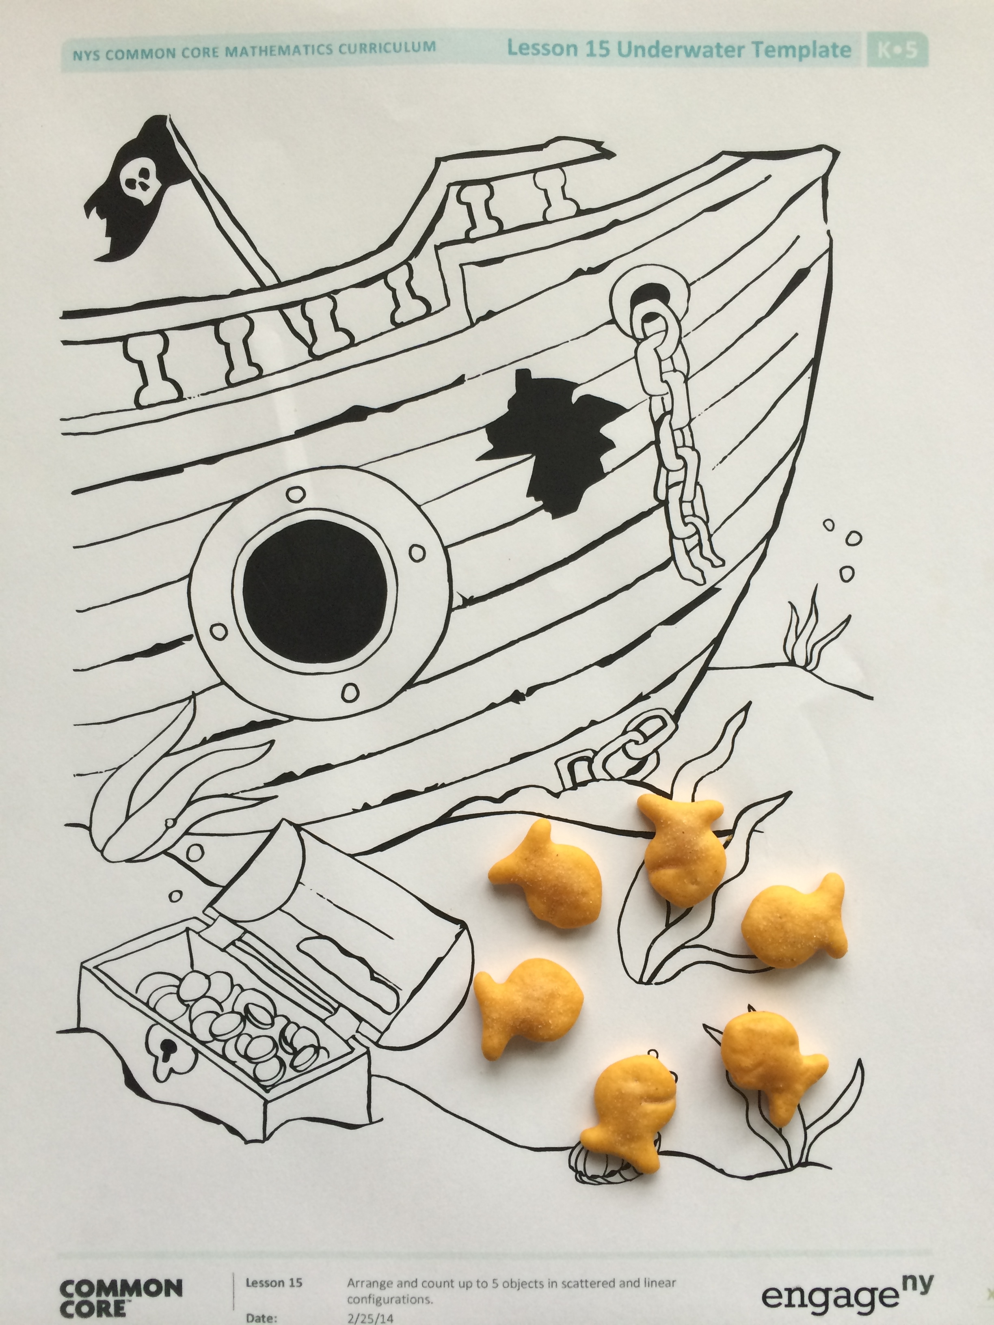Concept Development (14 minutes)

Part 1: Concept Introduction

Materials: (T/S) Underwater mat (Template 1), small cup with 7 Goldfish crackers (provide substitute for children with allergy or dietary restrictions), plastic shark (or see sharks on Template 2)

1. Gather students in a circle, and distribute a cup of Goldfish crackers and an underwater mat to each child. Have students count out 5 goldfish and place them in a circular configuration on their mats.
2. Describe what you are seeing using self-talk: “The 5 fish are swimming in a circle. One more fish joins their circle. How many fish are in the circle now?” Elicit ideas about how to mark the starting point of the count, and lead students in counting, “1, 2, 3, 4, 5, 6.”
3. Say, “Oh no, a shark is coming! These fish need to line up so they can swim through this little window to get away from the shark.” Ask students, “What should the fish do: line up or swim in a circle?” Students respond, “Line up!”

**MP.4**

1. Line up the fish (as students do the same), and lead the class in a choral count to 6 again. Guide students to see that no fish were eaten by the shark, thank goodness. There are still 6 fish, just arranged differently.
2. 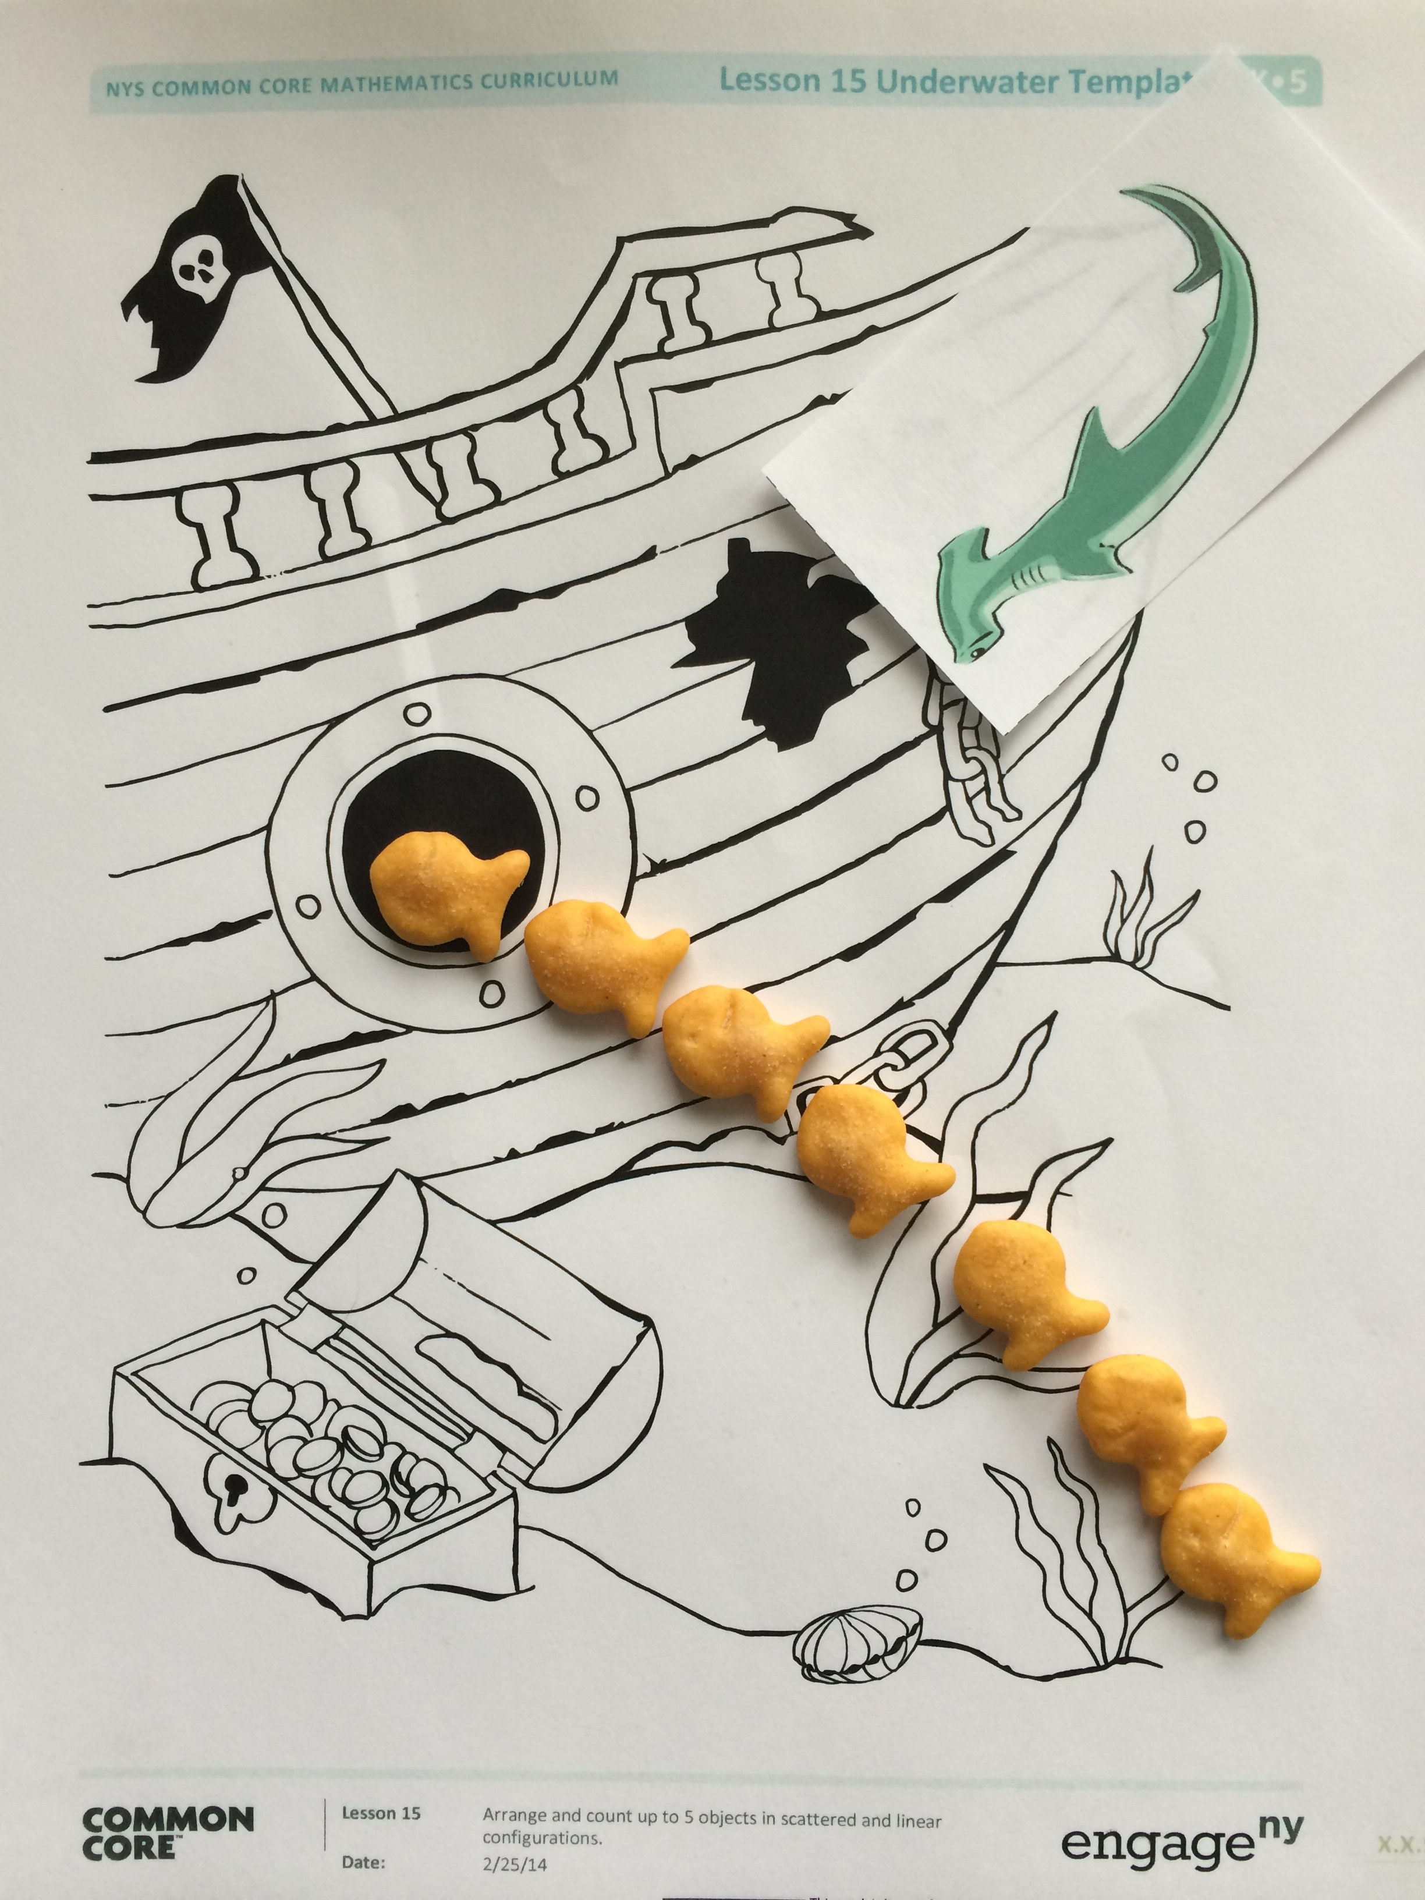Say, “Phew! The fish hid safely from the shark.” Say, “Do you know fish swim in schools, large groups just like us? Let’s pair up the fish in our school. How many fish are there?” (Guide students to count fish in the array configuration.)

**MP.4**

1. Say, “The fish found 1 more friend inside the pirate ship. (Show how he doesn’t have a buddy.) Since he doesn’t have a buddy, the fish decide to swim in a circle again.” Ask students, “How many fish are swimming?” Count to 7 chorally, and guide students to answer in a complete sentence: “There are….”
2. Say, “That sneaky shark is back! Let’s have the fish line up quickly!” Model as students move the fish into a line and recount to 7.

Part 2: Practice

Materials:(S) Per pair: baggie with 6–7 picture cards (Template 3), numeral cards 5–7 (optional, Lesson 7 Template 2)

|  |  |
| --- | --- |
|  | NOTES ON  MULTIPLE MEANS  OF REPRESENTATION: |
| Provide real life opportunities for students to practice counting in a variety of configurations throughout the day. For example, circle up then line up students during a classroom transition. This continued real life practice allows students to discover patterns and see the configurations (array, linear, and circular) within their daily routines. | |

1. Pair students and send them to tables with a baggie of 6–7 picture cards.
2. Say, “Look at the picture cards in front of you. What do you see?” Students might respond, “I see kitties in a circle,” “I see these puppies have buddies,” “The kitties are in a line for a drink of water.”
3. Instruct partners to take turns asking a *how many* question and counting the objects in the pictures. If students need an extra challenge, have them find the matching numeral.
4. As the students work, circulate and describe what they are doing using parallel talk: “Aravinder touched and counted 7 bees in a circle. Then, she counted 7 in a straight line.”

|  |  |
| --- | --- |
|  | CENTER CONNECTION: |

Practice counting up to 7 in different configurations in the block center. Select 6 or 7 blocks, have children playfully mix them up, and count how many. Then, ask the children to line up the blocks and count again. Finally, ask them to stack the blocks and count. Some students use conservation to understand that the number of blocks does not change when the blocks are rearranged.

Student Debrief (3 minutes)

**Lesson Objective:** Arrange and count 6 and 7 objects in varied configurations.

The Student Debrief is intended to invite reflection and active processing of the total lesson experience. It is also an opportunity for informal assessment. Consider taking anecdotal notes or using a simple checklist to note each child’s progress towards meeting the lesson objective.

As students complete the Practice portion of the Concept Development, listen for misconceptions or misunderstandings that can be addressed in the Debrief.

You may choose to use any combination of the questions below to help students express ideas, make connections, and use new vocabulary.

* Which is harder for you, counting when the fish are in a circle or when they are in a line? Why?
* If we moved from our circle on the carpet and made a line for lunch, would we still have the same number of children? What if we moved to work at our desks? How do you know? (Accept answers that notice that sometimes some children might be out of the classroom or elsewhere.)
* Do you like counting to 7? What do like about the number 6? The number 7?



_________________

underwater mat

|  |  |
| --- | --- |
| [1] |  |
|  |  |
|  |  |
|  |  |

|  |  |
| --- | --- |
|  |  |
|  | |
|  |  |
| _________________  6–7 picture cards | |

1. sharks