Lesson 8
Objective: Count 6 and 7 objects in circular configurations.

Suggested Lesson Structure
 Fluency Practice (6 minutes)
 Application Problem (5 minutes)
 Concept Development (11 minutes)
 Student Debrief (3 minutes)
Total Time (25 minutes)
Fluency Practice (6 minutes)
- Count to 8! PK.CC.3a (2 minutes)
- Build and Break a Stick PK.CC.3a (4 minutes)
Count to 8! (2 minutes)
Materials: (S) Plastic or metal lid (drum), 2 sticks (drum sticks)
Note: This fluency activity anticipates the work of Topic C by preparing students to count to 8 by rote so they are ready to count with one-to-one correspondence. By drawing out the “fiiiiive,” the students start to see the relationship of 6, 7, and 8 to 5.
T: Let’s play and count to 6. Join in when you are ready. 1, 2, 3, 4, fiiiive, 6. (Repeat the count until all are playing.)

NOTES ON
MULTIPLE MEANS
OF REPRESENTATION:
Daily counting practice strengthens memory. Students also benefit from connecting counting to a movement activity. Repeat this fluency activity with movements such as hopping or marching.

T: Now, let’s play and count to 7. Join in when you are ready. 1, 2, 3, 4, fiiiive, 6, 7. (Repeat until all are playing.)
T: Now, let’s play and count to 8. Join in when you are ready. 1, 2, 3, 4, fiiiive, 6, 7, 8. (Repeat until all are playing.)
Build and Break a Stick (4 minutes)
Materials: (S) 1 stick of 5 cubes, loose cubes
Note: Note that this fluency activity, just as in Lesson 7, asks students to build their stick of 7 cubes starting with 5 and putting first 1 more to make 6 and then 1 more to make 7. When they break their sticks, encourage students to see the familiar numbers inside 7. “Look, when you broke your stick, you made a little one! How many cubes are in that one?”
Application Problem (5 minutes)
Materials: (T) 1–5 white board or poster from GPK–M1–Lesson 22, 6 squirrels and 7 bears (Template 1), magnetic numerals 1–7
Gather children in a circle. Say the following rhyme, gesturing to each object on the chart:
One little flower, 2 little bees,
3 little birds in a tree.
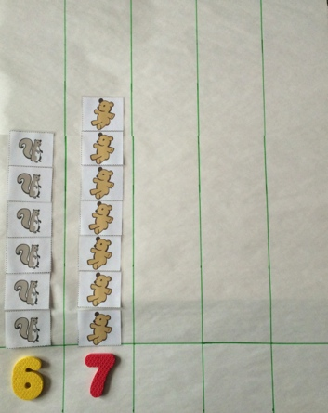
Nice, warm sun shines down on me.
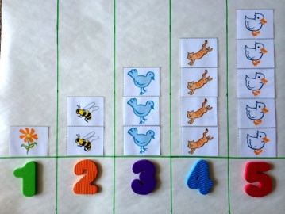
I can count! 1, 2, 3!

Four little kittens come out to play,
On this warm and sunny day.
Five little ducks take a dive.
Count them: 1, 2, 3, 4, 5!

Six little squirrels, quick as can be,
Climbing up the old oak tree.
In its shade sit 7 chairs,
1, 2, 3, 4, 5, 6, 7 bears!
Pass out the magnetic numerals 1–7. Ask, for each number, “Who has the number to show how many flowers there are? How many bees?” continuing up to “How many bears?” Have students put the magnetic numerals on the chart to match. Say, “Clap when I point to the number 6!” Point to each number in order from 1. Prior to clapping, the students should be completely silent to encourage “internal” counting. Repeat with 7.
Note: In Topics C, E, and G, numbers 8–10 will be added to this chart. Select a white board that can be used for this purpose for several days and leave space on the right side for the additions. Alternatively, use chart paper and objects and numerals with tape on the back.
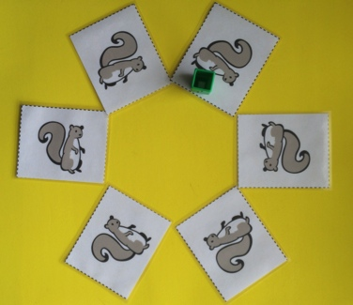
Concept Development (11 minutes)
Part 1: Concept Introduction
Materials: (T) Magnetic numerals 6–7, objects (e.g., 6 squirrels and 7 bears),
1 linking cube
Use the magnetic numerals and object images from the Application Problem.

- Take the squirrels off the board and put them in a circle. Say, “The squirrels are having a tea party. Let’s count how many squirrels are at the party.” Touch and count each squirrel. Instead of stopping at 6, continue around the circle until students notice a problem.
- Ask students for ideas about how to count things in a circle. Support them as they remember how to mark the start. Repeat the count, pretending the linking cube is a teacup to mark the start of the count.
- Ask children, “Point to the number that shows how many squirrels are at the tea party.” Ask them, “This number? This number?”
- Repeat Steps 1–3 with 7 bears.
Part 2: Practice
Materials: (S) Per pair: Numeral cards 5–7 (Lesson 7 Template 2), baggies containing circular configuration cards (Template 2 cut apart), sticker or linking cube (to mark start)
- Match students with a partner and tell them, “Let’s play school! One of you will be the teacher, and one of you will be the student.”
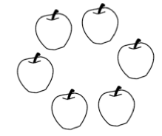
- Say, “Teachers, pick a bag and choose a card. Ask your student how many things are in the circle.”
- After students have done so, say, “Teachers, find the number that matches.”
- Students switch roles, repeating Steps 2–4.
- Circulate among groups and provide support as necessary. In particular, watch to see if students are marking a starting point for the count and if they realize the marked card is the first object counted and does not get recounted at the end of the count.
Student Debrief (3 minutes)

CENTER CONNECTION:
Invite children to help set up a pizza party for 6 or 7 stuffed animals in the dramatic play center. Place the stuffed animals in a circle and provide cups, plates, and napkins. Have children count the animals, cups, etc., as they are laid out in the circle. Assist them in marking the starting point of their count if needed.
Lesson Objective: Count 6 and 7 objects in circular configurations.
The Student Debrief is intended to invite reflection and active processing of the total lesson experience. It is also an opportunity for informal assessment. Consider taking anecdotal notes or using a simple checklist to note each child’s progress towards meeting the lesson objective.
As students complete the Practice portion of the Concept Development, listen for misconceptions or misunderstandings that can be addressed in the Debrief. You may choose to use any combination of the questions below to help students express ideas, make connections, and use new vocabulary.
Note: Have children bring their circular configuration cards to the Student Debrief.
- When counting objects in a circle, how did you know where to stop counting?
- Show me the card with strawberries. Tell your neighbor how many strawberries are on the card. Did your neighbor start counting in the same place?
- Draw or display 6 or 7 objects in a circle. (Display numerals 1–7 on the carpet.) Which number tells how many objects I have? (Pause as students will need time to count.)
- (Write the numeral 6 or 7 on the board, or hold up the foam numerals 6 or 7.) Show me this number on your fingers. (Call a student forward to trace the numeral with her finger. Have the other students trace it in the air with the student.) What does the number look like to you?

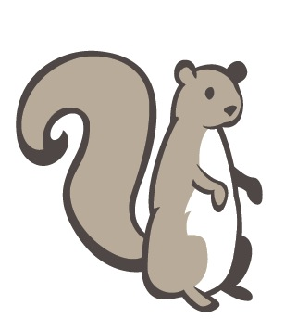
______________________
6 squirrels and 7 bears

______________________
6 squirrels and 7 bears

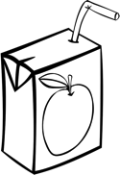 | 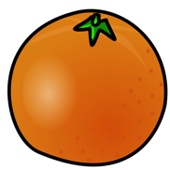
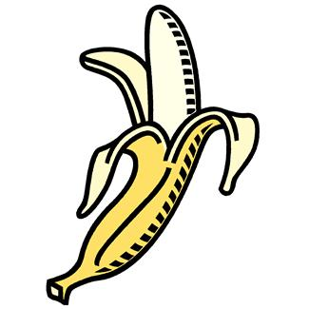
________________________
circular configuration cards

