Topic B
Matching One Numeral with up to 7 Objects
PK.CC.3ab, PK.CC.4
Focus Standard: | PK.CC.3ab | Understand the relationship between numbers and quantities to 10; connect counting to cardinality.  - When counting objects, say the number names in the standard order, pairing each object with one and only one number name and each number name with one and only one object.  - Understand that the last number name said tells the number of objects counted. The number of objects is the same regardless of their arrangement or the order in which they were counted.
 | PK.CC.4 | Count to answer "how many?" questions about as many as 10 things arranged in a line, a rectangular array, or a circle, or as many as 5 things in a scattered configuration; given a number from 1─10, count out that many objects.
Instructional Days: | 6
Coherence -Links to: | GK–M1 | Numbers to 10
 | GK–M5 | Numbers 10─20 and Counting to 100
In Module 1, children worked within 5, matching a group to the numeral that tells how many. Now, in Topic B, they extend this ability to groups of 6 and 7 (PK.CC.3ab). Pre-written numerals are introduced in Topic B so that students have plenty of time to touch and count to 7 before matching the count to the abstract numeral.
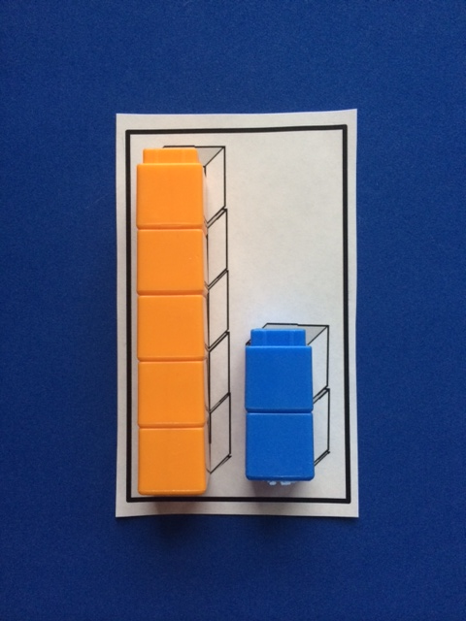
Lessons 6 and 7 introduce numerals 6 and 7 along with embedded numbers. These embedded numbers are referred to as partners or numbers “inside” bigger numbers. Children understand that 6 can be made of two familiar numbers. “We love 4 and 2 and know them so well. When I put these two sticks together we have 1 longer stick. The longer stick has 1, 2, 3, 4, 5, 6. Six cubes!”
Students practice breaking their sticks (or “towers”) into parts to fit inside a puzzle, “I have 5 cubes here and 2 cubes here.” As the towers are composed, students are introduced to the numerals. They re-assemble their 6- or 7-sticks from parts, and surprise! Although the puzzles look different, the numeral stays the same when all the cubes are counted.
In Lesson 8, children count groups of 6 and 7 in circular configurations and match the numeral that tells how many. They use objects and pictures to practice this skill. Lesson 9 provides practice counting a group of fish in varied configurations. Students see that the number of fish stays the same regardless of the arrangement (PK.CC.3b).
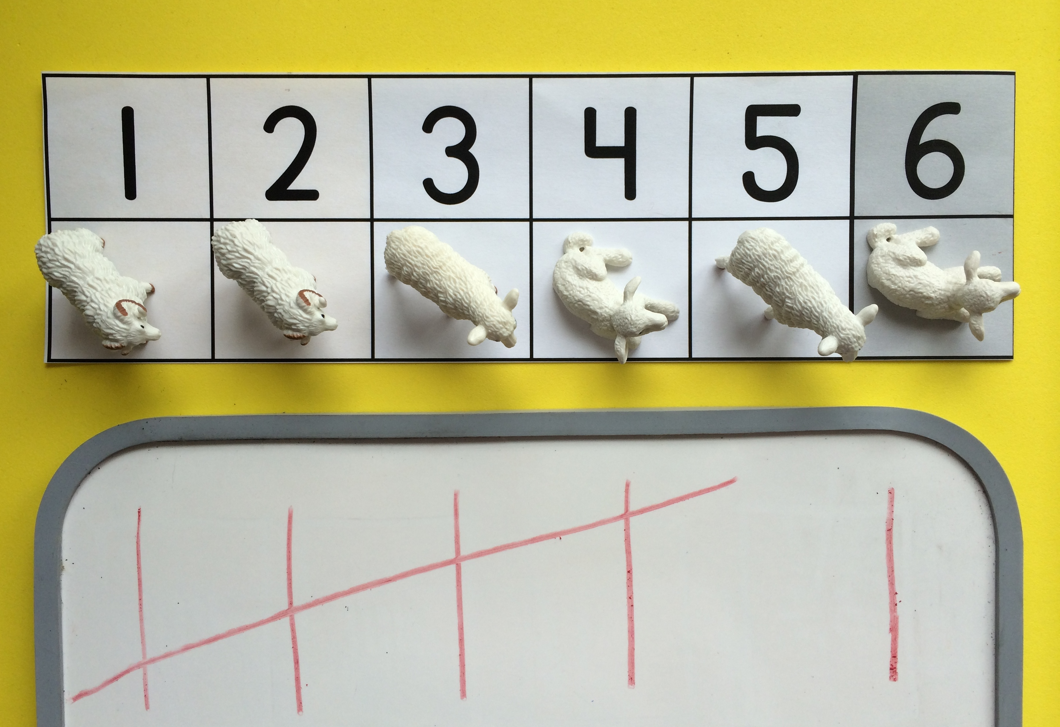
In Module 1, children learned to create groups of sticks to match a numeral up to 5. In Fluency Practice, they have been drawing tally marks to represent quantities up to 5 using their newly developed fine motor skills to make vertical and diagonal lines. In Lesson 10, children extend this to make tally marks to represent quantities to 7. This playful work also revisits the relationship of 7 and 6 to 5.
Lesson 11 asks children to make a group of up to 7 fish after seeing or hearing a number. As in Module 1, students use cards with numerals on one side and dots on the other. This supports children who still need to use matching in order to create a group.
Throughout Topic B, children develop fluency with rote counting through 8, tallying up to 5, and touching and counting up to 7 objects with one-to-one correspondence. The use of engaging materials, movement, and simple games allows children to build both skills and number sense joyfully.

A Teaching Sequence Towards Mastery of Matching One Numeral with up to 7 Objects
Objective 1: Compose 6, and then decompose into two parts. Match to the numeral 6.
(Lesson 6)
Objective 2: Compose 7, and then decompose into two parts. Match to the numeral 7.
(Lesson 7)
Objective 3: Count 6 and 7 objects in circular configurations.
(Lesson 8)
Objective 4: Arrange and count 6 and 7 objects in varied configurations.
(Lesson 9)
Objective 5: Tally 6 and 7 objects.
(Lesson 10)
Objective 6: Look at a numeral and count out a group of up to 7 objects.
(Lesson 11)

