Lesson 3
Objective: Count to 6 and 7 left to right with fingers.

Suggested Lesson Structure
 Fluency Practice (6 minutes)
 Application Problem (3 minutes)
 Concept Development (13 minutes)
 Student Debrief (3 minutes)
Total Time (25 minutes)
Fluency Practice (6 minutes)
- Rectangle Sides PK.CC.3a (3 minutes)
- Touch and Count Rocks PK.CC.1 (3 minutes)
Rectangle Sides (3 minutes)
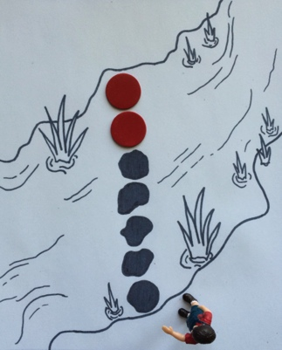
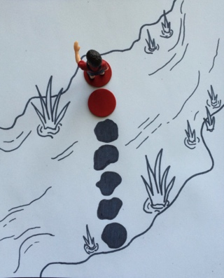
Materials: (S) 10 craft sticks per pair (placed on desks)
Note: Throughout Topic A, children line up and count craft sticks as a foundation for tallying numbers to 10.
T: Find and take the number of sticks you need to make the sides of a rectangle.
T: Make them into a rectangle on your table.
T: Move your sticks so they’re next to each other instead of making a rectangle. Now, line them up so they are like four students standing next to each other.
T: Move them back again to make a rectangle.
T: Move them next to each other again.
Touch and Count Rocks (3 minutes)
Materials: (S) Creek mat (Lesson 2 Template), 2 double-sided counters
Note: Students build from counting 5 objects to counting 7 objects. Those who struggle with touching and counting to 5 might be partnered with stronger students for this activity so that they have a chance to observe precision.
T: Touch and count the rocks that are in place for you to cross the creek. (As students do so, observe their counting strategies and synchronization of number words and movements.)
T: How many are there?
S: 5.
T: Put 1 more rock so you can get closer to the other side. Now, touch and count the rocks.
T: How many rocks are there now?
S: 6.
T: Put 1 more rock so you can get all the way to the other side. Now, touch and count the rocks.
T: How many rocks are there now?
S: 7.
T: Yeah! Are you better at counting to 7 today?
S: Yes!
Application Problem (3 minutes)
Note: Perspective is important when demonstrating how to count the Math Way (from left pinky to right pinky). When sitting beside students (both facing the same direction), model the count starting from the left pinky. When facing students, model the count starting from the right pinky, as children tend to mirror the teacher from this perspective.
T: Say, “It’s almost spring, and all the baby chicks (wiggle fingers) are warm inside their eggs inside their nests (make two fists on a surface).” Are all the eggs inside the nest?
S: Yes!
T: When spring comes, the chicks begin to hatch from the eggs. (Show one egg hatching by extending the left pinky finger.) Show on your fingers: How many came out?
S: 1 (show their left pinky finger extended).
T: Another chick hatches.
S: (Extend their ring finger next to their pinky.)
T: How many are out now?
S: 1, 2. 2 chicks!
Repeat the story until 5 chicks have hatched from the eggs.
Note: In anticipation of the Concept Development, students become familiar with the chicks and review counting the Math Way to 5.

Concept Development (13 minutes)
Part 1: Concept Introduction
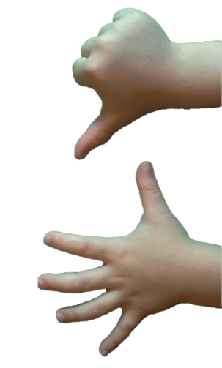
- Say, “It’s almost spring, and all the baby chicks (wiggle fingers) are warm inside their eggs inside their nests (make two fists on a surface).”

- Say, “When spring comes, the chicks in this nest (shake left hand) hatch first and stand up. The littlest one hatched first.” Demonstrate the first 5 hatching and standing up, starting with the smallest egg (left to right, starting from the pinky and moving to the thumb of the left hand). Have the children count the chicks as they emerge, “1, 2, 3, 4, 5.”
- There are more chicks waiting to hatch! (Shake your right fist.) One of them hatches and comes out.” Have 1 more chick hatch (right hand thumb).

NOTES ON
MULTIPLE MEANS
OF ENGAGEMENT:
Students who are ready can role-play the teacher and retell the chick story for a partner to count using his or her fingers. Students could also tell their own creative story that would elicit finger counting to 6 or 7.

- Tell them, “Let’s count how many chicks have hatched.” To support the count, lift your fingers off the surface and then drop them as the students count. Have them count, “1, 2, 3, 4, 5, 6.”
- Have the children show their nests and eggs. Have them pretend all the chicks are in the eggs in the nests again (two fists) and then count 9 chicks hatching again, starting with the littlest one.
- Ask them, “How many eggs are still in your nest?”
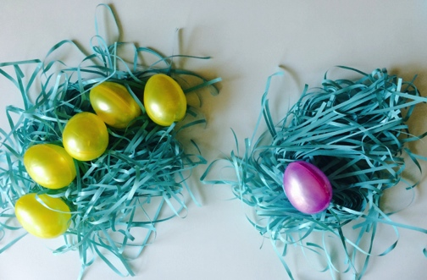
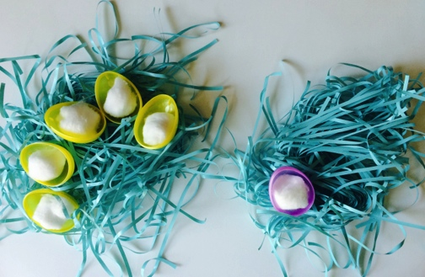
- Say, “Guess what? We just used our fingers to count the Math Way!”
Part 2: Practice
Materials: (S) Per pair: 2 nests (e.g., plastic grass or yarn, small bowl), 5 plastic eggs of one color, 1 plastic egg of another color, cotton ball “chick” in each egg
Send students to prepared tables.
- Have pairs put the eggs in both nests, separating by color.
- Have pairs “hatch” the chicks in their nests by opening the plastic eggs. Invite partners to touch and count the cotton ball “chicks.”
- Have students make their fists next to the nests. Tell them, “Six chicks hatch and stand, one at a time. Let’s count them as they hatch!” Have them count from left to right as they show each finger.
- Ask questions as you circulate. “How many chicks hatched?” “How many chicks hatched in this nest?” “This one?” “Which was the first chick to come out?” “Which was the last?”
MP.6
- Ask the children to show their partner two ways to count the chicks who hatched, by touching and counting using the chicks and by counting on their fingers.
Student Debrief (3 minutes)
Lesson Objective: Count to 6 and 7 left to right with fingers.
The Student Debrief is intended to invite reflection and active processing of the total lesson experience. It is also an opportunity for informal assessment. Consider taking anecdotal notes or using a simple checklist to note each child’s progress towards meeting the lesson objective.
As students complete the Practice portion of the Concept Development, listen for misconceptions or misunderstandings that can be addressed in the Debrief. You may choose to use any combination of the questions below to help students express ideas, make connections, and use new vocabulary.
- Show me your two nests. (Students show two fists.) Show me all the eggs. (Students show all their fingers.) On your fingers, show me the chicks that hatched today.

CENTER CONNECTION:
In the sensory center, provide opportunities for students to practice moving 6 fingers through a variety of materials (e.g., sand, oatmeal, shaving cream, finger paint). Use the chick context as a starting point, but invite children to make up other stories about their 6 fingers and the 6 paths that they create. This activity will help build fine motor muscles needed for counting the Math Way.
- (Display a set of nests while children continue to show 6 fingers.) How are your cotton ball chicks like the 6 fingers you are showing?
- What do you like about counting on your fingers to 6 using your two nests?
- What do you notice when you count on your fingers to 6? What is different about counting to 5 and counting to 6 on your fingers?
- When you counted the Math Way, you started with one hand and moved to the other. Is there anything else we do in the same direction?

