Lesson 2
Objective: Use linear configurations to count 6 and 7 in relation to 5.

Suggested Lesson Structure
 Fluency Practice (7 minutes)
 Application Problem (3 minutes)
 Concept Development (12 minutes)
 Student Debrief (3 minutes)
Total Time (25 minutes)
Fluency Practice (7 minutes)
- Tally 3 Objects PK.CC.3a (3 minutes)
- Touch and Count Beans PK.CC.1 (4 minutes)
Tally 3 Objects (3 minutes)
Materials: (T) 3 of the same item (e.g., tall boxes, identical dolls, or teddy bears) (S) Paper and crayon (or white board)
Note: Throughout Topic A, students tally up to 5 objects as a foundation for tallying numbers to 10.
T: (Put one tall box on the table.) Let’s draw a line to stand for this box. Draw a straight line on your paper from top to bottom.
S: (Draw line.)

NOTES ON
MULTIPLE MEANS
FOR ACTION AND EXPRESSION:
Provide students who are unable to draw vertical lines an alternative way to respond. For example, popsicle sticks could be used to represent the number of boxes. Also provide alternative times to practice making vertical lines using a variety of media such as markers or paints.

T: How many lines have you drawn?
S: 1.
T: How many boxes are there on the table?
S: 1.
T: (Put one more box on the table.) Let’s draw a line to stand for this box next to our other line.
S: (Draw line.)
T: How many lines have you drawn now?
S: 2.
T: How many boxes are there on the table?
S: 2.
Repeat the process with one more box.
Touch and Count Beans (4 minutes)
Materials: (S) Bag of 7 beans
Note: Use this activity as an opportunity to informally evaluate students’ performance level with counting, and modify counting activities in Module 3’s fluency to accommodate their needs.
T: Put 5 beans in a line. (Pause as students do so. Observe their strategies. Gently remove beans from those who struggle to count to 5 accurately until they have a number of beans they can touch and count with one-to-one correspondence. Make note of those students’ performance level with counting and modify Module 3’s fluency as possible to differentiate.)
T: (Quietly address students who are able to count to 5 correctly.) Jenny, Alexis, and Marta, put 1 more bean at the end of the line.
T: Touch and count how many beans you have now. (Pause as students touch and count. Observe carefully.) How many beans do you have now?
S: 6.
T: Count them again! See if you get better at counting them! (Continue to observe.)
Have the students count until they have mastered counting 6 beans. Encourage students who have mastered counting 6 beans to put 1 more bean in the line.
Application Problem (3 minutes)
Materials: Upbeat music, audio equipment
Invite 5 students forward to create a conga line. Start the music and have children move around the room until the music stops. Then, count the number of children in the line. Invite 1 more child to join in the fun, then 1 more up to 7 students. Each time 1 more child joins the line, ask the how many question after counting. Repeat the activity with different dancers, as time allows, so all students have an opportunity to participate in the conga line.
Note: This Application Problem is designed to practice the concept of 1 more from the previous lesson as students use a linear configuration to count up to 7.
Concept Development (12 minutes)

NOTES ON
LANGUAGE DEVELOPMENT:
Activate or build children’s background knowledge by talking about explorers in advance of this lesson. Knowing that explorers travel to find out about new places will help children understand why the explorer needs to cross the creek.

Part 1: Concept Introduction
Materials: (T) Creek mat (Template), 2 double-sided counters (e.g., red and white), explorer figurine (optional)
Gather children in a circle around the creek mat.
- Introduce students to the explorer and explain that he needs to cross the creek. Point out the line of rocks. Ask a volunteer to move the explorer across each rock while the class counts, “1, 2, 3, 4, 5.”
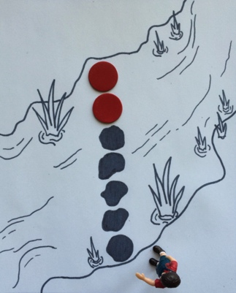
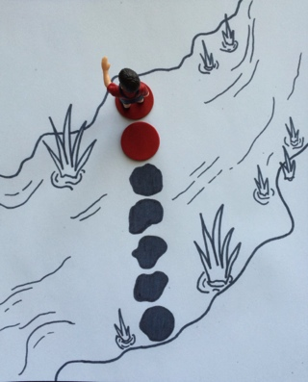
- Ask, “Do you think the explorer could cross if there was 1 more rock?” Add 1 red counter to the line.
- Ask, “How many rocks are there now?” Have another volunteer move the explorer across each rock while the class recounts 5 with 1 more, “1, 2, 3, 4, 5, 6. There are 6 rocks.”
- Say, “We had 5 rocks, and we added…?” Students respond, “1 more!”
- Repeat Steps 2–4 to count 7 rocks, recounting 6 with 1 more.
- Ask, “How many black rocks were there?” “How many red rocks did we use?” “How many rocks did the explorer need altogether to cross safely?” Give children an opportunity to count after each question.
Part 2: Practice
Materials: (S) Cross the creek (Template), 7 double-sided counters (e.g., red and white)
- Send students to prepared tables: “It’s your turn to help the explorer cross the creek.” Make sure children know that the counters are double-sided.
- Say, “First, take out your counters and cover the rocks in the creek. Use the white side. Tell your partner how many rocks are in the line.”
- Say, “Now, put a red rock in the line. Use your math words to tell your partner what you did.” A student might say, “I put 1 more,” or “I put another rock,” or “I made the path longer.”
- Guide students to count the white rocks, count the red rocks, and then count all the rocks each time they put 1 more in the line.
- Repeat Steps 3 and 4 to show 7 rocks in the line. Have students use their finger to represent the explorer and cross the creek! Celebrate the explorer’s crossing.
Student Debrief (3 minutes)

CENTER CONNECTION:
Invite children to use 7 mats or hula hoops as “rocks” in the dramatic play center. Allow students to naturally incorporate the rocks into their play. If they use the rocks to create a path, have them count each rock as they walk across the path.
Lesson Objective: Use linear configurations to count 6 and 7 in relation to 5.
The Student Debrief is intended to invite reflection and active processing of the total lesson experience. It is also an opportunity for informal assessment. Consider taking anecdotal notes or using a simple checklist to note each child’s progress towards meeting the lesson objective.

As students complete the Practice portion of the Concept Development, listen for misconceptions or misunderstandings that can be addressed in the Debrief. You may choose to use any combination of the questions below to help students express ideas, make connections, and use new vocabulary.
- How many rocks were in the creek at first? Count your fingers on your left hand. (Pause.) Five rocks and 5 fingers. It’s the same number!
- What did you need to do to help the explorer to cross the creek?
- Count the black rocks. (Pause as students count.) Count the red rocks. (Pause.) Count all the rocks. (Pause.) How many rocks did you count altogether?
- (If students are ready, consider asking the following question and demonstrating with linking cubes.) Listen to my pattern: 3 and 1 more is 4. 4 and 1 more is 5. 5 and 1 more is…? 6 and 1 more is…?

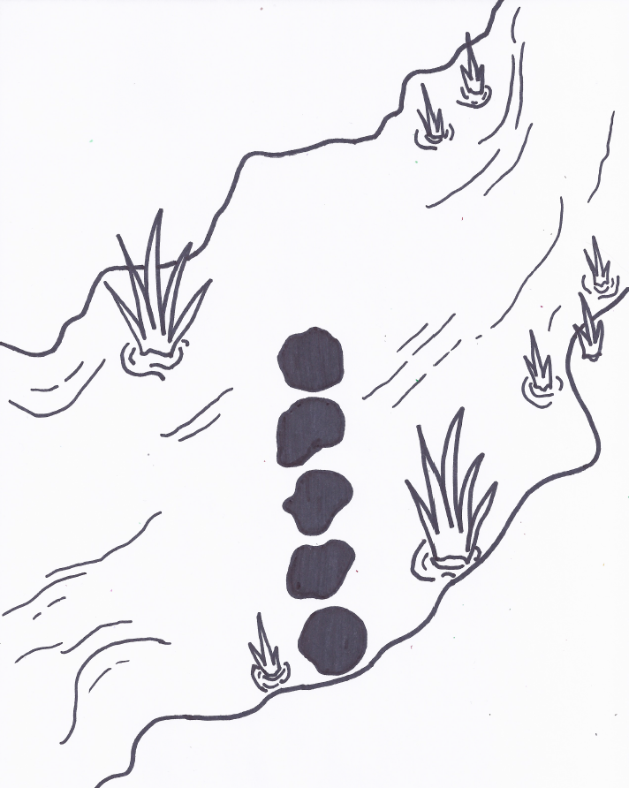
___________________
creek mat

