Lesson 1
Objective: Introduce 6 and 7, and relate 6 to 5 and 1 more and 7 to 6 and 1 more.

Suggested Lesson Structure
 Fluency Practice (5 minutes)
 Concept Development (17 minutes)
 Student Debrief (3 minutes)
Total Time (25 minutes)
Fluency Practice (5 minutes)
- Clap and Count to 6 and 7 PK.CC.1 (2 minutes)
- Triangle Sides PK.CC.3a (3 minutes)
Clap and Count to 6 and 7 (2 minutes)
Note: Rote counting to 6 and 7 prepares students for the objective of touching and counting to 6 and 7 by adding 1 more.
T: Let’s clap 6 times, and count our claps! Join in when you are ready. 1, 2, 3, 4, 5, 6. (Repeat until most students are either clapping, counting, or ideally, clapping and counting. Pause between counts.)
T: Let’s pat our heads 6 times, and count our pats! 1, 2, 3, 4, 5, 6. (Follow the same process as above.)
T: Let’s clap 7 times, and count our claps! 1, 2, 3, 4, 5, 6, 7.
T: Let’s pat our heads 7 times, and count our pats! 1, 2, 3, 4, 5, 6, 7.
Triangle Sides (3 minutes)
Materials: (S) 10 craft sticks per pair (placed on tables)
Note: Throughout Topic A, children line up and count craft sticks as a foundation for tallying numbers to 10.
T: Carefully get the number of sticks you need to make the sides of a triangle.
T: Make them into a triangle on your table.
T: Move your sticks so they’re next to each other instead of making a triangle. Now, line them up so they are like three students standing next to each other.
T: Move them back again to make a triangle.
T: Move them next to each other again.
Concept Development (17 minutes)
Part 1: Concept Introduction
Materials: (T) 7 objects to represent players, 7 objects to represent balls (e.g., dolls, bean bags)
(S) Baggie with 7 objects to represent balls (e.g., counters, beans)
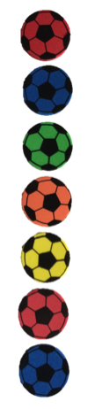
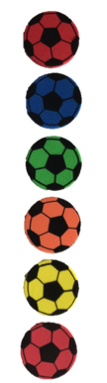
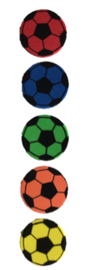
Line up 5 soccer players in front of the class.
- Point to the soccer players, and say, “This is the Pre-K soccer team. How many players are on the team?” Children count 5 players.
- Count out 5 soccer balls, 1 for each player. Have children do the same.
- Say, “The team needs 1 more player.” Place a doll to join the team. “Let’s point to each player and count together: 1, 2, 3, 4, 5, 6. How many players are there now?” Guide children to say, “There are 6 players.”
- Say, “We had 5 players and we added…?” Students respond, “1 more!”
- Ask, “How can we make the number of soccer balls match the number of players? What do we need to do?” Guide students to see that they need to add 1 more ball. Touch and count the soccer balls together, “1, 2, 3, 4, 5, 6.”
- Say, “We had 5 soccer balls and we added…?” Students respond, “1 more!” Have children repeat, “5 and 1 more is 6.”
- Repeat Steps 3–6 to count 7 players and balls.
Part 2: Practice
Materials: (S) Baggie containing 7 cubes (5 of one color or type, 2 of another color or type), Problem Set, crayons
Send students to tables with their baggies.

NOTES ON
MULTIPLE MEANS
OF REPRESENTATION:
Circulate and listen to all students as they count their soccer players, checking for one-to-one correspondence. Assist students who are having difficulty by guiding their hands as they touch each player and count 1, 2, 3, 4, 5, 6.

- Say, “These cubes are your soccer players. Touch and count all of your red players. How many players do you have? Tell your partner.”
- Invite children to put 1 more player on the team using 1 of the yellow cubes. Say, “Touch and count your players. How many players do you have now? Tell your partner.”
MP.6
- Repeat Step 2 to count 7 players.
- Distribute a Problem Set to each child. Instruct students to touch and count the first line of soccer balls for their partner.
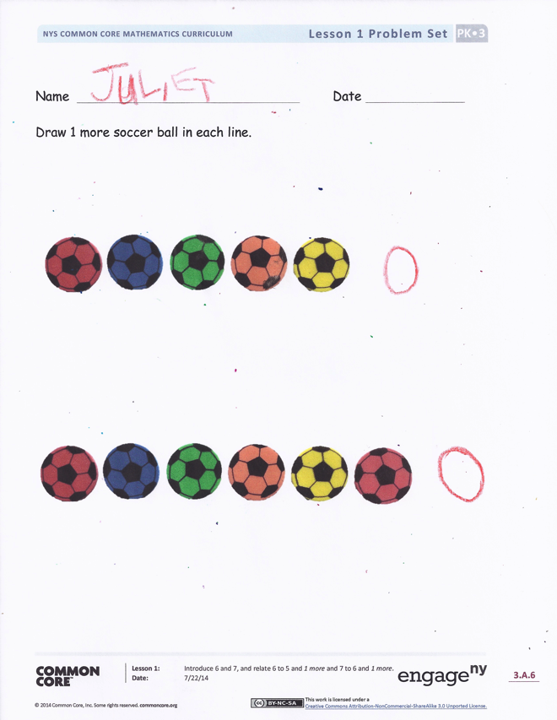
- Show children how to draw 1 more ball on the first line and say, “I had 5 soccer balls. I drew 1 more!” Then, have them recount to 6.
MP.6
- Repeat Steps 4 and 5 for the second line of soccer balls. Circulate as students work, asking questions and making suggestions such as “How many soccer balls are in this line?” “Put 1 more.” “Count how many there are now.”
Student Debrief (3 minutes)
Lesson Objective: Introduce 6 and 7, and relate 6 to 5 and 1 more and 7 to 6 and 1 more.
The Student Debrief is intended to invite reflection and active processing of the total lesson experience. It is also an opportunity for informal assessment. Consider taking anecdotal notes or using a simple checklist to note each child’s progress towards meeting the lesson objective.
As students complete the Practice portion of the Concept Development, listen for misconceptions or misunderstandings that can be addressed in the Debrief. You may choose to use any combination of the questions below to help students express ideas, make connections, and use new vocabulary.
- When we had 5 soccer players, did we put 1 more to make 6? When we had 6, what did we do to make 7?

CENTER CONNECTION:
Have children count out a group of 5 blocks in the block center. Add 1 more block, and ask them to count how many. Then, add 1 more block and have them count again. Finally, ask them to stack the blocks and count. Some students use conservation to understand that the number of blocks does not change when the blocks are rearranged.
- (Show a completed Problem Set.) Watch as I count these soccer balls: 1, 2, 3, 4 (skip object), 5, 6. What mistake did I make?
- I want to count to 6. Do I have to know how to count to 5 to do that? I want to count to 7. Do I have to know how to count to 6 to do that?

Name Date
Draw 1 more soccer ball in each line.

