Topic A
How Many Questions with up to 7 Objects
PK.CC.1, PK.CC.3abc, PK.CC.4
Focus Standard: | PK.CC.1 | Count to 20.
 | PK.CC.3abc | Understand the relationship between numbers and quantities to 10; connect counting to cardinality.  - When counting objects, say the number names in the standard order, pairing each object with one and only one number name and each number name with one and only one object.  - Understand that the last number name said tells the number of objects counted. The number of objects is the same regardless of their arrangement of the order in which they were counted.  - Understand that each successive number name refers to a quantity that is one larger.
 | PK.CC.4 | Count to answer "how many?" questions about as many as 10 things arranged in a line, a rectangular array, or a circle, or as many as 5 things in a scattered configuration; given a number from 1─10, count out that many objects.
Instructional Days: | 5
Coherence -Links to: | GK─M1 | Numbers to 10
 | GK─M5 | Numbers 10–20 and Counting to 100
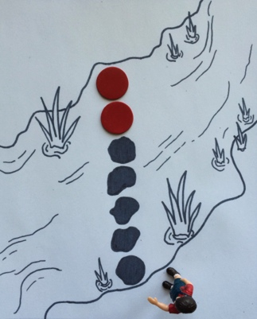
In Topic A, children build upon the understanding of the number core from Module 1, now including quantities of 6 and 7.
Lesson 1 introduces 6 and 7 in the context of a soccer team looking for more players. Children count with one-to-one correspondence as the team of 5 gets 1 more player: “Now, we have a team of 6!” Similarly, when 1 more player is added to the team of 6, the students count 7 players (PK.CC.3abc).
Lesson 2 further explores 6 and 7 in relationship to 5. In order to help an explorer cross the creek, students must create a line of rocks from counters. There are already 5 rocks, but students must add 1 more rock (red counter), then touch and count from 1 to 6. To get all the way across the creek, they must add another rock, and then touch and count from 1 to 7 (PK.CC.3c). The color change in the rocks emphasizes the relationship to 5 as children count 6 and 7 in a linear configuration. This lesson hints at the counting on strategy that children will use early in Grade 1.
In Lessons 3 and 4, children extend their ability to count the Math Way, now including the thumb of the right hand for 6 and the right pointer finger for 7. At this stage, children extend fingers for counting to show chicks (fingers) hatching from their nest (fist). During partner practice, students open plastic eggs, counting the cotton ball chicks as they hatch. As students continue to practice counting fingers (as chicks hatching and standing) from left to right next to the nests, they use two different ways of determining how many are in a given set.
In Lesson 5, children are introduced to arrays in the context of sorting laundry. First, they arrange 4 socks in an array. Then, they add another pair and count 6 socks in a 3 by 2 array. Children develop an organized counting path through the array (e.g., left to right, top to bottom).
Throughout Topic A, children develop fluency counting with one-to-one correspondence through touch and count activities to 7 using manipulatives such as pennies and cotton balls. Students also maintain familiarity with building shapes and tallying up to 5 using craft sticks. The use of engaging materials and simple games allows children to build number sense joyfully.
A Teaching Sequence Towards Mastery of How Many Questions with up to 7 Objects
Objective 1: Introduce 6 and 7, and relate 6 to 5 and 1 more and 7 to 6 and 1 more.
(Lesson 1)
Objective 2: Use linear configurations to count 6 and 7 in relation to 5.
(Lesson 2)
Objective 3: Count to 6 and 7 left to right with fingers.
(Lessons 3–4)
Objective 4: Count 6 objects in array configurations.
(Lesson 5)

